Management Accounting
Assessment 2

Mihail Cristian
Student ID: 2112321
Module: Management Accounting
Module Code: LCBB5002

Table of Contents
Introduction 3
Part A 3
i. Monthly control Budget 3
Flexed Budget 3
Original Budget 4
Variance Budget 5
ii. Analysis of the performance 6
iii. Recommendation 6
Part B 8
Discussion and advises 8
Conclusion 10
Reference list 11

Introduction
The report is based on “Accounting management”, and was required to calculate several calculations divided into two sections. The researcher may understand the various accounting aspects to demonstrate accounting knowledge. The report may discuss the monthly control budget, and its performance and further analysis of various considerations of relevant cost to recommend the companies for more development in the business. It also refers to demonstrating decision-making abilities to identify the risk in the management and mitigate it.

Part A

i. Monthly control Budget

Flexed Budget
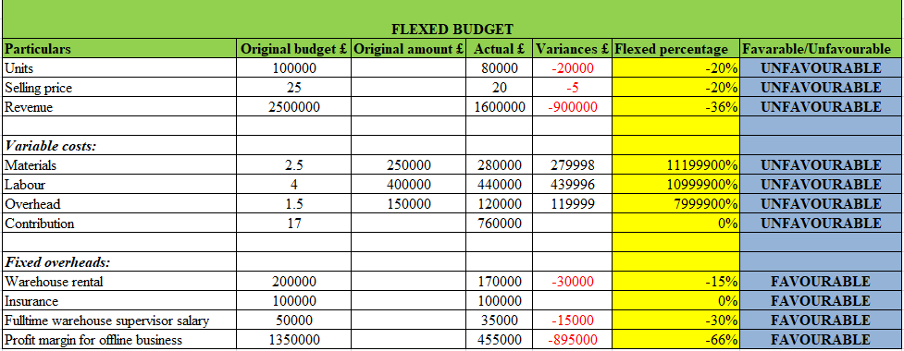
Figure 1: Flexed Budget
(Source: self-created)
The analysis of the flex budget varies the required changes in the amount of the earned value which is on actual revenue (Beck, et al. 2020, pg.03). Hence, a flex budget will be used to show its performance in the form of a percentage of revenue for a certain expense, rather than the values of the original value. The above figure shows the result analysis of the better comparability of budgeted and also based on the actual result. The flexed values have been calculated by using the variance, and original amount. By subtracting the original value from the actual value the result will show the variance value. Hence, the variance value will be divided by the original value to find the flexed percentage of the company. On the other hand, it will refer to making the different levels of the activities in the business, expenses, and revenue. The occurrence of efficiency in the organization in the process to ensure the approvals, and approvals in the management of the organization's working performance (Liu et al. 2020, p.03). Flexed budget refers to the modification in the different sections that will occur as the better performance in the business of Amana ltd. it is also adapted to making changes in the operating condition that may be useful to the managers, and owners of the company. As a result, the application of personnel at the level of the job is required to maintain better financial performance with fewer budget surpluses or deficits in the business.

Original Budget
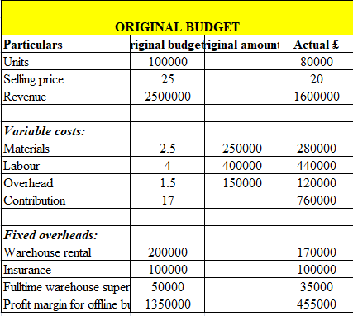
Figure 2: Original Budget
(Source: self-created)
The analysis of the original budget may refer to detailing the performance of the company, and the values that are required to perform the business (Faliszewski, and Talmon, 2018, p.02). Therefore, the forward-looking consolidated budget of Amana Ltd, and the borrowers with respect to different months of the agreement is to be required. It may refer to showing the profit, and loss statement of the business, hence various assumptions are also required. The above figure shows the three sections of business activity which are sales of the business, variable, and fixed costs in the business. Therefore, the estimated sales values of the production, cost, and marketing expectations will refer to the budget ground in the different sections. The above figure determines the original cost that occurs during the business activity of the company. Hence, it is selected by the owner of the company to determine a specific cost of the budget of the business to process a business (Gocardless, 2021). It is showing the budget benchmarking of the company that may refer to the offense of a convenient way to monetize that comparison in the business performance on a specific period of time.

Variance Budget
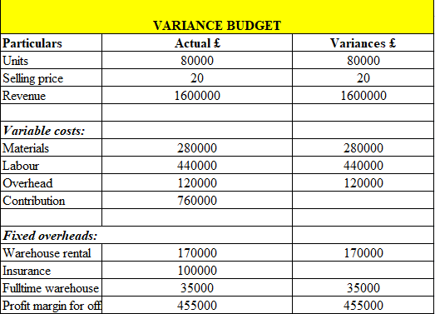
Figure 3: Variance Budget
(Source: self-created)
Variance budget refers to an accounting term that describes the instant value where the actual cost is either lower or higher than the original value or projected cost of the business. Further, it will be helpful to generate the budget, which helps to evaluate the performance of the company. Moreover, the variance refers to the difference between budgeted income, actual income, and expenditure of the business (FASOYE, and OLAYIWOLA, 2020, p.01). It also memes that the distribution with a coefficient of variation is higher is maintained. It may be considered below the variance or higher variance whereas the lower 1 value will be considered as the low variance. The above figure includes the calculation of the variance value for the business, which is evaluated by subtracting the actual value and original budget that is generated by the company. Hence, the occurrence value shows the number of values that are required to improve the business operations in the company of Amana Ltd.

ii. Analysis of the performance
The above discussion is based on the various budgets calculating Amana’s business performance, by analyzing the original budget, flexed budget, and variances. Hence, the flexed budget performance report refers to the management reporting process that may compare the actual revenue and variable cost for a limited period of time. The budgeted revenue and various costs may be based on the actual sales volume of the business (Smallbusiness.chron, 2022). The above-analyzed data shows the favorable and unfavorable responses on the accounting business performance. It refers to allowing the business to get more opportunities for the allowance of more variance in the business which comparatively refers to a static budget. The process of designing a budget, required to make sure about the section of not spending more than the business expects. Hence, the balance will be accommodated to the section to pay more for the business. The unfavorable performance refers to “setting a realistic goal” in the business that will help the business for making smart spending in the business. Further, it also creates more choices to create more options in the business in generating sustainability in the business (Sides, and Cuevas, 2020, pg.03).
The process of making a static budget can involve various types of predictions and assumptions. Hence, on the basis of that, it can be observed that the application of the flex budget in business of Amana shows favorable and unfavorable performances. The occurrence of the unfavorable in the seduction of selling products due to the negative value in the management. Subtracting the actual cost from the original budget the occurrence of variance cost was in negative value. Henec, the values can be determined as unfavorable due to the lower selling performance of the business (Chopra et al. 2019, p.10). On the other hand, the occurrence of favorable in the section of fixed overhead due to higher original budgeted cost in the management. Therefore, the occurrence of different flexed percentages at different sectors refers to showing different occurrences of a business situation in the form of percentages.

iii. Recommendation
The following recommendation refers to making the business performance of the company Amana Ltd more efficient and effective to get favorable responses in the business.
Recommendation 1: Accurate bookkeeping
The actual output quantity of data may use to apply for the calculation of the revenues for the creation of a flexible budget. This may refer to better performance if the business gets favorable in the business. Moreover, to improve the budget analysis of Amana ltd, required to follow the strategy of “accurate bookkeeping” of the business. This may refer to spending the doable translational data that may able to record the various performances that the company takes for the business. This will provide a proper track to reduce the cost of the management and to reduce the expenses of the business. Furthermore, the analysis of the future cost or expense of the business may refer to making things in a proper way to manage it.
Recommendation 2: The creation of a Budget with varying different levels of production
The analysis of the above data of the company by using the different types of budget on a monthly basis help to make a recommendation to improve the business performance is required. Hence, it is recommended that the development of a flexible budget in business at the start of the business for determining the actual sales. The development of the company is based on an evaluation of the budget by the experts of the business, which will help in creating expectations for a more likely level of sales, and expenses. Therefore, the occurrence of the sales activity will be referred to as the quantitative output in a better way.
Recommendation 3: Better cost control
Furthermore, it is also recommended that the company be required to create a flexed budget on a regular basis to provide a critical change in the business. It refers to quicker to adverse the business condition, which supposed to set up the budget to increase the sales in the management. Hence, the company may be able to report the sustainability of the business to reveal the errors and misleading engagement of the business (Omotayo et al. 2020, pg.02). Hence, it can be said that the creation of a dutiful static budget on a monthly basis refers to making a desk drawer to record the performance of the business that includes various activities of the business. The application of a Flexible budget may include lowering cost control in the business by reducing the various expenses of the company. Hence, by using the flexible budget Amana Ltd may preferable the application of a favorite management tool in the business.

Part B
Business Amana has been involved in the application of the online strategy in the business to make stable competition with its competitors in the UK market. Furthermore, the company goes to make its business activity with 50% of selling its product online. There are several types of factors that take in into consideration for expanding the business performance on the online platforms. There may be the inclusion of the cost of the different sectors such as website, salary, application of IT programmer, various types of online strategies, and cost of overhauling the current site (Chaffey and Ellis-Chadwick, 2019, p.16). The use of the online platform by Amana ltd refers to allowing the company to create relationships with targets to solve the issues of the consumers and make strong connectivity with them. This will also refer to sending messages to grab the attention of consumers in a different sector. The application of online tools allows for meeting both meet clients, influencers, and colleagues which may refer to making sustainable relationships and strength in the business (Wcc.ca, 2020). Therefore, the company is required to sell its product on an online platform such as Amazon. Amazon is one of the highest, using e-commerce platforms that are owned, and operated for enabling third parties. This type of online platform connected globally that grab the attention of the consumer through its products. Hence, Amana ltd is also trying to make a connection with Amazon, to sell its product at a higher number, and at a reasonable cost to the customers.

Discussion and advises
According to, Eva.guru, 2021, Amazon is a marketplace that is pretty and “seller-friendly”, as the platform for delivering new and innovative products. Furthermore, it is also the type of platform where the company also engaged through selling second-hand products that are allowed to be sold. Therefore, Amana ltd refers to make its 50% of its business through an online platform using the field of Amazon. Therefore, to continue the business through Amazon the consumer is required to maintain some cost in the business for better performance on the startup platform (Ullah et al. 2018, p.02). The company is required to pay the minimum amount of cost to Amazon for using its online platform to grab the attention of customers globally. Therefore, the occurrence of cost on an annual basis is charged £50000, which is the minimum rate for using the online platform for marketing its product.
The owner of the business Amana includes the cost of £150000, for delivering the network between the clients. These may refer to establishing the “warehousing, and distribution”, connectivity in the business. Hence, the company may able to take products right off to assembling the line in the process of the package and send it to the required customers (Li et al. 2020, p.04). Furthermore, the application of a “direct distribution network strategy”, may refer to the evaluating option of taking place of the product at the place it is required.
The uses of cost for the purpose of upgrading the current websites to handle the large volume of sales in business are required. Therefore, Amana ltd separated the amount of £50000, for the purpose of maintaining website crises that may occur during the process of sending and receiving the notification, to connect with a customer. Hence, the process of applying strategy to different types of the delivering services or products is required to maintain the cost. Therefore, the company can be said, to have startup costs for starting a business within a new platform. These may refer also include the cost of types of equipment, fuels, licenses, and marketing expenses.
The application of the target market in the performance of the business refers to making the customers that are required more in the sector of the quick delivering process for local areas mainly. According to techvera.com, 2022, a national survey of the process of couriers it is found that the average delivery makes $34 per hour. Hence, it is also surveyed that most of the part-time businesses by choice may refer to the get wages at a weekly paycheck that may preferable to enacted the costs. The requirement of an effective communication process in the business process, that highly applicable especially in the section on financial profitability is to be evaluated.
The Salary of a full-time IT programmer involves £35000 per annum by the analysis of Amana ltd, required to continue the business at online marketing platforms. It is observedthat it is required to make experienced IT business platforms in the management of team members. Hence, IT programming in the business plays a vital role in such as automated world. It is also involved in making the personnel, commercial, and non-profitability in the sector of simplest terms (Bala and Verma, 2018, p.04). The application of the various types of charges may refer to the business risk as it is newly startup of the company at a new business platform. Therefore, the occurrence of various types of costs may fall in the loss of the business. On the other hand, it also refers to the high profitability of the business. Furthermore, there is also the requirement to maintain connectivity with the users and business management. Hence, it is observed that the business has a profit margin at £1065000 after engaging with the online platform Amazon. Hence, the company may get better connectivity with the consumers and get more effective business performance in the company.

Conclusion
From the above analysis, it is concluded that the application of a monthly cost budget in the business of Amana ltd refers to the getting prediction of business performance. The uses of the Flexed budget refer to the well-performing prediction of the business and also making the availability of production, expenses, and overheads of the company. Moreover, the changing process of continuing business strategy towards the online platforms refers to the profitability in the business. The engagement of the company with Amazon to grab the attention of the customers to sell its product at a high number of risks refers to the betterment of the business. However, the business may get higher risk in the way of changing the process of selling the product through Amazon, but the company may get more advantages in the future.

Reference list
Bala, M. and Verma, D., 2018. A critical review of digital marketing. M. Bala, D. Verma (2018). A Critical Review of Digital Marketing. International Journal of Management, IT & Engineering, 8(10), pp.321-339.
Beck, F., Mucci, D.M. and Frezatti, F., 2020. Which are the Roles of the Flexible Budget Practices?. Anais.
Chaffey, D. and Ellis-Chadwick, F., 2019. Digital marketing: strategy, implementation & practice. Pearson uk.
Chopra, F., Haaland, I. and Roth, C., 2019. Do People Value More Informative New?. Available at SSRN 3523530.
Eva.guru, 2021, 6 Reasons Why Amazon Marketplace Is One of The Best-Selling Platforms, 2021, Available at: https://eva.guru/blog/6-reasons-why-amazon-marketplace-is-one-of-the-best/ (accessed on: 19.11.2022)
Faliszewski, P. and Talmon, N., 2018. A framework for approval-based budgeting methods. arXiv preprint arXiv:1809.04382.
FASOYE, K. and OLAYIWOLA, A.S., 2020, Dynamic Relationship Between Budget Variance and Fiscal Policy in Nigeria: A Vector Autoregressive (VAR) Approach.
Gocardless, 2021, The benefits of budgeting in business, 2021, Available at: https://gocardless.com/en-au/guides/posts/benefits-of-budgeting-in-business/ (accessed on: 19.11.2022)
Li, C., Mirosa, M. and Bremer, P., 2020. Review of online food delivery platforms and their impacts on sustainability. Sustainability, 12(14), p.5528.
Liu, L.L., Lin, C.Y., Diaz, J.F. and Fan, F.H., Factors affecting budget preparation and flexibility: Evidence from Taiwanese local government units.
Omotayo, T., Bankole, A. and OlubunmiOlanipekun, A., 2020. An artificial neural network approach to predicting most applicable post-contract cost controlling techniques in construction projects. Applied Sciences, 10(15), p.5171.
Sides, J.D. and Cuevas, J.A., 2020. Effect of goal setting for motivation, self-Efficacy, and performance in Elementary mathematics. International Journal of Instruction, 13(4), pp.1-16.
Smallbusiness.chron, 2022, Why Would a Company Find a Flexible Budget Variance More Informative? 2022, Available at: https://smallbusiness.chron.com/would-company-flexible-budget-variance-informative-34699.html (accessed on: 19.11.2022)
techvera.com, 2022, REASONS WHY YOUR BUSINESS NEEDS TO HAVE EXPERIENCED CODERS, 2022, Available at: https://techvera.com/reasons-why-your-business-needs-to-have-experienced-coders/ (accessed on: 19.11.2022)
Ullah, F., Sepasgozar, S.M. and Wang, C., 2018. A systematic review of smart real estate technology: Drivers of, and barriers to, the use of digital disruptive technologies and online platforms. Sustainability, 10(9), p.3142.
Wcc.ca, 2020, 5 Unexpected Benefits of Information Technology Courses, 2020, Available at: https://wcc.ca/blog/5-unexpected-benefits-of-information-technology-courses/ (accessed on: 19.11.2022)

