
Introduction to Electromagnetic Radiation
Arun Sherlock
2318644


Date: 23/04/2025
—
Lecturer: Stalin Jacob
—
Module: ACDC5009

Contents
1. Abstract & introduction 4
1.1 Abstract 4
1.2 Introduction 4
1.3 Introduction to EMR 4
1.3.1 EMR Spectrum 4
1.3.2 Waveguides 5
1.3.3 Antennas 5
2. Task 1A – Rectangular waveguide 1 6
2.1 Design & Setup 6
2.2 Results 7
2.2.1 Electric field vectors at excitation port 7
2.2.2 Magnetic & Electric Fields 8
2.2.3 Cutoff Frequencies 9
3. Task 1B – Rectangular waveguide 2 11
3.1 Design & Setup 11
3.2 Results 11
3.2.1 Electric field vectors at excitation port 11
3.2.2 Magnetic & Electric Fields 12
3.2.3 Cutoff Frequencies 13
4. Task 2 – Halfwave Dipole Antenna 15
4.1 Design & Setup 15
4.1.1 Calculations 15
4.2 Simulation 15
4.3 Results 16
4.3.1 Operating Frequency 16
4.3.2 Radiation Pattern 16
6. Conclusions 17
6.1 Task 1 17
6.2 Task 2 17
7. References 18

Table of Figures:
Figure | Content | Page
1 | Electromagnetic Spectrum [2]. | 4
2 | Design of waveguide for task 1A. | 6
3 | Electric field vectors at port 2, mode 1, task 1A. | 7
4 | Electric field vectors at port 1, mode 2, task 1A. | 7
5 | Electric field vectors at port 2, mode 2, task 1A. | 7
6 | Electric field vectors at port 1, mode 3, task 1A. | 7
7 | Electric field vectors at port 2, mode 3, task 1A. | 7
8 | Electric fields in mode 1, task 1A. | 8
9 | Magnetic fields in mode 1, task 1A. | 8
10 | Electric fields in mode 2, task 1A. | 8
11 | Magnetic fields in mode 2, task 1A. | 8
12 | Electric fields in mode 3, task 1A. | 8
13 | Magnetic fields in mode 3, task 1A. | 8
14 | Table comparing calculated versus simulated cutoff frequencies. | 10
15 | Cutoff frequencies determined through simulation. Plot shows frequency through the waveguide. | 10
16 | Electric field vectors at mode 1 excitation port, task 1B. | 11
17 | Electric field vectors at mode 2 excitation port, task 1B. | 11
18 | Electric field vectors at mode 3 excitation port, task 1B. | 11
19 | Electric field vector and magnitude, mode 1, task 1B. | 12
20 | Magnetic field vector and magnitude, mode 1, task 1B. | 12
21 | Electric field vector and magnitude, mode 2, task 1B. | 12
22 | Magnetic field vector and magnitude, mode 2, task 1B. | 12
23 | Electric field vector and magnitude, mode 3, task 1B. | 12
24 | Magnetic field vector and magnitude, mode 3, task 1B. | 12
25 | Calculated versus simulated cutoff frequencies, task 1B. | 14
26 | Simulated cutoff frequencies, task 1B. | 14
27 | Dipole excitation port, task 2. | 15
28 | Frequency sweep setup, task 2. | 15
29 | S Parameter Plot, Task 2. | 16
30 | Calculated versus simulated operating frequency, task 2. | 16
31 | Gain plot (radiation pattern), Task 2. | 16

Table of equations:
Equation | Content | Page
1 | Width of waveguide, task 1A. | 6
2 | Height of waveguide, task 1A. | 6
3 | Length of waveguide, task 1A. | 6
4 | Cutoff frequency in rectangular waveguides | 9
5 | Speed of light in a vacuum | 9
6 | TE10 cutoff frequency in waveguide 1. | 9
7 | TE01 cutoff frequency in waveguide 1. | 9
8 | TE20 cutoff frequency in waveguide 1. | 9
9 | TE11 cutoff frequency in waveguide 1. | 9
10 | Theoretical cutoff frequency in a rectangular waveguide, with non-vacuum fill. | 13
11 | TE10 Cutoff frequency, task 1B. | 13
12 | TE01 Cutoff frequency, task 1B. | 13
13 | TE11 Cutoff frequency, task 1B. | 13
14 | TE20 Cutoff frequency, task 1B. | 13
15 | Length of dipole antenna. | 15
16 | Theoretical operating frequency of dipole antenna. | 15

Abbreviations:
Abbreviation | Full Word
EMR | Electromagnetic Radiation
EM | Electromagnetic
PEC | Perfect Electric Conductor
RADAR | Radio detection and ranging
TE | Transverse Electric
TM | Transverse Magnetic
TEM | Transverse Electromagnetic
Coax | Coaxial (cable)
HFSS | High frequency structure simulator

Abstract & introduction

Abstract
A report investigating the concept of electromagnetic radiation, through studies into both theoretical and simulated scenarios involving waveguides and dipole antennas.

1.2 Introduction
Electromagnetic radiation is a type of radiation made up of both electric and magnetic components, which oscillate at right angles to one another, in a perpendicular fashion. They are usually “self-propagating” waves, meaning that they propel themselves through space. This report investigates the design & performance of wave guides and antennas, to develop practical understanding of the theory.

1.3 Introduction to EMR

1.3.1 EMR Spectrum
Electromagnetic radiation is characterized by its wavelength, which also determines its properties. The electromagnetic spectrum is the characterisation of these electromagnetic waves, depending on their wavelength. As shown below in figure 1, the spectrum contains several different types of electromagnetic waves, including visible light, microwaves, x-rays and more. Each of these wavelengths have their own uses in multiple applications, such as communication, medical uses and RADAR. Different spectra within the EM spectrum may have entirely different properties, however the fundamental rules remain the same for all [1].
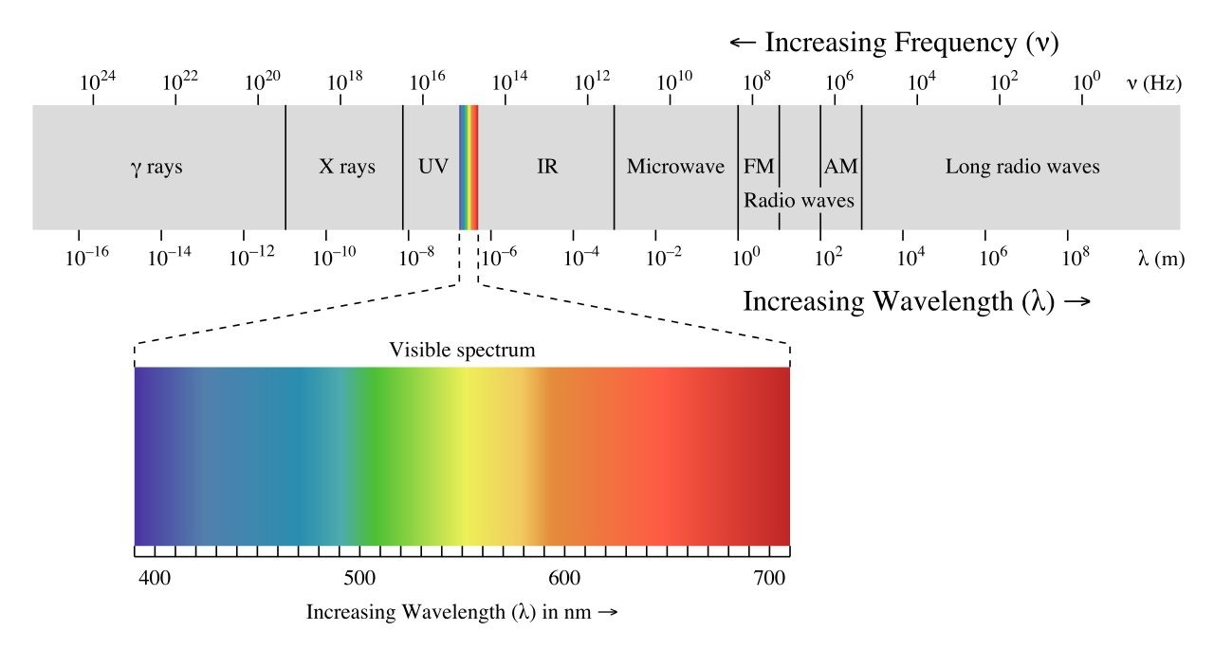
Figure 1 – Electromagnetic Spectrum [2].

1.3.2 Waveguides
Waveguides are channels which control the direction & propagation of electromagnetic waves [3]. An example which better illustrates the theory behind waveguides are fibre optics. An electromagnetic signal (light or laser) is transmitted along a fibre. The light is kept within the fibre by reflective surfaces and is transmitted from one end to the other. Different waves may travel along waveguides in different ways, the way that a wave travels through a guide is described as a mode [4]. Transverse modes describe waves which travel entirely in a transverse direction, with transverse electromagnetic (TEM), transverse electric (TE) and transverse magnetic (TM) describing variations of this, while hybrid modes describe a wave which has components within the longitudinal direction [4].
Waveguides may be used for many purposes and can be designed for most wavelengths – becoming impractical for particularly large wavelengths such as short-wave radio - across the spectrum, with other examples including microwave radiation, radio & RADAR guides. They are generally used to transmit a signal from one point to another, or to guide an output for a specific usage.

1.3.3 Antennas
Antennas are devices which are used to transmit electromagnetic signals. A signal is applied to the antenna, which then transmits it from its body to the environment. In this study, the design of a dipole antenna will be considered. A dipole is an antenna consisting of two “polar” antennas, equal in length, with signal inputted at the midpoint [5]. Using equations, an expected operating frequency may be calculated, however this often varies slightly in real world conditions with environmental influences & material properties.
**NOTE: An antenna is a transformation (transformer) between a signal in a transmission guide (e.g. coax, waveguide) into free space.

2. Task 1A – Rectangular waveguide 1

2.1 Design & Setup
The model is simulated in Ansys electronics, in HFSS simulation. The first stage of the scenario is to model the geometry of the waveguide. The dimensions of the waveguide are derived from student number (2318644).

Width $=a=23mm$
Equation 1 – Width of waveguide, Task 1A.

Height $=b=\frac{18}{2}=9mm$
Equation 2 – Height of waveguide, Task 1A.

Length $=50mm$
Equation 3 – Length of waveguide, Task 1A.

Once modelled, the properties are configured. The walls of the waveguide are modelled as a PEC, and the internal cavity is under vacuum. Excitation ports are defined on either end of the waveguide, as shown in figure 2.
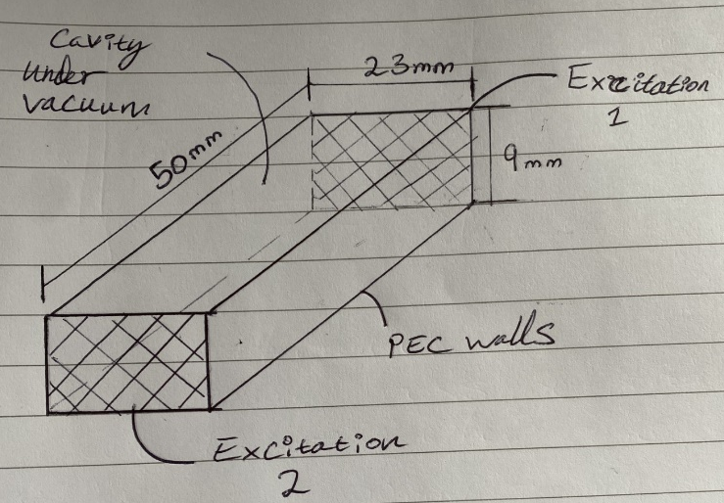
Figure 2 – Design of waveguide for task 1A.
The simulation is now setup, with a frequency sweep from 2GHz – 30GHz, with 3 modes enabled.

2.2 Results

2.2.1 Electric field vectors at excitation port
Mode 1- shown in shows a TE10 mode (Transverse electric), this can be determined as the direction of the arrows indicate a single half-wavelength across the width of the waveguide, so m = 1, n = 0. TE10 is very likely to be the dominant mode in rectangular waveguides, which adds weighting to this observation, however this can be confirmed via radiation patterns & cutoff frequency comparisons later in the study.
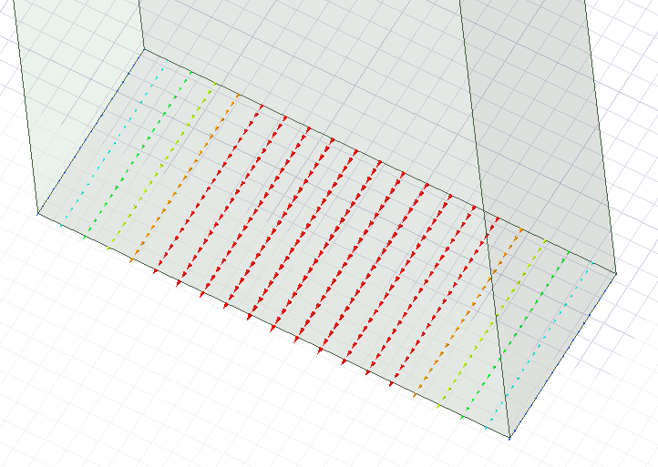
Figure 3 – Electric field vectors at port 2, mode 1, task 1A.

The second mode seen in this waveguide is likely TE20, as the field vectors show two half wavelengths across the excitation port’s width, which is consistent with TE20, and suggests that m = 2. There are no variations across the vertical face of the guide, which suggests that n = 0 in this waveguide.
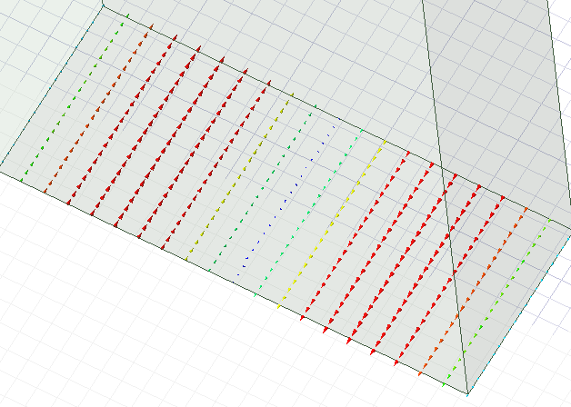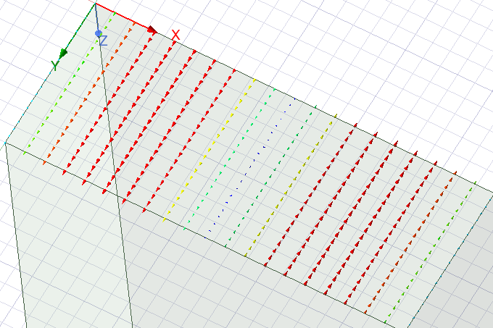
Figure 4 – Electric field vectors at port 1, mode 2, task 1A. Figure 5 – Electric field vectors at port 2, mode 2, task 1A.
The last mode seen in this waveguide is a less dominant transverse electric mode, very similar to mode 1. This is likely to be either TE01 or TE20 by a process of a deduction, assuming that only the most common modes are present. Assuming the most common modes, this is likely to be TE01, as the waves are travelling across the width of the guide.
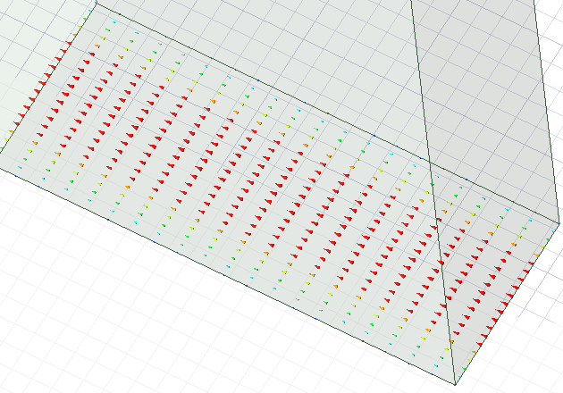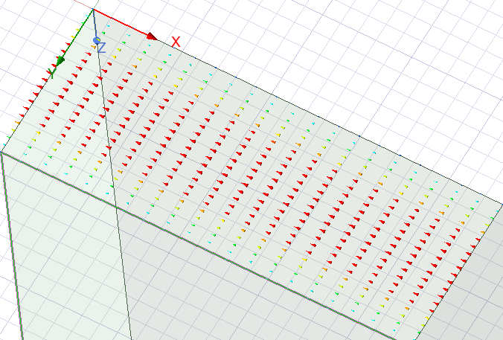
Figure 6 - Electric field vectors at port 1, mode 3, task 1A. Figure 7 - Electric field vectors at port 2, mode 3, task 1A.

2.2.2 Magnetic & Electric Fields
The below plots show the direction and intensity of the electric and magnetic fields within the waveguide. In mode 1, the electric field is not showing as it would usually be expected too in TE10, as the vectors are not moving in an entirely transverse direction, however this may be an artefact of the low height of the waveguide not allowing the waves to fully propagate. The magnetic fields do however seem to be mostly consistent with a TE10 mode. The results are in figures 8 & 9 below.
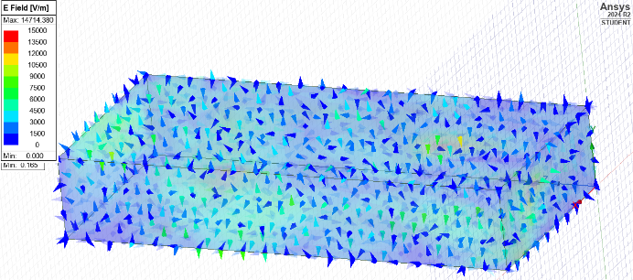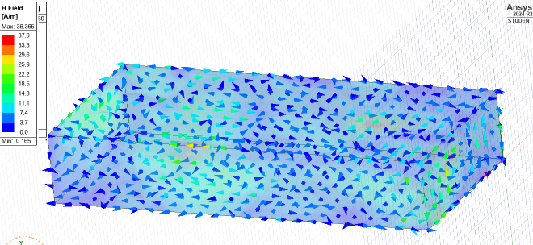
Figure 8 – Electric fields in mode 1, Task 1A. Figure 9 – Magnetic fields in mode 1, Task 1A.

Again, in mode 2, the vectors of the electric field are not in keeping with a TE mode and show a pattern more likely to be a TM mode. However, it could again be argued that this is likely the result of the height of the waveguide being too little. The magnetic field shows further variation, rendering an inconclusive result in this instance. Figures 10 & 11 show results.

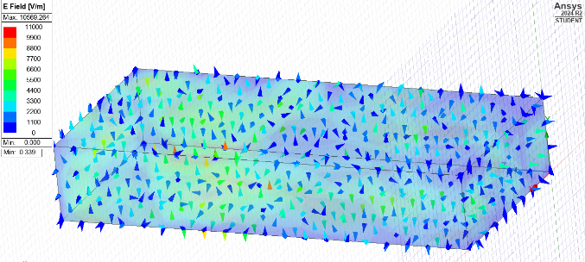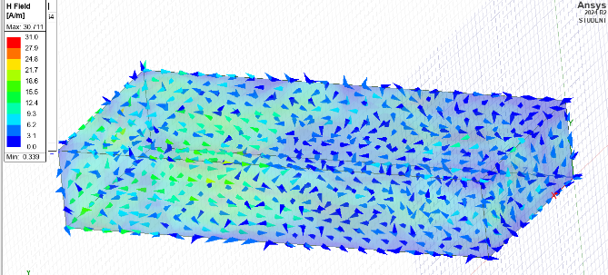
Figure 10 – Electric fields in mode 2, Task 1A. Figure 11 – Magnetic fields in mode 2, Task 1A.

Mode 3 shows fields in both electric and magnetic more likely to represent TE modes, again with multiple variations, likely resultant of the height. Overall, these results have proved less conclusive than expected, but this is likely the result of the low height of the waveguide in relation to the frequency being transmitted. The result of this is waves not having enough height to properly propagate along the waveguide. However, the magnetic field in this mode does show a result more in keeping with a TE mode. Figures 12 and 13 show the results for mode 3.

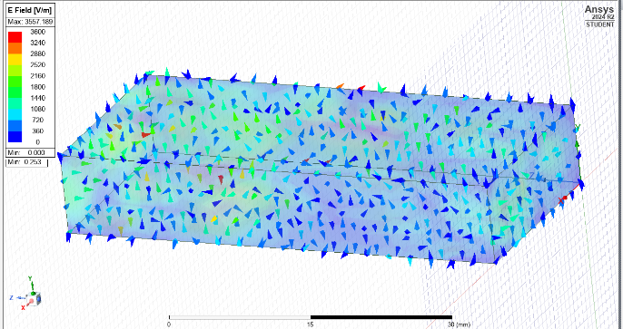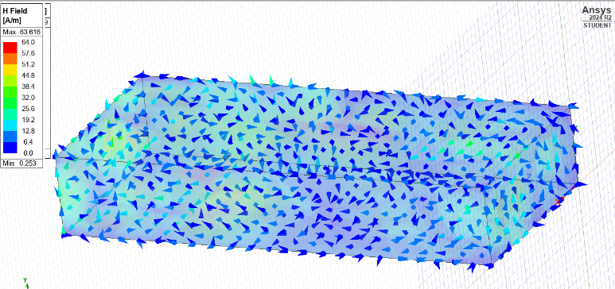
Figure 12 – Electric fields in mode 3, Task 1A. Figure 13 – Magnetic fields in mode 3, Task 1A.

2.2.3 Cutoff Frequencies

2.2.3.1 Theoretical calculations
To calculate the cutoff frequency in a rectangular waveguide, the formula for cutoff frequencies in TE modes:
$$fcmn​​=\sqrt{2c​(\frac{a}{m}​)2+(\frac{n}{b}​)2}​$$
Equation 4 – Cutoff frequency in rectangular waveguides.
Where:
$$c={3×10}^{8}$$
Equation 5 – Speed of light in vacuum.
Width and height are taken from equations 1 & 2, with mode indices denoted as m & n.
These calculations only consider TE modes, as these are assumed to be dominant in rectangular waveguides. Then, the cutoff frequencies at the lowest TE modes (TE10, TE01, TE20 & TE11) are calculated and then sort these by the lowest frequencies.
$$fc10=\frac{c}{2a}=\frac{{3×10}^{8}}{2×0.023}=6.52GHz$$
Equation 6 – TE10 cutoff frequency in waveguide 1.
$$fc01=\frac{c}{2b}=\frac{{3×10}^{8}}{2×0.009}=16.67GHz$$
Equation 7 – TE01 cutoff frequency in waveguide 1.
$$fc20=\frac{c}{2a}=\frac{{3×10}^{8}}{2×0.023}=13.04GHz$$
Equation 8 – TE20 cutoff frequency in waveguide 1.
$$fc11=\sqrt{\frac{{3×10}^{8}}{2}{​(\frac{1}{0.023}​)}^{2}{+(\frac{1}{0.009}​)}^{2}}=\frac{{3×10}^{8}}{2}×11267.1=16.9GHz$$
Equation 9 – TE11 cutoff frequency in waveguide 1.

The lowest frequency is 6.52GHz (TE10), Followed by 13.04GHz (TE20) and 16.67 (TE01). These should be the cutoff frequencies seen in simulation, especially considering these modes have been determined in earlier simulation results. The cutoff frequencies are plotted from the simulation and compared to those calculated in this section below.

2.2.3.2 Simulation results
Figure 15 compares the calculated and measured frequencies. Figure 16 shows the frequency plot for the waveguide from the simulation, with each cutoff frequency marked. M1 shows the dominant wavelength, the one with the lowest cutoff, which is 6.48GHz, very similar to the 6.52GHz calculated through theory. This confirms that the dominant mode is in fact TE10, due to the minimal difference between theoretical and simulated. Across all 3 modes, the differences are very minimal, likely suggesting that all modes are in fact TE modes as discussed in the excitation port analysis.

Mode | Calculated Freq. | Simulated Freq. | Difference
1 | 6.52GHz (TE10) | 6.48GHz | 0.04
2 | 13.04GHz (TE20) | 12.99GHz | 0.05
3 | 16.67GHz (TE01) | 16.63GHz | 0.04

Figure 14 – Table comparing calculated versus simulated cutoff frequencies.

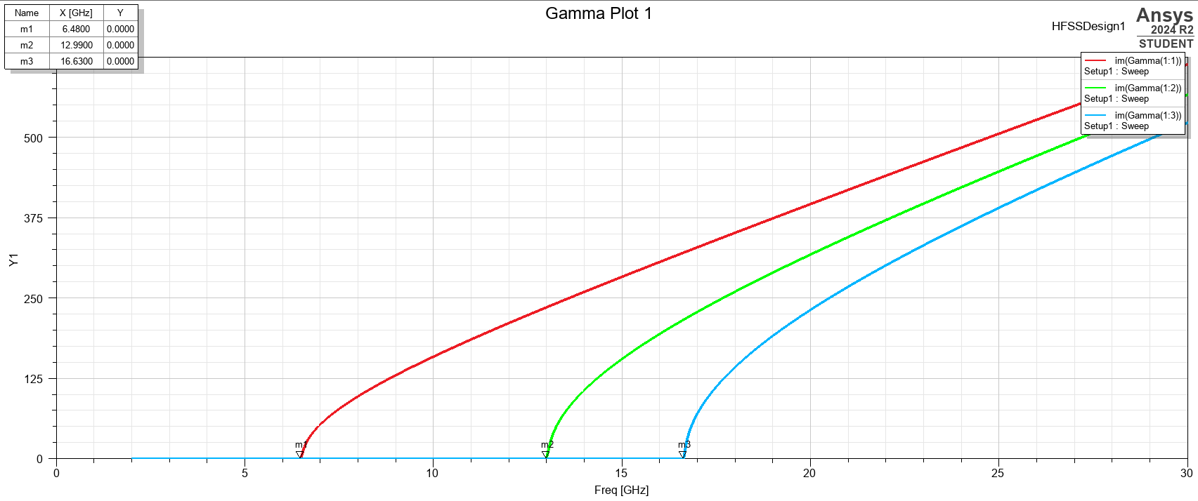
Figure 15 – Cutoff frequencies determined through simulation. Plot shows frequency through waveguide.

3. Task 1B – Rectangular waveguide 2

3.1 Design & Setup
Task 1B is based on the same principles as the first task, except for the waveguide filling, which is filled with Teflon in this instance. Teflon has a higher relative permittivity (2.1) than vacuum (0), so effectively, the EM waves will have a higher resistance to travel against, which will affect the results. These may be compared against previous results for a better understanding of the concept.

3.2 Results

3.2.1 Electric field vectors at excitation port
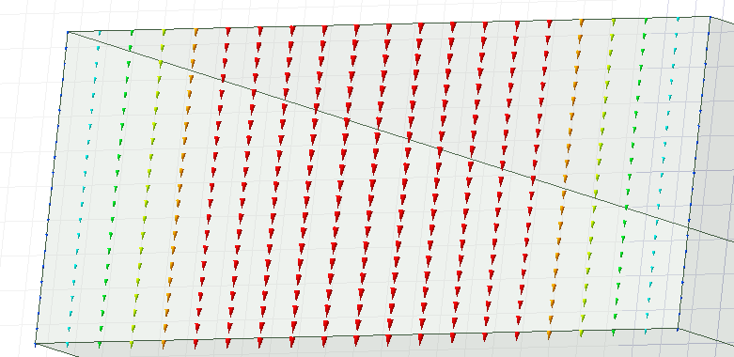
Figure 16 – Electric field vectors at mode 1 excitation port 1, task 1B.

Figure 16 shows the electric field vectors at the excitation port for mode 1. This likely shows TE01, as the field is travelling in a vertical direction, with no movement in the horizontal, thus m = 0 and n = 1. This is unexpected, as it does not show at TE10 mode, which would be expected to be the dominant mode in this waveguide, however this may be disproven based on later results.

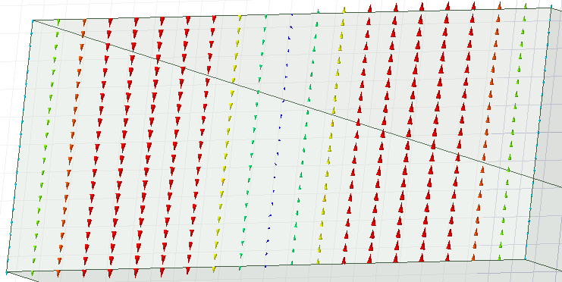
Figure 17 – Electric field vectors at mode 2 excitation port 1, task 1B.

Figure 17 shows a TM02 mode, as there are two vectors moving in the vertical plain, which is again an unexpected result, but the results are consistent atleast in the number of electric fields between task 1A and 1B so far.
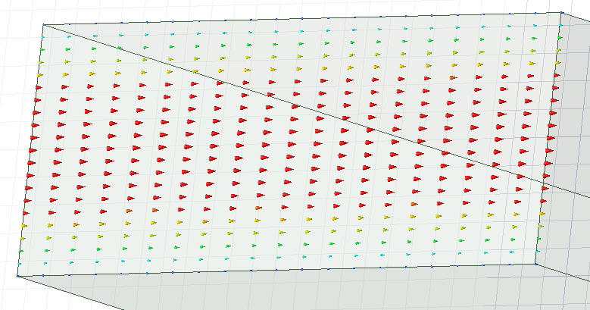
Figure 18 – Electric field vectors at mode 3 excitation port 1, task 1B.

Figure 18 shows a TE10 mode, which is more consistent with the expected results for a rectangular waveguide, where there is one magnetic field component travelling along the horizontal plane, and none in the vertical domain (m = 1, n =0).

3.2.2 Magnetic & Electric Fields
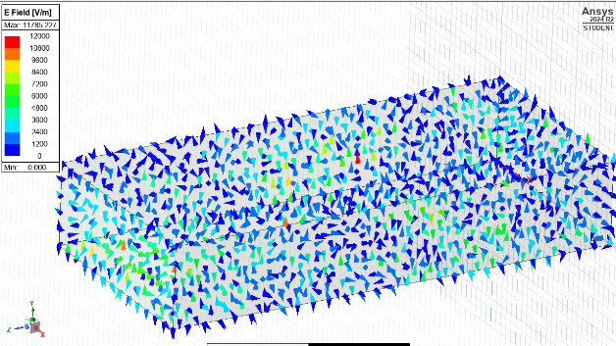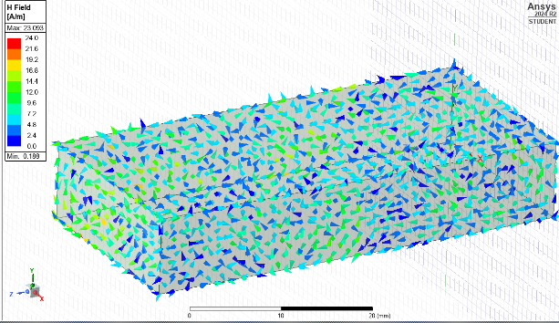
Figure 19 – Electric field vector & magnitude, mode 1, task 1B. Figure 20 – Magnetic field vector and magnitude, mode 1, task 1B.

Figures 19 and 20 show electric, and magnetic field strength & direction for mode 1. Looking at these plots, the magnetic field shows that of a TM mode, with the electrical field proving more inconclusive, although leaning towards the same. The electric fields are travelling mostly along the edges of the guide, as expected in a TM mode, however there are some anomolous areas where they appear to travel within the guide as would be seen in a TE mode, proving this result inconclusive.

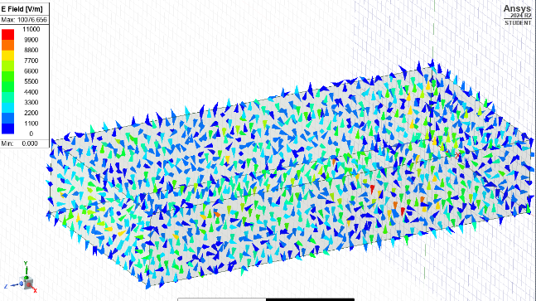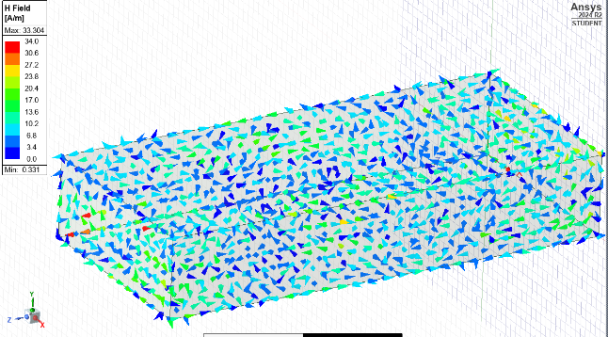
Figure 21 - Electric field vector & magnitude, mode 2, task 1B. Figure 22 - Magnetic field vector and magnitude, mode 2, task 1B.

Figures 21 and 22 show the same for mode 2. Both the electric and magnetic fields seem to be in keeping with a TM mode as identified previously. However, there are more anomalies seen in the results than in mode 1, which could suggest a hybrid mode in this instance.

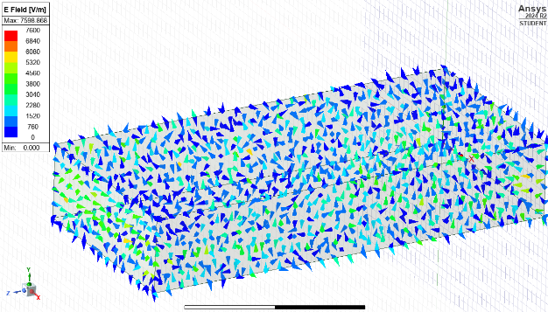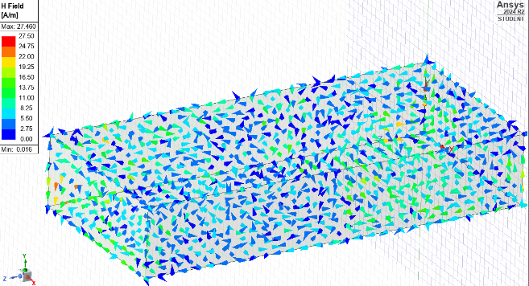
Figure 23 - Electric field vector & magnitude, mode 1, task 1B. Figure 24 - Magnetic field vector and magnitude, mode 1, task 1B.

3.2.3 Cutoff Frequencies

3.2.3.1 Theoretical calculations
To calculate the theoretical cutoff frequencies for each mode in this waveguide, the same equation as used previously is modified to include relative permittivity of Teflon ($εr$). This considers the effect of the teflon filled chamber in comparison to one filled with a vacuum. Although TM modes may have been identified, the cutoff frequency equation does not differ, and the most dominant modes (TM11 & TM01) are already considered in their TM form.

$$fcmn= \frac{c}{2}\sqrt{{(\frac{m}{a})}^{2}+{\frac{n}{b}}^{2}}×\frac{1}{\sqrt{εr}}$$
Equation 10 – Theoretical cutoff frequency in a rectangular waveguide, with non-vacuum filling.

$$fc10=\frac{{3×10}^{8}}{2×0.023×\sqrt{2.1}}=4.50 GHz$$

Equation 11 – TE10 Cutoff frequency, Task 1B.

$$fc01=\frac{{3×10}^{8}}{2×0.009×\sqrt{2.1}}=11.5 GHz$$

Equation 12 – TE01 Cutoff frequency, Task 1B.

$$fc11=\frac{{3×10}^{8}}{2.898}×1912.9=5.18 GHz$$

Equation 13 – TE11 Cutoff frequency, Task 1B.

$$fc20=\frac{{3×10}^{8}}{2×\sqrt{2.1}}×\frac{2}{0.023}=9.00 GHz$$

Equation 14 – TE20 Cutoff frequency, Task 1B.

3.2.3.2 Simulation results

Mode | Calculated Freq. | Simulated Freq. | Difference
1 | 4.50 GHz (fc10) | 4.45 GHz | 0.05
2 | 5.18 GHz (fc11) | 8.90 GHz | 3.72
3 | 9.00 GHz (fc20) | 11.45 GHz | 2.45

Figure 25 – Calculated versus simulated cutoff frequencies, task 1B.

As seen in the table above, the dominant mode seen in simulation does seem to follow that of the calculations very closely, however, the other two modes show large differences. This could be a result of the different types of modes present within the waveguides, as previously identified, however the discrepancy is unexpected in this instance. Another theory is the differences made by using a Teflon filled waveguide have resulted in different simulation characteristics, which could’ve resulted in lower accuracy.

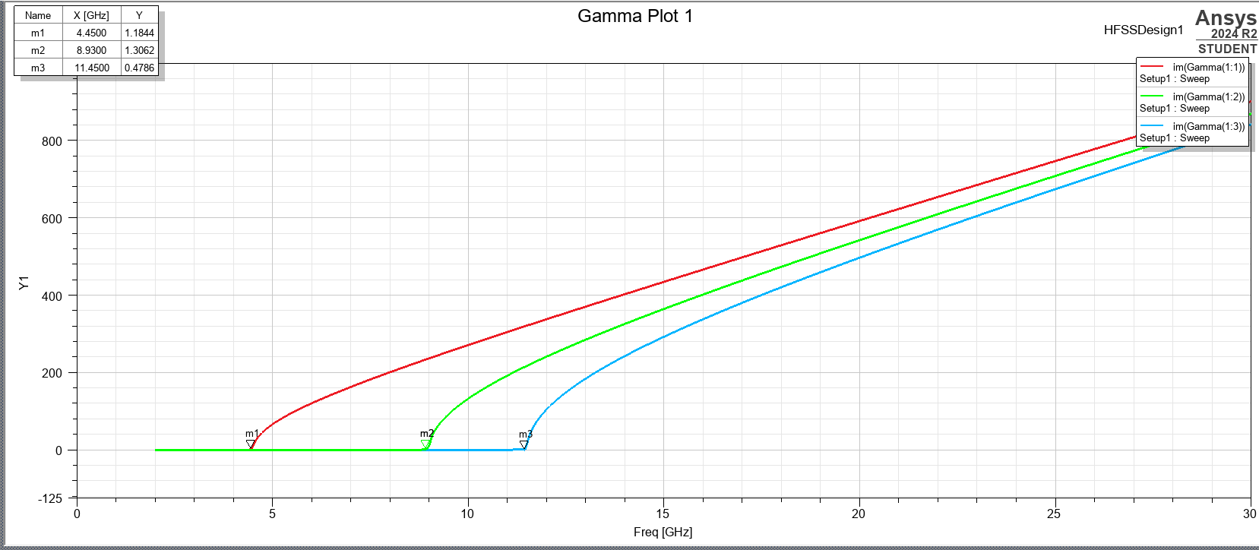
Figure 26 – Simulated cutoff frequencies, task 1B.

4. Task 2 – Halfwave Dipole Antenna

4.1 Design & Setup

4.1.1 Calculations

4.1.1.1 Length of Antenna
To determine the total length of the antenna, equation 15 is used. As the dipole antenna is half wave, the length of the antenna versus wavelength is half. The wavelength is determined via the first 3 characters of the student number (231mm).

$$L=\frac{λ}{2}≈\frac{231}{2}=115.5mm$$
Equation 15 – Length of dipole antenna.

4.1.1.2 Theoretical Operating Frequency
Too find the theoretical operating frequency of a dipole antenna, equation 16 is used. This equation describes the relationship between frequency, the speed of light and wavelength, in meters.

$$f=\frac{c}{λ}≈\frac{{3×10}^{8}}{0.231}=1.3 GHz$$

Equation 16 – Theoretical operating frequency of dipole antenna.

4.2 Simulation
Too model the antenna, first the geometry is created within Ansys electronics HFSS. The excitation is then defined, at the centre point of the dipole. Once modelled, the simulation is then setup, with a frequency sweep from 0.5 GHz to 10 GHz, to allow a wide enough range to determine the ideal operating frequency of the dipole antenna.

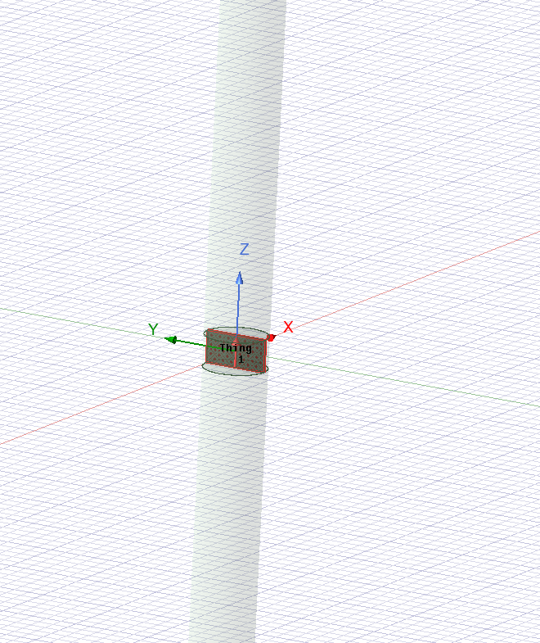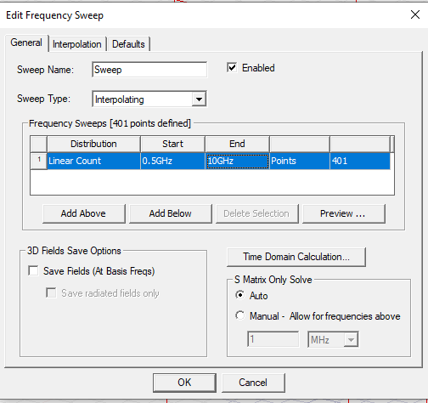

Figure 27 – Dipole excitation port, Task 2. Figure 28 – Frequency sweep setup, Task 2.

4.3 Results

4.3.1 Operating Frequency
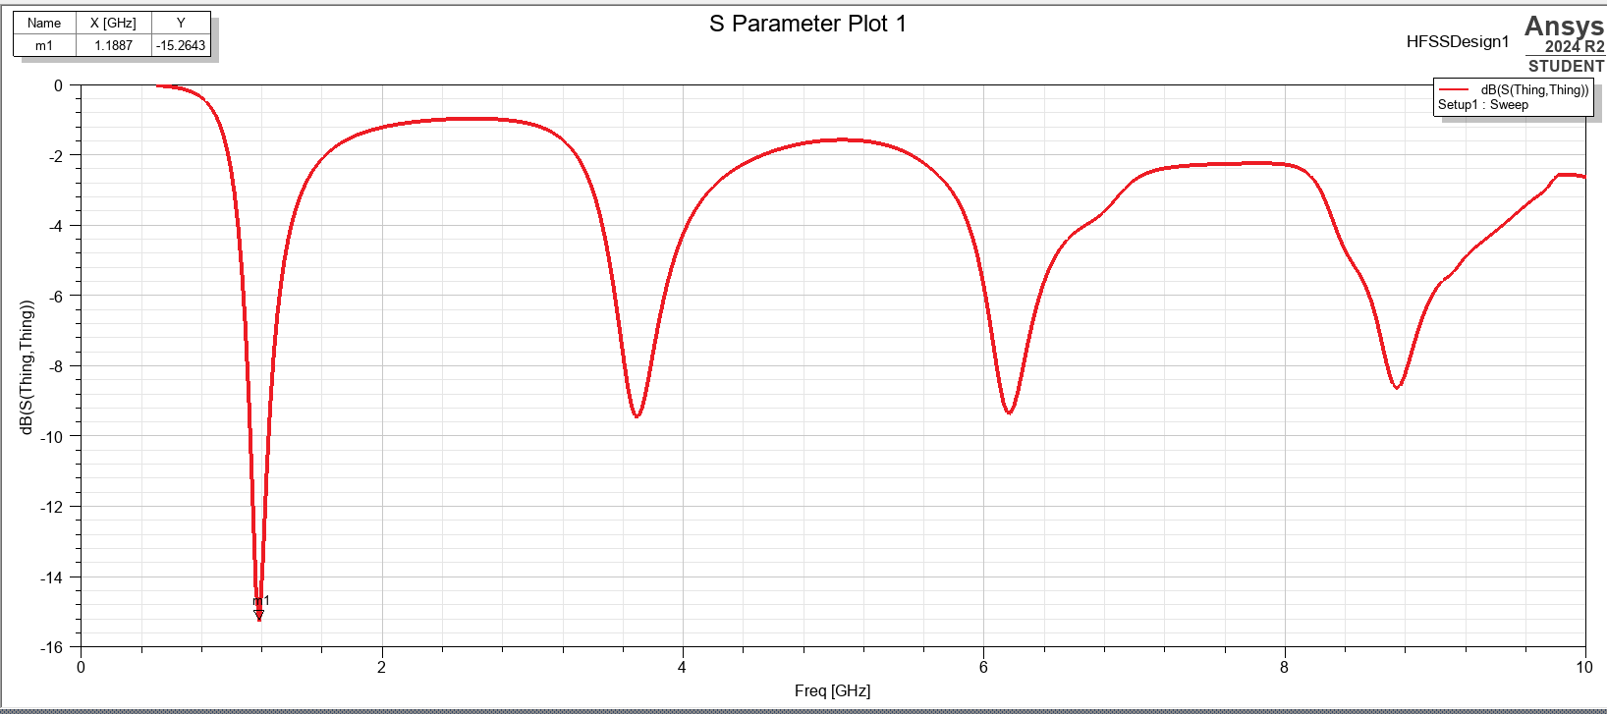

Figure 29 – S Parameter Plot, Task 2.

The plot above shows the output power in decibels, versus frequency in gigahertz. This can be used to identify the most efficient operating frequency, which can then be compared with the calculated one. The operating frequency is identified by marker M1, at 1.19 GHz.

Calculated Freq. | Simulated Freq. | Difference
1.3 GHz | 1.19 GHz | 0.11

Figure 30 – Calculated versus simulated operating frequency, Task 2.

As seen in figure 30, the calculated and simulated frequencies show very similar results. The difference between the calculated and simulated frequency could be explained by design of the dipole geometry in the simulation, where the excitation is at an imperfect midpoint (over a few millimetres, rather than one point) which could affect the effective operating length of the antenna, and thus the effective operating frequency.

4.3.2 Radiation Pattern
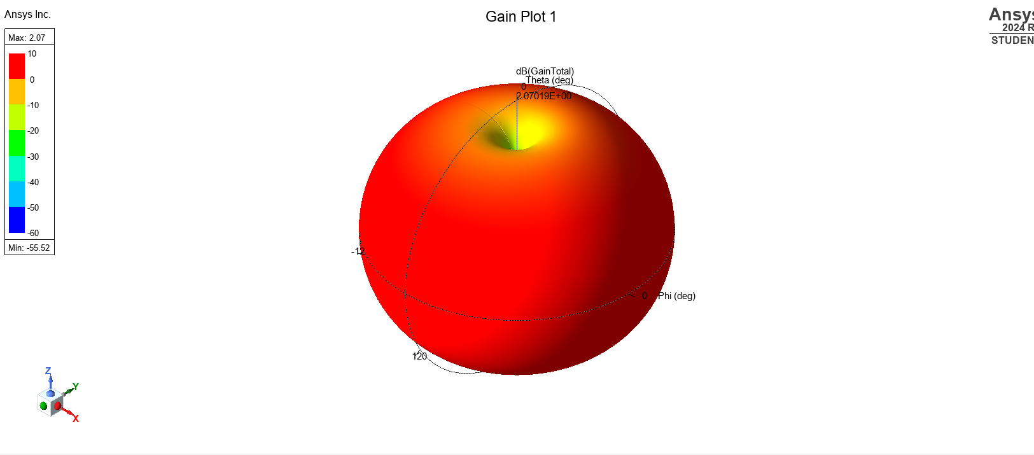

Figure 31 – Gain Plot (Radiation Pattern), Task 2.

The radiation pattern shown in figure 31 is typical of that of a halfwave dipole antenna. The maximum radiation is seen perpendicular to the antenna, with a uniform distribution around the entire radius, meaning an equal radiation in all directions. There is a small null (lower power) area at the top and bottom of the antenna, which is also typical of this type of antenna.

6. Conclusions

6.1 Task 1
The rectangular waveguide filled with vacuum allowed higher frequencies to propagate, while the one filled with Teflon reduced the cutoff frequency. In real world applications, this could effectively be used to tune the frequency transmitted out of a waveguide- especially useful in high power systems such as RADAR.
In terms of OME, rectangular waveguides are commonly used in several systems where high frequency is used, especially when this signal is to be directed. Electronic warfare (EW) systems are increasingly used in the modern combat environment, and at their most primitive, use a concentrated high frequency signal designed to disrupt or damage other electronic systems. In a system such as this, a level of directionality greatly improves the effect.

6.2 Task 2
The antenna performed as expected, giving an insight into the design and operation of a halfwave dipole antenna. Dipole antennas are a common sight in communication systems, due to their relatively even signal distribution, they make for an ideal antenna for point-to-point communication, especially in a battlefield environment.

7. References

[1] “Electromagnetic radiation - Continuous spectra of electromagnetic radiation,” Encyclopedia Britannica. https://www.britannica.com/science/electromagnetic-radiation/Continuous-spectra-of-electromagnetic-radiation

[2] “Electromagnetic Radiation Spectrum,” Leadertechinc.com, 2025. https://leadertechinc.com/wp-content/uploads/2016/08/Electromagnetic-Spectrum-optimized.jpg (accessed Apr. 16, 2025).

[3] S. Bhandarkar, “Waveguide,” Science Direct, 2005. https://www.sciencedirect.com/topics/materials-science/waveguide

[4] Wikipedia Contributors, “Mode (electromagnetism),” Wikipedia, Sep. 16, 2024. https://en.wikipedia.org/wiki/Mode_(electromagnetism)

[5] “The Dipole Antenna,” www.antenna-theory.com. https://www.antenna-theory.com/antennas/dipole.php

