Addressing the Global Burden of Lung Cancer: Prevention, Early Detection, Treatment, and Healthcare Solutions

Module Name: Introduction to Public Health
Module Code: LCHS 4008
Lecturer: Jolly Nwankwo
Student Name: Felix Ojo
Student ID: 2508025

Table of Contents
Introduction 3
Main Body 3
1. Approaches to Measure and Monitor Lung Cancer 3
2. Control Strategies for Lung Cancer 4
3. Consequences of Lung Cancer on Communities 5
4. Health and Social Care Support Services 6
Conclusion 7
References 8

Figure 1: Multi-Level Impact of Lung Cancer based on NHS England Findings, Source: Created by Self 6

Introduction
Lung cancer is a malignant tumour, and it begins mainly in the epithelial cells of the lung tissue, both bronchi and alveoli. The most common symptoms are a persistent cough, haemoptysis, chest pain, breathlessness, unexplained loss of weight, and fatigue. The World Health Organisation (2024) notes that worldwide, some two point two million cases of lung cancer are diagnosed annually. Lung cancer is the main cause of cancer death in the UK, where it is estimated that 48,500 new cases are found annually (Howell et al., 2023). Around 32,800 people die of the disease every year in the UK, with a 5-year survival rate of only 10-17% (Cancer Research UK, 2024). This report aims to explain that lung cancer remains the deadliest cancer worldwide, and it has been a major burden to the health systems of people, particularly in their early diagnosis, treatment and care in the long run.

Main Body

1. Approaches to Measure and Monitor Lung Cancer
Epidemiological surveillance is important in the surveillance of the incidence and trends of lung cancer. The UK National Cancer Registration and Analysis Service (NCRAS) offers a wide range of information on cancer incidence, treatment outcomes, and survival rates. On the same note, the Global Cancer Observatory (GLOBOCAN) by the World Health Organisation is providing useful global statistics, which can be used to compare the prevalence and mortality rates of lung cancer in different countries.
The screening procedures are crucial to the early diagnosis, especially among high-risk groups. CT scans at low doses, which are advised to smokers aged 55-74 years, have demonstrated that the mortality rate among high-risk populations has reduced by 26% (NHS website, 2023). Pilot NHS lung health checks in areas like Manchester and Liverpool also help in early diagnosis, hence early interventions. The data collection of lung cancer is based on incidence, prevalence, mortality, and survival rates and stratified by age, gender, and socioeconomic status. This stratification assists in identifying vulnerable populations, especially the deprived population, where smoking has been high.
One of the indicators of public health monitoring is the monitoring of smoking trends, the adult smoking rate in the UK is ~10.6% (or 5.3 million) for 2025 (ONS, 2025). The disease burden is also caused by environmental factors such as air pollution and occupational hazards. Nevertheless, although screening is effective, the cost-effectiveness of universal screening is a controversial issue. False positives and overdiagnosis are the risks that make the implementation of unnecessary treatment and allocation of healthcare resources an issue, and a balanced, evidence-based approach should be adopted.
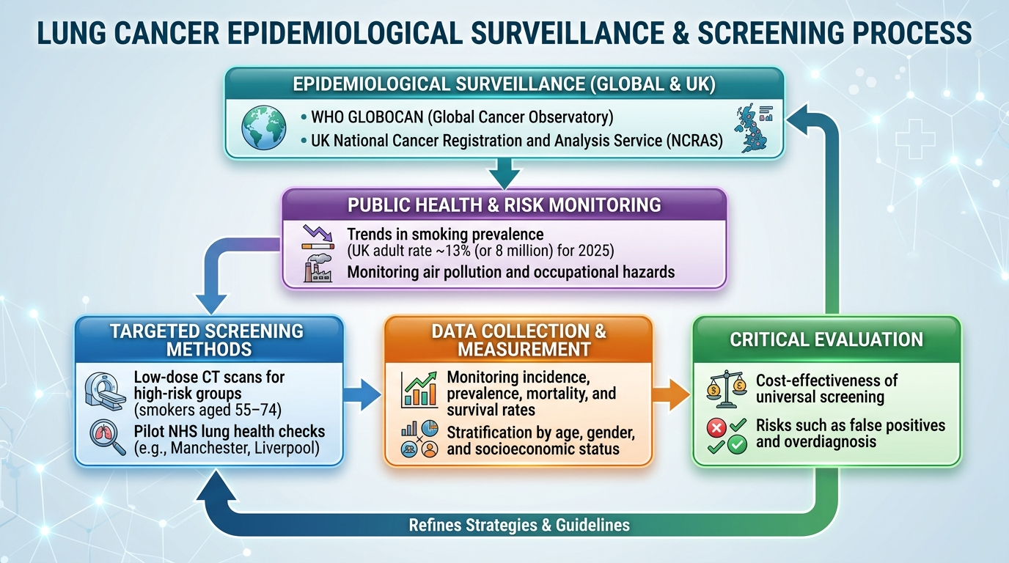

2. Control Strategies for Lung Cancer
The primary prevention of lung cancer is based on the reduction of tobacco consumption, which is the major cause of the disease. The UK has taken major policies on tobacco control, such as a smoking ban in public areas in 2007 and the plain packaging law of 2016, which seeks to decrease the attractiveness of tobacco products (WHO, 2016; Beard et al., 2020). There are smoking cessation programs such as Stoptober, which is a public health campaign, and, even more importantly, increased taxes on tobacco-related products, which make smoking less available. These initiatives have caused a gradual decrease in the smoking rates, and today the adult smoking rate in the UK is at 10% in 2024 exceeded to 13% in 2025.
Moreover, secondary prevention is aimed at early detection by performing a specific screening, especially in the high-risk population, i.e., smokers aged 55 to 74. The NHS Two Week Wait policy guarantees prompt GP referral of suspected cancer patients, so that they can be diagnosed and treated faster (NHS England, 2025). Tertiary therapy is associated with various treatment options, such as surgery, chemotherapy, radiotherapy, and immunotherapy (e.g., pembrolizumab) in cases of advanced treatment (Silva and Matos, 2024). Palliative care services are necessary as well, which provide symptom control and increase quality of life among the terminal patients.
The NHS Long Term Plan (2019) tries to target that, by 2028, 75% of cancers would be diagnosed at I or II stage, emphasising the detection of the cancer at an early stage to increase the chances of survival (NHS England, 2019). Although smoking cessation programs have been successful, health disparities and difficulty in diagnosing lung cancer at an advanced stage are critical issues, especially in the deprived regions where smoking rates are still high.

3. Consequences of Lung Cancer on Communities
Lung cancer has a very strong influence on its victims, both physically and psychologically. On the physical level, it leads to shortness of breath, tiredness, and lack of mobility, which cripples the activities of the day (Deshmukh et al., 2024). The patients usually develop anxiety, depression, and stigma, especially when their condition is associated with smoking psychologically. The emotional burden may be increased by the fact that this stigma may make individuals less willing to seek help or be treated. The family influence is quite significant. The caregivers feel an enormous emotional burden since they have to handle the physical and psychological needs of the patient (Lewandowska et al., 2021). Also, there is the financial burden caused by the inability of the patient to work and the expenses incurred in long-term care, such as visiting the hospital and modifying their homes in case of mobility problems (Moody et al., 2022).
The impact of lung cancer on the community is experienced in terms of a high mortality rate, which reduces workforce participation and productivity. The burden on the healthcare resources is evident in the annual cost of lung care in the UK NHS, which is estimated to be equal to 11 billion (NHS England, 2019a). In addition, it is possible to note health inequalities since lung cancer rates are significantly more common in the deprived regions where the smoking rates are disproportionately high (Payne et al., 2022). The problem is further aggravated by regional differences, the North of England having very high rates as compared to the South. Importantly, lung cancer causes poverty and poor health cycles, especially in disadvantaged communities. The social stigma that surrounds cancer related to smoking discourages a lot of people from seeking early medical assistance, which further interferes with early intervention and treatment chances (Salmon-Gayle, 2025).
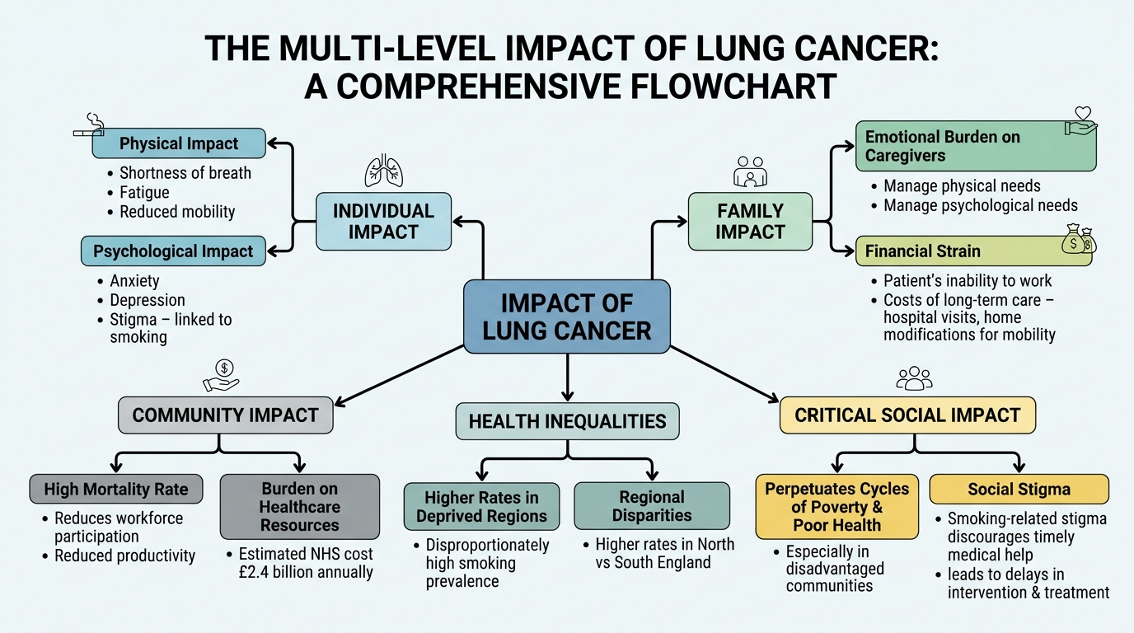
Figure 1: Multi-Level Impact of Lung Cancer based on NHS England Findings, Source: Created by Self

4. Health and Social Care Support Services
NHS offers holistic services to patients with lung cancer, with the oncology units specialising in the diagnosis and treatment of lung cancer offering advanced services. Oncologists, radiologists, nurses, and palliative care specialists form multidisciplinary teams (MDTs) to deliver holistic care when taking into account the medical and supportive needs of patients (Scott, 2021). This is the way to enhance the results and the quality of life. The community-based support is also vital, and the information, financial support, and emotional support are provided by organisations like Macmillan Cancer Support and Roy Castle Lung Cancer Foundation (Cancer Research UK, 2025). Palliative care is also offered by the local hospice care services, whereby patients are given tender care at the end of their sickness.
Social care needs are essential. Home modifications such as oxygen therapy and mobility aids are essential in helping patients to be independent. The emotional and physical burden on the caregiver is relieved through carer support programmes, and financial support is provided through financial aid, including Personal Independence Payments and Carer’s Allowance (Stephanou, 2023). In addition, the emotional consequences of lung cancer cannot be addressed without psychological support. Counselling and peer support groups assist the patients and family in managing the stigmas and isolation experienced by patients who have smoking-related cancers (Ostroff et al., 2022).
Reforms that have been initiated by NHS England to integrate health and social care are meant to streamline the services so that people can have easy access to services (Miller et al., 2021). Nevertheless, the increasing demand puts these services under great pressure and fair access to care among regions is a burning problem in terms of sustainable health care delivery.

Conclusion
This report showed that lung cancer continues to be one of the major health problems in the world and in the UK, which is characterised by a high rate of incidence, high mortality, and immense communal impacts. Early detection and monitoring can only be achieved through effective measurement using cancer registries and screening programs. The control measures are aimed at the prevention of such a risk by means of tobacco control, early diagnosis by screening, and the treatment that can be provided by surgery, chemotherapy, and immunotherapy. It has devastating effects on humans, families, and society, as it brings physical, psychological, and monetary injuries. The multifaceted needs of patients must be met through comprehensive health and social care services. The solution to lung cancer is in long-term policies of public health, especially focusing on prevention, early diagnosis and fair access to care. The community-based support and coordinated care are essential to decrease the incidence rates, enhance the patient outcomes, and provide a more efficient response to the disease.

References
Beard, E., Jackson, S.E., West, R., Kuipers, M.A. and Brown, J., 2020. Trends in attempts to quit smoking in England since 2007: a time series analysis of a range of population-level influences. Nicotine and Tobacco Research, 22(9), pp.1476-1483. ( Accessed: 9 March 2026)
Cancer Research UK, 2024. Lung cancer mortality statistics. [online] Cancer Research UK. Available at: https://www.cancerresearchuk.org/health-professional/cancer-statistics/statistics-by-cancer-type/lung-cancer/mortality. ( Accessed: 9 March 2026)
Cancer Research UK, 2025. Resources and organisations for people with lung cancer | Cancer Research UK. [online] www.cancerresearchuk.org. Available at: https://www.cancerresearchuk.org/about-cancer/lung-cancer/living-with/resources-books. ( Accessed: 9 March 2026)
Deshmukh, G., Sawarkar, H. and Biyani, K.A., 2024. Review on lung cancer with emphasis on current treatment. Epidemiology, 4(4). ( Accessed: 9 March 2026)
Howell, D., Buttery, R., Badrinath, P., George, A., Hariprasad, R., Vousden, I., George, T. and Finnis, C., 2023. Developing a risk prediction tool for lung cancer in Kent and Medway, England: cohort study using linked data. BJC Reports, [online] 1(1), pp.1–11. doi:https://doi.org/10.1038/s44276-023-00019-5. ( Accessed: 9 March 2026)
Lewandowska, A., Rudzki, G., Lewandowski, T. and Rudzki, S., 2021. The problems and needs of patients diagnosed with cancer and their caregivers. International journal of environmental research and public health, 18(1), p.87. ( Accessed: 9 March 2026)
Miller, R., Glasby, J. and Dickinson, H., 2021. Integrated health and social care in England: ten years on. International journal of integrated care, 21(4), p.6. ( Accessed: 9 March 2026)
Moody, E., Ganann, R., Martin-Misener, R., Ploeg, J., Macdonald, M., Weeks, L.E., Orr, E., McKibbon, S. and Jefferies, K., 2022. Out-of-pocket expenses related to aging in place for frail older people: a scoping review. JBI Evidence Synthesis, 20(2), pp.537-605. ( Accessed: 9 March 2026)
NHS England, 2019a. NHS England Respiratory Disease. [online] NHS England. Available at: https://www.england.nhs.uk/ourwork/clinical-policy/respiratory-disease/. ( Accessed: 9 March 2026)
NHS England, 2019b. NHS Long Term Plan ambitions for cancer. [online] England.nhs.uk. Available at: https://www.england.nhs.uk/cancer/strategy/. ( Accessed: 9 March 2026)
NHS England, 2025. NHS England» National cancer waiting times monitoring dataset guidance. [online] England.nhs.uk. Available at: https://www.england.nhs.uk/long-read/national-cancer-waiting-times-monitoring-dataset-guidance/. ( Accessed: 9 March 2026)
NHS website, 2023. Lung cancer screening. [online] nhs.uk. Available at: https://www.nhs.uk/tests-and-treatments/lung-cancer-screening/. ( Accessed: 9 March 2026)
ONS, 2025. Adult smoking habits in the UK. [online] Ons.gov.uk. Available at: https://www.ons.gov.uk/peoplepopulationandcommunity/healthandsocialcare/healthandlifeexpectancies/bulletins/adultsmokinghabitsingreatbritain/2024. ( Accessed: 9 March 2026)
Ostroff, J.S., Banerjee, S.C., Lynch, K., Shen, M.J., Williamson, T.J., Haque, N., Riley, K., Hamann, H.A., Rigney, M. and Park, B., 2022. Reducing stigma triggered by assessing smoking status among patients diagnosed with lung cancer: de-stigmatizing do and don't lessons learned from qualitative interviews. PEC innovation, 1, p.100025. ( Accessed: 9 March 2026)
Payne, N.W., Brown, K.F., Delon, C., Kotrotsios, Y., Soerjomataram, I. and Shelton, J., 2022. Socio-economic deprivation and cancer incidence in England: quantifying the role of smoking. PLoS One, 17(9), p.e0272202. ( Accessed: 9 March 2026)
Salmon-Gayle, S., 2025. Cancer-Related Stigma, Attitudes, and Cultural Beliefs on Intentions to Receive Lung Cancer Screening in African American Female Smokers (Doctoral dissertation, Walden University). ( Accessed: 9 March 2026)
Scott, B., 2021. Multidisciplinary team approach in cancer care: a review of the latest advancements. Oncology, 9(9), pp.2-13. ( Accessed: 9 March 2026)
Silva, V. and Matos, C., 2024. Recent updates in the therapeutic uses of Pembrolizumab: a brief narrative review. Clinical and Translational Oncology, 26(10), pp.2431-2443 ( Accessed: 9 March 2026).
Stephanou, M., 2023. Caregiver burden: Support needed for those who support others and the National Health Service. Patient Experience Journal, 10(2), pp.23-33. ( Accessed: 9 March 2026)
WHO, 2016. World No Tobacco Day, 31 May 2016: Get ready for plain packaging. [online] www.who.int. Available at: https://www.who.int/news/item/31-05-2016-world-no-tobacco-day-31-may-2016-get-ready-for-plain-packaging. ( Accessed: 9 March 2026)
World Health Organization, 2024. Global Cancer Burden growing, Amidst Mounting Need for Services. [online] WHO. Available at: https://www.who.int/news/item/01-02-2024-global-cancer-burden-growing--amidst-mounting-need-for-services. ( Accessed: 9 March 2026)

