
Bachelor of Arts:
Leadership and Management Skills for the Workplace
Module: Understanding and Engaging Stakeholders
Module Code: LCLM5001
Lecturer: Eric Osei

Launching the StaySmart+ AI-Driven Guest Experience Service at Park Plaza London Riverbank Hotel, London

Student Name: Plamena Petrova
Student Number: 2419095

Executive Summary
This report examines the role of stakeholder engagement in the successful implementation of the StaySmart+ project at Park Plaza London Riverbank Hotel, a leading international hospitality organisation located in London. Stakeholder engagement is considered a key factor in project success because it supports effective communication, collaboration and decision-making within organisations (Freeman, 1984).
The report begins with an overview of Park Plaza London Riverbank Hotel and analyses its business environment through SWOT and PESTLE analysis, which are commonly used strategic tools for evaluating internal capabilities and external market conditions (Gürel and Tat, 2017). It then identifies the key internal and external stakeholders involved in the StaySmart+ project, including the product development team, marketing department, sales department, hotel management, customers and external partners.
Furthermore, the report explains the roles and responsibilities of these stakeholders, as well as the benefits and challenges associated with their involvement. Several stakeholder engagement frameworks and models are also applied, including the Stakeholder Matrix, stakeholder engagement plan, communication plan and RACI matrix, which help clarify responsibilities and improve coordination among project participants (Bourne, 2015).
In addition, the report critically explains the process that a project manager would undertake to engage stakeholders using the 4C’s model-communication, collaboration, consultation and commitment, which supports effective relationship management and conflict resolution. Finally, the report evaluates how effective stakeholder engagement can positively influence organisational performance, strengthen brand reputation and support sustainable business growth (PPorter and Kramer, 2011). Recommendations are provided to improve stakeholder engagement practices for future projects within the organisation.

Table of Contents
1. Introduction ............................................................................. 4
2. Business Environment Analysis ............................................. 5
2.1 PESTLE Analysis ………………………………………………6

2.2 SWOT Analysis …………………………………………….7

3. Stakeholder Analysis........................................ 10
3.1 Internal Stakeholders………………………...11
3.2 External Stakeholder ………………………..11

3.3 Connected Stakeholders ………………...11

4. Roles and Responsibilities of Key Stakeholders ................. 12
5. Appropriate Frameworks, Models, and Theories for Stakeholder Engagement........... 13
5.1 Stakeholder Silence Model……………………...14

5.2 Stakeholder Engagement Matrix …………………16

5.3 RACI Matrix ……………..16

5.4 Stakeholder Engagement Plan ………………17

5.5 Communication Plan…………………17

6. Critical Analysis of Stakeholder Engagement for StaySmart+ Using the 4C's Model………….18
6.1 Application of the 4C’s Model (Communication, Collaboration, Consultation, Commitment)……………….19
6.2 Managing Stakeholder Conflicts………………...20
7. Evaluation of Stakeholder Engagement Impact on Business Performance and Recommendations for Future ............................................................................................. 21
8. Recommendations for Future Improvement ......................... 22
9. Conclusion .............................................................................. 23

10. Reference list………………………………………….24

1.Introduction
This report explores the implementation of the StaySmart+ premium customer experience service at Park Plaza London Riverbank, a four-star hotel located in the heart of London with exceptional views of the River Thames and iconic landmarks such as Big Ben and the Houses of Parliament. Although officially rated as a four-star property, the hotel offers a highly modern and technologically advanced environment, with automated room features including smart lighting, electronic curtains, and digital climate control. The selection of this hotel is also informed by first-hand guest experience, as the author stayed at the property approximately one year ago and observed a high level of comfort, efficiency, and service quality, which further supports its suitability as a pilot site for an AI-driven, personalised guest experience service.
Picture 1: interior photo of Park Plaza London Riverbank
Source: Park Plaza Hotels official website, 2026
Picture 2: exterior photo
Source: Park Plaza Hotels official website, 2026
1 2
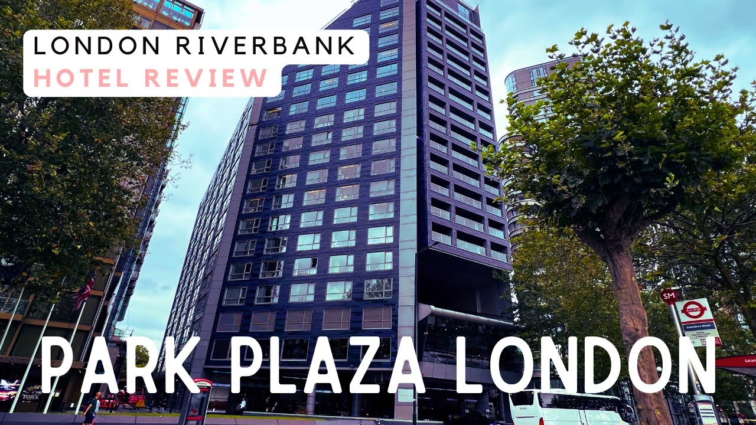
The first image shows the interior environment of the hotel and the view from the hotel overlooking the River Thames, demonstrating the hotel’s attractive location for guests. The second image shows the exterior appearance of the hotel building.
The hotel benefits from a prime central location, providing guests with immediate access to major tourist attractions, government buildings, business districts, and excellent transport links. Such accessibility increases guest expectations for fast, seamless, and technology-supported services. As customer demand continues to shift towards convenience, efficiency, and personalised experiences, hotels are increasingly required to integrate digital solutions into their core service offerings (Buhalis and Leung, 2018). StaySmart+ responds directly to these expectations by combining AI-powered guest interaction tools, tailored travel planning, and sustainability-focused amenities into a single integrated service platform.
In addition to technological innovation, sustainability has become a critical factor in hospitality strategy, as travellers are more likely to choose hotels that demonstrate environmental responsibility (Jones, Hillier, and Comfort, 2016). StaySmart+ supports these objectives by encouraging digital communication, reducing paper-based processes, and enabling smart energy management within guest rooms. These features align well with Park Plaza London Riverbank’s existing smart infrastructure and corporate sustainability commitments.
However, the successful deployment of StaySmart+ extends beyond technical capability. Effective stakeholder engagement is essential to ensure cooperation, acceptance, and long-term value creation. Stakeholder theory emphasises the importance of balancing the interests of multiple groups, including hotel staff, management, technology providers, and guests, in achieving sustainable business outcomes (Freeman, 1984).
Table1: part of the PPHE Hotel Group property portfolio
Source: PPHE Group (2023).
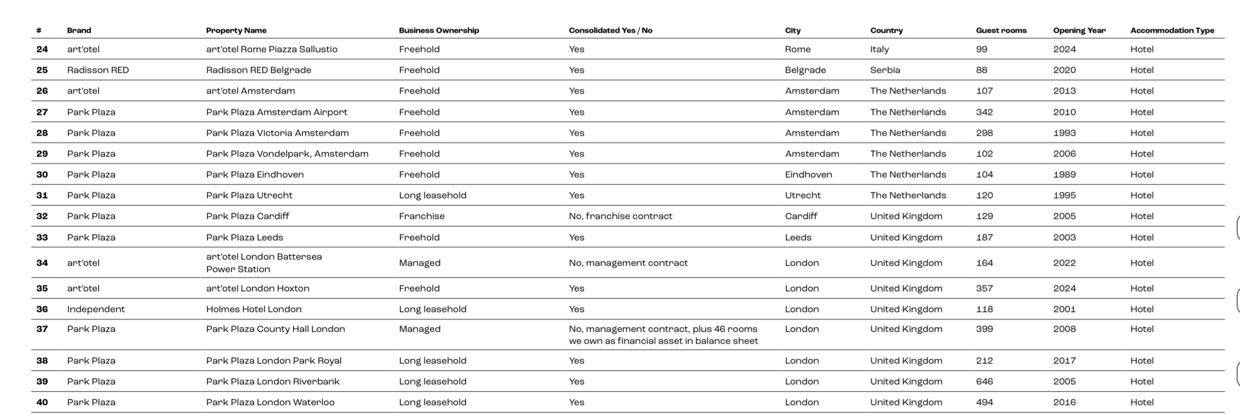
The table presents part of the PPHE Hotel Group property portfolio, highlighting several hotels operating under the Park Plaza and art hotel brands across Europe and the United Kingdom. The table provides key operational details including property name, ownership structure, consolidation status, location, number of guest rooms, and opening year. Within this portfolio, Park Plaza London Riverbank is listed as a long leasehold property located in London, United Kingdom, with 646 guest rooms and opened in 2005. According to PPHE Hotel Group (2023), the company manages multiple hotel brands across several European cities.

2. Business Environment Analysis

2.1 PESTLE ANALYSIS
PESTLE analysis is a strategic management framework used to evaluate the external factors that may influence an organisation or project. The acronym stands for Political, Economic, Social, Technological, Legal, and Environmental factors. This tool helps organisations identify opportunities and risks arising from external conditions that are beyond their direct control but can significantly affect business performance and project success (Johnson, Scholes, and Whittington, 2017). In the hospitality industry, PESTLE analysis is particularly useful for understanding how government policies, market trends, technological developments, and environmental pressures influence service design and operational decisions.
Table 2: PESTLE Analysis of StaySmart+ Project
Source: Graphic by Plamena Petrova
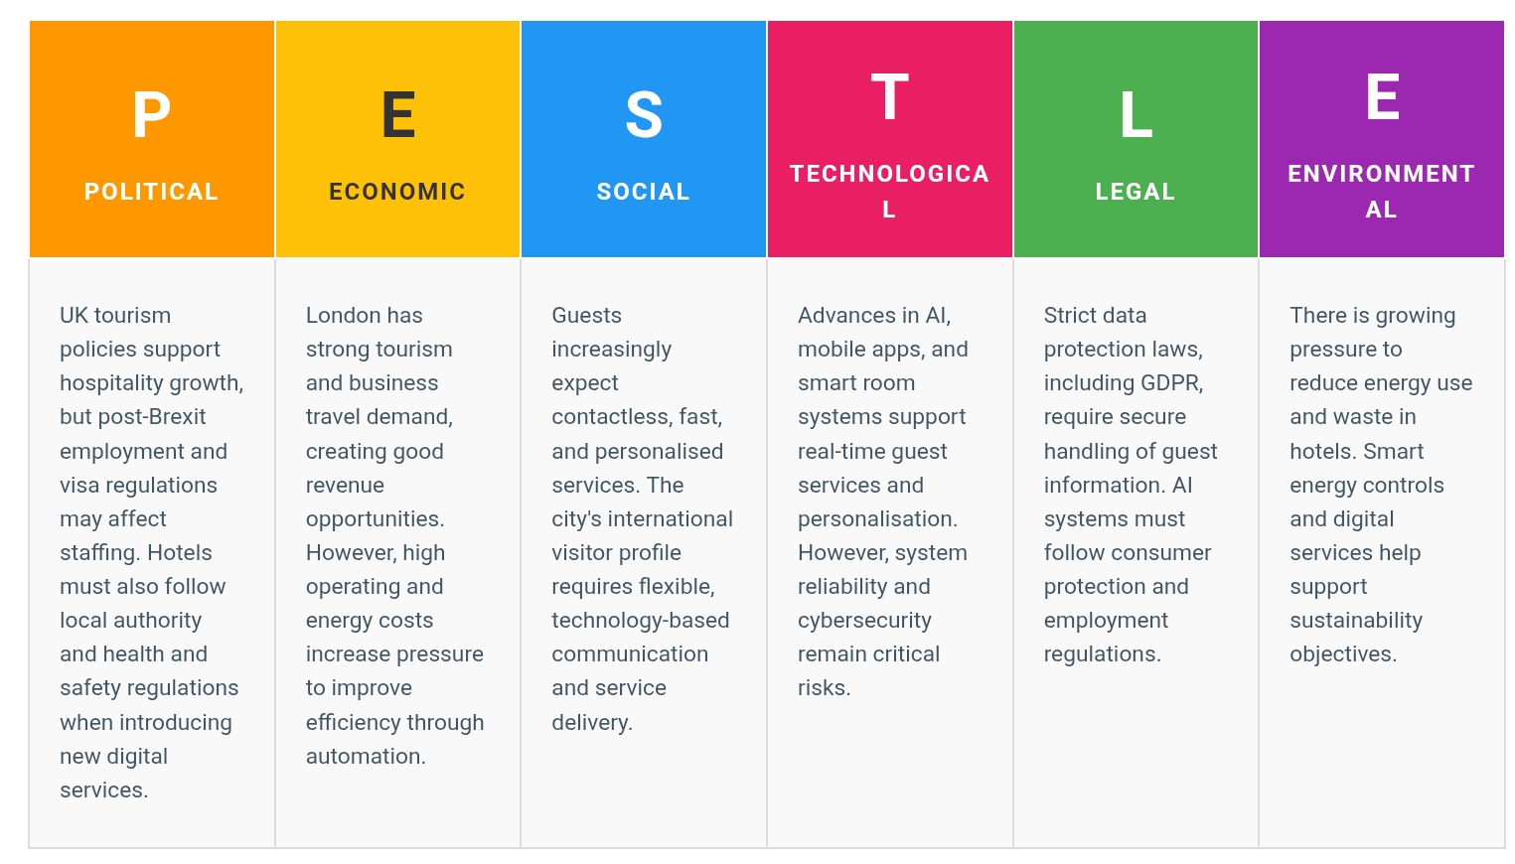

2.2 SWOT Analysis
SWOT analysis is a strategic tool used to evaluate internal and external factors supporting decision-making by linking organisational capabilities with market conditions (Gürel and Tat, 2017). For the StaySmart+ project at Park Plaza London Riverbank, this analysis provides a structured foundation for strategic planning.
Table 3: Strengths, Weaknesses, Opportunities, and Threats of StaySmart+ Project
Table by Plamena Petrova
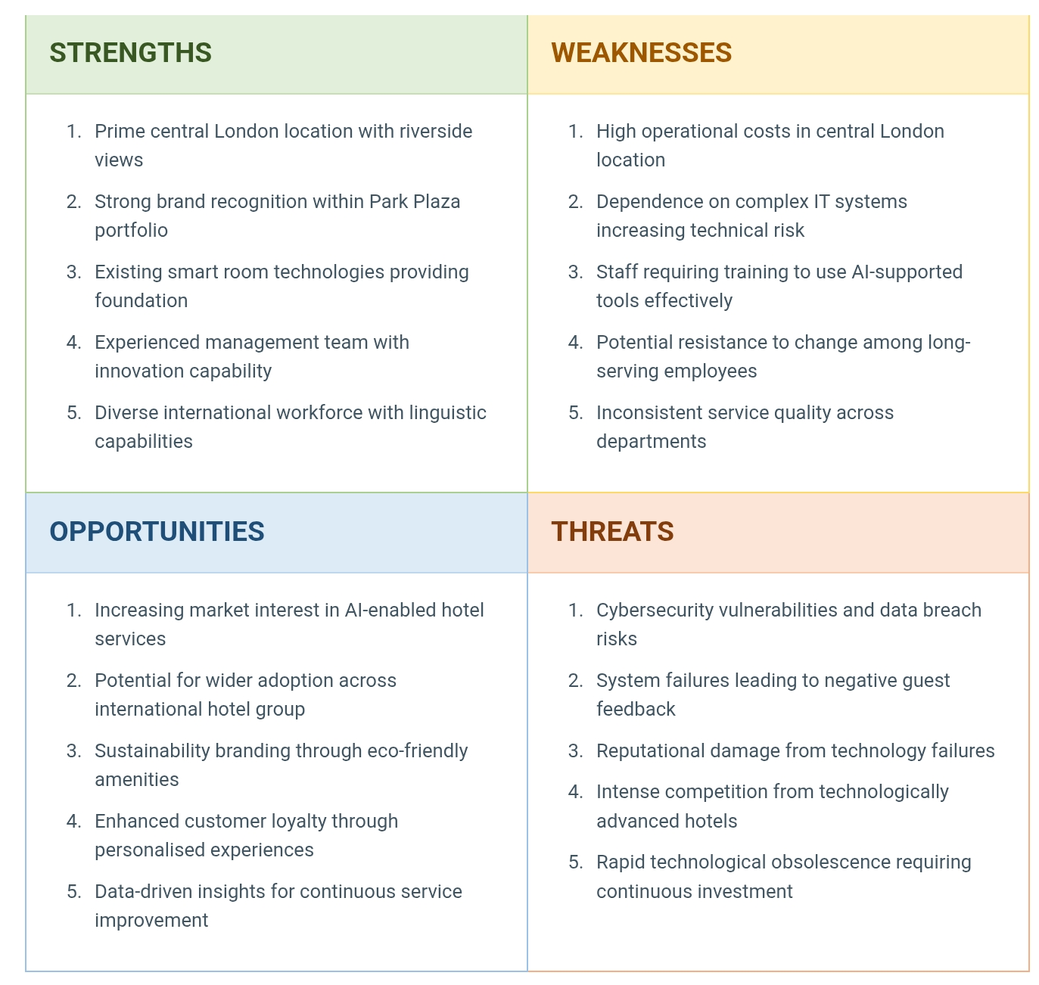
This table identifies the main strengths, weaknesses, opportunities and threats of the Park Plaza London Riverbank Hotel.

Weaknesses
High operational costs in central London create financial pressure, requiring rapid return on investment. Dependence on complex IT systems increases technical risk exposure, including integration challenges and potential system failures (Project Management Institute, 2021). Staff require comprehensive training to use AI-supported tools effectively, and potential resistance to change among long-serving employees may impede adoption (Buhalis and Leung, 2018).
Opportunities
Increasing market interest in AI-enabled hotel services creates receptive conditions for StaySmart+ adoption. Successful implementation offers potential for wider rollout across the international hotel group, spreading development costs. The system's sustainability-focused features align with growing consumer preference for environmentally responsible hospitality, while personalisation capabilities enable enhanced customer loyalty through tailored experiences (Ramanathan and Ramanathan, 2011).
Threats
Cybersecurity vulnerabilities represent significant risk, as data breaches would violate UK GDPR regulations and damage guest trust (ICO, 2021). System failures could generate negative reviews on platforms like TripAdvisor, causing reputational damage. The hotel faces intense competition from technologically advanced London hotels, and rapid technological obsolescence risks requiring further capital expenditure to maintain competitiveness.
Strengths
Management must leverage location and brand strengths while addressing training requirements through comprehensive programmes. Robust cybersecurity protocols and contingency planning are essential to mitigate threats, while marketing should capitalise on sustainability and personalisation opportunities to drive adoption and loyalty.

3. Stakeholder Analysis
This diagram illustrates the stakeholder map for the StaySmart+ project at the Park Plaza London Riverbank Hotel. The project is placed at the centre, surrounded by internal and external stakeholders. Internal stakeholders are directly involved in the project implementation, while external stakeholders influence the project through regulations, investment, suppliers, and customer feedback. The arrows show communication and relationships between stakeholders and the project.
Diagram 6: Stakeholder Map – StaySmart+
Source: Author’s own work
Stakeholder Map – StaySmart+
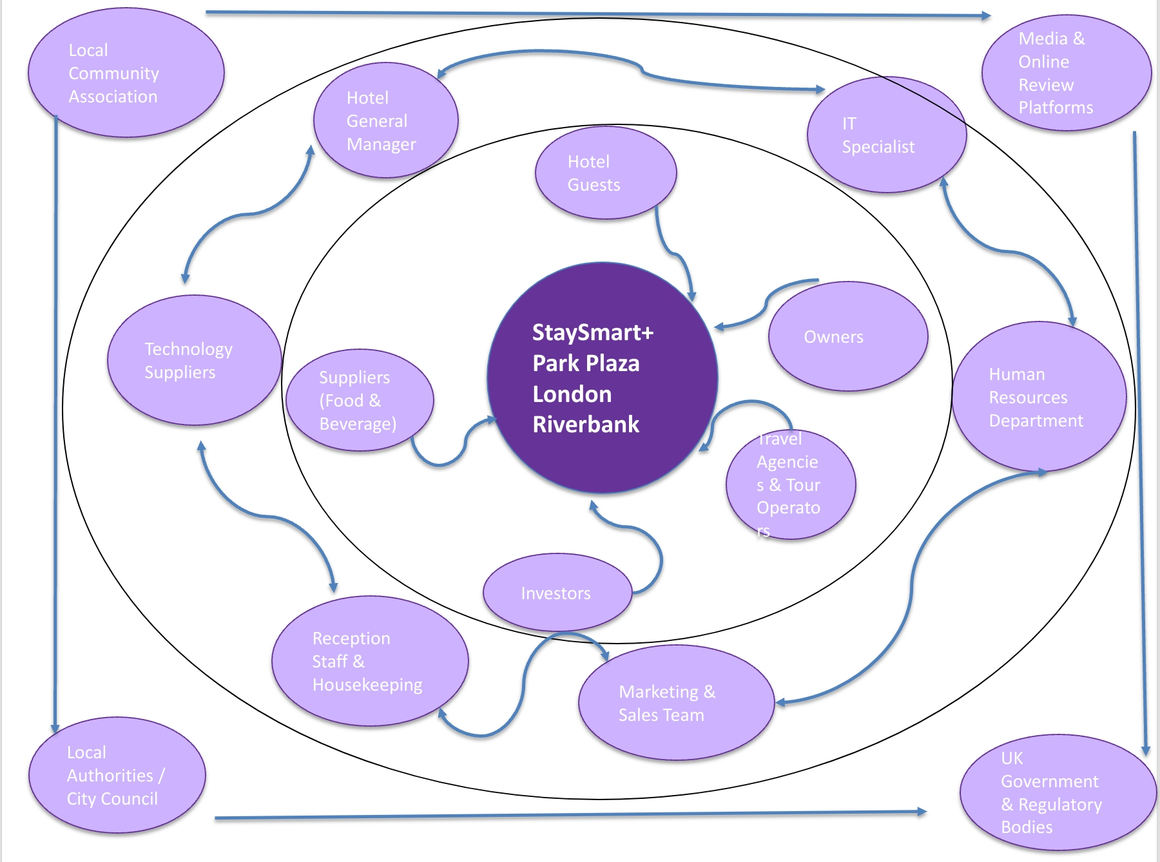

3.1 Internal Stakeholders
Internal stakeholders are those employed by or directly contracted to the organisation. The Hotel General Manager provides strategic leadership, project approval, and resource allocation, ensuring alignment with broader business objectives (Johnson, Whittington, Scholes, Angwin and Regnér, 2017). The IT Specialist bears responsibility for system installation, technical integration, cybersecurity protocols, and ongoing technical support, ensuring compliance with data protection regulations. Reception staff and housekeeping teams are frontline service deliverers responsible for implementing StaySmart+ in daily operations, including digital check-in support and responding to AI-driven service requests (Buhalis and Leung, 2018). The Marketing and Sales Team develops communication strategies to promote StaySmart+ to potential guests, creates in-room and digital materials explaining system features, and monitors guest feedback. The Human Resources Department is responsible for developing training programmes, managing employee concerns about technological change, and updating job descriptions to reflect new responsibilities (Project Management Institute, 2021).

3.2 External Stakeholders

External stakeholders operate outside the organisational boundary but significantly influence project outcomes. The UK Government and Regulatory Bodies, including the Information Commissioner's Office (ICO), establish and enforce legal frameworks governing data protection, employment practices, and technology deployment. Local Authorities and Westminster City Council oversee licensing, health and safety standards, and local business regulations affecting hotel operations. Media and Online Review Platforms, such as TripAdvisor, Google Reviews, and Booking.com, significantly influence public perception of StaySmart+ and the hotel's broader brand reputation. Technology suppliers and vendors provide the hardware, software, and ongoing support necessary for StaySmart+ to function reliably. The Local Community Association represents residents and businesses affected by hotel operations, with interests in employment, traffic, and neighbourhood relations.

3.3 Connected Stakeholders
Connected stakeholders maintain direct transactional relationships with the hotel. Hotel Guests represent the most visible connected stakeholders, as they directly interact with and experience StaySmart+ services throughout their stay. Owners and Investors provide financial resources and evaluate the project's return on investment over time, consistent with the resource provision function identified in stakeholder theory (Freeman, 1984). Travel Agencies and Tour Operators book significant room nights and have influence over guest choices through their recommendations and distribution channels. Suppliers of food, beverage, and other operational inputs may be affected by changes in ordering patterns, quality requirements, or service expectations resulting from StaySmart+ implementation.

4. Roles, Responsibilities, Benefits, and Challenges of Key Stakeholders
Each stakeholder group contributes distinctively to the StaySmart+ project while facing specific benefits and challenges that must be strategically managed to ensure project success and minimise resistance to change (Johnson et al., 2017).

Internal Stakeholders
The Hotel General Manager provides strategic leadership, project approval, and budget allocation, ensuring alignment with business objectives. Benefits include improved operational efficiency and enhanced guest satisfaction. Challenges include managing organisational change and controlling implementation costs. The IT Specialist is responsible for system installation, technical integration, cybersecurity, and ongoing support, ensuring compliance with UK GDPR requirements. Benefits include professional development and enhanced technological capability. Challenges involve managing cybersecurity risks and minimising system downtime (Project Management Institute, 2021).

Reception and housekeeping staff deliver the StaySmart+ experience in daily operations. Employee involvement in innovation directly correlates with improved service quality (Buhalis and Leung, 2018). Benefits include streamlined workflows and reduced manual tasks. Challenges include adapting to unfamiliar technologies and anxiety about job displacement. The Marketing and Sales Team develops communication strategies and monitors guest feedback. Benefits include enhanced targeting and strengthened brand positioning. Challenges include managing guest expectations and responding to negative feedback (Johnson et al., 2017).

External Stakeholders

UK Government and Regulatory Bodies ensure compliance with data protection regulations. Their role provides legal certainty, but challenges include adapting to regulatory changes (ICO, 2021). Local Authorities oversee licensing and safety standards, requiring navigation of administrative processes. Media and Online Review Platforms significantly influence public perception. Positive coverage benefits reputation, but negative feedback requires proactive management. Technology suppliers deliver reliable systems, facing challenges in integration complexity and ensuring peak-load reliability. The Local Community Association represents neighbourhood interests, requiring demonstration of positive local contribution.

Connected Stakeholders

Hotel Guests directly experience StaySmart+ services. Benefits include enhanced convenience, but challenges include data privacy concerns and potential dissatisfaction if technology is not balanced with human interaction (Buhalis and Leung, 2018). Owners and Investors provide financial resources and evaluate return on investment. Benefits include increased profitability, but challenges involve financial risk and uncertainty regarding return timelines (Freeman, 1984).

5. Appropriate Frameworks, Models, and Theories for Stakeholder Engagement

Effective stakeholder engagement requires the application of appropriate theoretical frameworks and practical management tools. For the StaySmart+ project at Park Plaza London Riverbank, a combination of established models enables structured engagement, improved communication, and enhanced organisational performance throughout the project lifecycle (Project Management Institute, 2021).

5.1 Stakeholder Salience Model
The Stakeholder Salience Model, developed by Mitchell, Agle and Wood (1997), provides a framework for prioritising stakeholders based on three attributes: power, legitimacy, and urgency. Power refers to the ability to influence the organisation, legitimacy refers to the social acceptability of claims, and urgency refers to time-sensitivity. At Park Plaza London Riverbank, regulatory bodies such as the Information Commissioner's Office possess high power and legitimacy, making them definitive stakeholders requiring regular engagement. Hotel guests possess high urgency and legitimacy due to their direct influence on revenue, requiring immediate response (Mitchell, Agle and Wood, 1997). This model ensures engagement strategies focus on stakeholders with the highest influence on project success.

5.2 Stakeholder Engagement Matrix
The Stakeholder Engagement Matrix, also known as Mendelow’s power–interest matrix, is used to map stakeholders according to their level of power and interest in a project (Johnson et al., 2017). The framework categorises stakeholders into four groups: high power–high interest (key players requiring close engagement), high power–low interest (stakeholders that should be kept satisfied), low power–high interest (stakeholders that should be kept informed), and low power–low interest (stakeholders requiring minimal monitoring). In the context of the StaySmart+ project at Park Plaza London Riverbank Hotel, hotel owners and investors represent key players who require intensive engagement, while stakeholders such as local community associations may require primarily information sharing and periodic communication.

Diagram 7: Mendelow’s Stakeholder Matrix
Source: illustration by Plamena , adapted from Mendelow (1991)

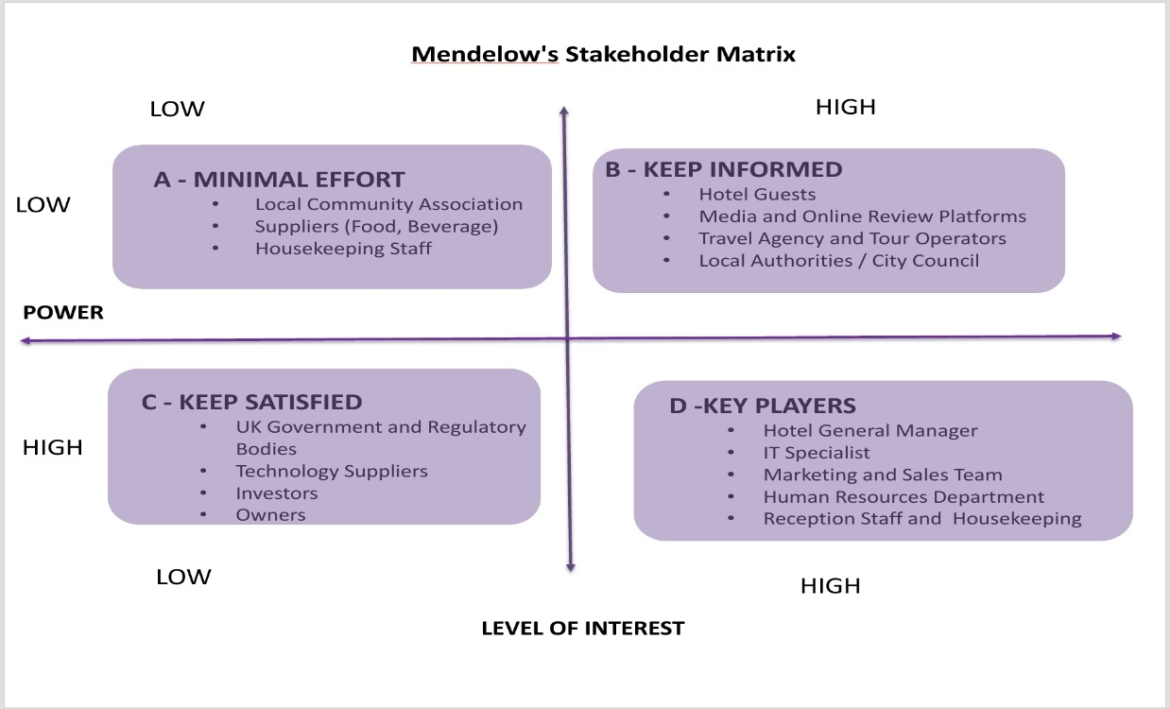
This diagram shows the stakeholder mapping for the StaySmart+ project at the Park Plaza London Riverbank Hotel using Mendelow’s Matrix. Stakeholders are classified based on their power and interest. Key players are closely managed, high power stakeholders are kept satisfied, high interest stakeholders are kept informed, and low power–low interest stakeholders require minimal effort. The matrix helps plan stakeholder engagement and communication strategies.

5.3 RACI Matrix
Table 8: RACI Matrix for StaySmart+ Implementation at Park Plaza London Riverbank Hotel
Source: Plamena Petrova

This Table of RACI Matrix presents stakeholder roles and responsibilities within projects. RACI stands for Responsible, Accountable, Consulted, and Informed (Project Management Institute, 2021). For StaySmart+, the IT specialist may be Responsible for system installation, the Hotel General Manager Accountable for overall success, technology suppliers Consulted for technical input, and reception staff Informed about operational changes. This structured approach reduces confusion and improves accountability (Smith, 2020).

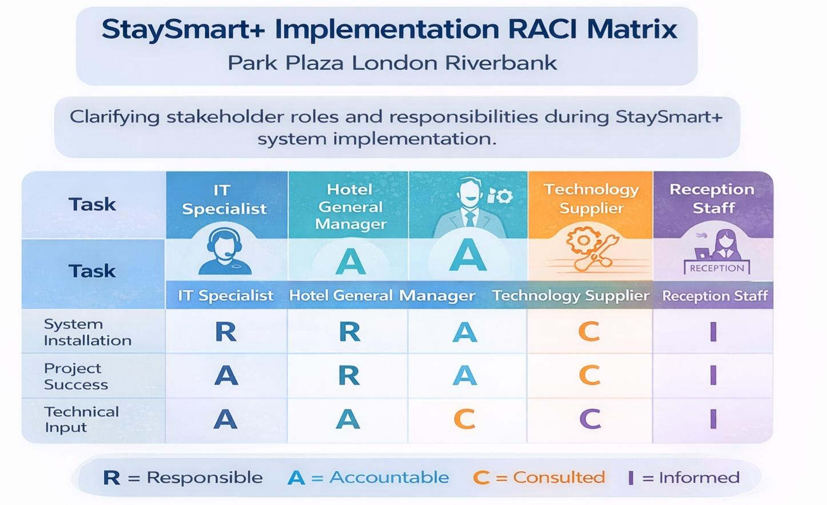

5.4 Stakeholder Engagement Plan
A Stakeholder Engagement Plan ensures consistent stakeholder involvement throughout project implementation. The plan identifies stakeholder expectations, influence levels, and appropriate communication strategies tailored to each group's needs (Project Management Institute, 2021). At Park Plaza London Riverbank, this may involve quarterly investor briefings, monthly supplier reviews, weekly employee consultations, and continuous guest feedback monitoring.

5.5 Communication Plan
This table shows the StaySmart+ stakeholder communication plan for Park Plaza London Riverbank, summarising what information is shared, with which audience, when it is communicated, the channel used, and who is responsible.
Table 3: Comunication Plan for StaySmart+ Project, Park Plaza London Riverbank
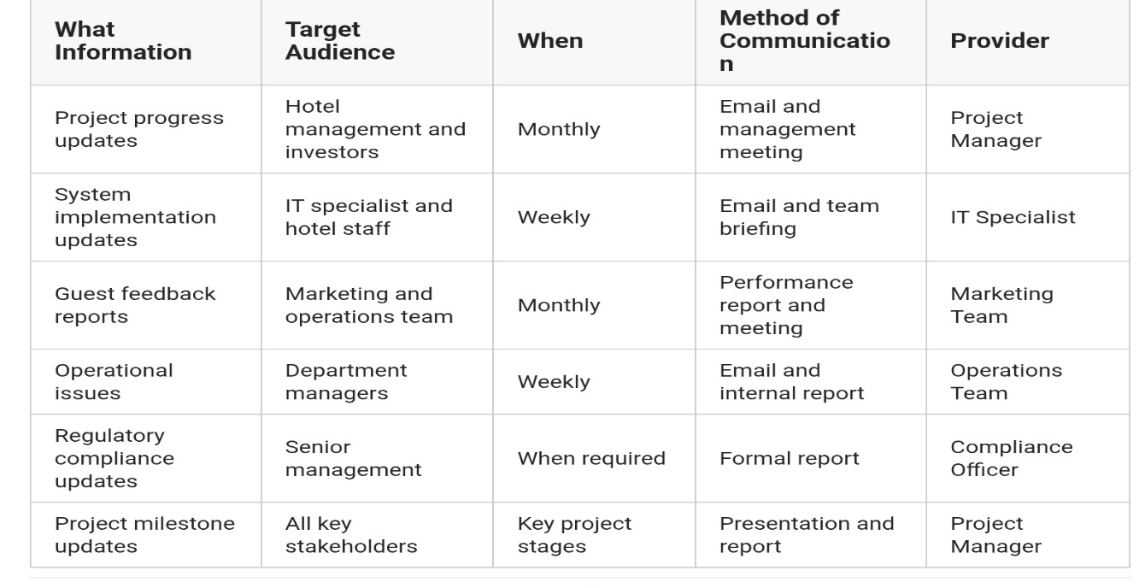
Source: Author’s Graphic

This Communication Plan defines channels, frequency, and information-sharing methods appropriate to each stakeholder group. Effective communication improves transparency, reduces uncertainty during change, and builds trust (Johnson et al., 2017). The plan should specify team meetings for employee updates, social media for guest communication, formal reports for investors, and regulatory submissions for compliance purposes, with feedback mechanisms ensuring two-way communication (Cornelissen, 2020).

6. Critical Analysis of Stakeholder Engagement for StaySmart+ Using the 4C's Model

6.1 Application of the 4C's Model
This graphic shows effective stakeholder engagement is essential for successful service innovation in the hospitality industry. For the StaySmart+ personalised guest experience system at Park Plaza London Riverbank, applying the 4C's model-Communication, Collaboration, Consultation, and Commitment provides a robust framework to navigate stakeholder interests, mitigate conflicts, and ensure seamless technology integration (Project Management Institute, 2021).
Graphic 10: 4C’s Model - StaySmart+ Project, Park Plaza London Riverbank
Source: Author’s Graphic
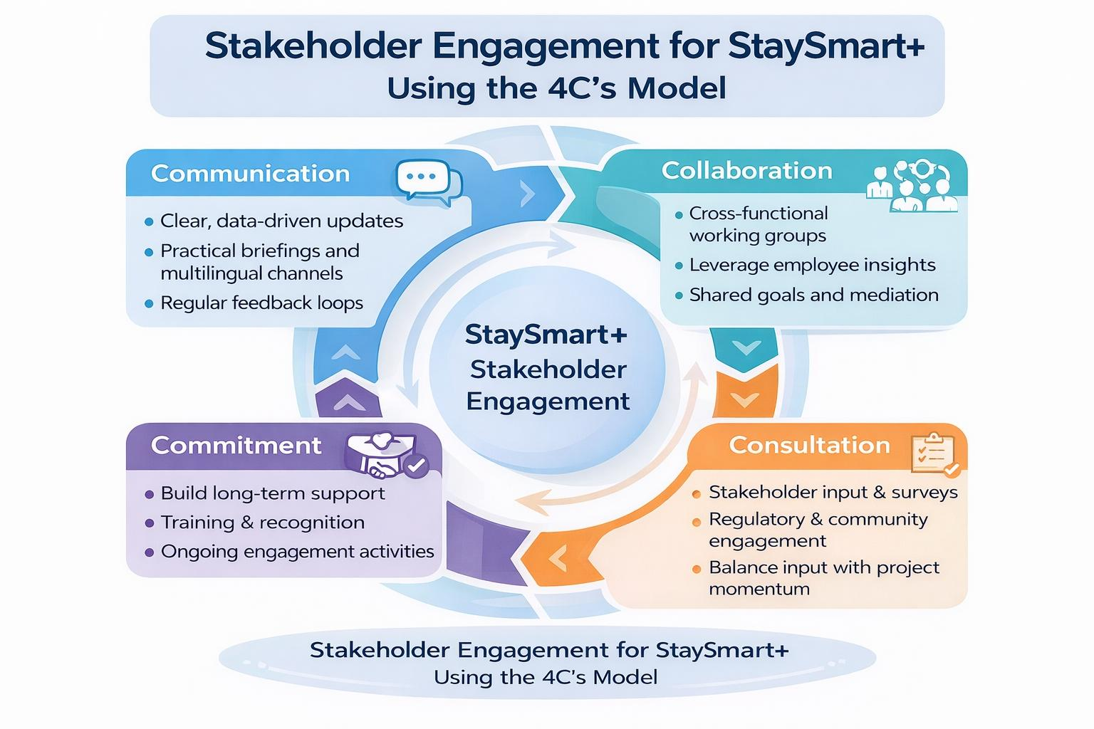

Communication: Building the Foundation of Trust
Communication forms the bedrock of stakeholder engagement. For StaySmart+, a multi-faceted strategy ensures all stakeholder groups understand the project's rationale, benefits, and operational implications. Senior management requires data-driven communication focused on strategic alignment and return on investment, building confidence and securing executive sponsorship. Frontline employees-receptionists, concierges, and housekeeping staff- need practical briefings and training that emphasise how StaySmart+ will augment their roles, not replace them. Guests must be engaged through marketing campaigns and in-app guides communicating the value proposition of enhanced personalisation.

However, communication at Park Plaza London Riverbank is complicated by its diverse, multicultural workforce and international guest profile. To overcome this, the project must utilise a blend of channels including digital platforms, face-to-face town halls, and multilingual materials. Establishing regular feedback loops through pulse surveys and digital comment cards ensures two-way communication, reducing uncertainty and building trust necessary for organisational change (Johnson, Whittington, Scholes, Angwin and Regner, 2017).

Collaboration: Fostering Shared Ownership
While communication is about informing, collaboration is about involving stakeholders in development and execution. For StaySmart+, collaboration requires partnership between hotel management, IT, technology suppliers, and operational staff. Creating cross-functional working groups leverages the invaluable tacit knowledge of employees. Involving housekeeping in testing service request modules or having reception staff trial digital check-in processes uncovers practical issues and generates improvements that external consultants would miss. This approach fosters ownership and reduces resistance to change. Buhalis and Leung (2018) highlight that employee involvement in innovation projects directly correlates with improved service quality.

Nevertheless, collaboration faces challenges. Different stakeholders often have competing priorities; IT may prioritise data security while marketing pushes for rapid feature deployment. As project manager, I must act as facilitator, establishing clear shared goals and mediating discussions to ensure collaborative efforts remain productive and focused on overarching project objectives.
Consultation: Validating Decisions and Building Consensus
Consultation involves seeking stakeholder input before making key decisions, ensuring perspectives are considered and valued. For StaySmart+, which directly impacts guest experience, consultation is paramount. Guests can be consulted through pre- and post-stay surveys, loyalty programme data analysis, and focus groups. This feedback is crucial for tailoring features to meet genuine customer expectations, ensuring investment delivers real value.

Consultation with external stakeholders is equally critical. Engaging regulatory authorities early ensures compliance with data protection regulations and health and safety standards, protecting the hotel's reputation. However, as Freeman (1984) notes, managing diverse interests is a balancing act. Thorough consultation builds consensus but can slow momentum; insufficient consultation leads to oversights and alienation. The project manager's skill lies in strategically timing consultations to gather maximum insight without causing "analysis paralysis."
Commitment: Securing Long-Term Support
Commitment is the ultimate goal the transition from passive acceptance to active support. Securing commitment requires consistent demonstration of transparency, reliability, and mutual benefit. Investors show commitment through continued financial backing, earned by delivering on milestones and communicating early successes. Employees demonstrate commitment through motivation to learn and use the new system, cultivated through comprehensive training, visible management support, and recognition. Guest commitment is reflected in brand loyalty and repeat bookings, a direct outcome of consistently enhanced experiences delivered by StaySmart+.
The Project Management Institute (2021) emphasises that sustaining commitment requires ongoing effort. Project managers must implement continuous engagement activities, sharing success stories, celebrating achievements, and using motivational strategies like incentive programmes for staff who excel in using new technology.
6.2 Conflict Management and the 4C's
The 4C's model is intrinsically linked to effective conflict management. Conflicts may arise from financial concerns, operational disruptions, or employee resistance to new technologies. By promoting open communication, collaborative decision-making, and stakeholder participation through consultation, the 4C's framework provides proactive conflict resolution. When disagreements occur, the foundation of trust built through these processes enables project managers to employ negotiation, compromise, and mediation strategies effectively, balancing diverse stakeholder interests to keep the project on track.
The 4C's model offers a comprehensive lens through which to manage the complex stakeholder landscape of the StaySmart+ project. By prioritising clear Communication, fostering genuine Collaboration, seeking meaningful Consultation, and diligently building long-term Commitment, the project manager can proactively address stakeholder needs, mitigate conflicts before they escalate, and create a shared vision for success. While each element presents challenges, a balanced and critical application of this framework will be instrumental in ensuring successful service innovation at Park Plaza London Riverbank.

7. Evaluation of Stakeholder Engagement Impact on Business Performance and Recommendations for Future
Effective stakeholder engagement is a strategic imperative that directly influences organisational performance across multiple dimensions. For the StaySmart+ project at Park Plaza London Riverbank, the quality of stakeholder engagement will determine not only successful project implementation but also long-term business sustainability and competitive positioning.

Impact on Financial Performance
Stakeholder engagement significantly influences financial performance. Engaged investors demonstrate continued financial commitment when they receive transparent communication about project progress and return on investment (Freeman, 1984). Research by Eccles, Ioannou and Serafeim (2014) demonstrates that organisations with high levels of stakeholder engagement outperform peers on stock market performance. For Park Plaza London Riverbank, maintaining investor confidence through structured engagement ensures continued funding for StaySmart+.
Furthermore, engaged guests generate revenue through repeat bookings and positive recommendations. Guest satisfaction directly correlates with willingness to pay premium rates and likelihood of return visits (Ramanathan and Ramanathan, 2011). StaySmart+, informed by guest consultation, should deliver personalised experiences that enhance satisfaction and drive revenue growth.
Impact on Operational Efficiency
Employee engagement directly impacts operational efficiency and service quality. Buhalis and Leung (2018) demonstrate that employee involvement in innovation projects correlates with improved service quality. Engaged employees who understand technological change are more likely to adopt new processes enthusiastically.
Involving reception and housekeeping staff in StaySmart+ testing enables identification of practical operational improvements based on frontline experience. This collaborative approach reduces resistance to change, minimises implementation errors, and accelerates post-launch learning (Project Management Institute, 2021). Engagement with technology suppliers ensures reliable system performance and rapid issue resolution, reducing downtime and protecting revenue.
Impact on Brand Reputation and Competitive Positioning
Stakeholder engagement significantly influences brand reputation. Positive media coverage and favourable online reviews, generated through effective engagement with review platforms, enhance brand perception and drive customer acquisition (Cornelissen, 2020). Negative reviews from system failures can damage reputation for extended periods. Engagement with regulatory bodies ensures compliance with legal requirements, protecting the hotel from fines and reputational damage associated with non-compliance (ICO, 2021). Engagement with the local community builds goodwill and protects the hotel's social license to operate, facilitating planning approvals and reducing opposition to operational changes.
Impact on Risk Management
Systematic stakeholder engagement functions as an early warning system for emerging risks. Regular consultation enables identification of potential problems before they escalate into project-threatening issues (Johnson, Whittington, Scholes, Angwin and Regner, 2017). The stakeholder salience model (Mitchell, Agle and Wood, 1997) enables management to prioritise engagement with stakeholders holding significant power, legitimacy, or urgency, ensuring critical relationships receive appropriate attention.

8. Recommendations for Future Stakeholder Engagement
First, implement continuous stakeholder salience assessment rather than one-time mapping. Stakeholder power, legitimacy, and urgency change over time. Quarterly reviews ensure engagement strategies remain aligned with current dynamics (Mitchell, Agle and Wood, 1997). Second, establish formal feedback mechanisms that close the loop with stakeholders. Stakeholders providing input should receive communication about how their feedback influenced decisions, building trust and encouraging continued participation (Project Management Institute, 2021).
Third, integrate stakeholder engagement metrics into performance management systems. Measuring engagement effectiveness through stakeholder satisfaction scores and employee adoption rates enables evidence-based improvement of engagement practices. Fourth, develop a comprehensive stakeholder communication platform enabling consistent, personalised communication across stakeholder groups. Integration with customer relationship management systems enables tracking of guest preferences and communication history.
Fifth, invest in stakeholder engagement capability building through training for managers and project team members. Effective engagement requires skills in communication, negotiation, conflict resolution, and cultural awareness (Cornelissen, 2020). Sixth, establish a stakeholder engagement advisory group comprising representatives from key stakeholder categories to review practices and identify emerging concerns.
Seventh, develop scenario-based engagement plans for potential crisis situations. System failures, data breaches, or negative publicity require rapid, coordinated stakeholder communication with pre-planned protocols. Stakeholder engagement fundamentally influences business performance at Park Plaza London Riverbank through impacts on financial results, operational efficiency, brand reputation, and risk management. By implementing these recommendations, the hotel can enhance stakeholder relationships, improve project outcomes, and build sustainable competitive advantage.

9. Conclusion
The successful implementation of the StaySmart+ personalised guest experience system at Park Plaza London Riverbank depends fundamentally upon the strategic identification, analysis, and engagement of diverse stakeholders whose interests and influence shape project outcomes. Drawing on Freeman's (1984) foundational stakeholder theory, this analysis has demonstrated that stakeholders are not passive recipients of organisational decisions but active participants whose cooperation is essential for innovation success.
The comprehensive stakeholder analysis revealed a complex ecosystem of internal stakeholders including the Hotel General Manager, IT specialists, reception and housekeeping staff, marketing and sales teams, and human resources, each with distinct roles, benefits, and challenges. External stakeholders, including UK regulatory bodies, local authorities, media platforms, technology suppliers, and the local community, exert significant influence through their power to grant legitimacy, shape reputation, and control essential resources (Mitchell, Agle and Wood, 1997). Connected stakeholders, particularly hotel guests, owners, investors, travel agencies, and suppliers, maintain direct transactional relationships that fundamentally impact project viability and long-term success.
The SWOT analysis identified critical internal strengths including prime location, brand recognition, and existing technological infrastructure, alongside weaknesses such as training requirements and potential resistance to change. External opportunities in AI-enabled service adoption and sustainability branding must be pursued while mitigating threats including cybersecurity vulnerabilities and intense competitive pressure (Gürel and Tat, 2017).
Application of appropriate theoretical frameworks, including the Stakeholder Salience Model, Resource Dependence Theory (Pfeffer and Salancik, 1978), and Network Analysis Theory (Rowley, 1997), provides structured approaches to prioritising and managing stakeholder relationships. Practical tools including the power-interest matrix, RACI matrix, stakeholder engagement plans, and communication plans operationalise these theoretical insights, ensuring clear accountability and consistent communication throughout the project lifecycle (Project Management Institute, 2021).
Ultimately, stakeholder engagement directly influences business performance through enhanced financial returns, operational efficiency, brand reputation, and risk management. The recommendations provided-continuous salience assessment, closed-loop feedback mechanisms, integrated engagement metrics, and capability building-offer a pathway for Park Plaza London Riverbank to not only implement StaySmart+ successfully but also build sustainable competitive advantage through exemplary stakeholder relationships in an increasingly technology-driven hospitality environment.

10. Reference List

Aksoy, L., Banda, S., Harmeling, C., Keiningham, T.L. and Pansari, A. (2022) ‘Marketing's role in multi-stakeholder engagement’, International Journal of Research in Marketing, 39(2), pp. 445–461.
Bourne, L. (2015) Stakeholder Relationship Management: A Maturity Model for Organisational Implementation. 2nd edn. London: Routledge.
Buhalis, D. and Leung, R. (2018) ‘Smart hospitality: interconnectivity and interoperability towards an ecosystem’, International Journal of Hospitality Management, 71, pp. 41–50.
Cornelissen, J. (2020) Corporate Communication: A Guide to Theory and Practice. 6th edn. London: SAGE Publications.
Freeman, R.E. (1984) Strategic Management: A Stakeholder Approach. Boston: Pitman.
Gürel, E. and Tat, M. (2017) ‘SWOT analysis: A theoretical review’, Journal of International Social Research, 10(51), pp. 994–1006.
Information Commissioner’s Office (2021) Guide to the General Data Protection Regulation (GDPR). Available at: https://ico.org.uk/for-organisations/guide-to-data-protection/ (Accessed: 1 March 2026).
Johnson, G., Whittington, R., Scholes, K., Angwin, D. and Regnér, P. (2017) Exploring Strategy: Text and Cases. 11th edn. Harlow: Pearson Education.
Jones, P., Hillier, D. and Comfort, D. (2016) ‘Sustainability in the global hotel industry’, International Journal of Contemporary Hospitality Management, 28(1), pp. 36–67.
Mendelow, A.L. (1991) ‘Stakeholder mapping’, in Proceedings of the Second International Conference on Information Systems. Cambridge, MA, December, pp. 10–24.
Mitchell, R.K., Agle, B.R. and Wood, D.J. (1997) ‘Toward a theory of stakeholder identification and salience: Defining the principle of who and what really counts’, Academy of Management Review, 22(4), pp. 853–886.
Neuhofer, B., Buhalis, D. and Ladkin, A. (2015) ‘Smart technologies for personalised experiences: A case study in the hospitality domain’, Electronic Markets, 25(3), pp. 243–254.
Nohria, N. (1992) ‘Information and search in the creation of new business ventures: The case of the 128 Venture Group’, in Nohria, N. and Eccles, R.G. (eds.) Networks and Organizations: Structure, Form, and Action. Boston: Harvard Business School Press, pp. 240–261.
Park Plaza Hotels (2026) Park Plaza London Riverbank – Hotel Images. Available at: https://www.parkplaza.com/london-riverbank (Accessed: 1 March 2026).
Pfeffer, J. and Salancik, G.R. (1978) The External Control of Organizations: A Resource Dependence Perspective. New York: Harper & Row.
Porter, M.E. and Kramer, M.R. (2011) ‘Creating shared value’, Harvard Business Review, 89(1–2), pp. 62–77.
Project Management Institute (2021) A Guide to the Project Management Body of Knowledge (PMBOK® Guide). 7th edn. Newtown Square, PA: Project Management Institute.
Park Plaza Hotels (2024) Park Plaza London Riverbank Hotel. Available at: https://www.parkplaza.com/london-riverbank (Accessed: 12 March 2026).
PPHE Hotel Group (2023) Investor presentation: 2023 results. Available at: https://www.pphe.com/~/media/Files/P/PPHE-Corp/documents/Downloadcenter/2023/PPHE-Investor-Presentation-2023-results.pdf (Accessed: 2 February 2026).
Ramanathan, U. and Ramanathan, R. (2011) ‘Guests’ perceptions on factors influencing customer loyalty’, International Journal of Contemporary Hospitality Management, 23(1), pp. 7–25.
Rowley, T.J. (1997) ‘Moving beyond dyadic ties: A network theory of stakeholder influences’, Academy of Management Review, 22(4), pp. 887–910.
Smith, M. (2020) Project Management: A Practical Guide. London: Routledge.
Ulrich, D. and Barney, J.B. (1984) ‘Perspectives in organizations: Resource dependence, efficiency, and population’, Academy of Management Review, 9(3), pp. 471–481.

