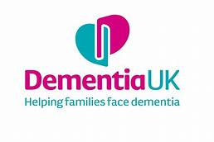


Shumana Begum
Student number: 1913892
Module name: Principles of Health & Social Care
Module code :BMHP5002
Assessment A1
Lecturer: Mentesnot Mengesha
Deadline: 7th Jan 2022

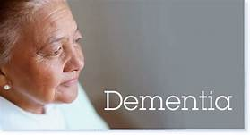

Content page
- Discussion/ Analysis
- Recommendations
- Introduction-
- Conclusion
- References-
- Appendix

Introduction
The aim of this report is to understand the principles of health care based on the case study in Assignment 1 and to be able to expand on the values and policies of the chosen healthcare organisations.
Dementia is a common and debilitating problem and is a phrase that is used to relate to a ranges of symptoms including memory loss, communication skills so this could have many impacts on individuals and societies. This can be a problem in a person’s capacity to carry out daily activities such as washing, cooking. Dementia is affected by different brain diseases most common is Alzheimer’s disease. (Gopalkumar Rakesh, Steve T. Szabo, George S. Alexapolus et.al 2017)
Dementia is also affected by different physical diseases of the brain such as Alzheimer’s disease, vascular dementia, DLB and FTD.
A person does not develop many symptoms of dementia but only depending on when a part of the brain are affected.
The type of dementia affects the area of the brain in the early stages. However, some symptoms can be similar depending on the type of dementia on how bad it is.
This progressive condition can have a big impact on families, carers and also the society on who’s living with dementia as it can be difficult.
In 2005 the number of deaths in men who suffers from dementia is 20,403 however for women is 41,283.
BBC News: Dementia now leading cause of death (14th Nov 2016)

Organisation: Social Services
Regarding this case study as both Mr and Mrs T need support in their home to ensure them to remain as independent as possible it needs be suggested that Mrs T needs to request a carers assessment and a social service assessment both for her husband and herself.
For this the assessments this will include a financial assessment and a care plan needs to be put in place which may include home care( domiciliary care) and day care. Possibly respite care for Mrs T may be provided by Mr T having a short-term care placement. Mrs T is also likely to have to attend physio appointments so she can carry out daily exercises at home which might help so while doing this it beneficial for her to supervise Mr T needs. There is also many electronic devices that can be provided such as a careline in the home if Mrs T is likely to fall. There are voluntary organisations that could help such as Age Concern, Alzheimer’s society, Helping Hands, Red Cross.
(https://www.nhs.uk/conditions/dementia/help-and-support/)

Home care
As Mr. T has progressive dementia I think home care is good for him because he can find support and a place for security and to increase independence.
There are many rehabilitation services that can involve manage daily activities and also there are there different therapies which may help,
However, with Mrs.T who had a fall recently followed by her hip operation, this can be requested for her to have physiotherapy sessions to carry out daily exercises at home as it can be beneficial to supervise Mr.T and have continuous appointments with her GP.

The Care Act 2014
The Care Act 2014 involves a duty on local authorities to promote the wellbeing of individuals when carrying out care and support functions that includes:
- Dignity thats treating individuals with respect
- Physical and mental health and emotional wellbeing
- Prevention from abuse and neglect
- Participation in work, education, training, or recreation
- Social and economic wellbeing
- Domestic, family, and personal relationships
- Suitability of accommodation
- The individual’s contribution to society
- (Department of Health, 2014)

The Mental Capacity Act 2005
The Mental Capacity Act 2005 requires the legal position of providing help or services to people who may lack the capacity in order to take certain actions or decisions for themselves. This defines key principles which must be applied such as presumption of capacity and supporting individuals to make their own decisions.
The Act also provides tools such as lasting power of attorney and advance decisions to refuse treatment which ensures individuals to retain some control. These measures also help people ensure their wishes are implemented in the event of future loss of mental capacity.
An understanding of the Act is essential for people working with those living with dementia. The Act and code of practice apply to all staff working with people who may lack capacity.
The human right Act 1998
This Act sets out a list of many rights and freedoms of all UK such as the freedom of expressions.
All UK citizens have the right to be treated equally especially with patients who have conditions.

The NHS with dementia patients
In the NHS Dementia is a growing challenge as the population ages and people live for longer which has become one of the most important health and care issues facing the world.
In the whole of the UK, the number of people who suffers from dementia is estimated at 850,000. Dementia affects older people and after the age of 65 the likelihood of developing dementia doubles every five years. However, for some dementia can develop earlier presenting different issues for the person affected.
There are around 540,000 carers of people with dementia in England. It is estimated that one in three people will care for a person with dementia in their lifetime. Half of them are employed and it’s thought that some 66,000 people have already cut their working hours to care for a family member.
There is an economic cost that is associated with the disease at £23 billion a year which is predicted to triple by 2040. This is more than the cost of cancer, heart disease and stroke.
A theory is ideas or prediction of something that might happen in the healthcare setting or an opinion that why it is important to have good communication between service users and staff (Gambrill, 2012).
Hepworth et al. (2010) mentioned that it is important that care workers develop better communication skills so they have good interactions with service users and can explain what treatment is needed for the patients so in that case care staff should use professional language and to know when to apply them to create a better health care environment (Cournoyer, 2013).
Confusing, professional language is unlikely to be understood by the general public and especially someone with dementia.

Discussion
In the case study provided in Assignment 1, I will identify what support is needed for Mr & Mrs T in the current health and social care settings. As a NHS worker in the care of Mr & Mrs T situation, I would suggest many things that can help Mr with dementia along with other chronic condition.
Firstly, it is a duty of care to know about patients health wellbeing and strategies on how to cope with condition like Mr & Mrs T.
I do not think so, they are unlikely to want this and NHS workers are not responsible for this social service.
In this case they are both over elderly so I would advise them to be put in a care home where they can be provided with daily activities so they can have enjoyment and support. As Mr has progressive dementia, they are techniques in order to manage this this which involves:
- speaking slowly by using short sentences
- Make eye contact with the person when they are talking or asking questions
- Give them time to respond.
- To help them to join in conversations with others.
- To use a simpler way to communicate for them to understand (ie) rephrasing the question.
- To be patient and remain calm, which can help the person communicate more easily

Analysis/ Literature review
- The impact of Covid-19 pandemic on people with mild cognitive impairment/dementia and on their caregivers-November (2020)
This article mentions that COVID-19 was first developed in Mainland China in December 2019 and soon started to spread throughout the world with multiple physical and psychological consequences across the affected populations.
Discussion:
Covid-19 threatens to disrupt the basic routines that promote mental and physical health of both people with MCI/dementia and their caregivers.
Methods
The study showed that two hundred and four caregivers took part in the study by completing a self-reported questionnaire about MCI/dementia and their own since the lockdown period which started in February and ended in May of 2020 in Greece.
Result:
This outcome suggested a significant overall decline of the people with MCI/dementia. However, the domains in which people with MCI/dementia were mostly affected were by communication, mood, movement, and compliance with the new measures. Caregivers also reported a great increase in their psychological and physical burden.
Conclusion:
By following these measures it helps to protect and provide support to people who suffers from dementia.

2. Influence of periodontal disease on risk of dementia: a systematic literature review and a meta-analysis (2020)
Based on this article this report mentions this disease is common and increases the number of cardiovascular diseases. However, it is unclear whether PD is connected with increased risk of dementia.
Result:
The study shows that five cohorts and seven case-control studies were identified for review. The eligible data to calculate the risk of dementia in relation to PD and computed the number of dementia cases saved through reducing PD prevalence. Out of 12 studies, Six were undertaken in Asia, four in Europe and two in America. Eleven studies showed a positive association between PD and the risk of dementia of which 10 were significant, and one reported a non-significant inverse association.
Conclusion:
Overall, their quality was good. Pooled RR of dementia in relation to PD from all high-quality studies was 1.38 (95%CI 1.01-1.90); in the five cohorts was 1.18 (1.06-1.31) and in the two case-control studies 2.25 (1.48-3.42). A 50% reduction in the current prevalence of 20% of PD in the population could save 850,000 (630,000-1,420,000) patients with dementia in the world. PD could increase the risk of incident dementia. Preventing and treating PD could contribute to controlling the global epidemic of dementia.

3. Article: Advance care planning in dementia: recommendations for healthcare professionals: (2018)
This is the care planning that is between an individual and their healthcare professionals which is concerning the individual's preferences and values for future treatment and care including end of life care.
Results:
In regards to the result of this report it is stated that 24 participants developed 32 recommendations covering eight domains. Almost all recommendations received a grading representing low to very low-quality evidence.
Conclusion: It is mentioned from this article that high-quality guidelines are available for ACP in dementia care. By combining evidence with expert and user opinions there are a set of recommendations for ACP in people living with dementia. These recommendations form a valuable tool for educating healthcare professionals on how to perform ACP across settings.

Recommendation
Regarding this report and what I found out that this is good to research analysis about the number of dementia patients which I found many literatures review on.
In the future it’s a good idea to use relevant research about the literature review and to emphasis on the number of people that is affecting and to provide support for the elderly.

Conclusion
In this academic report ,Firstly I was confused about this topic and what to include but now I have an understanding by referring to this case study on Mr & Mrs T and applying all the relevant strategies in order to manage Mr. T dementia and other their conditions by fining information and support on both their condition.
This has made me very interested in this topic because I know I have to apply relevant steps to make a decision.

References
- Nadim R, Tang J, Di Mohamed A, Yuan S, Wu C, Bakre AT, Partridge M, Ni J, Copeland JR, Anstey KJ, Chen R. et.al (2020) Influence of periodontal disease on risk of dementia: a systematic literature review and a meta-analysis. Eur J Epidemiol Vol (9) Pg:821-833. doi: 10.1007/s10654-020-00648-x. Epub 2020 Jun 12. PMID: 32533373.

- Tsapanou A, Papatriantafyllou JD, Yiannopoulou K, Sali D, Kalligerou F, Ntanasi E, Zoi P, Margioti E, Kamtsadeli V, Hatzopoulou M, Koustimpi M, Zagka A, Papageorgiou SG, Sakka P et,al (2021) The impact of COVID-19 pandemic on people with mild cognitive impairment/dementia and on their caregivers. Int J Geriatr Psychiatry. Vol.4 page 583-587. doi: 10.1002/gps.5457. Epub 2020 Nov 13. PMID: 33166418.

- Piers R, Albers G, Gilissen J, De Lepeleire J, Steyaert J, Van Mechelen W, Steeman E, Dillen L, Vanden Berghe P, Van den Block L. et.al (2018) Advance care planning in dementia: recommendations for healthcare professionals. BMC Palliat Care. 2018 Jun 21;17(1):88. doi: 10.1186/s12904-018-0332-2. PMID: 29933758; PMCID: PMC6014017.

- https://www.housinglin.org.uk/Topics/browse/HousingandDementia/Legislation/

- https://www.england.nhs.uk/mental-health/dementia/

Appendix

Date | Total dementia patients aged 0-64
April-18 | 14,935
May-18 | 14,910
June-18 | 14,972
July-18 | 15,030
August-18 | 16,145
September-18 | 16,771
October-18 | 16,716
November-18 | 16,819
December-19 | 16,733
Jan-19 | 16,648
Feburary-19 | 16,349
March-19 | 16,483
April-19 | 16,408
May-19 | 16,353
June-19 | 16,357
July-19 | 16,410
August-19 | 16,417
September-19 | 15,393
Octoberr-19 | 15,995
November-19 | 15,981
December-19 | 15,912
Janury-20 | 15,836
Feburary-20 | 15,776
March-20 | 15,693

Created by shumana
Figure 4: This graph shows the number of people with the diagnosis of dementia under the age of 65 from April 2018 – March 2020
The graph displays how the total number of dementia patients aged 0-64 has changed over the last 24 months by following a large increase in September 2018 that has been shown a gradual decrease month by month.
The proportion of patients diagnosed with dementia has ranged from 0.03% to 0.035% of the total number of patients aged 0-64 in the 2 years of data examined; In March 2020 the proportion is 0.032%. The denominator used was the number of patients registered at a general practice, aged 0-64 years old.
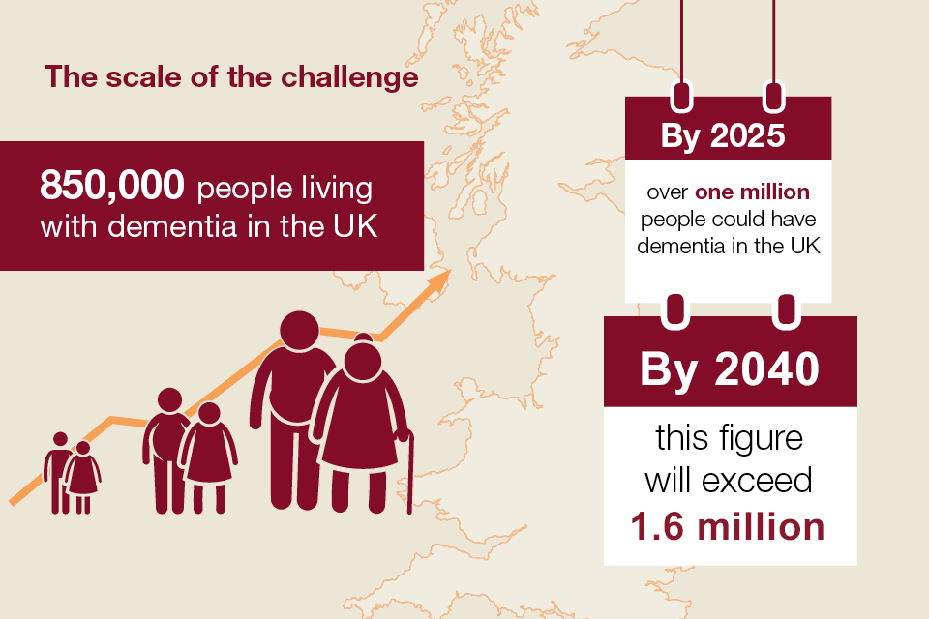

This table shows that there is more than 40,000 people in the UK under the age of 65 that are affected by this condition. Dementia costs society £34.77 billion a year in the UK and this cost is set to rise as the population ages.

Legislation | Relevant points | How it effects individuals
Human right Act 1998 | This provides a list of the rights & freedom of all UK citizens | All UK citizens have the same rights & freedoms so individuals with conditions must be treated fairly
Care Act 2014 | This Act is to ensure the care and wellbeing of individuals. | The local authority must meet the care and support needs of individuals & investigate abuse or neglect of individuals
Mental Health Act 1983 | This involves assessments, that its needed for individuals with mental health that have been detained under the mental health Act. | Decisions that are made on behalf of individuals must be made on their best interest\
CQC Fundamental Standards | Minimum standard of care that individuals can expect. | Individuals know the level of care that they can expect and how they can challenge organisations.
This table shows a list of polices, legislations and how they may affect day to day experiences of individuals with mental health conditions such as dementia and learning disabilities.

