University of Wales Trinity Saint David
Wales Institute of Science and Art


Electronic Circuits Testing and Applications
Electrical control systems
ACHA4010
Stanley Cherrington
2203262
18/03/23
Contents page.
1 Task 1 3
1.1 A 3
1.2 B 3
1.3 c (i) 3
1.4 c (ii) 3
1.5 c (iii) 4
1.6 c (iv) 4
1.7 d 4
1.8 e 4
1.9 f 5
1.10 g 5
2 Task 2 6
2.1 Scope Time Division Calculations 6
2.2 Function Generator output sine wave 6
2.3 Unsmoothed Rectifier Wave 6
2.4 Smoothed Rectifier Wave 7
2.5 Drop in Voltage Question 7
2.6 Rectifiers use in Automotive applications Question. 7
2.7 Probing Question 8
3 Task 3 9
3.1 Scope Time Division Calculations 9
3.2 Function Generator output sine wave 9
3.3 Capacitor charge and discharge wave marked at correct points. 9
3.4 Basic Capacitor Calculations 10
4 References 11

Task 1 circuit questions.

A) Resistance of E:
V=I x R
R=$\frac{V}{I}$
R=$\frac{12}{0.5}$
R=24Ω

B) Current through B and C
I_{a} +I_{b} +I_{c} = I_{t}
0.3 + I_{b} + I_{c} = 0.5
I_{b} + I_{c} = 0.2
I_{b} = 0.1 I_{c} = 0.1

C) Resistance of A
E = Q x V
E = I x T x V
0.9 = 0.3 x I x V V = 3V
3 = 0.3 x R
$$\frac{3}{0.3}R$$
R_{a} = 10Ω

C ii) Resistance of B and C
E = Q x V
E = I x T x V
0.3 = 0.1 x 1 x V
V = 3v
V = I x R
3 = 0.1 x R R = $\frac{3}{0.1}$
R_{B} = 30Ω
R_{C} = 30Ω

C iii) Potential difference across A, B and C

R_{T} = $\frac{1}{(\frac{1}{Ra}+\frac{1}{Rb}+\frac{1}{Rc})}$
R_{T} = $\frac{1}{(\frac{1}{10}+\frac{1}{30}+\frac{1}{30})}$ R_{T} = 6Ω
V = I x R
V = 0.5 x 6 v = 3v

C iv) Potential difference across D and resistance.
PD_{A-E} = 5v
PD_{A-C} = 3v
PD_{D} = $\frac{(5-3)}{2}$ PD_{D} = 1v
V = I x R 1 = 0.5 x R
R = 20 Ω

D) Calculate R and total resistance of parallel cells.
V = I x R 2 = 0.5 x R R = 4Ω
R_{parallel} = $\frac{1}{(\frac{1}{R}+\frac{1}{R}+\frac{1}{R}+\frac{1}{R})}$ $\frac{1}{(\frac{1}{4}+\frac{1}{4}+\frac{1}{4}+\frac{1}{4})}$
R = 1Ω

E) Voltage drop across F
V = I x R
V = 0.5 x 6
V = 3v drop

F) Total resistance of circuit
R_{A.B.C} = 6Ω
R_{E} = 24Ω
R_{F} = 6Ω
R_{Paralell cells} = 1Ω
R_{Total} = 6 + 24 + 6 + 1 R_{Total} = 37Ω

G) EMF of cells.
EMF = I(R+r)
EMF = 0.5 (37+4)
EMF = 20.5v

Task 2 full bridge rectifier.
2.1) Scope time division calculation.
Wave period = $\frac{1}{HZ}$
Wave Period = $\frac{1}{10}$ = 0.1s
2.2) Function Generator output.
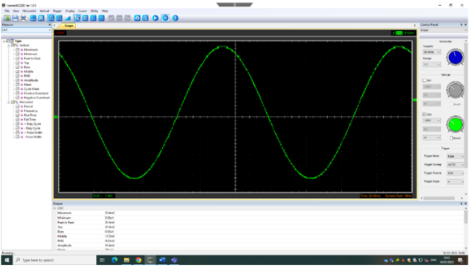
2.3) Rectifier without capacitor before resistor.
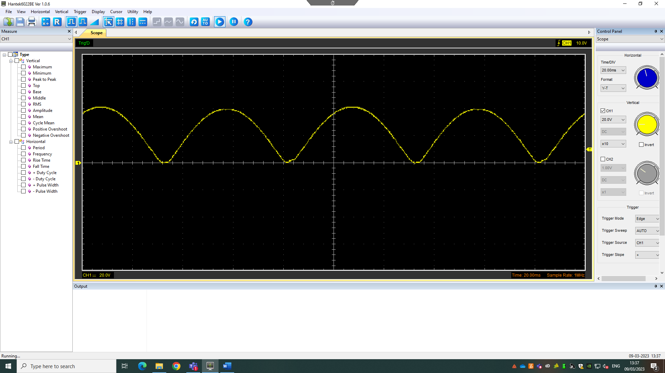

2.4) Rectifier with capacitor before resistor.
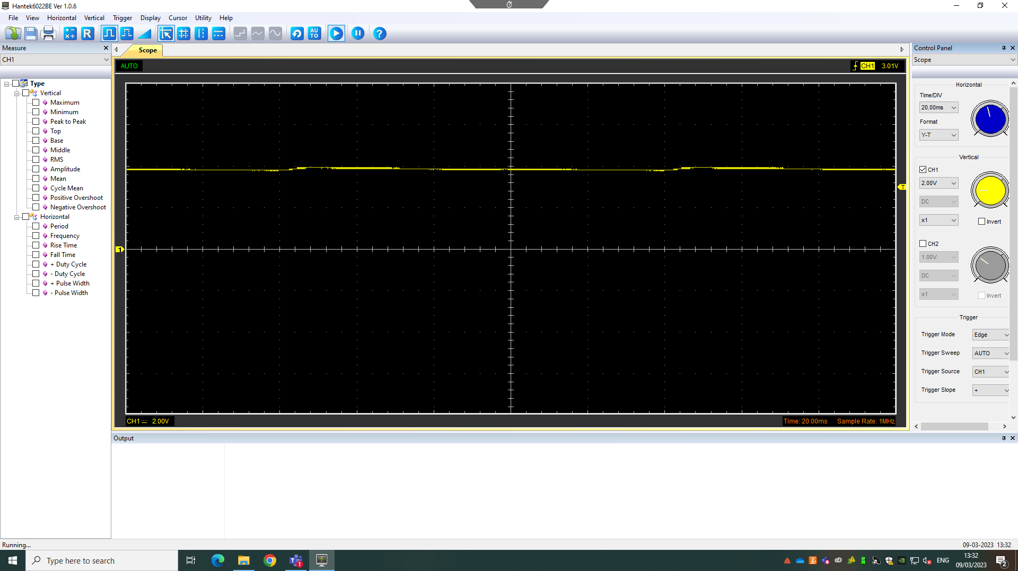

2.5) Drop in voltage question.
The rectifier DC output is lower than that of the peak sinewave input because the current is flowing through a full bridge rectifier. This means that the current has to pass through two diodes. Each of the two diodes creates a resistance to the current, therefore, increasing the drop in voltage. The most commonly used diodes that are used in full bridge rectifiers are made of silicone, the voltage drop will be a minimum of 1.2v and will increase in relation to the current.

2.6) Rectifiers in the automotive industry.
The conversion of AC to DC is known as rectification. Diodes produce rectification in circuits. In the automotive industry, the most commonly used rectifier in the automotive industry is in the electrical and battery regenerative systems such as the alternator.
As the engine turns over, a belt that is pulled tight over the crank pulley is rotated, as well as this the belt also rotates the alternator. This pulley on the alternator turns the inner rotor of the alternator through an electrical field generating a current (AC). This AC current is then converted into direct current or DC. This DC can then be used to power the car’s electrical systems such as the radio and lights. As well as this the DC is also used to recharge the battery.
Due to the alternator essentially being an AC generator, the polarity of the current is reversed on every revolution of the rotor. By controlling the flow of current, the rectifier in the alternator is able to prevent any damage to the vehicle, allowing the current to flow from the alternator to the battery.

2.7) Probing question.
The rectifier output and the function generator input can not be scoped at the same time using different channels on the oscilloscope as they use the same ground, if you did scope using two different channels, you would cause a short circuit. However, this problem can be easily rectified by using a 1:1 transformer which will allow the function generator to be isolated from the rectifier. This would then enable you to scope the input and the output simultaneously.

Task 3 Identify Capacitors
3.1) Scope time division calculation.
T = $\frac{1}{F}$ T = $\frac{1}{688.7}$ T = 1.45 x 10⁻³
Resistor used = 220Ω
Capacitor used = 0.33 x 10⁻⁶

3.2) Function generator output.
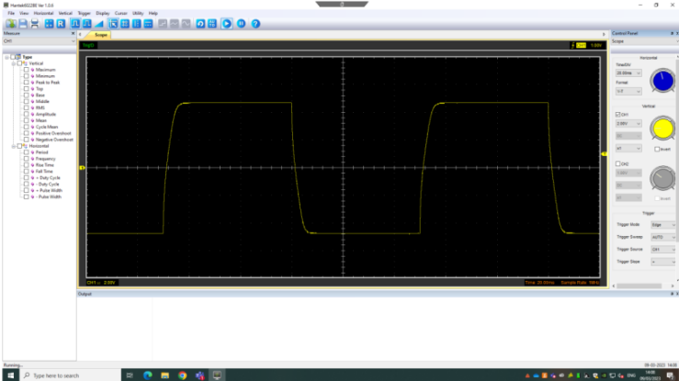

3.3) Capacitor charge and discharge
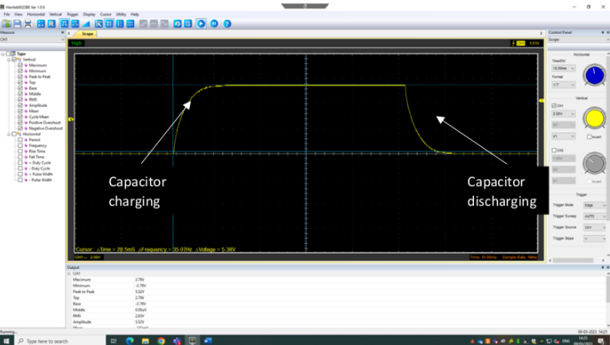

3.4) Capacitor calculations.
T = R x C
1.45 x 10⁻³ = 220 x C
$\frac{1.45 ×{10}^{-3}}{220}$ = C
C = 6.59 x 10⁻⁶ F

Reference list

How alternators work (no date) How Alternators Work. Available at: https://www.autoelectro.co.uk/alternators (Accessed: April 8, 2023).
What is an alternator and how does it work? (2022) Carorbis.com. Available at: https://carorbis.com/blog/what-is-an-alternator-how-does-it-work/#:~:text=Car%20batteries%20operate%20on%20direct,used%20to%20recharge%20the%20battery. (Accessed: April 8, 2023).
Why is the peak of output voltage a little less than the peak of input voltage for a half-wave rectifier? (no date) Quora. Available at: https://www.quora.com/Why-is-the-peak-of-output-voltage-a-little-less-than-the-peak-of-input-voltage-for-a-half-wave-rectifier (Accessed: April 8, 2023).
James, R. (2023) Electronic Circuits Testing and Applications . Swansea: University of Wales Trinity Saint David.

