Oliver Smith 219240
Assignment 2 M3XCP5 Geographical Information Systems
GIS Application

Contents
1. introcution 2
1.1. Problem 2
1.2. Solution 2
2. Data Sources 3
Dataset 3
Source 3
Type 3
3. Map Development 4
3.1. Starting off 4
3.2. Rejected Votes 7
3.3. General Election 2015 Results 10
3.4. Producing the map to compare eu referendum vote 13
3.5. Adding household income data 16
3.6. Hospital admission layer 18
4. Analysis 20
4.1. Did rejected votes have an impact? 20
4.2. Did each county elected party have a part to play? 21
4.3. Did the average household income for each county have an impact? 22
4.4. Did the NHS have a part to play in the decision? 23
5. Conclusion 24
Bibliography 25

introcution
On June 23rd 2016, the people of Great Britain took to the polling stations for one of the biggest votes in UK history. This vote would will determine the relationship between the United Kingdom and Europe. On that day, the British electorate delivered a majority vote in favour of leaving the European Union. The margin was very small, being 52% (to leave) and 48% (to remain). Even though the results were close, it was very clear that the people of the UK had made their decision (1).

Problem
Over one year later, this vote is still the most talked about things in UK politics. Over the last year and a half, government has been trying to figure out the decision on why the leave campaign had won. The government argues that the UKs National Health Service had a big part in the decision to leave the EU, with the leave campaign stating “We stop sending £350 million every week to Brussels and instead spend it on our priorities, like the NHS” (2). Others say that the decision was based on the living standards of the county and how much income on average homes across Wales receive. The leave campaign stated that leaving the EU would encourage UK employers to start paying the living wage, which would encourage people to vote leave (2). Some people think that each county elected party had a part in it, with different parties having a different view in Brexit (3).

The UK government wants the Welsh Assembly Government to conduct research on why they think most of Wales decided to leave the EU.

Solution
The solution to this problem is to analyse the data to see whether there were patterns in the vote and to see whether any of the points listed in the problem were a key factor in this decision.

Data Sources
All data that has been used in this project is recorded in the table below. Most data can be downloaded of various websites which are free.
Dataset | Source | Type
Base Map | http://moodle.nptcgroup.ac.uk/mod/resource/view.php?id=153708 (4) | Shape File
Electoral Data | https://www.electoralcommission.org.uk/our-work/our-research/electoral-data/electoral-data-files-and-reports (5) | CSV Files
Referendum of the UK’s membership of the EU | https://www.electoralcommission.org.uk/__data/assets/excel_doc/0009/215289/EU-Referendum-electoral-data-website-version.xlsx (5) | XLSX File (converted to CSV file)
General Election 2015 Results | http://electionresults.parliament.uk/ (6) | XLSX File (converted to CSV file)
Unemployment Results | http://www.dataunitwales.gov.uk | CSV Files
Hospital Waiting Times | https://www.healthmapswales.wales.nhs.uk/IAS/dataviews/view?viewId=146 | CSV Files

Map Development
All the tools and techniques that have been used to produce the final project has been documented in this section of the report.

Starting off
Once the base map was downloaded from the source, I needed to add it as a ‘vector layer’ in QGIS. When the map is imported into the software, it shows all the regions for Wales and England. For my analysis, I am only going to need all the Welsh regions, therefore I am going to have to delete all the English regions.
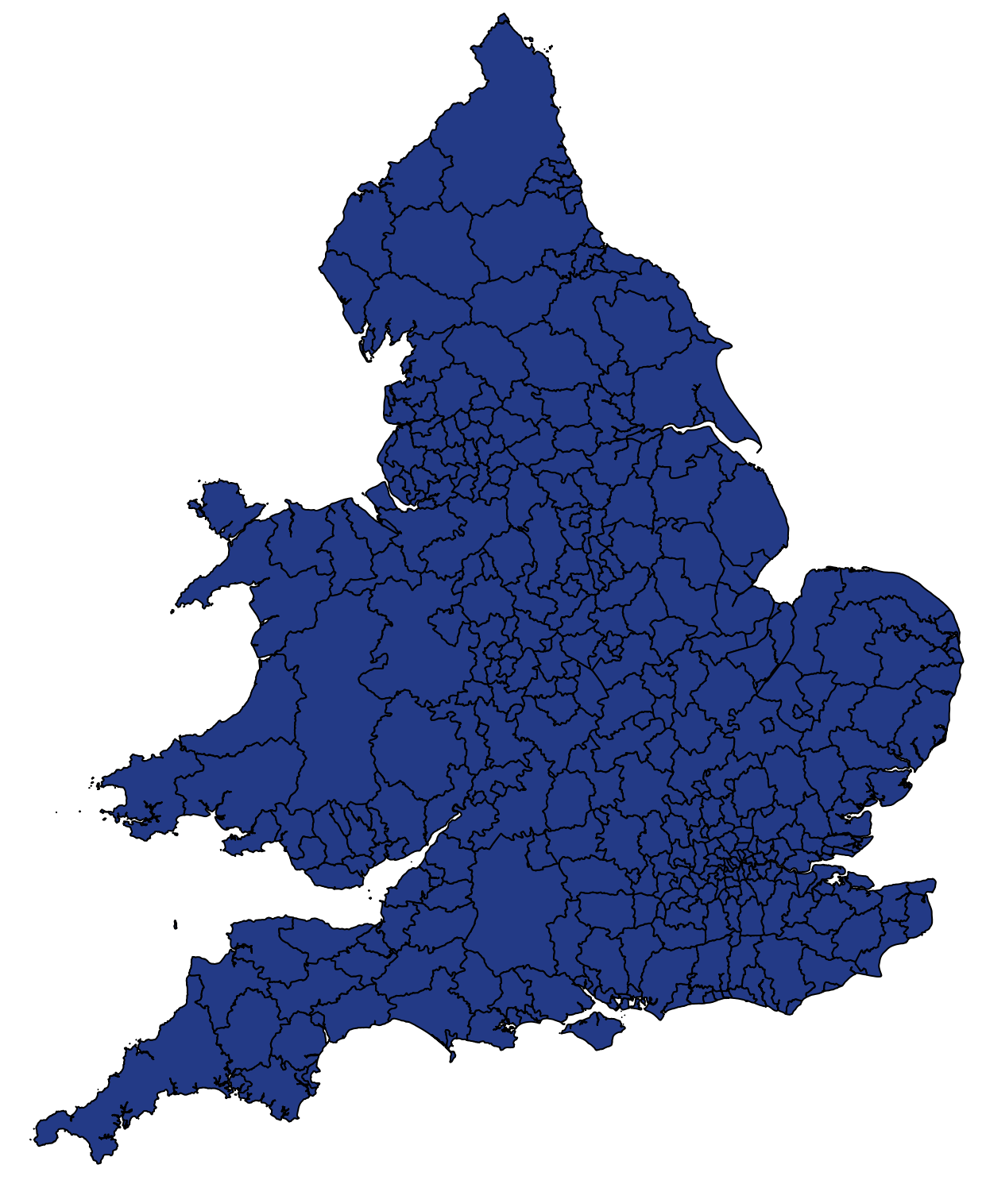
To delete all the English regions, I went into the attribute table. In this table, it had all the data for each local authority. I selected all the English regions and deleted them from the attribute table.
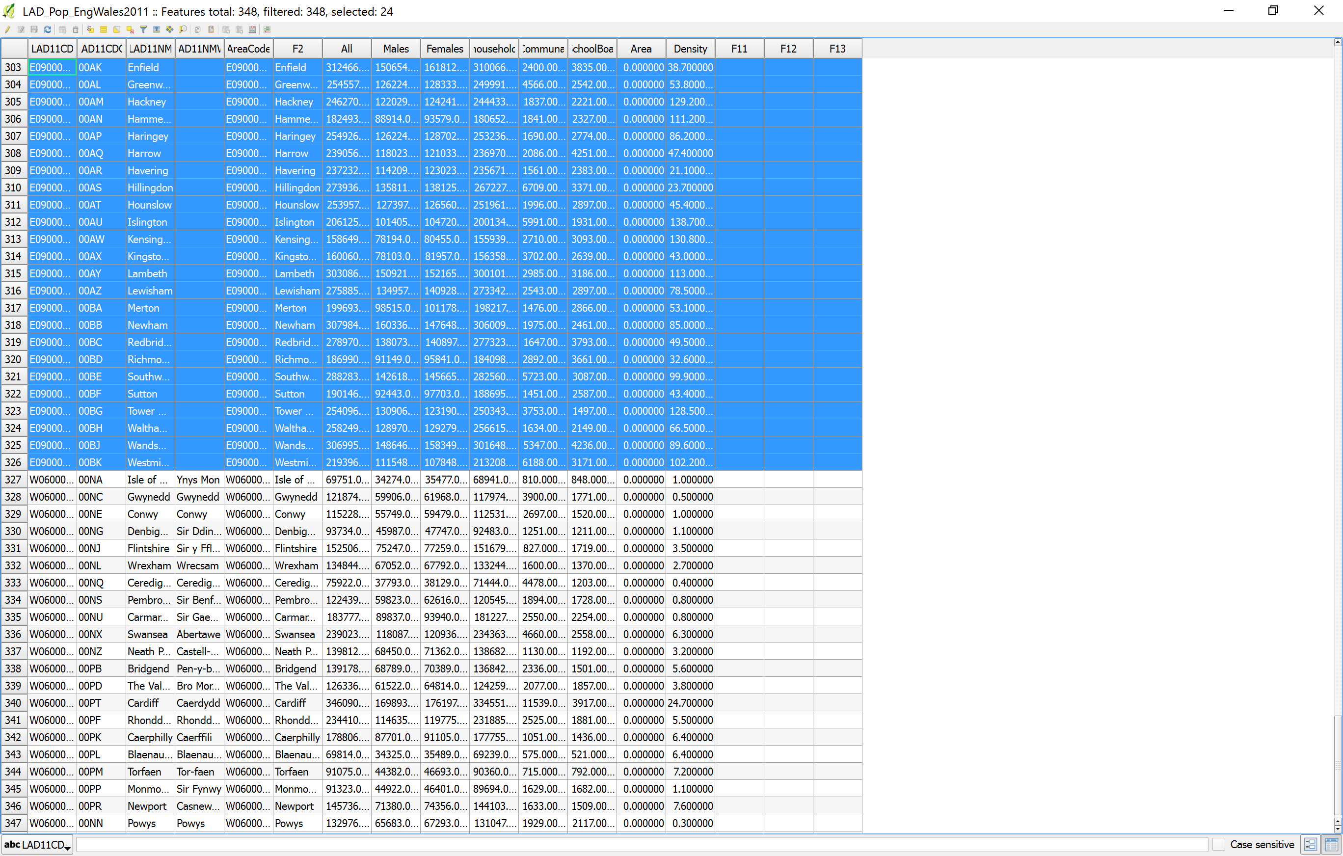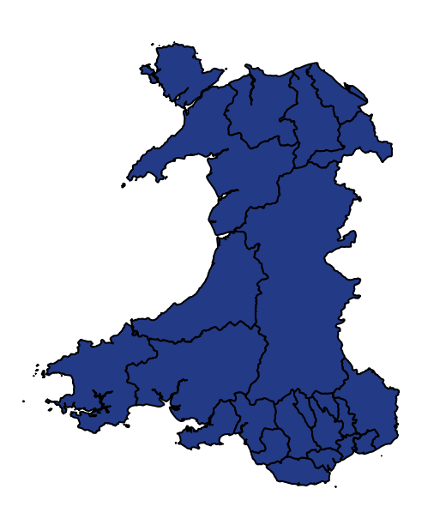

I have discovered the ‘Electoral Commission’ website, who are “the independent body which oversees elections and regulates political finance in the UK” (5). They release reports and statistics for UK votes from councillor elections to general elections. Moving forward, I am confident that the data that I am receiving is reliable and accurate.

On their website, all the reports and data files are available for anyone to access. The data file that I am interested is from 23 June 2016 “Referendum on the UK’s membership of the EU”.
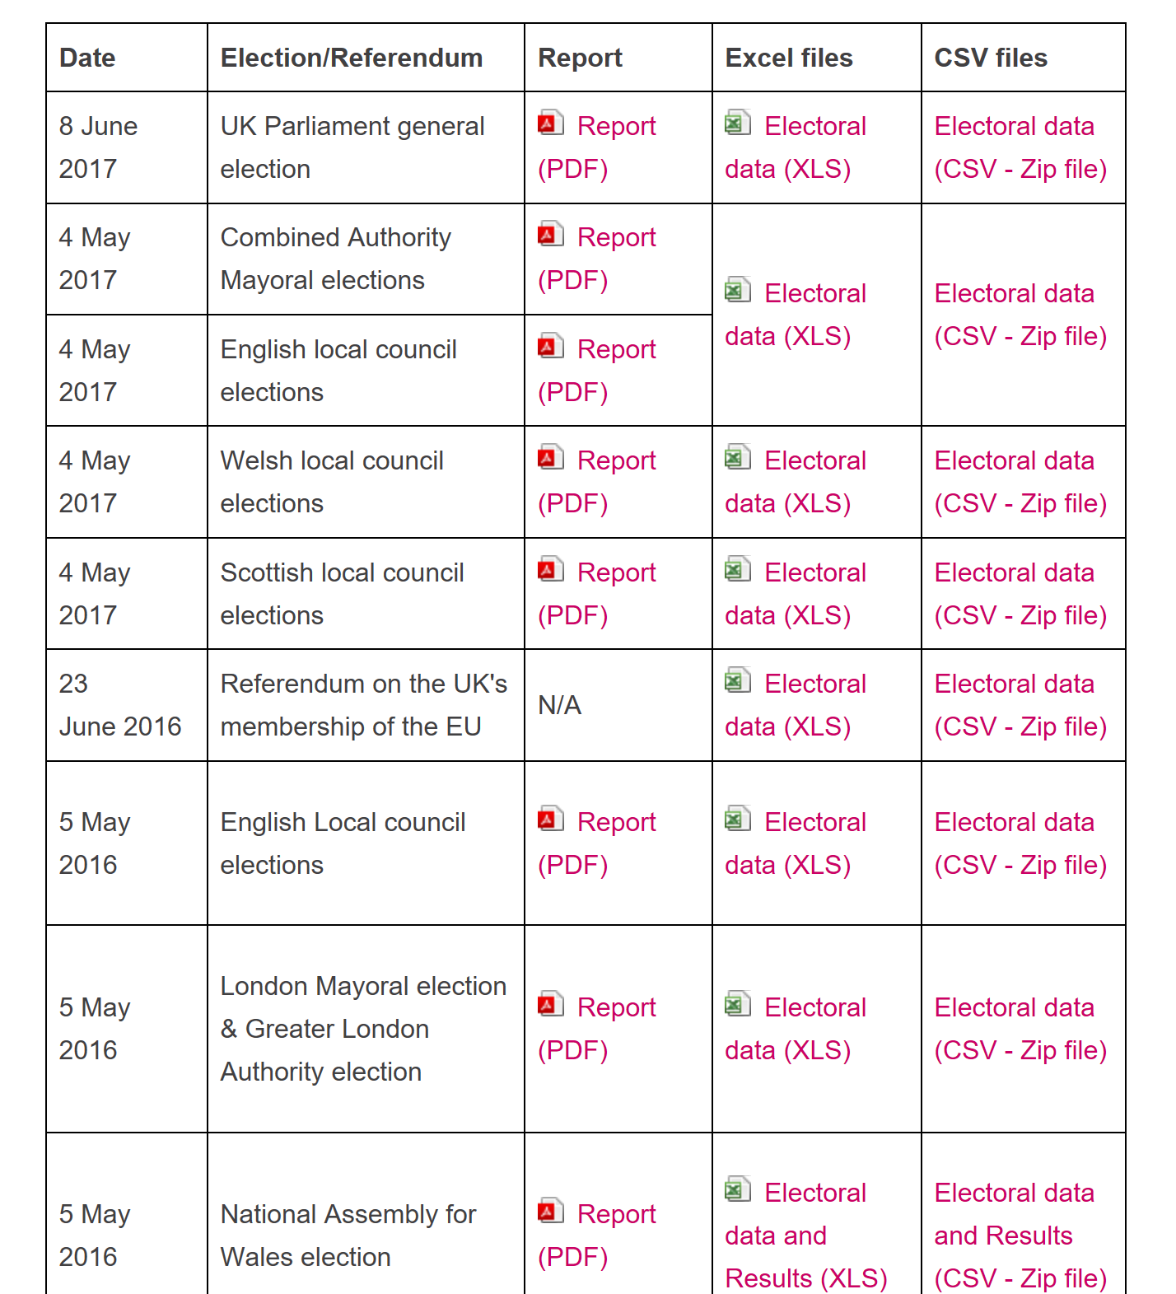

In the data file, there is 382 records, from all different local authorities. Most of these I do not need, as I am only interested in the data from Wales. I then filter the ONS area code and only selected “W92000004” which would result in only Welsh local authorities to be shown. This is the only data that I am interested in for the sake of this investigation.
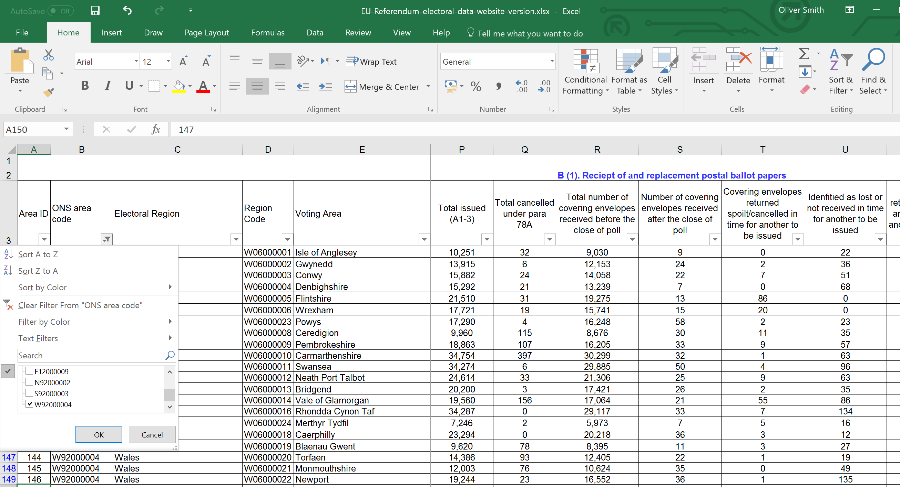

Rejected Votes
The first thing that I did was analyse the results of all the votes casted that were rejected. This would be a simple map, showing which local authority had the highest number of rejected ballots. To do this, I wold need to join the data to the actual map. The join layer was the data file, join field was the voting area and the target field on the map was the name.
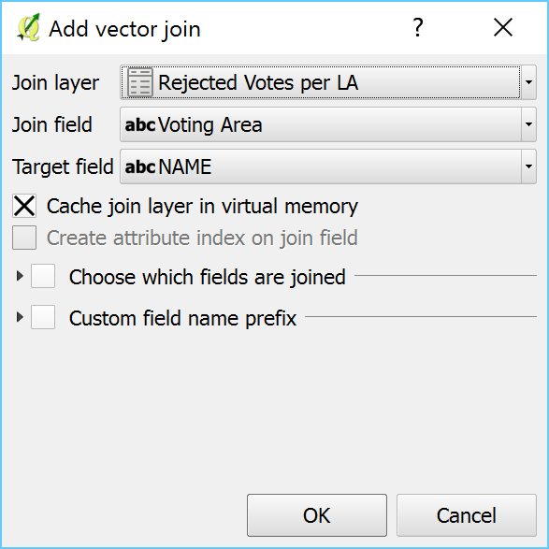
I then added a graduated style to the map. This would add the local authorities with the highest number of rejected voted a dark blue and the ones with the least will be in a lighter blue.
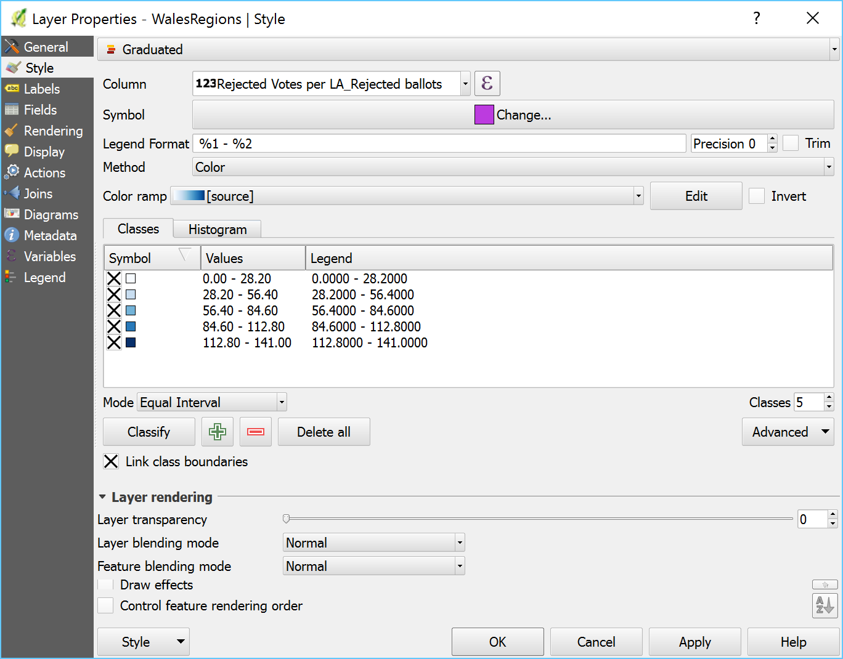
I wanted to display the name of the name of that local authority and the number of rejected votes on the map. So in the layer function, I added the following SQL statement:
NAME || '\n' || "Rejected Votes per LA_Rejected ballots"
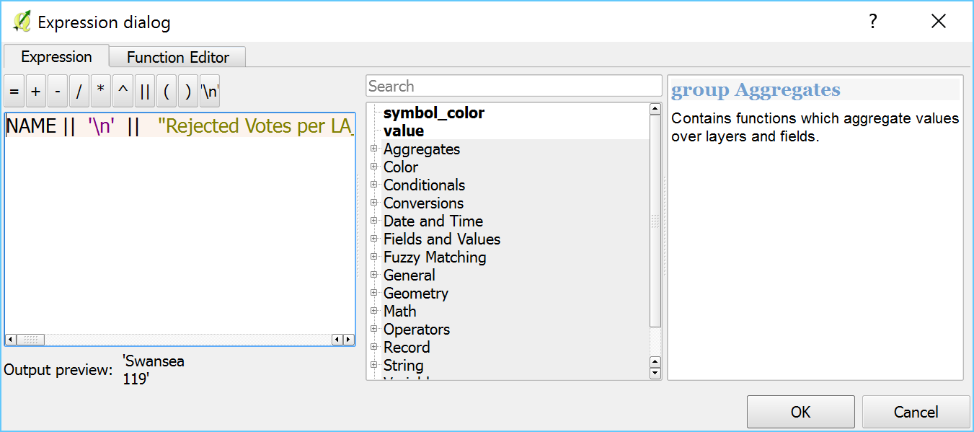
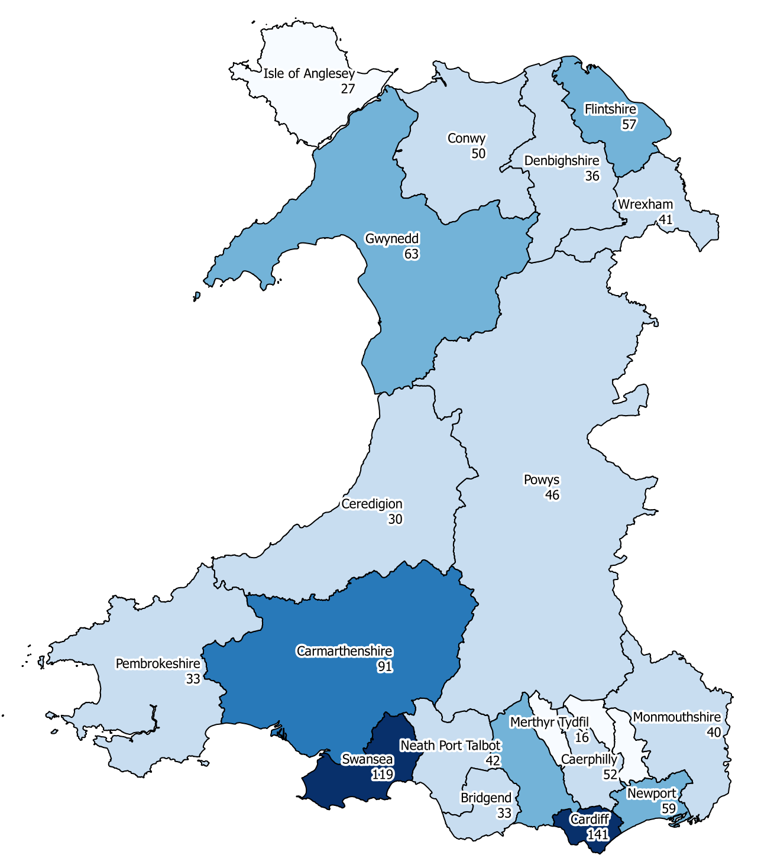

In order to make this data more meaningful, I am going to add the total electorates. So on the map, it will display the total number of rejected votes, along with the total number of votes for that region. To do this, I uploaded the data to the software and joined, following the same steps as above. I then went into the label settings and updated the query.
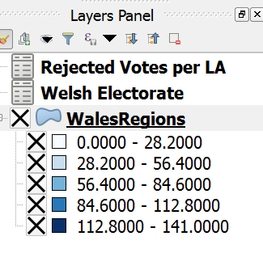
The query that was used: NAME || '\n' || "Rejected Votes per LA_Rejected ballots" || '\n' || "Welsh Electorate_Electorate"
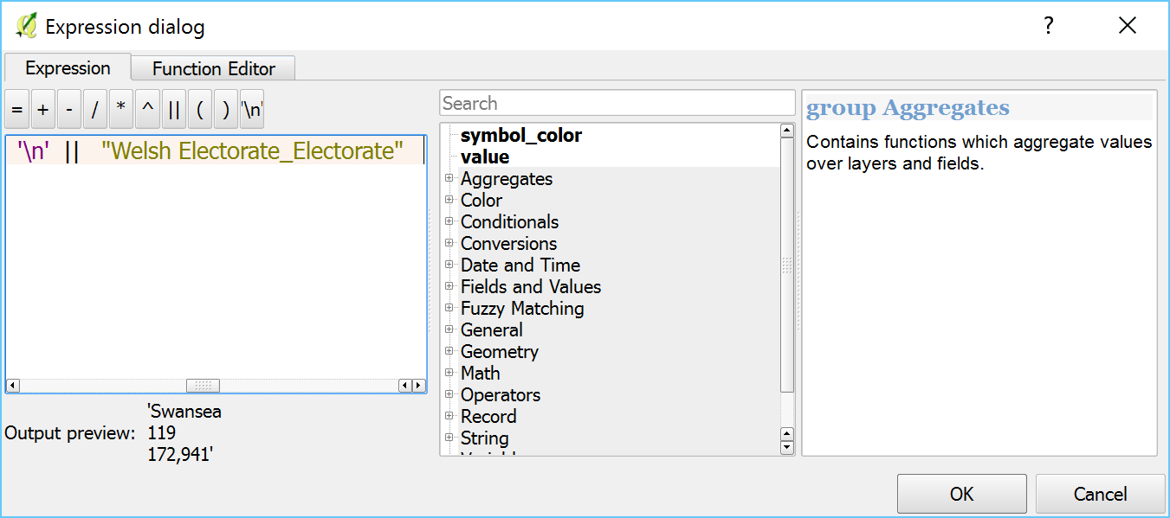

The map now shows more data that will be more understanding to the end user. For example, Powys had 46 rejected votes out of 103,270 voters.
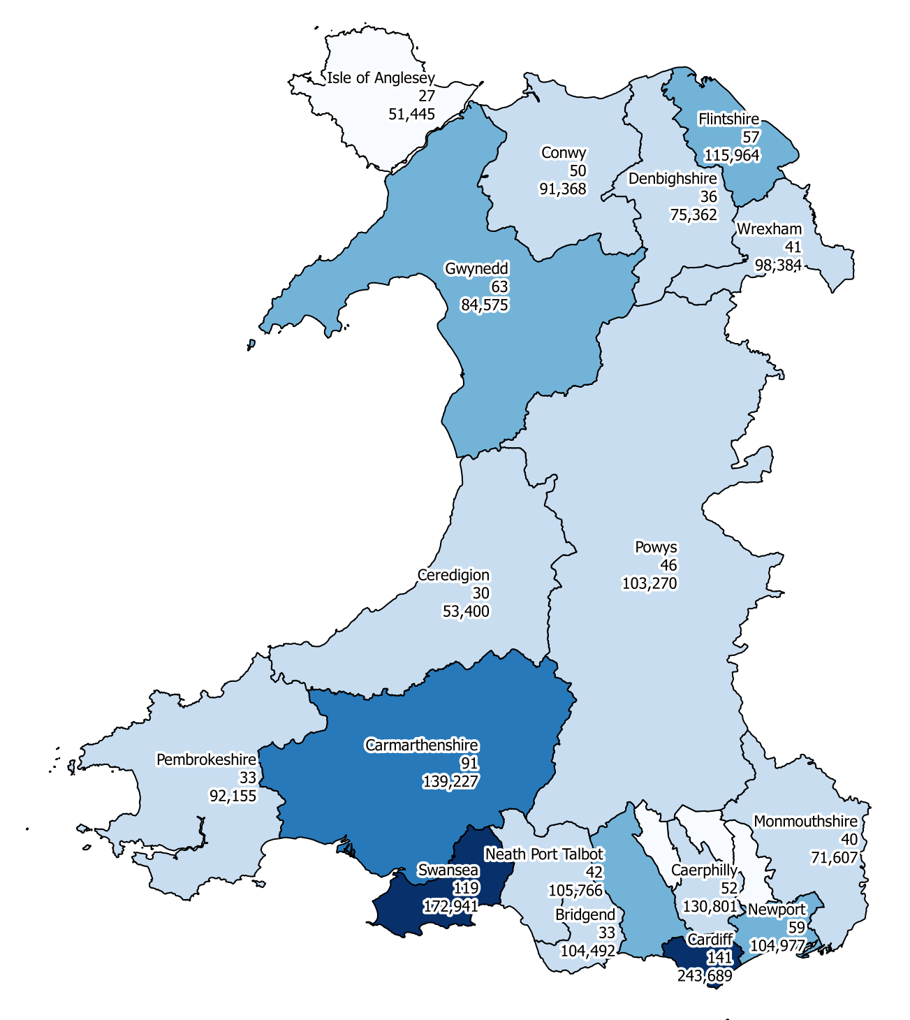

General Election 2015 Results
As all the general election data was gathered from the General Election Online website (6). As on most parliament websites and independent commissioner websites, all data regarding the general election were grouped in their constituency, rather than the county. In order to get the data within their county’s, I needed to input all data manually and save it as a CSV file.
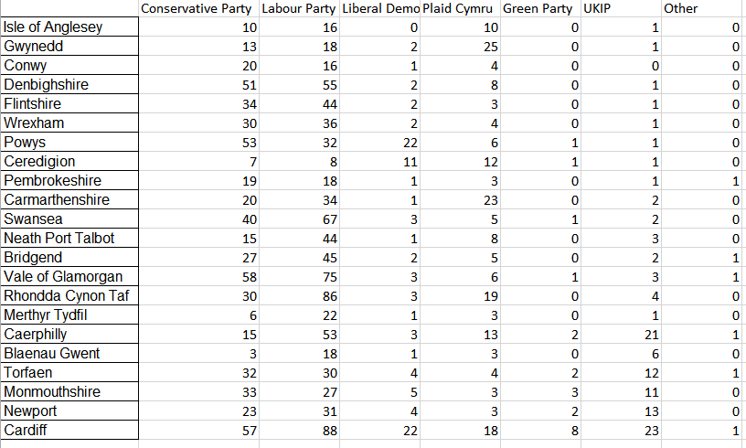
To get the data into QGIS, I followed the same steps as I did with the previous map. I want data to show the number of votes each party received in the 2015 general election. The party with the most votes, the colour that represents the party will fill the county on the map. For the colour, I categorised them, so each colour would display for different counties.

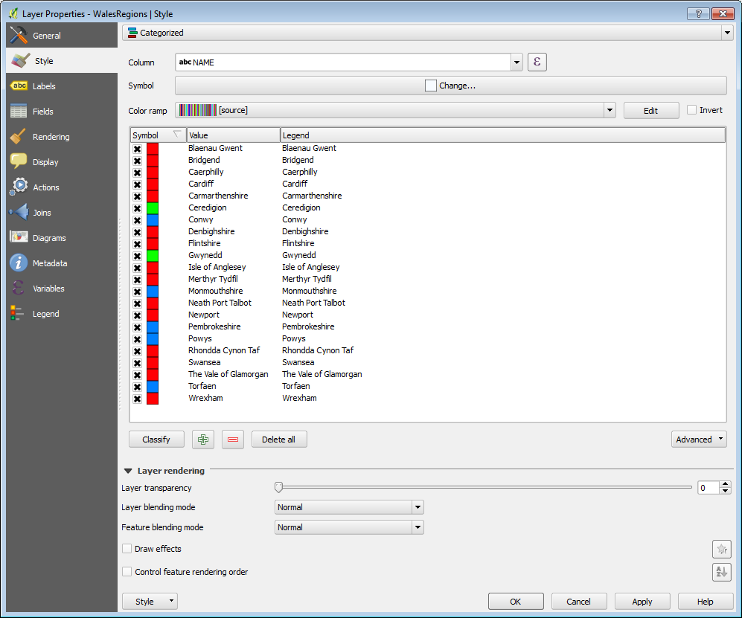

This was what the map then looked like. It shows all the counties with the number of votes that each party received. All the data that is displayed is per 0000s. I have added a legend, to help understand the data.
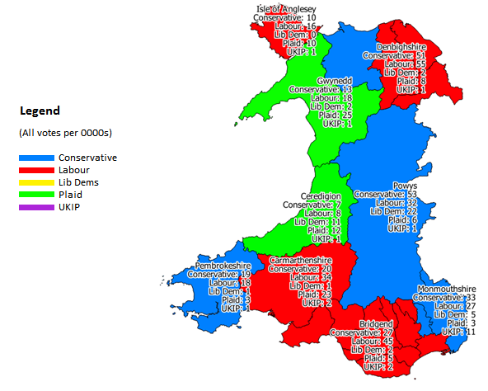

Producing the map to compare eu referendum vote
From the maps that I have produced above, I then added further data, by adding another table join. For this map, I have gathered the information in Excel to state the leading party for each county in Wales. I did this by sorting out the figures in Excel and then stating the winning party for that county. I then added a query to show the results in the label as shown below:
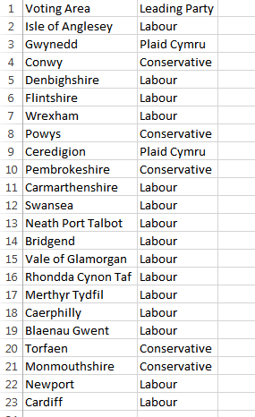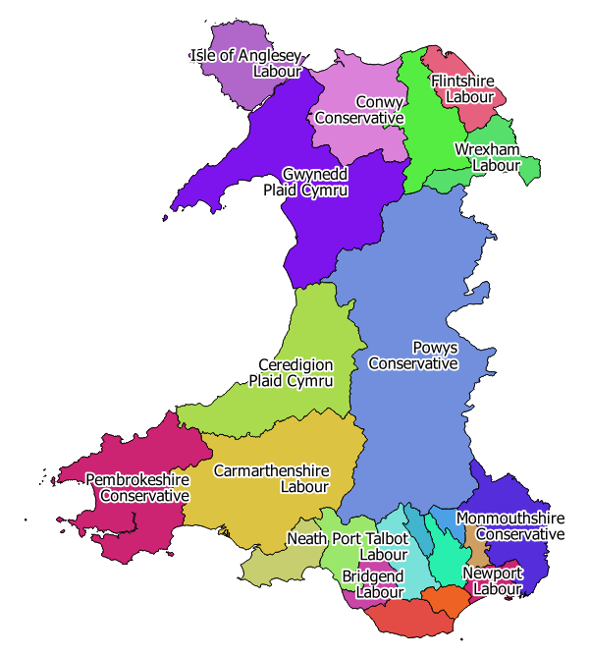
The next stage, I gathered all the information regarding the vote in the European Referendum vote in 2016. For this specific analysis, I didn’t need the exact figures for the vote, all I wanted was the overall result for who voted leave and who votes remain. I sorted all this data out in Spreadsheet, where I looked at all the data, and stated whether the result was remain or leave. I then this data as a new layer in QGIS. A query was created to show the result on the screen as shown below:
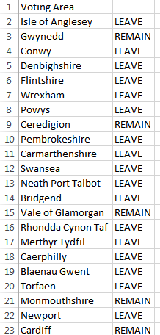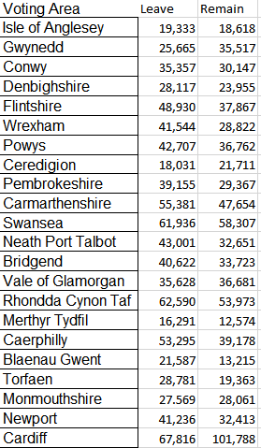
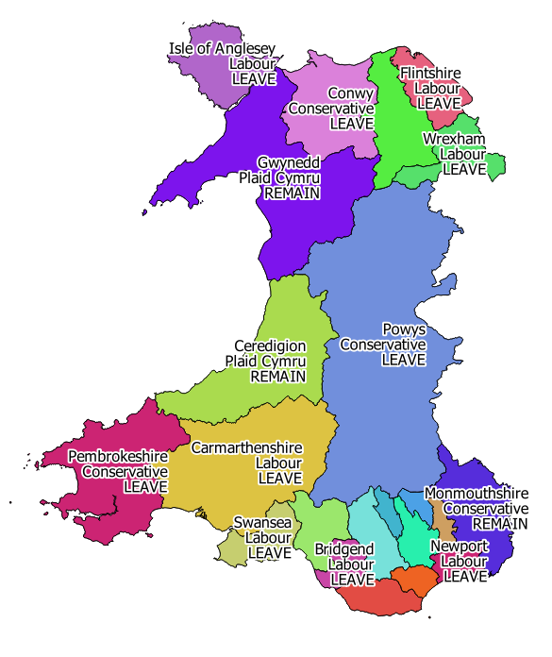
The final layer of data that I wanted to add was the total number of voters. I would add a gradient style to this, with the darker shade showing the highest number of voters and the lighter shade showing the lowest number.
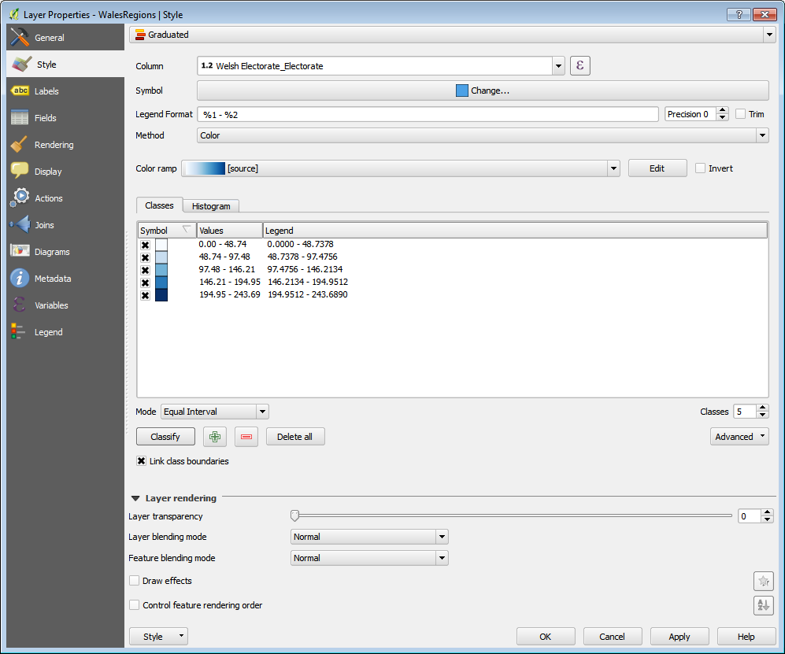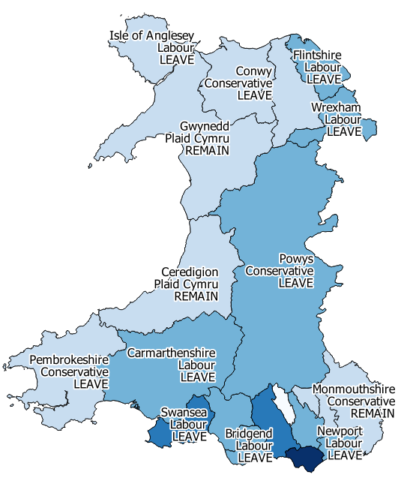

In order to make the data more understandable, I then created a legend. The legend would particularly show the figures for the total voters, so the viewer is able to understand what the different shades of blue mean.
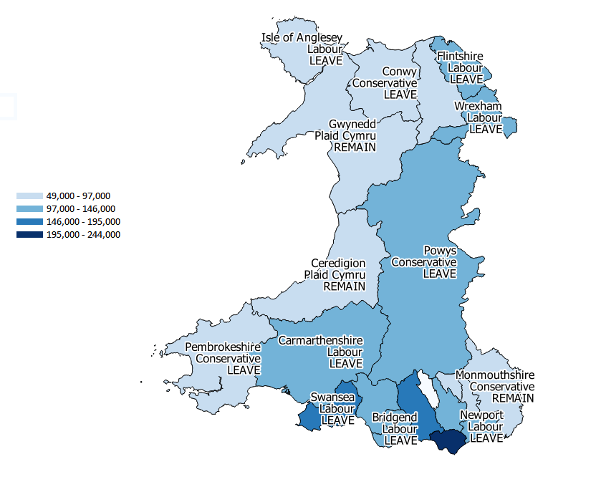

Adding household income data
The next thing I have done is add household annual income. This would be used for my analysis later on, to determine whether people with a higher income voted differently. To do this, I followed the same steps as the previous maps. I had to join the tables to create a graduate display with the darkest shade receiving the highest number and lighter shades receiving the least. A legend has been produced to show this.
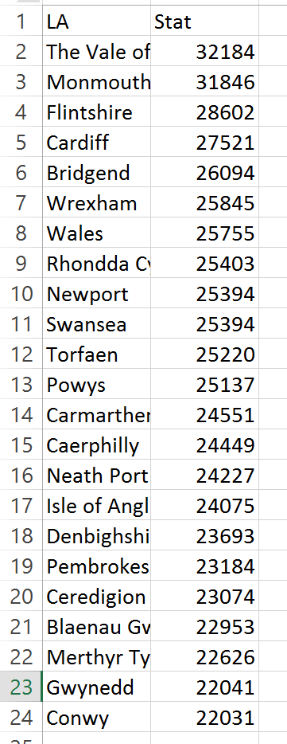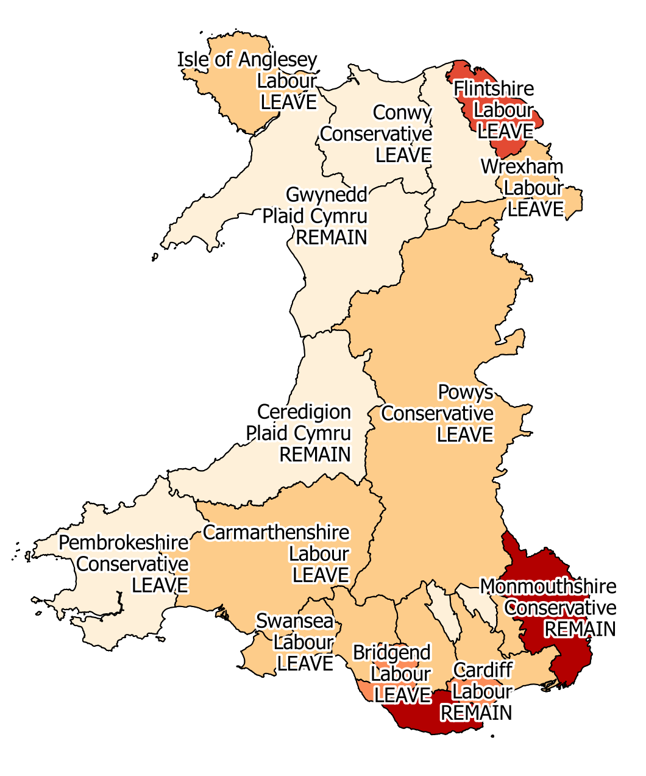
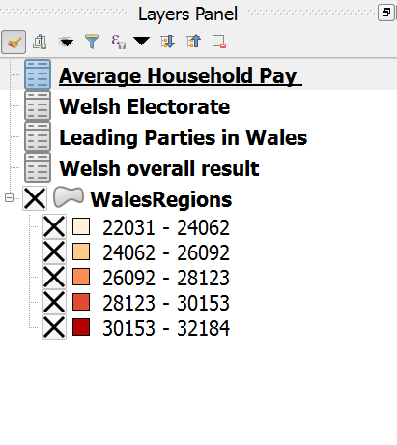
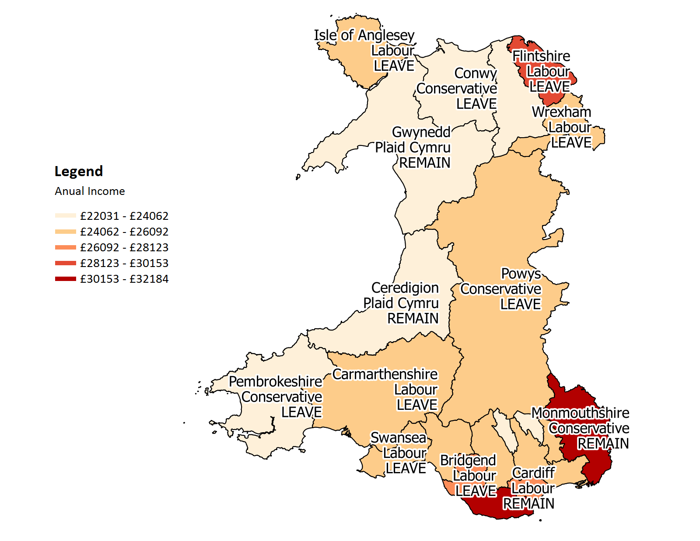

Hospital admission layer
I did the same for hospital admissions as I wanted to compare the data, to see if hospital admissions may have influenced the way people voted in the EU referendum vote. I had to join the tables to create a graduate display with the darkest shade receiving the highest number and lighter shades receiving the least. A legend has been produced to show this.
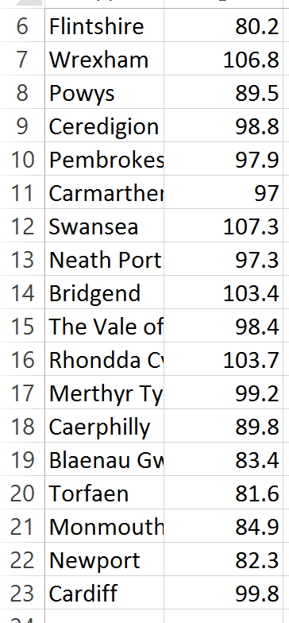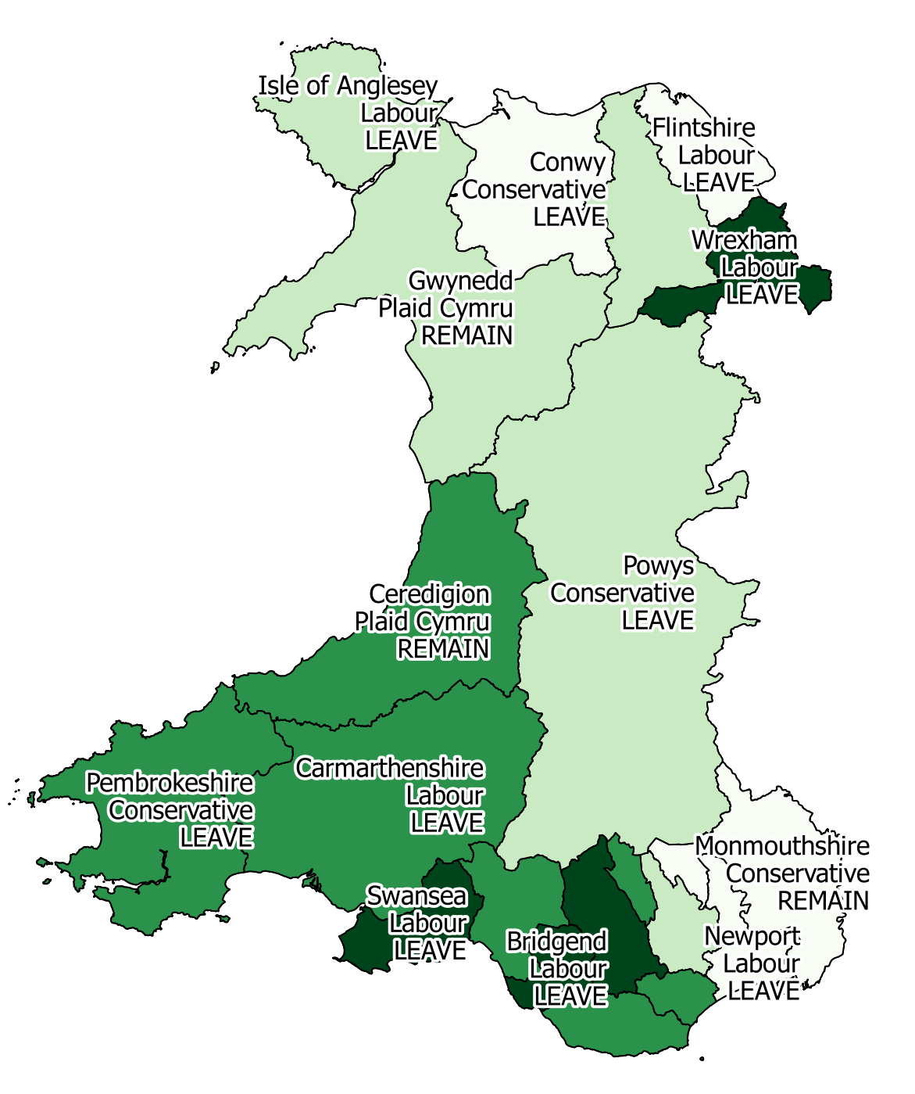
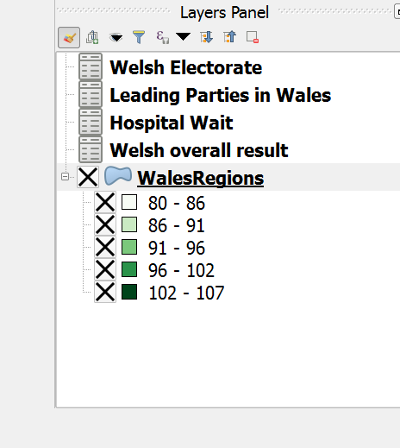

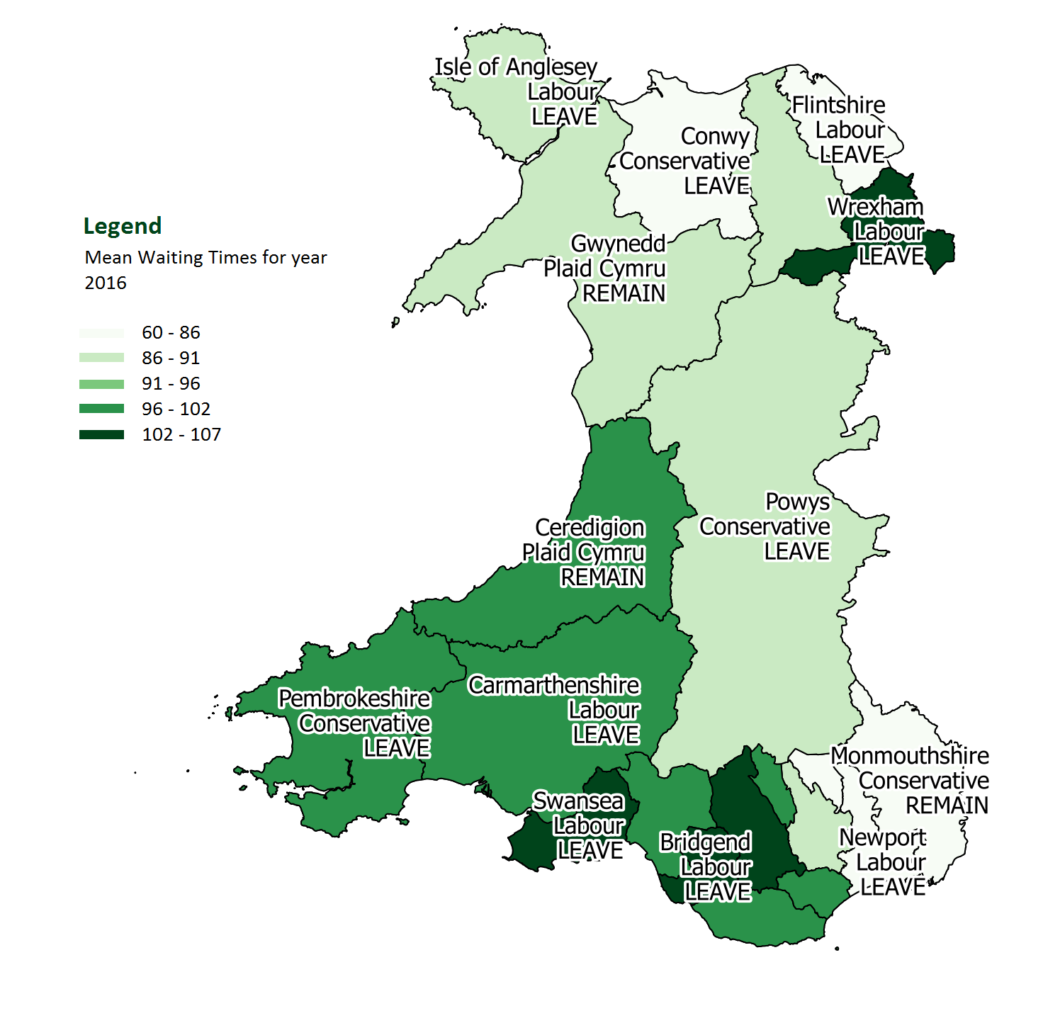

Analysis
After producing maps to display the data, I will now need to analyse the data, to see any patterns and to see if the points listed in the problem were a key factor of the vote.

Did rejected votes have an impact?
Looking at the data that has been produced, it is very unlikely that rejected votes had any impact on the overall result in Wales. Looking at the numbers, the rejected vote is too small up against the total number of voters. Looking at the map, you can see that the darker shade blue had the higher number of voters, therefore the number of rejected votes were also higher, but then the lower amount of total votes such as Isle of Anglesey had a low amount of rejected votes. A ballot paper will be considered rejected if a law declares or an election authority determines that it is invalid and this not included in the vote count (7). A paper can be rejected when instructions are not followed correctly or when rules are broken.

Did each county elected party have a part to play?

Party | Comment
The Conservative Party | Before Brexit, the Conservative Party was against Brexit.
The Labour Party | The Labour Party campaigned against Brexit.
UKIP | UKIP campaigned to leave the EU
Plaid Cymru | Plaid Cymru voted to remain.
(3)
Looking at the table above and looking at how each county voted, it shows that in most cases the party elected for that county had no part to play in the decision being made. The two only Plaid Cymru run counties were the only ones that voted with their party. Although there the Conservative party managed to have one county vote with them, they failed to do so with the rest. Labour had everyone vote against them in this EU referendum. The people of Wales voted to leave the EU, regardless that all the leading parties were remain campaigners.

Did the average household income for each county have an impact?

When the map is analysed, I am able to see that this had some part to play in it. In the map displayed, the darker shades of red have the highest average income and those with a lighter shade had lower. Right away, I can see that Cardiff and Monmouthsire have got the highest average annual income. Both of these counties were one of the few that actually voted remain. On their part, it could have been persuasion that leaving the EU would mean that those major areas would not benefit from the funded projects from the EU. However, the lowest earning household counties also voted remain such as Gwynedd and Ceredigion but these counties had strong remain supporting parties.

Did the NHS have a part to play in the decision?
Looking at the map, the NHS seemed to have a part to play regarding the vote to leave. The counties with the highest waiting times Swansea, Bridgend and Wrexham all voted to leave. The government has been criticised by the leave campaign for spending money remaining in the EU when the money could be going towards the NHS (2). However, some counties that voted to remain, also have a higher number for waiting times. But looking at this, the ones with the higher number wanted to see change and to see more money funded to the NHS to solve the problem.

5. Conclusion
The Welsh Assembly government wanted to find out the reason why Wales voted to leave the EU. After analysing the data that I have manipulated, it is uncertain to come up with a definite answer. In most cases, the leading party of that county had little impact on the decision so this really says that the campaign on their part were very weak. Plaid Cymru managed to keep their county on side, as they voted to remain.
The NHS had a part to play in most cases, as the counties with the highest number of waiting time all voted to leave, which shows that they are under a lot of pressure in their local hospitals. Although some counties with a high waiting time voted remain, I still believe that this was because Plaid Cymru put up a good campaign and got all their voters on side.
The household income also played a part in some cases, as those who were receiving the most money all decided to stay, where as the lower earning income counties voted to leave. Although all these are based on theory, it can never be certain why exactly people voted, although there are some obvious issues that have been identified in these maps. Everyone had their own reason to vote, whether that was to do with issues with the NHS, income or the campaign itself.

Bibliography
1. Curry, Stephen. What is the meaning of Brexit? EMBO reports. [Online] 4 August 2016. [Cited: 2018 January 27.] https://www.ncbi.nlm.nih.gov/pmc/articles/PMC5007566/.
2. The Leave Campaign. About the campaign. Vote Leave. [Online] [Cited: 2018 January 24.] http://www.voteleavetakecontrol.org/campaign.html.
3. BBC. General election 2017: Where UK's parties stand on Brexit. BBC News. [Online] 1 June 2017. [Cited: 24 January 2018.] http://www.bbc.co.uk/news/uk-politics-39665835.
4. Census Population Download. NPTC Moodle. [Online] [Cited: 23 December 2017.] http://moodle.nptcgroup.ac.uk/mod/resource/view.php?id=153706.
5. Electoral data files and reports. The Electoral Commision. [Online] [Cited: 23 December 2017.] https://www.electoralcommission.org.uk/our-work/our-research/electoral-data/electoral-data-files-and-reports .
6. 2015 General Election Results. Geberal Elections Onlne. [Online] [Cited: 4 January 2018.] http://electionresults.parliament.uk/.
7. BBC. What can you NOT do in a polling station? . BBC Election 2010. [Online] 6 May 2010. [Cited: 6 February 2018.] http://news.bbc.co.uk/1/hi/8661984.stm.

