Changemakers: Building your personal Brand for Sustainable Employment
BMHP5051_BIRM

Assignment 2: Reflect Report
Student Name: Natalie Tully
Student Number: 2025
Lecture Name: Kennedy Obohwemu

Contents
Introduction 3
Unit 1 Brand you 4
What Drives You? 4
Unit 2 Small world 5
Network Society 5
Unit 3 Opportunity Knocks 6
Me.com 6
Unit 4 The pursuit of happiness 7
Future Me 7
Conclusion 8
Personal Development Plan 8
References 9

Introduction
In this assignment, I will identify the key points which I have gained from the four units, which will outline my knowledge and understanding for each topic. I will be using online material to reflect on my experiences, to help with my journey into the working world, by evaluating these chosen topics. Which would inspire me to assess myself for changes and understanding how I work and develop to become more successful in my studies, my chosen career and which will strengthen my mindset.
My chosen topics are as followed:
- Unit 1, What Drives You?
- Unit 2, Network Society
- Unit 3, Me. com
- Unit 4, Future Me
I will identify the main points from my topics, which I can apply to personal employability development.
The second part of this assignment I will be developing a personal development plan.

Unit 1 Brand you
Unit 1 investigates why it’s important to brand yourself? Get yourself noticed by other people; how other individuals see you professionally. Understanding that ambition, setting career goals, what drives you? Also, the differences between Boundaryless career and Boundaryless skills.

What Drives You?
This is one of my chosen topics in unit one, it helps me to explore the skills needed to achieve my purpose, first I needed to understand what drives me.
This session focuses on the difference between doing something for money and being in the flow. Flow is when you concentrate on clear goals, that are effortless and easy. After reviewing this section, it made me understand the concept between them both, within my working environment I would feel I would benefit from doing a job I loved, to being in the flow creates happiness rather than the money, but also money is also a driving factor to consider.
According to Daniel pink motivations of ambitions on his ted talk, motivation is not driven by money, the three concepts are autonomy which self-direction to have more freedom to be more creative, mastery the urge to get better at something to higher the purpose to realise our ambitions (www.youtube.com, n.d.).
The pursuit of mastery, learning, improvement, and creation are the main sources of motivation. Employees can learn and develop by being presented with obstacles (Anon, 2016).

Unit 2 Small world
Unit 2, explores the overview of the importance of networking to expand connections, understanding our own networking within our family and friendship groups and making connections.

Network Society
The deliberate process of marketing oneself is known as personal branding. It is a process like any other, with inputs, a method, and intended results (Khedher, 2018).
In this section I learnt how to create powerful personal brand, I also understand the networks of the world and the coercion and persuasion to create action.
Coercion persuasion can be used as the same term as brainwashing, through reform or mind control (Ventegodt et al., n.d.). This gave me a great insight into people with power can try to influence us in different ways to try and change our opinion or get what they want.
Networks of influence helps gather more followers for my purpose, through connections of informally of a cohesive network, you have a more trusted group. Where you are more likely through communications and pressures will help convince others.
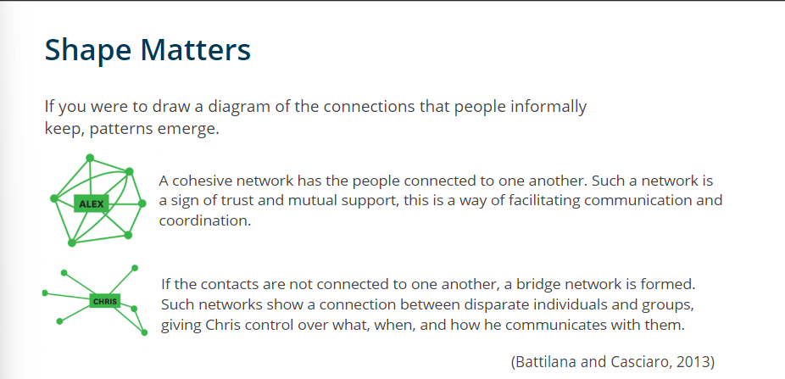

Understanding different types of networks can help me build my personal network to convince and develop more changes. Looking into unit 2 has given me a better understanding to my cohesive network map, I could possibly try to open my network to have some bridges. I found this very interesting that the times has change and developed into a new technology world which is a powerful tool with the right networks can create a strong alliance globally.

Unit 3 Opportunity Knocks
This unit explores how we deal with opportunities within our career roles, creating our own luck, using internet and social media.

Me.com
This section had me considering how I use social platforms and the way I use them to communicate with family and friends. Now I can take more advantage of creating a personal platform and making a professional name for myself. Learning about the 5’Cs of social media (Communicating, Collaborating, Connecting, Completing and Combining) will help me advertise my brand (www.manobyte.com, n.d.). I feel that I am more confidence to collaborate to create content with other people to achieve a common goal.
Before doing this unit, I did not understand the importance of posting blogs, or how they increase the levels of influence they have on your brand or company (Cohen, 2012).

Unit 4 The pursuit of happiness
Unit 4 investigates the journey to happiness and determination to meet your goal, by adapting to situations and the importance of plan, prepare and perform.

Future Me
This topic got me revisiting my reasons for attending university and the factors that influenced my decision. Thinking back to why I wanted to attend university was to feel I was good enough to gain a degree and get a better career. After doing the activity in this unit, my reasons for attending university, has not change direction. The table below shows why I came to university.
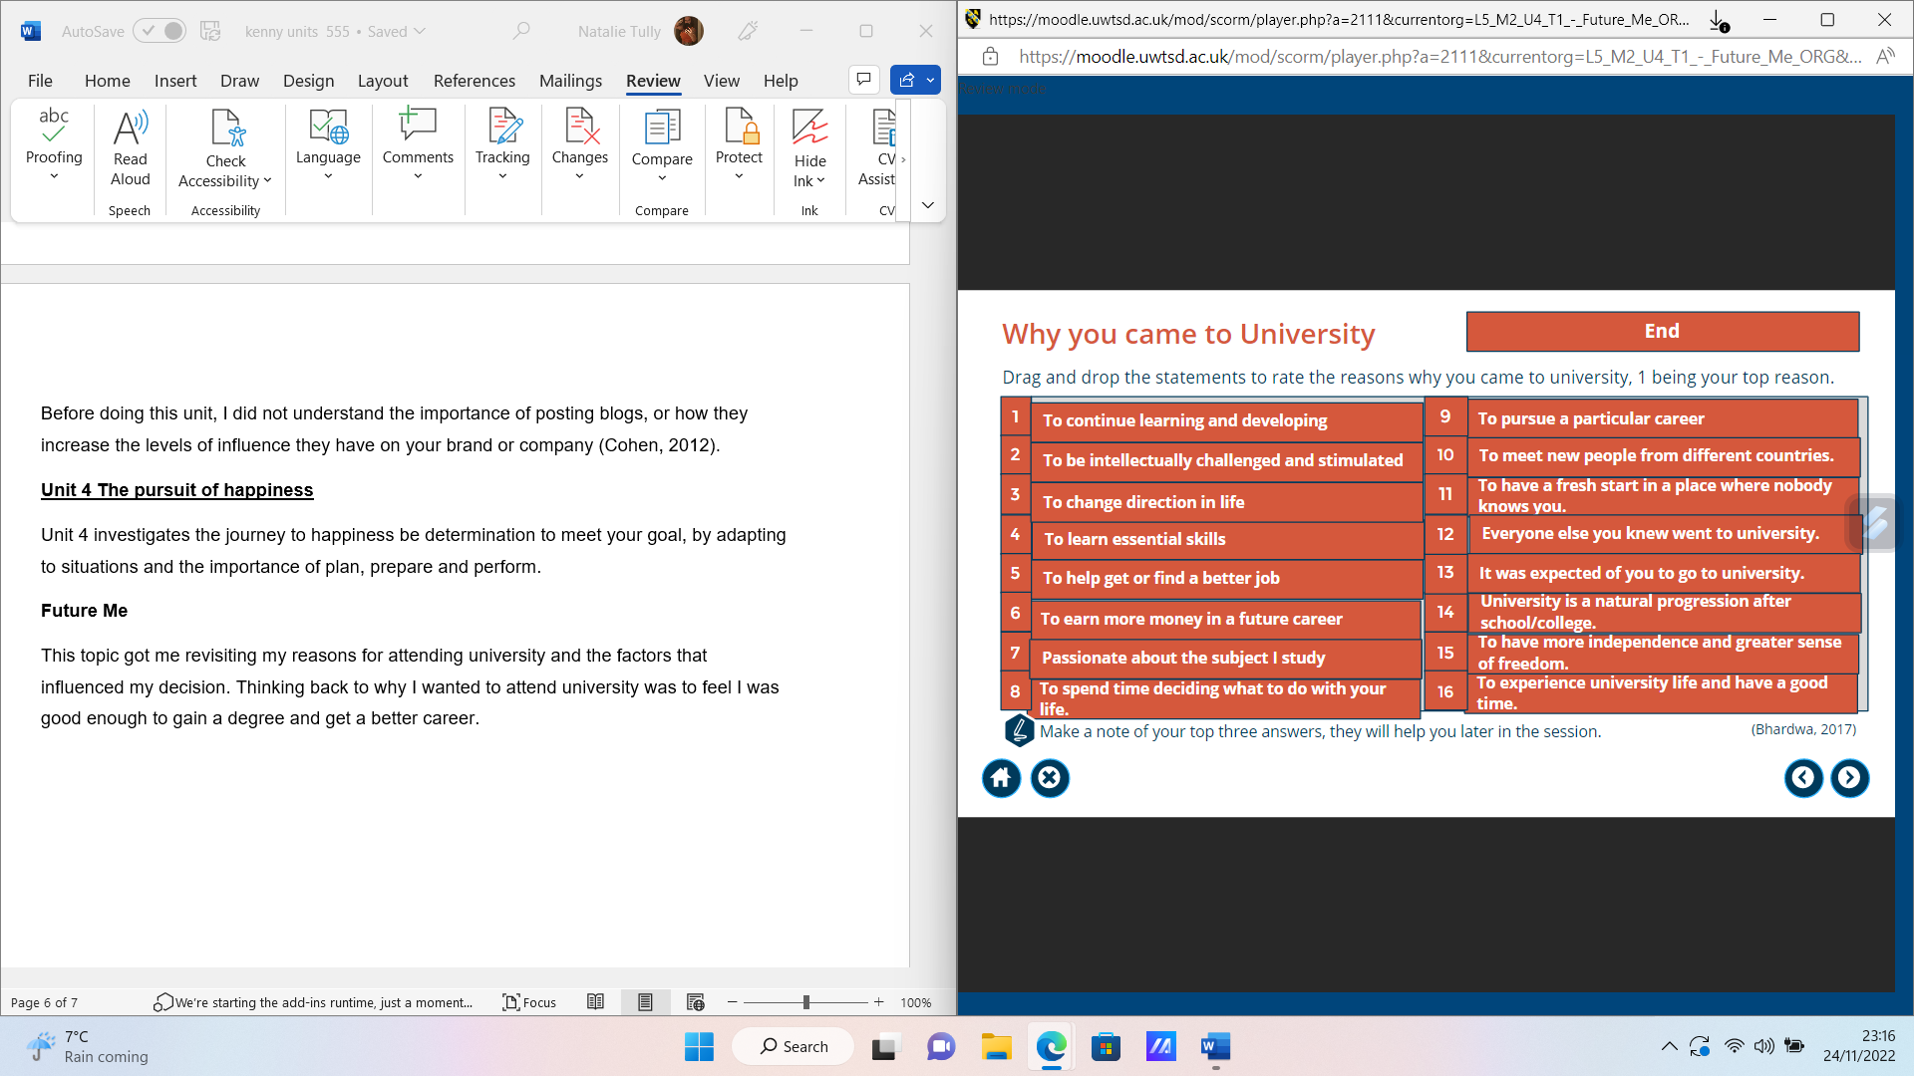
Section on limiting beliefs helped me have a better understanding, on how I can at times doubt myself (I can’t) and I know can have a negative impact on my progress moving forward to reach my goals. Evaluating my beliefs and recognising that my mind set can change my outlook in a positive and negative way. According to research on neuroplasticity, our ability to concentrate strengthens specific brain regions. We can even make the brain's positive neural connections stronger to rely less on its negative well-used pathways (The Berkeley Well-Being Institute, n.d.). Which at times I feel like giving up but deep down I know I have come to far to fail, these feelings can overwhelm me with emotions. I try and recondition my mindset which can help me develop more to reach my goals and future ambitions. After watching the video online material on growth mindset vs fixed mindset (www.youtube.com, n.d.). I have realised that my mindset is growth not fixed as I welcome feedback from my lectures on how I need to improve as I like learning, but I also can still get anxious as I want to aim high. A powerful tool is having a positive mindset to believe in yourself to achieve high with no limitations holding you back this is something I feel I need to improve on.

Conclusion
After reviewing the units and evaluating my personal experiences, based on all the knowledge I have learnt from the units, it has given me the power to move forward in my career options and develop myself to strengthen my understandings of different situations to get a clearer picture of what is needed and expected from me. Overcoming my limits of beliefs, being opened to face more challenges to border my knowledge.

Personal Development Plan

 | SKILL | CURRENT  ABILTY | TARGET ABILTY | DEVELOPMENT  OPPORTUNITY | CRITERIA TO JUGE SUCCESS | TIME  FRAME | EVIDENCE
1ST  PRIORITY | Written skills | Due to me being dyslexia, I have difficult with spelling and my grammar | To develop my grammar and spelling in a better format | With support from technology and my lectures. Using read aloud app and grammar apps to help spot with my mistakes. Also, to slow down and take my time. Sen my draft of to get feedback with 1 to 1 support | Achieve a positive attitude and mindset and academic writing skills program | By the end of level 6 as it gives me time to continue to learn and develop. | marks on my assignments and feedback from my lecture’s
2nd PRIORITY | Confidence and self-doubt | My confidence levels in academic setting are very low | To more confidence with myself to achieve my goals. Not scare to aim high or scared to keep trying. | Build on my self-confidence, the more I learn the better my confidence gets. | Asking for feedback, to build my confidence on myself doubt | Ongoing process that will get better with practices and time | Less anxious and will show in my work with having less mistake.
3rd PRIORITY | Problem solving | Very weak in this area | To be able to consistent within this area of my work | Be able to deal with stressful situations, to manage and solve problem to be able deal with more challenges | To manage my emotions and stay focus with the task to be able to problem solve | This is also ongoing | Staying focus and shows in my performance of delivering my assisgnments

References

Anon, (2016). Understanding the 4-Drive Model Theory on Employee Motivation - Bert Martinez. [online] Available at: https://bertmartinez.com/understanding-the-4-drive-model-theory-on-employee-motivation/ (Accessed 24 Nov. 2022).

Cohen, H. (2012). 10 Ways to Use Your Blog to Build Influence. [online] Heidi Cohen. Available at: https://heidicohen.com/use-your-blog-to-build-influence/ (Accessed 24 Nov. 2022).

www.manobyte.com. (n.d.). The 5 C’s of Social Media. [online] Available at: https://www.manobyte.com/growth-strategy/the-5-cs-of-social-media/?wvideo=6sid8arpke
(Accessed 24 Nov. 2022).

‌ www.youtube.com. (n.d.). (2/2) Daniel Pink on the surprising science of motivation - TED Talk. [online] Available at: https://youtu.be/r_5kz2jNiJE (Accessed 25 Nov. 2022).

‌Ventegodt, S., Andersen, N., Kandel, I. and Ma (n.d.). An ethical analysis of contemporary use of coercive persuasion (‘brainwashing’, ‘mind control’) in psychiatry. Journal of Alternative Medicine Research, [online] 1(2), pp.177–188. Available at: https://livskvalitet.org/pdf/75_239_JAMR-2009_Volume_1_Issue_2_FP_Version.pdf (Accessed 24 Nov. 2022).

‌
‌ The Berkeley Well-Being Institute. (n.d.). ​Positive Affirmations: Definition, Examples, and Exercises. [online] Available at: https://www.berkeleywellbeing.com/positive-affirmations.html (Accessed 25 Nov. 2022)

‌ www.youtube.com. (n.d.). Growth Mindset vs. Fixed Mindset. [online] Available at: https://www.youtube.com/watch?v=KUWn_TJTrnU&t=13s (Accessed 25 Nov. 2022).

‌

