LEARNING IN THE DIGITAL ERA

Table of Contents
E-Portfolio 3
Task 1: Written Summary 4
Task 2: Mind Map and Academic poster 5
Task 3: Automatic Referencing Tool 8
Task 4: e-Portfolio creation and review 9
Task 5: Report ……………………………………………………………………………………………………………………………12

E-Portfolio
https://sites.google.com/d/1LS0r21hRMvMEpaYyws9e9uNaxDWBUlg3/p/1Goj_WfxEpRjUM0O7Vr_C8Ev3P1sQz65z/edit\
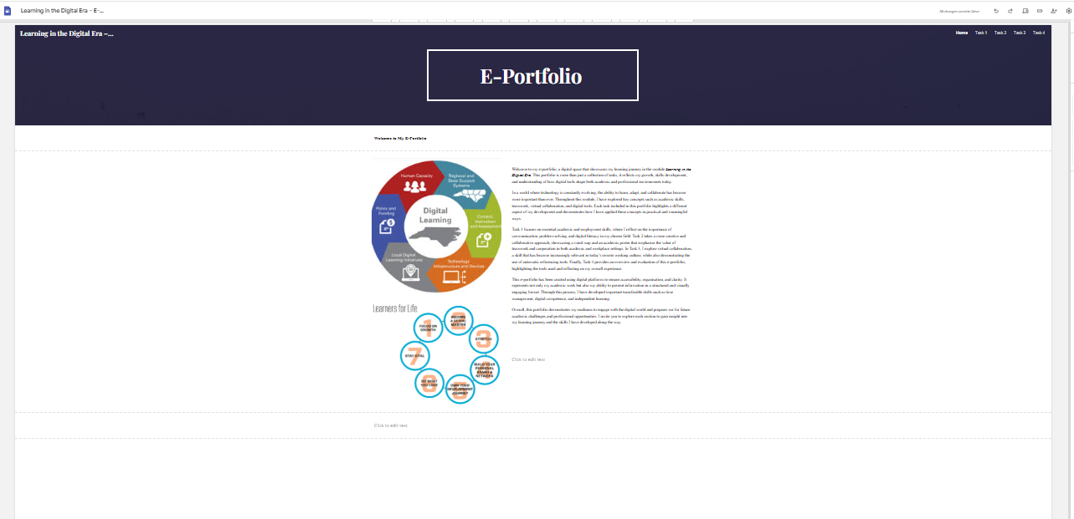

Task 1: Written Summary
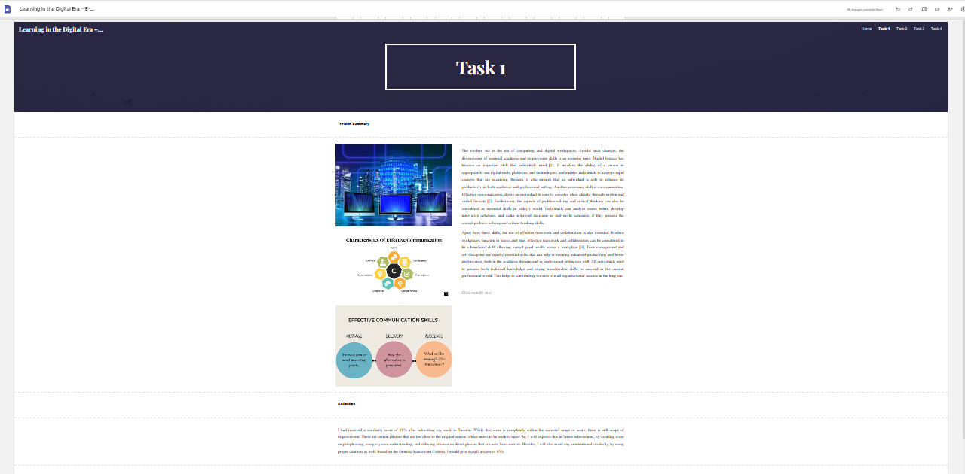

Task 2: Mind Map and Academic poster
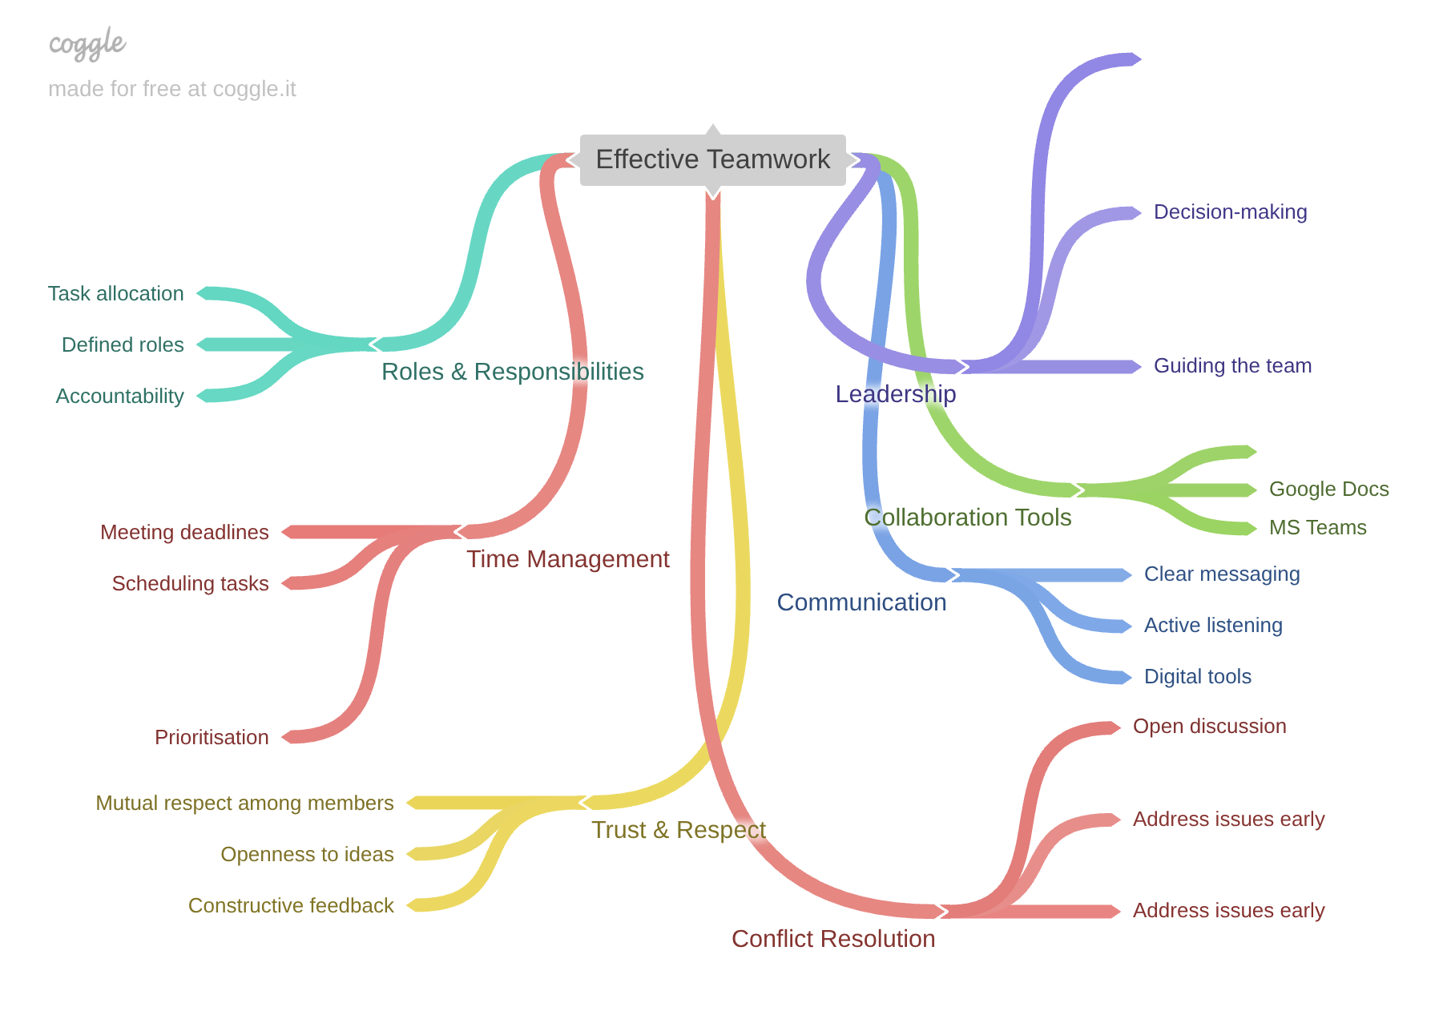
https://coggle.it/diagram/acDq1VGg8yrA7jAQ/t/-/E6J-wZilGdJSG4IAU-OjRyqFC9Fz7MH1Gf29qJDvJEY
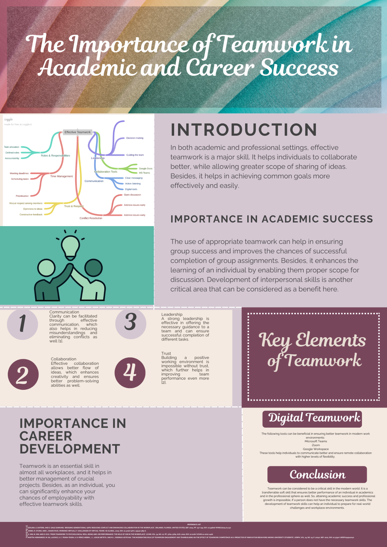

Task 3: Automatic Referencing Tool
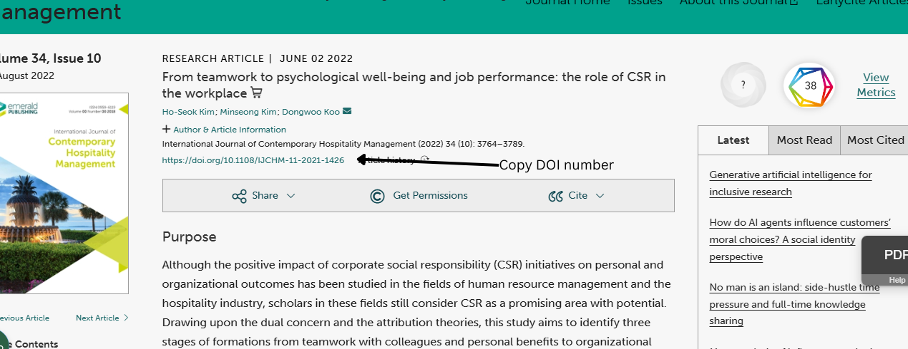
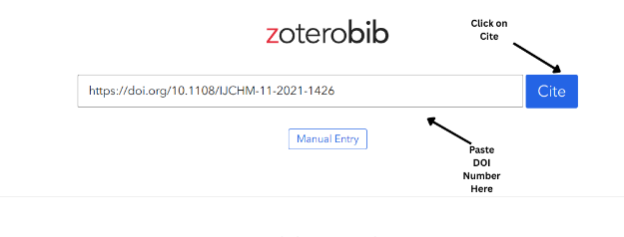
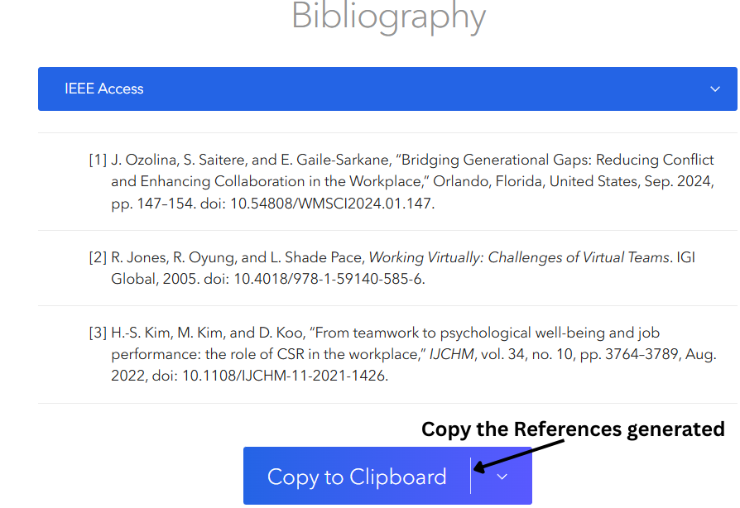

Task 4: e-Portfolio creation and review
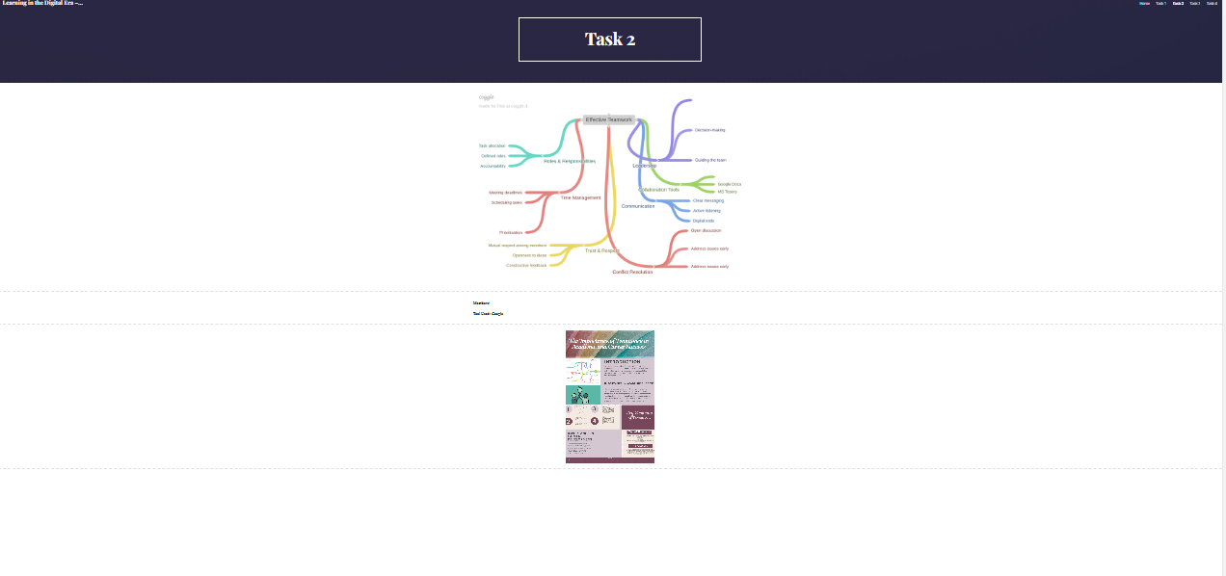
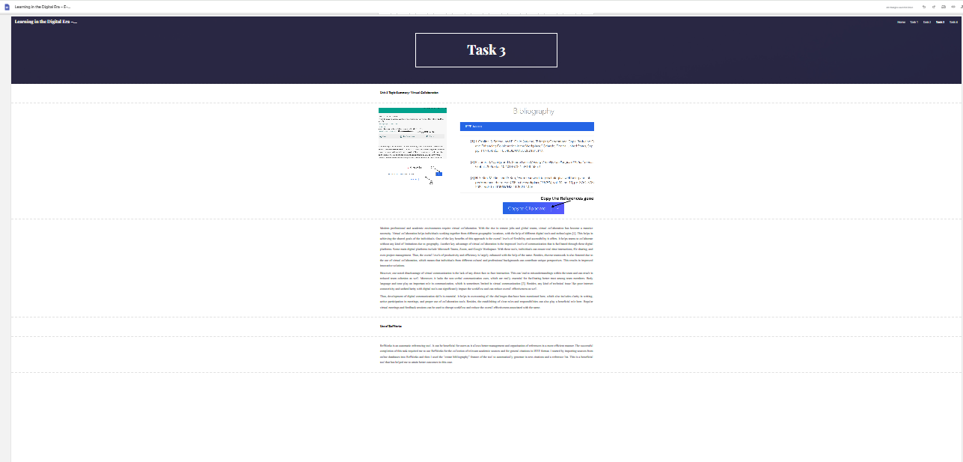
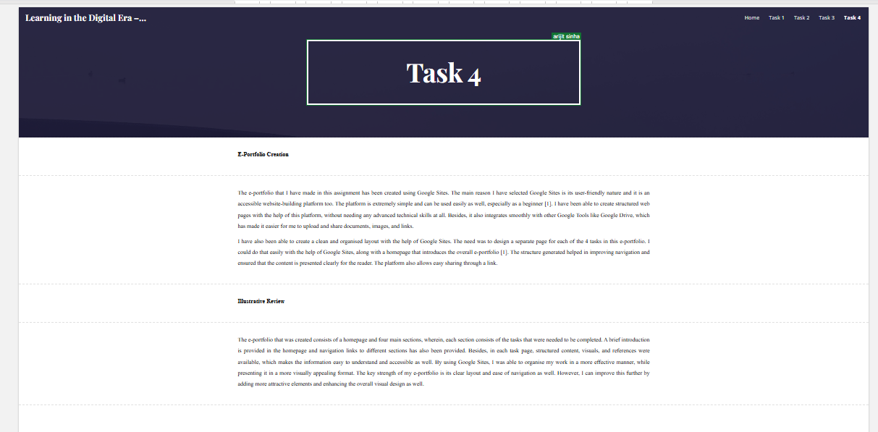

LEARNING IN THE DIGITAL ERA

Task 1: Academic and Employment Skills
Written Summary
The modern era is the era of computing and digital workspaces. Amidst such changes, the development of essential academic and employment skills is an essential need. Digital literacy has become an important skill that individuals need [1]. It involves the ability of a person to appropriately use digital tools, platforms, and technologies, and enables individuals to adapt to rapid changes that are occurring. Besides, it also ensures that an individual is able to enhance its productivity in both academic and professional setting. Another necessary skill is communication. Effective communication allows an individual to convey complex ideas clearly, through written and verbal formats [2]. Furthermore, the aspects of problem-solving and critical thinking can also be considered as essential skills in today’s world. Individuals can analyse issues better, develop innovative solutions, and make informed decisions in real-world scenarios, if they possess the correct problem-solving and critical thinking skills.
Apart from these skills, the use of effective teamwork and collaboration is also essential. Modern workplaces function in teams and thus, effective teamwork and collaboration can be considered to be a beneficial skill, allowing overall good results across a workplace [3]. Time management and self-discipline are equally essential skills that can help in ensuring enhanced productivity and better performance, both in the academic domain and in professional settings as well. All individuals need to possess both technical knowledge and strong transferrable skills to succeed in the current professional world. This helps in contributing towards overall organisational success in the long run.
Reflection
I had received a similarity score of 18% after submitting my work to Turnitin. While this score is completely within the accepted range or score, there is still scope of improvement. There are certain phrases that are too close to the original source, which needs to be worked upon. So, I will improve this in future submissions, by focusing more on paraphrasing, using my own understanding, and reducing reliance on direct phrases that are used from sources. Besides, I will also avoid any unintentional similarity, by using proper citations as well. Based on the Generic Assessment Criteria, I would give myself a score of 65%.
Task 2: Collaborative Teamwork and Academic Poster
Academic Poster Content
Poster Title: The Importance of Teamwork in Academic and Career Success
Introduction
In both academic and professional settings, effective teamwork is a major skill. It helps individuals to collaborate better, while allowing greater scope of sharing of ideas. Besides, it helps in achieving common goals more effectively and easily.
Key Elements of Teamwork
Communication
Clarity can be facilitated through effective communication, which also helps in reducing misunderstandings and eliminating conflicts as well [1].
Collaboration
Effective collaboration allows better flow of ideas, which enhances creativity and ensures better problem-solving abilities as well.
Leadership
A strong leadership is effective in offering the necessary guidance to a team and can ensure successful completion of different tasks.
Trust
Building a positive working environment is impossible without trust, which further helps in improving team performance even more [2].
Importance in Academic Success
The use of appropriate teamwork can help in ensuring group success and improves the chances of successful completion of group assignments. Besides, it enhances the learning of an individual by enabling them proper scope for discussion. Development of interpersonal skills is another critical area that can be considered as a benefit here.
Importance in Career Development
Teamwork is an essential skill in almost all workplaces, and it helps in better management of crucial projects. Besides, as an individual, you can significantly enhance your chances of employability with effective teamwork skills.
Digital Teamwork
The following tools can be beneficial in ensuring better teamwork in modern work environments:
- Microsoft Teams
- Zoom
- Google Workspace
These tools help individuals to communicate better and ensure remote collaboration with higher levels of flexibility.
Conclusion
Teamwork can be considered to be a critical skill in the modern world. It is a transferrable soft skill that ensures better performance of an individual in academics and in the professional sphere as well. So, attaining academic success and professional growth is impossible, if a person does not have the necessary teamwork skills. The development of teamwork skills can help an individual to prepare for real-world challenges and workplace environments.
Task 3: Automatic Referencing Tool
Unit 3 Topic Summary: Virtual Collaboration
Modern professional and academic environments require virtual collaboration. With the rise in remote jobs and global teams, virtual collaboration has become a massive necessity. Virtual collaboration helps individuals working together from different geographic locations, with the help of different digital tools and technologies [1]. This helps in achieving the shared goals of the individuals. One of the key benefits of this approach is the overall levels of flexibility and accessibility it offers. It helps teams to collaborate without any kind of limitations due to geography. Another key advantage of virtual collaboration is the improved levels of communication that is facilitated through these digital platforms. Some main digital platforms include Microsoft Teams, Zoom, and Google Workspace. With these tools, individuals can ensure real-time interactions, file sharing, and even project management. Thus, the overall levels of productivity and efficiency is largely enhanced with the help of the same. Besides, diverse teamwork is also fostered due to the use of virtual collaboration, which means that individuals from different cultural and professional backgrounds can contribute unique perspectives. This results in improved innovative solutions.
However, one noted disadvantage of virtual communication is the lack of any direct face-to-face interaction. This can lead to misunderstandings within the team and can result in reduced team cohesion as well. Moreover, it lacks the non-verbal communication cues, which are really essential for facilitating better trust among team members. Body language and tone play an important role in communication, which is sometimes limited in virtual communication [2]. Besides, any kind of technical issue like poor internet connectivity and unfamiliarity with digital tools can significantly impact the workflow and can reduce overall effectiveness as well.
Thus, development of digital communication skills is essential. It helps in overcoming all the challenges that have been mentioned here, which also includes clarity in writing, active participation in meetings, and proper use of collaboration tools. Besides, the establishing of clear roles and responsibilities can also play a beneficial role here. Regular virtual meetings and feedback sessions can be used to disrupt workflow and reduce the overall effectiveness associated with the same.
Use of Cite This for Me
Zoterobib is an automatic referencing tool. It can be beneficial for users as it allows better management and organisation of references in a more efficient manner. The successful completion of this task required me to use Zoterobib for the collection of relevant academic sources and for general citations in IEEE format. I started by importing sources from online databases into Zoterobib and then I used the “create bibliography” feature of the tool to automatically generate in-text citations and a reference list. This is a beneficial tool that has helped me to attain better outcomes in this case.
Task 4: E-Portfolio Creation and Review
E-Portfolio Creation
The e-portfolio that I have made in this assignment has been created using Google Sites. The main reason I have selected Google Sites is its user-friendly nature and it is an accessible website-building platform too. The platform is extremely simple and can be used easily as well, especially as a beginner [1]. I have been able to create structured web pages with the help of this platform, without needing any advanced technical skills at all. Besides, it also integrates smoothly with other Google Tools like Google Drive, which has made it easier for me to upload and share documents, images, and links.
I have also been able to create a clean and organised layout with the help of Google Sites. The need was to design a separate page for each of the 4 tasks in this e-portfolio. I could do that easily with the help of Google Sites, along with a homepage that introduces the overall e-portfolio [1]. The structure generated helped in improving navigation and ensured that the content is presented clearly for the reader. The platform also allows easy sharing through a link.
Illustrative Review
The e-portfolio that was created consists of a homepage and four main sections, wherein, each section consists of the tasks that were needed to be completed. A brief introduction is provided in the homepage and navigation links to different sections has also been provided. Besides, in each task page, structured content, visuals, and references were available, which makes the information easy to understand and accessible as well. By using Google Sites, I was able to organise my work in a more effective manner, while presenting it in a more visually appealing format. The key strength of my e-portfolio is its clear layout and ease of navigation as well. However, I can improve this further by adding more attractive elements and enhancing the overall visual design as well.

Reference List
Task 1
[1] A. Smith, Digital Skills for the Modern Workplace, London: TechPress, 2023.
[2] J. Brown, “Critical Thinking in Computing Education,” Journal of Digital Learning, vol. 12, no. 2, pp. 45–60, 2024.
[3] R. Kumar, “Teamwork and Collaboration in IT Projects,” International Journal of IT Management, vol. 9, no. 1, pp. 20–35, 2022.
Task 2
[1] M. Johnson, “The Role of Teamwork in the Workplace,” Journal of Business Studies, vol. 15, no. 3, pp. 50–65, 2023.
[2] L. Smith, Professional Skills for Students, Oxford: Oxford University Press, 2022.
Task 3
[1] J. Ozolina, S. Saitere, and E. Gaile-Sarkane, ‘Bridging Generational Gaps: Reducing Conflict and Enhancing Collaboration in the Workplace’, Orlando, Florida, United States, Sep. 2024, pp. 147–154. doi: 10.54808/WMSCI2024.01.147.
[2] R. Jones, R. Oyung, and L. Shade Pace, Working Virtually: Challenges of Virtual Teams. IGI Global, 2005. doi: 10.4018/978-1-59140-585-6.
[3] H.-S. Kim, M. Kim, and D. Koo, ‘From teamwork to psychological well-being and job performance: the role of CSR in the workplace’, IJCHM, vol. 34, no. 10, pp. 3764–3789, Aug. 2022, doi: 10.1108/IJCHM-11-2021-1426.
[4] P. Martín-Hernández, M. Gil-Lacruz, A. C. Tesán-Tesán, A. R. Pérez-Nebra, J. L. Azkue-Beteta, and M. L. Rodrigo-Estevan, ‘The Moderating Role of Teamwork Engagement and Teambuilding on the Effect of Teamwork Competence as a Predictor of Innovation Behaviors among University Students’, IJERPH, vol. 19, no. 19, p. 12047, Sep. 2022, doi: 10.3390/ijerph191912047.
Task 4
[1] Google, “Google Sites Help,” 2024. [Online]. Available: https://support.google.com/sites

