

A Study of Machine Learning based on
Physical Load Classification

by
Yuxuan Zhao

Supervisor: Tim Bashford

Project submitted as part of the requirements for the award of MSC-DAI Data and Artificial Intelligence

September 2022

Abstract
A whole system of gait data acquisition based on IMU sensors was completed in this study and an in-depth study was carried out based on the data collected by this system. The IMU data of human lower limb movements were experimentally verified to be usable for physical load recognition and classification work. As a result, the processed data used for machine learning is divided into three main categories: no-load, light-load and heavy-load. The traditional LSTM was able to achieve 71.1% accuracy for the multi-classification problem, and the Bi-LSTM was able to achieve a 74.5% correct classification rate. The excellent performance of multiple Bi-LSTMs for binary classification problems was exploited by changing the discriminative approach of the network, and a correct recognition rate of 94.1% was achieved for 3 classifications using 3 binary Bi-LSTM networks. This method can be used to provide a reference of the drive torque size and drive mode for the drive assist unit of an exoskeleton robot or a sports rehabilitation machine to achieve automatic determination of the torque size of the assist. It can reduce the energy consumption of the wearer during walking, reduce the fatigue during weight-bearing, increase the power-assist efficiency of the system and improve the performance of the system, which is of good reference value.

CONTENTS
1. Introduction 1
2. Literature Review 3
2.1 Research based on gait analysis 3
2.2 Research based on human weight-bearing behavior 4
2.3 Gait recognition method based on video image analysis 5
2.4 Gait recognition method based on wearable sensors 10
2.4.1 Bio-signal-based human motion intention prediction 10
2.4.2 Prediction of human motion intention based on physical signals 11
3. Research And Development Methodology 14
3.1 Data acquisition system 14
3.2 Experimental design 17
3.3 Data pre-processing 18
3.3.1 Interpolation 21
3.3.2 Data segmentation 22
3.3.3 Resampling 23
3.4 Machine learning methods 24
3.4.1 Traditional LSTM model 24
3.4.2 BiLSTM (Bidirectional LSTM) 26
4. Experiment 28
4.1 Data Acquisition 28
4.2 Data processing 29
4.3 Segmentation and resampling 30
4.4 Network training 31
5. Results and Evaluation 37
6. Conclusion 38
7. Reflection 39
References 40
8. APPENDIX 44

Introduction
With the rapid development of science and technology, people have become more conscious of the quality of life and more advanced technology has made many things possible that were previously unattainable. Getting rid of heavy physical labor has always been a wonderful vision for mankind, and for those who have difficulty walking due to injury, illness or disability, the desire to get up and walk again is even stronger. Today, despite the rapid development of industrialization and automation worldwide and the replacement of much of the heavy physical work by machines, there are still many things that can only be done by people with heavy physical labor. For example, in some heavy industries, in some agricultural production, in handling where machinery is not readily available, in earthquake relief, in fieldwork, in the military and in many other areas. People engaged in long-term heavy physical work are often physically overloaded and are prone to suffer from various bone and joint diseases, which can lead to their suffering from illness or even loss of working capacity, which is a great harm to them personally and to their families. On the other hand, the problem of ageing is becoming increasingly prominent worldwide, and the accompanying problem is the increase in degenerative diseases brought about by ageing, which also means that more elderly people will have problems with walking. The lack of lower limb mobility causes great inconvenience to the lives of elderly people and causes them great psychological stress [1]. In order to solve these problems, intelligent assisted lower limb exoskeleton as a class of mechanical equipment combined with artificial intelligence has become a hot research topic at home and abroad. These intelligent mechanical devices can combine the powerful power of machines with human intelligence, which can improve the weight-bearing capacity of the wearer or help some people with walking impairment to walk normally [2].
In order for intelligent devices such as assisted lower limb exoskeleton robots to provide assistance to users in a more rational manner, it is first necessary for them to accurately recognize the movements that the human body wishes to make. This is often referred to as human motion intent recognition, which involves the recognition of motion information such as movement patterns, spatial position, joint angles and angular acceleration. After the movement has been recognized, an electronically controlled force is determined, which is used to control the amount of force provided by the assist mechanism to assist the person in the movement. If too much force is applied, it is difficult for the user to control, and if not enough force is applied, the user's own fatigue accumulates too quickly to meet the expected demands.
This paper focuses on the control strategy of weight-assisted exoskeletons. The most significant features of the lower limb-assisted exoskeleton are its ease of operation, wearability and intelligence, as well as the integration of mechanical, bionic, control, sensing and information processing technologies. As the core of the lower limb-assisted exoskeleton, the control system is equivalent to the heart of the exoskeleton system and determines to a certain extent the excellent performance of the exoskeleton. The control strategy of the main body of the weight-bearing exoskeleton is to judge the human intention according to the human-machine sensing information, so that the exoskeleton provides the corresponding auxiliary torque in each gait phase of human walking. However, at this stage, it is difficult for various control strategies to meet the needs of different weight-bearing scenarios, and the user needs to manually adjust the torque size of the exoskeleton when facing different weight-bearing, which makes the system less adaptive and less efficient in assisting. Based on this background and the problems of the system, and according to the needs of the exoskeleton control strategy, this paper designs a machine learning based human lower limb motion gait detection system that collects the motion parameters of the human gait and classifies the magnitude of the weight-bearing load on the human body. An algorithm that can automatically identify the weight-bearing size is designed and implemented to provide reference to the drive torque size and drive mode for the drive assist unit of an exoskeleton robot or sports rehabilitation machine, enabling the automatic determination of the torque size of the assist. It can reduce the energy consumption of the wearer during walking, reduce fatigue during weight-bearing, increase the efficiency of the system's assistance and improve system performance.

Literature Review
The primary objective of this study is to develop a new assessment model and strategy to analyse the consistency and symmetry of gait, so as to reveal the differences in the kinematic patterns of the human lower limbs during weight-bearing according to the subtle differences in human lower limb movements under different weight-bearing conditions.

2.1 Research based on gait analysis
Currently, techniques related to gait analysis mainly include the following.
(1) temporal-spatial parameter analysis: usually measuring gait frequency, gait speed, gait length, support period and swing period, etc., is the most intuitive analysis method [3].
(2) kinematic parameter analysis: usually based on infrared devices or multi-sensor devices for gait data acquisition, so as to calculate landing angle, departure angle, torso tilt angle, and other parameters for analysis.
(3) Kinetic parameter analysis: usually the plantar pressure, ground reaction force and joint moment parameters are measured during the movement.
(4) Dynamic electromyography analysis: Dynamic electromyography can show the electrical signals accompanying muscle contraction, so as to assess the behavioral function of human muscles.
Most of the related studies based on gait analysis have focused on the analysis of temporal-spatial parameters and kinetic parameters, and the data acquisition method is mainly through plantar pressure sensors. M. Pistacchi [4], 2017 analyzed gait parameters of Parkinson's patients and healthy individuals using temporal space parameters, kinematic parameters, using plantar pressure sensors, and infrared devices to investigate the possibility of abnormal gait in early-onset Parkinson's patients. a. Hill [5], 2019 used temporal space parameters, kinetic parameters , using infrared devices to explore the effects of arm swing and gait symmetry on gait stability. Minhua Xu [6], 2017 Analyzing temporal-spatial parameters and exploring gait symmetry and regularity during barefoot walking using triaxial accelerometers. d. Gouwanda [7], 2011 Using gyroscopes to collect temporal-spatial parameters to investigate the effect of lower limb injuries on gait asymmetry. l. Wang [8], 2018 Temporal-spatial parameters Wearable sensors Estimating spatial asymmetry of gait using step length. Spatial asymmetry of gait. E.K. Allseits [9], 2019 Exploring the effects of sampling rate and filter design on angular velocity waveforms using time-space parameters, kinetic parameters, and wearable sensors.
The analysis of temporal-spatial, kinematic or kinetic parameters using methods such as ANOVA, principal component analysis and area of deviation analysis has the disadvantage of low data utilization and low performance in terms of accuracy. The reason for this is that the analysis of data through these methods is limited and difficult to make adaptations for differences between subjects. For example, when comparing the amplitude of leg limb movements, the determination of the range of motion for these methods relies on the maximum and minimum values within the gait data cycle, and the inability to dynamically grasp the oscillation amplitude interval based on the trend of the data can easily affect the squared error and make large differences in the results. In the current research process, the results of some studies remain controversial and the generalizability of the methods cannot be judged due to the lack of a unified data set, the majority of data collected by different researchers for their own studies, and the variety of sub-collection methods and types of data [10-12]. Researchers need to develop new models of gait analysis in greater depth to achieve better results in the field of gait analysis.

2.2 Research based on human weight-bearing behavior
The current research area based on human weight-bearing behavior contains the following main areas: rehabilitation in clinical medicine, assisted training in kinesiology, and sports biomechanics analysis. The literature on clinical medicine is more extensive and usually involves research on disorders such as lower extremity injuries and gait abnormalities, while there is relatively little literature on kinesiology and sports biomechanics. In kinesiology research, it usually involves the analysis of lower extremity muscle strength, lower extremity balance and fatigue level of athletes during different weight-bearing training; in sports biomechanics, it involves a wide range of aspects, including differences in gait in different experimental scenarios with various weight-bearing modalities such as double-shoulder, single-shoulder, diagonal straddle and hand-held, and sometimes it also involves changes in factors such as different weight-bearing levels and different age groups.
In clinical medicine, H. Li [13], 2021 To investigate whether patients with postoperative femoral neck fractures can go down early with weight bearing , D. Pfeufer [14], 2020 To analyze the differences in gait of patients with pelvic fragility fractures during lower extremity weight bearing . Li Chen[15], 2021 To investigate the effect of early weight bearing on the angle of repose after Achilles tendon rupture, etc. Guo Erfei[16], 2021 To investigate the effect of postoperative weight bearing exercises on the elderly after internal fixation of femoral neck fractures.
In kinesiology, Ren Manying [17], 2019 studied the differences in the effects of deep squatting in front of the neck and back squatting in high and low bar position on the balance and muscle strength of the lower limbs Liu Medi [18], 2019 studied the effects of weight training with different levels of stability on the fast strength and agility qualities of the lower limbs. Wang Zengang [19], 2017 To study the effect of weight-bearing running on both sides of the lower limbs on human balance.
In sports biomechanics: Tian Shisi [20], 2020 studied the gait characteristics of forward and backward walking under weight-bearing condition. hotfiel [21], 2017 studied the effect of different weight-bearing undershirts on the peak plantar pressure. Hyung [22], 2016 Studied the effect of different weight-bearing levels and backpack styles on the pelvis. Mu Chengcheng [23], 2020 Analyzed the plantar pressure data with different weight-bearing degrees and weight-bearing styles. Zhao Gonghe [24], 2020 Studied the kinematic characteristics of the trunk and pelvis of women while walking under different weight-bearing styles and weight-bearing weights. Studies on weight-bearing still focus on simple assessment of some discrete parameters, and the existing studies still lack the analysis of the variability of different parts of the lower limb segments and the comparison of complete gait data from both sides, so further exploration of the differences between weight-bearing gait is needed.

2.3 Gait recognition method based on video image analysis
Gait recognition methods can be divided into three categories: 2D gait recognition, 3D gait recognition, and a combination of 2D and 3D. 2D gait recognition is the extraction of low-level information through contours in monocular video taken by a single camera for analysis and recognition; 3D gait recognition is tracking based on a 3D model in multiple videos taken by two or more cameras, recovering the underlying 3D body structure and extracting gait dynamic features for analysis or recognition.

Single camera 2D gait recognition
2D image feature/appearance based gait recognition method
This method does not require an a priori model, but simply defines implicitly the features that should be observed by statistically analyzing the spatio-temporal patterns generated by the moving human body in the image sequence and uses them for feature extraction and analysis of gait, and is commonly used for low-resolution image sequences.
a) 2D low resolution (feature/appearance based approach): spatio-temporal templates Cuntoor, Kale and Chellappa studied dynamic features in front and side views [Cuntoor 2003], such as arm/leg sway, upper body sway and static features such as height, and combined these features for recognition. This has the advantage of improving recognition. Collins, Gross and Shi propose a viewpoint-based recognition technique based on template matching of human contours [Collins 2002b], matching two-dimensional contours of key frames extracted from the gait cycle. Collins, Liu and Tsin use the projected width of the gait motion contours in the horizontal and vertical directions as a Frieze
model [Collins 2002a]. Phillips, Sarkar and Robledo et al. explored the challenging problem of long-range gait recognition and proposed the baseline algorithm [Phillips 2002a, Phillips 2002b]. Wang, Ning, Hu and Tan proposed an appearance feature-based approach [Wang 2002a], where contour changes in pose over time are described in two dimensions corresponding to a sequential complex representation; the main contour model obtained by Procrustes' shape analysis method is used as a feature, combined with standard pattern classification techniques for individual gait recognition. Han Hongzhe, Wang Zhiliang et al. performed horizontal and vertical projections of human contours [Han Hongzhe 2003], combined the projection vectors together as feature vectors, applied principal component analysis (PCA) to compress the features, and finally used support vector machine (SVM) to perform recognition. SVM was used for recognition. Wang and Tan et al [Wang 2003c] proposed an efficient, model-free algorithm for 2D gait recognition based on the principal component analysis approach. For each gait sequence, the spatial contour of the person is extracted using a modified background reduction technique; the edges of the contour are then expanded counterclockwise into a series of distance templates relative to the center of mass; these template features are trained by using principal element statistical analysis methods to derive a trajectory representation of the changing pattern of gait shape in the feature space; the recognition is attempted with spatio-temporal correlation matching methods and normalized Euclidean distance-based nearest neighbor rule. At the same time, the fusion of physiological features such as body shape of the corresponding individual was introduced for the necessary gait classification checks. Bobick and Johnson [Bobick 2001, Johnson 2001] extract static body and stride parameters measured during walking, such as d1,d2,d3,d4 in Figure 2.2, as the basis for gait recognition, which can only be valid when people are doing a specific action such as walking, hence the term 'activity specific'. Kale, Cuntoor and Rajagopala et al. used an appearance and point-of-view based approach [Kale 2002a, Kale 2003, Kale 2004], using the binarised outer contour width of the walking human body as the basic feature, matched using dynamic time warping (DTW) to match, using non-linear time normalization to deal with variations in walking speed. BenAbdelkader and Cutler et al. proposed self-similarity plots for gait images [BenAbdelkader 2001, BenAbdelkader 2002a] features. This method is more robust to tracking and segmentation errors as well as to changes in clothing and background. Hayfron-Acquah, Nixon and Carter used the Generalised Symmetry Operator [Hayfron-Acquah 2001] to analyse the symmetry of human motion. It is more robust to noise and frame loss, and can handle occlusion, but not viewpoint changes.
b) Moment-based methods
In image sequences, as there is often translation and scaling of moving bodies, many recognition efforts must first eliminate these variations. Moments are an effective tool for dealing with translational, rotational and scaling variations. Classical Hu moments were used in two-dimensional image processing in the early 1960s [Hu 1962]. In recent years, moments have also been used in gait analysis and recognition. Little and Boyd used moment-based features to characterise optical flow [Little 1998] and to identify gait. Lee and Grimson calculate moment features for each part of the human model [Lee 2002a]: e.g. centre of gravity, main axis, etc. Liu, Collins and Tsin use first- and second-order moments of binary images to determine roughly aligned affine transformations between contours [Liu 2002].
Shutler and Nixon describe motion through Zernike velocity moments [Shutler 2001]. However, as the Hu moments and Zernike moments used are based on geometric moments, higher order moments are difficult to compute and have poor stability, so they are all described and analysed using only lower order moments, making it difficult to characterise the subtle features between signals. Two-dimensional low-resolution recognition is mostly an appearance-based approach, which does not require high video quality and has simple algorithms that are easy to implement. However, changes in viewpoint, shoes, lighting etc. must be taken into account.
Model-based methods
Model-based methods assume an a priori model and match 2D image sequences to the model, and are commonly used for high-resolution image sequences.
Niyogi and Adelson used a spatio-temporal slicing approach for human tracking [Niyogi 1994]. The spatio-temporal interweaving patterns generated by the trajectories of the human lower limbs are first observed, then the projection of head movements is located in the spatio-temporal domain, the trajectories of other joints are identified and finally a pedestrian profile is sketched using these joint trajectories. Using the outlined 2D contours, a more accurate gait analysis of a specific human body can be obtained. Cunado, Kale and Chellappa [Cunado 1995] matched the motion of the human thigh to an articulated pendulum motion model.
Yam, Nixon and Carter [1995] matched human thigh motion to a joint pendulum motion model. Yam, Nixon and Carter [Yam 2002] manually calibrated rotations of the thigh and calf measured in the vertical direction and extracted rotation angles as features for analysis in the work of Meyer, Denzler and Niemann [Meyer 1997], where jointed objects were extracted for identification in video sequences. A monotonic (monotony) operator that computes the displacement vector field initialises the human model and extracts the outer contour lines of the different body parts for tracking. The trajectories of the body parts represented by the 3D blocks are determined and the different gait anomalies are classified. To automatically localise the different body parts, a monotonic operator is used in the first two frames of the motion sequence with the aim of calculating the vector field displacements. The body movements are then tracked by contour line extraction of the different parts. The 3D shape and position of the body is extracted by estimating the shape and position of simple 3D blocks and matching the 2D contour lines extracted from the image with the projected contours of the 3D blocks projected onto the image. Lee and Grimson. used ellipses to match different body parts of the binarized contours of the moving body [Lee 2002a] and then extracted moment features of the ellipses, such as center of mass position, eccentricity etc. as features to be analyzed. Kale and Rajagopalan et al. [Kale 2004] select a set of samples (exemplars) for each individual and use these to generate a low-dimensional Frame to Exemplar Distance (FED) vector. the FED is used to train a continuous HMM, which is then recognized according to a specific HMM model. The FED is used to train a continuous HMM, which is then recognized according to a specific HMM model. This method is more robust to changes in speed. However, large changes in clothing can affect recognition performance.
Wang and Ning et al. represent the human body in a cone [Wang 2003a], which consists of 14 parts. The motion is represented as a 12-dimensional motion vector, and angular changes are obtained by tracking as a dynamic feature to recognize gait. Tabb and Davey et al [Tabb 2000] investigated the use of dynamic contour lines for gait analysis. The dynamic contour line model was used to detect human walking and to train a neural network for human motion analysis. Seven limb segments were used to model the human body (lower limbs were 6 segments, head, arms and body as one limb segment). Lower limb angles and velocities are measured and joint moments are calculated. The behavior of the model is given by a set of initial states and the history of moments, using LaGrange mechanics to study human gait [Onyshko 1980].
Stick figures are commonly used in skeletal models to study gait. A common method of experimentation can be implemented using Johansson's Moving Light Display (MLD) method. A point light source is attached to the joints of the body and the surrounding area is set to black. When the body is walking, running, cycling or push-ups, only the relevant motion array of the light source can be seen. Based on this, statistical analysis can be used to distinguish between types of movement, such as leg movements [Guo 1994a], or between genders [Kozlowski 1977].
A variation on the skeletal model is the cardboard model proposed by Ju, Black and Yaccob et al [Ju 1996], extending the work of Blakc and Yacoob [Black 1995]. The human body is represented by a set of connected flat slices. A parametric model of optical flow is used to handle the joint movements of the body. The body and its movements are represented based on the movement curves of the limbs obtained from the analysis, and the 3D position and pose of the body are estimated from the images. The field of video-based human dynamics has grown exponentially in the last decade as hardware has become cheaper and biometrics has grown in importance [Wang 2003d].
Two-dimensional high-resolution recognition is mostly a model-based approach, which requires high video resolution, is more complex to match and track, and is not invariant to viewpoint, and other conditions. The main drawbacks of 2D methods are their limitations on camera angles and the problem of occlusion. As most of the current work is done in 2D, and within the constraints, there is still much work that can be done in 2D recognition, such as moment-based recognition, paramedicine, etc. However, the ultimate solution to the viewpoint change and occlusion problem must rely on 3D, so 3D tracking is also used as the basis for extracting whole body movement joints as features and generating models to aid motion analysis, simulation, gait recognition, etc.
Compared to model-based methods, 2D methods do not require very high-quality contours and can obtain better recognition results based on temporal-spatial feature information of the gait, while their computational cost is lower and real-time computing is easily achieved. However, the two-dimensional method is more sensitive to the background of the video image and is more influenced by external factors, and the recognition performance of the method decreases significantly when there is occlusion and parallax in the scene.

2.4 Gait recognition method based on wearable sensors
Human motion intention prediction is the basis for realizing exoskeleton system control, and accurate and real-time recognition of human motion intention is the key to achieve perfect human-machine coordination and wearing comfort, which has been a hot spot in exoskeleton system research; the prerequisite for exoskeleton to realize human motion following is to obtain human motion intention, and human motion intention is usually predicted based on the human body itself or human-machine interaction information. The prediction of human motion intention can be divided into biosignal-based human motion intention prediction and physical signal-based human motion prediction according to the different ways of exoskeleton sensing system information acquisition.

2.4.1 Bio-signal-based human motion intention prediction
Bio-signal-based human motion intention prediction mainly refers to the acquisition of current human motion intention through direct acquisition of human EEG and EMG signals. The EEG signal can directly respond to the motion intention of human body, and the acquisition methods can be divided into invasive and non-invasive, among which the invasive EEG signal has the advantages of high signal-to-noise ratio and high purity, but there are risks associated with surgery and the problem of signal quality degradation over time, and the non-invasive EEG signal is safe to operate, and the head surface EEG waves can be acquired through the helmet and decoded to obtain effective signals, but there are problems such as poor anti-interference ability and limited signal bandwidth. Kim et al. proposed an invasive intracortical neural interface system (NIS) that enables a tetraplegic person to voluntarily move the computer cursor in any desired direction on a computer screen, hold the cursor still, and then click on the region of interest [; Hochberg et al. used an invasive neural interface system to control a robotic arm, and experimental results showed that Presacco et al. used a non-invasive brain-computer interface to obtain EEG signals and demonstrated that the kinematic parameters of the human lower extremity on a treadmill could be accurately obtained using only 12 electrode sites. Gancet et al. used non-invasive brain-machine interface technology to control the MindWalker exoskeleton in a virtual reality training environment to help paraplegics send brain control signals to use the exoskeleton.
EMG signals reflect the electrical signals of the superficial layers of human muscles, which are somewhat ahead of the external movements of the human body, and can be used to predict the intention of the human body effectively. The most mature exoskeleton utilizing EMG signal is HAL developed by Tsukuba University in Japan, which can use the surface EMG signal as input to estimate the force required for the next movement, so as to calculate the amount of force HAL needs to compensate the human body, thus realizing the exoskeleton assistance effect; the WPS exoskeleton system developed by Kanagawa University of Technology uses muscle hardness sensors to sense Morimoto et al. proposed a potential kinematic relationship between the human body and the exoskeleton, i.e., predicting joint angles and angular velocities from EMG data by a simple linear model, and used this result for XOR exoskeleton control; Fleischer et al. developed a biomechanically based Hill muscle model, simplified the model, and then input EMG data from six sampling points of the human thigh into the model to calculate knee joint moments for moment-proportional control of the TUPLEE exoskeleton to achieve a booster effect; La Scaleia et al. proposed a novel method to exploit the high involvement of shoulder muscles in lower limb movements and the natural coordination relationship between the arm and the leg, the electromyographic signals of the upper limb muscles can be correlated with the lower limb movement intention, which also provides a new idea for the study of electromyographic signals.

2.4.2 Prediction of human motion intention based on physical signals
The prediction of human motion intention based on physical signals mainly refers to estimating human motion intention by collecting signals from sensors installed at the human-computer interaction or the exoskeleton itself. The human-computer interaction is the contact part of human body and exoskeleton, such as the human foot, back, shoulder and leg, etc. The sensors installed at the human-computer interaction point acquire the force-level interaction information of human motion to estimate the human motion intention; the sensors of the exoskeleton itself are mainly used for real-time feedback of the motion state of the exoskeleton, which can indirectly reflect the human motion intention based on the state of the exoskeleton.
The BLEEX exoskeleton developed by Berkeley University can indirectly obtain the intention of human motion based on the exoskeleton's own sensors, and amplify the human motion trend through the method of sensitivity amplification, so that the exoskeleton does not interfere with human motion, i.e., the wearer only needs a small force to be detected by the exoskeleton to drive the exoskeleton to follow the human body; the HEXAR-C50 developed by Hanyang University The HEXAR-C50 developed by Hanyang University uses the human-machine interaction information of joints, soles and back, i.e., the control system is divided into swing and support phases through the plantar pressure information, and then the human-machine interaction force at the current joints is calculated in their respective phases, and the goal of the control is to change the human-machine interaction force to 0, so as to meet the purpose of the exoskeleton not to obstruct the human movement; the NTULEE system developed by Nanyang Technological University uses the inner layer of the exoskeleton that fits with the human body to The NTULEE system developed by Nanyang Technological University uses the inner layer of the exoskeleton that fits the human body to detect the human motion intention, and obtains the human joint motion information through the inner encoder to achieve the motion following of each joint of the outer exoskeleton; Li et al. define the human motion intention as the trajectory of the limb model motion, and consider the nonlinearity and time-varying nature of the limb model, propose the online estimation method of the neural network, and apply the estimated intention to the adaptive impedance control and validated by human-computer interaction experiments; Kim et al. obtained the human motion intent through a force resistor in the insole, a torque sensor on the knee joint of the exoskeleton, and an encoder in the motor, and controlled the exoskeleton Tibion PK100 with a control strategy based on the finite basis element method; Huang et al. proposed a new coupled cooperative primitive (CCP) method that has advantages over their previously proposed dynamic movement primitives (DMP) in a hierarchical interaction framework, which can be based on the human-computer interaction information between the wearer and the The method can model and estimate the human motion intention trajectory online based on the human-computer interaction information between the wearer and the exoskeleton.

Research And Development Methodology
This project anticipates the independent design and completion of a hardware system for collecting gait motion data and software for the data collection system, to complete the data collection and obtain experimental data for advancing the subsequent research. Secondly, the collected data will be studied using machine learning methods to find a machine learning method that can correctly identify human loads based on human lower limb movements. Prior to this, the collected data will need to be processed in various ways to meet the training requirements of the network. Ultimately the system needs to be used to achieve the task of classifying human loads based on gait data.
In the following, various aspects of the data acquisition system, pre-processing steps and machine learning methods will be presented.

3.1 Data acquisition system
3.1.1 Sensor selection
Sensor selection and placement will have an impact on the data acquisition [50], so the selection of accurate and reliable wearable sensors that are easy to disassemble and do not affect normal walking is more in line with the requirements. Considering the cost and performance indexes, the STM32 is finally selected as the control board to control the sensor and WIFI, and the IMU sensor is used as the motion data acquisition element and the ESP8266 is used for WIFI data transmission. Among them, the signal acquisition frequency of IMU needs to be above 100Hz, because most of the human activity frequency is lower than 20Hz, but need to ensure that the data is accurate enough and needs the highest possible sampling rate. The plantar pressure sensor was selected to collect the pressure generated during walking. the actual diagram of the IMU sensor is as follows.
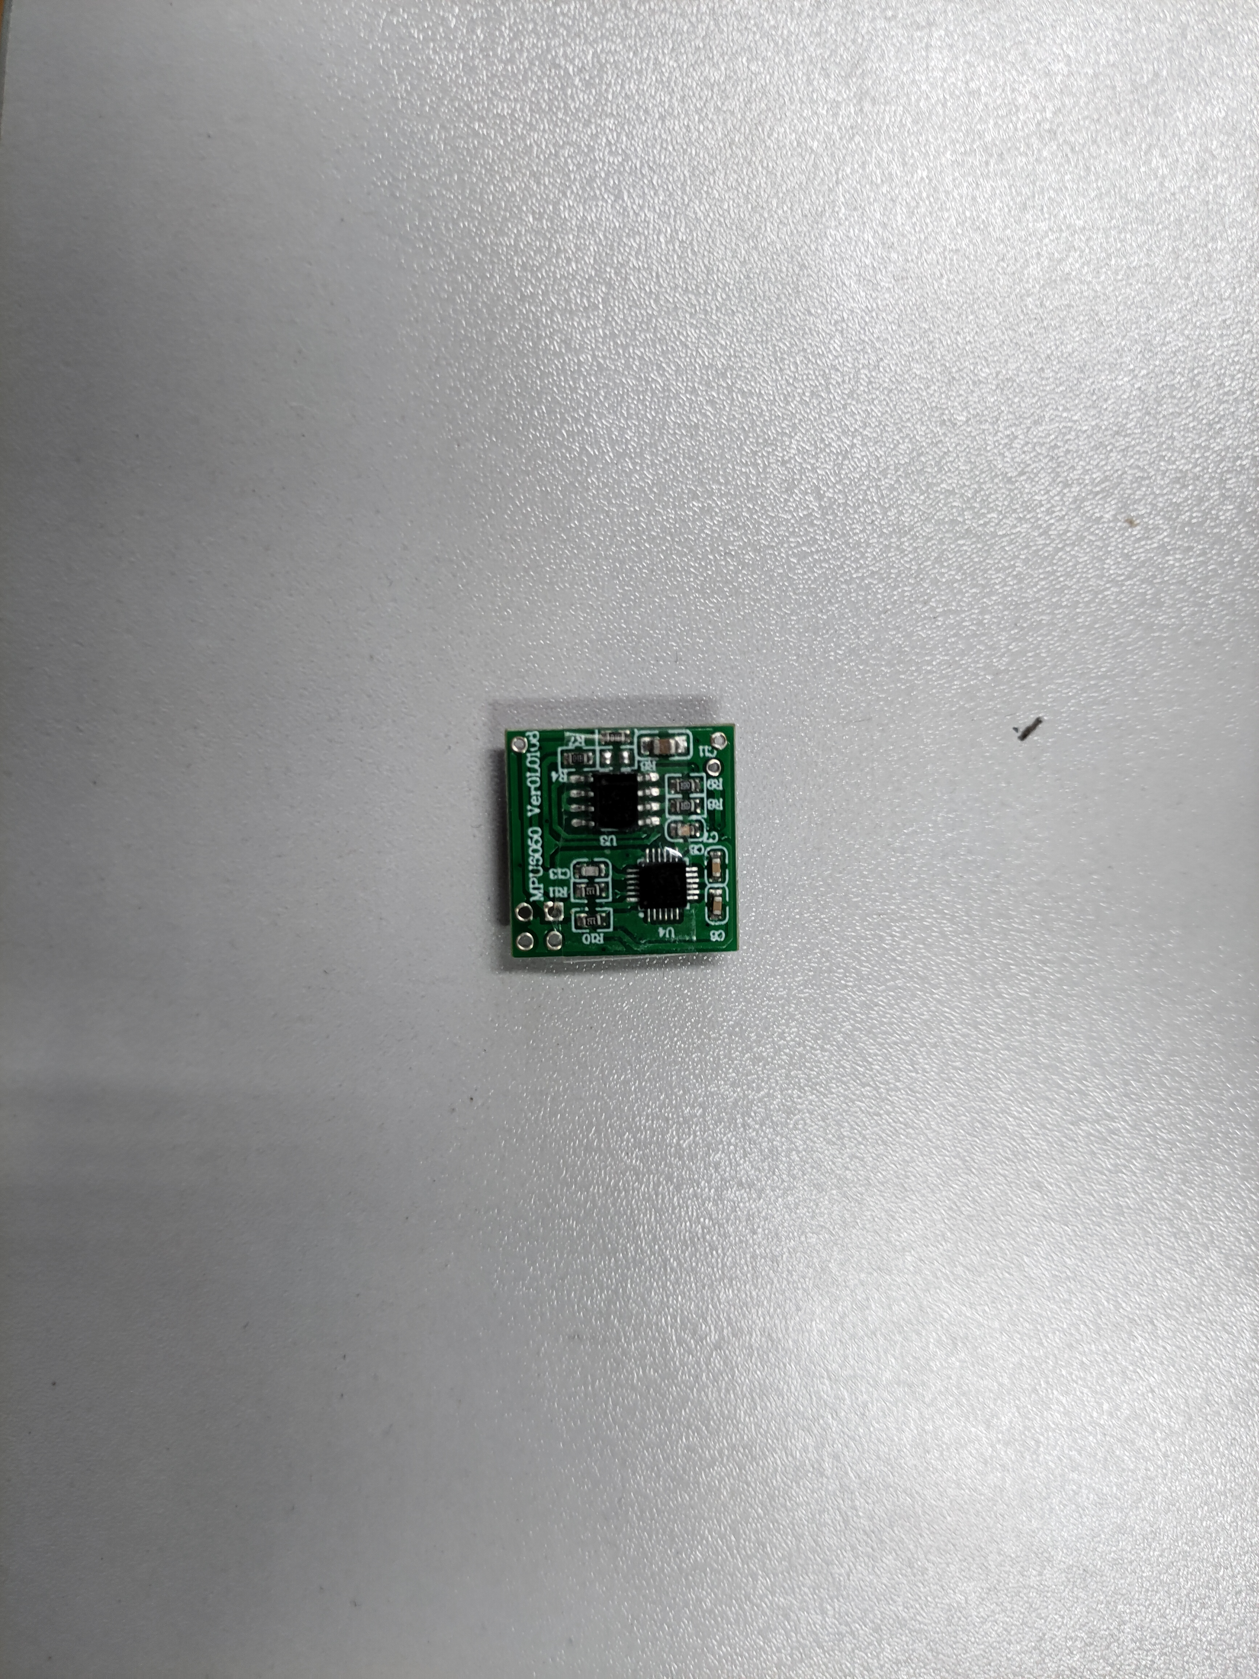
Figure 1 IMU sensor photo
The plantar pressure sensor was installed in different areas of the foot to achieve distributed measurement, which is easy to operate and less costly. The plantar pressure sensor adopts the domestic JHBM-M1 miniature pressure sensor, as shown in Figure 2-1(a), which has an external diameter of 20 mm, a height of 10.5 mm, and a range of 0-200 kg, and has the characteristics of small size, low height, and full sealing compared with other sensors, which is especially suitable for use in such a limited space as the sole of a shoe, and the range is large enough for people of different weights. The range is large enough for people of different weights. The pressure on the bottom of the foot when walking on a flat surface is a continuous gradual process from the heel to the toe, and the pressure sensor is installed on the sole of each shoe. The equipment is shown in the figure below.
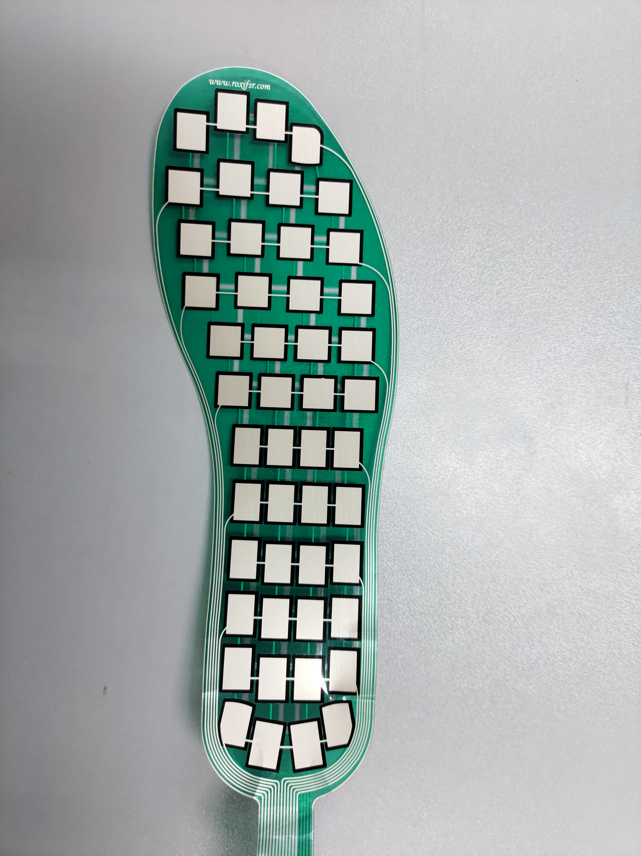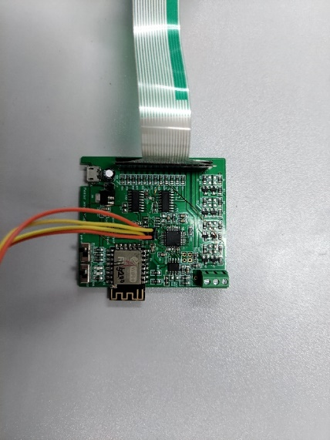
Figure 2 Plantar pressure sensor and microcontroller, WIFI module
3.1.2 Data acquisition software
The analysis of human gait characteristics and changes requires a large amount of data support, so special software needs to be written for data acquisition and processing. The main function of this software is to receive IoT sensor data from multiple ports by linking to a specific WIFI and write it to a file. After the data is collected, it is uploaded to a MySQL database on the PC for classification and management. Since the subsequent data processing and machine learning are done in Python, I choose Python language and Kivy development framework to complete a WIFI communication-based wireless sensor acquisition software that can run on PC/Android. The advantages of using Python for development are low development difficulty, good program portability, the ability to export data to other python scripts for processing at the same time of acquisition, and good flexibility.
The written software can achieve synchronous data acquisition for up to 5 chains with a total of 15 sensors. The software program uses a multi-threaded synchronous execution strategy, containing one main thread and five sub-threads. When the main thread issues the execution command, sub-threads 1-4 receive the command and perform a single round of data acquisition. When the acquisition process ends, the sub-thread flag bit is terminated and the cycle ends.
Since the users of this software are mainly Chinese, the main part of the interface is written in Chinese, and only a few buttons are in English.
The acquisition interface can set the file name of this acquisition, click the Start button to start the acquisition, click the Stop button to stop this record, and click the Write_DB button to write this data to MySQL database.
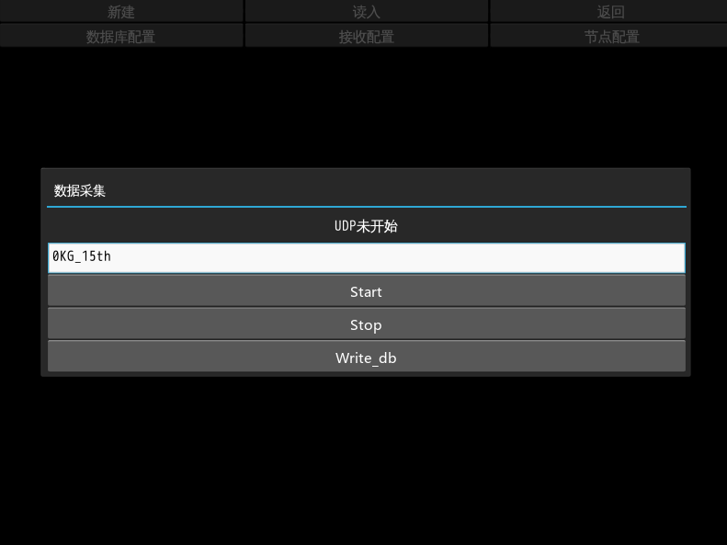
Figure 3 Data acquisition interface
The configuration pages of multiple sensors are as follows, setting the IP and port of each sensor separately to facilitate the distinction between the specific location information of different sensors, which are written into different tables according to the configuration information when writing to the database.IMU sensors are linked to the WIFI module using wires, which may be damaged due to the winding and pulling of wires during walking, and need to replace the corresponding IMU to complete Follow-up experiments, so the IMU node number needs to be configured flexibly to meet the experimental requirements.
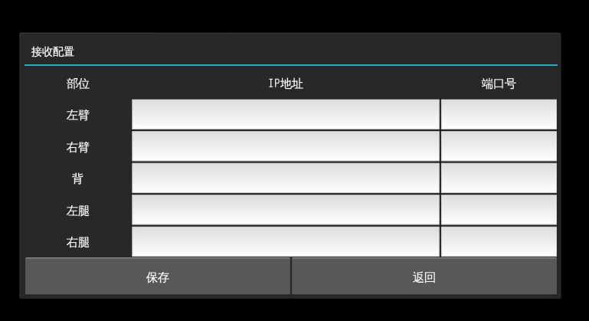
Figure 4 IP and Port setting interface of IoT chip
Database configuration interface, through the configuration of the program linked to the local database or cloud database, to achieve the upload of data. Due to the long experimental time, the data collection of each experiment may not be the same personnel and equipment, and need to consider multi-device collection, so it is more convenient to change the database configuration to facilitate the data entry operation, eliminating the tedious configuration process.

Figure 5 Database configuration interface

3.2 Experimental design
Part of the experiments for data collection were conducted outdoors, as lifting heavy objects is generally an outdoor activity, and the later part was tested indoors under fixed conditions, mainly due to the high temperature and the need to carry weight during the experiment, which was physically demanding for the subjects. A total of 10 adults participated in the data collection, including 8 males and 2 females. The experiment consisted of weighted walking on a flat road, during which the weight of the load was adjusted several times. The weight-bearing container for this experiment was a duffel bag, which exerted a balanced force on the body, did not affect the swinging arm and trunk movements, and had minimal effect on the lower limb gait. The experimental equipment used to adjust the load was a number of sandbags with a unit weight of 5Kg, and the weights of 15kg, 20kg and 25kg were chosen as the load classification.
Subsequently, the 15kg load was labeled as L0, the 20kg load as L1, and the 25kg load as L2, for a total of three load levels, so the subsequent work of this experiment is to classify and identify these three different load levels according to the gait data.
The IMU sensor will be placed directly on the anterior thigh, the anterior calf and the medial ankle of the subject. The thigh and calf are placed on the anterior side for stability reasons. If the IMU sensor is placed on the lateral side, the main angular variation is in the y-direction of the sensor, and because the sensor is a square piece, the data consistency is more likely to be affected by the fixation method when it is fixed on the lateral side. The ankle joint, however, is more difficult to fix in the frontal direction and is easily affected by the shape of the subject's shoes and dorsum of the foot, so fixing it on the medial side of the ankle can obtain more stable data. The final IMU fixation method is shown in the figure below.
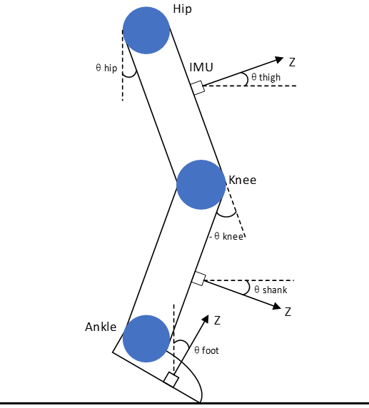
Figure 6 Diagram of sensor placement

3.3 Data pre-processing
Quadratic number solution
In 1843, Hamilton introduced the concept of quaternion, a super complex number that contains four components and does not satisfy the multiplicative exchange law [51]. At that time, he was studying the extension of complex numbers to higher dimensions, and he first thought of ternary numbers, but after several proofs, he was not able to do the example of three-dimensional space, that is, the concept of three-dimensional numbers does not exist in three-dimensional space, but quadratic numbers can be created in four dimensions. The quaternion was not widely used at that time, but with the development of space technology and navigation technology, the advantages of quaternion: small calculation, small storage space only a simple orthogonal processing to ensure the orthogonality of the quaternion pose matrix, has been widely recognized, the application field has been expanded.
The raw data of each IMU has 6 dimensions, which are acceleration in X, Y and Z directions and angular velocity in each direction. The reference values of the gyroscope and accelerometer can be obtained according to the Euler angles and rotation matrix, respectively, and the IMU's positional information can be solved by using the quaternion algorithm. The X corresponds to the yaw of the IMU, and the rotation is y, with the range of -90° to 90°. Y corresponds to the pitch of the IMU, and the rotation is p, with the range of 0 to 360°. Z corresponds to the roll direction of the IMU, and is r, with the range of -180° to 180°.
The three different directions of the rotation matrix are calculated as follows
$$M_{x}=\left[\begin{matrix}1 & 0 & 0 \\ 0 & \cos{r} & \sin{r} \\ 0 & -\sin{r} & \cos{r}\end{matrix}\right]$$
$$M_{y}=\left[\begin{matrix}\cos{p} & 0 & -\sin{p} \\ 0 & 1 & 0 \\ \sin{p} & 0 & \cos{p}\end{matrix}\right]$$
$$M_{z}=\left[\begin{matrix}\cos{y} & \sin{y} & 0 \\ -\sin{y} & \cos{y} & 0 \\ 0 & 0 & 1\end{matrix}\right]$$
The equation for solving the attitude angle from the accelerometer output in the IMU is as follows.
$$\left[\begin{aligned}&a_{x} \\ &a_{y} \\ &a_{z}\end{aligned}\right]=M_{x}⋅M_{y}⋅M_{z}⋅\left[\begin{aligned}&0 \\ &0 \\ &g\end{aligned}\right]=\left[\begin{aligned}-\sin{p} \\ \cos{p}⋅\sin{r} \\ \cos{p}⋅\cos{r}\end{aligned}\right]⋅g$$
$${roll}_{acc}=arctan⁡\left(\frac{a_{y}}{a_{z}}\right)$$
$${pitch}_{acc}=-arctan⁡\left(\frac{a_{x}}{\sqrt{{a_{y}}^{2}+{a_{z}}^{2}}}\right)$$
The formula for solving the attitude angle from the gyroscope data in the IMU is as follows
$\left[\begin{aligned}&g_{x} \\ &g_{y} \\ &g_{z}\end{aligned}\right]=M_{x}⋅M_{y}⋅\left[\begin{aligned}0 \\ 0 \\ \frac{dy}{dt}\end{aligned}\right]+M_{x}⋅\left[\begin{aligned}0 \\ \frac{dp}{dt} \\ 0\end{aligned}\right]+\left[\begin{aligned}\frac{dr}{dt} \\ 0 \\ 0\end{aligned}\right]=\left[\begin{matrix}1 & 0 & -\sin{p} \\ 0 & \cos{r} & \cos{p}⋅\sin{r} \\ 0 & -\sin{r} & \cos{p}⋅\cos{r}\end{matrix}\right]⋅\left[\begin{aligned}&\frac{dr}{dt} \\ &\frac{dp}{dt} \\ &\frac{dy}{dt}\end{aligned}\right]$
According to equation , the attitude angle ${roll}_{gyro} ,{pitch}_{gyro}{,yaw}_{gyro}$ can be obtained.
The accelerometer has better accuracy for the estimation of the attitude at rest, while the gyroscope can obtain better recognition when the rotation changes and calculate the relative change of the angle. Taken together, the six parameters of IMU are complementary, and combining the data of acceleration and gyroscope together for attitude solution can obtain good solution accuracy.
$$\left\{\begin{aligned}\begin{aligned} roll = {roll}_{gyro}+\left({roll}_{acc}-{roll}_{gyro}\right)⋅K \\ pitch = {pitch}_{gyro}+\left({pitch}_{acc}-{pitch}_{gyro}\right)⋅K\end{aligned} \\ yaw={yaw}_{gyro}\end{aligned}\right.$$
The K in the above equation is the scale factor, which is used to correct the angle calculation according to the specific situation, and its specific value needs to be further determined during the data processing. The above formula can convert the acceleration and angular velocity information of the IMU into the final sensor position angle value, which reflects the angle change value of the IMU in the forward direction of the real movement of the human body. By analyzing the human structure, we can learn that the hip joint angle is the angle between the torso and the thigh, and in this experiment, the torso of the experimenter can be regarded as upright, i.e., the thigh IMU angle is directly regarded as the hip joint angle. For the knee joint, the angle is the complementary angle between the thigh and the calf, so the knee angle can be obtained by a simple subtraction operation. The ankle joint is similar to the hip joint in that it is fixed directly to the medial side of the foot, so it can also be converted directly. The final formula for calculating the angles of the 3 joints of the human lower limbs is as follows.
$$\left\{\begin{aligned}\begin{aligned}{Angel}_{HIp}={roll}_{Thigh} \\ {Angel}_{Knee}={roll}_{Thigh}-{roll}_{Shank}\end{aligned} \\ {Angel}_{Foot}={roll}_{Foot}\end{aligned}\right.$$

3.3.1 Interpolation
In the process of data acquisition by walking colleagues, the sampling frequency of the IMU sensor was set to 100 Hz, i.e., 100 sample points per second. However, Considering that the data is transmitted via WIFI instead of wired, there is a certain degree of packet loss during transmission and some of the collected data will be lost, showing NAN or 0 in the result, and the sampling frequency is not always stable due to the delay of the modules of the sensor in network communication, so it is not guaranteed that a sample data can be collected every 0.004 seconds and saved in the My SQL database, and because each experimental It is also difficult to normalize the cut according to the period because each experimenter has different walking habits and different gait cycles. The good thing is that there is similarity between each gait cycle, so we will first perform a linear interpolation of the acquired data to fill in the missing data sections. The interpolated gait data has better cycles and can be easily used for subsequent model training.
The signal amplitude sequence is first fitted by linear interpolation to make the time interval between any two consecutive sample points consistent.
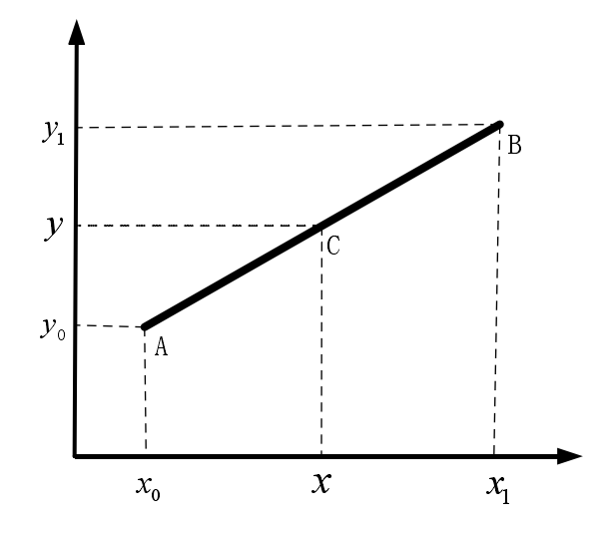
Interpolation, as the name implies, is the insertion of some desired values into a string of data. Interpolation can either compensate for the missing points in the data or expand or reduce the data size. The time series in this paper can be regarded as one-dimensional data on the time axis, which is suitable for linear interpolation methods, so the three-sample interpolation method of linear interpolation is chosen for the interpolation fit. The geometric principle of linear interpolation is given in Figure 2-5. The location of the point to be interpolated is known as point C. According to the two points A(x0, y0) and B(x1, y1) adjacent to the left and right of point C, the coordinates of point C can be found. A function p(x) can be constructed, and then p(x) can be used to calculate the coordinates of point C at the desired interpolation position. The function P(x) can be defined as
$$y=y_{0}+\frac{y_{1}-y_{0}}{x_{1}-x_{0}}\left(x-x_{0}\right)$$
The time between any two consecutive sample points in the original signal sequence is not equally spaced distribution. After the resampling process based on linear interpolation, the interval between any two adjacent sample points can be set to 0.01s.

3.3.2 Data segmentation
The walking in both natural and weighted states is a balanced and stable regular action, and the gait information collected by multiple sensors has significant periodicity. As shown in Figure 2-9, a complete gait cycle can be divided into a support period and a swing period [68], where the support period includes four gait events: foot following the ground, foot flattening, heel leaving the ground, and toe leaving the ground, and the swing period refers to the period from the toe leaving the ground to the heel landing again [69], which is divided into the pre-swing period (acceleration period), mid-swing period, and post-swing period (deceleration period). From the gait sequence shown in Figure 2-8(b), it is clear that the data sequence used in this paper has obvious "period-like" characteristics, so the data segmentation method based on the gait period [73] is used. The following data segmentation methods based on the gait cycle are commonly used: the over-zero method, the correlation coefficient method, and the peak detection method. Among them, the over-zero detection method refers to determining the number of steps walked by the number of times the signal sequence crosses the 0-axis; the correlation coefficient method refers to segmenting the gait data by calculating the correlation coefficient between the signal sequence and the template sequence; the peak detection method refers to segmenting the gait data by using the extreme or minimal values in the signal sequence to obtain the gait event points. In this paper, the peak detection method is used for segmentation. The accuracy of segmentation is also verified by using the pressure sensor on the bottom of the foot. According to the previous pre-processing process, the filtered acceleration amplitude signal is used as the data sequence to be segmented in this paper. In this data sequence, some extreme or minimal value points are found as the basis for segmentation to split the whole signal sequence, i.e., all sample points between any two adjacent extreme or minimal value points constitute a complete gait cycle. In this paper, the foot following the ground event is used as the basis for dividing the gait cycle, i.e., finding the acceleration minima when the foot follows the ground.
Suppose the acceleration amplitude signal is defined as
$${\left[x_{1},…,x_{i},…,x_{N}\right]}^{T}$$
where N is the number of sample points in the entire acceleration amplitude sequence. The idea of peak detection is to traverse all sample points in the entire gait sequence and detect all local minima. The process of local minima detection can be described by the following equation.
$$x_{i-1}>x_{i}\&x_{i}<x_{i+1}$$
where xi is the sampling point at the current moment, xi-1 and xi+1 are the previous and next sampling points of the current moment, respectively.

3.3.3 Resampling
Since the data for subsequent machine learning needs the highest possible consistency to achieve better results, for the problem of inconsistent gait cycles of the subjects, resampling the data of knee angle, hip angle and foot angle can stretch or compress the original unequal gait cycle data to the average, which is beneficial to the subsequent machine learning part.
Due to the variability of the gait cycle of the experimenters, their gait frequency range is about 70 to 100 steps per minute. In order to ensure the validity of the data and to match the gait cycle characteristics of most people and to keep as many sampling points as possible, it was finally decided to resample the data to 169 points, which is the square of 13. Another reason for choosing 169 is that the resampling frequency for upward sampling is about 140 Hz, i.e., 100 steps per minute, which can better preserve the high-frequency components and reduce the information loss during data processing.
After processing, the data of hip, knee and ankle joints were formed into a numerical matrix of length 169. From the above figure, it can be seen that the gait data of the same experimenter under different weights have the same trend of waveforms, but there are obvious differences. The trend that the amount of joint angle change becomes larger for the experimenter under different weight-bearing is also not for the same joint, for example, Hip is larger at L1, while knee joint angle becomes smaller only at L2. According to the motion analysis, it can be speculated that the gait width of this experimenter may become smaller and smaller when weight-bearing.

3.4 Machine learning methods
In order to continuously improve the accuracy and feature extraction capability of gait recognition algorithms, the gait pattern classification algorithms
research has gradually shifted from classical LDA, PCA, and SVM algorithms to convolutional neural networks (CNN), recurrent neural networks (RNN), deep neural networks (DNN), and other algorithms. The core problem solved by these gait recognition algorithms is how to extract and classify the sensor information features, considering that the IMU gait data used in this paper is a kind of time-series data, and its gait data waveform changes have strong time-space regularity, so this paper chooses to use the Long Short-Term Memory model (LSTM) as the main The method of LSTM (Long Short-Term Memory) is chosen as the main method for the follow-up study.

3.4.1 Traditional LSTM model
Theoretically, recurrent neural networks can establish long-interval dependencies between states. However, short-term dependencies may be learned due to gradient explosion and gradient disappearance in practice. RNNs prefer to update in the correct direction of the weights at the end of the sequence during the gradient descent phase of the training process. The more distant the sequence input can have less influence on the correct change of the weights, so the training results tend to appear biased towards new information, i.e., less able to have a longer memory function, and if the sequence is too long it can lead to problems of gradient dispersion during optimization [52]. In order to solve the gradient problem of RNNs during training, RNN neurons were improved based on the existing recurrent neuron structure. The long-term short-term memory model (LSTM) was born as a recurrent neural network with a special structure (Hochreiter and Schmidhuber 1997; Imrana et al. 2021). LSTM neural networks use the LSTM memory unit structure [53] to judge the information going and staying and control the transmission of information from the previous moment to the next moment, which can overcome the shortcomings of RNNs and better solve the long-term dependency problem.
The LSTM differs from the LSTM in that it is a special network structure with three "gates". The LSTM unit is a special network structure with three "gates", including "forgetting gate", "input gate" and "output gate", where the "forgetting gate" and the "input gate" are the gates of the LSTM. The "forgetting gate" and "input gate" are the core of the LSTM structure. The internal structure of LSTM is as follows.
Figure 7 Schematic diagram of the internal structure of the LSTM model
In the figure, σ denotes the gate activation function, usually a Sigmoid function; g denotes the input activation function, usually a tanh function; h denotes the output activation function, usually a tanh function. At time t, the "input gate" calculates the information input to the LSTM unit it, the "forget gate" calculates the information rounded off by the LSTM unit ft, and the "output gate" calculates the information output by the LSTM unit ot. The updated state ct is multiplied by ot to obtain the output ht of the whole unit.
$$\left\{\begin{aligned}\begin{aligned}\begin{aligned}f_{t}=σ\left(W_{f}⋅\left[h_{t-1},x_{t}\right]+b_{f}\right) \\ i_{t}=σ\left(W_{f}⋅\left[h_{t-1},x_{t}\right]+b_{i}\right)\end{aligned} \\ {\check{c}}_{t}=\tanh\left(W_{c}\left[h_{t-1},x_{t}\right]+b_{c}\right)\end{aligned} \\ c_{t}=f_{t}*c_{t-1}+i_{t}*{\check{c}}_{t} \\ o_{t}=σ\left(W_{o}⋅\left[h_{t-1},x_{t}\right]+b_{o}\right) \\ h_{t}=o_{t}*\tanh\left(c_{t}\right)\end{aligned}\right.$$
where σ is the sigmoid activation function, b is the bias vector, W is the weight matrix, tanh is the hyperbolic tangent activation function, and h_(t-1) and c_(t-1) are the hidden layers of the t-1 time step state and cell state.

3.4.2 BiLSTM (Bidirectional LSTM)
The traditional LSTM model neuronal information can only be passed from front to back, which means that the input information at the current moment can only be used for the previous moment. However, for the gait weight recognition of this topic, the joint angles in the human motion state data are linear and continuous, so the data before and after the current moment have important reference values, and the states before and after the current state should be equally weighted.
Since the LSTM is not well adapted to this topic, one can consider strengthening the LSTM network using the idea of BI-RNN network, which is a bidirectional RNN. Conventional RNN networks pass information in a front-to-back sequence, which leads it to judge the output of the next moment only based on the past input information. The Bi-RNN consists of two RNNs superimposed above and below each other, and the output is determined by the states of both RNNs together, giving the network the ability to determine the state based on information from future moments. Forward to backward: Forward computation from moment 1 to moment t. The output of the hidden layer at each moment is obtained and saved to propagate backward. Backward to forward: backward propagation from moment t to 1. The output of the hidden layer at each moment is obtained and saved backward. For each moment t, the input is provided to two RNNs in opposite directions at the same time. the computation process is to first compute h_1, h_2... , h_t, and then compute from backward to forward to finally obtain two hidden states. The complete hidden state is stitched together the forward and backward hidden states.
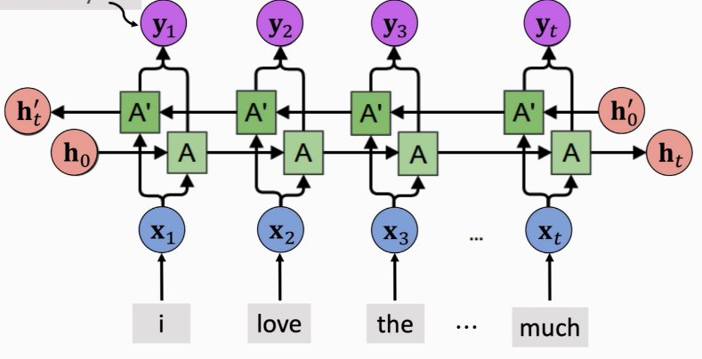
Figure 8 Bi-RNN model structure diagram
Combining the ideas of LSTM and BI-RNN, a Bi-LSTM network is formed by adding an additional layer to the LSTM that propagates information in reverse time series to enhance the performance of the network. By adding this, the LSTM has the ability to correct the classification prediction using subsequent data.
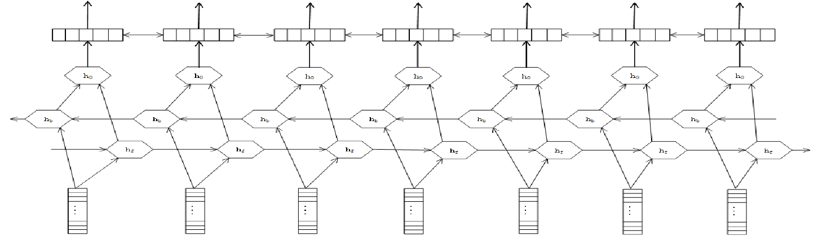
Figure 9 Schematic diagram of Bi-LSTM model structure
The above figure shows the network structure of Bi LSTM. It can be seen that the modified network has a 2-layer structure, and the data is transmitted in opposite directions in the front and back layers, one layer is in time forward order and one layer is in time reverse order. The joint angle information is input to the two layers in different time directions for training, and the resulting vectors are synthesized and then output, which together affect the final decision layer output. In this case, Bi LSTM can utilize both the information before and after the current moment, which is very suitable for joint angle-based weight recognition tasks.
the hidden states of two layers at time t are $h_{t}^{(1)}$ and $h_{t}^{(2)}$ respectively, as represented in formula (11), the hidden layer vector $h_{t}$ at time t is obtained by adding $h_{t}^{(1)}$ and $h_{t}^{(2)}$ .
$$\left\{\begin{aligned}\begin{aligned}h_{t}^{(1)}=f\left(U^{\left(1\right)}h_{t-1}^{\left(1\right)}+W^{\left(1\right)}x_{t}+b^{\left(1\right)}\right) \\ h_{t}^{(2)}=f\left(U^{\left(2\right)}h_{t-1}^{\left(2\right)}+W^{\left(2\right)}x_{t}+b^{\left(2\right)}\right)\end{aligned} \\ h_{t}=h_{t}^{(1)}⊕h_{t}^{\left(2\right)}\end{aligned}\right.$$

Experiment

4.1 Data Acquisition
There are multiple ways of carrying weight on the human body, such as carrying on the back, single-handed carrying, two-handed carrying, carrying, lifting, and other multiple ways. In this experiment, since the problem to be investigated is to distinguish and identify the size of the load according to the gait data, it is beneficial to choose a load-bearing mode with less influence on the gait for the experiment, and after considering the adjustment of the load, the choice of equipment, etc., the subjects were chosen to use a backpack to carry a heavy load for indoor and outdoor walking on flat ground, at which time the gait under load did not change much from normal walking The recognition performance in this case can highlight the effectiveness of the algorithm.
The information of the subjects is as follows. The subjects were mainly university students, in good health and without motor impairment. The average height of the subjects was 178 cm, with the shortest being 160 cm and the tallest being 187 cm. The average weight of the subjects was 72 kg, with the lightest being 58 kg and the heaviest being 85 kg. The age was evenly distributed between 19 and 24 years old.
The experimental procedure was relatively simple: the subjects first put on the IMU sensors of the lower limbs with the help of a support person to ensure that the sensors were positioned and fixed in the expected way. After the device is turned on, the data collector opens the corresponding software and gives walking commands to the subject to enter the data acquisition phase. After the subject walks a certain distance on flat ground (usually tens of meters), the data collector gives a stop command to the subject and ends the stop data recording in the data collection software and transfers it to the local database.
After a single data recording, the subject rests for a few minutes to recover and then adjusts the weight by adjusting the number of sandbags in the back duffel bag, each time the order of weight adjustment is randomized to circumvent the effect of weight order on the experimental data. Each subject was eventually tested four or more times at each weight to ensure that the amount of data was rich enough to ensure that the amount of data required for subsequent machine learning was satisfied.
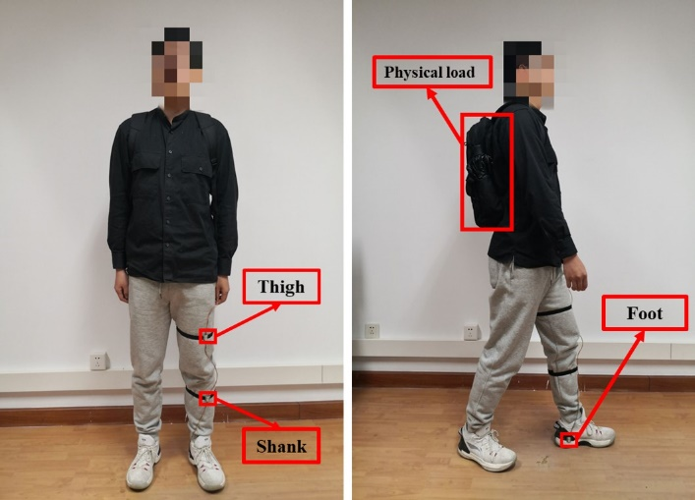
Figure 10 IMU sensor markers for lower limb fixation and backpack weighting
Finally, through the experiment, a total of more than one thousand gait cycles were collected for training and testing, and the capacity and variety of the dataset were sufficient for subsequent experiments.

4.2 Data processing
The raw sensor data waveforms are shown below. It contains the raw data of 3 sensors, the acceleration in 3 directions and the angular velocity in 3 directions of each sensor are included, and the data are very scattered and not processed in various ways, so that no valid information can be obtained.
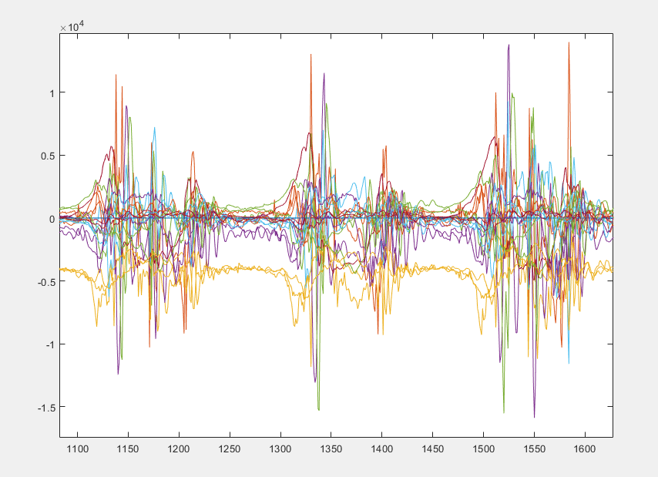
Figure 11 The waveform of the original sensor data
The waveforms of some data solved by the quadratic method and interpolated are shown below. It can be seen that the angular information after solving has strong periodicity, which greatly improves the difficulty of interpreting the data. The highest peak is the plantar pressure sensor value, which can be used to distinguish the gait phase by the plantar pressure value and serve as a reference corroboration for subsequent data segmentation. The lower three lines are the joint angles of each joint of the lower extremity.
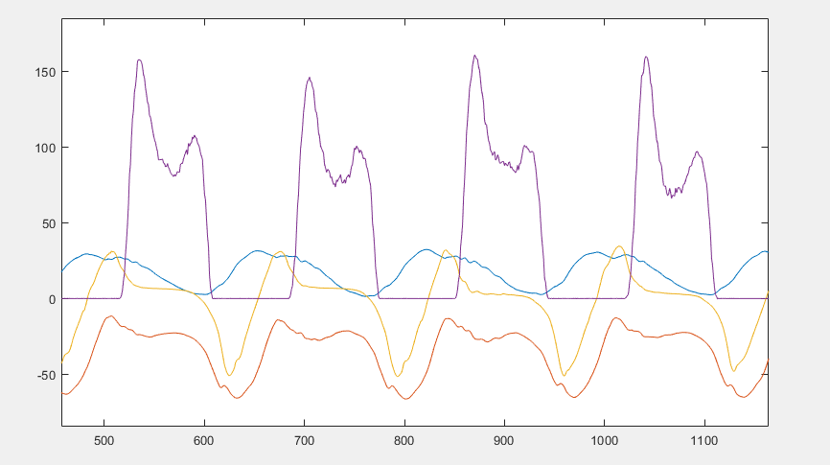
Figure 12 Waveforms of gait data and pressure sensor data after interpolation
The plantar pressure values in the above figure are mainly used as reference values for subsequent gait cycle segmentation, while the remaining three joint angles will be segmented in the next steps and finally input to the network for training and recognition.

4.3 Segmentation and resampling
Based on the plantar pressure values and the peak-to-peak values of the ankle joint angles, the data collected in a single experiment can be segmented into dozens of individual cycles according to the gait cycle. The waveforms of the gait data after segmentation and resampling processing are as follows.

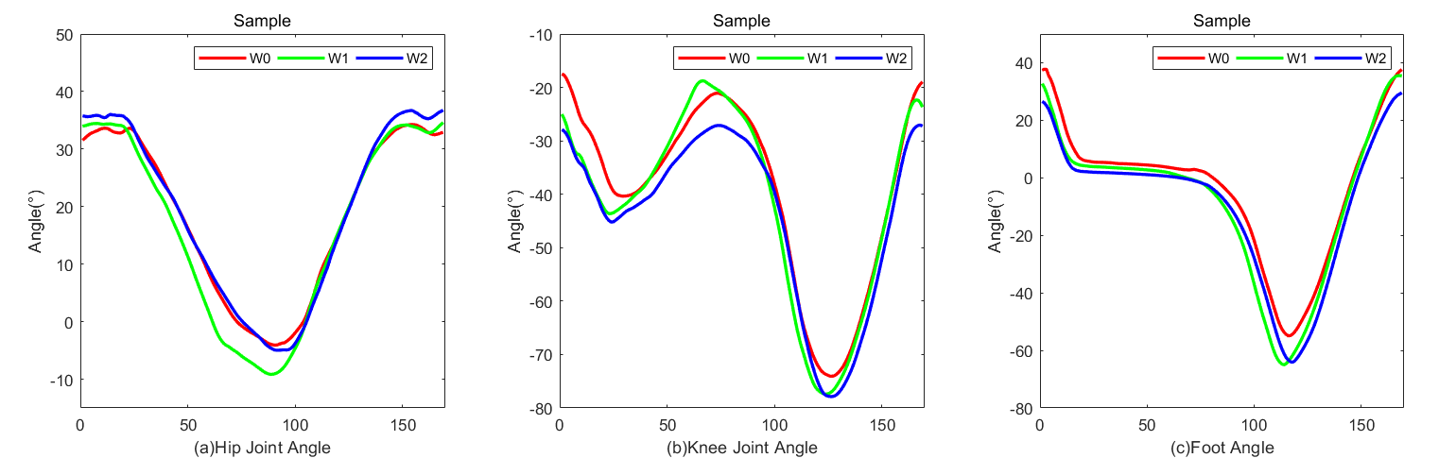
Figure 13 Numerical differences between subjects' walking data under 3 physical loads
The above figure is the final form of the data processing, with smooth curves and consistent movement trends, but at the same time there are visible differences with the possibility of further differentiation.

4.4 Network training
Since network training is very time consuming, in order to speed up the experimental process, pre-training is performed using Matlab's pre-defined tools, and additional structures can be defined manually by writing Python code in parallel with the training process. I first pre-trained directly in matlab with some of the data to observe the differences and characteristics of different networks and to confirm some of the conjectures in Chapter 3.
Since the data length is 169, I first used an 80-layer LSTM and a BI-LSTM for training to compare and verify whether the Bi-LSTM can have better classification results than the LSTM in gait weight recognition scenarios. Since we only need to verify the difference in validity, there are only 2 categories of training data at this time, namely no-weight-bearing data and 25KG-weight-bearing data.
The screenshots of the training process are as follows.
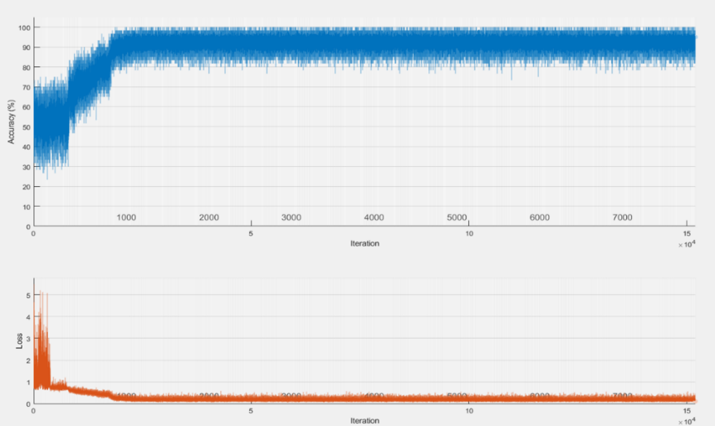
Figure 14 80-layer LSTM training process diagram
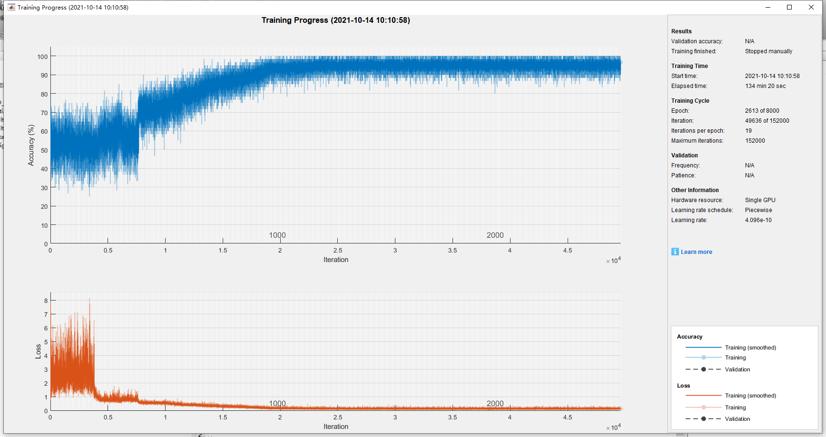
Figure 15 80-layer Bi-LSTM training process diagram
By comparing the above training process, it can be found that Bi-LSTM can indeed achieve better results in the case of weight recognition based on gait, with higher accuracy and less fluctuation in the later stage of training. It verifies the previous conjecture that Bi-LSTM is more suitable for this recognition scenario.
I then adjusted the number of layers of the LSTM network several times, hoping to obtain the effect of different layers on the recognition rate, and some of the data are shown in the following table.
Table 1 Pre-training results table
 |  | 80-layer |  |  |  | 120-layer
LSTM | Predictions  Labels | L1 | L0 |  | Predictions  Labels | L1 | L0
 | L1 | 94.93% | 5.07% |  | L1 | 94.93% | 5.07%
 | L0 | 47.21% | 53.79% |  | L0 | 60.82% | 39.18%
BI-LSTM | Predictions  Labels | L1 | L0 |  | Predictions  Labels | L1 | L0
 | L1 | 94.47% | 5.53% |  | L1 | 94.47% | 5.53%
 | L0 | 60.82% | 39.18% |  | 无负重 | 55.22% | 44.78%
From the above table, it can be analyzed that appropriately increasing the number of hidden layers of LSTM and Bi-LSTM can reduce the cases of misclassification for no negative weight.
After confirming the above conjecture, Pytorch was used to build and train the network.
The speed of training the network with Pytorch was significantly improved, so I gradually increased the number of layers of the network to further find the optimal number of layers.
The individual parameters and the formulae used to measure the performance of the network are as follows
$$\begin{aligned}\text{ Sensitiv}\text{i}\text{ty }&=\frac{TP}{TP+FN} \\ \end{aligned}$$
$$\begin{aligned}\text{Specificity }=\frac{TN}{TN+FP} \\ \end{aligned}$$
$$\text{Precision }=\frac{TP}{TP+FP}$$
$$F-\text{score }=2×\frac{\text{ Precision }×\text{ Sensitivity }}{\text{ Precision }+\text{ Sensitivity }}$$
$$\text{Accuracy }=\frac{TP+TN}{TP+FP+TN+FN}$$
The following is the result of increasing the number of layers of the network to 160. The first table in the following table shows the classification with and without weight, and the second table shows the classification without weight, with 15kg weight and 25kg weight. The third table shows the classification of no weight, 15kg weight, 20kg weight and 25kg weight.
Table 2 Secondary classification results
LSTM | Predictions
Labels | L0 | L1，L2，L3
L0 | 81.67% | 18.33%
L1，L2，L3 | 1.7% | 96.17%
Bi-LSTM | Predictions
Labels | L0 | L1，L2，L3
L0 | 88.55% | 18.33%
L1，L2，L3 | 1.7% | 98.3%
Table 3 Triple classification results
LSTM | Predictions
Labels | L0 | L1 | L3
L0 | 86.99% | 8.59% | 0.81%
L1 | 7.14% | 88.57% | 4.29%
L3 | 3.64% | 20.91% | 75.45%
Bi-LSTM | Predictions
Labels | L0 | L1 | L3
L0 | 90.63% | 8.59% | 0.8%
L1 | 8.24% | 82.35% | 9.41%
Table 4 Triple classification results
LSTM | Predictions
Labels | L0 | L1 | L2 | L3
L0 | 81.67% | 11.45% | 6.11% | 0.76%
L1 | 2.89% | 35.84% | 59.54% | 1.73%
L2 | 7.2% | 15.2% | 77.6% | 0%
L3 | 2.33% | 13.37% | 36.05% | 48.25%
Bi-LSTM | Predictions
Labels | L0 | L1 | L2 | L3
L0 | 88.55% | 8.40% | 2.29% | 0.76%
L1 | 4.24% | 42.42% | 48.48% | 4.85%
L2 | 0.8% | 41.6% | 57.6% | 0%
L3 | 4.07% | 31.40% | 16.28% | 50.3%
The results are summarized in the following two tables。
Table 5 160 layers LSTM Classification results
Lstm160 |  | TP | FP | FN | TN | Sensitivity | Specificity | Precision | Accuracy
SP1 | L0 | 107 | 18 | 24 | 452 | 81.67% | 96.17% | 85.60% | 93.01%
SP2 | L0 | 107 | 79 | 16 | 336 | 86.99% | 97.39% | 92.24%
 | L1 | 62 | 38 | 8 | 265 | 88.57% | 87.45% | 62.00%
 | L3 | 83 | 4 | 27 | 300 | 75.45% | 96.68% | 95.40%
SP3 | L0 | 107 | 18 | 24 | 452 | 81.67 | 96.17% | 86.60% | 79.03%
 | L1 | 62 | 57 | 111 | 371 | 35.84% | 81.00% | 52.10%
 | L2 | 97 | 173 | 28 | 303 | 77.60% | 63.66% | 35.93%
 | L3 | 83 | 4 | 89 | 425 | 48.25% | 99.07% | 95.40%

Table 6 160 layers Bi-LSTM Classification results
BiLstm160 |  | TP | FP | FN | TN | Sensitivity | Specificity | Precision | F-score | Accuracy
SP1 | L0 | 116 | 8 | 15 | 462 | 88.55% | 98.3% | 93.55% |  | 96.17%
SP2 | L0 | 116 | 7 | 12 | 338 | 90.63% | 97.97% | 94.31%
 | L1 | 70 | 65 | 15 | 238 | 82.35% | 78.28% | 51.85%
 | L3 | 83 | 9 | 54 | 295 | 60.58% | 97.03% | 90.22%
SP3 | L0 | 116 | 8 | 15 | 462 | 88.55% | 98.3% | 93.55% | 93.55% | 80.99%
 | L1 | 70 | 117 | 95 | 359 | 42.42% | 75.42% | 37.43%
 | L2 | 72 | 111 | 53 | 365 | 57.6% | 76.68% | 39.43%
 | L3 | 83 | 9 | 82 | 420 | 50.30% | 97.90% | 90.22%
It can be seen that the performance of the network is bottlenecked, and no better results are achieved even if the number of layers of the network is subsequently continued to be increased.
After continuous parameter tuning, the optimizer that updates the model weights during training was set to adaptive moment estimation. The learning rate was set to 0.001, and this parameter value was found to be appropriate based on training experience to achieve more stable results within 3000 rounds. The loss function for binary classification uses binary cross-entropy, and the loss function for multi-class classification uses categorical cross-entropy. To avoid overfitting, I applied a drop rate of 0.1 to each layer. Since the BI-LSTM performs better than the traditional LSTM in all aspects, the subsequent section only performs network tuning for the BI-LSTM. The following network was finally selected for further study.
Table 7 Result of BI-LSTM network with good classification results after training
 |  | TP | FP | FN | TN | Sensitivity | Specificity | Precision | F-score | Accuracy
Net1 | L0/L2 | 134 | 0 | 3 | 134 | 0.978 | 1 | 1 | 0.989 | 98.9%
Net2 | L0/L1 | 129 | 5 | 8 | 167 | 0.942 | 0.971 | 0.963 | 0.952 | 95.8%
Net3 | L1/L2 | 166 | 5 | 6 | 129 | 0.965 | 0.962 | 0.971 | 0.955 | 96.4%
 | L1 | 103 | 0 | 34 | 306 | 0.752 | 1 | 1 | 0.858
Net4 | L2 | 161 | 40 | 11 | 231 | 0.936 | 0.852 | 0.801 | 0.863 | 88.0%
 | L3 | 126 | 13 | 8 | 296 | 0.94 | 0.958 | 0.906 | 0.923

It can be observed that as the classification category increases, the network is less effective in distinguishing between different classes of weights, which is due to the fact that as the difference in weights decreases, the difference in form variables during human movement also gradually decreases, due to the fact that the decision output layer of the LSTM is the SoftMax layer, and the SoftMax layer is less effective in making decisions when the difference in network outputs is small. However, the Bi-LSTM is able to achieve good accuracy for classification of both negative weights, which is a good finding.
In order to solve the problem that a single Bi-LSTM has poor recognition effect in the face of multiple loadings and can achieve good recognition effect for more than two different loadings, multiple different Bi-LSTM networks can be used to classify two different loadings, and finally the decision outputs of multiple networks are combined to decide the final output of the network. The multi-Bi-LSTM decision structure is as follows.
Figure 16 Multi-Bi-LSTM decision network structure diagram
The classification decision formula is shown below.
$$\begin{aligned}\begin{aligned}{h\left(X\right)}_{t}^{\left(1\right)}=f\left(U^{\left(1\right)}h_{t-1}^{\left(1\right)}+W^{\left(1\right)}x_{t}+b^{\left(1\right)}\right) \\ {h\left(X\right)}_{t}^{\left(2\right)}=f\left(U^{\left(2\right)}h_{t-1}^{\left(2\right)}+W^{\left(2\right)}x_{t}+b^{\left(2\right)}\right)\end{aligned} \\ h_{t}\left(X\right)={h\left(X\right)}_{t}^{\left(1\right)}⊕{h\left(X\right)}_{t}^{\left(2\right)} \\ R=softmax\left(h_{t}\left(X\right)\right)\end{aligned}$$

Table 8 Classification results of gait data after passing Muti-Bi-LSTM.
 |  | TP | FP | FN | TN | Sensitivity | Specificity | Precision | F-score | Accuracy
 | L1 | 123 | 3 | 14 | 320 | 0.898 | 0.991 | 0.976 | 0.935
Muti-Bi-LSTM | L2 | 165 | 15 | 7 | 278 | 0.959 | 0.949 | 0.917 | 0.938 | 94.1%
 | L3 | 129 | 8 | 5 | 314 | 0.962 | 0.975 | 0.942 | 0.952

Results and Evaluation
In this section, the results will be evaluated.
First, in this paper, I designed the hardware system for collecting gait motion data and the software for the data collection system independently, completed the data collection, and obtained a large amount of experimental data for advancing the subsequent research. Secondly, it was experimentally demonstrated that LSTM can distinguish the physical load magnitude of human body by gait data, which is in accordance with the conclusion in the literature review.
Next, it was found during the experiments that the use of LSTM and Bi-LSTM could achieve excellent recognition results in the binary classification problem of weight bearing, but the misclassification cases increased greatly when the number of classification species was increased, which seriously affected the recognition results of the network. Finally, the cascaded discriminations of multiple Bi-LSTMs overcome the problem of decreasing accuracy of multiple classifications (3 classes, 0kg, 15kg, and 25kg) and achieve 94.1% recognition rate in the triple classification problem. The limitation of this method is that when the number of classification categories increases, the overall number of networks increases exponentially, which seriously affects the real-time performance of the system recognition.
Overall, this experiment accomplished the desired goal of using machine learning methods to evaluate gait data to obtain weight classes, but still has many shortcomings. I think the most important part that affects the recognition effect is the decision layer of the LSTM, and probably better recognition results can be achieved using the LSTM-CNN structure, because the CNN network has stronger decision making ability.

Conclusion
This project has completed a complete set of IMU sensor-based gait data acquisition system and conducted an in-depth study based on the data collected by this system to verify that human lower limb IMU motion data can be used for physical load identification and classification work. The final processed data for machine learning are classified into three main categories: no-load, light-load and high-load. The traditional LSTM was able to achieve 71.1% for the multi-classification problem, while the Bi-LSTM was able to achieve 74.5% correct classification rate. By changing the discrimination method of the network and using the excellent performance of Bi-LSTM for the binary classification problem, a final recognition rate of 94.1% was achieved. The above recognition rate is based on the single-step human motion data, and the performance of the network can be further improved by considering the actual application scenario where multiple consecutive cycles of data can be sequentially input into the network for comprehensive discrimination.
The field of weight bearing is a very challenging research topic. In this paper, only exploratory work is done based on multi-sensor data analysis, and future research work can be carried out based on the following aspects.
(1) Consider the influence of other factors on the lower limb motion state and test the performance of the method under the influence of other factors.
(2) Build an adaptive control system in multiple movement modes, so that the lower limb exoskeleton can assist the user's movement in a natural, coordinated and stable way.
(3) The weight-bearing cases in this paper are all uniform weight-bearing on the human torso, and no data have been collected when the weight is carried asymmetrically on the left and right. In the future, the data of asymmetric weight-bearing can be further collected and compared with this experiment to compare the needs and effects of balanced load and asymmetric load on identification.
(4) Multi-view analysis of weight-bearing behavior can add video data or human skeletal data to further explore the kinematic patterns of lower limb segments.

Reflection
The subject situation of this study is relatively ideal, only the gait data of walking on flat ground under uniform weight-bearing of the trunk was collected and tested, and no analysis was conducted for more complex motion situations, such as walking up and down slopes, going up and down stairs, etc. Secondly, although the number of data samples reached more than one thousand, and certain conclusions can be drawn within the scope of this research, the generalization performance for the conclusions was not well tested, and a lot of subsequent validation is needed to ensure reliable conclusions.
In the process of reviewing the literature, I found that the way of weight-bearing has a much greater effect on human movement than even the effect of different weights on gait, and that weight-bearing has different effects in different positions and in different activity situations. For example, the human motion has a strong asymmetry when carrying a heavy object in one hand, which is circumvented in my current study by adjusting the weight in a duffel bag.
The most critical point is that although this system is initially designed to allow real-time incoming data for recognition, it actually uses the complete gait cycle data for recognition after data processing, and the data processing part does not achieve real-time, and the network structure of multiple BILSTMs leads to a high overall time complexity of the algorithm, which cannot satisfy real-time. In the condition that the human body is weighted in situ battle force without walking, the human body needs to use force against the gravitational force of the weight, but since there is no walking, this algorithm cannot identify whether there is a weight, and thus has been unable to drive the exoskeleton to assist the human body, and this problem needs further research.

References
[1] Mu Guangzong, Zhang Tuan. The development trend of population aging in China and its strategic response[J]. Journal of Huazhong Normal University (Humanities and Social Sciences Edition), 2011, 50(5):29-36.References
[2] Song Thuzhi, Wang Xiaoguang, Wang Xin, et al. Analysis of the development status and key technologies of multi-joint exoskeleton-assisted robots[J]. Journal of Military Engineering, 2016, 37(1):172-185. [3] Carretero-Navarro, Germán, Márquez, Gonzalo, Cherubini, Doménico, et al. Effect of different loading conditions on running mechanics at different velocities[J]. European Journal of Sport Science, 2018:1-8.
[4] M. Pistacchi, M. Gioulis, F. Sanson , et al. Gait analysis and clinical correlations in early Parkinson's disease[J]. Funct Neurol, 2017, 32(1): 28-34.
[5] A. Hill, J. Nantel. The effects of arm swing amplitude and lower-limb asymmetry on gait stability[J]. Plos one, 2019, 14(12):e0218644.
[6] Xu Minhua, Gao Fanrong, Chen Huihui, et al. Correlation analysis of factors influencing human gait balance[J]. Control Engineering, 2017, 24(S0): 140-145.
[7] D. Gouwanda, S. Senanayake. Identifying gait asymmetry using gyroscopes--a cross-correlation and Normalized Symmetry Index approach[J]. Journal of Biomechanics, 2011, 44(5): 972-978.
[8] L. Wang, Y. Sun, Q. Li, and T. Liu. Estimation of step length and gait asymmetry using wearable inertial sensors[J]. IEEE Sensors Journal, 2018, 18(9):3844-3851.
[9] E. K. Allseits, V. Agrawal, A. Prasad, et al. Characterizing the Impact of Sampling Rate and Filter Design on the Morphology of Lower Limb Angular Velocities[J]. IEEE Sensors Journal, 2019: 4115-4122
[10] Qiu S, Liu L, Zhao H, et al. MEMS inertial sensors-based gait analysis for rehabilitation assessment via multi-sensor fusion[J]. Micromachines, 2018, 9(9): 442.
[11] Qiu S, Liu L, Wang Z, et al. Body sensor network-based gait quality assessment for clinical decision-support via multi-sensor fusion[J]. IEEE Access, 2019, 7: 59884-59894.
[12] Hsu Y L, Chung P C, Wang W H, et al. Gait and balance analysis for patients with Alzheimer's
[13] Li HF, Liu Y, Yin QD, et al. Risk of complications in early weight bearing after internal fixation of intra-articular fractures of the femoral neck: 2-year follow-up[J]. Chinese Tissue Engineering Research, 2021, 25(18): 2875-2880.
[14] D. Pfeufer, C. A. Becker, L. Faust, et al. Load-Bearing Detection with Insole-Force Sensors Provides New Treatment Insights in Fragility Fractures of the Pelvis[J]. Journal of Clinical Medicine, 2020, 9(8): 2551.
[15] Li CH, Dong B, Chen T, et al. Clinical study on the effect of early weight-bearing on postoperative rehabilitation of Achilles tendon rupture[J]. Hebei Medicine, 2021, 27(1): 75-79.
[16] Guo E F, Tian Z F, Song L L, Wu H L, et al. Effect of postoperative weight-bearing exercise time on postoperative rehabilitation after internal fixation of femoral neck fractures in the elderly[J]. Clinical misdiagnosis and mismanagement, 2021, 34(2): 58-63.
[17] Ren Manying, Zhang Peng, Wei Hongwen. A comparative study on the effects of three types of weighted squats on lower limb Y balance, knee strength and longitudinal jump[C]. Abstracts of the 11th National Sports Science Congress, 2019.
[18] Liu, M.D.. Experimental study on the effect of weight-bearing exercises with different stability conditions on the fast strength and agility quality of lower limbs[D]. Beijing: Beijing University of Sports, 2019.
[19] Wang Zengang, Ding Mingchao, Huang Qiangnian, et al. Effects of weight-bearing round-trip running on the dominant and non-dominant sides of the lower limbs on the balance ability of trainees[J]. Journal of Military Sports, 2017, 36(4): 61-64.
[20] Tian Shisi. A comparative study on the gait characteristics of forward and backward running under load[J]. Guangdong Public Security Science and Technology, 2020(2): 33-35.
[21] T. Hotfiel, H. D. Carl, Wendler F, et al. Plantar pressures increase with raising body weight: a standardised approach with paired sample using neutral shoes[J]. Journal of back and musculoskeletal rehabilitation, 2017, 30(3): 583-589.
[22] E. J. Hyung, H. O. Lee, Y. J. Kwon. Influence of load and carrying method on gait, specifically pelvic movement[J]. Journal of physical therapy science, 2016, 28(7): 2059-2062.
[23] Mu Chengcheng, Liao Junfan, Luo Yaping. Study on the effect of weight bearing on plantar pressure characteristics[J]. Journal of Railway Police Academy, 2020, 30(3): 69-74.
[24] BenAbdelkader C, Cutler R, and Davis L. Stride and cadence as a biometric in automatic person identification and verification[C]. In Proceedings of the Fifth IEEE International Conference on Automatic Face and Gesture Recognition, 2002: 372-377.
[25] Lee L, Grimson W. Gait analysis for recognition and classification[C]. In Proc. Int. Conf. Automatic Face and Gesture Recogntion, Washington, DC, 2002: 155-162.
[26] Yoo J H, Hwang D, Monn K Y, and Nixon M S. Automated Human Recognition by Gait using Neural Network[C]. In First Workshops on Image Processing Theory, Tools and Applications, 2008: 1-6.
[27] Deng M, Wang C, Cheng F, et al. Fusion of spatial-temporal and kinematic features for gait recognition with deterministic learning[J]. Pattern Recognition, 2017, 67: 186-200.
[28] Tang J, Luo J, Tjahjadi T, et al. Robust arbitrary-view gait recognition based on 3d partial similarity matching[J]. IEEE Transactions on Image Processing, 2016, 26(1): 7-22.
[29] Han J, Bhanu B. Individual recognition using gait energy image[J]. IEEE transactions on pattern analysis and machine intelligence, 2005, 28(2): 316-322.
[30] Jeevan M, Jain N, Hanmandlu M, et al. Gait recognition based on gait pal and pal entropy image[C]. 2013 IEEE International Conference on Image Processing. IEEE, 2013: 4195-4199.
[31] DeCann B, Ross A. Gait curves for human recognition, backpack detection, and silhouette correction in a nighttime environment[C]. Biometric Technology for Human Identification VII. International Society for Optics and Photonics, 2010: 76670Q-76670Q-13.
[32] Wolf T, Babaee M, Rigoll G. Multi-view gait recognition using 3D convolutional neural networks[C]. 2016 IEEE International Conference on Image Processing (ICIP). IEEE, 2016: 4165-4169.
[33] Pappas I P I, Popovic M R, Keller T, et al. A reliable gait phase detection system[J]. IEEE Transactions on neural systems and rehabilitation engineering, 2001, 9(2): 113-125.
[34] Taborri J, Rossi S, Palermo E, et al. A novel HMM distributed classifier for the detection of gait phases by means of a wearable inertial sensor network[J]. Sensors, 2014, 14(9): 16212-16234.
[35] Jung J Y, Heo W, Yang H, et al. A neural network-based gait phase classification method using sensors equipped on lower limb exoskeleton robots[J]. Sensors, 2015, 15(11): 27738-27759.
[36] Mohammed S, Same A, Oukhellou L, et al. Recognition of gait cycle phases using wearable sensors[J]. Robotics and Autonomous Systems, 2016, 75: 50-59.
[37] Maqbool H F, Husman M A B, Awad M I, et al. A real-time gait event detection for lower limb prosthesis control and evaluation[J]. IEEE transactions on neural systems and rehabilitation engineering, 2016, 25(9): 1500-1509.
[38] Farah J D, Baddour N, Lemaire E D. Gait phase detection from thigh kinematics using machine learning techniques[C]. 2017 IEEE International Symposium on Medical Measurements and Applications (MeMeA). IEEE, 2017: 263-268.
[39] Martinez-Hernandez U, Mahmood I, Dehghani-Sanij A A. Simultaneous Bayesian recognition of locomotion and gait phases with wearable sensors[J]. IEEE Sensors Journal, 2017, 18(3): 1282-1290.
[40] Joshi C D, Lahiri U, Thakor N V. Classification of gait phases from lower limb EMG: Application to exoskeleton orthosis[C]. 2013 IEEE Point-of-Care Healthcare Technologies (PHT). IEEE, 2013: 228-231.
[41] Qiu S, Liu L, Wang Z, et al. Body sensor network-based gait quality assessment for clinical decision-support via multi-sensor fusion[J]. IEEE Access, 2019, 7: 59884-59894.
[42] Zion Z, Chen XJ, et al. A gait recognition method based on multi-classifier fusion[J]. Computer Applications, 2019, 39(3): 712-718.
[43] Y. Ma, Z. E. Ashari, M. Pedram, et al. Cyclepro: A robust framework for domain-agnostic gait cycle detection[J]. IEEE Sensors Journal, 2019, 19(10): 3751-3762.
[44] J. Barth, C. Oberndorfer, et al. Stride Segmentation during Free Walk Movements Using Multi-Dimensional Subsequence Dynamic Time Warping on Inertial Sensor Data[J]. Sensors, 2015, 15(3): 6419-6440.
[45] A. Cfm, B. Vc, B. Pk, et al. Wearables-based multi-task gait and activity segmentation using recurrent neural networks[J]. Neurocomputing, 2020.
[46] J. Chen, X. Huang, H. Jiang, et al. Low-Cost and Device-Free Human Activity Recognition Based on Hierarchical Learning Model[J]. Sensors, 2021, 21(7): 2359.
[47] O. Nafea, W. Abdul, G. Muhammad, M. Alsulaiman. Sensor-Based Human Activity Recognition with Spatio-Temporal Deep Learning[J]. Sensors, 2021, 21(6).
[48] S. Mekruksavanich, A. Jitpattanakul. LSTM Networks Using Smartphone Data for Sensor-Based Human Activity Recognition in Smart Homes[J]. Sensors, 2021, 21(5): 1636. [49] E. Soleimani, E. Nazerfard. Cross-subject transfer learning in human activity recognition systems using generative adversarial networks[J]. 2021: 26-34.
[50] Han Yali, Xu Youxiong, Gao Haitao. Research on knee joint exoskeleton swing control based on conductance control [J]. Journal of Automation, 2016, 42(12): 2-8.
[51] Hamilton WR. On quaternions: or a new system of imaginaries in algebra[J]. Philosophical Magazine, 1884, 25: 489-495.
52] Pascanu R，Mikolov T，Bengio Y.On the difficulty oftraining recurrent neural networks[C]//30th International Conference on International Conference on Machine Learning.Atlanta，USA：IMLS，2013：1310-1318.
[53] Graves A.Long short- term memory[M]//Supervised sequence labelling with recurrent neural networks.Berlin Heidel- berg：Springer，2012：37-45.

APPENDIX
DECLARATION AND FORM OF CONSENT

DECLARATION

I, ............................................Yuxuan Zhao………………………………… declare that I am the sole author of this Project; that all references cited have been consulted; that I have conducted all work of which this is a record, and that the finished work lies within the prescribed word limits.

This work has not previously been accepted as part of any other degree submission.

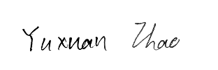
Signed : ................... ..........................

Date : ............. 2022.09.07................

FORM OF CONSENT

I _______ Yuxuan Zhao __________ hereby consent that my Project, submitted in candidature for the M.Sc. Data and Artificial Intelligence if successful, may be made available for inter-library loan or photocopying (subject to the law of copyright), and that the title and abstract may be made available to outside organisations.

Signed __________________________

Date ________2022.09.07__________

