Dissertation Proposal

Keywords:
- Life and Death
- Morals and ethics
- Beauty within death

Is it ethically and morally right to use deceased humans and/or animals within art and science?

My Dissertation will focus on the issues faced within and around death. Throughout my work, I will be expressing my opinions about how other cultures and religions express their emotions towards death and how the different traditional values differ from one another around the world. Alongside this, I will be discussing the morals and ethics surrounding death and how this relates throughout the animal species, differentiating between humans and the rest of the animal kingdom. Amongst these thoughts, I will briefly talk about how death can be perceived as beautiful and how it can be approached by different emotional attachments.

In this first section, I will be discussing a variety of death rituals within different cultures and comparing them to one another and to our own westernised society. I will be delving into what can be classified as ‘normal’ and what can be categorised as ethically and morally right or wrong.
In Western culture, we are taught to perceive death as an emotional and trying time. We have our own traditions such as wearing all black in respect for the deceased, embalming the body to preserve them, as well as either burying them in a cemetery or getting them cremated. For us, this is the normal ritual and if this is altered in some way, the family and relations of the dead will be ridiculed for expressing their grieving process. In other countries such as South Korea, the families of the deceased would have the body cremated and have the ashes compressed into gem-like beads in turquoise, pink, or black. These beads are known as “death beads” and are traditionally displayed in the home. This tradition came about as there was very little space in cemeteries across South Korea, leading to a law being passed which requires anyone who is burying one of the deceased must remove the grave after 60 years. This became unpopular as this culture deals with death very similarly to us. Digging up a deceased loved one was not desired by the people of South Korea which lead to multiple businesses opening up around the country trying to profit from death. There are some cultures that use the natural resources of the earth to help bury their dead. The Caviteño, who live near Manila, bury their dead in hollowed-out tree trunks. When someone becomes ill, they select the tree where they will eventually be entombed. These two traditions are relatively standard and are similar to our own process; someone dies, we bury or cremate them, and keep our memories of them to help us grieve in a particular way.
Unlike the previously stated rituals, Buddhists believe in reincarnation of the soul. What this means is that they believe the soul moves on and can start a new life in a different physical form or body after the biological death. To allow the soul to move on and to return the body back to the earth, the Buddhists in Mongolia and Tibet hewn the body into pieces and place them upon a mountain top which exposes it to the elements, this includes a feast for animals and also allows the natural decomposition process to occur. For us, this is a sign of disrespect. The body is not preserved in a way that we know it is safe for the afterlife, but to the people of this culture, the body is just an empty shell and is no longer useful to the living so is given back to the earth in the most natural way possible.
Anthropologist Kelli Swazey talks about the death ritual in her husband’s homeland of Sulawesi Island in Eastern Indonesia. This culture is known as the ‘culture of death’ as they are “… a community of people that experience death not as a singular event but as a gradual social process” (Swazey, 2013) as they don’t necessarily bury their dead straight away. Death is very symbolic for the family as it can show the wealth of the person and the generation of the remaining family. The deceased is placed in a room of the traditional home called the tongkonan and this is symbolic not only of the family’s identity but also of the human life cycle from birth to death. The body remains in this room and continues to be a member of the family until the funeral ceremony is held. The funeral can be held years after the person’s physical death as the family gathers offerings for the deceased’s journey to the ancestral resting place and allows the family to begin a number of ritual injunctions, which communicates to the wider community around them that one of their members is undergoing transition from this life into the afterlife known as Puya. For many cultures and religions, death is processed generally in the same way. There are always similar aspects throughout these rituals and they can all be perceived as normal, even though they differ significantly from one another.
Carrying on from the previous statement, I am going to discuss why it is deemed culturally appropriate in some countries to remove the deceased from their burial places, for the benefit of the family and compare it to the sport of trophy hunting amongst western civilisations for the benefit of art and status. I will also touch upon the subject of the use of bodies in science and research which will then lead me onto the photography aspect of this topic.
In some cultures when a family member dies, there are certain rituals that are performed to benefit the deceased but also to benefit the remaining living family. There is another tribe in Sulawesi, Eastern Indonesia called the Torajan people. This tribe, like the relatives of Anthropologist K. Swazey, have the same ritual for death. Their deceased family member could still be a part of their family home for years until they are eventually buried. But another element to the Torajan ritual is gathering the deceased bodies from their catacombs or graves, drying the bodies out, cleaning, feeding, and changing their clothes several years after being laid to rest. This process is called Ma’nene’. To this tribe, carrying out these routines is a part of their grieving process. For them, it reminds them to show love for their ancestors. “Maybe I wasn’t born yet and my ancestors had died, but during this ma’nene’ I can show gratitude toward them, as it would have been impossible for me to be born if not for my ancestors.” (Sambara, 2016). As I am not accustomed to this way of life, or even, death, I question why this culture thinks it is appropriate to do such procedures in order to grieve in the “right way”. Comparing this recognized tradition to trophy hunting is a difficult process as it is two completely different scenarios, but they can be very similar in some circumstances. I am also not accustomed to Trophy hunting, but because there is a huge decline in animal population, it is deemed an issue around the world which is constantly head lining news articles. Trophy hunting is a process where people will go out and hunt wild animals for their own recreational purposes. This is leading to multiple animals becoming extremely endangered, and on the verge of extinction, yet this sport is legal in a lot of countries. The comparison between the Torajan death rituals and the sport of trophy hunting is the obvious wealth status. The longer the deceased bodies are kept in their homes, the longer the families can look after them which in turn, shows how wealthy they are. It is the same with trophy hunting. People can pay up to millions just to shoot an animal to hang in their homes as decoration or furniture. This is just a selfish act against the animal kingdom just to show the superiority of certain members of the human race. If one minority of the human population can display their deceased family members for several years and it be deemed as a grieving ceremony as well as a normal tradition, why is it that displaying dead animals in a home is deemed inappropriate and a waste of an animal’s life? In reality, both these events are for the same reason. It’s all for the prestigious hierarchy.
Sally Mann stated; “…Euphemisms of death – it was a dead body, not “remains,” nobody “passed,” there was no “eternal rest.” People died and that was it.” Sally published a book under the title of “What Remains”. Within this book turned exhibition, Mann delved into her relationship with death and how it has always perplexed her. After her father passed away in her home, she was always intrigued by death and how the earth takes back our bodies, stating; “…death is the sculptor of the ravishing landscape, the terrible mother, the damp creator of life, by whom we are one day devoured.” As a photographer, Mann dealt with her relationship with death through the eye of the lens. In the book stated above, Sally expressed her feelings with a particular series of images known as “Body Farm”. A body farm is a research facility where decomposition can be studied in a variety of settings. Solely for scientific purposes. As a result of Mann exploring different areas of death, she visited a body farm at the University of Tennessee Forensic Anthropology Centre, to delve deeper into her explorations. She took several images of human bodies in different stages of decomposition [Fig.1] and displayed them along aside photographs of the remains of her deceased pet greyhound.[Fig.2]
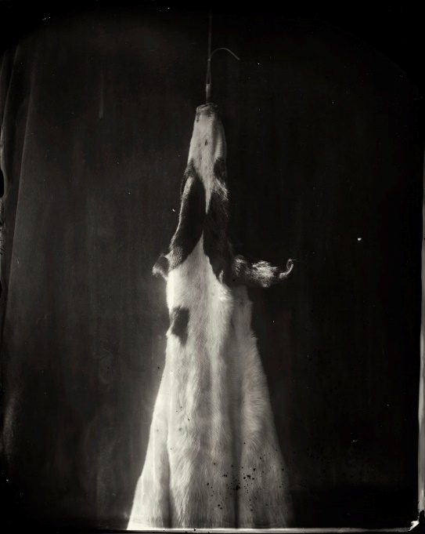
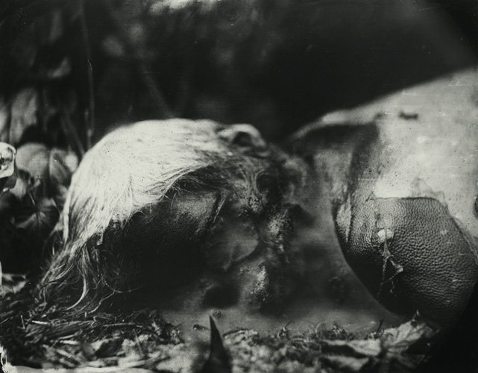
Fig.2
Fig.1
There was a lot of controversy around Mann’s work about how it can be deemed as insensitive toward the deceased people in her images. As one journalist says; “The most morbid pictures contain two kinds of violation. The first, unavoidable if you’re set on photographing corpses, is the violation of the privacy and decency of the dead” … “the second kind of violation: the dreadful things Ms. Mann has done to the surfaces of her photographs.” (Boxer, 2004) It can be understood that the images can be seen as a violation of the privacy of the deceased, but the cadavers in the photographs have been donated to science, so therefore before dying, the people consented to their bodies being exposed to such elements as the outdoor conditions and photographic documentation. The process Mann used to create her images was the wet-plate collodion process. This process makes the images look burned, torn, or spotted. The bodies can be identified as female or male, but cannot be identified as whom the people once were. Mann made it clear that her work is based primarily on the earth and the process that is made by decomposition, not the people involved. It is a documentation of death and is research for herself to grasp the concept of death in her own way. Going back to the previous topic of trophy hunting and death rituals in eastern civilisations, the idea of death being used as a status symbol is somehow not frowned upon, but this status is only used for art, decoration and wealth. I feel this is not a good enough reason for someone to be taken from their place of rest or an animal being killed, whereas, people giving permission for their bodies to be used after they have died is more helpful to us as a species and helps us develop and expand our knowledge of the human body and how it could help with future generations. This is the way the human race thinks and it seems there is not much change happening around the topic of death, the set traditions are always going to be within the small communities and it will be difficult to change the way death is dealt with amongst these people.
In this next body of text, I will be focussing on how and if death can be seen as beautiful and discussing what the limits are between death and the art world. Joel Peter Witkin is a still life photographer renowned for his images containing body parts of cadavers and animals integrated into still life photography. Although his work is very controversial, he is well known for it and is praised for his unique take on the subject of death. Witkin’s work is a perfect example of how artists can push limits when working with the deceased. He poses the cadaver parts in ways that could be very offensive towards the deceased person and the deceased person’s family and relations. A fine example of this, is his image titled; “The Kiss”. [Fig.3] He has posed two severed heads of older gentlemen, in a kissing stance. This image was created in 1982 and of that time, homosexuality was
still a controversial topic. He was pushing boundaries of political stature both from the sexuality status and from the disrespect of using cadavers inappropriately.
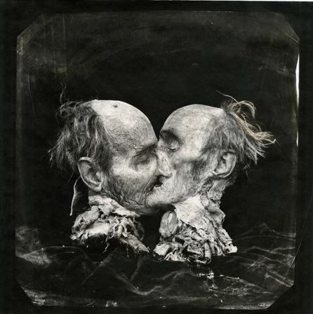
Fig.3

These views and opinions are that of my own. The impression of Witkin posing cadavers in such a way is a very precarious manoeuvre for him to have produced. Although some attestors of Witkin’s work will agree with my personal views, others may think differently. “… empathy and sentimentality were often viewed as weaknesses, I like to think my upbringing has made me pragmatic and thick-skinned, a coper and a realist.” (Black, 2018) Sue Black is a Professor of Anatomy and Forensic Anthropology, and has grown up with a different view on death to most children. Her father died when she was reasonably young, this gave her the fortuity to pursue her education further into the subject of death, leading to her career. Some people will view Witkin’s work in a similar way to how Black would view it. From reading her book, she projects herself as one whom would view the photographs as art, and nothing more. The boundaries of using death as a subject within an art piece are solely limited by how the attestors want to interpret what the artist is trying to portray.
I briefly looked into the topic of why animals’ lives are worth less than that of human lives, and I would like to research deeper into the topic of testing on animals. Be that in a scientific way, were the animals are held captive in laboratories having cosmetics and human products tested on them. Or be it for the fashion industry, were in some cases, animals are skinned alive for their fur. I would also like to expand on how death can bring a better quality of life to others. There was a case of a woman who was pregnant with a child who would be severely disabled and wouldn’t survive long after birth. She was given the option to terminate the pregnancy, but she took the opportunity to carry on to the full term so that she could donate her baby’s organs to young children who actually had a chance in life. This is a different view on the “Beauty of Death” but it is still valid, as it is a topic that is not discussed very much, just like death and it has the potential to create a meaningful piece of art.
The question asked can be perceived in a variety of different ways and I intend on touching on a lot of various subjects surrounding the ethics and morals behind the use of deceased humans and/or animals within the art industry. This can conjure up many other sub-questions within this essay which will benefit my research into the various different aspects of death within art.

References
Boxer, S. (2004). PHOTOGRAPHY REVIEW; Slogging Through the Valley of the Shutter of Death. [online] THE NEWYORK TIMES. Available at:
https://www.nytimes.com/2004/07/23/arts/photography-review-slogging-through-the-valley-of-the-shutter-of-death.html
Black, S. (2018). All that remains, A LIFE IN DEATH. [Script] Penguin Publisher. Pg.4.
Mann, S. (2003). What Remains. Bullfinch Press. Pg.5.
Mann, S. (2003). What Remains. Bullfinch Press. Pg.6.
Fig.1 Mann, S. (2003). What Remains (body farm). [Photography]. Bullfinch Press. Pg.53.
Fig.2 Mann, S. (2003). What Remains (Matter Lent). [Photography]. Bullfinch Press. Pg.9.
Fig.3 Witkin, J.P. (1982). The Kiss, New Mexico. [Photography] Tucson, Etherton Gallery
Sambara, P. (2016). When Death Doesn’t Mean Goodbye. 03:05. [online] NATIONAL GEOGRAPHIC. Available at: https://www.youtube.com/watch?v=hCKDsjLt_qU
Swazey, K. (2013). Life that doesn’t end with Death. 00:33. [online] TED TALKS. Available at: https://www.ted.com/talks/kelli_swazey_life_that_doesn_t_end_with_death/transcript

Bibliography
Death is not the end. (2013). We humans. [online] TED TALKS. Available at:
https://ideas.ted.com/11-fascinating-funeral-traditions-from-around-the-globe/

Falls the shadow: Sally Mann and the Body Farm. (2017). [online] Available at:
https://www.academia.edu/34918498/FALLS_THE_SHADOW_Sally_Mann_and_the_Body_Farm

Mum carrying terminally ill baby ‘to be a donor’. BBC NEWS. (2017). [online] Available at:
https://www.bbc.co.uk/news/uk-england-humber-42409289

