Qualification: CIPD Diploma in Applied Human Resources

Module Name: Understanding the Management of Employment Relations

Activity: On the Job Training

Word Count: 1251
Student Name: Jacqueline Towell
Student Number: 1808171
CIPD Membership Number: 23203590

By signing below, I confirm that the work/evidence presented is my own, unaided work. I understand the regulations pertaining to candidate malpractice and the action that may be taken as a result.

Signed: 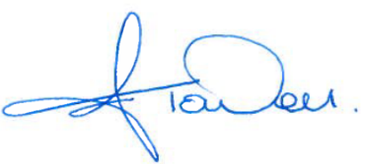
Date: 10th July 2019

On-the-job Training Observations
Point 1b (731 Words)
As much as practically possible The Premier Group follows the company Disciplinary Policy and Procedure, as set out in the Employee Handbook, the ACAS code of practice for disciplinary and grievance procedures, ACAS, (2018) and also find the process set out in the guidelines very useful (ACAS b, 2019);
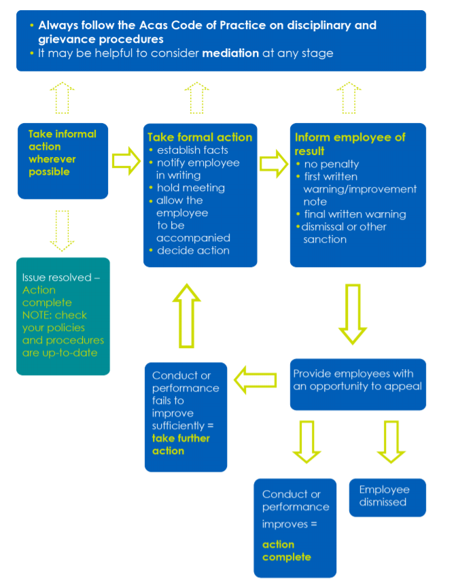
On 17th May 2019 following an investigation, which took into account ACAS guidance, ACAS b, (2019), I participated in a disciplinary hearing, which resulted in the employee receiving a final written warning, to remain on the employee record for 12 months. The process is documented in Appendix 1 (a-h).
The employee and companion arrived in plenty of time for the meeting and waited in the reception area, however, the employee was extremely nervous and visibly shaking. The employee had decided to bring along a work colleague to accompany them to the hearing, I felt that the choice of a companion was a good one, they were supportive, level-headed and assisted the employee to overcome their nerves, but the employee had not confirmed the companion attendance as they had been asked to do in the letter inviting them to the hearing.
The meeting was held by myself and our Managing Director (MD), who had double booked himself, this resulted in a small delay to the hearing starting and added to the employee stress.
The hearing itself was a controlled meeting, with myself facilitating and taking notes, and followed both the ACAS Guidance, ACAS b, (2019), and the CIPD Guidance, CIPD, (2018), very accurately. The events resulting in the hearing were discussed and evidence discussed in detail. The employee had the opportunity to ask questions, explain how the events occurred and state their regret at what had occurred and their intentions for the future. The companion offered a reminder of points that the employee had forgotten to mention and remained composed. When all points had been discussed to the satisfaction of all parties the meeting was adjourned and the employee asked to take a coffee whilst the MD and myself discussed the potential outcomes and made a decision on the sanction to be taken.
Our Considerations
Despite the fact that the employee had a non-negative Drug Test, the second laboratory test had advised that the level was below the Laboratory cut off point, therefore we felt that summary dismissal was excessive, however, the Employee Handbook states that we have a zero tolerance to Drugs and Alcohol in the workplace, and the drug taken was prescribed for somebody else, therefore, our decision was to move straight to final written warning, with a request that the employee sign the new employment contract stating that the company has a right to carry out random drug and alcohol tests.
Reflections and Feedback with Steve Evans MD
- Conducting Workplace Investigations, ACAS a, (2019), sets out the steps below for conducting investigations, in the case under review, all critical steps were followed, however, in The Premier Group having enough resources to appoint independent roles in the process can be difficult, for example the majority of the process was managed by myself as HR Manager, I was also the investigating officer, in more complex cases, we agreed that the company ought to consider appointing another Manager to carry out the investigation, this would be more in line with ACAS Guidance, (ACAS a, 2019).
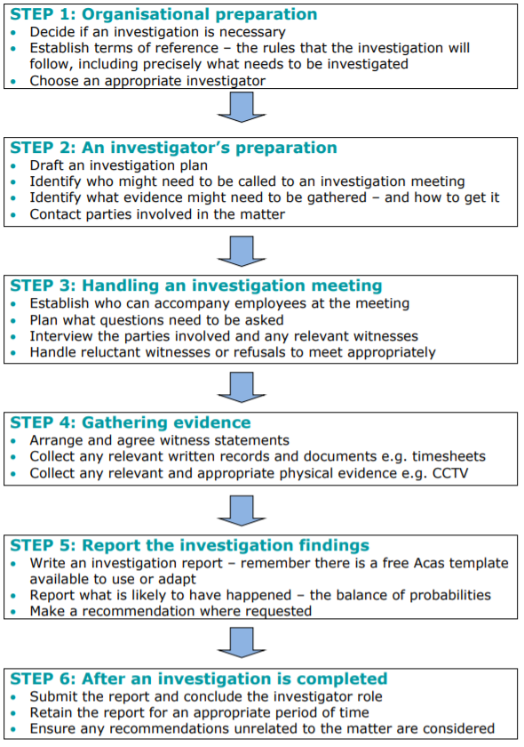
- Whilst the letter to the employee asked for confirmation of whether the employee would bring a companion and who the companion was, that did not happen, in this case the companion was a work colleague and therefore a suitable choice, however, because the company had not been informed the situation may not have been acceptable and could have delayed the hearing, Steve Evans suggested that going forward it would be advisable to make at least one attempt make verbal contact with the employee to ensure the content of the letter was understood and to inquire whether the employee has chosen a companion.
- We agreed that Steve being late for the meeting was not acceptable and future meetings of this nature should have priority, it was unfair to the employee and added to his nerves, this could have affected the hearing, given cause for an appeal or a grievance.
- Overall Steve agreed that both the process and the outcome was effective, all parties felt the matter had been addressed fairly.
Point 2 (520 Words)
On 1st May 2019, I facilitated the Employee Representative Group Meeting, which was a slightly different format to the way in which we usually conduct them, The Premier Group encourage employees to drive the agenda in a form described by the CIPD, (CIPD d, 2019) of Representative Participation, and in a similar way to how (Gennard, et al., 2016) describe Direct Two Way Communication. The company encourages this is because Representatives feel that this is their opportunity to speak on behalf of the employees and for the company to cascade information to employees. In this particular case the company needed to communicate some extended information, so was more prescriptive than on other occasions, this was explained to the Representatives at the start of the meeting, a copy of the Agenda is attached in Appendix 2 and the resulting Action Plan in Appendix 3.
The company set out to engage with the Representatives on aspects of work and work-related activities that were not being managed effectively and there were key messages to get across, however, the Agenda did not follow the order because attendees were sidetracked on these important issues which they were clearly quite passionate about.
The agenda overran and representatives left the meeting with unresolved agenda items, resulting in frustrations and poor feedback for the meeting.
Reflections and Feedback with Steve Evans MD
It was fortunate that my line manager Steve Evans was present at the meeting, therefore we were able to discuss quite accurately the success of the meeting and whether our objectives had been met, overall, we felt that the meeting did not meet objectives, despite being a successful forum in the past our reflections are;
- The company had managed to discuss all of the points that were needed, however, that was at the detriment of the Representative Agenda
- The Company are not confident that the messages will be conveyed effectively
- We had proposed too many topics for timescale and this type of forum
- Representatives felt overwhelmed with the amount of information to feedback
- No support with feeding back to employees was offered
- The Company should have produced supporting material to help with communication
- We have 70 employees and we do not feel we are meeting our obligations under ICE, (ACAS, 2001-2009), particularly with regard to having a formal agreement in writing or formally setting out how employees will be communicated and consulted with.
Recommendations
- Improve deadline setting and assigning responsibilities, by doing this ownership is assigned to ensure the action is completed
- Company 360-degree review of action points, a further mechanism for ensuring the loop is closed
- Using CIPD and ACAS guidelines, CIPD d, (2019), HR Manager to arrange a Workshop with the company representatives to discuss employee voice, what that is and the mechanisms for allowing that to be successful;
    - Number of company action points to be considered
    - Discuss company responsibilities and obligations with regard to ICE
- Future Employee Representative Group minutes to be supported with company communications regarding specific points.
- Always ensure the Representative Group Agenda is heard.

Appendix 2



AGENDA
Employee Representative Group
Thursday 1st May 2019

Those of you who have attended the Rep Group Meeting before will know that we try not to impose a company agenda for these meetings, we want to encourage the representatives to bring the topics, however, on this occasion we have quite a few topics to discuss with you, we will still have the round table discussion and everyone will have the opportunity to put their points forward.

- Health & Safety
- Drug and Alcohol Testing / Recent Incident
- Recruitment / Training / Blue Helmet Scheme
- Accommodation
- Weekend Travel, current guidelines and a new proposal
- Introduction / Feedback - Mid-Week Meal Allowance
- Appraisals
- Rest Days on Location
- Company Vehicles, Costs, Expectations, (Respect, Responsibility, Accountability)
- Family Fun Day

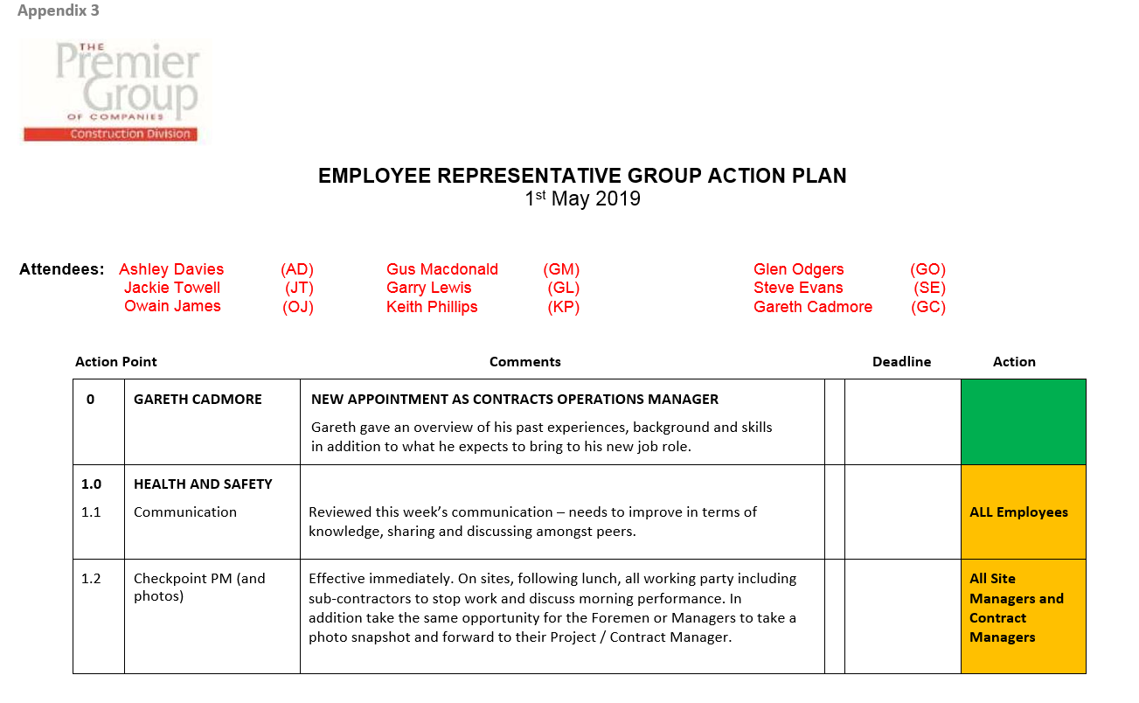
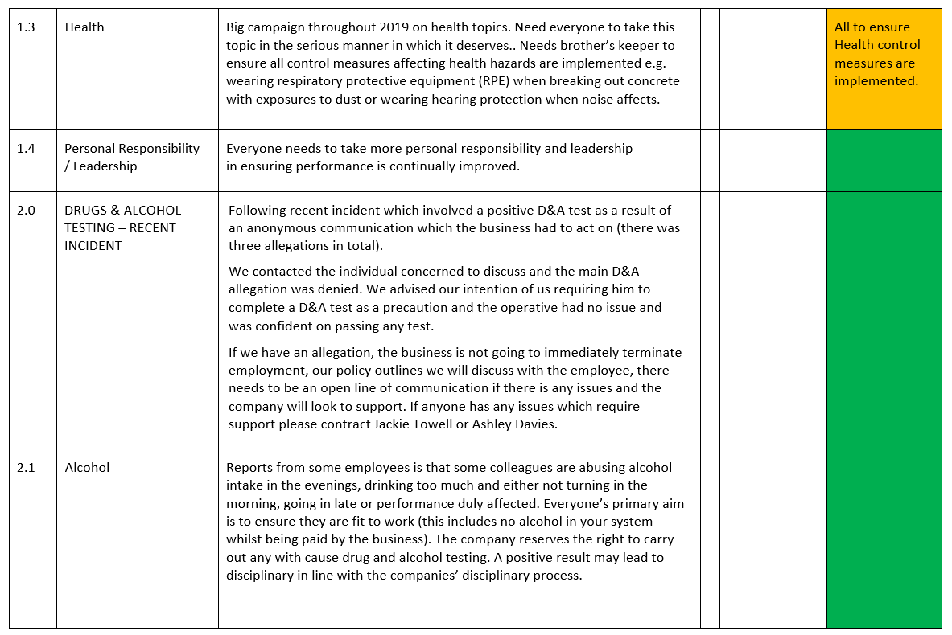
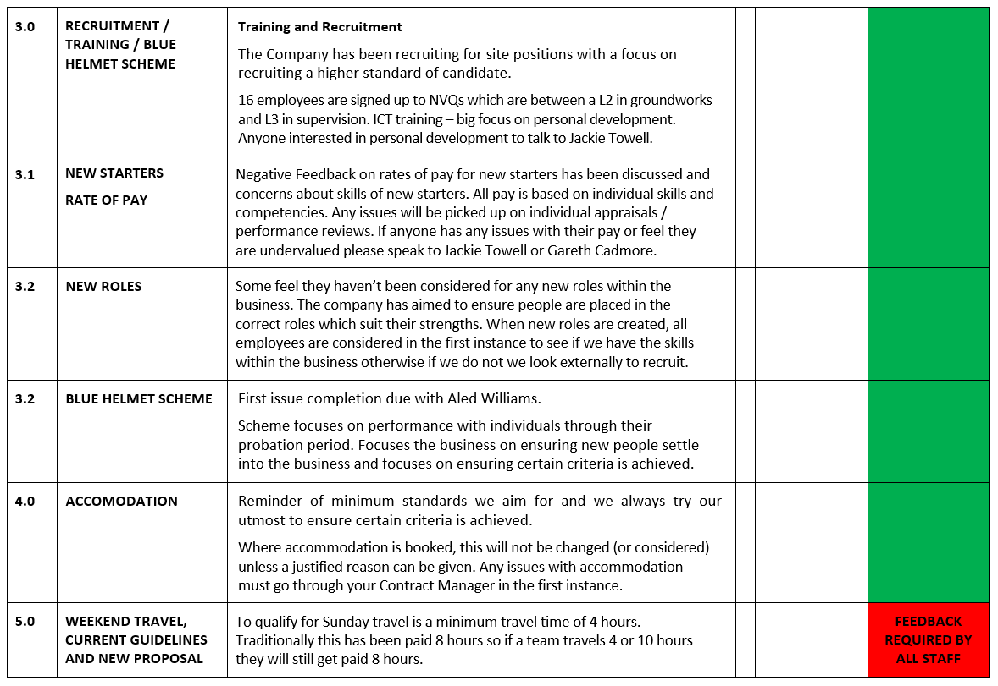
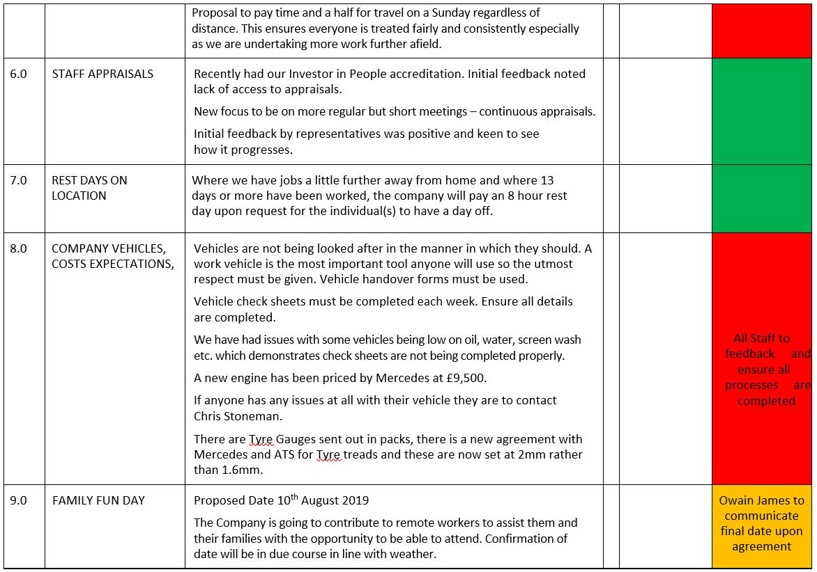
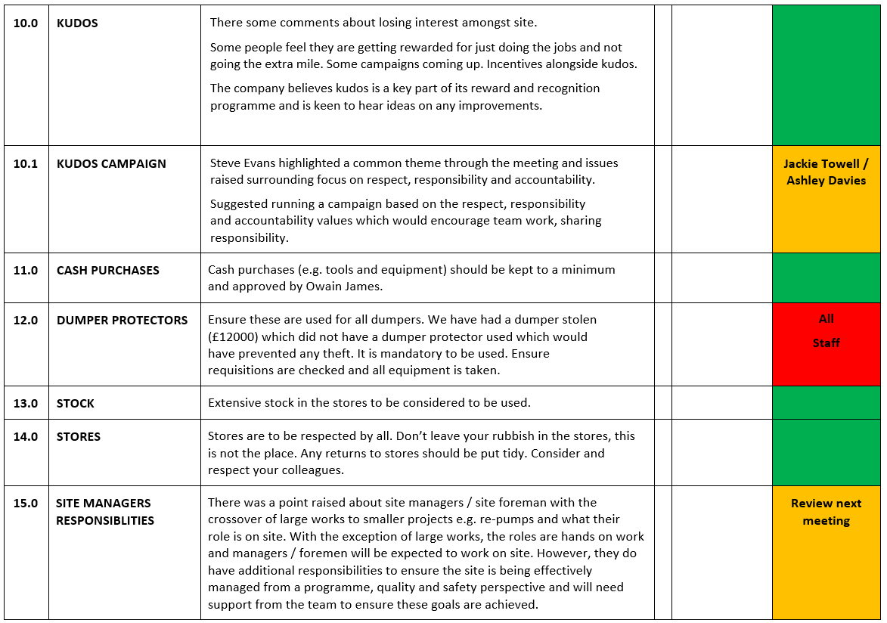
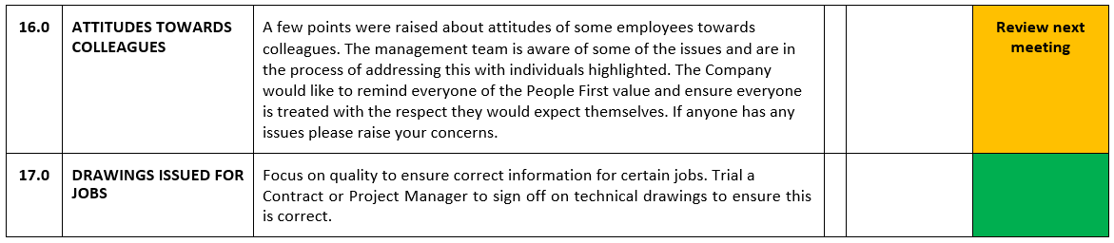

Bibliography
ACAS a, 2019. http://www.acas.org.uk. [Online]
Available at: http://www.acas.org.uk/media/pdf/d/f/Conducting_Workplace_Investigations.pdf
[Accessed 30th June 2019].
ACAS b, 2018. http://www.acas.org.uk. [Online]
Available at: http://www.acas.org.uk/media/pdf/p/f/11287_CoP1_Disciplinary_Procedures_v1__Accessible.pdf
[Accessed 7 June 2019].
ACAS b, 2019. http://www.acas.org.uk. [Online]
Available at: http://www.acas.org.uk/media/pdf/p/3/DG_Guide_Feb_2019.pdf
[Accessed 9 June 2019].
ACAS, 2001-2009. http://www.acas.org.uk. [Online]
Available at: http://www.acas.org.uk/index.aspx?articleid=1598
[Accessed 3 June 2019].
CIPD d, 2019. https://www.cipd.co.uk. [Online]
Available at: https://www.cipd.co.uk/knowledge/fundamentals/relations/communication/voice-factsheet
[Accessed 4 June 2019].
CIPD, 2018. https://www.cipd.co.uk. [Online]
Available at: https://www.cipd.co.uk/knowledge/fundamentals/emp-law/discipline/factsheet
[Accessed 14 June 2019].
Gennard, J. J., Bennett, G., Richard, T. & Richard, S., 2016. Employee Involvement and Participation. In: Managing Employee Relations. London: Chartered Institute of Personnel and Development, pp. 197-221.

