University of Wales Trinity Saint David
Advanced Computational Methods
Transient Thermal Diffusion Model using the
Finite Difference Method.

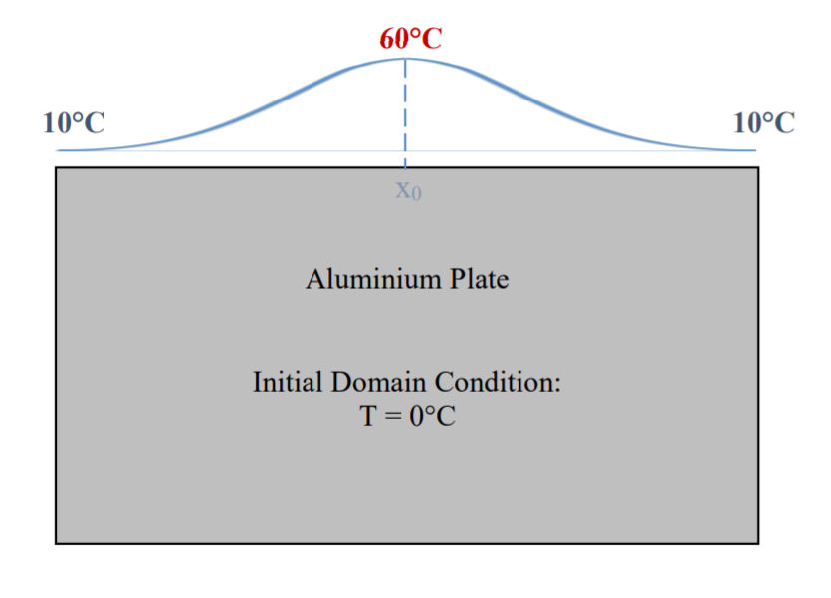

Advanced Computational Methods
M6X00408
Jordan Ross Jenkins
P149066
Due: 27/01/2020

Table of Contents
1 Introduction 1
1.1 Aims 1
1.2 Objectives 1
2 Main Body 2
2.1 The Constitutive Equation 2
2.2 Derivation 2
2.2.1 Conservation of Energy 3
2.2.2 Fourier’s law 4
2.3 Numerical method chosen to discretise the constitutive equation. 6
2.3.1 Finite Difference Method 6
2.3.2 Taylor series expansion 7
2.4 The initial and boundary conditions. 9
2.4.1 Dirichlet conditions 9
2.4.2 Neumann conditions 10
2.4.3 Initial conditions 10
2.4.4 Linear Distribution model for Analysis 11
2.5 Details of the Finite Difference Model 12
2.5.1 User Inputted Values 12
2.5.2 Initial matrix generation 14
2.5.3 Time Step Value (including Stability Criterion) 14
2.5.4 Test Code 16
2.5.5 Gaussian Distribution 16
2.5.6 Plot Type 16
2.5.7 Applying the FDM Equation 17
2.6 Analysis 21
2.6.1 Grid spacing 21
2.6.2 Time Step 23
2.6.3 Convergence 25
2.7 Limitations and suggested improvements to the model. 27
2.7.1 Limitations 27
2.7.2 Improvements 27
3 Conclusion 28
References 29

Figure 1: 1D Heat Energy Flow Diagram 3
Figure 2: 3D Heat Energy Flow Diagram 4
Figure 3: cartesian Coordinates Diagram 6
Figure 4:Boundary and Initial Conditions 9
Figure 5: Linear Distribution Boundary Conditions 11
Figure 6:: Linear Distribution In Equilibrium 11
Figure 7 : Graph showing change in equilibrium time with grid spacing 22
Figure 8 Graph showing change in Iterations with grid spacing 22
Figure 9 : Table of results for changing grid spacing 22
Figure 10: heat map showing linear distribution equilibrium 23
Figure 11: Graph Showing Equilibrium time vs Time Step 24
Figure 12: Graph Showing Iterations vs Time Step 24
Figure 13: Table of Results for change in time step 24
Figure 14: Table of Results for change of Convergence 25
Figure 15:Graph showing Iterations vs Convergence 27
Figure 16: Graph Plotting Equilibrium Time vs Convergence 27

Introduction
The study of thermal diffusion is widely used in engineering design and optimisation. Prior to widespread digital computation, thermal diffusion problems were solved through a process of arduous hand calculations and experimentation. All of these processes were susceptible to huge calculation times and systematic errors due to the repetitive nature. In recent times, digital computation has revolutionised the way in which mathematicians, scientists and engineers solve such problems, including thermal diffusion, by automating the repetitive cycle. The use of modern computers in mathematics, science and engineering has not only improved the analysis of problems that predate their creation, but also enabled new forms of numerical analysis which contain arrays much larger and more complex than previously conceived.

Aims
This report aims to detail the creation of a MATLAB Model to solve time-dependent thermal diffusion equations using FDM (finite difference method) in order to calculate the temperature distribution within a two-dimensional plate. The Model will be evaluated for effectiveness and efficiency.

Objectives
- Investigate and discuss the constitutive equation.
- Explain the numerical method used to discretise the constitutive equation.
- Discuss the boundary conditions for both linear and gaussian distributions.
- Give details of the model created to solve the heat diffusion problem.
- Analyse the scripts by varying the input variables and evaluating how this affects the outputted results.
- Discuss the benefits and limitations of the model.
- Discuss potential improvements to the model, and how they may affect the results.
- Conclude the findings of the report.

Main Body

The Constitutive Equation
Throughout this report the constitutive equation is the thermal diffusion/heat equation, a partial differential that defines the heat distribution of a specific region of interest at a given time (Kirkwood, 2018). The heat equation is a specific type of the convection-diffusion equation, the convection-diffusion equation describes the transfer of thermal energy through a solid body with respect to time (Deville, 2014).
For $T\left(x,y,z,t\right)$ where the $t$ is the time variable and $x,y,z$ are cartesian spatial variables, the heat equation is expressed as;
$$\frac{∂^{2}T}{∂x^{2}}+\frac{∂^{2}T}{∂y^{2}}+\frac{∂^{2}T}{∂z^{2}}+ \frac{\dot{q}}{k}=\frac{ρ∙C_{p}}{K}∙\frac{∂T}{∂t}$$
Where; $T_{(X,Y,Z,T)}$ = Temperature with Respect to Space and Time, $\dot{q}=$Heat Transfer Rate, $k$ = Thermal Conductivity, $ρ=$ Density, $C_{p}$ = Specific Heat Capacity.
In this instance, this can be simplified to ;
$$\frac{∂^{2}T}{∂x^{2}}+\frac{∂^{2}T}{∂y^{2}}=\frac{ρ∙C_{p}}{K}∙\frac{∂T}{∂t}$$
Assuming that; Two-dimensional plate cancels the change in temperature with regards to z and there is no internal heat generation ($\dot{q}$=0).
Also, implementation of the Laplacian operator $\frac{∂^{2}T}{∂x^{2}}+\frac{∂^{2}T}{∂y^{2}}∙∙∙ = ∇^{2}T$ and the thermal diffusivity equation$α=\frac{k}{ρ∙C_{p}}$ further simplifies the heat equation to;
$$∇^{2}T =\frac{1}{∝}∙\frac{∂T}{∂t}$$

Derivation
In order to derive the heat equation, Fourier implemented both the laws of thermal conduction and conservation of energy to describe the diffusion of heat through a body with respect to space and time (Davies, 2018). The law of thermal conduction (Fourier’s Law), is a phenomenological equation in that it is proved experimentally. The law states that $\dot{q}$ through a material is proportional to the negative gradient of the temperature (Me Mechanical , 2016).
Fourier’s law is denoted by (1-D);
$$q_{x} =-k∙\frac{∂T}{∂x}$$
Where; $q_{X}$ = Heat Flux, $k=$Thermal Conductivity, $A$ = Area, $t=$ Time.

Conservation of Energy
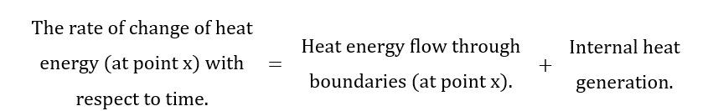
The first step in deriving the heat equation is to apply conservation laws, specifically the conservation of energy, below is a word equation that describes how the rate of heat energy changes with time;

In order to derive a mathematical representation of the word equation above, we must quantify each element in terms of factors that affect them with regards to space or time.
For the heat energy flow$(q)$ through boundaries (assuming the perimetral surface is perfectly insulated);
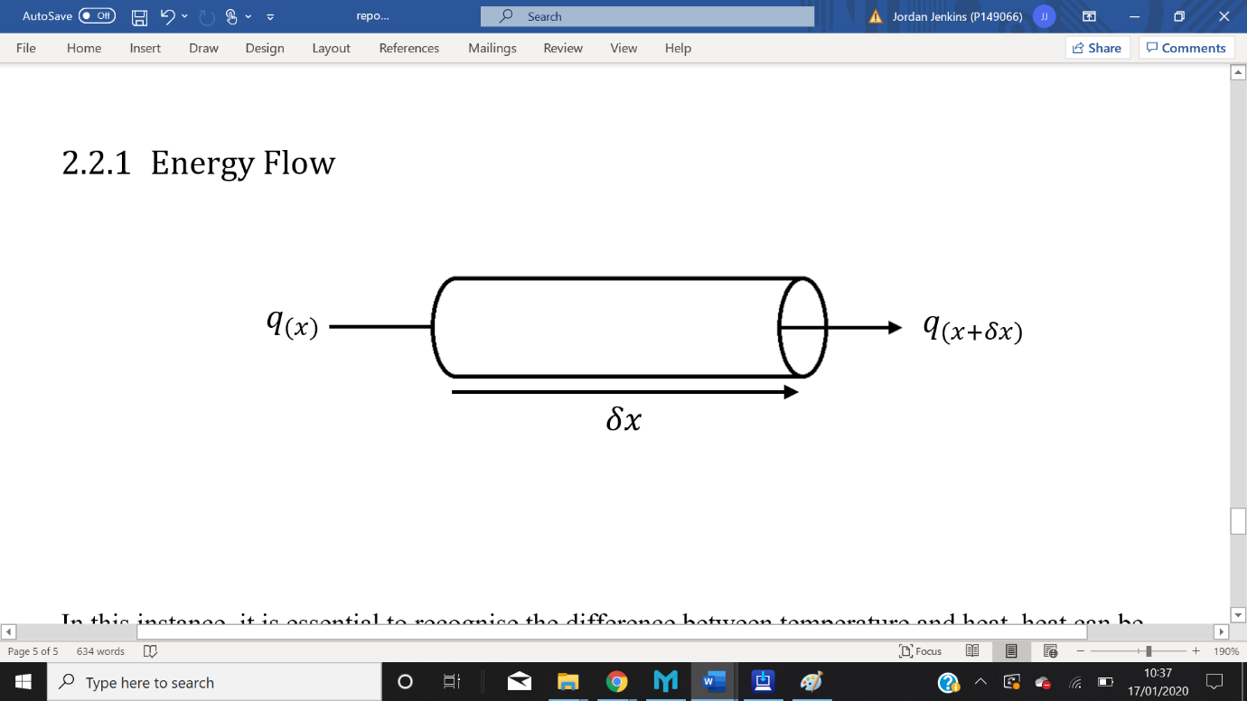
Figure 1: 1D Heat Energy Flow Diagram

If $q_{(x)}=q_{(x+δx)}$then no heat energy is gained or lost, energy flow in =$q_{(x)}$, energy flow out = $q_{(x+δx)}$.

Hence using Taylor series expansion;
$$q_{(x)|_{(x+δx)}}=q_{(x)|_{(x)}}+\frac{δq_{(x)}}{δx}∙δx$$
Where net energy flow =$q_{(x)|_{(x)}-}q_{(x)|_{(x+δx)}}$ ;
Net energy flow = $q_{\left(x\right)|_{\left(x\right)}}-(q_{\left(x\right)|_{\left(x\right)}}+\frac{δq_{\left(x\right)}}{δx}∙δx)$
Hence;
$$q_{(x)}= -\frac{δq_{\left(x\right)}}{δx}∙δx$$
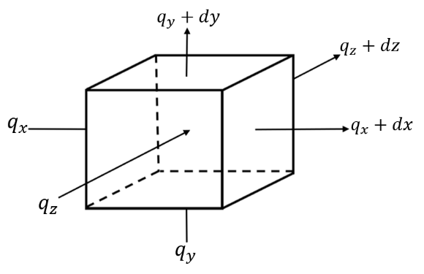
This relation can also be applied to 3-dimensions, where;
Figure 2: 3D Heat Energy Flow Diagram
$q_{(x)}= -\frac{δq_{\left(x\right)}}{δx}∙δx$ & $q_{(y)}= -\frac{δq_{\left(y\right)}}{δy}∙δy$ & $q_{(z)}= -\frac{δq_{\left(z\right)}}{δz}∙δz$
For the rate of change of heat energy (at point x) with respect to time (Assuming the material is homogenous);
Rate of change of energy = $\frac{∂u}{∂t} ×Mass$
where $u$ = internal energy per unit mass.
From the 1st law of thermodynamics;
$$u= C_{p}∙∆T$$
Therefore;
Rate of change of energy = $C_{p}∙\frac{∂T}{∂t}×ρ∙(δx∙δy∙δz)$

Where $C_{p}$ = The amount of heat per unit mass required to raise the temperature by one unit of its temperature, J/kg.C , $ρ$ = Density, kg/m³, T = Temperature at point x, K.
For internal energy generation;
Rate of energy generation = $\dot{q}∙volume$
Therefore;
Rate of energy generation = $\dot{q}∙(δx∙δy∙δz)$

Fourier’s law
This section describes the relationship between temperature and heat energy flow.
In the conception of the law of conduction, Fourier made a series of observations, these include;
- If there is no heat energy flow then the temperature = 0.
- Heat flow is positive from Higher to lower temperature (temperature gradient lower to higher = $-q$).
- Heat flow is proportional to the change in temperature. (Davies, 2018)

The above observations can be expressed by;
$q_{(x)} =-k∙A∙\frac{∂T}{∂x}$
Hence;
$q_{(x)} =-k(δy∙δz)\frac{∂T}{∂x}$
Substitute into above relation ${(q}_{(x)}= -\frac{δq_{\left(x\right)}}{δx}∙δx$);
$q_{(x)}= -\frac{δ}{δx}(-k∙δy∙δz∙\frac{∂T}{∂x}) δx$
Therefore;
$q_{(x)}= \frac{δ}{δx}(k∙\frac{∂T}{∂x}) δx∙δy∙δz$
Again, this relationship can be applied to 3-dimensions, thus
$q_{(x)}= \frac{δ}{δx}(k∙\frac{∂T}{∂x}) δx∙δy∙δz$
$q_{(y)}= \frac{δ}{δy}(k∙\frac{∂T}{∂y}) δx∙δy∙δz$
$q_{(z)}= \frac{δ}{δz}(k∙\frac{∂T}{∂z}) δx∙δy∙δz$

Finally, we can substitute all of the relationships deduced above into the word equation derived from conservation laws;
$C_{p}∙\frac{∂T}{∂t}×ρ∙(δx∙δy∙δz)$ = $(δx∙δy∙δz)∙\left[\frac{δ}{δx}(k∙\frac{∂T}{∂x})+ \frac{δ}{δy}(k∙\frac{∂T}{∂y})+ \frac{δ}{δz}(k∙\frac{∂T}{∂z}) +\dot{q}\right]$
Thus;
${\frac{δ}{δx}\left(k∙\frac{∂T}{∂x}\right)+ \frac{δ}{δy}\left(k∙\frac{∂T}{∂y}\right)+ \frac{δ}{δz}\left(k∙\frac{∂T}{∂z}\right)+\dot{q}= C}_{p}∙ρ∙\frac{∂T}{∂t}$
Assuming material is homogenous;
$$\frac{∂^{2}T}{∂x^{2}}+\frac{∂^{2}T}{∂y^{2}}+\frac{∂^{2}T}{∂z^{2}}+ \frac{\dot{q}}{k}=\frac{ρ∙C_{p}}{K}∙\frac{∂T}{∂t}$$
In this instance, this can be simplified to (2-dimensions and no internal energy generation) ;
$$\frac{∂^{2}T}{∂x^{2}}+\frac{∂^{2}T}{∂y^{2}}=\frac{ρ∙C_{p}}{K}∙\frac{∂T}{∂t}$$
Also, implementation of the Laplacian operator $\frac{∂^{2}T}{∂x^{2}}+\frac{∂^{2}T}{∂y^{2}}∙∙∙ = ∇^{2}T$ and the thermal diffusivity equation$∝=\frac{k}{ρ∙C_{p}}$ further simplifies the heat equation to;
$$∇^{2}T =\frac{1}{α}∙\frac{∂T}{∂t}$$

Numerical method chosen to discretise the constitutive equation.
It can be argued that differential equations are amongst the most important form of mathematical analysis used in engineering. For instance, modelling of any problem that consists of a physical quantity that varies over space or time, be it stress, strain, pressure, temperature, displacement etc, can be calculated from differential equations (Xie, 2010).
Solving differential equations can be generalised into to main approaches; analytical and numerical methods. Put simply analytical methods for solving differential equations can be obtained exactly, however, for some functions, an exact solution can be either very difficult or even impossible (Valli, 1994). In such cases a numerical approach is required. Numerical solutions to differential equations are best described as approximations, however Numerical solutions can be very useful, one such use is in a scenario where the governing equations of the problem are functions of multiple different parameters, such as partial differential equations (Morton, 2005).

Finite Difference Method
The constitutive equation (thermal diffusion equation) in this problem is a partial differential (PDE). Analytical solutions to PDE’s are functions that satisfy both the PDE and the initial and or boundary conditions. In this case and many cases involving PDE’s there is no analytical solution, meaning a numerical approximative approach is needed (causon, 2010).
One such approach is the finite difference method (FDM). Put simply, the finite difference method is a process of substituting the derivatives in PDE’s with difference equations, FDM uses a series of discretisation’s to approximate the differences, these can be backwards, forwards or central (Lewis, 2019).
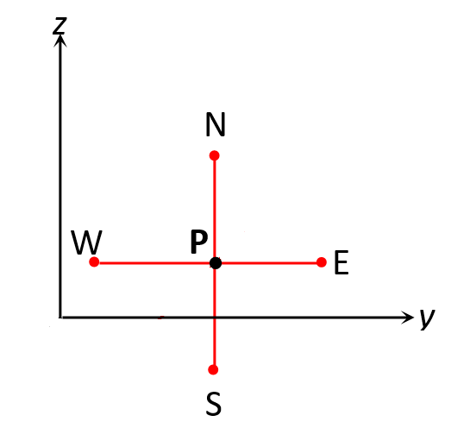
FDM is one of the earliest forms of numerical solutions to ODEs and PDEs. The method was first used by Euler, in around 1768 (Blazek, 2005). The FDM is applied to the differential form of the Constitutive equation. In this instance, the equation of thermal diffusivity with respect to space and time. The FDM uses the Taylor series expansion in order to derive approximations of a function around (N,E,S,W) and at a given point P. (see figure 3).
Figure 3: cartesian Coordinates Diagram

Taylor series expansion

The Taylor series equation is shown below;
$$f\left(x\right)=\sum_{n=0}^{∞}{f^{\left(n\right)}\left(x_{0}\right).\frac{{\left(x-x_{0}\right)}^{n}}{n!}}$$
As mentioned above, the Taylor series can be derived for backwards, forwards or central differences for 1st order differentials.
Backwards Difference = $f^{'}\left(x_{0}\right)≈\frac{f\left(x_{0}\right)-f\left(x_{0}-h\right)}{h}$
Forward Difference = $f^{'}\left(x_{0}\right)≈\frac{f\left(x_{0}+h\right)-f\left(x_{0}\right)}{h}$
Central Difference = $f^{'}\left(x_{0}\right)≈\frac{f\left(x_{0}+h\right)-f\left(x_{0}-h\right)}{2.h}$
For the scope of this problem, only the central difference equation is needed for second order differentials.
2nd order Central Difference = $f^{''}\left(x_{0}\right)≈\frac{f\left(x_{0}+h\right)-2.f\left(x_{0}\right)+f\left(x_{0}-h\right)}{h^{2}}$
In order to solve this diffusion problem, we need to apply a combination of the forward and 2nd order central difference equations to the thermal diffusion equation mentioned above;
$$∇^{2}T =\frac{1}{α}∙\frac{∂T}{∂t}$$
We need to substitute a difference equation into each differential, to solve the change in temperature over time $(\frac{∂T}{∂t})$ the forward difference equation is used;
$$∇^{2}T =\frac{1}{α}∙\frac{∂T}{∂t}$$
Substitute Taylor series expansion;

$$∇^{2}T =\frac{1}{∝}∙\frac{f\left(x_{0}+h\right)-f\left(x_{0}\right)}{h}$$
Hence,
$$∇^{2}T =\frac{1}{α}∙\frac{T_{p}^{t+∆t}-T_{p}}{∆t}$$
we also need to apply the 2nd order central difference equations to the thermal diffusion equation mentioned above, we do this by applying the 2nd order difference equation into each differential within the Laplace operator, to solve the change in temperature over the spatial variable $(\frac{∂T}{∂xyz})$ the forward difference equation is used;
$$∇^{2}T= \frac{∂^{2}T}{∂x^{2}}+\frac{∂^{2}T}{∂y^{2}}$$
Hence,
$$\frac{∂^{2}T}{∂x^{2}}+\frac{∂^{2}T}{∂y^{2}}= \frac{1}{α}∙\frac{T_{p}^{t+∆t}-T_{p}}{∆t}$$
Substitute Taylor series expansion;
$$\frac{∂^{2}T}{∂x^{2}}= \frac{T_{E}-2T_{p}+T_{W}}{h^{2}}$$
$$\frac{∂^{2}T}{∂y^{2}}= \frac{T_{n}-2T_{p}+T_{s}}{h^{2}}$$
Therefore,
$$\frac{T_{E}-2T_{p}+T_{W}}{h^{2}}+ \frac{T_{n}-2T_{p}+T_{s}}{h^{2}} = \frac{1}{α}∙\frac{T_{p}^{t+∆t}-T_{p}}{∆t}$$
$T_{p}^{t+∆t}$ is unknown, thus rearrange,
$$\frac{{(T}_{E}+T_{W}+ T_{n}+T_{s}-4T_{p})}{h^{2}} ×α×∆t= T_{p}^{t+∆t}$$
$$∴$$
$$=\frac{α×∆t}{h^{2}} \left(T_{E}+T_{W}+ T_{n}+T_{s}\left(\frac{h^{2}}{α×∆t}-4\right)Tp\right)$$
Substitute in the equation for Fourier’s number $\left(\frac{α×∆t}{h^{2}}\right)$ where F₀ is a dimensionless ratio between the rate of heat conduction to the rate of heat storage;

$$T_{p}^{t+∆t} =F_{0} \left(T_{E}+T_{W}+ T_{n}+T_{s}\left(\frac{1}{F_{0}}-4\right)Tp\right)$$

The initial and boundary conditions.
Both initial and boundary conditions must be defined when solving transient Heat transfer problems, this is due to the derivatives with respect to the time and spatial variables in the heat transfer equation. Boundary conditions are dependent on the spatial derivatives, whereas the initial conditions are those that depend on time (Lewis, 2019). In heat transfer problems we must specify two boundary conditions for each spatial derivative, thus in 2 dimensional problems, 4 boundary conditions must be specified. There are 4 main types of boundary conditions used in heat diffusion problems, these include; Dirichlet, Neumann, Robin and Mixed (Croft, 1989). Dirichlet conditions are where the temperature at the boundary is known/specified. Neumann conditions are those where the rate of heat flow at the boundary is known, Robin conditions are where an energy balance is stated at the boundary. Mixed conditions are a combination of the aforementioned boundary conditions.
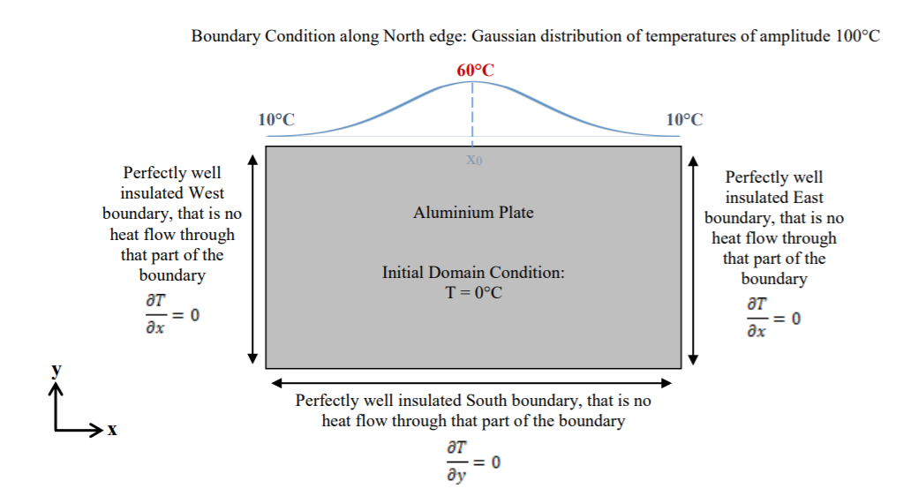
The boundary conditions used in this problem are Dirichlet and Neumann conditions.
Figure 4:Boundary and Initial Conditions

Dirichlet conditions
The Dirichlet boundary condition is used on the northmost boundary of the domain, it specifies the fixed temperature. This condition can be denoted mathematically by the following expression.
$$T_{b}=f(x,y,t)$$
Where $T_{b}=$Boundary Temperature.

Gaussian Distribution
As shown in figure 4, the temperature of the northmost boundary follows the Gaussian/ normal distribution. The Gaussian distribution Is calculated from the following equation.
$$y= A∙e^{\frac{{-\left(x-μ\right)}^{2}}{{2σ}^{2}}}$$
Where;
$y=$the vertical height of some point on the Gaussian distribution,
A= Amplitude,
$σ$ = standard deviation,
$x$ = distance along x-axis,
$μ$ = Mean distribution.

Neumann conditions
The Neumann conditions are applied to the east, west and south boundaries of the domain. As mentioned above the Neumann condition describes a known rate of change of temperature at the boundary, in this problem the boundary is adiabatic, hence the condition can be expressed using Fourier’s law;
$$q_{b}=-K\frac{dT}{d(x,y)}=0$$
Where $q_{b}=$Boundary heat flux, $K= Thermal Conductivity$

Initial conditions
Due to the transient nature of the problem, initial conditions need to be specified. Initial conditions are defined as those that depend on the time derivative (Davies, 2018), in this problem, the initial conditions refer to the Temperature of all nodes within the domain at time = 0. The initial conditions are stipulated in the assignment specification as 0ºC. Using the Cartesian Coordinates the initial conditions can be expressed as follows;
$$T\left(x,y,t_{0}\right)=0^{o}C$$
Where; $T=$ Temperature,ºC. $t_{0}=$ Time zero.

Linear Distribution model for Analysis
In order to validate the finite difference model, A model with linear Dirichlet boundary conditions is used. The Boundary conditions are as follows;
50 through 0 degrees applies linearly along the north and south boundary
50 degrees applied to the west boundary
0 degrees applied to the east boundary
The initial condition of the domain is the same as the gaussian distribution finite difference model.
$$T\left(x,y,t_{0}\right)=0^{o}C$$
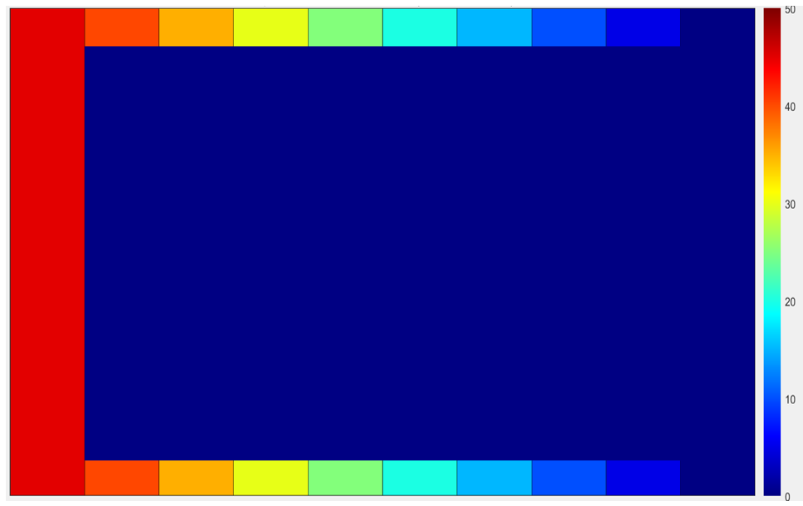
The boundary and initial conditions of the linear distribution test code are best described in the heat map bellow (figure 5).

Figure 5: Linear Distribution Boundary Conditions
When the matrix is in equilibrium, vertical bars matching the colour of the boundaries should propagate through the plate from the west boundary to the east boundary.
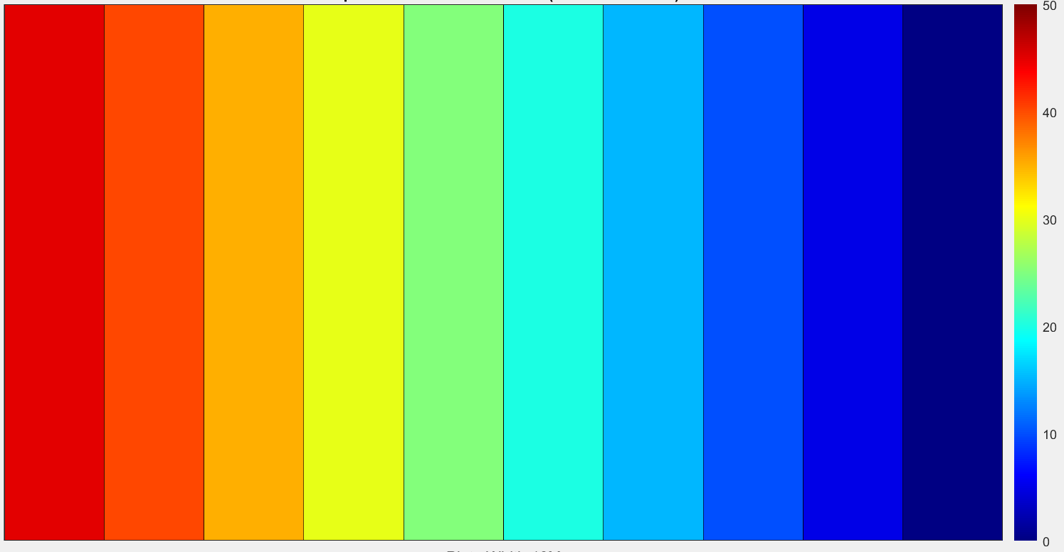
figure 6 below shows how the heat map will appear when the plate has reached equilibrium.
Figure 6:: Linear Distribution In Equilibrium

Details of the Finite Difference Model
This section gives details of the code developed to both solve and display the thermal diffusion problem detailed above. The main method behind developing the code involved increasing functionality in terms of the number of accepted plate sizes, grid spacings and time step combinations. Another important consideration in the development of the code was the optimisation of the solve time as well as usability. The code was developed closely alongside the stipulated conditions set out in the assignment brief.
The model uses a series of functions to consolidate large chunks of code into sections, the only reason for this is it made the code, which was becoming sizable, easier to follow and troubleshoot during development.

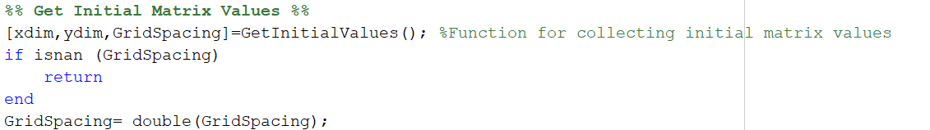
User Inputted Values
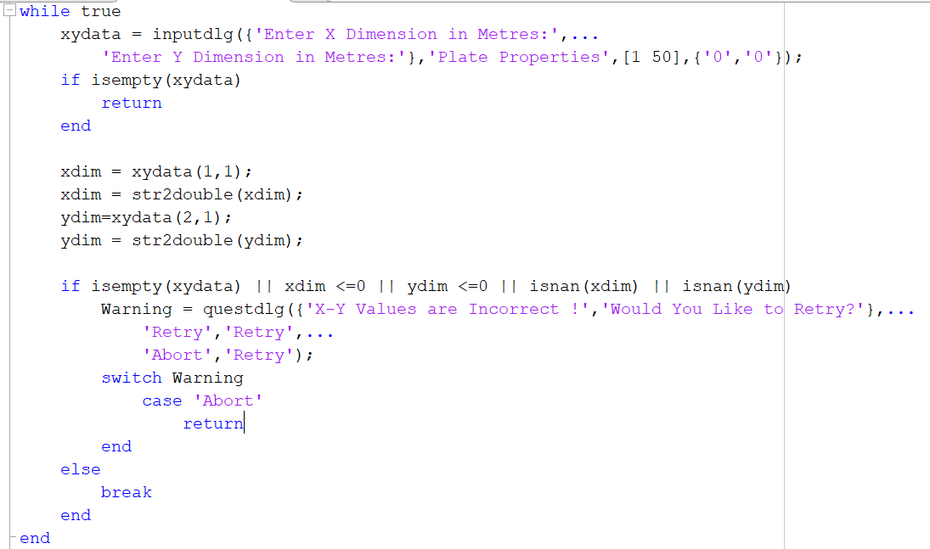
Above is the line of code that calls the function for collecting plate size and the grid spacing values. There are no inputs to this function and the x dimension, y dimension and grid spacing are outputs.
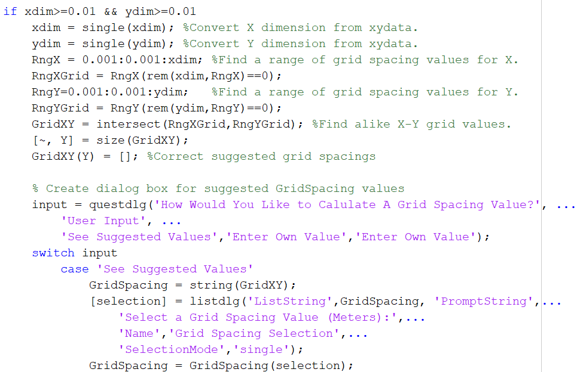
The plate x and y dimension values are collected using dialog boxes, in this instance named “xydata”. Values outputted from dialog boxes in MATLAB are strings, hence the str2Double function is used to convert the x and y dimension to a numerical value. This entire section is within a ‘while true’ loop, this is simply to keep redisplaying the dialog box if the user enters an incorrect value. An if statement is used to check that the entered values are compatible, the if statement includes conditions such as not a number, smaller or equal to zero, isempty. As long as the user enters values that do not satisfy any of the if statement conditions, the while loop is broken and the code progresses.
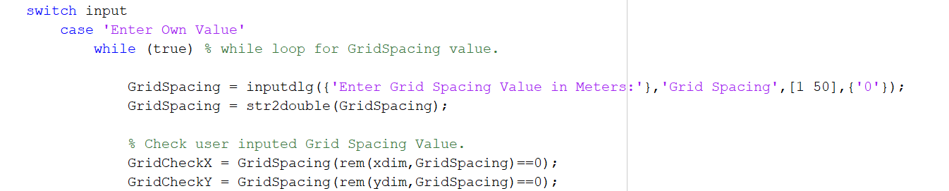
For 1x1 cm and above plates, the user can choose from a series of suggested grid spacings, this can be particularly useful when the user enters an incorrect value. The suggested values are calculated by creating a row vector (RngX/RngY) of every number between 1mm and the inputted x/y value, with a step off 1mm. A function that calculates the remainder after division is then used to create 2 vectors (RngXGrid/RngYGrid) of all the numbers that have a remainder of 0 when xdim/ydim are divided by all the values in the row vectors (RngX/RngY). A function called intersect creates another vector (GridXY) of all of the alike numbers in RngXGrid/RngYGrid, these numbers are all devisable by the x & y dimension so are therefore compatible grid spacings.
User inputted Grids spacings are collected in dialog boxes using the same ‘While true’ method discussed for the plate dimension inputs above. These values are then checked using the remainder function to ensure there is no remainder when xdim/ydim are divided by the entered grid spacing.
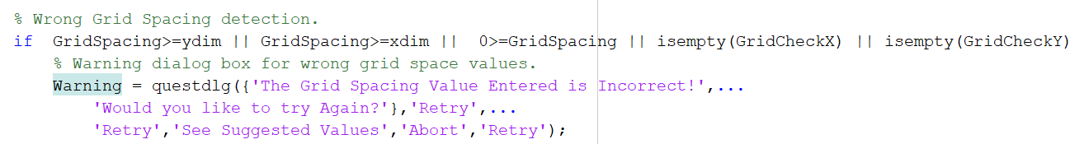
Again, an if statement is used to detect incorrect grid spacings and thus prompt the user to retry, the conditions for this statement are; if the grid spacing is greater or equal to the x/y dimension, less than or equal to zero, an if the remainder checks mentioned above do not return a logical 1 (because the grid spacing isn’t divisible by xdim/ydim).

Initial matrix generation
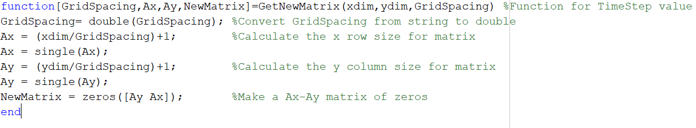
Once all the values are collected, it is logical to then generate the initial matrix, this is done by calling the function “GetNewMatrix”. The inputs to this function are; xdim, ydim and GridSpacing. The function outputs GridSpacing, Ax,Ay and NewMatrix.
In this function, Ax and Ay add 1 to the x/y dimensions to account for the boundary conditions. The matrix is also pre-allocated with zeros in ‘NewMatrix’. Pre-allocation of matrices outside of a calculation loop is an optimisation technique to decrease solve time.

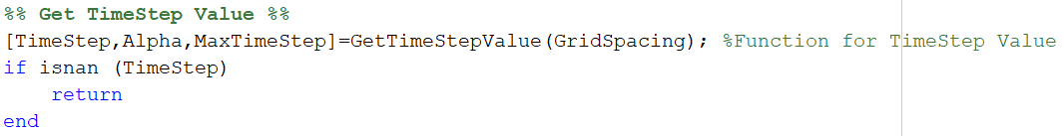
Time Step Value (including Stability Criterion)
The next step is to collect a Time Step value, this is done by calling the ‘GetTimeStep’ Function. The input to this function is the grid spacing and the function outputs the user entered time step and the calculated alpha and max time step values.
The equation $α=\frac{k}{ρ∙C_{p}}$ is used in order to find the thermal diffusivity of aluminium, which is then used to calculate the maximum time step.

Stability Criterion
It is necessary to calculate the upper limit to the time step in order to abide by the stability criterion, where Fourier’s number must not exceed 0.25 for 2 dimensional problems. The stability criterion will be discussed further in the limitations of the model section. The max time step is calculated by rearranging the Fourier’s number equation $F_{o}=\left(\frac{α×∆t}{h^{2}}\right)$ for $∆t$ and substituting in the max Fourier’s number value stipulated by the stability criterion ;
$$t_{max}= \frac{F_{o}∙h^{2}}{α}$$
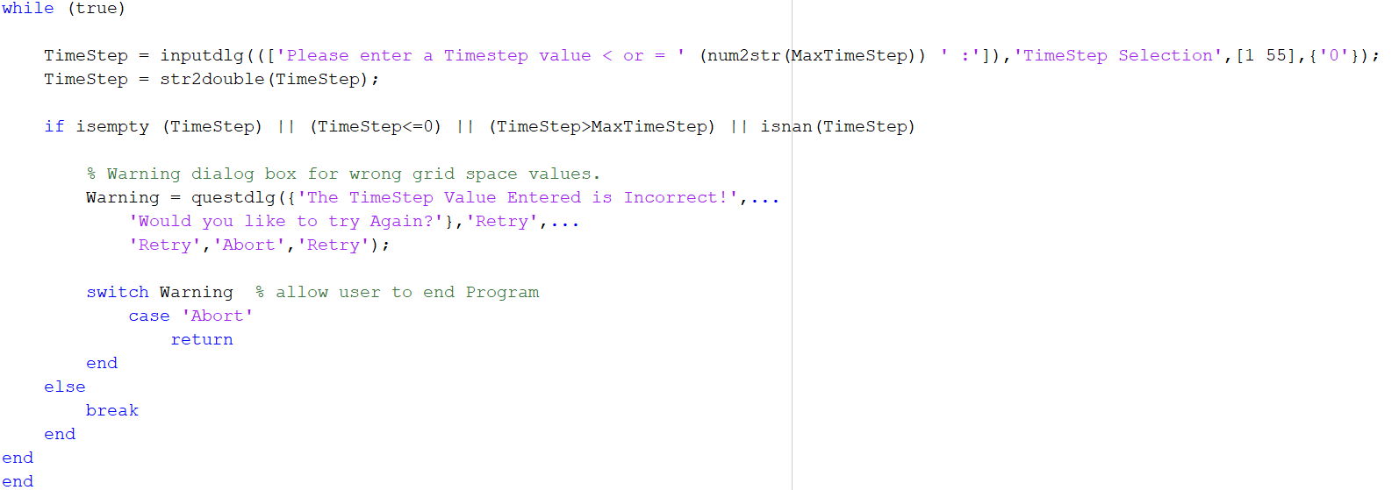
Where; $t_{max}$ = max time step, $F_{o}$= Fourier’s number,$h$ = grid spacing,$α$= thermal diffusivity.
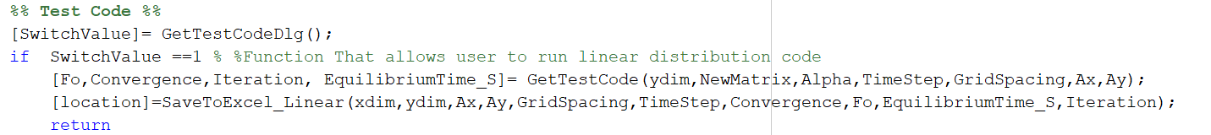
The time step value is collected using the same dialog box and ‘while true’ convention discussed above. The Max Time step is displayed in the dialog box string to prompt the user to enter a compatible time step value. The entered value is then checked with another if statement, the conditions of the if statement are; time step is empty, less than or equal to zero, is grater than the calculated max time step and is not a number.

Test Code
Within the model there is also an option to run a test code with a linear boundary condition, this code will be used and hence discussed in the analysis section.

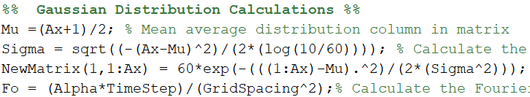
Gaussian Distribution

The next section of code calculates and applies the Gaussian distribution to the northmost boundary of the domain. The standard deviation is unknown, hence the equation for normal distribution is rearranged for $σ$. Sigma is then plugged back into the normal distribution equation to calculate the temperature at each point in x at the northmost boundary.

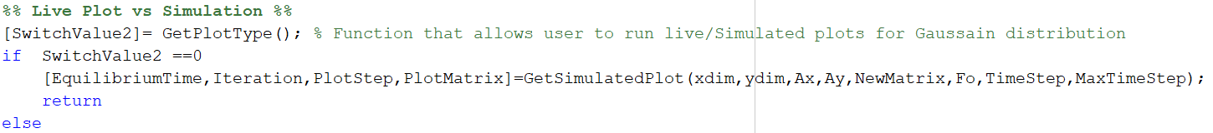
Plot Type
The code also gives the user the option of choosing the way in which the program plots the graph that displays the heat diffusion through the plate over time. The first option is a live plot, where the graph is plotted and updated within the calculation while loop, this method is advantageous in that it uses the least computer memory, however for problems with large plate sizes, small grid spacings or small time steps, this method can dramatically increase the overall solve time. In MATLAB, high-level plotting functions such as contourf and surf severely impact performance.
The second option is to pre-allocate a 3-dimensional array, and using a sampling factor (in this case every 100 iterations) assign each layer of the array with the plate temperatures at each time step, this can dramatically reduce the solve time of the calculation as the program doesn’t need to plot inside of the calculation while loop. Once the calculations are completed, the code uses the data stored in the 3D array to plot a graph of the heat transfer through the plate. This is also beneficial in that the plate equilibrium time and total number of iterations are calculated more quickly, as well as the ability to add multiple plots such as contourf, surf and line plots without affecting the solve time of the computation. One limitation to this method is storage capacity, for large plates, plates with very small grid spacings or time steps, the arrays stored may require substantial free storage space.
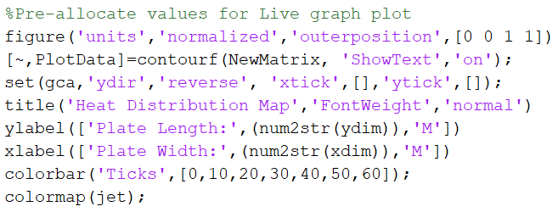
The section of code above is used to pre-allocate the heat distribution graph plot. Without pre-allocation these values, such as; axis labels, title, graph colour scheme etc., would be redefined on each iteration of the calculation while loop, this increases demand on computational resources and hence increases the solve time of the calculation. By implementing the pre-allocation method shown above, only the plotted data is redefined or updated on each iteration of the calculation loop.

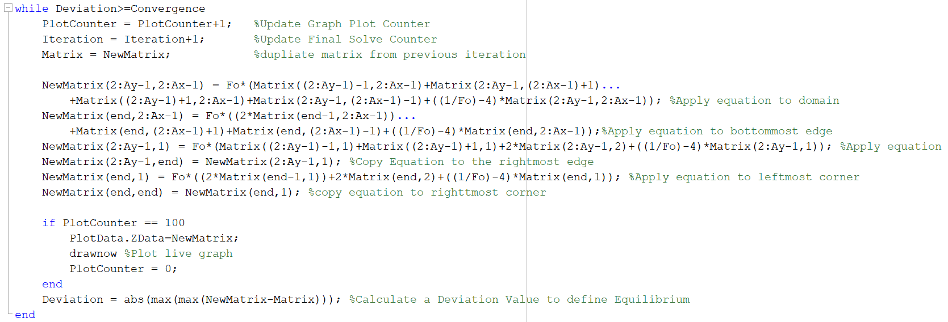
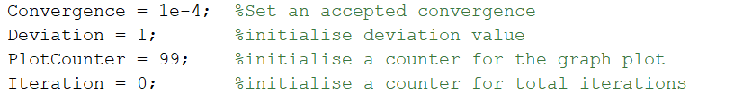
Applying the FDM Equation
This section of code is the calculation while loop or the finite difference scheme used to solve the thermal diffusion equation. Some initial variables are defined outside of the loop, these include; iteration counters used for the graph plot sampling factor as well, as the total number of iterations taken for the plate to reach equilibrium and a convergence value that is used later in the code to define equilibrium.
Within the while loop, the variables mentioned above (iteration counters etc.) are updated on each iteration. The Matrix is duplicated at the start of each iteration by simply assigning the values to a new name (Matrix). After the finite difference equation has been applied to the matrix at least once, these 2 matrices essentially become the current and future representations of the temperature diffusion through the plate. The finite difference equation defined above is applied to the matrix on each iteration, in total 6 variations of the equation are used in order to account for the boundary conditions as well as the domain. Initially these equations were written using for loops containing vectors of each position with respect to the x or y direction however, they have since been vectorised in order to decrease solve time.
The Finite difference Equation (discussed above) is given by;
$$T_{p}^{t+∆t} =F_{0} \left(T_{N}+T_{E}+ T_{S}+T_{W}\left(\frac{1}{F_{0}}-4\right)Tp\right)$$

Domain
The first equation used in the calculation loop applies the finite difference equation to the centre section of the plate known as the domain. The $T_{p}^{t+∆t}$ is applied to every cell within the domain of the New Matrix;
$$T_{p}^{t+∆t} = NewMatrix(2:Ay-1 , 2:Ax-1)$$
The north, south, east and west locations are given by.
$$T_{N}= Matrix((2:Ay-1)-1 , 2:Ax-1)$$
$$T_{E}= Matrix(2:Ay-1 , (2:Ax-1)+1)$$
$$T_{S}= Matrix((2:Ay-1)+1 , 2:Ax-1)$$
$$T_{W}= Matrix(2:Ay-1 , \left(2:Ax-1\right)-1)$$

Bottom Boundary
The lines of code above calculate $T_{p}^{t+∆t}$ at the bottom most boundary and then assign the values to NewMatrix. The end function is used to specify the last row in the matrix. The East and West coordinates stay the same as those used in the equation for the domain. In this scenario there is no south node as the e $T_{p}^{t+∆t}$ is in the bottom boundary. Applying the Neumann boundary relation;
$$q_{b}=-K\frac{dT}{d(x,y)}=0$$
The condition essentially states that the boundary is perfectly insulated and there is no heat transfer across the boundary, this can also be interpreted as no heat is lost at the boundary. It is then necessary to use the relation $T_{S}$ = $T_{N}$.
Hence
$$T_{p}^{t+∆t} =F_{0} \left(T_{N}+T_{N}+ T_{E}+T_{W}\left(\frac{1}{F_{0}}-4\right)Tp\right)$$
$$∴$$
$$T_{p}^{t+∆t} =F_{0} \left({2∙T}_{N}+ T_{E}+T_{W}\left(\frac{1}{F_{0}}-4\right)Tp\right)$$

Right & Left Boundary
$T_{p}^{t+∆t}$ for the left most boundary is also calculated applying the Neumann boundary condition. The relationship $T_{W}$ = $T_{E}$ is used to satisfy the boundary condition, this is expressed as;
$$T_{p}^{t+∆t} =F_{0} \left(T_{N}+ T_{E}+T_{S}{+T}_{E}\left(\frac{1}{F_{0}}-4\right)Tp\right)$$
$$∴$$
$$T_{p}^{t+∆t} =F_{0} \left(T_{N}+ T_{S}+2∙T_{E}\left(\frac{1}{F_{0}}-4\right)Tp\right)$$
Due to the fact that the gaussian distribution used in this instance is perfectly symmetrical, as well as the Neumann conditions on both the right and left boundaries, the values for $T_{p}^{t+∆t}$ for the left boundary and be ‘copied’ to the right boundary

Bottom left & Bottom right boundary
$T_{p}^{t+∆t}$at the bottom corners of the matrix is a combination of the horizontal and vertical boundary conditions. For the left bottom corner, $T_{S}$ = $T_{N}$ & $T_{W}$ = $T_{E}$ must be used to satisfy the boundary condition.
$$T_{p}^{t+∆t} =F_{0} \left(T_{N}+ T_{E}+T_{N}{+T}_{E}\left(\frac{1}{F_{0}}-4\right)Tp\right)$$
$$T_{p}^{t+∆t} =F_{0} \left({2∙T}_{N}+2∙T_{E}\left(\frac{1}{F_{0}}-4\right)Tp\right)$$

Again, the values for $T_{p}^{t+∆t}$ for the bottom left boundary is copied to the right bottom boundary.
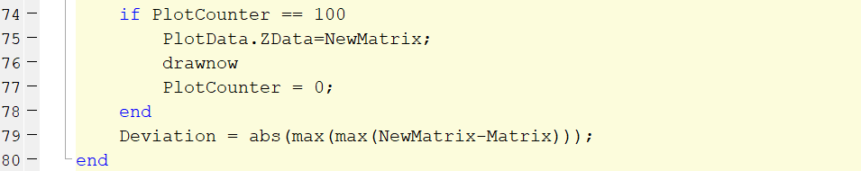
The lines of code above show the last section of the calculation loop, this section includes the live plot, definition of equilibrium. For the plot of the heat map, a sampling factor of 100 iterations is used, this means the plot is updated every 100 iterations within the loop, this increases the solve time by decreasing the computational resources used on each iteration. The .ZData function Is used to update the plotted data every 100 iterations.
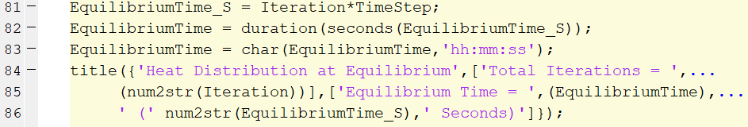
The variable named ‘Deviation’ is used in the definition of equilibrium for the finite difference scheme. Equilibrium in this model is defined as the value of the deviation calculation being less than or equal to the convergence value defined above (1e-4). The use of max in the calculation looks for the value with the biggest difference between the two arrays and ‘abs’ negates whether the value is negative.
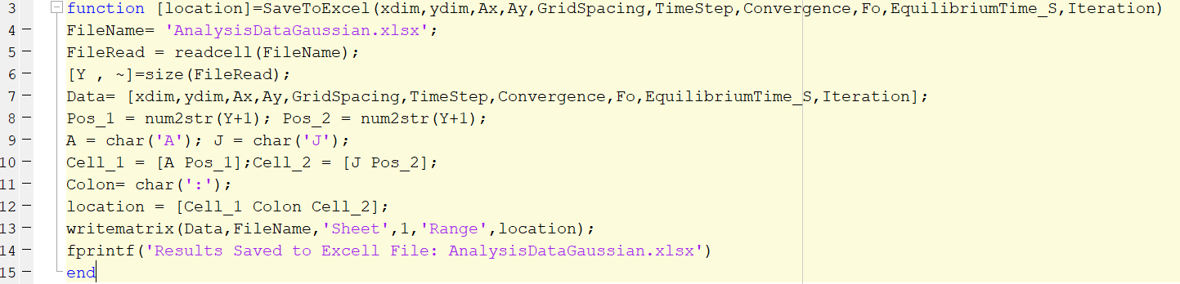
The time taken for the plate to reach equilibrium is calculated once the calculation loop is completed, this is done by multiplying the total number of iterations by the time step. The time is then converted from seconds to a hh:mm:ss format for display.
A function was also created to save the results of each solve to an excel spreadsheet for use in the analysis section.

Analysis
In this section, the Results of the linear distribution code are analysed. The linear code is used to validate the finite difference scheme used in the gaussian distribution model. It would be particularly difficult to complete such an analysis on the gaussian model as the equilibrium position for each variable combination is not as easy to define as that of the linear distribution code. The methodology for the analysis is an empirical variable dependency study, in which each variable is changed independently of the others to see how they affect the results in each solve. The variable dependencies tested in the scope of this analysis include;
- Grid Spacing
- Time Step
- Convergence value
Firstly, a set of control parameters are created, for the scope of this analysis, the control parameters are;
- X dimension = 10m.
- Y dimension = 10m
- Grid Spacing = 1m
- Time Step = 38s
- Convergence value = 1e-5
The convergence value specified above was chosen by trial and error when developing the model. Having changed and tested the convergence value multiple times, 1e-5 appear to allow the biggest range of plate size, grid spacings, and time step combinations to reach equilibrium.

Grid spacing
To analyse how the grid spacing affects the results yielded from the model, the variables for x/y dimension, timestep and convergence were kept constant throughout all of the solves. The grid spacing value was increased on each iteration of the code, from 0.1 to 5 metres over the course of 11 runs. At the end of each iteration the values for the final equilibrium time and total number of iterations are calculated and compared against the changing Grid Spacing as to offer a tangible visualisation as to how the grid spacing affected the results of the model.
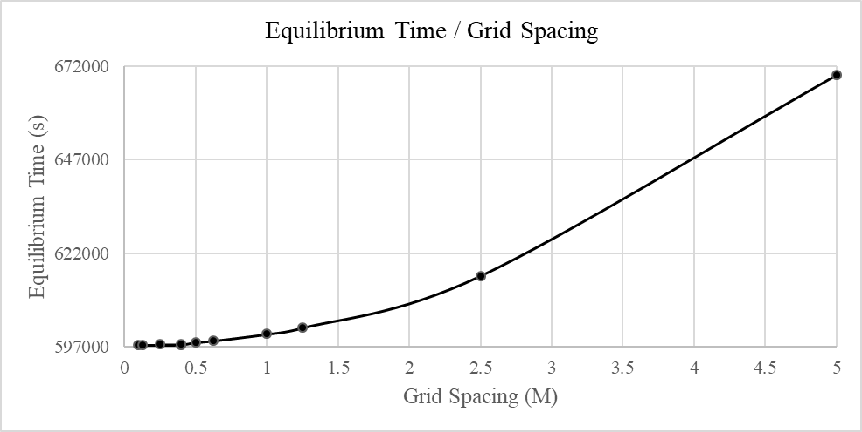
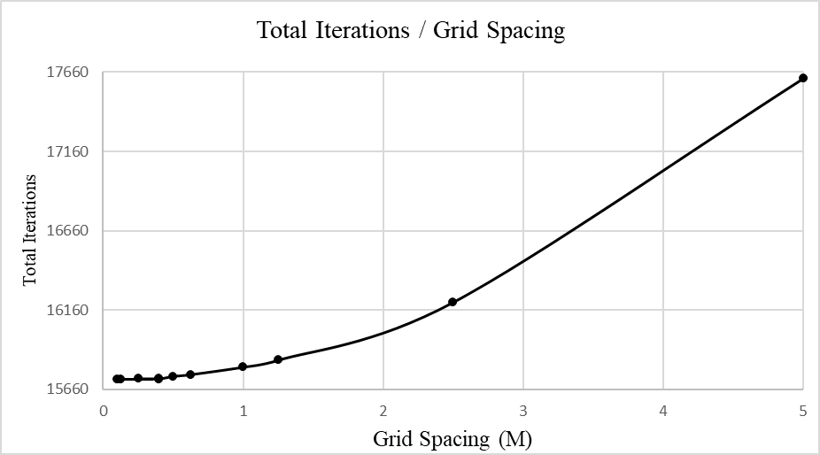
Figure 7 : Graph showing change in equilibrium time with grid spacing
Figure 8 Graph showing change in Iterations with grid spacing
Figure 9 : Table of results for changing grid spacing
All of the results collected in the 11 runs for the change in grid spacing appeared to converge. The definition of convergence is made by observing the colour map at the end of each solve. A converged result should have straight colour bars that start at 50ºc and decrease linearly.

Figure 10: heat map showing linear distribution equilibrium
The results plotted in figure 7 show that as the grid spacing increases so does the equilibrium time. The rate of change of the equilibrium time appears to increase as the increment between the grid spacing increases. It has to be noted that there is a substantial difference between the range of results. between a grid spacing of 0.1 and 5, the range of calculated equilibrium time is 72,200 seconds.
The results shown in figure 8 also follow this same trend, as the grid spacing increases, the iteration count increases substantially.
It is fair to assume that a finer grid should yield more accurate results, according to (lewis, 1996), the accuracy of finite difference schemes improves as grid spacing and timestep approach 0. In this case, the increase in equilibrium time and iterations may be attributed to an increasing truncation error.

Time Step
To analyse how the time step affects the results from the model, the variables for x/y dimension, grid spacing, and convergence were kept constant throughout all of the solves. The time step value was increased by factors of 10 on each iteration of the code, from 0.38 to 3800 metres over the course of 5 runs. At the end of each iteration, the values for the final equilibrium time and total number of iterations are calculated and compared against the changing time step as to offer some insight into how the time step affected the results of the model.
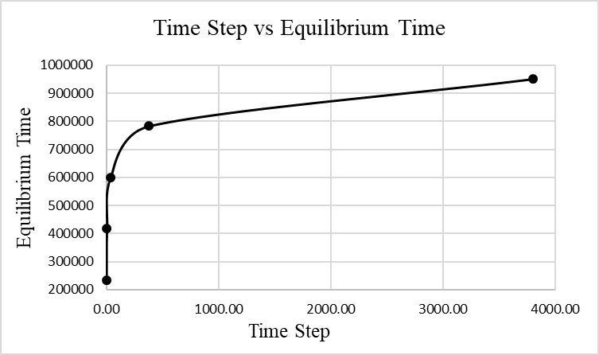
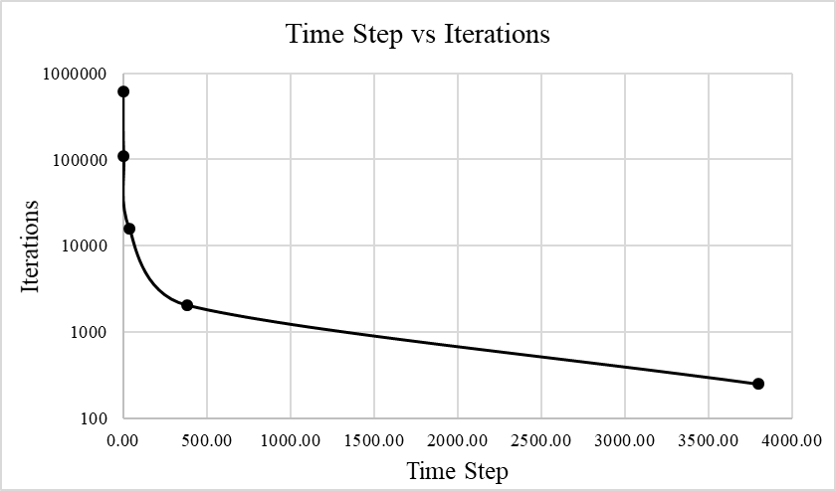
Figure 11: Graph Showing Equilibrium time vs Time Step
Figure 12: Graph Showing Iterations vs Time Step
Figure 13: Table of Results for change in time step
Two of the results plotted in figures 11 & 12 did not converge/ reach equilibrium. The red dashed line on each figure shows the point after which the results reached equilibrium. Figure 12 appears to show that the rate of change of the equilibrium time gets significantly larger the closer the time step is to zero. The figure also shows that generally the equilibrium time increases with increased time step, however this relationship Is far from linear. It appears that as the time step increases above 1/100 of the maximum time step the relationship becomes more linear.
The change in iteration count seems to be the inverse of change in equilibrium time. Again, as the time step value exceeds 1/100 of the max time step the change becomes more linear. As the time step nears 0, the iteration count falls drastically, generally the relationship can be described as decreasing with the increase in time step.
It is widely known that the accuracy and stability of Finite difference methods increases the closer the time step is to 0 (lewis, 1996). If this is true in this case, both of these graphs display a substantial disparity in the accuracy of equilibrium time and iteration calculations when large time steps are used.

Convergence
To analyse how the convergence value affects the results from the model, the variables for x/y dimension, grid spacing, and time Step were kept constant throughout all of the computations. The convergence value was increased from 1e-1 to 10e-10 over the course of 10 runs. At the end of each iteration, the values for the final equilibrium time and total number of iterations are calculated and compared against the changing convergence as to show how the convergence affected the results of the model.
Figure 14: Table of Results for change of Convergence

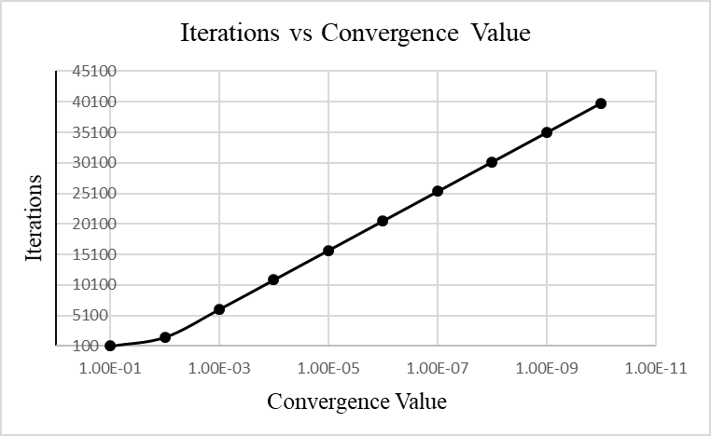
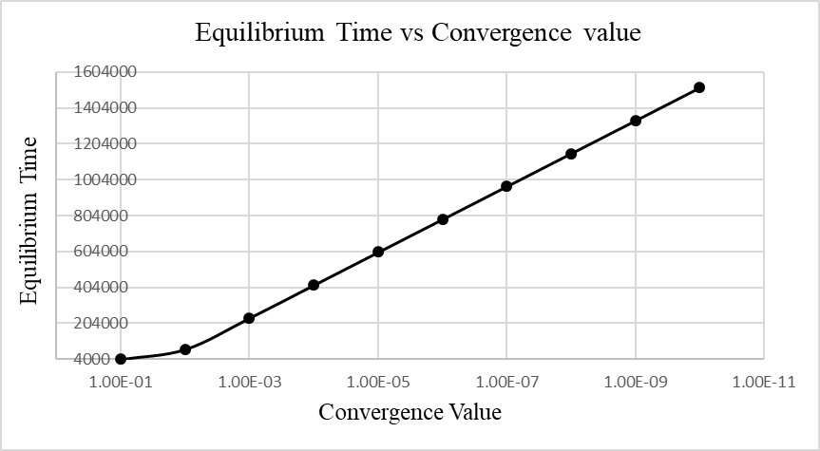
the results for both graphs (figure 15&16) show a linear increase in the equilibrium times and iteration counts while the convergence value increased. The model converges around convergence =1e-4. These results highlight a major flaw with the finite difference model in that the accuracy of the results is entirely dependent on how equilibrium is defined. For example, if the convergence value is too high for a given time step & grid spacing combination, the results may be drastically over estimated.
Figure 15:Graph showing Iterations vs Convergence
Figure 16: Graph Plotting Equilibrium Time vs Convergence

Limitations and suggested improvements to the model.

Limitations
- Equilibrium Definition
Analysis of the code revealed that the accuracy of the results outputted by the model is largely dependent on how the equilibrium state is defined. The convergence value is also dependent upon the time step and grid spacing combination. For example, a given convergence value may drastically overestimate the equilibrium time for one combination and simultaneously underestimate the equilibrium time for another.
- Time Step & Grid Spacing combinations
Although the model allows the freedom to model any Time Step & Grid Spacing combination, in order to achieve an acceptable level of accuracy the time step and grid spacing need to be as close to zero as possible. This can lead to lengthy calculation periods even for smaller plate parameters.
- Truncation error
Defined as the difference between the exact analytical solution to the constitutive equation and the results from the finite difference approximations, truncation errors occur in all forms of FDM. Amplification of truncation errors can cause the incorrect approximations of the temperatures within the model thus causing either over or underestimated equilibrium times.
- Roundoff error
As with most computer based calculations, FDM is susceptible to roundoff errors, these occur because computers cannot represent some values exactly, these values get rounded to a value that can be represented. This error is then carried and amplified, especially in iterative problems like this model.

Improvements
One possible improvement to the model could be to use higher order derivative approximations derived from Taylor series expansion in order to lower the truncation errors.
Another method for improving the model could be to develop a system for automatic grid refinement, this could be done by calculating the lowest possible grid spacing and time step combination available for a given plate dimension, this method would be heavily dependent on the computational resources available.

Conclusion
Finite difference methods can be very useful in approximating the solution to PDE’s that don’t have exact analytical solutions. Whilst other forms of numerical analysis may yield more accurate results for more complex problems, its relative simplicity and lower demand on computational resources makes FDM a valuable tool in solving transient problems such as heat diffusion.
The model developed in this study is a good proof of concept in terms of the validity of using the finite difference method to solve heat diffusion problems. The model is capable of accepting a wide range of plate dimensions, grid spacings, and timestep combinations and displaying results in a user friendly manner . It is however important to question the accuracy of the results of the model, as the analysis shows, a higher level of accuracy can be achieved by optimising the time step and grid spacing combination to bring it as close to zero as possible.
Further work on this model could be to develop a better means of defining equilibrium than simply calculating the difference between the plates and specifying and acceptable convergence. An equilibrium definition that doesn’t suffer the limitations incurred due to roundoff and truncation errors would enable the model to make even more accurate approximations and hence better results.

References
Blazek, J., 2005. Computational Fluid Dynamics: Principles and Applications. 1st ed. St Augustin: Elsevier.
causon, P. d., 2010. Introductory Finite Difference Methods for PDEs. 1st ed. s.l.:ventus publishing .
Croft, D. R., 1989. flow calculation equation function energy transient algorithm furnace 2D two-dimensional. s.l.:PAVIC.
Davies, T. W., 2018. Thermopedia. [Online]
Available at: http://www.thermopedia.com/content/781/
[Accessed 12 12 2019].
Deville, M., 2014. One-dimensional linear advection–diffusion equation: Computers and Fluids. 1 ed. s.l.: Elsevier.
Elert, G., 2019. The Physics Hypertextbook. [Online]
Available at: https://physics.info/temperature/
[Accessed 2020 01 10].
Kirkwood, J., 2018. Mathematical Physics with Partial Differential Equations. 2nd ed. s.l.:Advanced Publishers.
lewis, R., 1996. the finite element method in heat transfer analysis. 1 ed. swansea: john wiley and sons.
Lewis, R., 2019. The Finite Element Method in Heat Transfer Analysis. In: The Finite Element Method in Heat Transfer Analysis. s.l.:John Wiley & Sons.
Me Mechanical , 2016. Fourier’s Law of Heat Conduction. [Online]
Available at: https://me-mechanicalengineering.com/fouriers-law/
[Accessed 12 12 2019].
Morton, K. W., 2005. Numerical Solution of Partial Differential Equations: An Introduction. 2nd ed. Cambridge : Cambridge Press.
Valli, A., 1994. Numerical Approximation of Partial Differential Equations. 23 ed. berlin: Springer.
Xie, W.-C., 2010. Differential Equations for Engineers. 1 ed. Cambridge: Cambridge University Press.

