Student name: Isaac Owen Saer
P Number: 2501869
Programme of Study: Graphic Design BA (Hons)
Module: Ways of Thinking (ADDA4022/C)

Tasks in order I received them:
Task 1: Observational Writing = 488 words
Task 2: Manifesto Writing = 514 words
Task 3: Practice-based writing = 480 words

Task One: Observational Writing

Semiotics is the study of signs and symbols and how they are used — in language, culture, and communication — to create meaning (Encyclopaedia Britannica, 2025). This meaning is created through socially shared systems. Using this knowledge, I will decode this album cover.
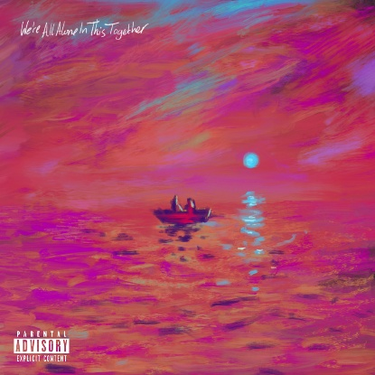

Figure 1: (Remikie, 2021, We’re All Alone in This Together)
We’re All Alone in This Together is the second studio album by British rapper Dave, released in 2021. The album highlights Daves personal struggle with mental health, love and loneliness, as well as deep-rooted political and historical issues, darting between hedonistic swagger and unsparing social commentary (The Guardian, 2021).
The cover art for the album (Figure 1) depicts two figures in a small rowing boat on a still body of water, paying homage to Claude Monet's 1872 painting, Impression, Sunrise. Whilst at first glance the piece appears simple, there are many connotative signifiers within that show links to the album's name, music and meaning.
On a denotive level, we see the centrepiece of the album cover, the two figures in the boat, which is aligned centrally, surrounded by a body of water with a sun or a moon in the background. However, on a connotative level, this boat floating on what seems an endless body of water can imply several things. The boat could symbolise isolation and solitude, going hand in hand with the name of the album. The feeling of floating in the abyss with nothing else around you perfectly demonstrates the feeling of being truly alone, with no companionship or guidance. This simple signifier enables the artist to convey loneliness without needing to say a word. As a metaphor for solitude, the image of a single boat on open water strikes a chord. However, this boat can also connote migration, a recurring topic within the album itself, with the boat symbolising freedom of movement (Dave, 2021).
This, however, is a juxtaposition. Upon further inspection, we see that this single boat holds two people, implying that although alone from the rest of the world, these individuals are together. Again, this symbolism aligns with the album's name. This detail connotes companionship within isolation, being ‘alone’ yet ‘together’. This could be taken as the artist and the listener going on a journey together, or suggesting to the viewer to find someone to share the burden of loneliness with. Dave himself interprets the two figures as him and his mother in a GQ Magazine interview (GQ, 2021). The figures are visually ambiguous on purpose; ambiguity allows for broader symbolisms and for the viewer to create their own reading of the image.
Another standout feature of the artwork is its cool pink, purple and blue tones. These colours specifically can symbolise vulnerability and tenderness, key themes throughout the album, especially when discussing political, social and personal issues. “The image suggests a fine line between joy and sadness, hope and fear, intimacy and vastness”, said Ciaran Thapar (2021).
The key takeaway from this analysis has been that semiotics are everywhere. Connotation isn’t always a simple right and wrong; often, it’s down to interpretation. My first thought when seeing this album cover was that the colours were eye-catching; however, after analysing the work, I've come to realise that it’s full of powerful meaning.

Bibliography
- Encyclopaedia Britannica, 2025. Semiotics. Available at: Semiotics | Definition, Theory, Examples, & Facts | Britannica (Accessed: 16 November 2025)
- Rachel Aroesti (2021) ‘Dave: We’re All Alone in This Together review – an eerie, anguished triumph’ review of We’re All Alone in This Together by Dave. Available at: Dave: We’re All Alone in This Together review – an eerie, anguished triumph | Dave | The GuardianDave: We’re All Alone in This Together review – an eerie, anguished triumph | Dave | The Guardian
(Accessed: 16 November 2025)
- Omoregie, D. (2021). Interview with GQ Magazine, ‘Dave interview, 2021’. Available at: Santan Dave: ‘When I write, I think, “I cannot afford to fail.” That pressure is exhausting’ | British GQ
- Omoregie, D. (2021). Interview with GQ Magazine, ‘Dave interview, 2021’. Available at: Santan Dave: ‘When I write, I think, “I cannot afford to fail.” That pressure is exhausting’ | British GQ
- Tharpar, C. (2021). Interview with GQ Magazine, ‘Dave interview, 2021’. Available at: Santan Dave: ‘When I write, I think, “I cannot afford to fail.” That pressure is exhausting’ | British GQ

List of Figures
- Figure 1: Remikie, T. (2021) We’re All Alone in This Together [Oil on canvas]. Available at: Dave - We’re All Alone In This Together Lyrics and Tracklist | Genius (Accessed: 16 November 2025)

Task Two: Manifesto

- Stay curious
- Be happy to make mistakes
- Be authentically yourself, all the time
- Be better than you were yesterday
- Positivity is contagious; surround yourself with it
- Stay humble, leave your ego at the door
- There are no limits, so don’t make any
- Design needs new scenery, explore the world
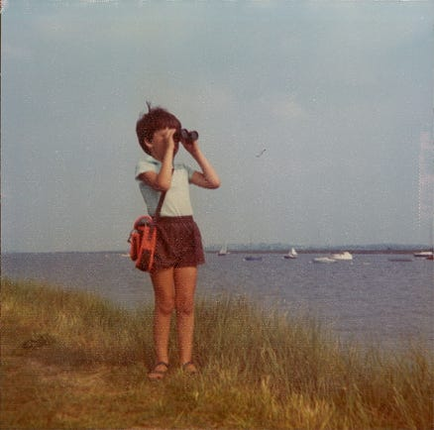
1. Stay curious

Figure 1: (Sanders, 2014, Child looking through binoculars)
As illustrated in Figure 1, children are naturally curious. They ask questions constantly and about everything: How does that work? Why is she doing that? When does that happen? “Curiosity in children is a fundamental source motivating development, playing a crucial role in their ability to learn, explore, and make sense of the world” (Murphy, 2023). Knowing that this curiosity is crucial to development, it begs the questions of why and when do we stop questioning everything? At some point in life people stop being curious and driven simply for the sake of gaining knowledge. Is this perhaps down to the societal norm of needing to know all the answers and being hesitant to show uncertainty? As often paraphrased, Socrates claimed, “I know that I know nothing” (Plato, Apology 21d). Here we see a great philosopher acknowledging the limit of his understanding, displaying openness to learning and intellectual humility. Therefore, should not-knowing be seen as an invitation to learn rather than an inadequacy? Through the process of discovery, curiosity allows us to find meaning.
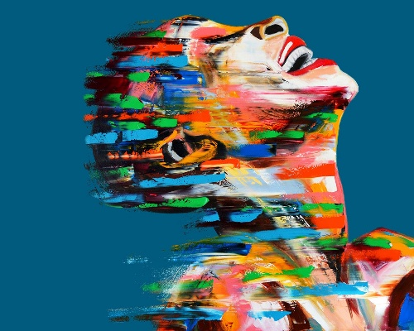
5. Positivity is contagious; surround yourself with it

Figure 2: (Magen, 2021, Happiness)
Nicholas Christakis, a Harvard Medical School professor of medical sociology and of medicine, has found that “happiness may be a collective phenomenon: Having a happy friend who lives within a mile of you, for example, appears to increase the probability that you will be happy as well” (Cerretani, 2011). From both personal experience and reference to proven studies, it appears that happiness and other emotions are contagious. Feelings within will radiate around us like invisible vibrations, as shown in Figure 2, creating an emotional resonance between individuals and shaping the collective atmosphere: “The science behind emotional energy strengthens the argument that our emotions possess unique frequencies and vibrations that significantly influence our well-being and the world around us” (Connor-Savarda, 2023). In order to achieve a positive mindset and work optimally, it is necessary to be surrounded by optimistic individuals and high-frequency vibrations. This is relevant to both day-to-day life and design, as I believe creativity thrives within an inspiring environment.
8. Design needs new scenery, explore the world
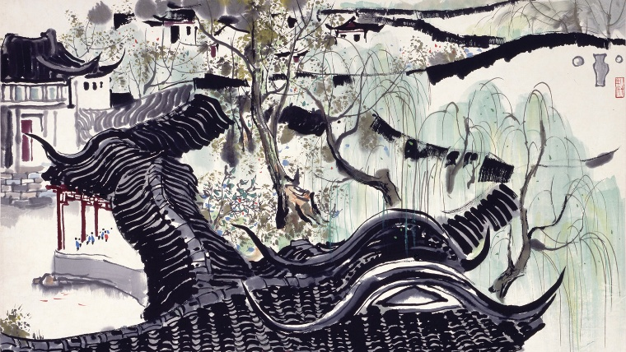
Figure 3: (Guanzhong, 1980, Humble Administrator’s Garden in Suzhou)
Travel and exploring the world increase a designer's visual vocabulary, offering new perspectives that can’t be accessed through familiar surroundings. Miller stated, "One's destination is never a place but rather a new way of looking at things” (1957), reminding us that the value of travel lies in shifting our perspective of the world. Travel encourages people to do things they wouldn’t otherwise do, try new foods, view new scenery, and immerse themselves in a completely new culture. “Travelling allows you to see the world from different perspectives and incorporate these new influences into your art” (Gabler, 2025). Figure 3, created by Chinese painter Wu Guanzhong displays contemporary Chinese art, featuring expressive brushstrokes and fluid lines. The fact that this piece demonstrates a different style from the contemporary fashion in the West exemplifies how encountering new cultures and aesthetics can inspire designers to engage with new methods in their own work.
Bibliography
- Murphy, T. F. (2023) Curiosity in Children: Psychological Advantages You Need to Know. Psychology Fanatic. Available at: Curiosity in Children: Psychological Advantages You Need to Know - Psychology Fanatic. (Accessed: 30 November 2025)
- Plato (n.d) Apology. Translated by B. Jowett. Available at: The Internet Classics Archive | Apology by Plato. (Accessed: 30 November 2025)
- Cerretani, J. (2011) The Contagion of Happiness. Harvard Medicine Magazine. Available at: The Contagion of Happiness | Harvard Medicine Magazine. (Accessed: 30 November 2025)
- Connor-Savadra, B.N. (2023) The Science Behind Emotional Energy: Exploring the Vibrations of Our Emotional World. Emotional Intelligence Magazine+. Available at: The Science Behind Emotional Energy: Exploring the Vibrations of Our Emotional World | Emotional Intelligence Magazine (Accessed: 1 December 2025)
- Miller, H. (1957) Big Sur and the Oranges of Hieronymus Bosch. New York: New Directions Publishing.
- Gabler, M. (2025) The Role of Travel in Artistic Inspiration: How Exploring New Places Can Spark Creativity. Matt Gabler Studios. Available at: The Role of Travel in Artistic Inspiration: How Exploring New Places Can Spark Creativity (Accessed: 1 December 2025)

List of Figures
- Figure 1: Sanders, I. (2014) The Art of Curiosity [Photograph]. Available at: The Art of Curiosity:. A manifesto for living a more curious… | by IanSanders | Medium (Accessed: 30 November 2025)
- Figure 2: Magen, I. (2021) Happiness [Oil on canvas]. Available at: Happiness Art: Modern Abstract Face Canvas Print. (Accessed: 30 November 2025)
- Figure 3: Guanzhong, W. (1980) Humble Administration’s Garden in Suzhou [Ink and colours on paper]. Available at: Chinese Ink Paintings: A Selection of Modern Masters - Exhibitions - Asian Art Museum. (Accessed: 1 December 2025)

Task Three: Practise-based writing
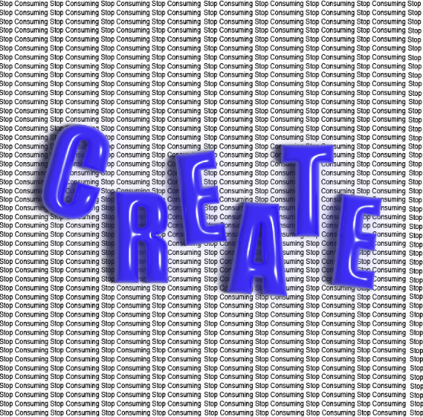

Figure 1: (Saer, 2025, Stop Consuming, Create)
Figure 1, Stop Consuming, Create (2025) came from my growing awareness of how much time I spend scrolling through social media, consuming content that adds little to no value to my personal and creative development. This became the catalyst for creating a piece that I believe visually expresses the tension between passive consumption and active creativity. At the same time, being relatively new to graphic design, I wanted to use this piece to experiment with typography and learn more about Adobe Illustrator. Therefore, my intention with this piece was both expressive and educational, to communicate a message whilst also expanding my design skills.
During the making process, I relied on a YouTube video to learn how to apply the balloon effect to the type. Using 3D and Materials, Inflate, and then rendering the object, although now seems like a straightforward task to me, at the time felt like a breakthrough in my understanding of the software. “All progress is experimental” (Chapman, 1900, p.6) is a quote that summarises this body of work for me. Although it appears simple, this process required trying new tools, making mistakes and re-attempting before I was happy with the result.
It was my intention with this piece to create an obvious contrast between the foreground and background. The repeated phrase ‘Stop Consuming’ forms a dense, overwhelming background, symbolising visual noise and social media feeds, where information becomes a blur rather than insightful. In contrast, the word ‘Create’ brightly and boldly conveys clarity and direction. This reflects Berger’s (1972, p. 9) statement that “we never look at just one thing; we are always looking at the relation between things and ourselves”. Here, the boldness of ‘Create’ disrupts the bluntness of the layer behind, guiding the viewer's perception and utilising visual hierarchy to shape perception.
While creating the piece, I was primarily trying to communicate a message effectively, but without the technical skill to execute it at a professional level. Csikszentmihalyi (1996) notes that creativity often begins with play, curiosity, and exploration—qualities that were central to my process. At the time, the work felt exciting: a visual affirmation that creating is more fulfilling than passively consuming content.
However, upon reflection, my thoughts on the piece have changed as my skills have developed. I still appreciate the conceptual message, but I also see opportunities for refinement—such as adjusting the balance of the piece or improving visual hierarchy. I also no longer feel that the balloon effect for the foreground is suitable. At the time, I thought the effect looked cool and wanted to learn how to do it; however, now I can see alternative ways of presenting the message.
Ultimately, this piece represents an early stage in my journey as a designer. It captures not only a message I wanted to communicate, but also the moment I began actively choosing to create rather than merely consume.
Bibliography
- Chapman, J.J. (1900) Practical Agitation. New York: Charles Scribner’s Sons. Available at: Practical agitation. (Accessed: 4 December 2025)
- Berger, J. (1972) Ways of Seeing. London: BBC / Penguin Books. Available at: Ways of Seeing-John Berger
- Csikszentmihalyi, M. (1996). Creativity: Flow and the Psychology of Discovery and Invention. New York: HarperCollins.

List of Figures
- Saer, I. (2025). Stop Consuming, Create [Digital Artwork]. Created using Adobe Illustrator

