Using flame tests to identify metal chlorides and find their wavelength, frequency, and energy
C. Doherty, UWTSD
L4 Chemistry (OME), Lab Group 1
Date of Experiment: 14/02/2025
This paper looks at the practical approach for identifying 8 unknown metals chlorides. The approach taken within describes observing the emission spectra of metal solutions by thermal excitation (via Bunsen burner) and highlight the large human errors present. The wavelengths of light associated with each metal chloride was found (±50nm) due to their distinctive colour upon heating.

Introduction

First discovered by Robert Bunsen [1], and building on the theory of De Broglie [2], heated elements were shown to produce unique emission spectrums when colliding with high energy particles [3]. These colliding electrons absorb energy and move to a higher energy state affecting its stability. The instability of the excited electron results in photon emission with wavelength proportional to the gained energy (Eq. 1) returning the excited electron to its original state.
λ$=\frac{ħc}{E}$ (Eq. 1)

The energy needed to cause excitation within different elements produce a unique and repeatable emission spectrum, with many states typically falling within the bounds of visible light. This results in a distinctive colour for each element. The experiment within uses this principle to distinguish 8 mixtures of metal chloride name A-H. Respectively, the metals were (Ba²⁺), calcium (Ca²⁺), lithium (Li⁺), strontium (Sr²⁺), potassium (K⁺), sodium (Na⁺), and copper (Cu²⁺), with the mixture being Sodium and Potassium. The metal cation would be the main producer of visible light during the experiment as chlorines emission spectrum largely falls outside of visible light [4], this is typical of many anions [5]. Applications for this experiment can be seen in everyday life such as the vibrant colours seen in fireworks, UV light bulbs, and is the primary principle used in spectrometers.

Method

For the setup a Bunsen burner was lit on top a fireproof mat, with the safety flame on while not in use. The thermal energy given out by a Bunsen burner is large enough to induce excitation, resulting in a coloured flame that can be seen and compared against the visible light spectrum. A metal rod was then washed in 2M HCL and heated until no colour was present on the flame. This was followed by deionised water to strip any remaining HCL. The process of washing and drying ensures that no leftover material can affect the colour present in the flame, this is repeated after each solution. The metal rod is then dipped into a solution and held within the flame until a colour is produced. This is then repeated with the same mixture but observed through cobalt glass to find the sodium-potassium mixture by filtering out any sodium light.
Results

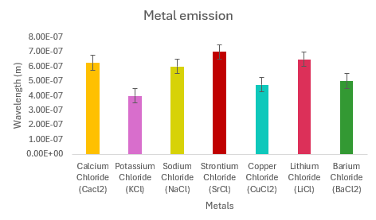
Figure 1. The visible colour produced by metal solutions A-G and their respective wavelengths, ±5x10⁻⁸ (m).

Shown in Figure 1, each solution produced a distinctive colour allowing for identification. The sodium potassium mixture (H) is exempt as its colour changes upon using cobalt glass. The cobalt glass was not used on each solution and instead only on yellow/orange flames. This is only possible from knowing the mixtures beforehand, otherwise it should be used consistently. The wavelength was estimated using a visible light spectrum with wavelength markings every 100nm, hence the large uncertainty.
The wavelength of the emitted light is proportional to its energy, with this energy being equal to a specific change in energy level for each metallic element. From Figure 2, we can assume that KCL (solution B) is of a lower energy state naturally, hence needing more energy to induce excitation, or that the specific energy provided by the flame allows for a larger jump in energy level for the subsequent KCL electron.
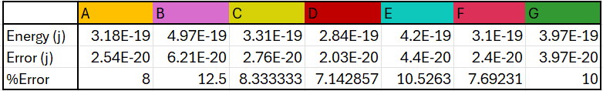
Figure 2. The energy associated with each solution along with the propagated error. The units for Energy and Error shown are in Joules (j).

Discussion

From the wavelength we can find the energy (Eq. 1), but we can also find the frequency (Eq. 2).

E$=ħf$ (Eq. 2)

Taking the highest and lowest energy solutions (B and D) with 4.97E-19 (j) and 2.84E-19 (j) we can see that that the largest energy has the lowest wavelength, and vice-versa. The frequency associated with B and D (7.49E14 and 4.28E14) further suggests that the higher the energy, the lower the wavelength, and the larger the frequency.

The results from the experiment came with large errors due to the colour spectrum used to for comparison. This could have been narrowed down by using a smaller scale, however the experiment as a whole suffers from innate human errors. Using the naked eye allows for large error, as when comparing to the scale on the spectrum it is hard to narrow down an exact colour match. These errors would be impossible to estimate and have hence been void from any calculations. For future experiments, a device capable of reading the colour of the flame is suggested to reduce the need for human bias. Another error arises when considering that the solutions were also being shared by the group and hence some contamination is to be expected. With best practice measures in use this can be estimated to be relatively low and the precision of the colour spectrum used is not high enough for this to pose a threat to the results. For future experiments, individual solutions for each group performing the experiments would be the best option.

When it comes to OME, the principles behind the flame test – being that of thermally excited electrons emitting photons in a visible portion of the electromagnetic spectrum – is applicable. This can be seen in areas such as tracer rounds, where producing a coloured light from the combustion of pyrotechnic mixtures allows for the firing of ammunition with a visible path, as seen in the report by SAA [6]. In said report, an example given is that of Strontium Nitrate, which when combined with Chlorine produces SrCl. In combustion this produces a distinctive red light, and these results agree with the flame test findings in Figure 1. Strontium nitrate is not used directly as it reacts too violently and produces unwanted light, in this case polyvinylchloride acts as a chlorine donor (CH2:CH-Cl) for strontium during reaction to form a metallic chloride. The characteristic wavelengths produced from metallic chloride excitation are very practical and distinctive in colour and are typically used most in military pyrotechnics [7].

Conclusion

The experiment was successful as the solutions were identified and produced unique colours when heated. The solution containing sodium and potassium was also identified using cobalt glass, demonstrating the importance of a light filter to help minimise human error. The findings show that the larger the energy, the lower the wavelength, and suggest that the electrons from the higher energy emission spectrums were originally of a lower energy state or jumped to a much higher state than the others. To further test this hypothesis the full emission spectrum should be analysed for each solution.

Human errors were present throughout the experiment, and these can only be minimised by using digital equipment to read the colour produced and relating this to a higher precision colour to wavelength chart, and by taking precautions to not contaminate the solutions.

References
[1] W. B. Jensen, “The Origin of the Bunsen Burner,” J. Chem. Educ., vol. 82, no. 4, p. 518, 2005, doi: https://doi.org/10.1021/ed082p518.
[2] L. de Broglie, “XXXV. A tentative theory of light quanta,” The London, Edinburgh, and Dublin Philosophical Magazine and Journal of Science, vol. 47, no. 278, pp. 446–458, Feb. 1924, doi: https://doi.org/10.1080/14786442408634378.
[3] M. B. L and S. S. J, “Electron Impact Excitation of Atoms,” RMP, vol. 40, no. 2, pp. 238–353, Apr. 1968, doi: https://doi.org/10.1103/RevModPhys.40.238.
[4] curtis.suplee@nist.gov, “Atomic Spectra Database,” NIST, Jul. 21, 2009. https://physics.nist.gov/asd
[5] M. J. Sanger, “Flame Tests: Which Ion Causes the Color?,” Journal of Chemical Education, vol. 81, no. 12, p. 1776A, Dec. 2004, doi: https://doi.org/10.1021/ed081p1776a.
[6] S. Buc, G. Adelman, and S. Adelman, “Development of Alternate 7.62mm Tracer Formulations,” SAA International LTD, Maryland, Dec. 1993. Accessed: Mar. 13, 2025. [Online]. Available: https://web.archive.org/web/20240118225247/https://apps.dtic.mil/dtic/tr/fulltext/u2/a335414.pdf
[7] A. K. Bose, Military Pyrotechnics. CRC Press, 2021.

Appendix

Equipment used:

- Bunsen burner
- Heat resistant mat
- Matches
- Metal wire
- 1M of solutions A-H
- Beaker with 2M HCL
- Beaker with DI water
- Cobalt glass (blue)

Full method:

- Set up a Bunsen burner on the surface of the heat-resistant mat and connect it to a gas source. Turn on the gas tap and light the Bunsen burner using the matches and open the air vent to obtain a non-luminous flame with two blue cones. Use the safety flame (yellow) when not in use.
- Clean the wire by dipping it into the 1M HCl and heat it in the hottest part of the flame. Repeat until no colour is shown.
- Record the colour of the 1M HCL
- Dip the wire in DI water and heat
- Record the colour of the flame for DI water
- Repeat steps 2 and 4 after testing each solution
- When the wire is cooled enough (not glowing), dip it into one of the solutions.
- Heat the dipped wire in the hottest part of the flame
- Record the change in colour of the flame, as seen in Figure 4.
- Use the cobalt glass on solutions which you expect may be the mixture of sodium and potassium (any yellow or orange flames)
- Repeat 6-10 for the remaining solutions.

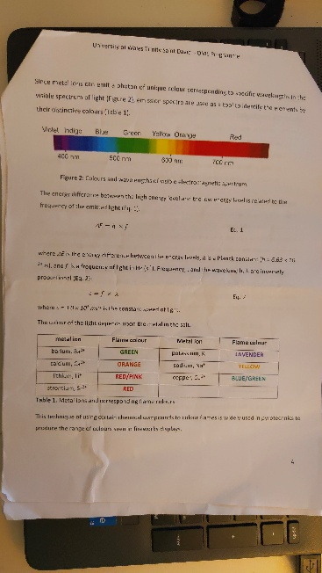
Figure 3. Scanned copy of the worksheet used for the practical.

Error Appendix

$α_{λ}=\frac{100*{10}^{-9}}{2}$ (Eq. 3)

Figure 3 shows that the smallest separation is 100nm. Half of this value is used when finding the error associated with an analogue measuring device, as seen in (Eq. 3)

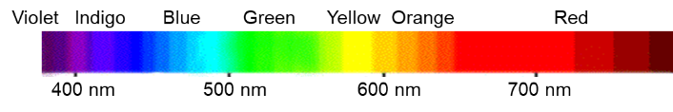
Figure 4. The colour to wavelength chart used for the experiment.

$α_{E}=(E)(\frac{α_{λ}}{λ})$ (Eq. 4)

(Eq. 4) shows how the error in energy is propagated from the error in the wavelength. The percentage error remains unchanged.

Scientific Summary for a General Audience

The flame test is an invaluable tool that allows individuals to gain firsthand experience with pyrotechnics. The flame test works by providing an electron with extra energy by heating a substance, in this case with a Bunsen burner. This energy is then released in the form of electromagnetic radiation (light) which will have a defined wavelength and frequency, proportional to the amount of energy the electron originally gained. The electron gets rid of the extra energy as it makes it unstable. Measuring either variable produces a unique result that is repeatable, providing scientists with another way of identifying a substance without knowing what it is, or to simply produce colourful light. This principle has many applications such as measuring the effectiveness of drugs, analysing unknown chemicals, producing UV light, and even producing the vibrant light seen from a firework.

