Hotel Placement - Food & Beverage
Forest of Arden Marriott Hotel & Country Club
Department: Zest Bar
M4X01920_BIRM
Mubaraca Mombassa - 1905613
Week: 1
Work Undertaken:
- Tips Trainings
- Pour a pint
- Change keg
- Training up selling techniques
- Daily Special/Side order/up sell desert
- Up sell Beverage promotion of the Month
- Training Bar set up
- Training: Paddy & Scott’s / coffee culture, Confectionary
- Coffee Machine Training
- Serve a Table, (drinks /food)
- Training Bar stock/Rotation
- Count Bar stock
- Zest Bar Cleaning Rota ( Saturday & Sunday)

Self – Appraisal
Strengths:
Last weekend, I had an opportunity to have some basic understanding of what happens inside the department of Zest Bar and also what kind of responsibilities, duties and how they work there. The Zest Bar comprises five rooms, such as office, one bar, kitchen and, an outdoor terrace where you can eat or sip a drink al fresco when the weather in Birmingham is mild.
Open for breakfast and lunch. It is a good experience knowing the styles of service prepare for the Bar. Where the Staff who go out of their way to make every event, of every size, truly fantastic.
There has been a lot of progress in terms of understanding how, they organize and run: Private functions: such as golf, events, morning breakfast, lunches, and small meetings.
I know that I should maintain positive guest interactions while accurately mixing and serving beverages to guests and servers in a friendly and efficient manner.
I learned how to check plans, bar assurance Checklist, Member's Menu, social events, a sequence of Service in the bar, set menus, Choice menus, and Also how to checklist, refreshing a room. Creation & Delivery (Drink Service, Beer Service, and Wine bottle service), Body Language,(Appearing confident behind the bar makes the guests trust my ability and feel comfortable, Maintaining a good posture instils confidence and also prevents strain injuries). Keeping my chin up and scanning the bar area ensures that I make eye - contact with all guests and keep the bar top clean. Tidy up the room and ensure the next shift or Day be clean and ready.

WEAKENESS
I had some problems with the drink menu. Such as cappuccino, Americano, mocha, lux hot chocolate, and flat white. I didn't understand which portions and quantities I should use for those drinks, check the identification of guest if he has the membership card. Another struggle, for example, was serving beer and dried drinks and in how to deal with certain administrations, for instance delivering dishes to customers. However, in next day, everything was solved with the help of the staff of the zest bar. The plan of table administrations, table set up, table numbers on certain occasions, Marriott standard, make the stock, payment method, and Menu standard. In any case, with the assistance of the staff, I have learned different abilities and furthermore I had the option to do it with more certainty.
Lost opportunities
I might want to rehash a few occupations I have done over the most recent two days, to feel increasingly certain, for example, serving beer at the bar, understand the Micro system administration, be administration ,be acquainted with the table plan of the bar. Finally, be confident when I am serving all kind of café drinks, also how to utilize the espresso machine at the Zest Bar.
Plans for next week:
- Make an appointment with the kitchen manager
- Review and intensify all skills I learned in the last week
- Interact with customers, take orders for drinks and snack
- Prepare alcohol or non-alcohol beverages
- Service wine and beer to guests
- Serve customers in a friendly and helpful manner

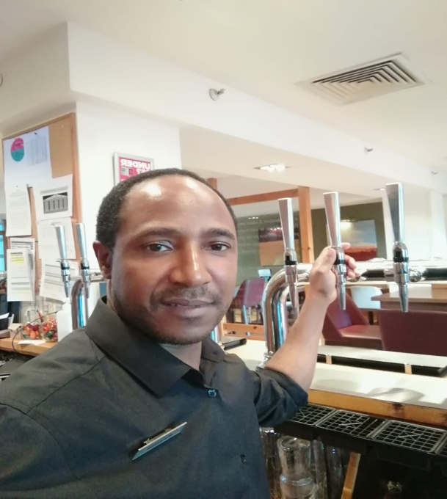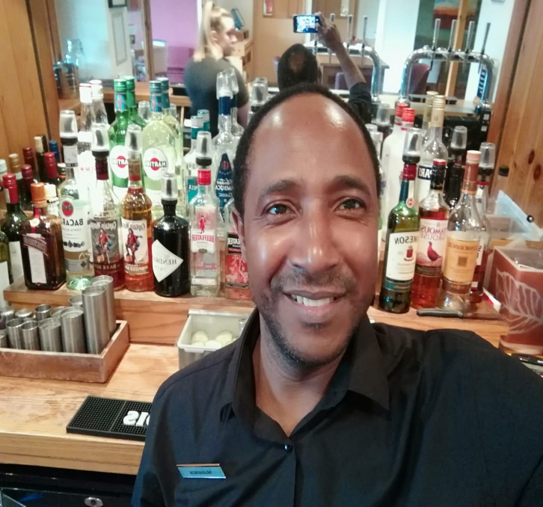
Bar service.
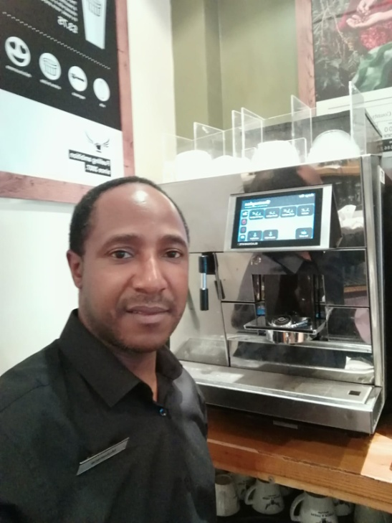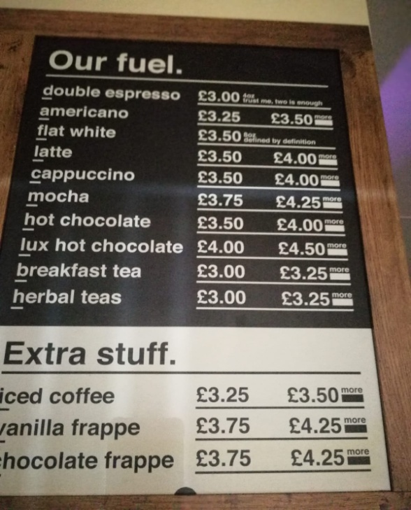
Coffee service
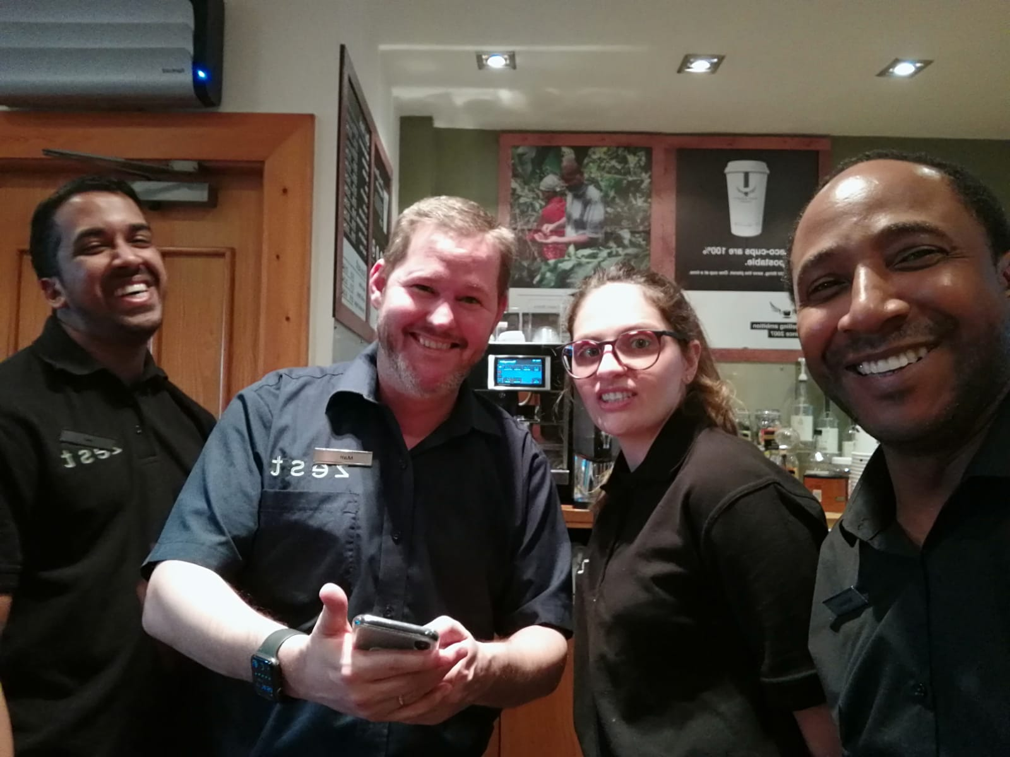
With the zest Bar Manager “Matt & Nujh and Andréa.

