
This Photo by Unknown Author is licensed under CC BY-SA
Student Name | Anafieu Jalloh
Student number | 1913505
Module No | BMSW4003
Module Title | Digital Skills and Research Methods
Lecturer | Modak Koushik

Subject:
The impact of Virtual Learning Environment for Students in UWTSD London Campus.

Table of Content

- Introduction
- Rationale
- Research Objectives
- Review of Existing Literature
- Methodology
  - Research Methods
  - Data
  - Data Collection Process
  - Population Sample and Sample Size
  - Ethics in Data Collection
- Findings Analysis and Discussion
  - Summary of the Findings
  - Graph Analysis
- Conclusion
- References
- Appendix
9.1 Appendix 1
9.2 Appendix 2

Introduction
This report will look at the impact of Virtual Learning Environment for the student of UWTSD London Campus. During this report I will be doing research about VLE, and also collecting data for my research. I will be reading articles online and also journals to collect data’s.
During this reporting I will be talking about the four main topics: Research Objectives, Review of Existing Literature, Methodology and Findings Analysis and Discussion. This report will establish on research applying the two primary and secondary sources of data. It will also apply research methodologies such as qualitative and quantitative research whereby it will establish on questionnaires, surveys etc also graphs and chat will be analysed while an appendix will be made for my questionnaires

According to TechTarget (2011) Virtual Learning Environment (VLE) Is a set of teaching and learning equipment which is made to improve a student learning experience by involving computers and the internet during the studying procedures.

Rationale:
The reason why i choose to look at the impact of virtual learning environment, for student in UWTSD campus London. Is because I find it very fascinating, that you can learn from home. So, I wanted to find out how it impact the students. In finding information’s to answer my research questions, I had to create a Questionnaire, read Journals, articles, books to conduct my research. I choose these research data sources because I believed they are reliable.

Research objectives:
this research is to find out the answers which is hidden, and which has not been discovered as yet. however, it main objective is to be able to identify solutions to the issue, and develop ways how to implement them, in other to achieve a meaningful and a successful research objective. It intends is to find out how VLE impact its students at UWTSD campus.
What this research will hope to achieve is to make you aware of the purpose of the survey which is the impact of Virtual learning on its students at UWTSD campus London.

Review of existing literature:
Impact of Virtual Learning
Since the pandemic started, we have seen a very strong impact in virtual learning its competence and output has been very good. so, this report will look at various researches carried out, and the results or findings on the virtual learning system and its impact.
According to (Chen Y.L.I et, al 2009) who’s research topic is Examining the Factors Influencing Participants Knowledge Sharing Behaviour in Virtual Learning Communities. This research tries to study the factors that influence knowledge sharing from the perspective of people conduct. The research method which was used during this research is the primary research. One of its findings shows that the users practice behaviour to internet, will disturb their internation of subsequent internet use. which I absolutely agreed because the excessive use of the internet might cause harm. However, according to (Alves P et, al 2017) who’s research topic is The Influence of Virtual Learning Environments in Students Performance. The research work key objective is for students to find indicators to access in virtual learning environment and the relation among such entrée. And to make sure that they can create strategies which can reach their desires. The research methods which is used during this research is the primary research method. The research finds out that, the online education approach of the student is not the same and have a different reflect on Learning uses of VLE. Which I agreed on because every student have their own way of using VLE. According to (Chou, W, H 2007) who’s research topic is about Learning effectiveness in a web-based virtual learning environment. Stated that the structure between leaner control and learning effectiveness that defines these two relationships is absent, and therefore the purpose of the research is to fill the void. The research method that is used for this research is the primary research method. The study shows that students in the technology-mediated Virtual Learning(tvle) environment accomplish well educational performance than the traditional way of learning. which I disagreed because, the traditional way of learning you feel the present of the teacher more. According to (Page T & Thorsteinsson, G.2007) whose research topic is A Practitioner-based approach to virtual reality learning. Its research goal is to compare both views(opinion) of the British and international virtual learning practitioners on virtual reality learning future. the research method that is used for this research is the primary research method. The findings showed both the International and their counterpart, (British) shares the same opinions on reality virtual learning. However, the result in the main tells us that the international practitioners display uncertainty in views, whereby the British highlighted importance in a personal level. Which I disagreed on the international view because, I think Virtual Learning has advanced in such a way that there shouldn’t be doubts or uncertainty. According to (Yang, Z & Liu, Q. 2004) whose research topic is Research and development of web based virtual online classroom. Which stated that this system of learning (web-based virtual online classroom) is designed and established built on learning theories, and streaming media technologies. Their research methods used was the primary research methods. In their findings concluded that the teachers prefer the traditional way of teaching, which is the face to face method. they believe by that way of teaching they can be more in control of their students, while the students prefer using tools such as chat-room, BBS etc to regulate their learning pace. which I absolutely agreed because even though virtual learning have been improved it is not the same as face to face traditional learning.

Summary
This research has looked into the impact of virtual learning.
The main aim of this research is to see the impact of virtual learning in the eyes of 5 authors with different virtual learning topics. it has briefly explained every researcher topics, methods and findings. also agreed and disagreed with their findings.

Methodology
Research Methodology
Accord to (Jansen, D & Warren K, 2020) Research Methodology is how systematically a researcher conduct a form of learning, that ensure validity and reliability that discuss the aims and objectives of a research.
There are different types of Methodoly. These are: Qualitative, Quantitative and Mix Method.
Qualitative Research Method According to QuestionPro(2020) this method concentrate on collecting data through open-ended and personal interaction.
Quantitative Research Method According to (Bhandari, P. 2020) Quantitative Research Is the procedure where in numerical data been collected and analysed.
In my research i will be using both the quantitative and qualitative methods. This mean I’m going for the combination method. As from my opinion, both methods are complementary to each other. So, having both will make my point more efficient and clearer to the audience.
the Qualitative method would give me the opportunity to get more information possible. Wherein the Quantitative method I would be collecting some data’s that will enable me to create some statistic and I can show some graphs and analysis. So, having both of their statistics together will make the sense clearer to the audience, and this is the reason I think it will be more efficient.
Data According to (CollinsDictionary 2020) Data means information particularly when it delivered in the form of facts or statistics that can be examined.
we have two different types of Data and these are: Primary and Secondary Data. In my research I will be covering both different types of Data’s.
Data Collecting Process:
Secondary Data: I have collected these data from different books, journals, different online resources and websites.
Primary Data: I have collected these data’s by conducting survey, because of the pandemic I conducted a survey online by preparing a questionnaire, and then I sent my questionnaires to my classmates through emails. Also, I had to use WhatsApp technology to remind them to respond to my questionnaires, after few days I finally received the response back through e-mail as well. after doing that I presented those results on excel table and this is how I get it done.

Population Sample and Sample Size:
Population (Investopedia, 2020) is the whole pool wherein a statistic is drawn it can be an entire set of people, objects, etc.
Sample (Kenton, W 2020) is a lesser controllable version of a group that is bigger, so is basically a subsection that has the characteristics of a bigger population
Sample Size (Zamboni, J 2018) is an amount of the specific observation or sample in a statistical setting, which can be from a public opinion survey or from a science experiment.
Ethics in data collection According to (ReadindCraze 2017)”Ethics in data collection is not only an important but sensitive issue, the respondent has all the right to say no to answer questions to your answers .he has all the right to say no to participation in the survey and it all depends on his/her will that you will be able to collect data” However during this research I have respected the code of conduct of every each of my participants and followed the rules and regulations from all the sources I have obtained information from during this research.

Findings Analysis and Discussion
In this section I am going to explain all the responses that I have received from my questionnaires, during my survey. And how did all my participants responded to my questionnaires. They are plotted into charts, and they are presented here with analysis.

1) Do you enjoy this module?

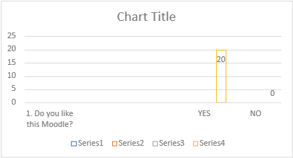
Q1) as the chart shows 100% of the study shows that they enjoy this module.

2) was there any doubt when you choose to study this module?
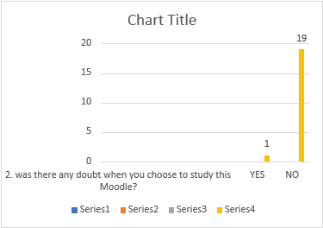
Q2) as the chart shows that 90% of the students did not have any doubts when choosing this mudule.

3) Why do you enjoy this Moodle?

Most students enjoy the module because they find it very convenience and practical, and love the fact that they can continue their studies without going to the classroom

4) Before the lockdown have you ever experience online learning?
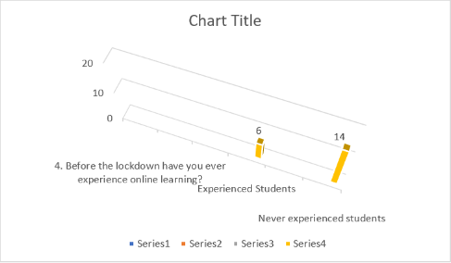
Q4) as it showed in the chart about 75% of the students have never experienced virtual learning

5) From scale 1 to 10 how much will you rate this Moodle?
Q5) In this question most of the students rated it average.

6.) How often during the week do you have virtual learning?
Q6) Majority of the students answered twice a week.

7.) Virtual learning is a system of learning that takes place?
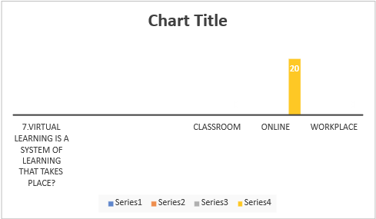
Q.) As it shows in the chart 100% of the student knew the answer to this question

8.If you were not doing this Moodle what another Moodle would you have been doing?
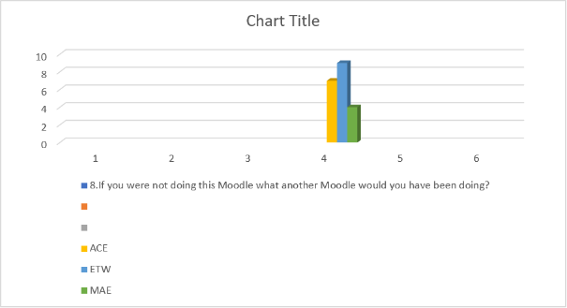
Q8.) this chart is very interesting as you can see that majority of the students would have been doing ETW if they where not doing this course however it is interesting too to see how big the gap between ACE and MAE is

Conclusion

This report has investigated the impact of virtual learning for the students of UWTSD London campus. It has able to meet its original objectives which is to investigate the impact of virtual learning. and also it has explored the following research methods; Research Objectives, Review of Existing Literature, Methodology and Findings Analysis and Discussion. During the literature review it has able to show you 5 different authors research findings about virtual learning. while during the Questionnaire it has able to show results of the students that participated on the impact of virtual learning. it has also demonstrated the ability how a data is collected and explained the different types of methodology and the types that was used during this research.

Even though It was a little struggling with collecting data for this research, because of time limitation and couldn’t search all the databases channels I would’ve wanted to. but I must say I am very delighted with this body of work that I am able to deliver.

References:
Collins dictionary (27/08/2020) [online] Available at: https://www.collinsdictionary.com/dictionary/english/data
accessed :31/08/2020.

Derek Jansen & Kerryn Warren(june2020)[online]Available at:
https://gradcoach.com/what-is-research-methodology/
Investopedia (19/03/2020 [online]Available at: https://www.investopedia.com/terms/p/population.asp
Accessed: 30/08/2020

irene Y.L Chen, Nian_Shing Chen and Kinshuk (January- 2009)j ournal Article website:JSTOR. Available at: https://www.jstor.org/stable/jeductechsoci.12.1.134?seq=3#metadata_info_tab_contents
Accessed: 28/08/2020.

https://www.jstor.org/stable/jeductechsoci.12.1.134?seq=3#metadata_info_tab_contents
Accessed: 29/08/2020
Jon Zamboni (23/04/2018) [online]Available at:
https://sciencing.com/meeting-sample-size-5988804.html
Accessed: 30/08/2020
Paulo Alves Miranda,L Carlos Morais(march 2017) Article website ResearchGate Available at: https://www.researchgate.net/publication/317307245_The_Influence_of_Virtual_Learning_Environments_in_Students'_Performance

Pritha Bhandari (12-06-2020) [online]Scribbr available at:
https://www.scribbr.com/methodology/quantitative-research/
Accessed: 29/08/2020.
QuestionPro (2020) [online]Available at: https://www.questionpro.com/blog/qualitative-research-methods/ Accessed on 31/08/2020.
ReadingCraze (20/04/2017) [online]Available at:
http://readingcraze.com/index.php/ethics-data-collection-research/
Accessed: 31/08/2020.

shih-Wei chou(February 2005)Article (website) ResearchGate. Available at: https://www.researchgate.net/publication/220663188_Learning_effectiveness_in_a_Web-based_virtual_learning_environment_A_learner_control_perspective
Accessed: 28/08/2020.

TechTarget (24-03-2011) [online] Available at: https://whatis.techtarget.com/definition/virtual-learning-environment-VLE-or-managed-learning-environment-MLE

Tom Page,Gisli Thorsteinsson(April-June 2007)
journal[website]ProQuest. Accessed (30/08/2020) Available at:
https://scholar.google.co.uk/scholar?q=virtual+learning+research&hl=en&as_sdt=0&as_vis=1&oi=schlarart#d=gs_gabs&u=%3Dqklw9q3q9VYJ

Will Kenton(19/03/2020)[online] Available at: https://www.investopedia.com/terms/s/sample.asp
Accessed: 31/08/2020.

Zongkai Yang&Qingtang Liu(2 feb 2007) Journal[website]Available at: https://www.sciencedirect.com/science/article/abs/pii/S0360131505000084
Accessed on 30/08/2020.

Appendix: 1
VIRTUAL LEARNING ENVIRONMENT
Student Name: Anafieu Jalloh: ID Number:1913505
RESULTS ON THE QUESTIONAIRE ABOUT THE IMPACT OF VIRTUAL LEARNING ENVIRONMENT ON THE STUDENTS OF UWTSD LONDON
SAMPLE SIZE:20 STUDENTS
1. Do you like this Moodle?
YES
NO
2. was there any doubt when you choose to study this Moodle?
YES
NO
3. Why do you enjoy this Moodle?
Enjoyed Students
Didn't Enjoyed Students
4. Before the lockdown have you ever experience online learning?
Experienced Students
5.From scle 1 to 10 how much will you rate this Moodle?
Answer:
6. How often during the week do you have virtual learning?
Answer:
7.Virtual learning is a system of learning that takes place?
Classroom
Online
Workplace
8.If you were not doing thid Moodle what another Moodle would you have been doing?
ACE
ETW
MAE

Appendix: 2
VIRTUAL LEARNING ENVIRONMENT
 |  | Student Name: Anafieu Jalloh: ID Number:1913505
RESULTS ON THE QUESTIONAIRE ABOUT THE IMPACT OF VIRTUAL LEARNING ENVIRONMENT ON THE STUDENTS OF UWTSD LONDON
SAMPLE SIZE:20 STUDENTS
1. Do you like this Moodle?
YES |  |  |  | 20
NO |  |  |  | 0
2. was there any doubt when you choose to study this Moodle?
YES |  |  |  | 1
NO |  |  |  | 19
3. Why do you enjoy this Moodle?
Most students find it very convenience and practical, and love the fact that they can continue their studies without going to the classroom.
4. Before the lockdown have you ever experience online learning?
Experienced Students |  |  |  | 6
Never experienced students |  |  |  | 14
5.From scale 1 to 10 how much will you rate this Moodle?
Answer: In this question most of the students rated it average.
6. How often during the week do you have virtual learning?
Answer: Majority of the students answered twice a week.
7.Virtual learning is a system of learning that takes place?
Classroom |  |  |  | 0
Online |  |  |  | 20
Workplace |  |  |  | 0
8.If you were not doing this Moodle what another Moodle would you have been doing?
ACE |  |  |  | 7
ETW |  |  |  | 9
MAE |  |  |  | 4

