https://www.london.edu/think#sort=%40articledate%20descending
(Retrieved 11-10-23)
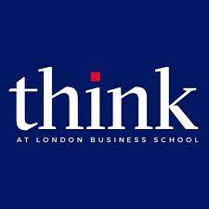

Three ways leading has changed – and what to do about it
John Dore looks at the trends shaping the future of work and shares advice on how leaders can better navigate this hybrid world
JOHN DORE
20 SEPTEMBER 2023
The future of work Leadership Management Leading teams
Save to my profile
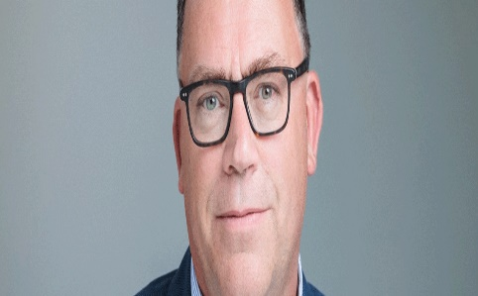
Being a business leader has never been easy. While the purpose might be strategic, the reality of the role often means tackling a burgeoning in-tray of people and process issues, while encouraging innovation, breaking down silos, ensuring compliance, improving wellbeing and inclusion, as well as making the numbers.
A demanding remit is one thing, but then disruption regularly rears its head, and it is as perennial as the weather. The philosopher Heraclitus described this constancy of change as unnerving for the leader; “You cannot step twice into the same river; for fresh waters are ever flowing in upon you.” These relentless waves have become the new normal – pandemic restrictions, regional conflicts, global uncertainty, a skills deficit, inflation, climate change, artificial intelligence and more. If that were not enough, in the past few years, three particular forms of change have made the leader’s role even tougher, fundamentally raising the bar for those managing people. Leading has changed, work itself has lost its lustre, and the people whom leaders are trying to manage are very different.

1. Leading has changed.
Managers are now expected to be expert “hybrid” leaders, and it is a complicated, demanding and uncharted remit.
Before 2020, “hybrid” managers were rare, highly paid and often deployed to manage internationally based teams, where “hybrid” working was thought completely normal. Since 2020, we have witnessed a seismic shift in working patterns, and now just about every manager, even of small- and medium-sized enterprises, is expected to have that same rare “hybrid manager” skillset. The geographical scope may be narrower, but the function of management has become increasingly demanding. Leaders have to connect dislocated individuals, on different work patterns, with different values, outlooks and motivations; some online and remote, some down the corridor, some ever-present, some on flexible terms and some remote on a Caribbean island.
Discover fresh perspectives and research insights from LBS
Sign up to Think
“Britons now work from home more than any other European nation”
There was no training manual issued for managers as the world quickly switched over to this new paradigm during the pandemic. For some it felt like the 1980’s TV show Dallas, where Bobby Ewing went into the shower, got out and everything he knew in the past was just a dream. Gone is the old normal where the vast majority of office employees commuted and worked for much of the week in an office. Requests to work-from-home, the liberation of a ‘dress-down Friday’ and the need for a sick-note to avoid coming into the office are redundant. Employees have cried freedom from the commute and managers wearily reached for a Zoom setting called “touch up my appearance”.
In June 2021, Deloitte told its 20,000 UK employees that you can “work from home forever” and much of the services and technology sector followed suit. The public sector also embraced this new flexibility. In July 2023, the UK tax inspectorate HMRC reported that fewer employees were now attending the office than during the pandemic. In Wales, only 10% of office space is regularly occupied by its civil servants. The saying goes “an Englishman’s home is his castle.” Well, since 2020 it has increasingly become his and her workplace of choice as well. According to research undertaken by the Munich-based Ifo Institute, it seems now that Britons work from home more than any other European nation.
In response, some employers embarked on an employee benefits ‘arms race’ to make their offices more attractive but too few employees seem impressed, with attendance remaining stubbornly low.
Even firms including Zoom and Google are now requiring some minimum level of mandatory attendance. It seems once out of the bottle; the genie of hybrid working is not going to go away. In giving such broad flexibility and choice to individuals, organisations have left their managers to navigate a complex 4D chess game of people, place, time and mode and many are, unsurprisingly, exhausted.

2. Working has changed.
Work is increasingly a ‘slog’, fun is in short supply, and the benefits of hard work have never been less certain.
Work-pattern flexibility had long been craved by employees, and lobbied for by unions, so leaders may have anticipated a resultant uptick in employee engagement, and even some improvement in productivity. Unfortunately, that has not happened with measures of employee engagement remaining poor, productivity flatlining, and increased staff turnover the norm. Hybrid working is not the panacea some had hoped.
Neither does working seem to pay. In the UK, wage growth has not outpaced inflation since 2008. Employees in their thirties have never actually experienced a real-world increase in their earnings. In the past two years, inflation has been endemic in most major economies, with the cost-of-living crisis exacerbated by soaring energy prices, insurance costs and taxation levels. The payback for hard work, long hours and discretionary effort has never seemed less rewarding. So, rather than double-down on the “hustle”, many employees have checked out, with a rise in those reported to be “quiet quitting”, social-loafing, and finding better things to do with their time.
“Studies show that employees who do regularly go to the office were now less likely to socialise after work”
One recent survey of remote workers reported that a fifth of those aged 24 to 35 were spending much of their time at home taking a nap, socialising with friends, doing some DIY or having sex (though not necessarily in that order). But whatever the workplace proposition, fun seems to be in short supply. Two recent studies show that even those employees who do regularly go to the office were now less likely to socialise after work, with evening socials on the wane.
So what might be a smart organisational response to issues of disengagement and demotivation? A recent YouGov survey of major employers found that a fifth were planning to respond by implementing some form of online surveillance and monitoring technology to observe remote employees. Somehow a compliance-led response to check-up on disengaged employees, bored by bureaucracy, unfilled by the mundanity of their work and actively seeking more meaningful alternatives seems possibly counterproductive, but those technologies are now being widely deployed.
Meanwhile, managers are being asked to (choose your own cliché) cascade change, gauge the pulse, engage the troops and build consensus. It’s a tall order for the very best leaders when the upside of work itself seems to feel to so many to be so remote.

3. Workers have changed.
Organisations are composed of different generations with differing outlooks, values and needs, made up of employees, consultants, gig workers and freelancers.
The reality for leaders is that regardless of their best endeavours, their most talented people are already looking to leave. Many of those they rely on most are unlikely to be formally “employed” by the firm, and those older reliable staff, who have been around for years, are also quitting at an alarming rate.
Gallop reports that ‘next generation’ employees are likely to change jobs as many as ten times between the ages of 18 and 34. It appears that these “digital natives” don’t want to stick around with the same employer for years and they seek regular moves for sometimes no more additional remuneration than the prospect of more ‘meaningful’ work.
At the other end of the spectrum, and this is a notable trend in the UK, older workers, who may have early access to pension savings, or have some equity to release, have also been exiting the employment market at an alarming rate.
Meanwhile, what it means to “work for a firm”, has itself become ambiguous, with colleagues being variously self-employed, or gig-workers, in-sourced, out-sourced, contracting, or consulting. Modern firms blithely talk about accessing an “ecosystem of skills” from a market of people resources. We can applaud the flexibility and efficiency this creates, but those essential human assets of the firm do not appear always to be embraced, well-loved, or properly protected.
Managers are expected to manage, motivate, supervise and encourage a ‘smorgasbord’ of colleagues from a broad demographic, who in turn, have a wide spectrum of working preferences, employment status, and attitudes to work itself. It seems the leader’s already tough task has been made almost impossible.

So, how should leaders respond?
Given these compelling trends, the answer is not to swim against the tide, but to pause and rethink the role of the leader. The saying goes: “when the going gets tough, the tough get going” and a leader’s instinct may be to work harder, hustle more and demand the same of others, doubling down on their management skills and capabilities even further. But more management is not the answer.
Whatever depths of personal resilience and determination a leader enjoys, that approach may turn out to be like trying to nail jelly to the ceiling. The profound change affecting our modes of work, and the loosening relationship employees have with their firm and one another, requires a similarly fundamental reimagining of the role of the leader.
This re-imagining is not straightforward, or easily adopted. It requires an approach which can feel counter-intuitive: building a sense of belonging through providing greater autonomy; being obsessed with others’ effectiveness, not one’s own; developing random relationships, not strategic alignment; encouraging failure, not fear; deliberately being unusual, not conforming to fit the corporate norm.
Organisations need a radically different mode of leadership for the ways we now work and live our lives. The leaders’ role in the future may be more of a coach than a manager, more mentor than monitor, more shelter than supervisor. A leader’s principal role will be to cohere others, harnessing disparate talents to find value in connection, to be the person who joins the dots and helps make work feel meaningful again.
Leaders urgently need to refocus, not on themselves, but on harnessing relationships, making their organisations more humane, and finding new ways to engage and unleash talent. And like many solutions, the clues to doing that can be found in the recent past, when leaders sought to harness relationships to create an organisational advantage. In the future, the single most impactful thing a leader can do is to cultivate some new organisational glue.
John Dore is the Programme Director of LBS’ flagship executive education course The Senior Executive Programme (SEP).
His new book GLUE: Transforming Leadership in a Hybrid World is published by Routledge in October 2023.
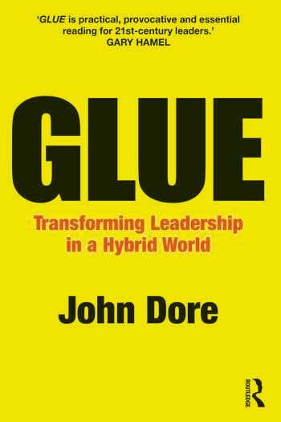
The adoption of remote, hybrid and flexible working is the new normal. But like the old normal, no one seems very happy. The solution requires a different type of leadership – one that unites, transforms and elevates performance. Leadership that creates glue.
With employee engagement, productivity and personal ties on the wane, leaders urgently need to refocus on harnessing relationships, making their organisations more humane, and finding new ways to engage and unleash talent. To do that, the single, most impactful thing leaders can do is to create and nurture an intangible, yet essential, factor called glue.
So, this book sets out some ideas about glue: where to look for it, how to use it and, most importantly, how to cultivate glue amongst your most valuable people. It explores the approach of some unusual leaders, and of firms transformed through the ‘organisational advantage’ of smartly configuring and harnessing talent. Using stories from firms such as Alibaba, Apple, Barclays, Sky, Husqvarna Group, HSBC, Space X, Zopa and Richer Sounds, the book shows how leaders can shape the effectiveness of teams, reimagine the workplace, and reinvigorate their business through the talents, ideas and energy of their firm’s best people.

This book is for anyone who has a genuine interest in leading others with impact and wants to better unite, transform and elevate their business. Whatever your role, sector or seniority, this book sets out a distinctive vision for the firm and shows the profound impact you can make through creating and nurturing glue.

https://www.linkedin.com/in/johndore/

https://www.linkedin.com/feed/update/urn:li:activity:7111960553190739968/

https://www.waveyourarms.com/

