Qualification: CIPD Diploma in Applied Human Resources

Module Name: Contributing to Resourcing & Talent Planning in the Organisation

Student Name: Wendy Roach
Student Number: 1907138
CIPD Membership Number: 55521124

By signing below, I confirm that the work/evidence presented is my own, unaided work. I understand the regulations pertaining to candidate malpractice and the action that may be taken as a result.

Signed: Wendy Roach
Date: 30th April 2021

Record of Evidence

Appendix 1 | HR People Strategy 2019-2021
Appendix 1.1 | Redeployment visual process
Appendix 1.2 | Employee Requisition form
Appendix 1.3 | Email FOR DISC
Appendix 1.4 | Data Pack
Appendix 1.5a | Email SServices Apprenticeship proposal
Appendix 1.5b | Proposal paper
Appendix 3 | Corporate Critical Services
Appendix 3.1 | Temporary Employee vetting
Appendix 3.2 | Skills Matrix
Appendix 3.3 | Covid 19 Doc
Appendix 3.4 | Managers email
Appendix 3.5 | Redeployment email
Appendix 3.6 | JD Home Care Support
Appendix 3.7 | Em Training plan
Appendix 3.8 | Temp care worker induction
Appendix 3.9 | Extract Temp Care worker handbook
Appendix 3.10 | Induction check list
Appendix 3.11 | Recruitment email
Appendix 3.12 | Copy of chase t/plan
Appendix 3.13 | Completed t/plan
Appendix 3.14 | Support Services message
Appendix 3.15 | Discussion doc

  - Assess how and to what extent the organisation undertakes workforce and talent planning.

According to the CIPD (2020a) “workforce planning is the balancing of labour supply against demand”.

Pembrokeshire County Council is a local authority with approximately 6000 employees in a diverse range of roles. Rurally located, recruitment of employees in specialised roles can be difficult. Likewise retaining employees can be challenging with limited opportunities for them to develop into. Location also means that attracting the younger generation to remain or to return to Pembrokeshire once qualified is an issue and attracting professionals to move to Pembrokeshire has also been proven difficult with a poor education review, high house prices and closure of amenities e.g. local hospital etc. We have a habit of attracting older employees who see this as their career end and wish to retire in Pembrokeshire.

Tackling the above dilemma is ongoing. The latest Strategic Workforce Planning (Appendix 1) document has limited inclusion relating to resource and talent planning. The focus within this plan at its time of introduction was to reduce the number of mandatory redundancies.

PCC budget restrictions meant that significant redundancies were anticipated. The strategy highlights the introduction of a ‘SWITCH’ programme. The use of ‘job families’ as part of role profiles to recognise generic skills and knowledge and allow easier movement between directorates. This also linked to the organisations redeployment approach (Appendix 1.1). Any external recruitment had to be justified and follow the requisition process for approval (Appendix 1.2). Notably only roles that required specialist qualifications were approved for external advert.
From the previous module I have recognised that as highlighted by CIPD (2020), work force planning should complement an organisations objectives. Regardless of size, an organisation should always be thinking ahead.

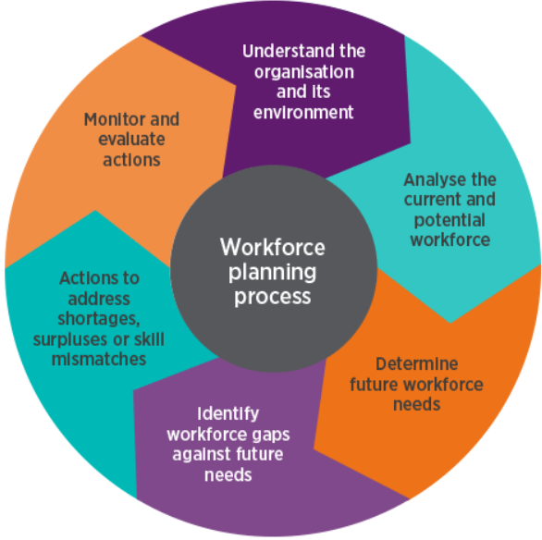 (CIPD 2020)

The above process identifies a clear approach but as an organisation we have not embraced this approach but would benefit from doing so.
Unfortunately, I believe that PCC has suffered financial cuts year on year, coupled with a change of leadership and senior management roles leading to a reactive approach rather than a proactive approach.
A new Chief Executive is due to start in September of this year and once again internal decisions have been ‘stalled’ for fear he may wish to change any decisions.

As a Local Authority our finances rely on central government and are at the continual scrutiny of the Elected Members. Although Elected Members are a key part of the Local Authority, their agendas can be political and their priorities differ from that of Senior Management. Thus often times the HR function is not included in decisions that can impact workforce planning and if financial cuts are to be made these are usually met by employee redundancies.

(Taylor 2014) highlights that organisations most commonly link reward and benefits to resourcing. Once again as a Local Government organisation, salaries are ‘set’ across the organisation and monetary rewards or benefits e.g. healthcare etc. do not exist. Thus ‘we’ struggle to compete with the private sector and are not viewed as an employer of choice.

  - Analyse internal and external information relating to the organisation’s future people and skills needs and the availability of talent.

The COVID pandemic has served to highlight the importance of recruitment and talent management. As a Learning & Development Advisor within HR my role has limited involvement with workforce planning. I requested to become involved in the planning and introduction of a formal apprenticeship ‘approach’. (Appendix 1.3). This email highlights the areas considered as risk areas within our workforce for the future:-

WFP identifies key risk areas

Children's social workers & Care workers
Planning officers
Building control officers
Legal professionals
Adult social workers
ICT professionals
Chartered surveyors
Mental health social workers
Finance officers (other than s151)
Environmental health officers
Engineering professionals
Educational psychologists

It also highlights that as an organisation Directorates and teams often work in isolation and we do not have a central point where this information is held and maintained. The intention is to consider how we can use the apprenticeship levy to upskill current employees and allow them to access higher level apprenticeships in the same way that I have done undertaking this qualification, along with developing a more structured framework for new apprenticeship pathways to meet the need of those areas identified as at risk. This would allow us to ‘grow our own’ for the future.

Looking at the Nomis web statistics in relation to the labour supply in Pembrokeshire, the following stand out:-

Percentage of males in employment in relation to both Wales and Great Britain as a whole.

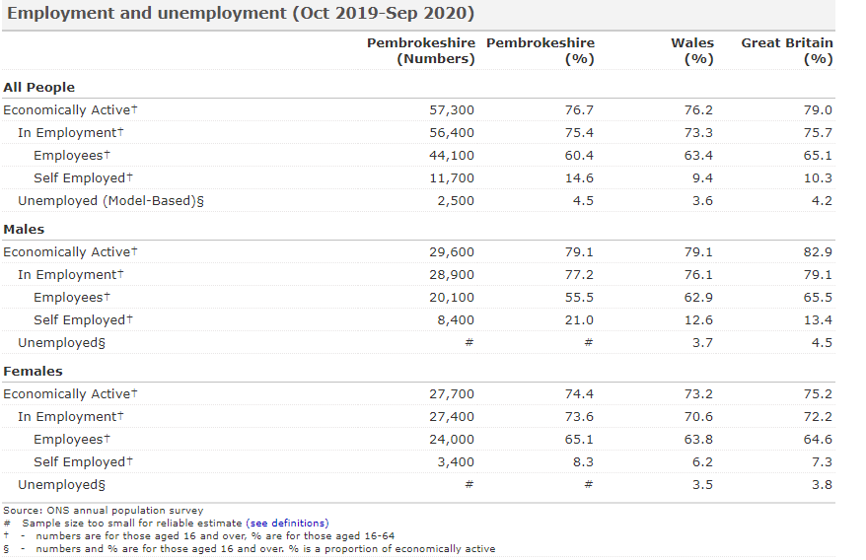

Again the number of those in Groups 1-3 in comparison to both Wales and Great Britain supports the organisation’s issue in recruiting those in professionally qualified roles. This is further highlighted later on in the report where qualifications NVQ4 and above are significantly lower than the rest of Great Britain.

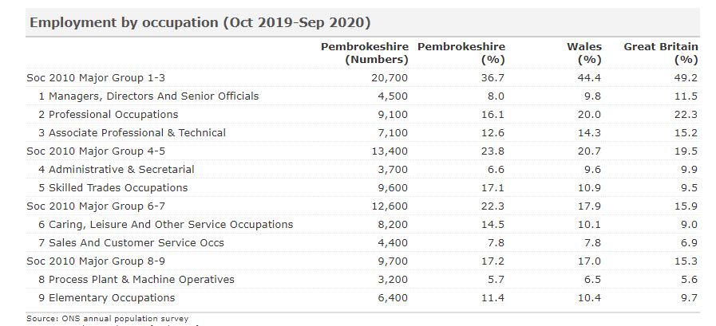

As you would expect the figures for Group 6-7 exceed Wales and Great Britain, typically linked to an aging demographic and tourism industry within Pembrokeshire.

This could be related to the fact that we only have a small higher education college in the area and thus forging links with universities to support future workforce needs is extremely limited. Again it supports the suggestion that people leave Pembrokeshire for further education and fail to return.
Perhaps one of the main reasons for this is linked to earnings:-

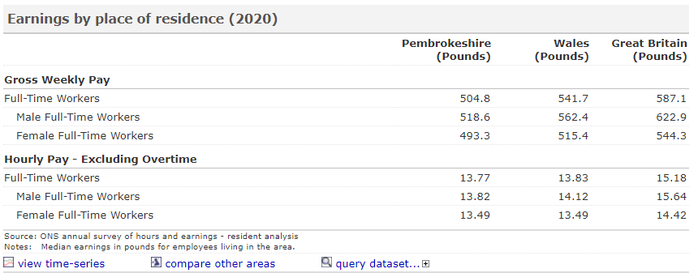

The difference between Pembrokeshire, Wales and Great Britain stands out.

A recent recruitment for refuse operative posts showed application numbers of 135 in comparison to both a Senior Technical Clerk of only 1 applicant and Planning Officer only 3 applicant (Appendix 1.4).

Conclusions:-

- PCC are in a challenging situation balancing finance with delivering services.
- Although I have researched external factors, this is not something undertaken internally but is a suggestion I will make as part of my involvement in the apprenticeship project
- The organisation needs to utilise the opportunities that the Apprenticeship Levy provides. This would have limited impact on internal finances.
- As an employer we may struggle to recruit in the future and do need to concentrate efforts on how we develop internal employees and attractive career pathways to improve our brand image.

  - Assess the extent to which current organisational planning activities are addressing potential needs.

Regular Directorate meetings have become more common with the inclusion of HR and L&D Link Officer. During these meetings a ‘data pack’ (Appendix 1.4) is always included and a brief discussion takes place but this is mainly focused around sickness stats. Due to the pandemic the latest data collated is from February 2020. Directorate meetings are due to recommence this year.

This evidence shows the employee data for one of the Directorates, it highlights that the age demographic of our workers between the ages of 45 to retirement is 921 against a total employee figure of 1721 in this area. From a workforce planning perspective this should ring alarm bells and as an organisation we should be planning now how we address this impending shortfall.

The Social Service Directorate is a good example of how PCC is planning to address one of the key risk areas, namely Social Workers in the future. Working as part of this ‘working group’, a ‘paper’ was recently submitted to Senior Management and Cabinet for a pilot approval (Appendix 1.5a/1.5b). This highlights how we can utilise the Apprenticeship Levy to address the ongoing recruitment challenges that we are facing in this Directorate and forge a partnership with the local higher education college.
If successful this pilot would act as an excellent model for other Directorates to adopt.

We can compare this approach with the four stages as identified by Taylor & Woodhams (2016)

Forecasting demand – We have identified that Social Service roles are an area of risk.
Forecasting supply – If we work in partnership with the local college we will have a pool to recruit from and also raise our profile as an employee
Identifying gaps – By introducing a career pathway and learning framework we can upskill current employees and consider future needs.
Address the gaps – The introduction of a comprehensive apprenticeship program will support any ‘gaps’. It will also serve to improve our ‘branding’ as an employer highlighting that there are development opportunities and a ‘thought out’ career path.

We should add to these steps how we intend to monitor and evaluate as highlighted by the CIPD (2020) steps, to understand if our approach is meeting its objective and the organisations needs.

2.1 Make reasoned recommendations for how the organisation can maintain an appropriate number of people with the skills required by the organisation.

I would also recommend further activities as highlighted by Taylor & Woodhams, (2016):-

Performance Management – We are currently introducing a new system that has the technology to store employee qualifications linked to competencies, skills and knowledge. Used effectively this could provide us with valuable information at the press of a button.
Succession Planning – encouraging the identification of key risk roles and potential employees to meet these roles. The introduction of a Graduate programme would invite new and younger talent to the organisation.
Career Development Planning - We currently run a Leadership & Management Programme but attendance records are not ‘held anywhere’ or linked to recruitment in anyway.
Employer Branding – I do believe that we do little to promote ourselves here. We have been to slow to embrace social media and positive ways of marketing what the organisation has to offer. We need to build on the work that was done during the pandemic, with employee good news stories supporting the community. Likewise the exceptional work that has been done with recycling and the amazing ‘Elvis’ UTube promotion (https://www.youtube.com/watch?v=ryVGjh7dIkU).
If the environment is important to a potential employee then this is an opportunity to improve our image.
Staff Retention – Acknowledging why people leave and addressing these reasons, a personal bug bear of mine, HR always undertake an exit interview but this is a tick box exercise and does not address real issues. Sadly, as an organisation we have a very poor reputation of bullying and doing nothing about it. The HR function needs to look at its own processes.

During the pandemic I witnessed PCC ‘move’ to becoming a forward thinking organisation, quick to react in a measured and thought out way. I sincerely hope we do not return to the slow autocratic approach of the past but fear this may happen.

3.1 Identify and explain the rationale for a specific resourcing activity within the organisation.

3.2 Agree roles and responsibilities with other contributors to the activity.

3.3 Identify organisational procedures and legislative requirements which underpin the activity.

3.4 Plan and prepare for agreed role, ensuring the availability of any materials or resources required.

3.5 Undertake agreed role in a timely and accurate manner, in line with organisational procedures and legislative requirements.

PCC are responsible for the Social Care provision in Pembrokeshire which includes care homes and care in the community. The ‘Care role’ was identified as a ‘critical need’ to support the increase in demand when the Covid pandemic started. The intent was to create a pool of temporary ‘carers’ who could be used to fill staffing gaps as and when they arose.

My role within this task as a Learning & Development Advisor was to design, develop and deliver the required training that would be needed along with supporting employees and tracking their completions. Working alongside the HR Generalist Advisors using the current role profile to include COVID requirements along with considering current policies and practices that may need to be amended. I was involved at all stages of the task to ensure that I had a full understanding of the process due to the emergency nature of the situation. I would be expected to communicate and support redeployed staff. It was important to ensure that all those involved could communicate the same message to avoid any issues or time delay.

The following shows the approach that was taken internally to redeploy staff into these roles:-

Action taken | Document evidence
Corporate Critical roles/ areas identified  Paper to Senior Management Team to request a change in recruitment and vetting protocols both externally and internally | Appendix - 3  Appendix – 3.1
Request to Line Managers to identify employees for redeployment and completion of a skills matrix of these employees  A Corporate critical services list was also used to identify opportunities for redeployment | Appendix – 3.2
Temporary Redeployment policy introduced | Appendix – 3.3
Once employees identified, a redeployment email was sent to LM along with the new temporary redeployment policy.  Likewise, an email communication was sent to the employee. At this stage we did receive a small number of individuals who challenged redeployment to a care role due to the perceived risks attached to this. This can be seen from the spread sheet | Appendix – 3.4  Appendix – 3.5
The current job description was deemed suitable for use | Appendix – 3.6
I developed an Emergency Redeployment Training Plan for the role using the job description | Appendix – 3.7
Design of training material including a training plan for all employees to follow and ensure consistency and meet statutory requirements of role  Temp Care worker Induction power point / webcast notes  Temporary Care workers handbook  Induction checklist to be used by new Line manager on day 1 in role, buddy approach with an experienced carer encouraged  Recruitment email | Appendix – 3.8  Appendix – 3.9  Appendix – 3.10  Appendix – 3.11
Monitoring of training completion, providing support, updating completions and liaising with redeployed staff and the Generalist HR Advisor with any employee issues | Appendix – 3.12  Appendix – 3.13  Appendix – 3.14

The above loosely emulates Bechet (2008) definition as a number of stages:-

1 Critical roles were identified
2 Skills & capabilities defined
3 Possible candidates were identified and skills/knowledge gaps addressed
4 A tailored plan was developed. Bechet (2008) suggests that this should be bespoke, providing innovative talent and development opportunities. The nature of the situation did not allow for this in total but arguably we might well see employees considering a change in career path having been given an opportunity to try something new.
5 Evaluation has not yet taken place, ongoing minor amendments to the process were made when identified. Basic records have been maintained throughout but we will look to seek evaluation including:-

Employees who went through the process
Employees supporting them
Impact of effectiveness
What could have been done differently?

3.6 Reflect on the effectiveness of the resourcing activity in meeting required objectives and report back to stakeholders.

This activity was undertaken in the early months of the pandemic. In ‘normal times’, the introduction of such a process within PCC would have taken months to put in place. This was an unprecedented emergency and a lot of the normal ‘red tape’ was ‘abandoned’ to ensure the organisation was able to effectively meet the challenges.

Although we faced a small amount of employee resistance, this was mainly down to the fear of the risks that individuals might face in catching COVID. If raised by the redeployed employee, my response was always to speak to the individual on a one to one basis and allow them to share their fears and concerns. The organisation’s approach was not to ‘force’ individuals but encourage them, ‘work with the willing’. Anyone refusing to redeploy to a caring role was considered for other redeployment roles before being furloughed. Forced redeployment was not an approach we wanted to take. It was anticipated that it would only ultimately result in sickness absence and potential Trade Union involvement.

The effectiveness of my part within this activity was positive. The Induction approach and training plan was clear and easy to follow. Employees were encouraged to complete the training within 10 days wherever possible and were provided with contact details for support. The majority of this training was online and could be accessed on a range of personal devices.

The spread sheet was centrally stored to allow access for all of the HR team to access, both Generalist and L&D to allow it to be updated in the present. At the end of each day I had a short skype update meeting with a HR Generalist. Updates were reported as part of the weekly HR contribution to the COVID Corporate update meetings.

Storey (2007) argues that an organisation cannot afford to accept one approach to human resource planning and that unpredictability should always be factored in for an organisation to remain ahead of the game.

I do however believe that as an organisation we acted with speed and in an organised fashion to the critical issues we have been faced with in the last twelve months, a testament to the skills and abilities that the HR team within PCC possess and the often unacknowledged role that they contribute to as an organisation with over 6000 employees.

My hope would be that the importance of the HR function is recognised moving forward and the importance of the workforce plan is driven forward.

According to the CIPD, workforce planning… the right number of people with the right skills employed in the right place at the right time, for the right cost and on the right contract….

The Head of HR has already started to push forward the importance of developing career pathways (Appendix 3.14) for those roles identified as a recruitment critical risk in the future and follow the (CIPD 2020) description, succession planning as a means of “identifying and growing talent to fill leadership and business-critical positions in the future”. (Appendix 3.15)

Reference list
Bechet, T.P. (2008). Strategic staffing : a comprehensive system for effective workforce planning. New York: American Management Association ; [Alexandria, Va.
CIPD (2020a). Succession Planning | Factsheets. [online] CIPD. Available at: https://www.cipd.co.uk/knowledge/strategy/resourcing/succession-planning-factsheet#gref [Accessed 27 Apr. 2021].
CIPD. (2020b). Employer Branding | Factsheets. [online] Available at: https://www.cipd.co.uk/knowledge/fundamentals/people/recruitment/brand-factsheet# [Accessed 27 Apr. 2021].
Storey, J. (2007). Human Resource Management: A critical text. 3rd ed. Routledge.
Taylor, S. and Chartered Institute Of Personnel And Development (2014). Resourcing and talent management. London: Chartered Institute Of Personnel And Development.
Taylor, S. and Woodhams, C. (2016). Human resource management : people and organisations. 2nd ed. London: Chartered Institute Of Personnel And Development.
www.youtube.com. (n.d.). The Wonder Of You - Pembrokeshire Recycles. [online] Available at: https://www.youtube.com/watch?v=ryVGjh7dIkU [Accessed 27 Apr. 2021].

Appendices

Appendix 1

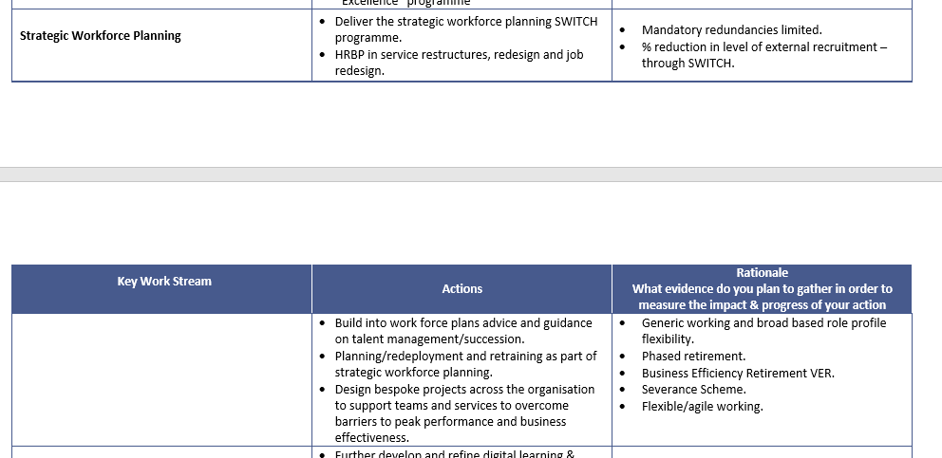

Appendix 1.1

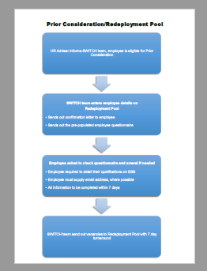

Appendix 1.2

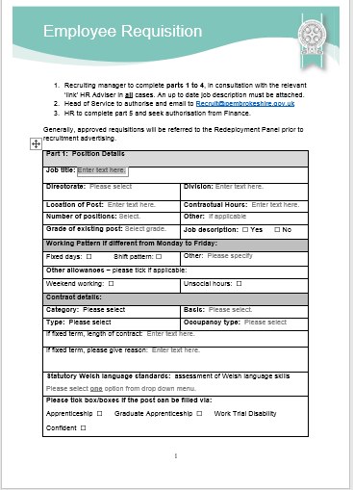

Appendix 1.3

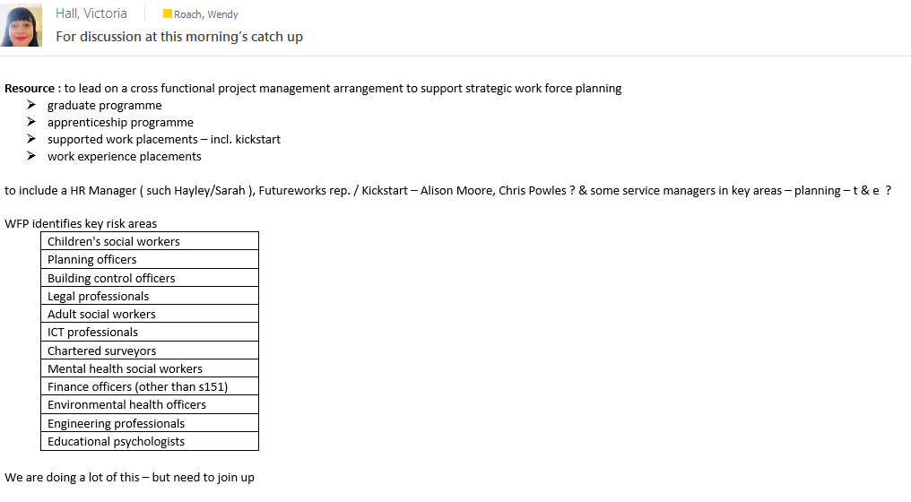

Appendix 1.4 samples from data pack

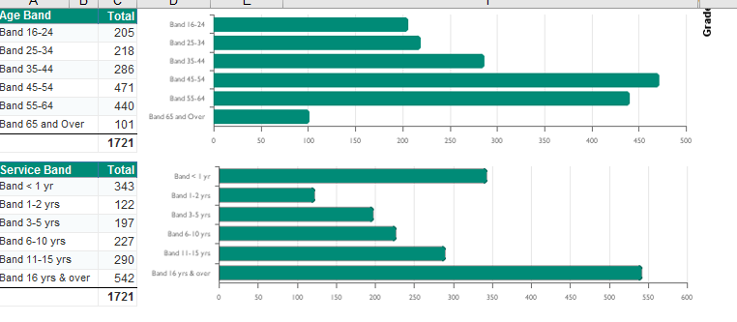

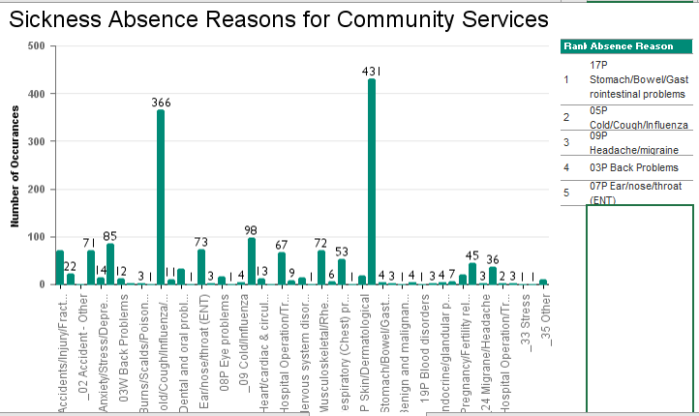

Appendix 1.5a

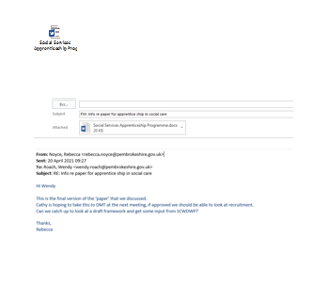

Appendix 1.5b first part of report

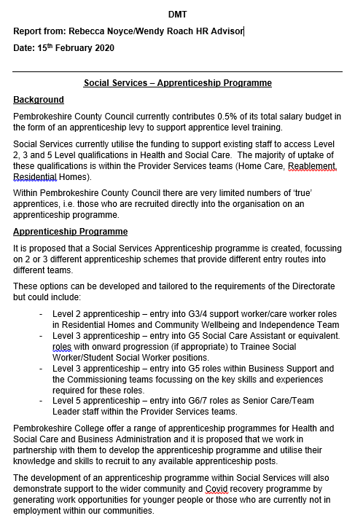

Appendix 3

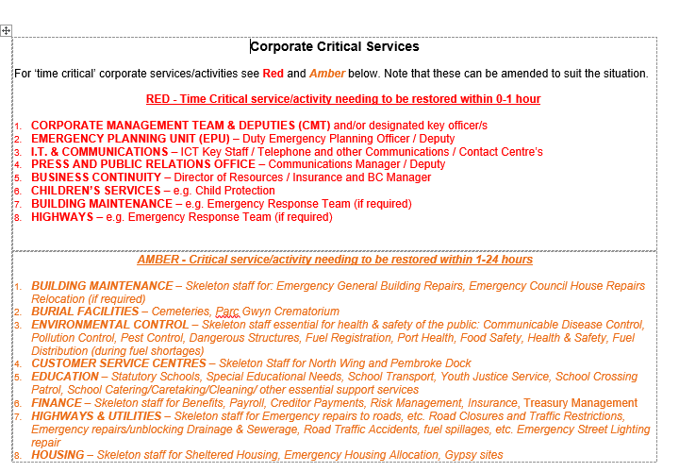

Appendix 3.1

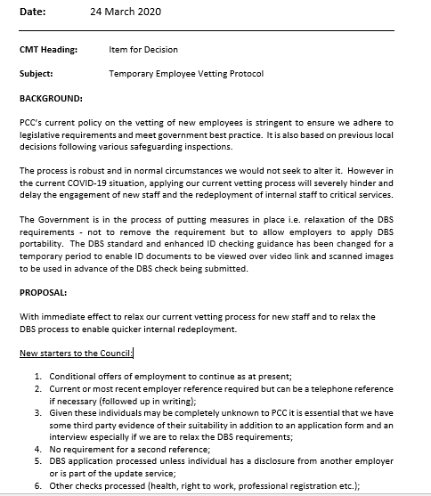

Appendix 3.2

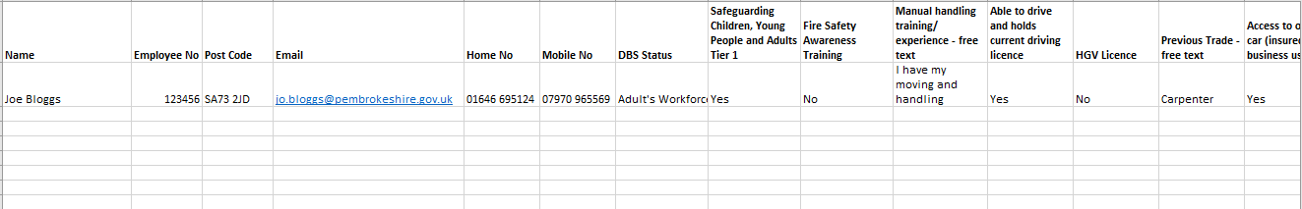

Appendix 3.3

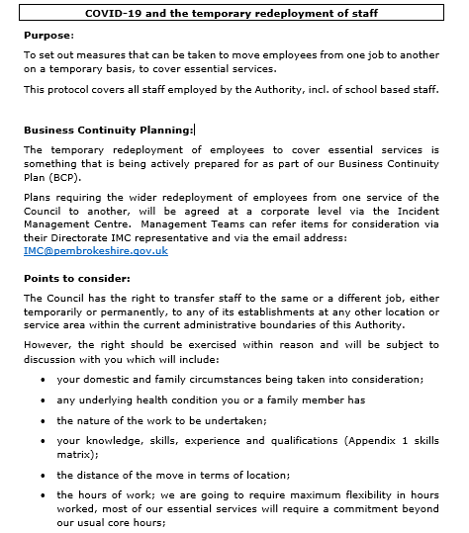

Appendix 3.4

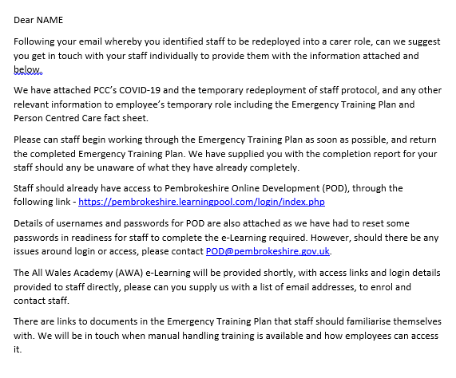

Appendix 3.5

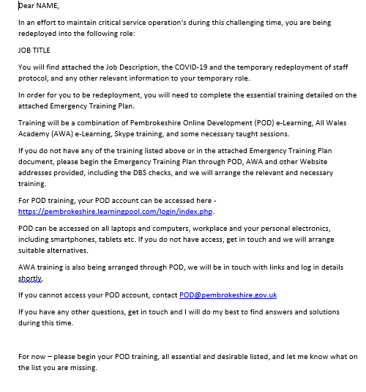

Appendix 3.6

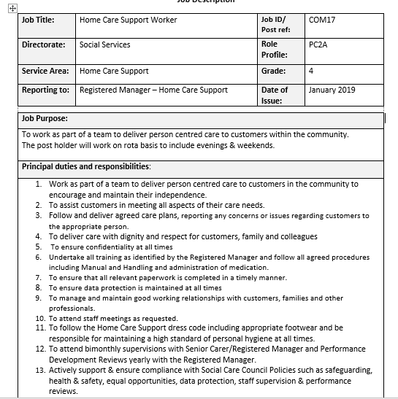

Appendix 3.7

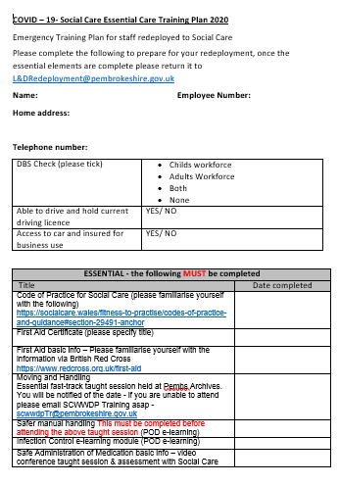
Appendix 3.8



Appendix 3.9

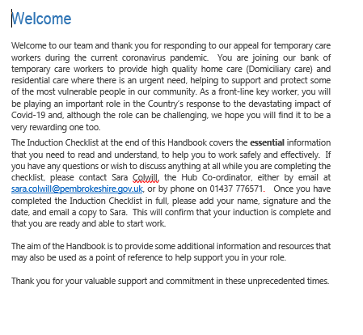

Appendix 3.10

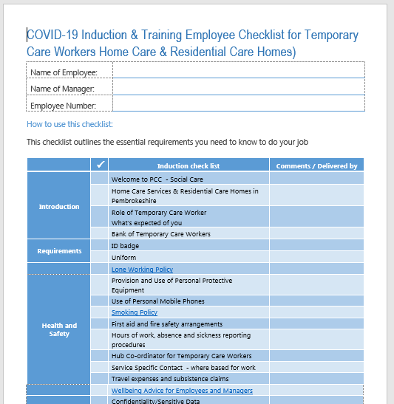

Appendix 3.11

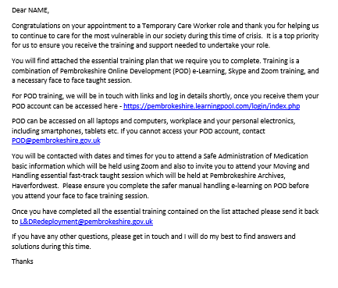

Appendix 3.12

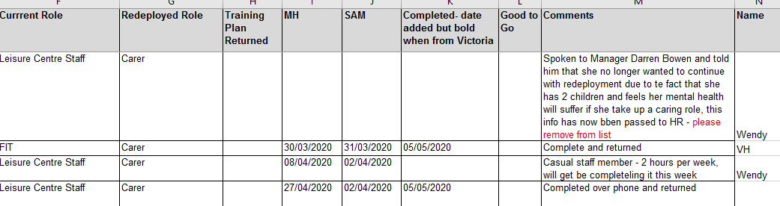

Appendix 3.13

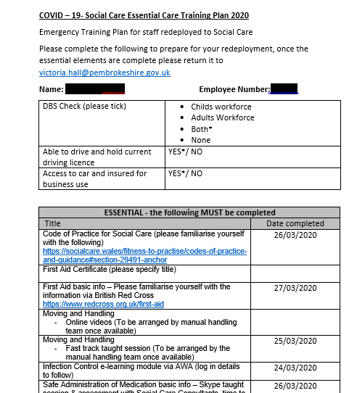
Appendix 3.14



Appendix 3.15



