The Smile Factory
Documentation
Adam Clarke
2018

Contents
Relationship Diagram: 2
Report Output: 3
Forms: 8
User Guide: 11
The Main Menu: 11
Table editor: 12
Add appointment: 13
All appointments report: 14
Print Invoices: 15
Improvements: 17

Relationship Diagram:
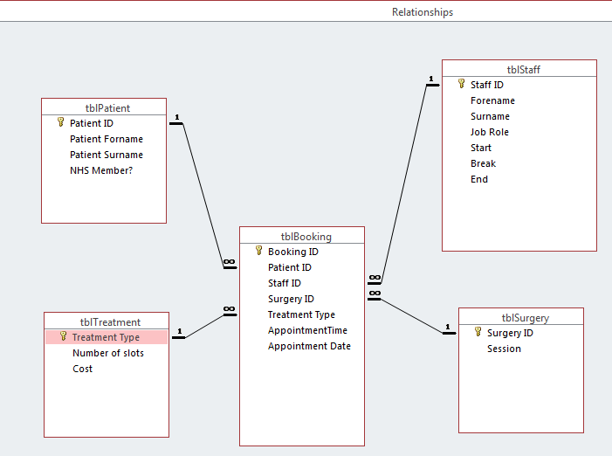
Above is the Relationships in my Database. There are one to many relationships. One patient ID can have multiple bookings/appointments. However, one appointment cannot have more than one patient ID. The same can be said for all other one to many relationships. One appointment cannot have more than one staff ID but one staff member can have multiple appointments. The relationships ensure that data is consistent throughout my database. The relationships in my database work very well and link together nicely and effectively.
You are a little bit sparse on attributes in your entities (contact details)

Report Output:
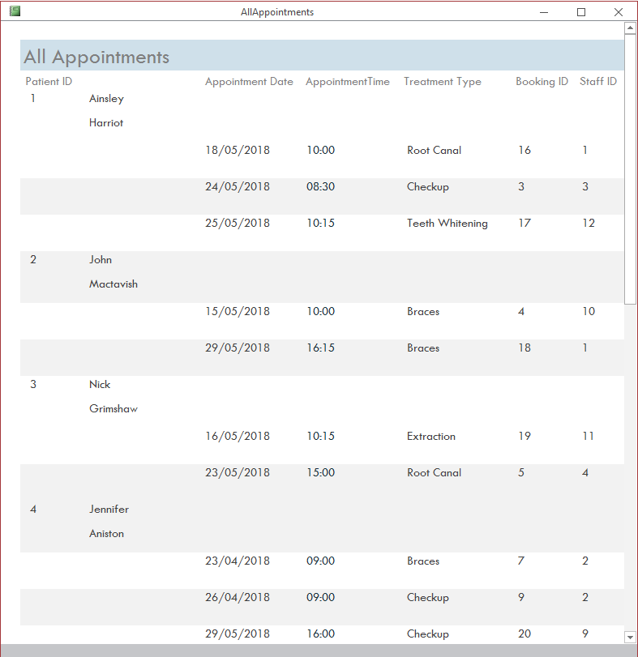
First part of the ‘All Appointments’ report. This report contains all patient appointments so the user can easily see how many appointments there are, how many appointments each patient has, when the appointment is and what it is for, for example a root canal at 15:00 on 23/05/2018. Patients can have multiple appointments but not at the same date/time. The report is generated from a query that selects all patient appointments; so it only uses one table to generate a report. In reports you need to show staff name rather than IDs
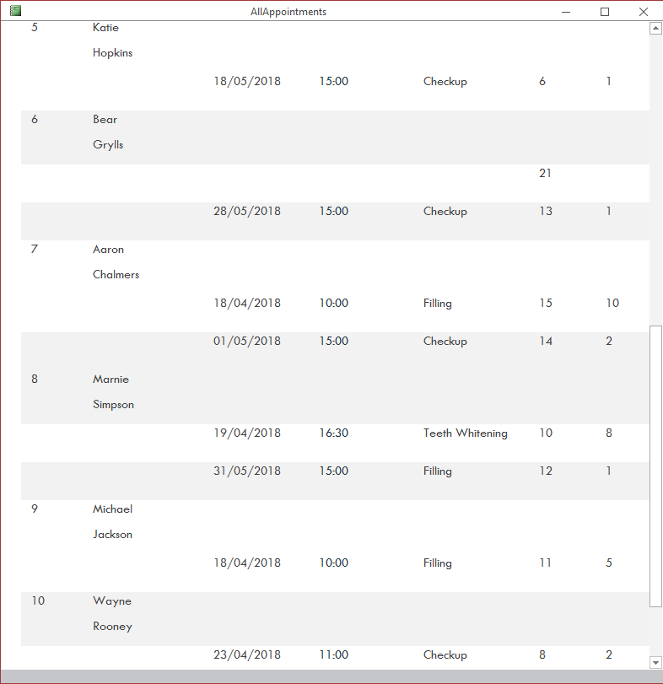
Above is the second part of the ‘All appointments’ report. It contains the remaining appointments continuing from the first page.
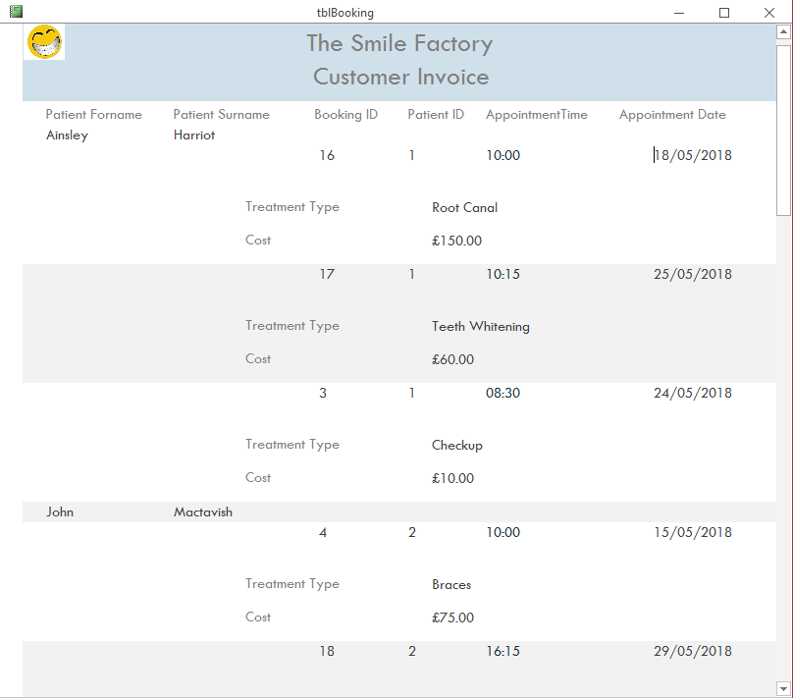
This is the first part of my Invoice report; it is a report design used as a template for singular invoices. The original report contains all customer data though. However, when generating customer invoices it will not contain all the data above, only the same fields with relevant data.
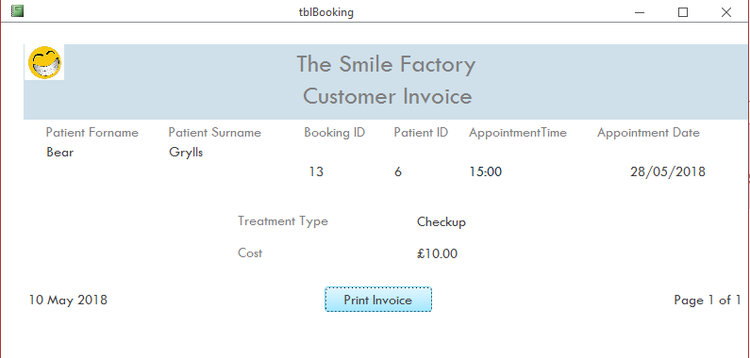
Above is the first output from the report design above. It only generates data from booking ID 13, not any of the other bookings/appointments. This is done with the use of a macro that generates a report using only the booking ID that is selected in the current form. Each subsequent report will be unique but use the same report design.
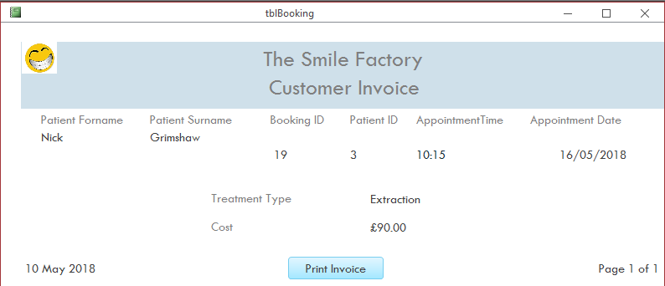
This is the second output from the invoice report design. Similar to the previous report, it is unique and uses the original report design. But this report only contains the information from booking ID 19.
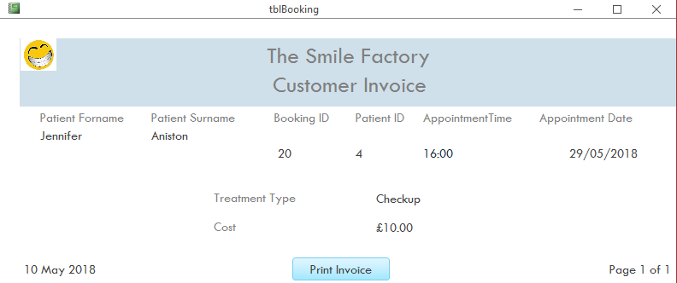
This is the third output from the invoice report design. This report only shows the data from booking ID 20.
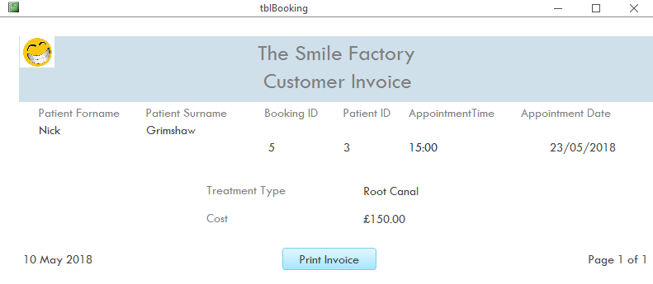
This is the fourth output from the invoice report design. This report only shows the data from booking ID 5.

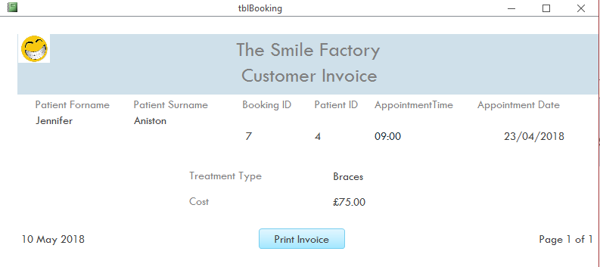
This is the fifth output from the invoice report design. This report only shows the data from booking ID 7.
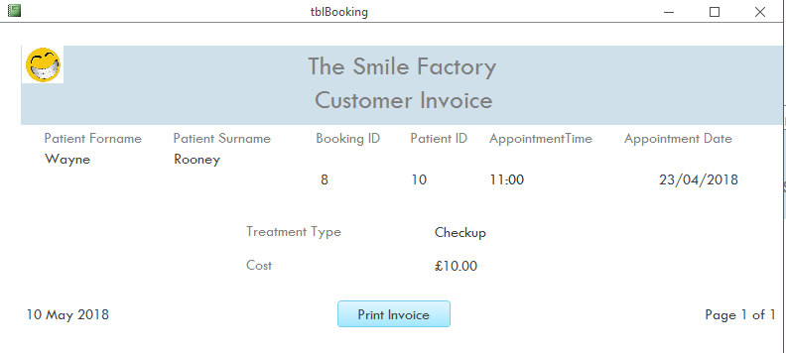
This is the sixth output from the invoice report design. This report only shows the data from booking ID 8.
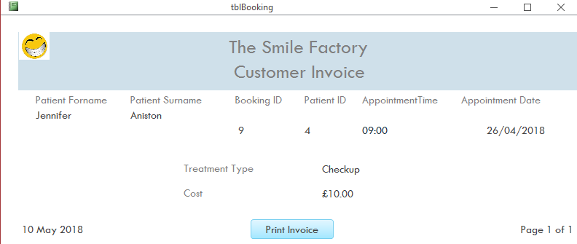
This is the last output from the invoice report design. This report only shows the data from booking ID 9.

Forms:
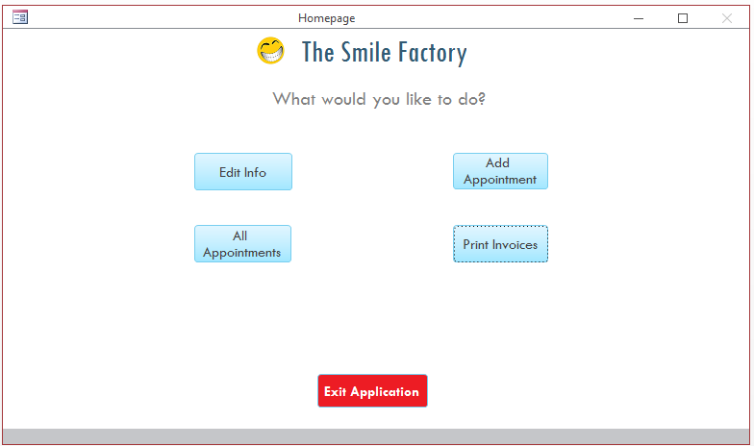
My Homepage Form. It opens automatically upon starting the database with the AutoExec macro.✓ It has 5 buttons, 4 that take the user to different forms/reports or one that closes the whole database using an embedded macro.✓ This is functional as a program and not just a Microsoft Access program.
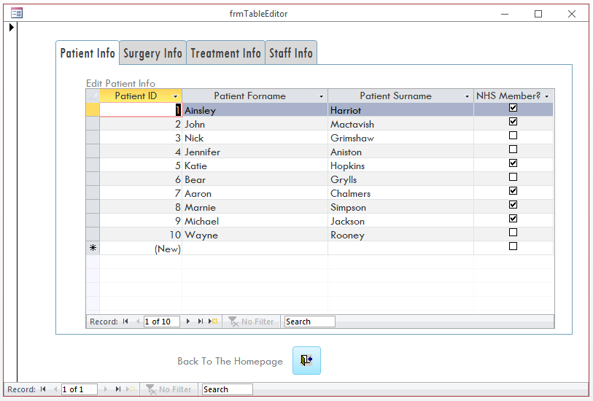
Table editor form with 4 sub-forms. This gives the user the ability to edit or delete information from all tables. For example, they can change the staff info table if a new staff member is hired or a staff member does not work there anymore, or if a staff member receives a change in job role. Patient info can be changed such as patient name or whether or not they have NHS membership. Treatment info can also be edited if a price changes or new treatments are added. Good use of tabs
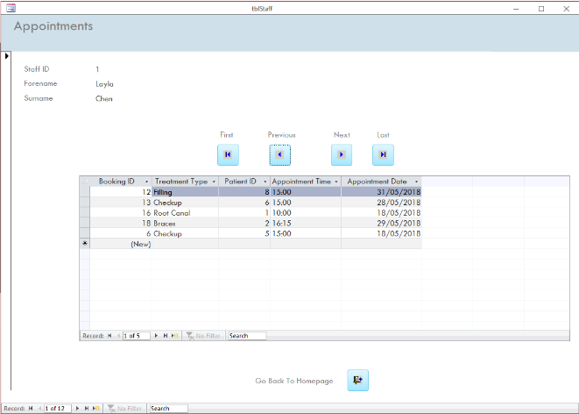
Staff appointment form with booking table sub-form. This from allows the user to see each staff members list of patient appointments and also gives the user the ability to add new appointments. It prevents the user from adding duplicate values for one staff member.✓ good functionality They cannot double book a staff member on the same time/date but the same time/date can be used for another staff member provided that they are not already booked on that date. The arrows allow the user to navigate through each and every member of staff and view and add new bookings. The sub-form is dynamic and will change depending on which staff member is selected. There is also a button at the bottom that closes the from and takes the user back to the homepage.
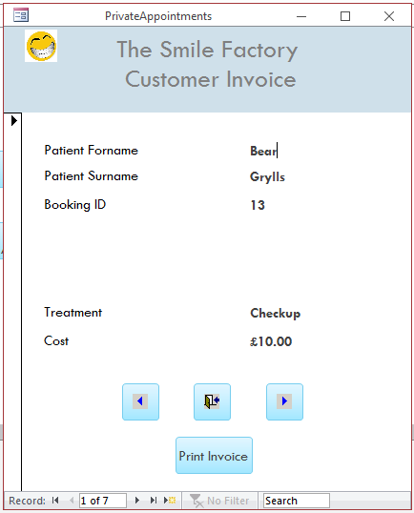
This is my customer invoice form that is used to generate my invoice reports. This is a basic form that enables the user to generate a report which will print out a unique invoice for each patient appointment and how much they owe the dentist. The arrows change which booking is selected and thus how much is owed. A bit simplistic and only for a single item

User Guide:

The Main Menu:
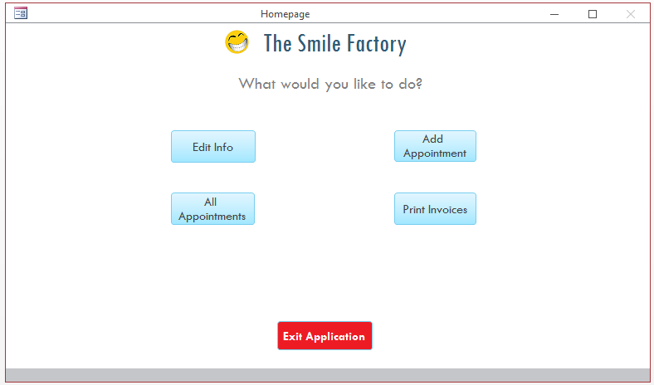
This is the main menu; the ‘edit info’ button will send the user to a separate form which gives them access to edit all tables in different sub-forms. The ‘Add appointment’ button will send the user to a separate form with all members of staff and each of their appointments. The ‘All appointments’ button will open a report with a list of all customer appointments. The fourth button named ‘Print invoices’ will open up another form with customer appointment invoices. Finally, the last button ‘Exit application’ will close the database and Microsoft Access altogether.

Table editor:
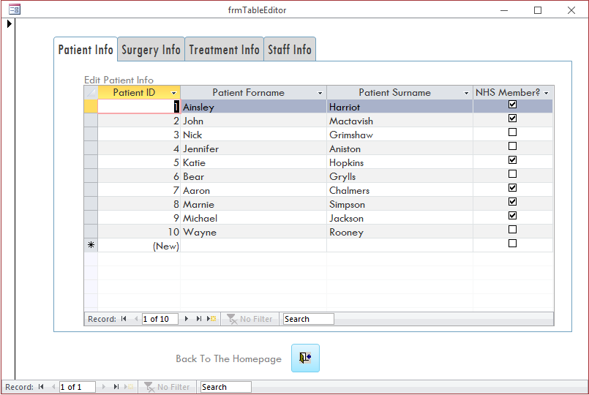
This is the Table Editor form where the user can edit the information in the tables via the sub-forms that are found in the form. For example, patient info can be edited like if a patient where to change their name or become an NHS member, or a staff member may leave and need to be deleted from the database. This can all be achieved in this form.
To leave the form and go back to the main menu, the user must press the ‘Back to Homepage’ button.

Add appointment:
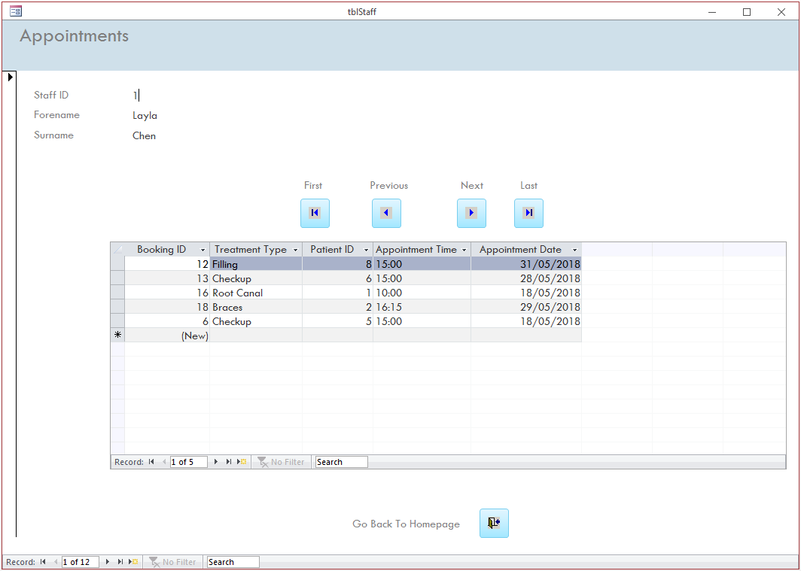
This is the form that the user will use to add new appointments. The buttons above the table sub-form can be used to change which staff member is being viewed. The table will change depending on which staff member is being viewed. It lists each all the appointments for each staff member.
New appointments can be added easily; the user must choose information from combo-boxes. The treatment time, patient ID and treatment type can all be chosen from a combo box and the date picked from a calendar, automatically generating a unique Booking ID. Duplicate data entries are prevented with an error message as shown below:
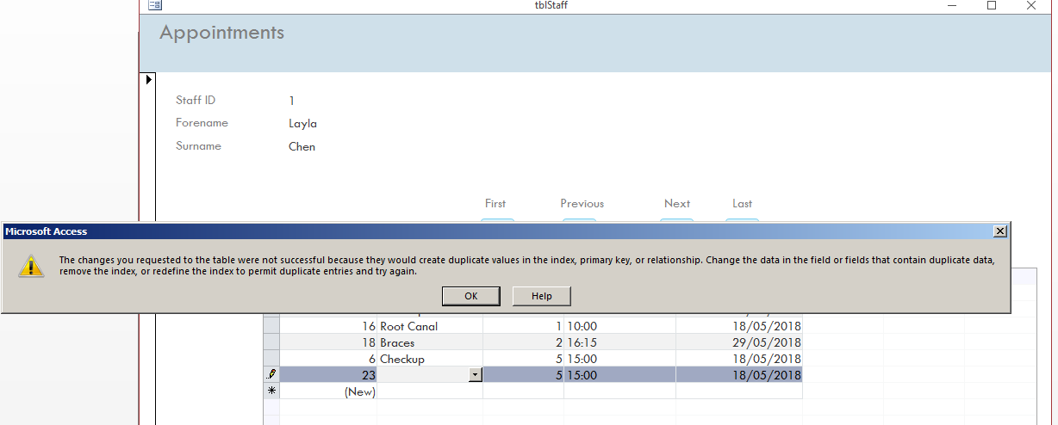

All appointments report:
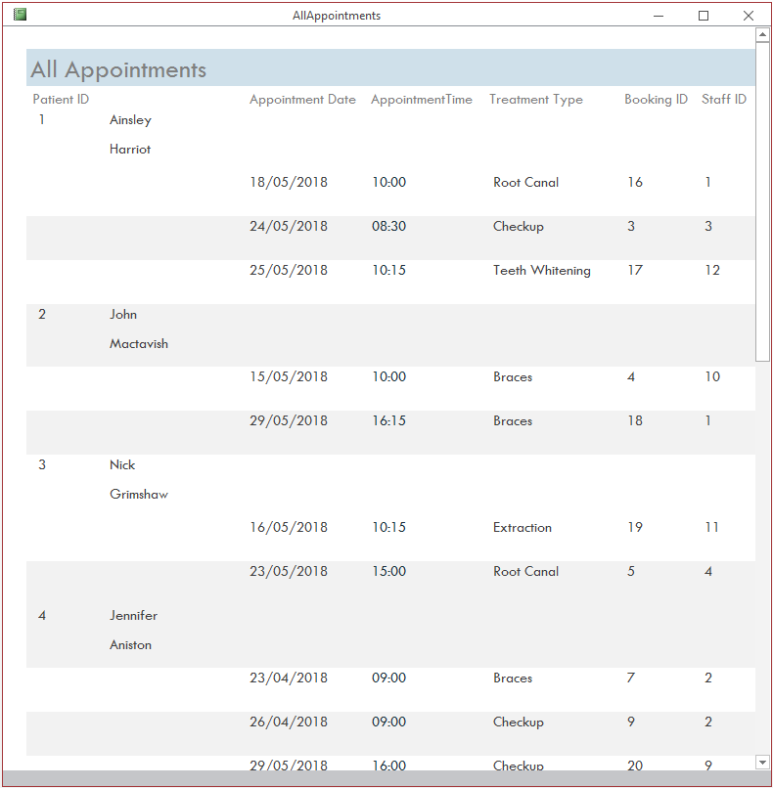
Above is the report that opens and shows all patient appointments and relevant information to each one; the booking ID, Staff ID, booking date and time as well as the patient name and ID. There is not much functionality on this page and is mainly for viewing purposes.

Print Invoices:
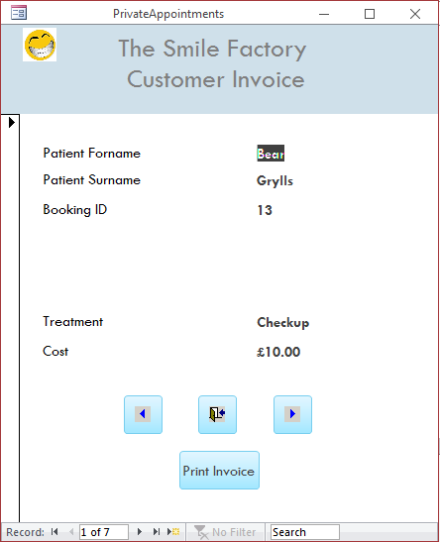
Above is the form for customer invoices; it shows individual appointments for customers that are not NHS members, therefore, they will be charged and sent an invoice. The arrows will scroll through different appointments.
To print an invoice, press the print invoice button and it will generate a unique report from a report design:
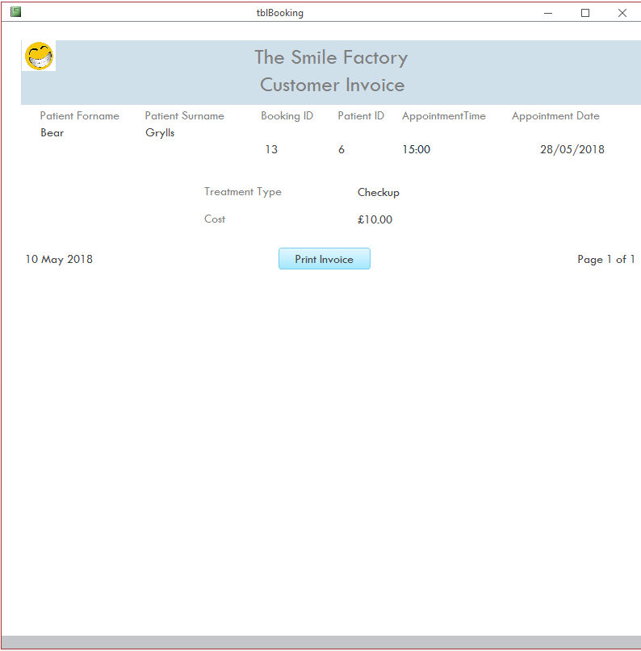
This is a report that will generate and will be different for all appointments. To print the invoice, press the ‘print invoice’ button and choose a printer.

Improvements:
If I were to improve upon the database I would add a few more features such as producing calculation in a report; I could have done this in the within the report for all appointments; I could have calculated the total cost of all invoices from all private appointments.
Furthermore, I could have included customer names into the customer ID combo box in the appointment sub-form; this would have made creating an appointment a lot easier than it was.

