15.03.2023
Computer Architecture and Operating Systems

Jamie Richards (0852036)
ACCA4022 – Computer architecture and operating systems
Table of Contents
1 – Introduction Page – 2
2 – Operating Systems Page – 2
2.1 – Key Functions Page – 3
2.1.1 – The Kernel Page - 3
2.1.2 - Memory and Process Management Page - 3
2.1.3 - File and Directory Management Page - 4
2.1.4 - System Security Page - 4
2.1.5 - Device Management Page - 5
3 – Windows Operating Systems Page – 5
3.1 – Command Line Input commands Page – 6
3.1.1 – Windows Operating System Scripts Page - 8
4 – Linux Operating Systems Page – 9
4.1 – Command Line Input commands Page – 9
4.1.1 – Linux Operating System Scripts Page - 11
5 – Conclusion Page – 11
6 – References Page – 12
7 – Appendices Page – 13
7.1 – Tutorial Activity Page – 13
7.2 – Online Certified Course Page – 14

1 - Introduction
This report will begin by looking into what an operating system is and researching its key functions, the core of this report will illustrate several different commands and scripts associated with operating systems, this report will end with a conclusion.

2 – Operating Systems
“It has been rightly said that operating system is the first software we see when we turn on the computer and the last software we see when the computer is turned off”[1].
The quotation above cited from the book “operating system concepts”, written by Ekta Walia, describes briefly what a user sees when they interact with an operating system, as stated an operating system is a piece of software used within a computer to control the hardware resources and provides a platform for application to run.
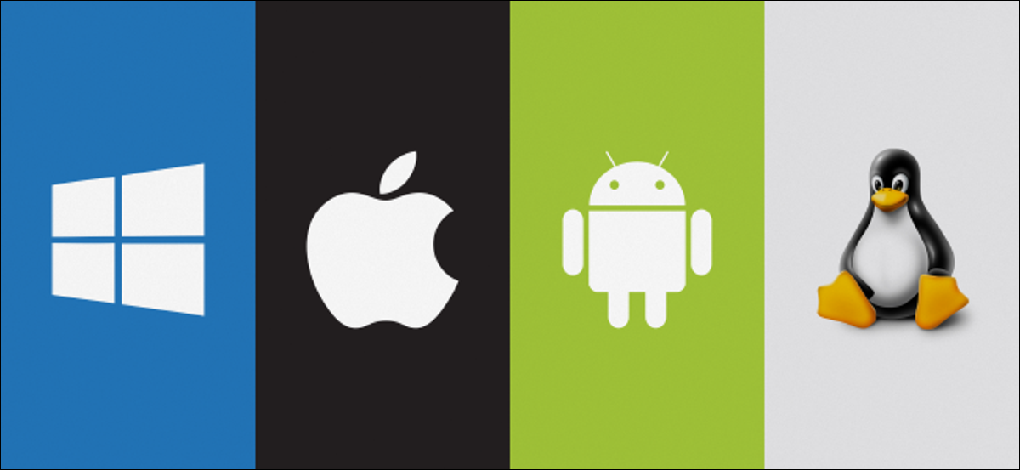
Figure 1 above illustrates a few brand logos of popular operating systems used today. On the left is Windows followed by Apple, Android and finally Linus on the right. [2]
Its not just computers that run operating systems, the majority of everyday technology uses an OS such as smartphones, tablets and even smart TVs. The OS basically sits in the middle of the hardware and the applications running of said device. [3]

2.1 – Key Functions.
Operating systems often is abbreviated to simply OS and they offer a vast number of functions for the user and this report will now investigate several key functions and their purpose.

2.1.1 – The Kernel
Before investigating functions, this report will briefly explain the Kernel.
With any OS comes its core or heart, known as the Kernel. This ultimately controls everything within that said device even more so than the OS, the Kernel will be responsible for different functions within the OS such as task and device management. There are different types of Kernels, again dependant on the operating systems design, one example is known as the Monolithic Kernel, this is where the process and memory organization is conducted within the Kernel itself, other designs or versions of the Kernel involve these actions being done elsewhere. [8]

2.1.2 - Memory and Process Management
The primary memory within a computer is its RAM, known as random access memory, one of the functions of an operating system is to instruct the computer on how to use and allocate that memory depending on the user’s applications or processes. The main purpose of this function is to ensure the memory is used correctly allowing the computer to perform its tasks effectively for the user.
Secondary memory comes in the form of an external device such as a hard drive or memory sticks, also known as solid state storage devices. [9]
Virtual memory allows a computer to use more memory than it has available, this is done by moving storage to the secondary memory, this is known as swapping.
Process scheduling is where an operating system manages multiple processes at once and decides what process gets what CPU time. An algorithm allows the computer to determine how much time each process needs, some popular algorithms are the Round Robin and First Come First Serve or FCFS for short.
The process management function as the name suggests involves the processes of the computer, common actions would be allocating time from the CPU to undertake a process for an application or even terminating process effectively.

2.1.3 - File and Directory Management
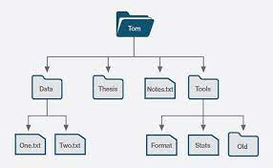
Figure 2 to the left illustrates a visual representation of a file directory sourced from from operatingsystemsam.com.[10]
The file and directory management function within an operating system is again as the name suggests, it is the process of organising the files stored within that system.
The files contained within this management system vary between text files, images audio and video. The management of these files allows the user to create, delete copy and rename allowing easy access and organisation.
Apple uses a different file system to Windows known as APFS or Apple File System, its biggest feature being encryption. Apply uses this management system across their products like the iPhone, Mac and Apple TV.
Windows currently uses the NT File System also known as NTFS the biggest feature here is that the files allow the user to be rolled back to their last saved point, this is known as transaction.
Linux supports an Extended File System or Ext for short, similar to the old Windows file system known as FAT, Ext can hold a huge amount of storage in their file system.

2.1.4 - System Security
An operating system uses a number of security techniques to ensure its contents and functions remain safe, these are but not limited to user accounts and passwords, access control, encryption and anti virus software. [11]
The most common being user accounts and passwords, this allows certain users access to the system. Access control in a similar manner is where certain users have access to different areas of the operating system, encryption is where files and data get encrypted, protecting it from unauthorised access and anti virus software prevents the system from being attacked with a virus.

2.1.5 - Device Management
The device management in an operating system is where the hardware devices are managed, both input and output devices are organised with the operating system responsible for identifying and allocating the necessary process to run these devices.
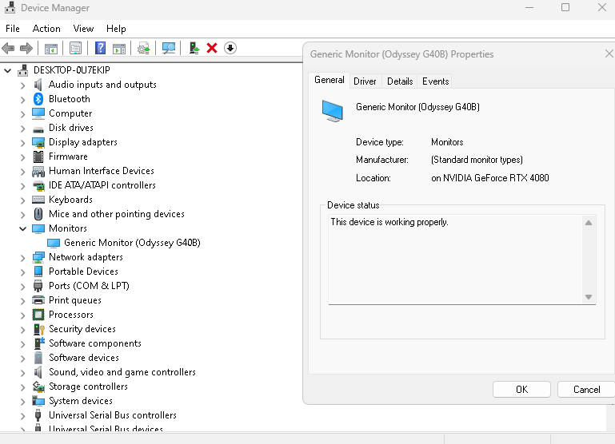
Different functions are available to maintain this management process, one example being device configuration, this is where the operating system allows the user to alter the devices settings. For instance a monitor is a device, using this method allows the user to edit the display settings on the monitor, an example of this is shown to the left.

3 – Windows Operating Systems
The remainder of this report will look into a few different Command Line Input commands also known as CLI and scripts. CLI is a way a user can interact with an operating system, to do this the user simply enters a command text into the interface in order to perform a specific task.
System Operating scripts work in similar ways to commands where the user uses a text base command to automate the system to perform tasks.
Microsoft developed a tool allowing users to execute commands and scripts, known as PowerShell, this will be used to illustrate some examples of commands, see below examples. [12]

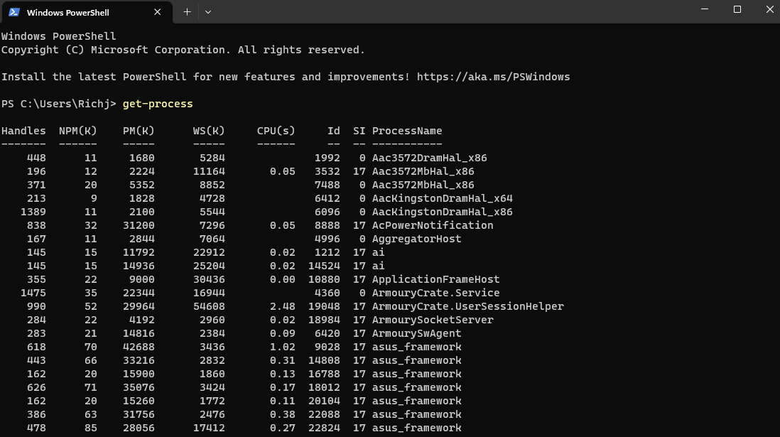
3.1 – Command Line Input commands.

Get-process – the screenshot to the left shows the get-process command which shows the user the processes running on their system.

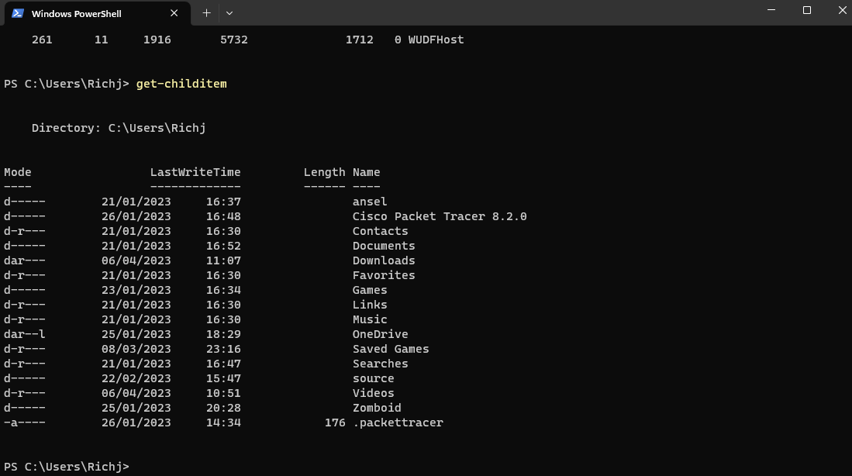

Get-childitem – the screenshot to the right illustrates the get-childitem command allowing the user to view files in a directory.
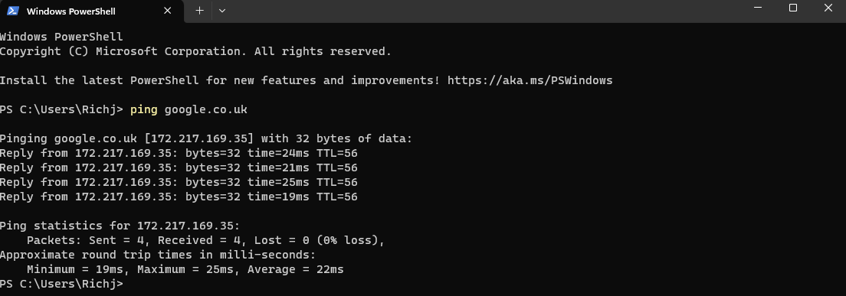
Ping – the screenshot above illustrates the use of the ping command this allows the users to test a server connection.
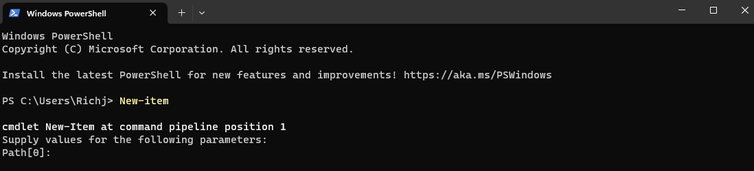
New-item – the screenshot above illustrates the new-item command which can be used to create a new file.
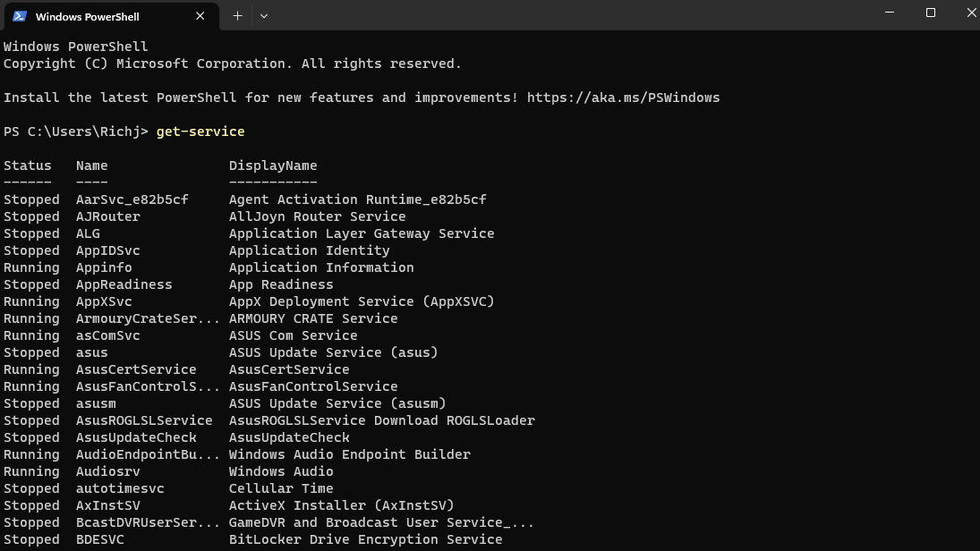

Get-service – this command will display the current processes running on the computer for the user, see screenshot on the left.
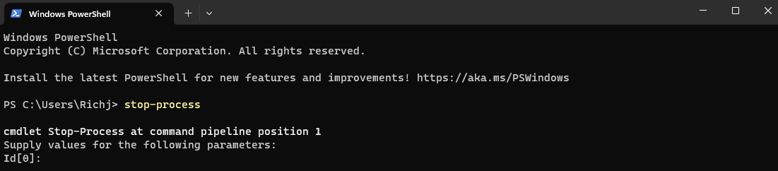
Stop-process – as the name suggests the above screenshot illustrate the stop-process command which allows the user to stop a running a process.
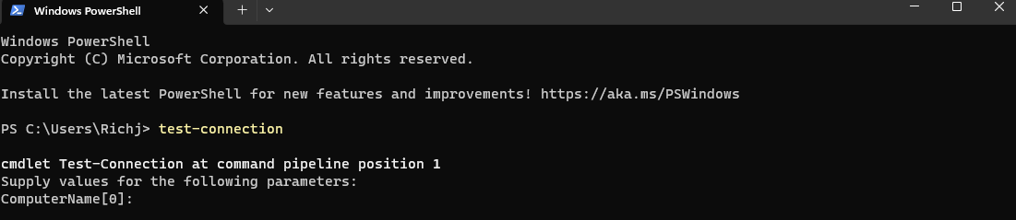
Test-connection – this command allows the user to test the connection in a network. [13]

3.1.1 - Windows Operating System Scripts.
PowerShell also uses a scripting language to allow the uses of scripts, below are three key features.

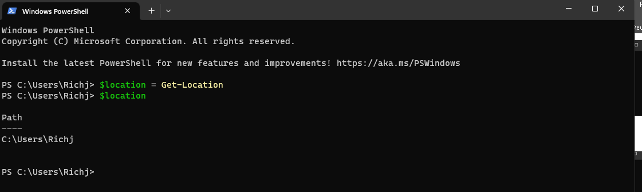
The above screen show illustrates a basic script in PowerShell, using the $ sign allows the user to create a variable from there the user can assign the variable the Get-location command. [14]

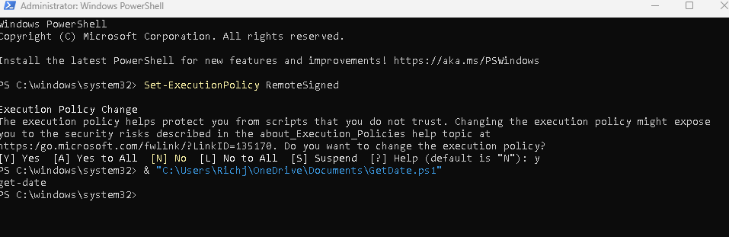
The above screenshot illustrates two things, firstly using PowerShell in admin mode allows the user to edit any restrictions in place when using scrips, finally executing a command to use an external ps1 file created.[15]

4 – Linux Operating Systems
Linus is an alternative operating system to windows, being open sources and created in the early 90s. below are examples of CLI commands and scripts within the Linux operating system.

4.1 – Command Line Input commands.
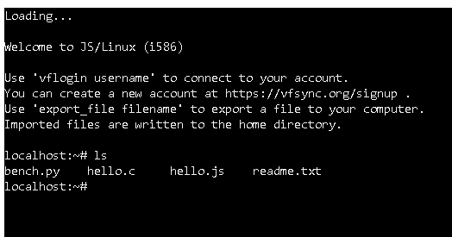
The first command is example is “cd” which allows the user to change the directory their in, entering cd / home/user/ would move the user from the location their in to home.

“ls” is a commonly used command and lists all the contents of the current directory to the user, the screenshot on the left illustrates this.

“mkdir” allows the user to create a new directory, see below for an example.
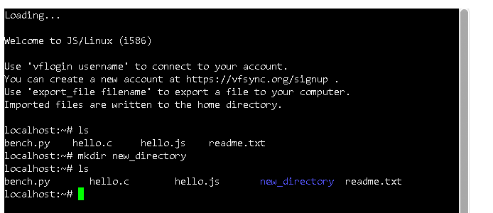

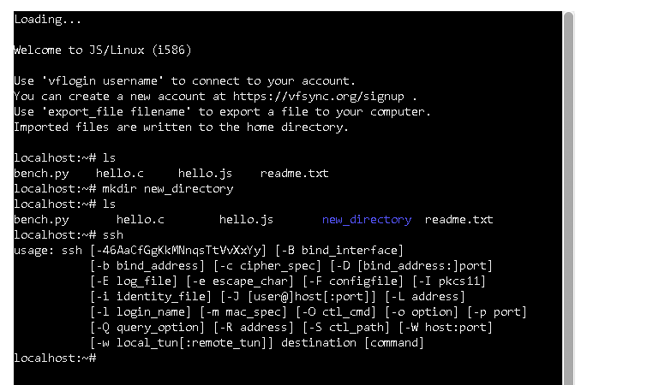
Users will have certain permissions assigned to them allowing them access to do certain things within the system, the admin user would use “chmod” command to alter permission on files and locations.

The image to the right illustrates the next command “ssh” which allows the user to access the server. [16]

4.1.1 - Linux Operating System Scripts.
Like Windows and PowerShell, Linux also has script features, below area few examples.

The above image illustrates a variable being created and assigned a value.
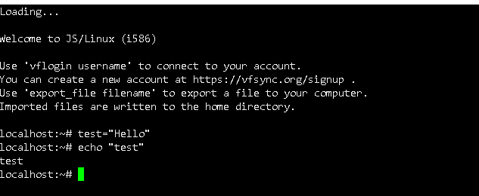

another example can be illustrated using if and else conditions, for instance setting the below syntax allows the user to display messages depending on the conditions set.
if [ -f /path/to/file.txt ]; then
echo "File exists"
else
echo "File does not exist"
fi

5 – Conclusion
Following the examples and research displayed in this report both Windows and Linux show immense qualities in the technology industry today, understandable rivals in their field and the front runners.
Linux has become vital for a lot of companies who run and manage their own servers and Windows as a well established brand name is the go to for any family.
The amount of in depth capabilities both have in their operating systems allow users to virtually do anything on their systems.

6 – References
[1] E. Walia, Operating System Concepts, KHANNA PUBLISHING HOUSE, 2002.
[2] (08.08.). Figure 1. Available: https://www.howtogeek.com/wp-content/uploads/2018/08/img_5b68e80f77e33.png?width=1198&trim=1,1&bg-color=000&pad=1,1.
[3] (08.08.). What is an Operating System?. Available: https://www.howtogeek.com/361572/what-is-an-operating-system/.
[4] Anonymous (). What is Windows?. Available: https://www.computerhope.com/jargon/w/windows.htm [Accessed Mar 17, 2023].
[5] Anonymous (). 5 Most Popular Operating Systems. Available: https://www.wgu.edu/blog/5-most-popular-operating-systems1910.html [Accessed Mar 17, 2023].
[6] Anonymous "Android (operating system)," 2023. Available: https://en.wikipedia.org/w/index.php?title=Android_(operating_system)&oldid=1143683369.
[7] Anonymous (). What is the Linux operating system?. Available: https://www.techtarget.com/searchdatacenter/definition/Linux-operating-system [Accessed Mar 17, 2023].
[8] Anonymous (). What is Kernel in Operating System and what are the various types of Kernel?. Available: https://afteracademy.com/blog/what-is-kernel-in-operating-system-and-what-are-the-various-types-of-kernel [Accessed Mar 17, 2023].
[9] Anonymous (). The need for secondary storage - Memory and storage - AQA - GCSE Computer Science Revision - AQA. Available: https://www.bbc.co.uk/bitesize/guides/zfssv9q/revision/4 [Accessed Apr 4, 2023].
[10] Anonymous "File Management," 2016. Available: https://operatingsystemsam.wordpress.com/file-management/.
[11] Anonymous (). IBM Documentation. Available: https://www.ibm.com/docs/en/cognos-analytics/10.2.2?topic=SSEP7J_10.2.2/com.ibm.swg.ba.cognos.crn_arch.10.2.2.doc/c_securing_the_operating_system.htm [Accessed Apr 4, 2023].
[12] Anonymous (). Windows commands. Available: https://learn.microsoft.com/en-us/windows-server/administration/windows-commands/windows-commands [Accessed Apr 6, 2023].
[13] Anonymous (). PowerShell Commands Library | PDQ | PDQ. Available: https://www.pdq.com/powershell/ [Accessed Apr 6, 2023].
[14] Anonymous (). Powershell - Scripting. Available: https://www.tutorialspoint.com/powershell/powershell_scripting.htm [Accessed Apr 6, 2023].
[15] Anonymous (). How to write & run your first Windows PowerShell script | PDQ. Available: https://www.pdq.com/blog/writing-your-first-powershell-script/ [Accessed Apr 6, 2023].
[16] F. Yesmin, "30 Bash Script Examples," Available: https://linuxhint.com/30_bash_script_examples/.

7 – Appendices

7.1 – Tutorial Activity

For the purpose of this exercise 4 different types of operating systems will be looked into starting with, arguably the most popular Microsoft Windows.
Commonly known as Windows this operating system was developed by Microsoft, first announced back in 1983 and generally used on personal computers multiple versions were released over the coming years. Even though the core of the operating system stayed the same each version came with extra features, the latest version being Windows 11. [4]
Apple which is Windows biggest competitor, published the mac operating system, published around the same time as windows, customers happily used the mac operating system because of its consistent growing user interface. [5]
Android, known for its mobile based operating system was launched in around 2007 and its main focus was for the touchscreen mobile devices with its first mobile device the HTC Dream releasing later the next year. Now android is up there with Apple and Microsoft with the OS being utilized in games consoles, TV’s and even digital cameras. [6]
Finally, Linux which is an open source operating system, this OS seems to be very popular when used for the purpose of server related tasks such as databases or email applications. There are hundreds of different versions of Linus each altered to coincide with its intended task. [7]

7.2 – Online Certified Course

In this exercise an online Microsoft learning course was undertaken in order to increase knowledge base on PowerShell, find below screenshots of the achievements for completing the modules.


