Surveying Assessment

Basic Site Levelling at the SA1 Swansea Waterfront development(Land/site surveying)
Assessment code: M4X01317

Name: Gregory David Thompson
University Number: 1705753
Date: 28/01/2019


- Introduction
I intend to plot out various points to allow me to collect the reduced level across the car park located next to the University of wales Trinity Saint David library. Also, I will be working out the fly level from one end of the car park to the other.

1.1 Aims
The aims of the 2 reports is to be able to …… the reduced level across the car park area and plot the fly level on a straight axis across the car park. This will enable us to plan a construction of a building.

1.2 Equipment
Personal Protective Equipment (PPE) is needed on every construction site across the United Kingdom. Depending on the type of work will depend on the extend of the PPE that will be required to carry out those jobs safely. For the simple tasks that I was carrying out all the PPE required was a Hi-Visibility jacket and Steel toe capped boots.
The equipment I used to carry out the tests were: -
- Tripod – this is used to hold the electronic level in place and allows it to be moved into various locations.

- Electronic level – this part of equipment is how we read the measures. It is tightened onto the tripod and has a zoomed in lens which allows readings to be made from a far.

- Grade rod – the grade rod is also known as the measure rod. It is a large stick with measurements which are easily read from the electronic level.

- Marking paint - this is used to mark on the floor where the fly levels will start and end. This way you can plot it clearly once completed the survey.

- Umbrella – the umbrella was to protect the electronic level. As it was only a shower the readings were still visible.

- Measuring tape will be used to measure the length of the reading and determine the boundaries or the building.

- Field book would be used to record the results of the measurements taken.

Processes
Once the locations of the readings have been plotted and marked with paint or some kind of marking tool, then the electronic level can be set up in location one ready to take the first reading. The electronic level Is set up on top of a tripod. There is a bubble located on the side of the level, this has to be inside of the middle ring to make sure the level is flat. Once the level is flat and your team mate is holding the grade rod in an upright position on the mark which needs to be measured. An accurate measurement is then taken and noted in the field book.
A tape measure is also run across this area to note the distance between the two points. This is always necessary; however, it could be a crucial bit of information for future planning. When we carried out our readings it was a clear day with no obstacles in the way. But, if there is adverse weather conditions then an umbrella will be needed to not only protect the electronic level but to gauge a clear reading on the grade rod.

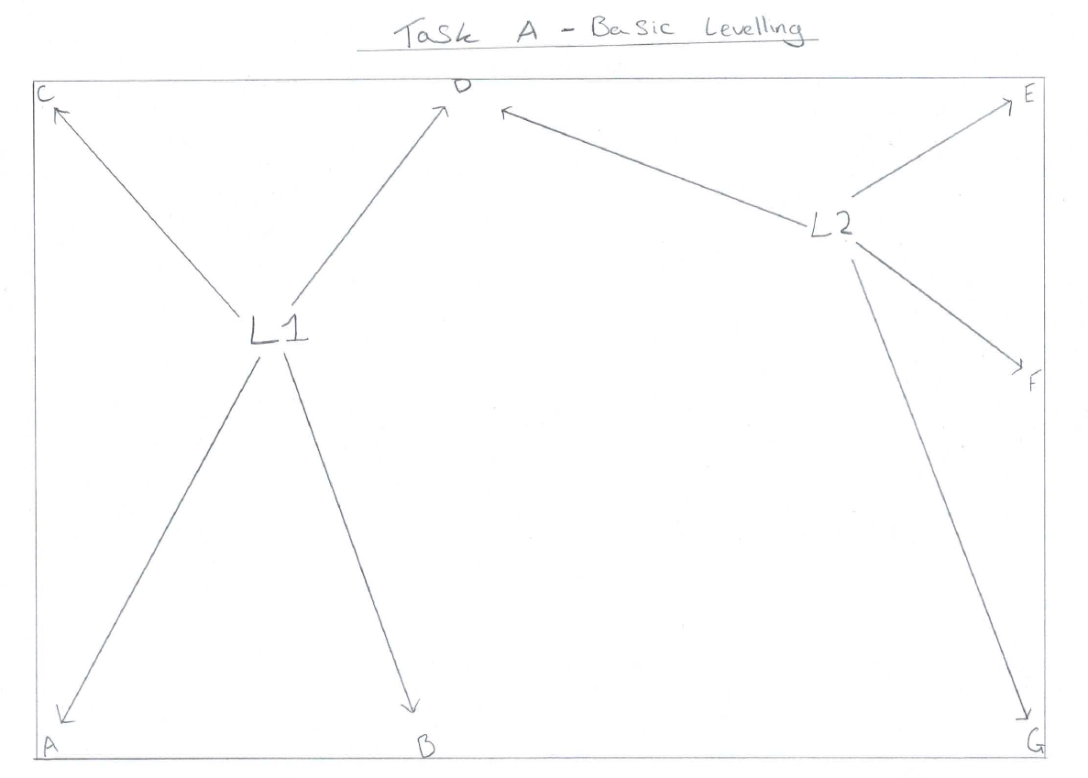
1.3 Basic leveling plan of stations
1.0 diagram, layout of the stations in the UWTSD car park

1.4 field book
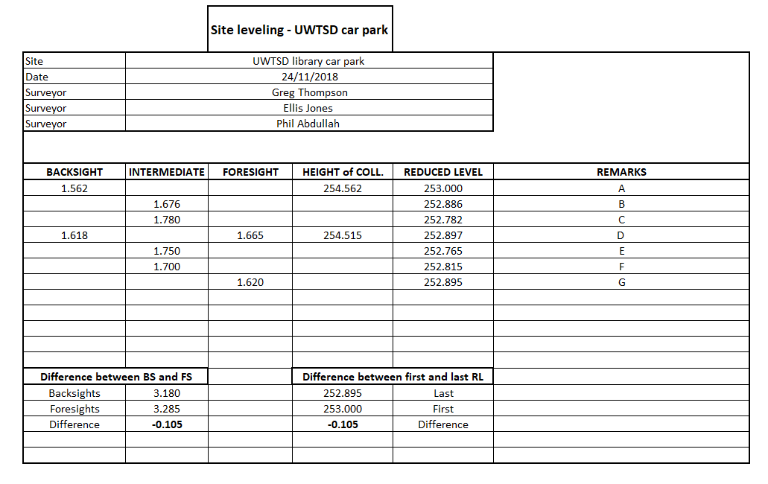
Below are my results from the ground leveling survey I completed on the 24/11/2018
Table 1.0 – basic leveling from the UWTSD car park

1.4 - 6 Limiting Factors
1) Weather
If there are adverse weather conditions, then this could cause significant issues when taking readings. If there is fog or rain, then the electronic level will not be able to get a clear reading from the measuring pole. If there is light rain, then the use of an umbrella to protect the level could be used and an accurate reading may be recorded.

2) Obstacles
Often a plot of land is located in a populated area. This means that there will be foot traffic and cars either parked or moving. If there are cars, objects or people in the way of a reading their will be a level of inaccuracy and will have to be completed at another time.

3) Human error
Human error happens in all aspects of work. It can be as simple as writing a number down wrong in the field book. Moving the grade rod so an incorrect reading is taken, these things can be common if there is a lack of concentration within the group.

4) Level of grade rod
The level of the grade rod is crucial to an accurate reading. If this isn’t upright, then the reading would be either more or less depending on which way it was tilted. This is down to the person who is holding the grade rod to get right.

5) lack of experience
The lack of experience is a key part in any task in any job. However, especially in construction, this is a key aspect of having the understanding of how the equipment is used correctly. Not only that, but it is also a factor in not making these mistakes when taking the readings. It would take a certain level of experience to pick up when an error is being made.

6) Identifying the stations
By identifying the stations where you are looking to measure the height of allows the room for error to be decreased. If you do not have a plan of the area, then you may take a reading from a section of land that is not needed or that is wrong. If a new building is to be constructed, you will need to find the boundaries for that building and not stray from them otherwise the foundations could be installed wrong.

2.0 Fly leveling
Fly leveling is used to find the height of land from the TBM (sea level) at a given point across the land. It is used in construction as there is no limit on the area of land that can be covered. It is often used for mapping out roads or train tracks.

This is the points that I used to measure the fly level across the UWTSD car park
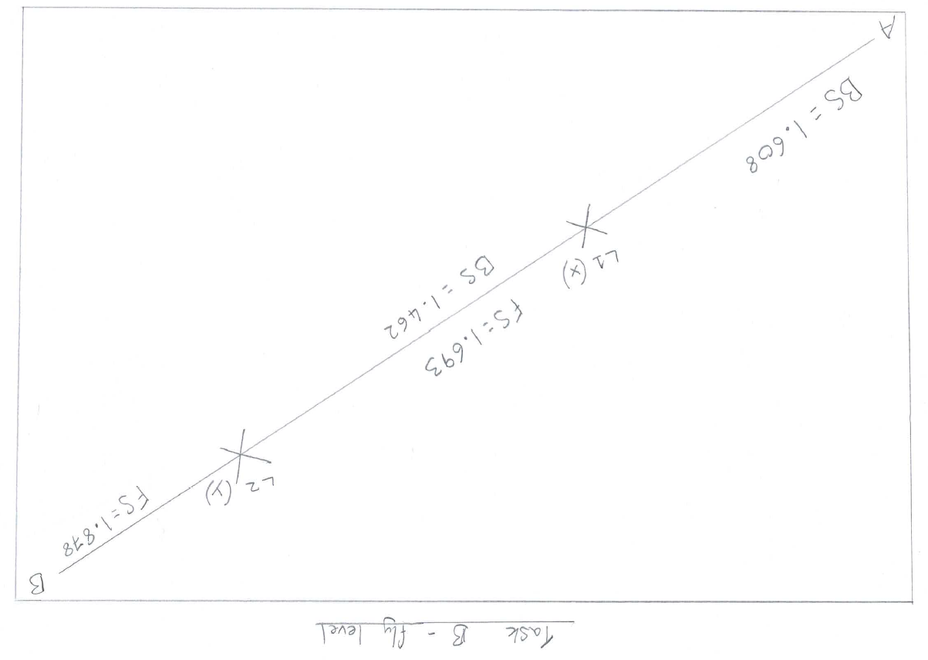

1.1 diagram, fly level plan of station for the UWTSD car park

2.1 Field book
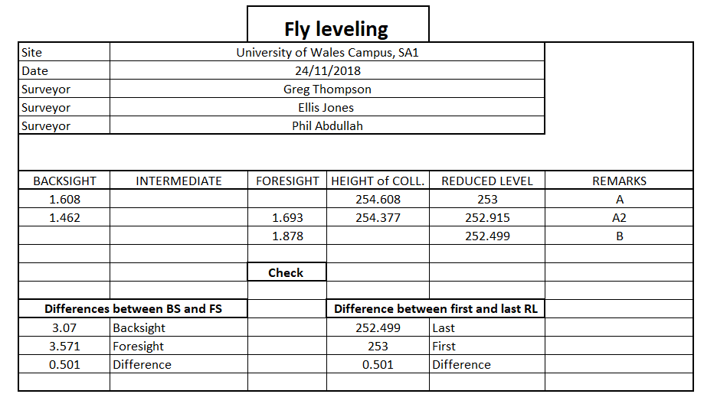

Basic equations used
1. Reduced level = Height of collimation – Foresight
2. Height of collimation = Reduced level + Back sight

2.2. Sketch of how already done
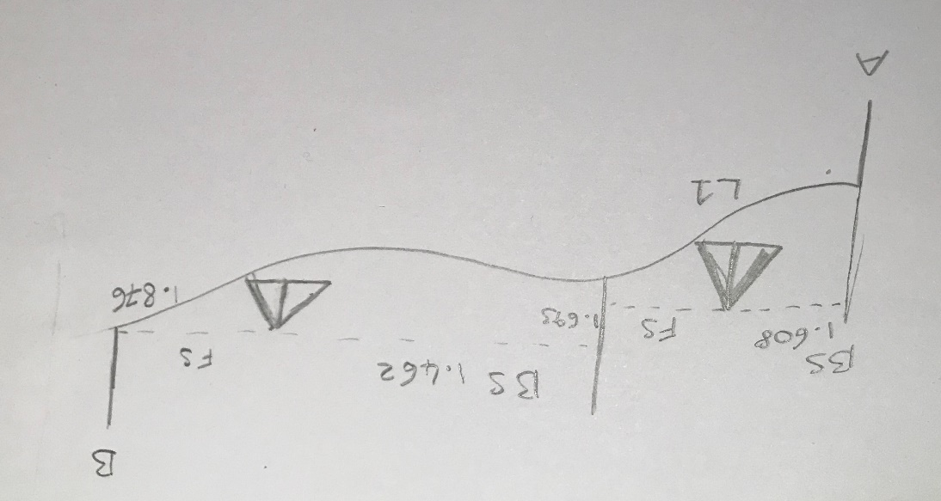

1.2 diagram of the fly leveling of the car park

