Ntework Programmability

Network Operating Systems and Services

Component 2
  - Samuel Richards Student Number - 1901717

Contents
Screenshots Worksheet 2 2
Task 1: Pre -requisite task 2
Task 2: Deploying Active Directory as a role or feature based installation 4

Screenshots Worksheet 2

Task 1: Pre -requisite task
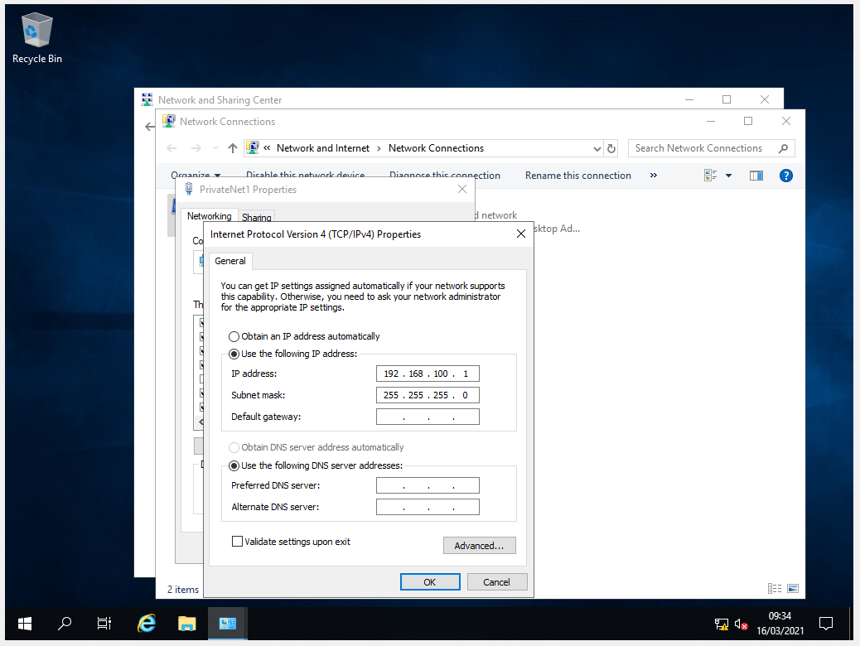
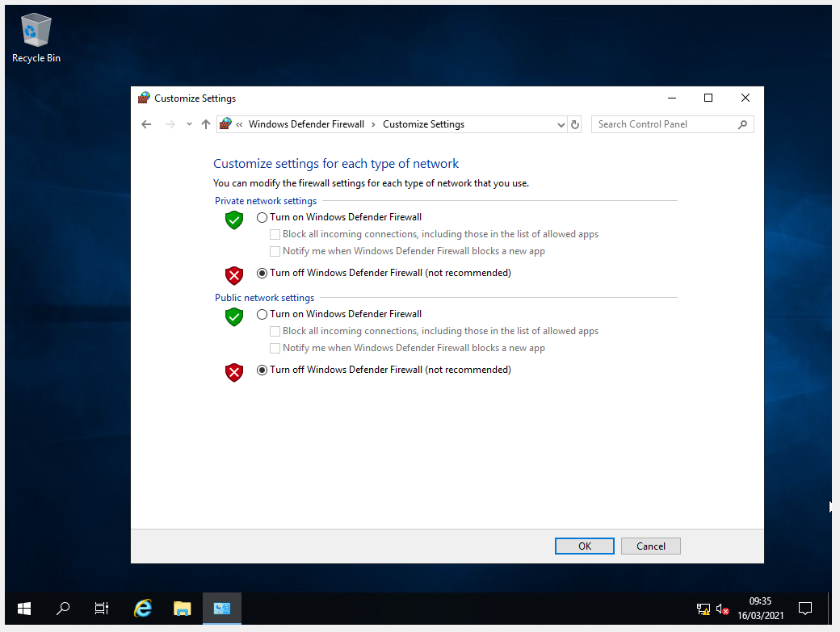
These Screenshots are to show that the server 1’s IP is defined and that the firewall is indeed off.

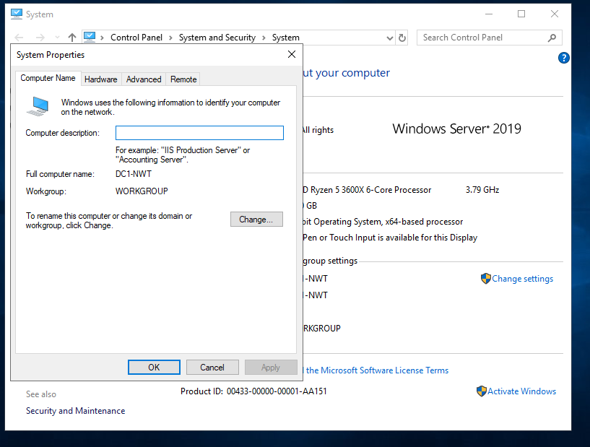
The next step was to change the name of the server 1 PC to “DC1-NWT”, This was done via through settings and physically renaming the system properties.

Task 2: Deploying Active Directory as a role or feature based installation
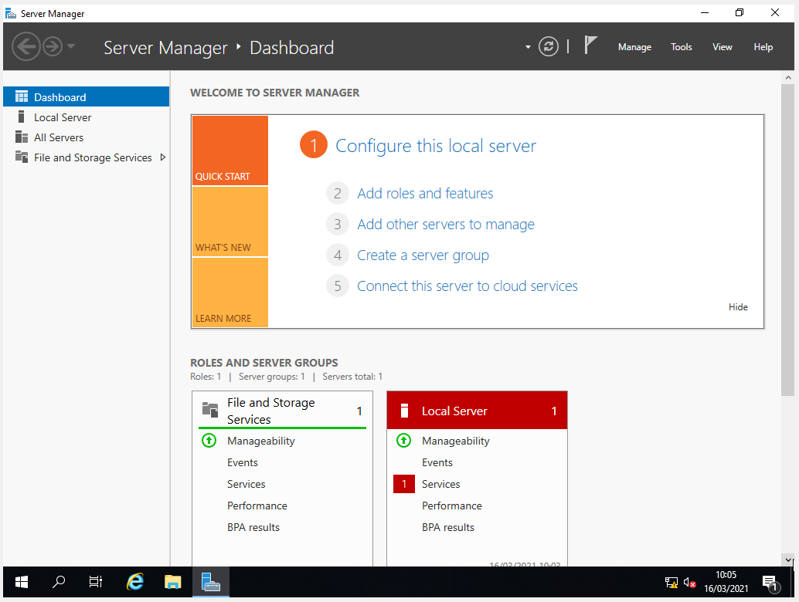
Navigate myself to the “Server Manager”
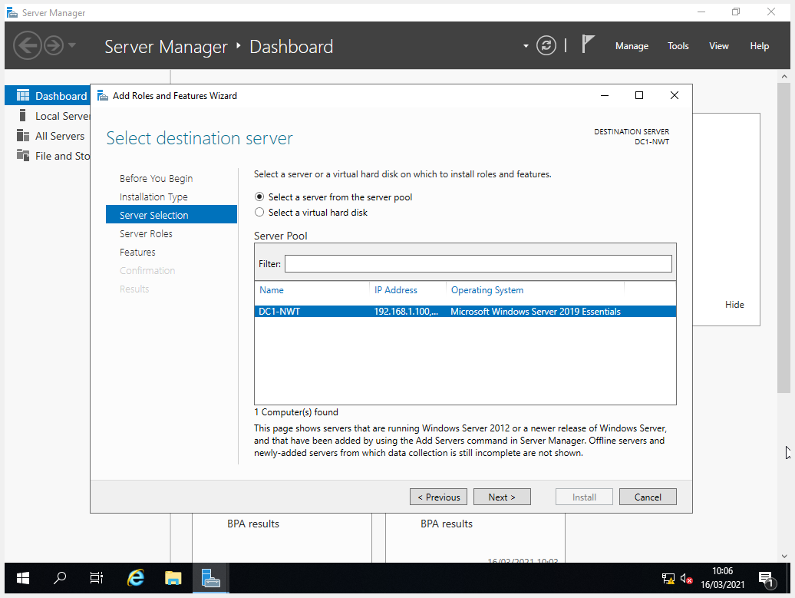
After selecting the “add roles and features”, start going through a set up process and installation.

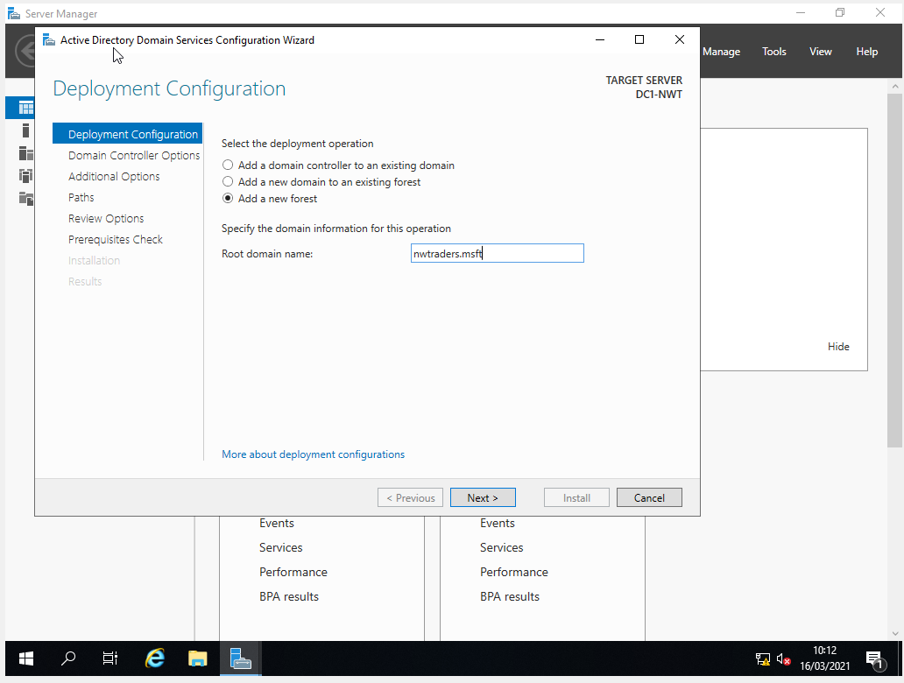
After everything has been set up and installed what was needed, the next step was to promote the server.
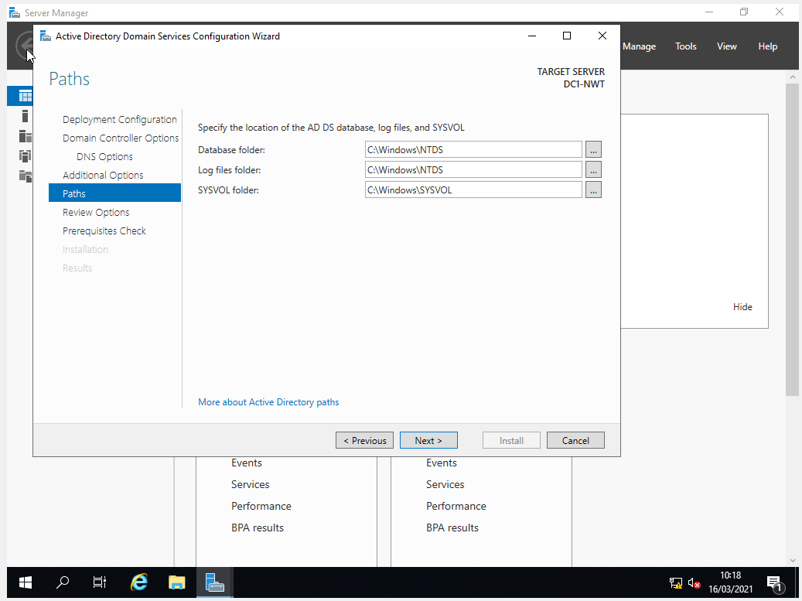
In the “Paths” stage, this states the location of the database folder will be, very important to know.

Task 3: Creating user account objects using Active Directory Users and Computers snap-in console
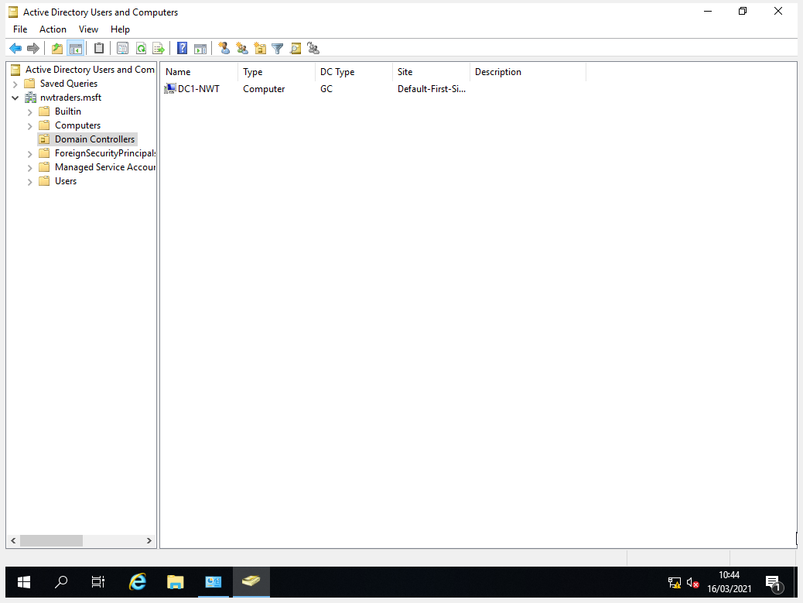
Administrative tools, and then gain access to the AD users and computers, as you can see from above DC1-NWT is the domain controller.
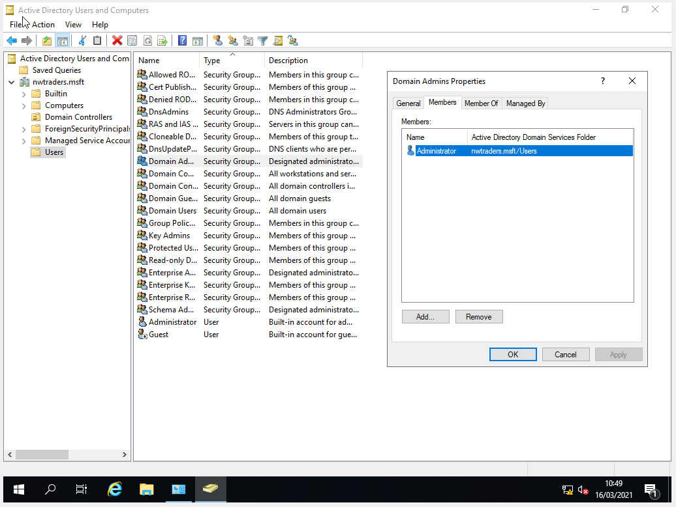
Getting used to AD users and computers, was navigated to the users file on the left-hand side and checking out the users, the domain admin was the one that took my attention.
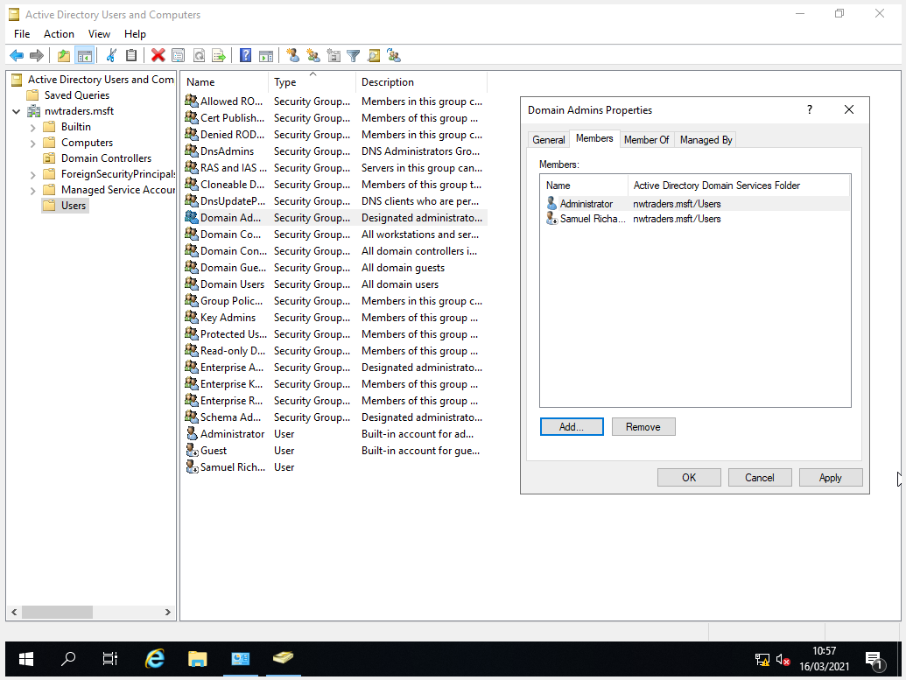
Next step was to create a user account, which was myself, and then add that user to the “Domain Admins” Group.

Task 4: Object attributes of interest

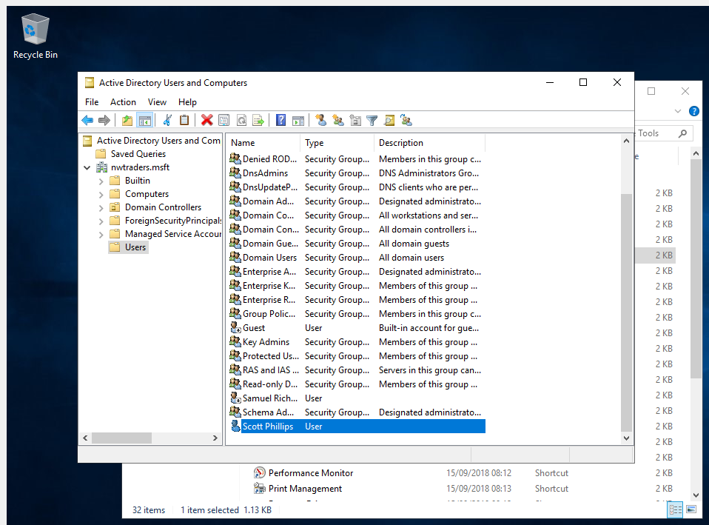
User I Just created. In the new member’s tab.
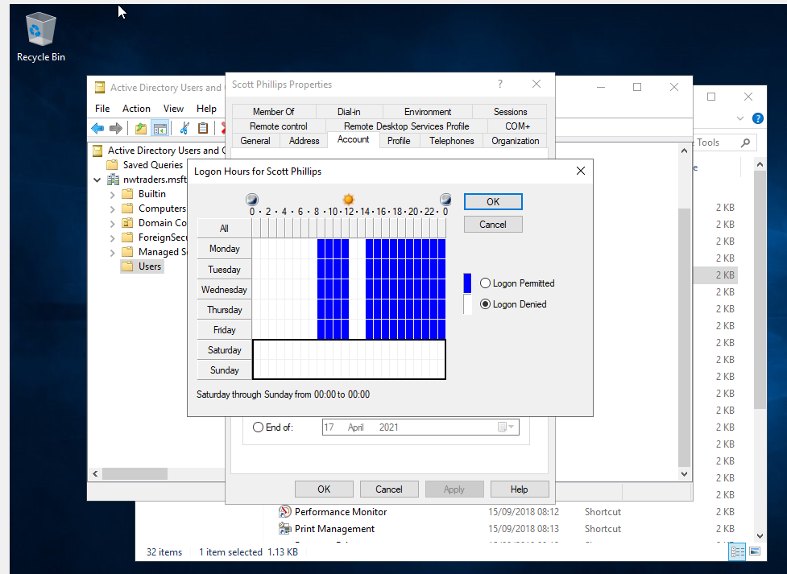
This is the time period that the student is allowed to log on.

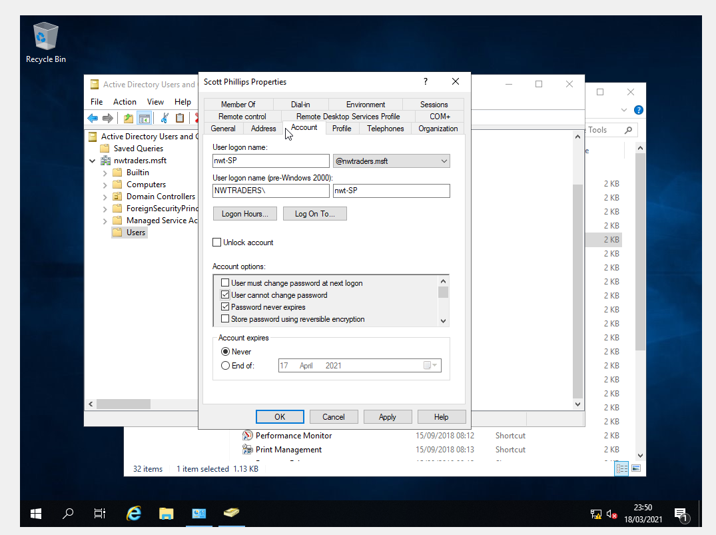
Also as you can see the option for “User cannot change password” has been enabled as the brief has been instructed too.

Task 5 – Adjoining the Domain and Testing User Logins
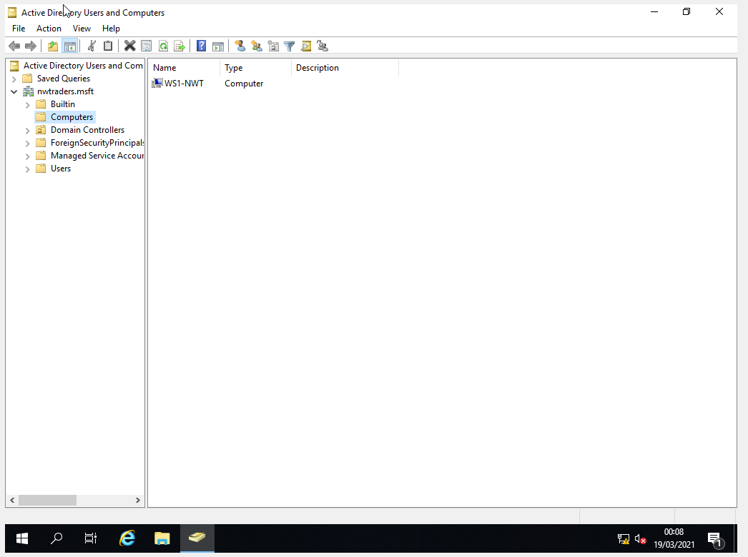
New Computer Name has been Created.
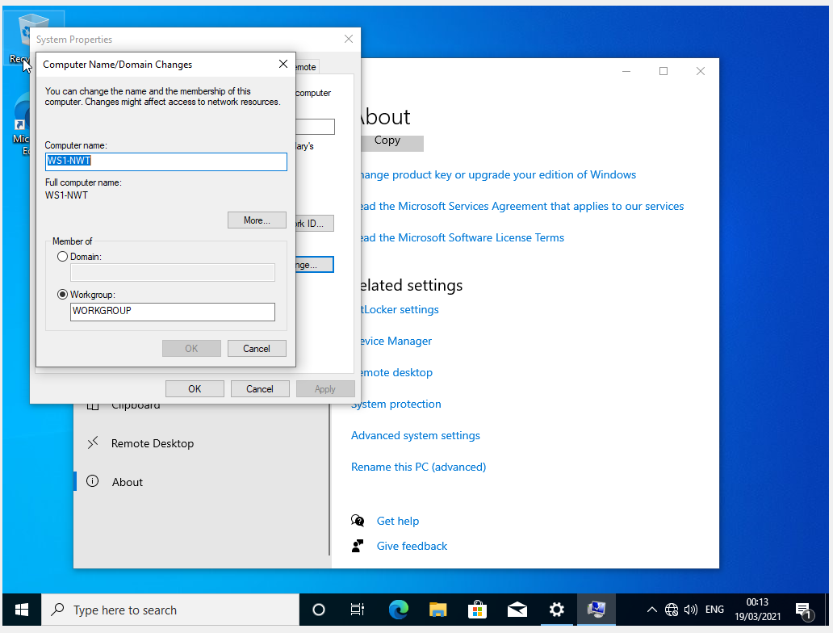
Was then asked to go into the settings and change names such as “WS1-NWT”w
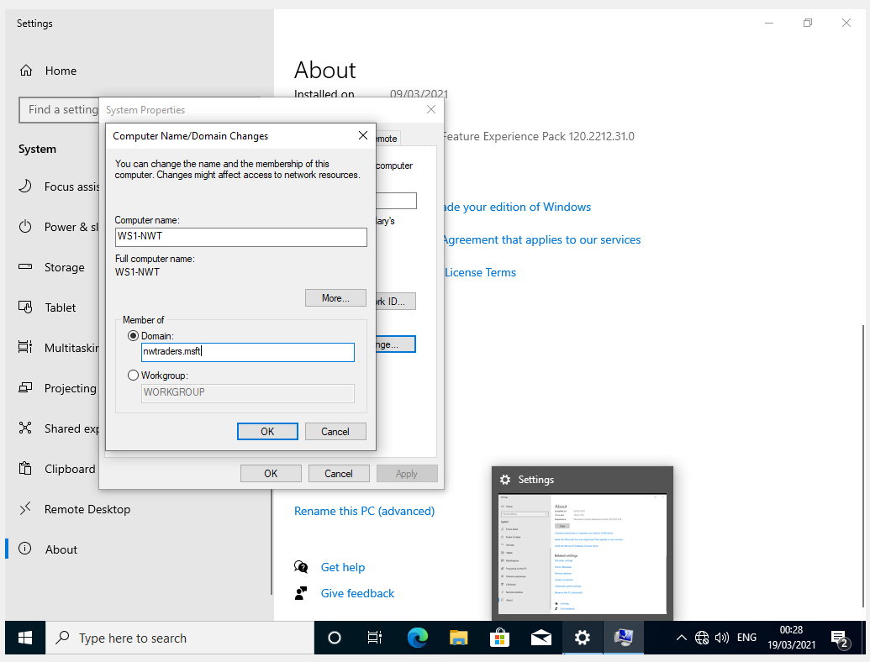
Was asked to go through “MY PC” and setting’s and navigate to this screen and was promoted to change the name to “nwtraders.msft”
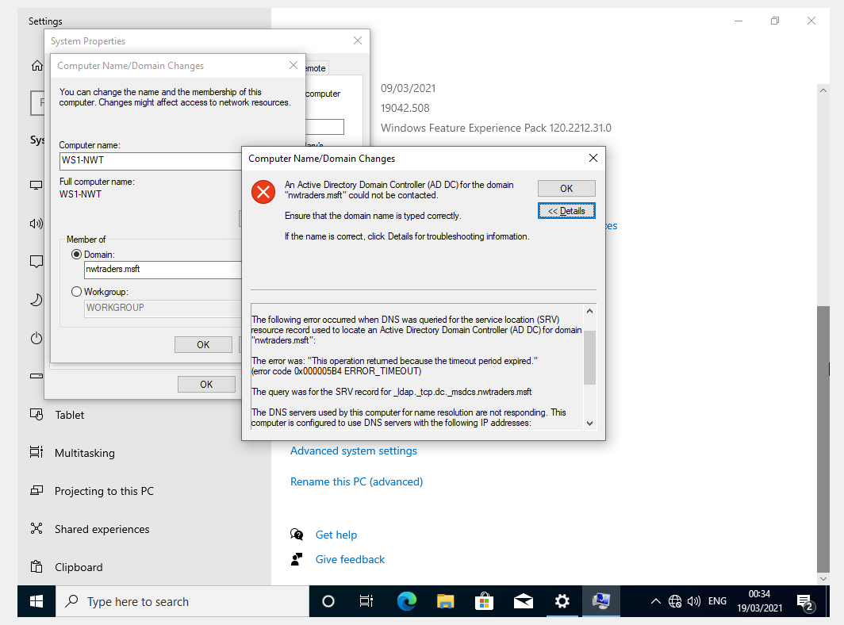
Then get prompted with this which I presume is wrong unfortunately cannot continue with the task. Thank you

Task 6 – Observational Tasks

6 a) DNS - DNS is stood for “Domain Name Systems”, and DNS is something that people use on a day-to-day basis. DNS is mainly known as a directory of names that would match with numbers, but the numbers would be IP addresses which is used by the technology, these IP addresses is what is used by the devices to find where you are looking/calling or sending emails as such. However, with DNS there can be some “DNS flaws” such as not configuring properly, or potential “Malicious threats and attacks” unfortunately some of these vulnerabilities can be exploited by others [1].

6 b) I think everyone can agree upon AD “Active Directory” being one of the most critical roles and features to be installed as part of an active network, as AD simplifies the job for Administrators and makes life easier for both them and users on the network, but also it enhances the security for the business as well as other things, But also another role that is believed to be important would be the “Remote Access” setting, this is to be believed to be important in a business because, any issues which arise on a day to day basis, can be flagged and the IT Staff can fix this issue from their office instead of wasting time going to the issue and fixing it, it can all be done from where they are stationed.

6 c) RBAC (Role-Based Access Control) is very important to have within a business because it restricts network access based on the user’s role within the business. RBAC would allow the staff member to have access to what they need within the network, it gives them the right to have access to only what they need to do their job, and thus would prevent the user from having access to information they should not have and need. For example an admin would have access to staff members information such as names id numbers and other information because they are in charge of user accounts and they would not have access to financial records because they have no right to have access to that.

References

[1] | W. B. S. ,. M. M. W. I. M. H. Jalalzai, “DNS security challenges and best practices to deploy secure DNS with digital signatures,” IEEE, 15 01 2015. [Online]. Available: https://ieeexplore-ieee-org.ezproxy.uwtsd.ac.uk/document/7058517/authors#authors. [Accessed 11 03 2021].

