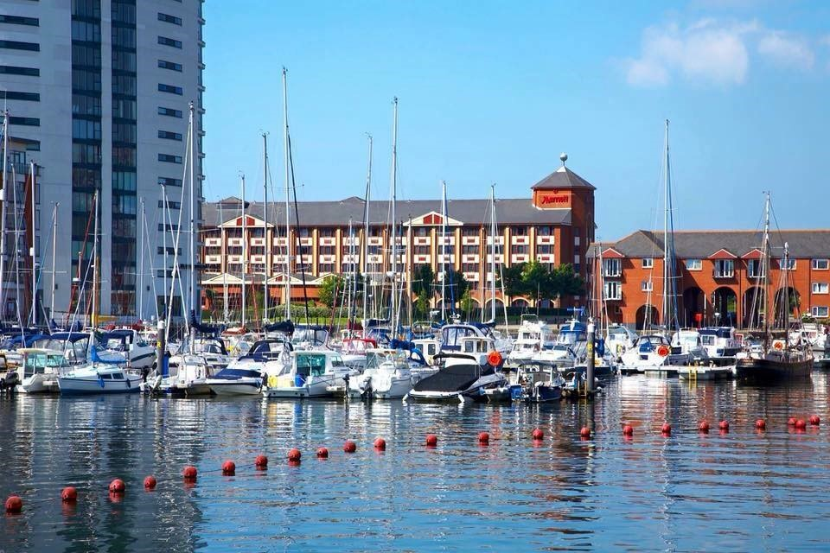

Swansea Marriott Hotel

March 22

DIVINE CONSULTING GROUP
Client: Rhiannon Boyce-Coles

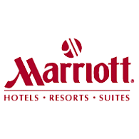

Executive Summary
Overview
This report presents Swansea Marriott Hotel, which will discover the problems or issues at stake, research and exploration with results, individual analysis from researches. Recommendations have been included as realistic and minimal as possible, which have higher chances of improvements for the hotel.

The Problems/Findings
Some of the problems that I will be solving or providing possible recommendations from the researches I have conducted via online reviews and inspection throughout multiple websites that conduct business or provide eye opening feedbacks to individuals. The potential issue that can be discovered is that many unsatisfied customers were indicating that the rooms contained molds, dust, the smell of damp and many more, which can be found at the latter part of this report. This may not seem big of an issue, but it shall affect the health of the customers, which is a quite serious problem that needs to be looked at as soon as possible, especially during these trial times from covid.

Not only are the customers of all ages are affected, but this will also play big role on the hotel sales, as people will less likely to stay here if nothing is done about it. If the hotel sales are not performing well then it is most likely for it to lose large amount of money, or even possibility of the institution having to close. If this happens then many employees will be out of job, and they will be affected financially and may struggle to find jobs, especially during these times, as things are taking long time to be normal again.

The Solution/Recommendations
The potential suitable solution that can be given is that the rooms may seem out of date, and they can put customers off from returning. In this case the staff at the Marriott hotel shall begin with reasonable solutions, such as getting feedback from majority number of customers through variety of different methods. More cleaning staff should be hired, or they should be questioned about their cleaning expertise, as customers beg to differ. The molds and the damps should be located from all the rooms, and deep clean will be required, which I shall detail latter part of the report.

If possible then having an architect to pay a visit to the hotel, and may be able to state potential amendments or figure out how it can be modernized, and being able to stay updated as there are many trends that are going around, which attaches customers to stay. Some solutions may be difficult but are doable, also it might consume large amount of time, so it will be best to start from little issues and see the feedback from the customers. If there are still complaints then the serious solution actions will need to be taken, and hopefully it meets the Marriott hotel’s budget as they are quite big hotel chain around the world.

Highlights/Analysis
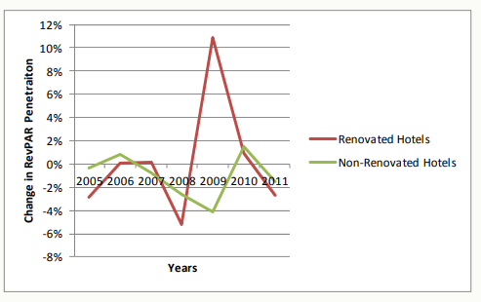

The above illustration shows how positive hotel renovations, are for the long run and how it can improve the sales of the hotel. The newer and clean the hotels are especially the rooms, it will bring in customers, but advertisement will need to be undertaken, for the people to be aware about the renovations. This can be done by closing the hotel for a certain amount of time, or closing some parts of the hotel, while the other sections are serving customers, so it will allow the hotel to generate money while it being spent on renovations.

Introduction
There are many different purposes of this report, as this will provide crucial information to my client, and ways in which they will be able to improve the quality of their hotel and become more appealing and attractive for regular and newer customers. This report will mainly focus on the positive and negative points about the Marriott hotel, within the hearts of Swansea in a great sightseeing view. There will be researches that will be a part of this report, as it will be beneficial of how much information I am able to dig out about the hotel, and how easy accessible the individuals have in reading the reviews via online.

The main methods I will be using to analysis the problems/issues are online searches, gathering information about the Marriott hotel, and checking out the reviews which are left on, google, TripAdvisor, Marriott website, booking.com, expedia etc. The other main methods that I will be using is known as SWOT and PESTELS, this is because they have a simple framework, provides better understanding of the wider business environment, better strategic thinking and planning, understanding the strengths and the weaknesses etc. Through this the managers can decide on a plan and work towards improving the structure of the hotel via internally and externally. As the main goal is to better the hotel as days go on and it to be in a high standard for the future, so it is best to examine the hotel and figure out the correct direction to move towards.

Scope & analysis
Marriott hotel Swansea is addressed at Maritime Quarter, Swansea, SA1 3SS United Kingdom, this is within the lively city center and very near to the beach and it is the edge of the marina. This is located at a perfect spot for individuals to explore the Swansea attractions alone or with family and friends. The hotel has a great check in and check out time so individuals won’t be left stranded and can have long night of sleep before needing to check out, those timings are 3pm when individuals can start checking in and 12pm to checkout so individuals get 21 hours to take advantage of the spacious room.

Driving to the hotel then individuals can place their car in the hotels on-sight parking for free of cost, which is great spec, and it has one electric car charging station. Even if the customers are not travelling by car, there is a close Swansea train station so there are a lot travel options. The hotel room contains “plush bedding, large windows, flat-screen TVs with Netflix and ample workstations”, individuals have all they can need from a hotel room but if they want extra nice experience then they will be able to upgrade their room into Superior accommodation, that has an impressive marina views, included with a mini-bar and complimentary Wi-Fi to stay connected with the world.

The Marriott hotel in Swansea offers so much to the customers, as they have an outstanding food in their Cast Iron Bar & Grill, which contains mouthwatering British cuisine and there is a stunning waterfront view. There are multi-purpose venues that includes a luxurious garden, if individuals want to work out then there is a fitness center available. There are 4 floors within this hotel and there are 121 rooms for individuals to book and stay at, also there is 6 meeting rooms so plenty rooms to book and conduct meetings or conferences, there is an indoor pool.

PESTEL stands for political, economic, social, technology, legal and environmental. SWOT stands for strengths, weaknesses, opportunities, and threats. Political consists of the government policy such as law making or changes happening within the country, the political stability, tax, industry regulations, global trade agreements and or restrictions. Economic consists of exchange rates this can be when individuals are booking rooms from different countries or certain currency rate is better than others so in some countries individuals may pay extra for same type of room which they may pay less in another country, globalization, economic growth/decline, inflation, interest rates which can be charge with vat, cost of living, labour costs, and consumer spending habits such as are customers spending money or are willing to spend money at that hotel.

Social consists of consumer trends/tastes as days, weeks and years go by trends is one of the biggest aspects to individuals lifestyle as they go to high rated places or consume certain type of food, fashions this can be about how the hotel is looking such as does it look old school as newer generations prefer flashy hotels and designs, consumer buying are the hotels in a standard where people are willing to spend their money to stay there, habits, lifestyle factors this can also be linked up with fashion and the way individuals live, career attitudes, work-life balance, population demographics probably how many people are staying at the hotel each day and night.

Technology consists of the automation within equipment’s and communications, robotics, security, upgrades to smarter devices and better equipment’s which can be easier for both hotel staff and customers when booking rooms or just enquiring, and social networking etc. Legal consists from variety laws such as the employments, common laws to health and safety regulations. Environmental consists of restrictions within environments that has been by the government, CSR, future pandemic, and transport etc.

For SWOT, the internal factors are the strengths and the weaknesses of the Marriott hotel, and the external factors are the opportunities and threats of the hotel. There are ways in order to overcome the weaknesses but firstly they will need to be identified that’s why SWOT and PESTLE analysis asks questions that can pin point most of the issues with explorations of how they can be sorted in order for the hotel to be running better and successfully.

PESTLE | Factors affected within the hotel | Importance to the hotel
Political | The UK has decided to leave the EU, via Brexit voting. This means that future trading within these countries may have restrictions, as to what is allowed and what it is not. The pounds have become weaker and the profit margins within trading’s may be disrupted.  Long lockdown has been implemented a few times past over year.  Visas will be required to travel to European countries from the UK, due to the Brexit. | High  Medium  Medium
Economic | There is uncertainty in the UK within the business markets and investors as UK no longer part of the EU.  Covid has caused people to stay home unless required to go out and it has slowed down people from travelling from one country to another and this is a big negative hit on the hotel industry.  People are most likely to waste money on online shopping’s and have less money to travel once the lockdown calms down.  Many people are losing jobs and many businesses have to stay shut, so they are losing money and the people that have lost work then they have no kind of income and can affect on the cost of living.  Many businesses out of commission as they depend on EU products, which means they may be charged extra interest rates. | Low  Medium  Low  Medium  Medium
Social | People may not be into the British cuisine, especially the travellers that prefer their own type of food, which means they buy food from elsewhere.  Not much diversity within the area, so certain ethnic groups may find it awkward or even struggle with communication, especially if they don’t know welsh or English that much.  The hotel fashion may be outdated, and it could be more modernised so that it does include the people that are into trends. | Low  Low  High
Technology | Standard computers might be at the front desk, standard card payment machine and standard wired telephone in guest rooms etc.  The standard or old-fashioned equipment’s may be running slow or does not look fancy as how tech companies are coming out with smart devices.  Data storage confidentiality and consumer rights be kept locked inside a computer instead of so many paper works.  A lot of hacking and cyber-attacks can occur, where customers details can be exposed and compromised. | Low  Medium  High  High
Legal | Health and safety will need to be in place from fire exits, signs showing the closets exits, making sure floors are clean and clear so people do not fall.  The quality of the rooms may not be in the best conditions as moulds and damps might infesting the rooms.  The wages of staff may increase every year, if they are paid well then, they are likely to do an excellent job providing great services to the customers. Modern Slavery Act is there to protect the workers. | Medium  Medium  High
Environmental | Social distancing is in place to keep people safe from covid. Face mask is required when entering institution premises even hotels.  Customers relationships have been improved from CSR and sourcing policy; this will allow individuals to come back again. | Medium  Medium

From the table above it contains brief descriptions of some of the concerns that is affecting the hotel and the industry in general due to covid. I have used the PESTLE analysis method to get a better understanding about how things outside from the hotel can affect the sales and the issues within the institution. There are many lockdowns that are happening all around the world, and the UK government are even more strict regarding it, so not many people able to travel as they must stay in their local areas. The hotels are not able to have too many guests and staff members, which means that the hotel cleanliness can be neglected and the individuals that stay might find some rooms unclean, and they have admitted to it via the reviews that they have left.

Even UK people are not really allowed to travel within the UK as well, so the individuals are not able to visit the attractions and the beach in Swansea, this is affecting the business as they are not able to make much money due to not having large number of guests. Some staff may have lost their jobs and others may not be able to come in much so the cleaning and the refurbishment can take a long time before actions can be taken. The hotel may be able to take the advantage to renovate the hotel as there are not many guests and that can be one of the solutions in dealing with the molds or even out of date fashion, if that is not possible then an action plan or meetings can be undertaken using this report to figure out the next move to improve the Marriott hotel for the guests.

Due to Brexit people living the UK or entering the UK will have to undertake extra security including visas, some people may not like the hassle which is a issue and if they don’t travel then they may not stay at the Marriott hotel Swansea, there is not much my client do but they can request for a board meeting with other Marriott hotel managers and discuss a possibility for a petition to ease travelling procedure and just keep promoting the hotel with all the local attractions that guests can benefit from by staying at this hotel.

The recent feedbacks that the Swansea Marriott hotel has received are fairly good to excellent on the TripAdvisor website, one individual had a few issues but they did not specify it as the hotel staff have given them a rate deduction and this is a positive action that has been taken, because at the end of it the customer was satisfied with the stay, they also have complimented the room, food and the staff and they recommend for people to stay here with 21 upvotes, which many individuals may actually consider it. This hotel has a quite a reputation for its location and what the hotel has to offer, even though some may say that the hotel is quite pricey but the hotel has so many facilities within it including an indoor pool which many hotels fail to have.

As shown above on the table that within the technology section securing customers details is very important, especially to keep it away from the cyber-attacks, but even in one incident they have failed to do this. Back in 2014 which has led to all the to 2018, someone unknown has attacked the Starwood system by installing a code that is known by the web shell, this allowed the attacker the ability to access and edit the contents within the device remotely. The access allowed the attacker exploit which allowed the installation of a malware, which this eventually allowed for the attacker to access to the system as a privilege user, this meant the individual had unrestricted access upon the relevant devices, it also allowed them to have access to other devices within the network.

The attacker installed additional tools in order to gather login credentials for many more users within the Starwood network, with this they were able to gain access to the storing reservation data, which then it was exported by the attacker. The Marriott estimated that around 339 million guest records throughout worldwide were affected from the cyber-attack and the ICO has fined them 18.4 million pounds as they have failed to keep their customers details safe.

Strengths | Weaknesses
There are many strengths within the Swansea Marriott hotel, and they have all the qualities to challenge biggest hotel companies and the local hotels as well, with a great indoor pool.  The location of the hotel is astonishing and if the people want the views with sun and breeze then this place is great and an amazing unique bar and grill.  Free parking is available to individuals that are driving there.  Marriott hotel have a great global presence, this allows them to increase their revenue by getting more guests, but also if a certain region is declining business then they can rely on the profitable business, until they can bring themselves up.  They operate across 127 countries and territories globally, which means they do have the exposure of people knowing about the brand.  The brand Marriott is the largest hotel chain within globally, as they have 81 hotels, over 30 brands and $25.1 billion in assets in their portfolio. They have the hunger and great business plan, which allowed them to do better than their competitions.  They have 6,500 properties which offers over 1.2 million rooms around the globe, and by them being the largest group it allows them to take advantages of the full benefits within the economic scale.  They have excellent reputations, strategic partnerships, profitable acquisitions, code of conduct, loyal customer and they are highly innovative. | This is not a very big weakness, but they only have 6 meeting rooms, which some could have been used for a wedding reception as this hotel has a fantastic view.  People will need to land in Cardiff airport, as there is not direct flight to Swansea, so individuals will need some sort of transport from there to get to Swansea.  They had ineffective data protection, which was under cyber-attack. This meant many guests didn’t trust them and avoided them as their crucial personal information’s were leaked.  They would consider themselves to be in a poor positioning, as the brand is family-focused business, and this is from market position to management. They believe that the future of hospital industry will fall into young single individuals, which is different from family focused.  They have faced a civil lawsuit, as they were sued and fined for the amount $600,000, due to them blocking their customers personal WIFI which cited into security concerns. When a hotel faces something like this then their guest will leave them and bring business to other hotel brands.  The Marriott brand have strict individuals, as they monitor their employees severely, which can bring down their morale, productivity, and efficiency. Being strict allowed them to be this successful but certain people may not like to work for them.
Opportunities | Threats
A lot of young individuals are following the trends and have started to travel while staying in hotels, this allows Marriott to make changes and make it flashier with youthful fashions, so they choose Marriott over other brands. As they are the largest brand this means they have better opportunity to catch their attention.  high-end hospitality services are becoming high in demand within the developing countries, this means there is an opportunity for the Marriott to enter their markets and take advantage of it by probably establishing more hotels.  Marriott are able to separate itself from their competitors, and they do this by offering customised services, which caters and focuses on that specific needs of customers.  Marriott have opportunity to do business that are related to the hotel chain, such as offering houses for hire like Airbnb or even invest on catering businesses. | The Marriott have lost around 92% of their profits as customers have been declining due the covid pandemic, and people are stuck in lockdown also if it continues for a longer period then they will keep losing money.  The hospitality industry is very much competitive, and many hotel chains would like to take the Marriott’s business in the market share.  Recession is a very big threat as it can destroy companies severely, business is decreasing which leads to a lot of jobs being lost and even companies shutting down, this can be anyone’s fate.  There are possibilities of terror attacks, as the Marriott are 5 star branded hotel, so terror groups tend to target businesses that tend to have large number of foreigners.

The SWOT table above it shows the positive and the negatives through the strengths and weaknesses, and this is based internally also known as how it operates inside of the hotel and as a whole brand. This table has allowed me to research and analyse in order to find out how successful they are and how they keep it running very well. Even though they have quite a bit of weaknesses, but they do not hide it from people, which can be a good thing and also a negative thing. The positive thing would be that they are transparent, and the negative thing would be that they lose certain number of customers.

There are opportunities and threats that even the larges hotel chain can face, the opportunities allow them to grow their businesses and increase their revenues, also staying clear away from their competitors and gain more consumers. There are threats, which can affect the Marriott and bring down their business, especially during the covid lockdowns and if more lockdowns were to occur then the consumers are less likely to travel, making the Marriott lose large amount of money.

Main Body
In the above sections I have been analysing and scoping out all the issues that are from external and internal base. There are many ways that those problems can be improved for the future, as being a 4 star hotel there are flaws but there are also good things and practices, this makes the customers come back also even recommend to others via personally or via online review basis. The positive reviews allows individuals from international countries, to have a understand how other people have found the hotel, which can make them consider this place and check out all the attractions that are located near them from histories to beaches.

As stated within the above sections that the Marriott has been fined due to not being able to store securely customers details, which in my opinion is a crucial issue that not only this hotel faces but the whole brand faces. As time goes by people are travelling move than they ever have from previous years, due to travelling becoming easier and more affordable, so when people get the chance they are always travelling. Most of the people are normed to staying in a hotel, which the guests have share variety of details but if they feel that their personal details can be attacked via cyber, then they are most likely to avoid staying at this brand hotels.

The ICO placed an investigation within this case and they were able to discover that the Marriott did not put in technical or organisational measures in place that would have protected the personal data being processed in their system, as it was required by the general data protection regulation (GDPR). in order for this to be improved and worked on, my client would need to organise better technology and security system, which it will be harder for individuals to attack, and as the tech is getting smarter then I recommend that my client keeps up to date with the security system and the newer technologies, so they do not face that difficulty again, even though it may be costly but at least their guest will stay safe and the relationship builds stronger, which also will be beneficial economically.

PESTLE and SWOT analysis has showed me that there are different ways the Marriott is influenced and have a way of running their business. Their strict and honest mindset has allowed to become the largest hotel chain around the globe, this is not something that can be succeeded overnight, matter of fact they made sure that they are focused and think about their consumers who bring in revenues for them.

The Marriott hotel does provide staff training and it is quite effective and strict, they provide new hire orientation program, where they make sure the newer staff have skills that they need to perform effectively. This allows the new employees to understand and get a taste of the Marriott culture, brand, and their specific geographical location hotel. They also offer international hourly training, where each hourly individuals get 15 minutes of training each day, this training focuses on essential skills and knowledge areas for example, rooms operation, purchases, and all the essentials they require in order to do well at their job. The Marriott also offers a training called gateways where this is designed for individuals that hourly non-management employees, the focus is on training the specific skills which is necessary for their role as a discipline, such as HR, PR, IT and finance etc.

As there are so many types of training that the Marriott offer, it will be difficult to go through them all here but this is a positive thing as they focus on their staffs and making sure they are up to date with their skills, this will ensure that they are capable of doing their job and also providing excellence service to the guests. I personally believe that the staff training doesn’t need to be enhanced as they are working well for them, but if more better and unique training can be bought up if the Marriott decides, still this is one their strengths regardless. There are barely any complaints about the staff members, which goes to show that they have been trained well.

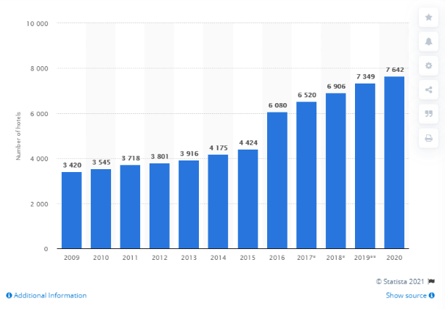

The chart above shows how the number of hotels has been increasing throughout the years around the globe even to current time. This goes to that the hotel business has been doing very well in order for more to be built, it’s a good thing that more hotels are opening all over the place, as it allows the hotel chain to grow and become stronger. The Marriott hotel have invested in so many hotels and they have been taking advantage of the hospitality market, the more hotel they have around the globe it allows them to be accessible for customers to experience the hotel and stay there. When loyal customers are being built, then they are most likely to stay in that same brand of hotel, in this case the Marriott hotel has done a good job for opening large number of hotels for old and newer customers, also since they have opened their first hotel in 1957 and from then they have been doing fantastic.

The most complaints that the customers have had about the hotel were cleanliness of the rooms, price, and some noise complaints from one room to another. This are mostly internal issues and the most convenient solution would be to refurbish or renovate the rooms and the hotel, as of the customer left dissatisfied and they would like the hotel to be upgraded, because times are changing and places need to be modernised and be following the trends for the attractions. People appreciate that the hotel is located very well as it is quite near to everything that individuals may require, such as great shopping centre, sight-seeing, attractions, history, sports stadiums, theatre and many more.

Even the Marriott loyalty members have quite a bit of complaints, which they have noted in TripAdvisor with a large paragraph. They have stated that they have had bad experience in the past with this particular hotel, which made them stay in a different hotel, but as they were being loyal members, they decided to give this hotel another go, still they had a terrible experience and they dissatisfied and unhappy. They visit Swansea frequently as they have family there, they booked a king size bedroom as they always do through the mobile app and it stated that there was king size room available but once they have gone in to check-in, the king size bedroom was not available so they had to stay in a 2 double bedroom, which meant they had to sleep in separate beds. It gets even worse as they have stated so many issues:
- The room was filthy
- Plenty dusts
- Stains on furniture’s and bathroom
- Carpet needed vacuuming
- Bathroom had mould in grout and around the tub
- Inside the shower curtain it contained nasal discharge
- The faucet within the bathtub
- Lightening terrible, difficult to read and put make up on
- Furniture seems very old
- A/C cannot be changed
- Amenities not being replaced or filled
- Towels not being replenish
- Used glass and ice bucket not being taken in morning
- Food from Cast Iron Grill were terrible
- They said they will not return as newer hotels are being built and they will stay there

Recommendations
Potential actions that can be taken now if the refurbishment or renovation cannot be done:
- My client should speak to the cleaners of the hotel, ask them why they are not doing their jobs properly, tell them how it is affecting the hotel and the guests that stay there.
- Change or hire better cleaners
- Hold a board meeting with all the staff members, to remind them on what the customers ae complaining about
- My client or a staff member should go to each room for inspections
- Try getting verbal feedback from customers, before they check out
- Deal with the problems they may have
- Get the moulds and damps checked out, as it can really affect guest health negatively
- Ask guest feedbacks on what food they may desire

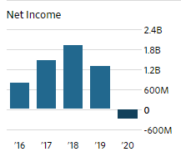
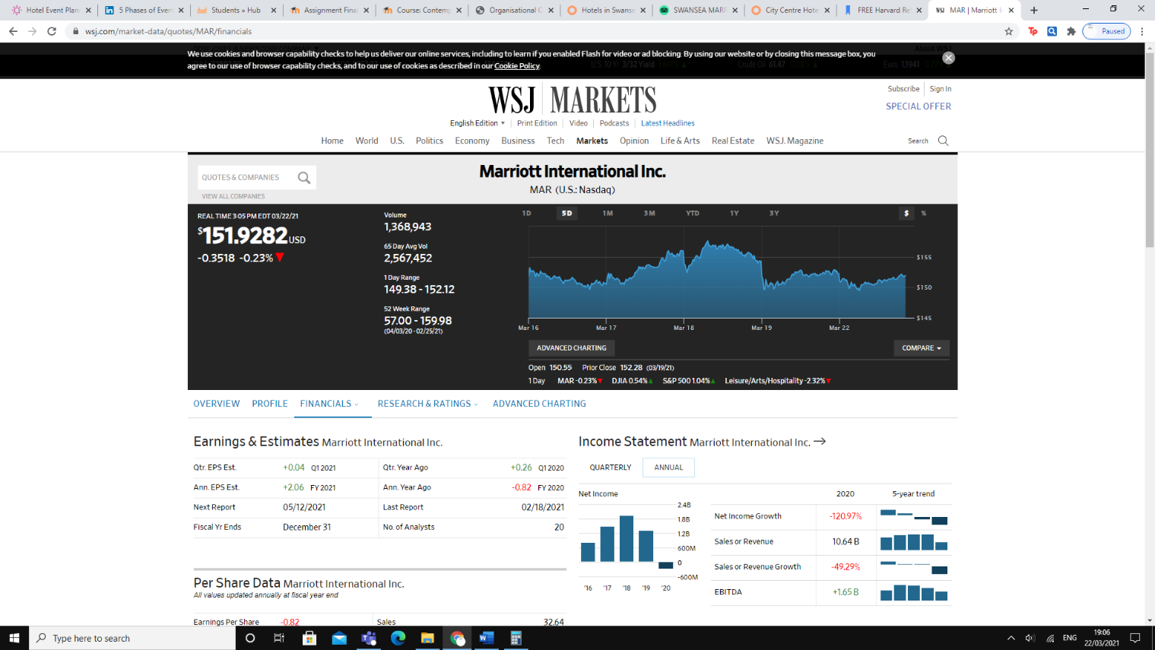

Above illustration show how poorly the hotel is doing currently and past year due to the pandemic, the hospitality industry has hit a brick wall and they have no control over it, as they are required to follow the governments guidelines so they do not end up getting a fine during these tough times.

Findings & Results/Conclusion
I have researched and found out a lot about the Marriott as a brand and also as a hotel chain, the region I focused on was in Swansea. It can be figured out that people have no problems with the location, as it meets most of their needs and it also has a great view. I have focused the hotel as a whole instead of certain part of the hotel, in my opinion one aspect of the hotel does not define the whole institution, this means there is more to a hotel even external wise as things that happen outside of the hotel can still affect the hotel, such as the pandemic. I wouldn’t say that the hotel has a large amount of issues, but some are quite big and can take time before it is undertaken, such as renovation or refurbishment.

Due pandemic the hotel is not able to make any profit and they are losing money, so updating the hotel going to take a while until financial system is sorted out first. I have included some of the things that can be undertaken during the pandemic with right measures in place, all the solutions that I have provided from all the findings that I have managed to gather, will meet the budget but when it comes to renovation or refurbishment they may need to increase the budget a little unless they are able to get a good deal. In conclusion the hotel is doing above average to very good, as the hotel needs an update and stay in touch with the trends, in order to be excellence. As long as they keep the customers priority they shall do better, because without them the hotel will not be generating any revenue/profits, also once the pandemic settles down then hospitality industry can start providing their services again and bring up the countries economic.

Number | Problem | Solution | Desired outcome | Time scale | Completion date | Planned budget
1 | Unclean bedrooms | Holding staff meetings.  Getting rid of old cleaners and replacing with new cleaners.  Changing the cleaning company.  Hotel staff to be more aware about the unclean bedrooms.  Communicate with guests and meet their needs.  Making sure the rooms are clean before the guest are given the room. | Firstly, confronted the cleaners and if changes are still not made then newer staffs shall be hired and be offered training if possible.  Hiring more cleaning staff so deep cleaning can be undertaken so a lot of cleaning products will need to be purchased. | 3 months | 23/06/2021 | £3000-£5000
2 | Outdated hotel | Getting architect to plan a potential change that can be made.  Renovation or refurbishments.  Getting customers feedback on what designs and layouts they may prefer.  Offering customers to do questionnaire about the hotel structure.  Changing the furniture’s. | As people want the hotel to be updated so its best to be renovated or refurbished but the pandemic needs to be taken into considerations so it can take few years before the full transformation is completed. | 2-3 years | Estimation 23/03/2024 | £20,000

References:
Business Strategy Hub. (2020). Marriott SWOT Analysis. [online] Available at: https://bstrategyhub.com/marriot-swot-analysis/.

EFFECTS OF MAJOR RENOVATIONS ON HOTEL MARKET PENETRATION AND NET PRESENT VALUE THE EFFECT OF MAJOR RENOVATIONS ON HOTEL MARKET PENETRATION AND NET PRESENT VALUE EFFECTS OF MAJOR RENOVATIONS ON HOTEL MARKET PENETRATION AND NET PRESENT VALUE | PAGE 2 EFFECTS OF MAJOR RENOVATIONS ON HOTEL MARKET PENETRATION AND NET PRESENT VALUE INTRODUCTION OF TOPIC AND IMPORTANCE. (2014). [online] . Available at: https://www.hospitalitynet.org/file/152005338.pdf.

Hotel Management. (2010). HR: Marriott employee training and development program. [online] Available at: https://www.hotelmanagement.net/human-resources/hr-marriott-employee-training-and-development-program.

ico.org.uk. (2020). ICO fines Marriott International Inc £18.4million for failing to keep customers’ personal data secure. [online] Available at: https://ico.org.uk/about-the-ico/news-and-events/news-and-blogs/2020/10/ico-fines-marriott-international-inc-184million-for-failing-to-keep-customers-personal-data-secure/.

Marriott International. (n.d.). We Are Marriott International. [online] Available at: https://www.marriott.co.uk/marriott/aboutmarriott.mi.

Shewan, D. (2020). How to Do a SWOT Analysis for Your Small Business (with Examples). [online] Wordstream.com. Available at: https://www.wordstream.com/blog/ws/2017/12/20/swot-analysis.

Statista. (2009). Marriott: hotels worldwide 2009-2018 | Statista. [online] Available at: https://www.statista.com/statistics/247285/number-of-marriott-international-hotels-worldwide/.

TripAdvisor. (n.d.). SWANSEA MARRIOTT HOTEL - Updated 2021 Prices, Reviews, and Photos. [online] Available at: https://www.tripadvisor.co.uk/Hotel_Review-g186466-d192327-Reviews-Swansea_Marriott_Hotel-Swansea_Swansea_County_South_Wales_Wales.html#REVIEWS [Accessed 21 Mar. 2021].

www.wsj.com. (n.d.). MAR | Marriott International Inc. Financial Statements - WSJ. [online] Available at: https://www.wsj.com/market-data/quotes/MAR/financials [Accessed 22 Mar. 2021].

