5CO02

Level 5 Associate Diploma in
People Management

Alys Thomas
ID: 2126236

Report

Introduction
This report explores evidence-based practices for fostering effective critical thinking and decision-making. From useful analysis methods to performance measures, it provides concise insights to guide organisations in making informed decisions while upholding ethical standards and adding value.

1.1
Evidence-based practice is built on the idea that sound judgement and good decision-making is most successful when considering both critical thinking and the most reliable data (Barends and Rousseau, 2018, ch. 01, p. 2). By utilising evidence from dependable sources, this helps to better inform practice and achieve better decisions (Waite, et. al, 2021). Evidence-based practice is important to HR professionals as we often face people-related issues and organisational matters, therefore the consequences of making ill-informed decisions could be detrimental, personally, and professionally (Waite, et. al 2021). Waite, et. al (2021) highlight relying on opinions “could be risky”, and this introduces potential biases that could be held if decisions are not evidence-based. According to CMI (2015), there are several biases that we may face when decision-making, examples include confirmation bias which is accepting facts that support pre-existing beliefs without thoroughly analysing. False analogy is another type of bias which is the assumption that current circumstances are like the last, discounting any differences (CMI, 2015).

Wide engagement in decision-making has its benefits, like autonomy and transparency, but it can also bring challenges (CMI, 2015). There is a possibility groups will succumb to ‘groupthink,’ where some participants will put aside their views and follow suit to prevent discord (Cherry, 2022). To get the best out of a group, De Bono’s Six Thinking Hats could encourage impartial decisions (CMI, 2015); see 1.4 for more detail.

This is why it is important to ensure decision-making is fair and based on evidence. Young (2023) highlights the main sources of evidence:
- Scientific literature: academic research from “empirical” research.
- Organisational data: information gathered by the organisation.
- Experiential knowledge: insights and experience from professionals.
- Stakeholder: values and concerns from both internal and external stakeholders.

For better decisions, these sources should be used with the CIPD’s six-steps which are outlined in image A below (Young, 2023).
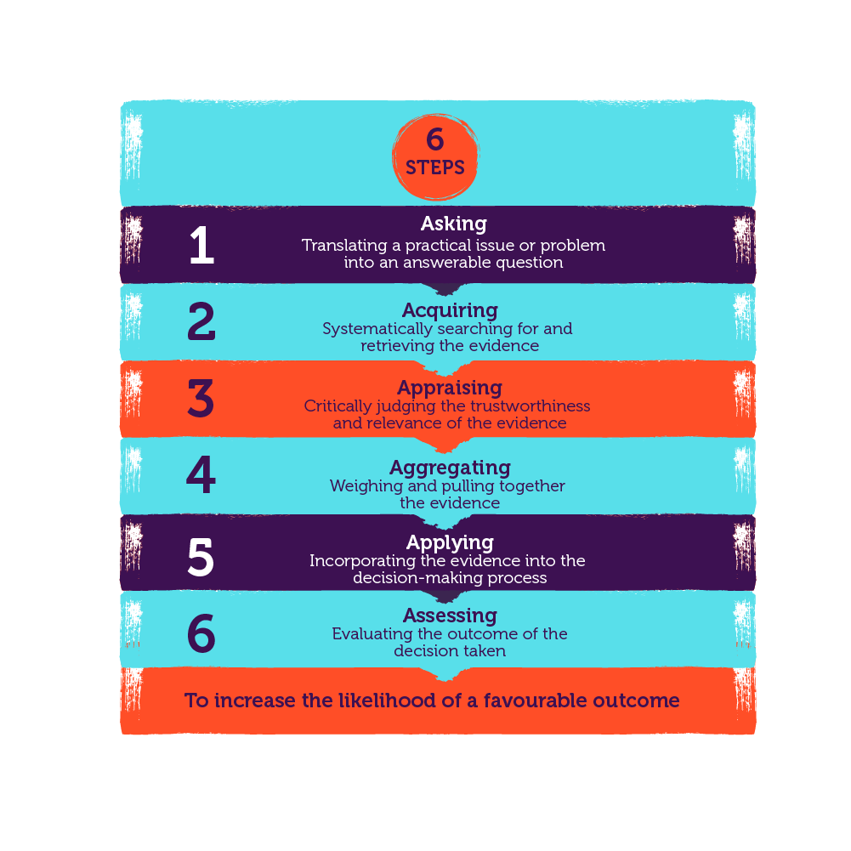
Image A.

1.2
Force Field Analysis is a tool used to assist decision-making processes by identifying forces in favour or against (MindTools, no date a). This enables professionals to put plans in place to encourage the driving forces and minimise the resisting forces (CMI, 2015). Using this analysis tool allowed Han et. al (2023) to identify specific forces that influenced shared leadership. By identifying the drivers and resistance, Han et. al (2023) were able to develop bespoke interventions to help, influence and support the change process through recognising underlying issues and benefits. However, it is also important to acknowledge that limitations may arise. Due to the nature of the model, it is possible to create a divide within a group by associating certain people with a specific category, which may lead to conflict and have a negative influence on teamwork (Freeman, no date).

There are a range of analysis methods to recognise issues and opportunities such as interviews, observations, and organisation metrics to name a few. An example of organisation metrics is people analytics which are used to drive organisational change (CIPD, 2022a). This is a common analysis method as it measures specific areas therefore enables more effective decision-making as it is evidence-based and relevant (CIPD, 2022a). People analytics, gathered through surveys, enabled VIVD to gain a better understanding of staff wellbeing amidst an organisational change and, by using this information appropriately, were able to put adequate measures in place to help (CIPD, 2021). However, there are problems with excessive use of organisational metrics. Lahiri and Schwartz (2018) argue the growing development and use of people analytics causes an increased risk of security and transparency with organisations and their stakeholders, and a growing number of employees are starting to worry about the privacy and safety of the level of people analytics held in organisations (Lahiri and Schwartz, 2018). Despite this, there are legal obligations (GDPR, 2018) that companies must adhere to when managing and storing personal information, otherwise face serious penalties (Marr, 2020). In addition to this, Taylor and Woodhams (2022) highlight the importance of using the chosen sampling method appropriately, by ensuring it is representative, otherwise potential bias may become known in the data and therefore affect the overall decision.

1.3
According to Howlett (CIPD, 2019) critical thinking is “the ability to think well” and critically evaluate others’ opinions and arguments. We use critical thinking every time we consider our options, our priorities, and consequences of decisions (MindTools, no date b). It requires curiosity and asking questions when presented with an issue or a decision to prevent jumping to conclusions and causing bias (GCFLearnFree, 2019). As referred to in 1.1, image A is a way of thinking critically.

In comparison to everyday thinking, which we do automatically, critical thinking is intentional (GCFLearnFree, 2019). It is becoming more important to use this skill to discern between real and fake news, especially as we continue to grapple with information overload that technology has brought us (Dolden, 2022), as it not only influences our judgements but may also play a significant role in developing biases (Gordon, no date). We can use a rational decision-making model to help us assess the reliability and accuracy of the information, such as the classic approach (Adair, 2016):
“1. Define the objective;
2. Collect relevant information;
3. Generate feasible options;
4. Make the decision;
5. Implement and evaluate.”

Adair (2016) also highlights the need to distinguish “available and relevant” information; this is important as it streamlines the decision-making process by reducing distractions and enabling people professionals to make well-informed choices.

1.4
According to Gifford and Wietrak (2022) “effective decision-making can be difficult” as it requires professionals to examine evidence whilst being critical about assumptions to prevent biases. There are several models available to aid this process, but it is important to note the chosen model will depend on the scenario (CMI, 2015).
- Edward De Bono’s Six Thinking Hats is a technique to help reach decisions and minimise groupthink outlined in 1.1 (CMI, 2015). Each hat represents the different role in the process, so by mentally wearing these hats, it encourages critical thinking, different perspectives, and structure within the meeting (TheDeBonoGroup, no date). Below highlights the responsibilities of each hat applied to organisational development, (TheDeBonoGroup, no date):
  - White Hat: required information, focusing on the facts – gathering and analysing organisational metrics to identify current and historic trends.
  - Yellow Hat: optimistic, focusing on the benefit – identifying the benefits of that may arise from interventions and highlighting areas for opportunity.
  - Black Hat: obstacles, focusing on managing risks – identifying challenges associated with implementing change.
  - Red Hat: emotions, focusing on feelings associated with decisions – consider and explore the emotional impact of change on employees, and how initiatives may affect morale and well-being.
  - Green Hat: creativity, focusing on areas for opportunity and new concepts – generating new ideas for initiatives and driving change as well as fostering a culture of innovation.
  - Blue Hat: managing and controlling the structure of the decision-making process – managing the process by setting clear objectives and agenda for organisational development and facilitating conversations around scope for change.

- Stakeholder analysis methods are used to identify who the relevant stakeholders are, their interests and how they will be affected a decision (Hoory and Bottorff, 2022). According to CMI (2014), a stakeholder analysis enables professionals to anticipate difficulties, gain buy-in from the most powerful stakeholders, enhance what an organisation has to offer and how it interacts with people. Once stakeholders are confirmed, they could be primary or secondary, they need to be prioritised and mapped using a matrix, such as image B (CMI, 2014).
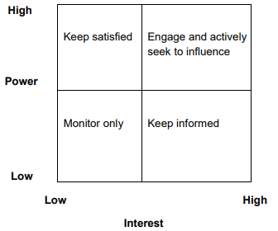
Image B.
Image B.

This matrix provides an opportunity to understand key stakeholders and how to engage with them, as well as the ability to build trust (NHSEngland, no date). Once this is complete, Gifford, Young and Barends (2023) advise qualitative methods like focus groups to be utilised to highlight feedback and issues from stakeholders which will ultimately affect the decision. Regular reviewing and monitoring should be conducted as interests and views of stakeholders could also change overtime (CMI, 2014).

- Plan, Do, Check, Act (PDCA) cycle is used when implementing change. The steps are repeated for continuous improvement (ASQ, no date). Cuofano (2023) highlights the stages within this iterative cycle include the following, which have been applied to organisational development:
  - Plan: define the aspirational culture, understand the current culture, identify where change is required, develop a plan or initiative with clear objectives and goals.
  - Do: execute the initiative and collate data, regularly communicating the need for change.
  - Check: monitor progress of the initiative and the effect is has on culture through additional surveys and focus groups, review the changes in line with the plan, highlight successes and learning.
  - Act: analyse the results from the data, identify themes and make adjustments based on the analysis i.e., addressing barriers and implementing interventions and embed the new culture.

1.5
Green and Russell (2022) state “organisations should ‘do the right thing’ because it’s the right thing to do” which implies that people professionals need to be ethical in their practice in conjunction with employee needs.

Utilitarianism is an “impartial well-being consequential” theory (CIPD, 2015a) which indicates the best course of action is determined by the result that brings maximum happiness. This is supported by CIPD’s report (2015a) where utilitarianism is intricately linked to the well-being lens of the corporate world, where work should be good and designed to promote happiness. Although, it is important to note that utilitarians do believe that rules can be broken in extreme situations to achieve desired results (Mitra, 2019).

Utilitarianism influences decision-making in the workplace by focusing on the most positive result for the greater good (LinkedIn, 2023). According to Mitra (2019), this theory is beneficial as it is based on facts and evidence which is key in decision-making. It can also do favours for the reputation of an organisation, as the impact of a decision on happiness and well-being of the community is at the forefront (LinkedIn, 2023). However, it also has its drawbacks. LinkedIn (2023) highlight the possible conflict this theory might cause as it does not consider individual needs and therefore, some may feel neglected in the decision-making process. Mitra (2019) argues that individual rights should be protected. As well as this, it can be difficult to quantify happiness and well-being as this is subjective to everyone (LinkedIn, 2023).

Deontology is another ethical theory that determines whether a decision is right or wrong by how well it complies with rules or principles, irrespective of results (MyEducator, 2023) which suggests that in decision-making, deontologists abide by moral rules and should always do what is ethically right (Sus, 2023). Deontology interlinks with the fairness and rights and duties lens within the corporate environment (CIPD, 2015a), and emphasises Green and Russell’s quote (2022) at the beginning of 1.5.

This theory influences decisions by establishing ground rules to determine the nature of an action and considers the intention. This differs to utilitarianism, as deontologists believe adhering to moral principles is more important than attractive results (Sus, 2023). According to BBC (2014), deontology focuses on the value of every individual which “provides a basis for human rights.” However, BBC (2014) also argue that this perspective could result in making the world “less good” due to the lack of interest of outcomes. There are also deontological dilemmas where individuals must make personal choices between duty and happiness, but this can be resolved by thinking critically and evidence-based research (Tabarcea, 2012). It is worth mentioning using this theory to make decisions can hugely impact culture, good or bad, due to individual views of right and wrong, through deontology reflexes, and “on the spot reaction” to said dilemma (Tabarcea, 2012).

Communitarianism is a political and social theory which highlights on the importance of community (TheBrief, 2023). Communitarians believe that individuals are rooted within their communities, and their social and moral values are maintained through relationships (TheBrief, 2023). Therefore, individuals’ responsibilities sit with serving the good of the community (Longley, 2020) which impacts their social identify and position in society. This is similar to corporate social responsibility (CSR) where organisations are encouraged to contribute to social and environmental well-being of the community they operate in (Fernando, 2023). Haan (2023) emphasises the importance of CSR as it considers the wider societal impact and social value, which contributes the greater community and therefore, operating as an ethical company. This theory focuses on communal well-being but can also be challenging when trying to define a community.

It is clear to see these ethical theories shape decisions. Utilitarianism, with its focus on maximising overall happiness, gives actionable guidance that can help HR professionals prioritise actions which may benefit the majority, but also may neglect individual rights. Deontology brings clear rules and intent yet encourages critical thinking and reflection to make better judgements, which can aid HR to maintain ethical standards. Finally, communitarianism encourages professionals to consider the overall well-being of the organisation, promoting shared values and a collaborative workplace, but to consider how to overcome the challenges in defining ‘community’ and avoid marginalising the minority. In practice, HR must navigate these theories when making decisions based on differing situations whilst aligning them with the organisations goal and ethics. In addition to this, Grave (2018) states HR “must speak up about ethics” to enable organisations to operate properly and ethically.

3.1
Performance is critical to success in an organisation; in the words of Wainwright (2018), “if it does not add value, your organisation or organisational unit has no reason to exist.” The better the performance, the greater the likelihood of achieving organisational goals becomes (Stange, 2020). Performance can be measured financially and non-financially.

Financial KPI’s are a measurement of performance used to analyse and trace an organisation’s financial health which enables a thorough understanding of performance from a financial point of view (Stobierski, 2020). Profit margins like gross profit and net profit are examples of financial KPIs used to measure business performance and Houston (2021) argues business owners should be aware of these to understand how their business is performing, i.e., whether profits are increasing or decreasing will be the ultimatum of success. On the one hand, KPIs provide a straightforward way to measure outcomes if they are specific, measurable, achievable, relevant and timely (SMART), and also give insight to understand why something was not achieved (Unboxed Staff, 2021). But on the other, KPIs “don’t always offer actionable information immediately” which implies that in circumstances where real-time decisions are required, it may not be as effective (Unboxed Staff, 2021).

Lau and Sholihin (2005) argue using financial measures alone are “narrow in focus.” Organisations will always want to improve performance, and this often relies on non-financial measures (ICAEW, 2023) which has a greater impact on long-term goals (Lau and Sholihin, 2005). Employee satisfaction is a non-financial measurement used to analyse performance; anonymous surveys are a method of collating honest feedback based on employee satisfaction and provide an in-depth understanding of what needs improving (Indeed, 2022), which will in turn better performance levels. It is vital that feedback is acted on and responded to, otherwise this can damage morale and performance (Miller, 2020).

In summary, assessing organisational performance requires a balanced approach to encompass both financial and non-financial measures. The financial KPIs mentioned above offer valuable quantitative insights to financial health and strategic decision-making, and employee satisfaction as a non-financial measure provides qualitative, contextual data which offers better understanding of organisational culture. Together, these measurements provide a comprehensive evaluation that informs strategic decisions, culture, and ensures overall health and sustainability. Recognising the connection of financial and non-financial performance metrics is vital to achieve well-rounded decisions.

3.2
There has been a shift in perspective of the people profession over the last century which is simply highlighted in the change from ‘personnel management’ to ‘human resources’ and more recently, using ‘people’ in job titles (Taylor and Woodhams, 2022). This small yet noticeable change reflects the importance of the employee experience, and links to the concept of adding value; as Burke (2016) describes it, people “have been and always will be an essential driver of value creation.” The need for people practices has also changed overtime, from ensuring contracts were in place and employees were being paid to adapting to technology changes, competing for talent, and retaining (CIPD, 2022b).

Value creation, through people practices, spotlights the human capital within an organisation (CIPD, 2017) to enhance organisational performance and productivity by focusing on wellbeing, talent acquisition, learning and development and many more initiatives. It is important to be aware of measuring the impact people practices have; CIPD (2018) argue that efficiency measures like cost per hire, absence levels and turnover are continually scrutinised, but they do not consider value-creation. Lawlor et. al (cited in CIPD, 2018) emphasises the importance of impact measures to capture value-creation through performance and contribution as it builds integrity and trust as a people professional, not only in monetary value, “but they also add value from the intangible aspect” which provides long-term value (CIPD, 2015b). People practices can add value to organisation through well-established recruitment and selection processes, developing a structured onboarding procedure, ensuring employees have a voice and autonomy, collating quantitative and qualitative feedback from new employees on work practices, creating reward packages and fostering learning and development opportunities (Waite, et. al 2021).

Return on Investment (ROI) is a method of measuring impact by focusing on cost and time savings (Gammon, 2022). According to Gammon (2022), there should be a broader focus as people practices contribute to the bigger picture – the strategic goals. An example of this could be a 5% increase in retention; organisational metrics stored within a HR system can be analysed to compare data overtime, identify reasons for or low high retention, and even further to identify themes. People professionals can use this information to develop new initiatives or provide support where needed, thus hopefully resulting in retaining staff when they receive the support they require.

A cost-benefit analysis is another method of measuring impact (EmploymentHero, 2022) which enables professionals to analyse financial data to influence a decision. There are many financial aspects to consider when recruiting like advertising costs, training, salary, equipment, etc. (UndercoverRecruiter, no date). Doing a cost-benefit analysis can help justify the need for new employees or a programme like an apprenticeship, and provide tangible and intangible benefits (EmploymentHero, 2022), such as:
- Increased productivity
- Improved culture
- Reduced overtime
- Reduced agency costs
- Increased retention rates
- Positive employer brand

Although it is clear to see people practices can bring value, Taylor (2014) argues professionals need to enable and empower leadership by ensuring they are aware of consequences their actions may have on matters like employee satisfaction, morale, performance, absence, turnover, etc. to effectively bring value to not only an organisation, but employees too.

In conclusion, as highlighted by Taylor and Woodhams (2022), people practices have become essential to achieving strategies objectives. Not only do people professionals continue to manage the legal and financial aspects, but their attention is equally focused on structural and cultural changes due to an interchangeable, competitive, and complicated environment (Taylor and Woodhams, 2022).

Analysis Review
Introduction
This review delves into a quantitative and qualitative analysis of EDI salary data, along with feedback on hybrid working practices.
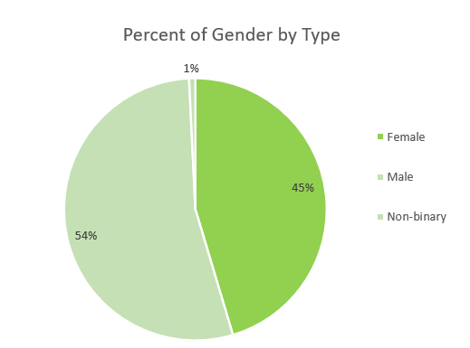
A)

This chart provides a visual representation of the split between genders. Female and male ratio is relatively balanced, with a slight majority of males by 9%. Notably, there is a 1% representation of non-binary individuals within this workforce.
The data shows the current workforce demographics and highlights the diversity in gender identities, which reflects an inclusive and more effective workplace, “diverse views and perspectives lead to better decision-making and creativity” (Behavioural Insights Team, 2017).

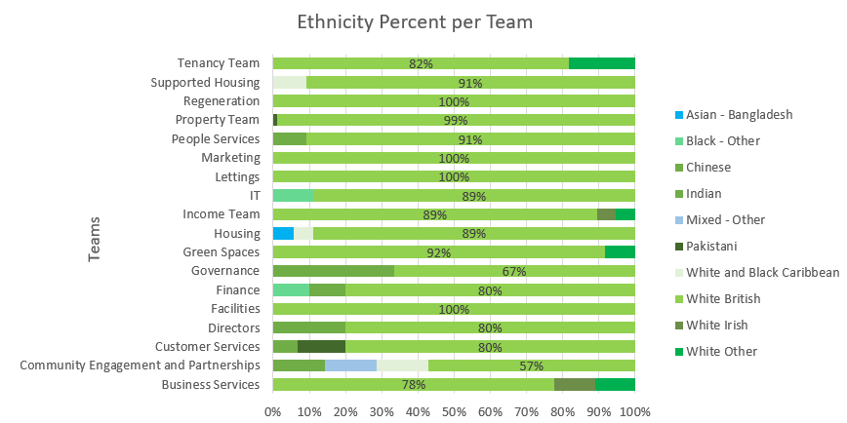
B)

Despite the organisation’s commitment to diversity, it is significant most employees identify as White – British particularly in Regeneration, Marketing, IT and Facilities teams (100%), Property (99%). This raises concerns about the overall diversity, indicating a potential need for interventions to foster a more inclusive workplace.
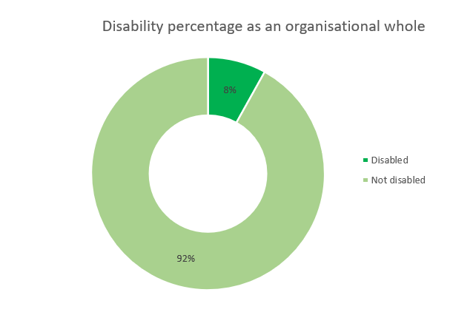
C)

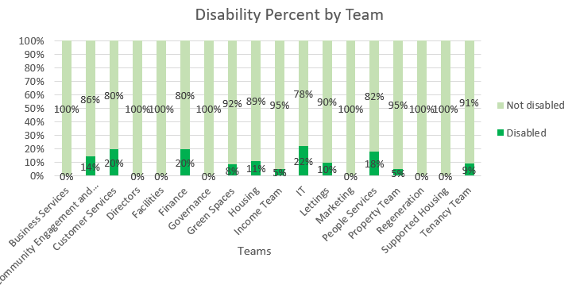

The pie chart shows an 8% representation of disabled individuals compared to 92% non-disabled, highlighting an opportunity to strengthen inclusion efforts.
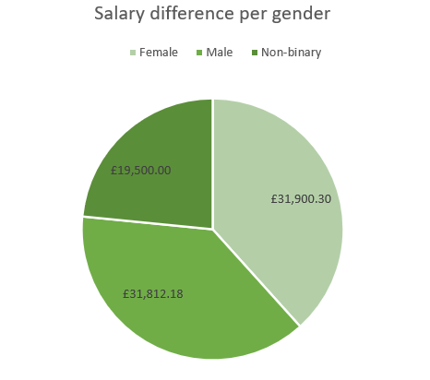
Analysing further, the 8% representation is distributed across 11 teams. IT have the highest number of disabled employees (22%), followed by Finance (20%). This breakdown highlights specific areas for improvement.
D)

Females earn more on average, followed by men, with non-binary individuals earning considerably less than both. Females earn £88.12 more than men and £12,400.30 more than non-binary, while men earn £12,312.18 more. This shows a gender-based pay gap which should be addressed, along with equitable compensation across all identities.
E) The overall average salary paid by the organisation is £ £31,757.46. The team that makes up the majority the organisation’s salary of this figure is the Directors, predominately 80% female, earning an average salary of £93,791.00. In contrast, the team that earns the lowest average salary is Green Spaces, amounting to £21,030.00, where 75% of the team are male. The graph below illustrates a snapshot of the average salary distribution; the line provides a benchmark. While both female and male align with this, there is a noticeable difference for non-binary individuals, whose salaries are considerably lower than the organisation average.
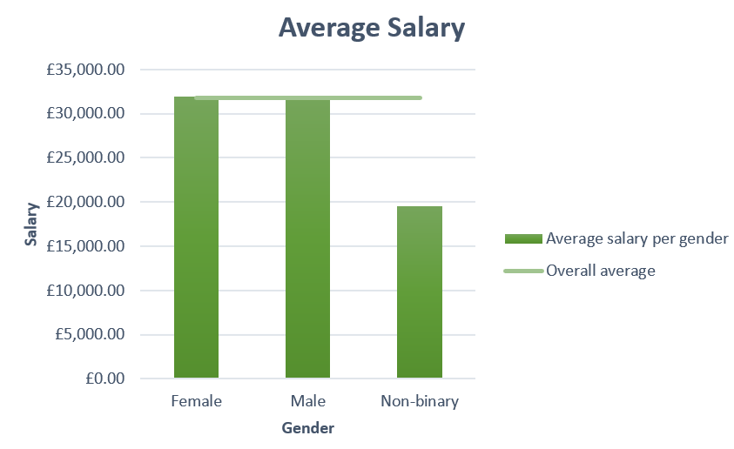

Also, some roles, despite being similar, show significant salary discrepancies across the teams.
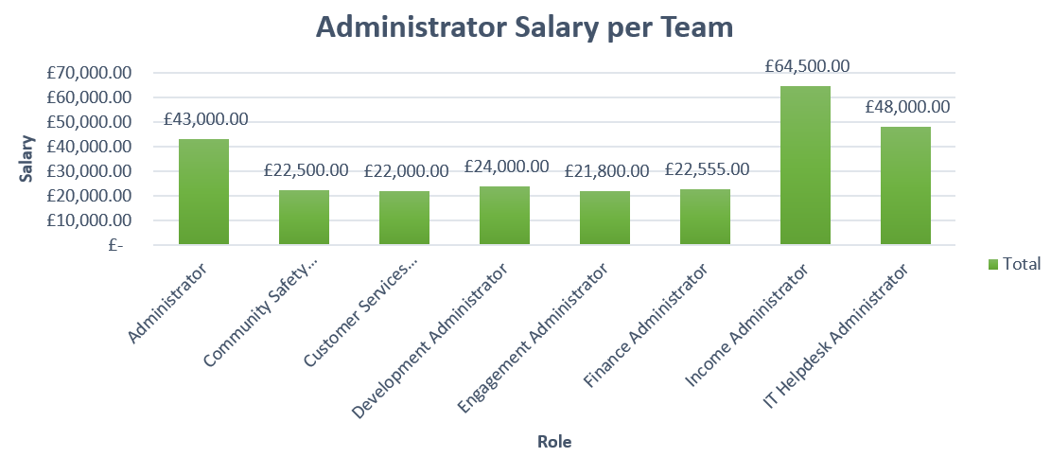
Recommendations
Considering this analysis, to enhance ED, the following recommendations are suggested:
- Diversity recruitment training
Implement diversity-focused recruitment strategies to attract all genders, disabilities, and under-represented ethnic backgrounds.
- Inclusive policies
Establish inclusive policies and procedures that supports all employees.
- Staff networks
Establish support groups for non-binary individuals, ethnic minorities, and employees with disabilities to network, mentor and share experiences.
- Leadership diversity
Promote diversity at director level, encouraging a balanced representation.
- Salary equity
Conduct a review to address the disparities in salaries between non-binary and female/male, as well as similar roles.

Benefits
- An equal, diverse, and inclusive workforce increases level of engagement, innovation, talent, and better decisions (Ali, 2022).
- Commitment to EDI enhances reputation, making it an attractive and responsible employer (Fletcher, 2023).
- Inclusive practices enhance morale, fostering a sense of belonging and trust, leading to job satisfaction and higher retention (HRGrapevine, 2022)

Implications
- Potential risk of increased discrimination claims if disparities are not acknowledged.
- Failure to prioritise diversity may result in missing out on valuable talent acquisition and retaining skilled employees (Doughty, 2020)
- Non-compliance may lead to fines and legal actions in line with the Equality Act 2010 (Ali, 2022).

Feedback Scores: Hybrid Working
Introduction
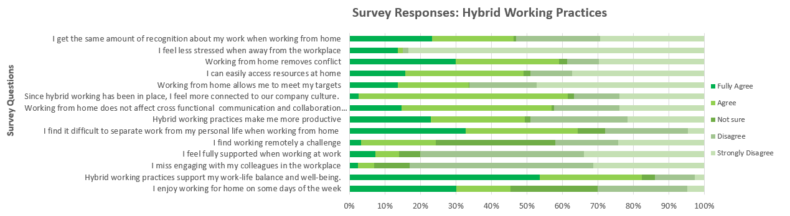
This report offers a comprehensive understanding of employees’ experience regarding hybrid working practices.
The feedback scores above present a nuanced view on hybrid working highlight a complex, versatile nature of this practice. Benefits such as increased flexibility and good teamwork are counteracted by concerns about stress, performance and collaboration.
This analysis discovered that 33% of employees find it difficult to separate personal life and work when working from home, 27% do not feel it makes them any more productive and 34% feel it affects their cross-functional communication and collaboration. Yet, 56% disagree they miss engaging with colleagues at work, which appears to be a conflicting view.
The most concerning statistics highlight a difficulty with reaching targets when working from home (47%) and suggests it causes stress, with a staggering 83% of employees strongly disagreeing they feel less stressed when away from the workplace.
Despite this, 37% strongly agree they enjoy working from home some time of the week and 54% strongly agree it supports work-life balance. In addition to this, some employees (59%) agree hybrid working practices has enabled them to feel more aligned to the company culture. Contrary to concerns mentioned above, 59% agree hybrid working does not affect communication and collaboration; this may be due to the advanced technology as it has enabled seamless teamwork.
There are uncertainties within this survey, including 34% of employees being unsure whether they feel remote working if challenging. This may suggest that some are still adapting and navigating challenges. As well as this, 52% disagree and 31% strongly disagree they miss engaging with colleagues at work which suggests alternative ways to engage and connect are needed.
Recommendations
To address the mixed views on hybrid working, consider implementing the following:
- Flexible working arrangements
Offer flexible working arrangements and prioritise work-life balance; encourage breaks, setting boundaries, and resources for mental health and stress support.
- Invest in technology for collaboration and recognition
Encourage collaboration across teams on platforms such as Microsoft Teams, Zoom and Skype, and implement recognition programmes regardless of environment.
- Enhance employee support
Provide regular check-ins through 1:1’s and PADRs and feedback sessions to promote an open dialogue.
Benefits
- Clear communication, recognition and appreciation, and flexible working arrangements can boost morale and productivity (McCartney, 2023)
- Supportive and flexible environments attract talent and increases retention (CMI, 2020)
Implications
- Failing to provide these recommendations could result in high turnover, meaning increased recruitment and training costs.
- These recommendations are considered a legal requirement. Failure to comply may result in fines or legal action. Fines as large as £175,000 have been awarded to employees where employers have not prioritised their health and wellbeing (CIPD, 2022c).

Reference list
- Adair, J. (2016) Decision Making & Problem Solving Strategies. Available at: file:///C:/Users/alys1/Downloads/Adair%20-%20Decision%20making%20and%20problem%20solving%20strategies.pdf (Accessed: 8th November 2023).
- Ali, L. (2022) Equality, diversity and inclusion (EDI) in the workplace. Available at: https://www.cipd.org/uk/knowledge/factsheets/diversity-factsheet/#Equality (Accessed: 26th November 2023)
- ASQ (no date) What Is The Plan-Do-Check-Act (PCDA) Cycle? Available at: https://asq.org/quality-resources/pdca-cycle (Accessed: 14th November 2023)
- Barends, E. and Rousseau, D. (2018) Evidence-Based Management. Available at: https://cdn.koganpage.com/media/public/document/evidence-based-management_eric_01_9780749483746_c01.pdf (Accessed: 27th October 2023)
- BBC (2014) Duty-based ethics. Available at: https://www.bbc.co.uk/ethics/introduction/duty_1.shtml (Accessed: 19th November 2023)
- Behavioural Insights Team (2022) How to improve gender equality in the workplace. Available at: https://www.bi.team/wp-content/uploads/2021/07/BIT_How_to_improve_gender_equality_report.pdf (Accessed: 20th November 2023)
- Burke, E. (2016) People and the creation of value. Available at: https://www.cipd.org/globalassets/media/knowledge/knowledge-hub/reports/people-and-the-creation-of-value_tcm18-19955.pdf (Accessed: 14th November 2023)
- Cherry, K. (2022) How Groupthink Impacts Our Behaviour. Available at: https://www.verywellmind.com/what-is-groupthink-2795213 (Accessed: 30th October 2023)
- CIPD (2015a) Ethical decision-making: eight perspectives on workplace dilemmas. Available at: https://www.cipd.org/globalassets/media/knowledge/knowledge-hub/reports/ethical-decision-making-2015-eight-perspectives-on-workplace-dilemmas_tcm18-9564.pdf (Accessed: 19th November 2023)
- CIPD (2015b) Making maximum impact as an HR professional in an SME. Available at: https://www.cipd.org/globalassets/media/knowledge/knowledge-hub/reports/making-maximum-impact-hr-professional-sme_tcm18-8791.pdf (Accessed: 17th November 2023)
- CIPD (2017) Creating and capturing value at work: who benefits? Available at: https://www.cipd.org/globalassets/media/knowledge/knowledge-hub/reports/creating-and-capturing-value-at-work_2017-who-benefits-2_tcm18-33097.pdf (Accessed: 17th November 2023)
- CIPD (2018) Creating and capturing value at work: who benefits? Available at: https://www.cipd.org/globalassets/media/knowledge/knowledge-hub/reports/creating-and-capturing-value-at-work_2018-who-benefits-part-2_tcm18-37078.pdf (Accessed: 17th November 2023)
- CIPD (2019) Critical thinking [Podcast]. 5 November. Available at: https://www.cipd.org/uk/knowledge/podcasts/critical-thinking/ (Accessed: 8th November 2023)
- CIPD (2021) Solving business problems with people analytics: Vivid. Available at: https://www.cipd.org/uk/knowledge/case-studies/vivid/ (Accessed: 3rd November 2023)
- CIPD (2022a) People Analytics. Available at: https://www.cipd.org/uk/knowledge/factsheets/analytics-factsheet/ (Accessed: 2nd November 2023)
- CIPD (2022b) What value does HR bring to today's organisations? [Podcast] Available at: https://www.cipd.org/uk/knowledge/podcasts/purpose-and-value-of-hr/ (Accessed: 14th November 2023)
- CIPD (2022c) Stress and wellbeing: UK employment law. Available at: https://www.cipd.org/uk/knowledge/employment-law/wellbeing-stress/ (Accessed: 26th November 2023)
- CMI (2014) Stakeholder Analysis and Management. Available at: https://www.managers.org.uk/wp-content/uploads/2020/03/CHK-234-Stakeholder-analysis-and-management-1.pdf (Accessed: 14th November 2023)
- CMI (2015). Developing Decision Making Skills. Available at: https://www.managers.org.uk/wp-content/uploads/2020/03/CHK-277_Developing_decision_making_skills.pdf (Accessed: 27th October 2023)
- CMI (2020) How can flexible working benefit your organisation? Available at: https://www.managers.org.uk/knowledge-and-insights/article/flexible-working-benefit-organisation/ (Accessed: 26th November 2023)
- Cuofano, G. (2023) PDCA Cycle: The Plan-Do-Check-Act Cycle In A Nutshell. Available at: https://fourweekmba.com/pdca-cycle/#:~:text=The%20PDCA%20%28Plan-Do-Check-Act%29%20cycle%20was%20first%20proposed%20by,an%20essential%20component%20of%20the%20lean%20manufacturing%20philosophy. (Accessed: 14th November 2023)
- Data Protection Act (2018). Available at: https://www.legislation.gov.uk/ukpga/2018/12/introduction/enacted (Accessed: 8th November 2023)
- Dolden, L. (2022) Information Overload: Why Majority of Brits Are Experiencing Daily Stress. Available at: https://techround.co.uk/news/information-overload-why-majority-of-brits-are-experiencing-daily-stress/ (Accessed: 8th November 2023)
- Doughty, D. (2020) Diversity and inclusion: what’s the risk? Available at: https://www.linkedin.com/pulse/diversity-inclusion-whats-risk-david-doughty/ (Accessed: 26th November 2023)
- Employment Hero (2022) How to perform a cost-benefit analysis of hiring. Available at: https://employmenthero.com/uk/blog/cost-benefit-analysis-of-hiring/ (Accessed: 18th November 2023)
- Equality Act (2010) https://www.legislation.gov.uk/ukpga/2010/15/contents/enacted (Accessed: 26th November 2023)
- Fernando, J. (2023). Corporate Social Responsibility (CSR) Explained With Examples. Available at: https://www.investopedia.com/terms/c/corp-social-responsibility.asp (Accessed: 19th November 2023)
- Fletcher, A. (2023) A Complete Guide to Equity, Diversity and Inclusion in the Workplace. Available at: https://www.fitzgeraldhr.co.uk/equity-diversity-inclusion-work#:~:text=A%20strong%20EDI%20focus%20can%20enhance%20an%20organisation%E2%80%99s,commitment%20to%20creating%20an%20inclusive%20and%20equitable%20workplace. (Accessed: 26th November 2023)
- Freeman, J. (no date) Advantages and Disadvantages of Force Field Analysis. Available at: https://www.edrawsoft.com/force-field-analysis-advantages-and-disadvantages.html (Accessed: 2nd November 2023)
- Gammon, C. (2022) ROI in HR: what it is and how to measure it. Available at: https://www.iris.co.uk/blog/hr/roi-in-hr-what-it-is-and-how-to-measure/ (Accessed: 17th November 2023)
- GCFLearnFree (2019) What is Critical Thinking? 30 April. Available at: https://www.youtube.com/watch?v=-eEBuqwY-nE&t=81s (Accessed: 8th November 2023)
- Gifford, J. and Wietrak, E. (2022) People performance: an evidence review. Practice summary and recommendations. London: Chartered Institute of Personnel and Development.
- Gifford, J., Barends, E. and Young, J. (2023) Evidence-based HR: Make better decisions and step up your influence. Guide. London: Chartered Institute of Personnel and Development.
- Gordon, W. (no date) True or false? How much is fake news influencing our lives? Available at: https://www.derby.ac.uk/magazine/issue-12/influence-of-fake-news/ (Accessed: 8th November 2023)
- Grave, K. (2018) HR must speak up about ethics. Available at: https://www.peoplemanagement.co.uk/article/1741719/hr-must-speak-up-about-ethics (Accessed: 19th November 2023)
- Green, M. and Russell, T. (2022) Ethical practice and the role of people professionals. Available at: https://www.cipd.org/uk/knowledge/factsheets/ethics-role-hr-factsheet/#what-is-ethical-practice-in-organisations (Accessed: 18th November 2023)
- Haan, S. (2023) Corporate responsibility: An introduction. Available at: https://www.cipd.org/uk/knowledge/factsheets/corporate-responsibility-factsheet/ (Accessed: 19th November 2023)
- Han, S. et al (2023) Why do employees welcome or refuse shared leadership?: A qualitative exploration through force-field analysis. Available at: https://onlinelibrary-wiley-com.ezproxy.uwtsd.ac.uk/doi/pdf/10.1002/hrdq.21495 (Accessed: 2nd November 2023)
- Hoory, L. and Bottorff, C. (2022) What Is A Stakeholder Analysis? Everything You Need To Know. Available at: https://www.debonogroup.com/services/core-programs/six-thinking-hats/ (Accessed: 14th November 2023)
- Houston, M. (2021) Profit Margin Is An Essential KPI To Monitor In Your Business. Available at: https://www.forbes.com/sites/melissahouston/2021/12/22/profit-margin-is-an-essential-kpi-to-monitor-in-your-business/?sh=751ae12a1fef (Accessed: 19th November 2023)
- HRGrapevine (2022) Valuing employees | Diversity and Inclusion help to drive morale and productivity. Available at: https://www.hrgrapevine.com/content/article/johnson-fleming-2022-09-22-diversity-inclusion-help-to-drive-morale-productivity (Accessed: 26th November 2023)
- ICAEW (2014) Guideline - Using non-financial measures. Available at: https://www.icaew.com/technical/business/Business-performance-management/KPIs/guideline-using-non-financial-measures (Accessed: 19th November 2023)
- Indeed (2022) 11 Non-Financial Measures of Performance To Boost Success. Available at: https://www.indeed.com/career-advice/career-development/non-financial-measures-of-performance (Accessed: 19th November 2023)
- Lahiri, G. and Scharwtz, J. (2018) People data: how far is too far? Available at: https://www2.deloitte.com/us/en/insights/focus/human-capital-trends/2018/people-data-analytics-risks-opportunities.html (Accessed: 3rd November 2023)
- Lau, C. and Sholihin, M. (2005) Financial and nonfinancial performance measures: How do they affect job satisfaction? Available at: https://www.sciencedirect.com/science/article/abs/pii/S0890838905000417 (Accessed: 19th November 2023)
- LinkedIn (2023) How do you foster a culture of utilitarianism in your organization or team? Available at: https://www.linkedin.com/advice/0/how-do-you-foster-culture-utilitarianism-your#how-to-apply-utilitarianism? (Accessed: 19th November 2023)
- Longley, R. (2020) What Is Communitarianism? Definition and Main Theorists. Available at: https://www.thoughtco.com/communitarianism-definition-and-theories-5070063 (Accessed: 19th November 2023)
- Marr, B. (2020) What Are The Pitfalls Of People Analytics And Data-Driven HR? Available at: https://www.forbes.com/sites/bernardmarr/2020/02/12/what-are-the-pitfalls-of-people-analytics-and-data-driven-hr/?sh=312b88063c38 (Accessed: 3rd November 2023)
- McCartney, C. (2023) Flexible working practices. Available at: https://www.cipd.org/uk/knowledge/factsheets/flexible-working-factsheet/#title4 (Accessed: 26th November 2023)
- Miller, B. (2020) Pros and Cons of Employee Surveys. Available at: https://hrdailyadvisor.blr.com/2020/09/28/pros-and-cons-of-employee-surveys/ (Accessed: 19th November 2023)
- MindTools (no date a) Force Field Analysis. Available at: https://www.mindtools.com/a23ewmr/force-field-analysis (Accessed: 30th October 2023)
- MindTools (no date b) Critical Thinking. Available at: https://www.mindtools.com/a3ixqae/critical-thinking (Accessed: 8th November 2023)
- Mitra, R. (2019) Utilitarianism: An Ethical Decision-Making Approach. Available at: https://www.researchgate.net/publication/335589309_Utilitarianism_An_Ethical_Decision_Making_Approach (Accessed: 18th November 2023)
- MyEducator (2023) What is HR Management? Available at: https://app.myeducator.com/reader/web/1114/topic1/kg16g/ (Accessed: 18th November 2023)
- NHS England (no date) Stakeholder analysis. Available at: https://www.managers.org.uk/wp-content/uploads/2020/03/CHK-234-Stakeholder-analysis-and-management-1.pdf (Accessed: 14th November 2023)
- Stange, J. (2020) The Who, What, Why, and How of Performance Management. Available at: https://www.quantumworkplace.com/future-of-work/performance-management (Accessed: 19th November 2023)
- Stobierski, T. (2020) 13 Financial Measures Manager Should Monitor. Available at: https://online.hbs.edu/blog/post/financial-performance-measures (Accessed: 19th November 2023)
- Sus, V. (2023) 10 Deontology Examples. Available at: https://helpfulprofessor.com/deontology-examples/ (Accessed: 19th November 2023)
- Tabarcea, A. (2012) The “Deontological Reflex” and Its Implications on Organizational Environment. Available at: https://www.sciencedirect.com/science/article/pii/S1877042812036087?ref=pdf_download&fr=RR-7&rr=828f79b50b6d63e3 (Accessed: 19th November 2023)
- Taylor, S. (2014) Resource and Talent Management. Available at: https://cdn.koganpage.com/media/public/document/resourcing-and-talent_08_gorell_9781398600461_c01-1.pdf (Accessed: 18th November 2023)
- Taylor, S. and Woodhams, C. (2022) Studying Human Resource Management. 3rd edn. London: Kogan Page.
- The Brief (2023) Understanding Communitarianism: Philosophy, Theory, and Criticisms | Educational Video. 16 March. Available at: https://www.youtube.com/watch?v=joTedINXPkk&t=19s (Accessed: 19th November 2023)
- The De Bono Group (no date) Six Thinking Hats. Available at: https://www.debonogroup.com/services/core-programs/six-thinking-hats/ (Accessed: 14th November 2023)
- The Undercover Recruiter (no date). The True Costs of A New Hire in the UK. Available at: https://theundercoverrecruiter.com/true-costs-hiring-uk/ (Accessed: 18th November 2023)
- Unboxed Staff (2021) What Is the Importance of KPIs for Performance Measurement? Available at: https://unboxedtechnology.com/blog/advantages-and-disadvantages-of-performance-indicators/ (Accessed: 19th November 2023)
- Wainwright, B. (2018) What is employee performance? Available at: https://www.effectory.com/knowledge/what-is-employee-performance/ (Accessed: 19th November 2023)
- Waite, K. et al (2021) People Practice: A Complete Guide. London: Kogan Page Limited.
- Young, J. (2023) Evidence-based practice for effective decision-making. Available at: https://www.cipd.org/uk/knowledge/factsheets/evidence-based-practice-factsheet/#what-evidence-should-we-use (Accessed: 18th October 2023)

