
A Critical Analysis of the Hotel and Change Management Practices at Hyatt Hotels Corporation
Management and Organizational Behavior

Module Code: | BMIH5004
Student No:  Student Name: | 2218871  Madalina Duta
Lecturer Name: | Jessica Newport

Executive Summary
Organisational behaviour management is the process of applying the principles of management at both an individual and group level. This report analysed Hyatt Hotels Corporation, the global hospitality company, based on the framework of organisational structure, culture, and strategic management. It was also found that organisation structure and culture were major determinants of organisational performance, flexibility as well and future prospects in the cutthroat nature hotel business. Hyatt had managed service operations for a portfolio of luxury and lifestyle brands around the globe aimed at customer satisfaction, productivity and brand loyalty.
This study demonstrated that Hyatt had the most flexible organisational structure and focused on its employees and guests, which allowed it to adapt to the changes in the market while providing equally good services in all its subunits. Some strategic undertakings that were active during the year were directed to the company’s major strategic objectives of diversifying its brands, delivering value to customers, and encouraging environmentally responsible practices. Under its ‘World of Care’, Hyatt focused on caring for the planet and caring for society by significantly enhancing the appeal of its brand proposition.
The list of recommendations to further improve the management included designating targeted guest experiences to create personalised experiences, implementing sustainable property certifications, creating long-term stay membership to generate extra income, and involving guests in creativity to improve the competitive advantage and growth of the company.

I confirm that I have use of AI for my research only:

AIHR, 2024. Divisional Structure. Accessed from <https://www.aihr.com/hr-glossary/divisional-structure/> accessed on 02-11-2024
Hyatt, 2021. 2021 Global Reporting Initiative (GRI). Accessed from <https://about.hyatt.com/content/dam/hyatt/woc/Hyatt2021GRIIndex.pdf> accessed on 02-11-2024
Hyatt, 2021. 2030 ENVIRONMENTAL GOALS. Accessed from <https://about.hyatt.com/content/dam/hyatt/woc/2030EnvironmentGoals.pdf> accessed on 03-11-2024
Hyatt, 2021. Available today at several participating U.S. properties, the new contactless key technology enables World of Hyatt Guests to seamlessly and securely tap their iPhone or Apple Watch to unlock. Accessed from <https://newsroom.hyatt.com/news-releases?item=124174> accessed on 05-11-2024
Hyatt, 2021. Hyatt Company in the year 2021 bought another company - Apple Leisure Group (ALG). Accessed from <https://investors.hyatt.com/news/investor-news/news-details/2021/Hyatt-Completes-Acquisition-of-Apple-Leisure-Group-Creating-Global-Leader-in-Leisure-and-Luxury-All-Inclusive-Travel-11-02-2021/default.aspx> accessed on 05-11-2024
Hyatt, 2023. Advancing Our Purpose pf Care - Diversity, Equity, and Inclusion at Hyatt. Accessed from <https://about.hyatt.com/content/dam/hyatt/woc/2023DEIReport.pdf> accessed on 05-11-2024
Hyatt, 2024. Culture. Accessed from <https://about.hyatt.com/en/world-of-care/caring-for-people/culture.html> accessed on 06-11-2024
Hyatt, 2024. Our Brands. Accessed from <https://www.hyatt.com/development/ourbrands> accessed on 06-11-2024

Table of Contents
Introduction 4
Main Body 5
Organisation Structure, Culture, and Goals 5
Organisational Structure 5
Corporate Culture and How It Influences Operations 6
Goals of the Organisation 6
Recent Change Initiatives 7
Recent Initiatives Undertaken by the Organisation 7
Impact of these Initiatives on the Organisation 8
How Well These Changes Were Managed 9
Strategic Direction 10
Strategic Direction of the Organisation 10
Strategies Implemented to Achieve Long-term Objectives 10
Conclusion 12
Recommendations 12
Corporate Level 12
Launch a Green Property Certification for Sustainable Tourism 12
Individual Level 13
Develop an Exclusive ‘Hyatt Residences’ Membership for Extended Stays 13
Create Hyper-Personalised Travel Experiences Using Data Insights 13
References 14

Introduction
Hyatt Hotels Corporation is a diversified hospitality company that manages and franchises hotels with over 1200 units, with a global revenue of 6.67 billion USD in 2023 (Staitsta, 2024). Hyatt Corporation is famous for luxury and convenient services, providing also Park Hyatt, Grand Hyatt, Andaz and other hotels for recreation and business tourists (Hyatt, 2024). Hyatt is an example of a company that enjoys both the management of hotel operations and the ownership of properties and expansion of the company’s control.
The aim of this report is to critically evaluate the strategic dynamics underpinning Hyatt’s organisational structure, culture and current and past change management strategies as they relate to the overall corporation and its subsidiary hotel units. The report will include an analysis of the organisational culture, structure, and goals of Hyatt Hotels. The recent change initiatives taken by the organisation will also be discussed followed by an examination of the strategic direction of the company. Furthermore, recommendations for improvement will be provided with proper change management considerations.


Figure 1: Hyatt Logo
(Source: Hyatt, 2024)

Main Body

Organisation Structure, Culture, and Goals

Organisational Structure
Hyatt Hotels Corporation employs a divisional organisational structure with the objective of flexibility, customer orientation and regional decentralisation due to the global requirements of the organisation at both the corporate and individual levels (Giousmpasoglou and Marinakou, 2024). This structure dissects the organisations into segments for particular brands, geographical locations and functions thus enabling each segment to meet the market's needs. Hyatt’s corporate structure is fairly flat with regional subunits that allow decentralised operation but in terms of the company’s overall tactics (Fuchs, 2022). This structure enhances operational effectiveness and efficiency, with subsequent differentiation of services by brand, as guided by the numerous customers’ expectations while maintaining cohesiveness in corporate mannerism.
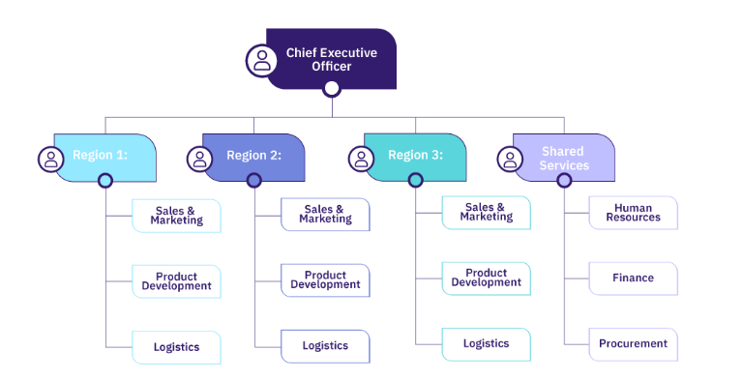
Figure 2: Divisional Organisational Structure Flowchart
(Source: AIHR, 2024)

Corporate Culture and How It Influences Operations
Hyatt has one of its defining organisational culture values playing into its operations, which aligns with the Culture of Care model, consisting of both corporate and individual levels (Demianenko, 2022). This value is reflected in the mission that practices empathy so they can be their best in a dependable work environment, which is also a part of the target clientele of the hotel chain (Hyatt, 2024). Hyatt implements people-first as a foundation for its employee engagement strategy as well as focusing on the values to create loyalty to the brand. The company’s diversity, equity, and inclusion (DEI) stance also strengthens its culture since Hyatt aims to embrace everyone, including customers and its employees. This results in guest individualisation where teams are given the autonomy to make the changes needed to support the delivery of services (Hyatt, 2023).
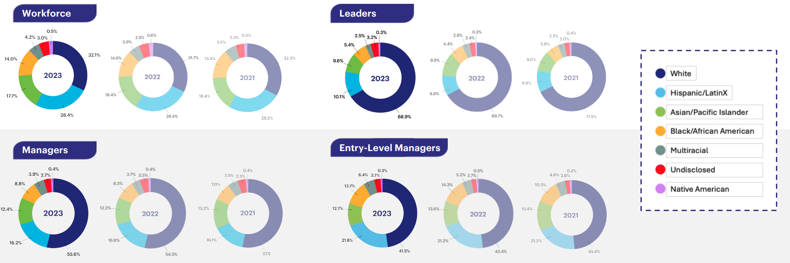
Figure 3: DEI at Hyatt Hotels based on Workforce
(Source: Hyatt, 2023)

Goals of the Organisation
Corporate Level: At the corporate level, Hyatt has the following objectives namely - to achieve sustainable growth in its operations while at the same time increasing its brand portfolio (Gomes, 2023). This program links with Hyatt’s sustainability goals, especially in environmental conservation, DEI and positive impact on respective communities through the World of Care program initiated by the organisation. Strategic objectives concern providing standard and value-added services in all the establishments that are under operation across the globe, integrating innovation in all operations, and maximising shareholders’ returns (Walters and Helman, 2023).
Individual Level: Business units like Hyatt Regency or Andaz are in accordance with the corporate strategy but also set objectives that are specific to the local market. These units appear to build guest loyalty and deliver high-quality service to the organisation as well as enhance the brand image (Brites, 2023). Coordinating both corporate-driven requirements with adaptability to regional requirements helps create harmony among Hyatt’s hotels while maintaining consistency and hence keeping true to maintaining the flexibility and consistency of the brand (Loughran, 2020).

Recent Change Initiatives

Recent Initiatives Undertaken by the Organisation
Corporate Level: Over the past year, Hyatt Hotels Corporation has undertaken a number of strategic change processes that sought to improve customer satisfaction, and innovation in the digital frontier, and boost its environmental and social responsibility features. One such initiative is the World of Care launched by Hyatt in 2021, which operates under the pillars of Environmental Social Governance (ESG) including environment, social, and governance (Hyatt, 2021). This change is consistent with Hyatt's Corporate social responsibility goal of embracing environmental conservationism and diversity. This fits together with Lewin’s Change Management Model, where the unfreezing stage happens as Hyatt understands the requirement for a sustainable and socially responsible organisational strategy that will attract ethics-conscious consumers (Harrison et al., 2021).
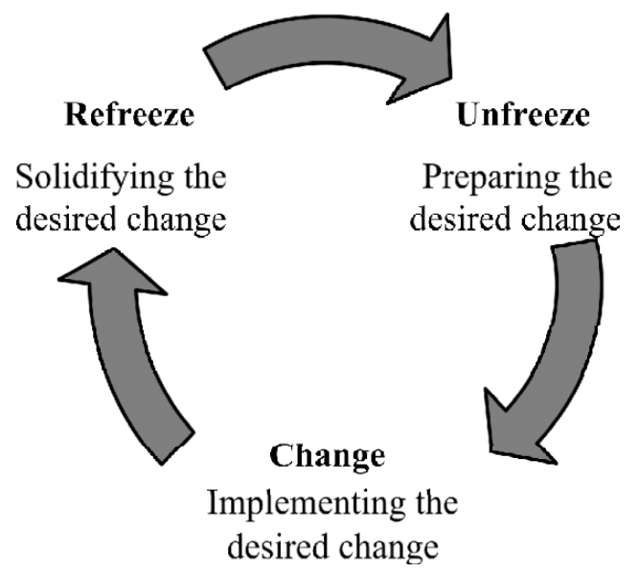
Figure 4: Kurt Lewin's Change Management Model
(Source: Dissanayake and Rajapakse, 2020)
Individual Level: Another important milestone is the introduction of Hyatt’s digital transformation plan which also encompasses an increase in the use of contactless solutions on its sites, where guests could use their iPhones and Apple watches to unlock doors at their accommodation (Hyatt, 2021). Due to a change in the preferences of guests during the COVID-19 outbreak, Hyatt had to advance the use of what can be referred to as contactless technology solutions including mobile check-ins, touchless room keys, as well as buying solutions (El-Said et al., 2024). In order to further understand these changes, Kotter’s 8-Step Change Model can be applied where Hyatt concentrated on steps such as building urgency and creating strategic visions of a new future. This particularly happened during the onset of the pandemic due to the significant changes in business models that occurred during the pandemic (Laig and Abocejo, 2021).
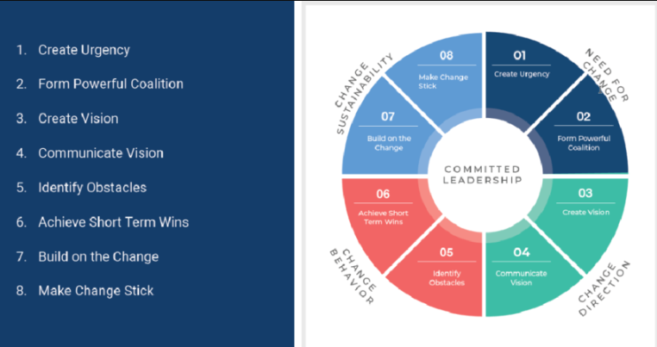
Figure 5: Kotter’s 8-Step Change Model
(Source: Sager, 2021)

Impact of these Initiatives on the Organisation
Corporate Level: These efforts have yielded considerable results. The World of Care program has been also helpful in strengthening Hyatt's brand image as it interested a segment of guests who care about the environment and society (Luiten, 2020).
Individual Level: Digital transformation has enhanced performance and customer satisfaction, which are also important points contributing to current trends in the hospitality industry.
This supports the Resource-Based View (RBV) theory, where resource differentiation must be used to attain a competitive advantage – in this case, by Hyatt’s commitment to responsibility (Andersen, 2021).

How Well These Changes Were Managed
Hyatt’s change management effectiveness can be recognised in the ADKAR model, where communication strategies and stakeholder involvement are used proactively, in this case for both the corporate and individual levels. For instance, the firm offered massive training to the staff as the digital transformation took place, explaining that properties needed to be transformed for the concept to work, thereby showing that Hyatt valued staff training (Rauhavirta, 2021). However, World of Care has encountered some problems, mainly owing to the existing struggle between accomplishing the objectives of sustainability and meeting the functional necessities of the hotel business at a national level (Rubio-Mozos et al., 2020). Nevertheless, change for Hyatt has been efficiently handled by setting specific parameters and the general focus on clarity, as well as the modification of change initiatives on the basis of feedback.
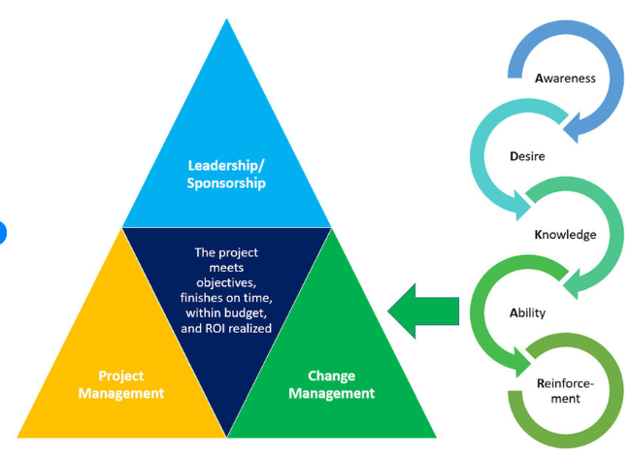
Figure 6: ADKAR Model
(Source: Greaves et al., 2023)

Strategic Direction

Strategic Direction of the Organisation
As for the Hyatt Hotels Corporation, the strategic management objectives are centred on growth, scope expansion, technological development, and responsibility towards the environment. Being a prominent member of the hospitality industry, Hyatt Corporation seeks strategic objectives that are its commitment to increase shareholders’ utility, increase its geographical coverage, and meet customers’ growing needs (Gomes, 2023). This direction is consistent with the Ansoff Matrix which enables to determine Hyatt’s strategic approach to market development and market diversification to meet long-term goals (Demianenko, 2022).
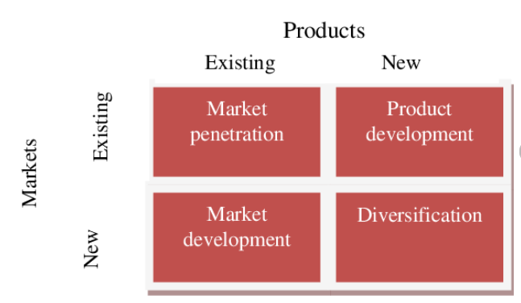
Figure 7: Ansoff's Product/Market Growth Matrix
(Source: Aziri and Nedelea, 2013)

Strategies Implemented to Achieve Long-term Objectives
Corporate Level: When it comes to growth, Hyatt has gone on an acquisition and partnership spree to bolster its brand portfolio. Hyatt Company in the year 2021 bought another company - Apple Leisure Group (ALG) - a luxury resort company to expand into leisure travel that has also been in demand after the COVID-19 outbreak (Hyatt, 2021). This acquisition also belongs to the diversification strategy in the Ansoff Matrix since Hyatt will be expanding its service portfolio and markets. Through liberalisation of its product mix to embrace all-inclusive luxury resorts, Hyatt caters for increasing leisure travel as it seeks to disengage from rigid business travel-related concerns, making it responsive to change (Fachada. 2023).
Individual Level: Moreover, most of Hyatt’s plans for digital innovation include upgrading customers’ experiences through technology intervention, which is a part of Hyatt’s bigger picture. Hyatt has applied development in mobile applications, contactless check-ins, and digital key facilities to ensure smooth interactions which are more convenient for the guests (Dikken, 2020). Most of Hyatt’s choices here correctly align with Porter’s Value Chain Model as Hyatt tries to make improvements to its logistical production function to increase its competitive advantage by correspondingly enhancing customer value (Dubey et al., 2020). In addition, digital innovation provides Hyatt with the ability to gather and use customer information to deliver personalised service to customers, an important element of fostering brand commitment in the competitive hotel market.
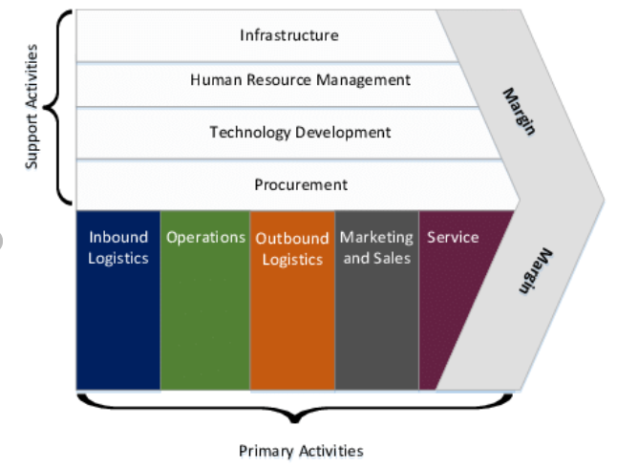
Figure 8: Porter’s Value Chain
(Source: Berntzen and Krumova, 2017)
Hyatt has a deep commitment to corporate sustainability embodied in the World of Care policy which addresses the issues of environmental protection, social inclusion of minorities, and support of community members. Hyatt’s emission reduction target of a 27.5% reduction by 2030 has been approved by the Science-Based Targets Initiative (SBTi) (Hyatt, 2021). The achievement of this strategic goal is in line with the Stakeholder Theory that underscores an organisation’s success in meeting the needs of all stakeholders such as employees, community and environment. It is to their advantage since it targets clients who are concerned with environmental impacts and helps them build a strong reputation for their company (Serafeim, 2020). This makes them a responsible organisation, thus creating corporate value.
By satisfying the interests of multiple stakeholders and considering industry tendencies, Hyatt enhances the company’s position in the market and creates the prerequisites for long-term development as the key player in the rather volatile sphere of the hospitality industry.

Conclusion
In conclusion, Hyatt Hotels Corporation has an effective strategic direction by expanding more brands, technology optimisation, and organisational commitment to sustainable development. The company’s flexible and well-developed, people-oriented culture ensures uniformity of guest experiences and compliance with the objectives in the field of growth. Moreover, Hyatt has made recent efforts to adapt to new market needs with the purchase of Apple Leisure Group and upscaling of digital services. Hyatt needs to uphold sustainable strategies and accord adequate attention to its stakeholders as it moves on to establish a more robust brand that will complement the current corporate and customer demand.

Recommendations

Corporate Level

Launch a Green Property Certification for Sustainable Tourism
In line with Hyatt’s sustainability vision, a new initiative could be developed as a ‘Green Hyatt Certification’ for individual Hyatt hotels that wish to conform to environmental standards (Hadi Atmoko et al., 2024). These properties would embrace the use of renewable energy, measures on biodiversity and zero waste. This certification could also open up its own market appeal as a quality mark, attracting environmentally aware tourists and even starting a great story of Hyatt as a pioneer of sustainable luxury travel.

Individual Level

Develop an Exclusive ‘Hyatt Residences’ Membership for Extended Stays
With the current growth of remote work and the “work from home” phenomenon, Hyatt could benefit from the branding of ‘Hyatt Residences’ as a rental program targeting digital nomads and other long-stay guests (Stringam, 2020). These can include modern, fully-fitted apartments with individual working space, special offers for long stays, free health programs and ‘Local Members Only Concierge Services’. This would be useful to cover a more significant part of the expanding population that demands both sophistication and versatility in their additional amenities that are similar to accommodation (Bardukova, 2023).
These recommendations can help Hyatt increase guests’ dedication to the brand, and achieve continuous improvement in the sphere of travelers’ expectations and their ideas of sustainable development.

Create Hyper-Personalised Travel Experiences Using Data Insights
Despite being an established industry player, Hyatt could consider developing a ‘Hyatt Experience Lab’ that harnesses big data to target and enhance guests' experience across markets. With the data from loyalty programs and feedback from customers, Hyatt could provide personalised services like travel, meals, and even morphing the lights and odour of rooms, or the types of amenities in every room when checked in (Bharwani and Mathews, 2021). This would be a unique service since other companies lack this element and would set Hyatt aside from other providers.

References
Andersen, J., 2021. A relational natural-resource-based view on product innovation: The influence of green product innovation and green suppliers on differentiation advantage in small manufacturing firms. Technovation, 104, p.102254.
Aziri, B. and Nedelea, A., 2013. Business strategies in tourism. Ecoforum Journal, 2(1), pp.10-26.
Bardukova, L., 2023. Navigating the Hospitality Horizon: Current Trends and Strategies for Customer Attraction and Retention in the Hotel Industry. Economics and computer science, 2, pp.88-103.
Berntzen, L. and Krumova, M., 2017. Big data from a business perspective. In Information Systems: 14th European, Mediterranean, and Middle Eastern Conference, EMCIS 2017, Coimbra, Portugal, September 7-8, 2017, Proceedings 14 (pp. 119-127). Springer International Publishing.
Bharwani, S. and Mathews, D., 2021. Techno-business strategies for enhancing guest experience in luxury hotels: a managerial perspective. Worldwide Hospitality and Tourism Themes, 13(2), pp.168-185.
Brites, A.M.C., 2023. The impact of KPIs on profits and customer satisfaction in luxury hospitality: The Hyatt Regency Lisbon perspective (Master's thesis).
Demianenko, A., 2022. Improvement of Corporative Sustainability Development Strategy (on the basis of Internship Report at Hyatt Regency Kyiv) (Doctoral dissertation).
Dikken, N., 2020. Designing a digital key for hotel applications (Doctoral dissertation, ETSI_Informatica).
Dissanayake, K. and Rajapakse, B., 2020. Environmental Management Accounting for Corporate Sustainability: A Case from a Sri Lankan Automobile Company. International Journal of Auditing and Accounting Studies, 2(1), pp.41-65.
Dubey, S., Singh, R., Singh, S.P., Mishra, A.H. and Singh, N.V., 2020. A brief study of value chain and supply chain. Agriculture Development and Economic Transformation in Global Scenario, pp.177-183.
El-Said, O.A., Elhoushy, S., Smith, M. and Youssif, M., 2024. Crisis-driven innovation in hospitality: How do international hotel chains innovate to recover from a global crisis?. International Journal of Hospitality Management, 120, p.103758.
Fachada, B.C., 2023. Business adaptive strategies in crisis: the case of Hilton Hotels Worldwide (Doctoral dissertation).
Fuchs, M., 2022. The Management of the Multinational Firm. In International Management: The Process of Internationalization and Market Entry Strategies (pp. 269-326). Berlin, Heidelberg: Springer Berlin Heidelberg.
Giousmpasoglou, C. and Marinakou, E., 2024. The Contemporary Hotel Industry: A People Management Perspective. Springer Nature.
Gomes, M.V.M., 2023. Hyatt Hotels Corporation Equity Research-Implications of the New Industry Outlook (Master's thesis, Universidade NOVA de Lisboa (Portugal)).
Greaves, R., Kricka, L., Gruson, D., Ferrari, M., Martin, H., Loh, T.P., Bernardini, S. and IFCC Emerging Technologies Division, 2023. Toolkit for emerging technologies in laboratory medicine. Clinical Chemistry and Laboratory Medicine (CCLM), 61(12), pp.2102-2114.
Hadi ATMOKO, T.P., IHALAUW, J.J., Novi Adhi NUGRAHA, A.K. and SUGIARTO, A., 2024. Green Human Resources Management Practices at The Green Hotel Business of Hyatt Regency, Yogyakarta (2017-2022). Quality-Access to Success, 25(202).
Harrison, R., Fischer, S., Walpola, R.L., Chauhan, A., Babalola, T., Mears, S. and Le-Dao, H., 2021. Where do models for change management, improvement and implementation meet? A systematic review of the applications of change management models in healthcare. Journal of healthcare leadership, pp.85-108.
Laig, R.B.D. and Abocejo, F.T., 2021. Change management process in a mining company: Kotter’s 8-step change model. Journal of Management, Economics, and Industrial Organization, 5(3), pp.31-50.
Loughran, J., 2020. Stadiums of Status: Civic Development, Race, and the Business of Sports in Atlanta, Georgia, 1966-2019.
Luiten, S.C., 2020. Corporate social responsibility and consumerism: case examples from Hyatt, Scandic and Walt Disney. Worldwide Hospitality and Tourism Themes, 12(5), pp.547-562.
Rauhavirta, M., 2023. How to Support a Change Agent's role execution by Utilizing Behavioral Insights?.
Rubio-Mozos, E., García-Muiña, F.E. and Fuentes-Moraleda, L., 2020. Sustainable strategic management model for hotel companies: A multi-stakeholder proposal to “walk the talk” toward SDGS. Sustainability, 12(20), p.8652.
Sager, D., 2021. Hindrances on the journey to autonomous mining Important considerations for a successful implementation of autonomous operation HWZ University of applied science Zürich. Master Thesis. University of Applied Sciences, Zurich.
Serafeim, G., 2020. Social-impact efforts that create real value. Harvard Business Review, 98(5), pp.38-48.
Stringam, B.B., 2020. A profile of the hospitality industry. Business Expert Press.
Walters, D.W. and Helman, D.A., 2023. Profitability and Productivity. In The Value Chain Network: Unlocking Organizational Excellence through Effective Operating Models (pp. 133-161). Cham: Springer International Publishing.

