Student name: Elza Soares
Student code: 1815430
Programme: BA International Hotel Management
Module Name: Management & Organizational Behavior
Module code: M5X01924
Lecturer: Dr: Olu Adegbite

Assignment Title: Hotel Management Audit

Hilton Hotel

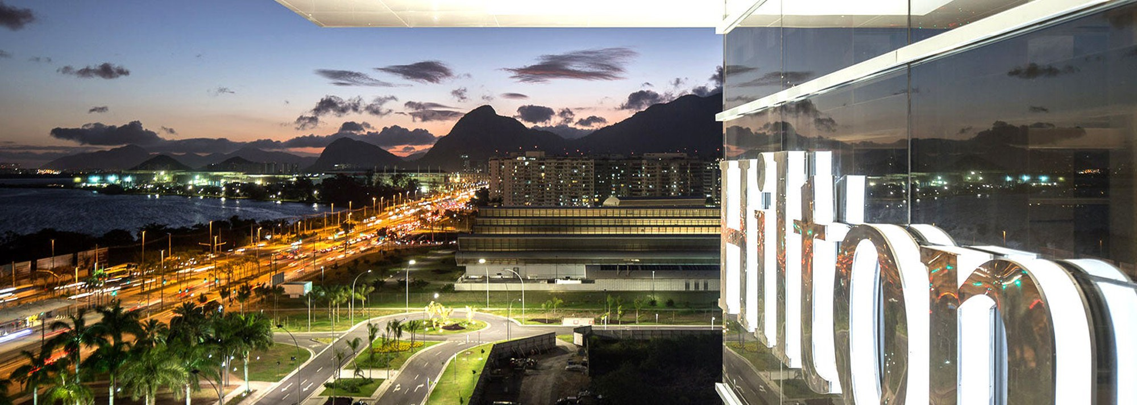

Table of Contents

Introduction 2
Organisation Structure, Culture, and Goals 2
Organisational Structure 2
Organisational Culture 3
Organisation Goals 3
Strategy 4
Employee Satisfaction 4
Impact and Initiative in Hilton Hotel 5
Conclusion 6
Reference List 7

Introduction

The work is designed to provide information about organisational behaviour along with healthy audit function and the critical tool in the hotel industry to verify compliance with company standards, assess any risks to the business and provide verification against fraud and abusive practices.
For a more realistic analysis, the internal audit is fundamental because it is the only way to analyze and control financial risks of all operations.
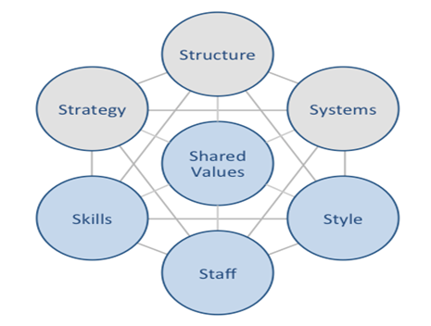
Starbucks McKinsey 7S Model Hilton Hotels Business Strategy and Competitive Advantage. (Dudovskiy, 2016)

Organisation Structure, Culture, and Goals
Organisational Structure
This organization has an organizational management structure, all units are decentralized, the size of decision-making power, finance and accounting functions can be maintained at headquarters.
When the board of directors makes a decision, they pass it on to the general manager, and the general manager requests another department.
The general manager has the responsibility to communicate with other departments and make the final decisions.

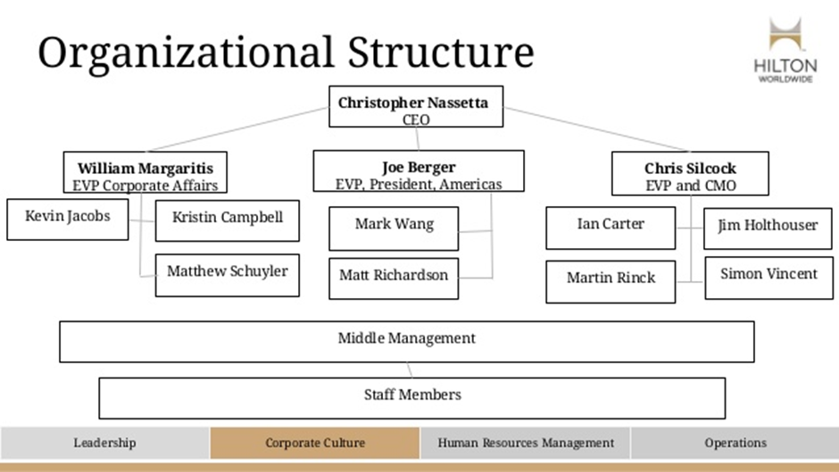
Hilton Strategic Management Presentation (Alex Mutch, 2016)

Organisational culture

Organisational culture is a combination of values, beliefs, work styles and associations that differentiate one company from another. (Kontoghiorghes, 2015)
The corporate culture in all organisations is based primarily on effects that allow researchers to understand how company employees think about their organisation. That also informs researchers about how organisational culture influences employee decisions. (Jung and Yoon, 2015)
Hilton aligns the organization's culture with all employees to standardize the quality of global service. Always greet the guests using the host's local language with a friendly smile, and remember that the guests have confidence in us so it is important to feel at home. Try to understand what the client's demand is and meet their needs.
“We're passionate about delivering exceptional guest experiences.”
Integrity :“Hilton Hotels do the right thing, all the time.”
Leadership “Hilton are leaders in our industry and in our communities.”
Teamwork: “Hilton are team players in everything they do.”
Ownership: “Hilton are the owners of their actions and decisions.”
Now “Hilton are operate with a sense of urgency and discipline.”
‘This organization excels in exclusivity both with the team members and in a more generalized way in order to comply with their daily agenda. (Schuyler, 2020)
Above all, respect everyone, have a diversity included in everything.

A Hilton is one of the best companies they invest a lot in their culture of inclusion, create many initiatives to expand diversity, culture, and an organization for everyone
• Recruitment and scholarships that support diversity and economically disadvantaged
• Hiring at a non-college level and promotion
• Accommodation of employees with physical or cognitive impairment

Organisation Goals
In short, the group needs to be or as it requires the human being in which it operates to be a vision of the universal. It is a continuous vision and focuses on perspectives. It can be sensitive and is an incentive starting point.
In the Hilton group, top management is responsible for the situation, the extended time and the short-term goals. The board of directors, the area managers of all operational managers in the area, are primarily responsible for setting the goals. Some external audiences, such as financial advisers, researchers, and media personalities, are also anxious about the decision-making process.
In this organisation, every separation has a blue copy of the management plan process. The operational managers in each sector manage the planning process.
Have a global human rights approach to global operations, end forced labour by creating partnerships with networks within territories
They know the risk that traffickers can have when using their hotels, and commercial sexual exploitation and that is why they are making efforts so that this does not happen, they are better reinforcing their team, making this type of training mandatory. Members can report an anomaly.

Strategy
The high-quality service and the motto of the Hilton chains, a cutting edge technology always within the events, bet on the total mastery of the experience in all sectors have internal training to always be on the front line thus winning the loyalty of the customers.
They try to be always in front of events so they can surprise their customers
Hilton uses an aggressive international business strategy and differentiation of services and quality. This is because, in order to maintain its business strategy, Hilton must regularly engage in significant financial investments, despite the revenue volatility caused by the seasonal and cyclical nature of the business and several other factors.
Employee Satisfaction
Job satisfaction seems to be a fascinating subject about the organisation's organisational behaviour.
Job satisfaction is an analysis of the individual's level of assessment of how the work environment meets their demands. (Taneja, Sewell and Odom, 2015)
Some organisational cultures seem to be more welcoming than others, and this is an intriguing study that needs answers.
Organisational culture is a common set of values ​​and standards expressed within an organisation by individuals and groups. For them, the company culture governs how workers communicate with each other and with non-organisation stakeholders. (Jun and Lee, 2016)
The Hilton Hotels are in the business of people serving people, and they invest in their Team Members to ensure their continued success.
All team members at Hilton hotels deserve a path of development that allows them to thrive, a great career, a great leader. Hotels offer a variety of tools and resources to help employees develop personally and professionally: Hilton University, CultureWizard mobile applications, LinkedIn Learning.
The Hilton team believes in its leaders, thus committing itself to the development in the leadership of the team, giving the possibility that everyone can grow within the company from being a leader in the primary level to the junior executive, they have several programs created with one of the best universities Havard in the world, so it helps your teams achieve the best within their goals in career development.
Impact and Initiative in Hilton Hotel
2019
In the past 100 years, a Hilton has had a tremendous positive impact on billions of lives around the world, "said Hilton CEO Christopher J. Nassetta. While looking to the future, we will continue to prioritise sustainable and inclusive growth, which will allow us to strengthen further the collective impact we have on the people and communities we serve.

2020
The Hilton Hotel has suffered devastating impacts due to the pandemic, which reduced the demand for travel and accommodation away from home to almost zero during March and April, while people stayed at home to prevent the virus from spreading.
Hilton Hotel CEO Christopher J. Nassetta said that to protect the business, it was necessary to cut about 22% of employees worldwide. It was a difficult decision, never seen in Hilton's 101-year history.
Affected corporate employees will receive a severance package and a guarantee that they will be hired again after the pandemic. Hilton has always had a culture of support for its team members, added Nassetta.
With the reopening, it will have to face new realities, implementation of social distance, more magnificent sanitation guidelines, temperature checks, according to a set of guidelines recently established by the Travel Association (AHLA).
Contactless payment methods, greater physical distance in the hotel and restaurant areas and room is cleaning only at the request of a guest.
Hilton Clean Stay has partnered with one of the largest companies with knowledge and research on the global pandemic. To keep its customers confident in their hotels, this company exclusively supplies hygiene products at the hospital level. For this reason, they intensively train their employees and, in some cases, rely on the help of infrared to detect possible infected sites.
- Extra disinfection of the top 10 high-touch areas in the rooms, including light switches and door, handles
- Higher frequency of cleaning public areas
- Disinfectant wipes accessible to visitors at entrances and high traffic areas
- Reduced paper services (such as pillows and guest directories) in rooms
- Enhanced cleaning and other changes to buffets, dining and meeting rooms
- Industry-leading contactless check-in and check-out with Digital Key at more than 4,700 properties worldwide
- Evaluation of new technologies such as electrostatic sprayers with disinfectant mist and ultraviolet light to clean surfaces and objects
- Improved safety and well-being of team members with personal protective equipment and improved training and protocols. (Hilton Press Center, 2020)

Environmental Impact
Even with the pandemic, Hilton is knowing how to turn the situation around in a positive way, withdrew its guidelines for 2020 by increasing its stock buyback plan
Already with a plan of action to examine each of these measures in more detail, as well as what a well-known hedge fund manager, said about Hilton.
Hilton Hotels acknowledge their critical responsibility to protect our planet and to preserve the beautiful destinations in which they work for future generations. Since 2009, they have been using LightStay's own award-winning corporate responsibility management system to measure, report and improve their environmental impact in their global portfolio of managed and franchised hotels. They are proud to be a leader in the fight against climate change, as the first major hotel company to launch science-based greenhouse gas reduction targets under the Paris Agreement. They are also taking significant steps to reduce waste throughout their portfolio, to improve water management and to implement sustainability initiatives throughout the supply chain.

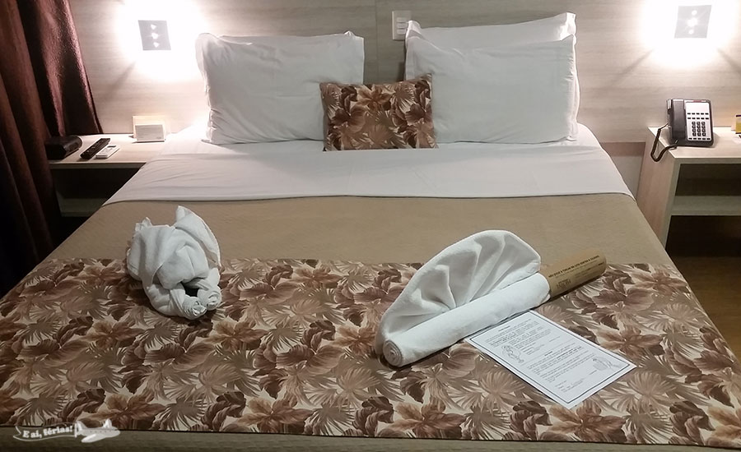

Conclusion
This work was very important for my knowledge, understanding and deepening of the theme "Audit Hotel", which allowed to know better and develop in a positive way.
Based on the search results, I can recommend some improvements:
Create a flashy environment to attract the public, fun to bring energy to musical attractions, bar, restaurant with quality and variety of drinks and typical foods, focus on transmitting part of the art, culture and tradition services, to memorable experiences and positive local emotions. Have themed rooms,
The Hotel's address in the local language in the key so guest can get help if get lost.
Partner with local taxis to give your guests more confidence.
Use Whatsapp with local tourist information to the customer during their stay or send them the taxi, restaurants, clubs, bus.

Reference list
Alex Mutch (2016). Hilton Strategic Management Presentation. [online] Available at: https://www.slideshare.net/AlexMutch1/hilton-strategic-management-presentation.
‌Corporatereport.com. (2018). Hilton 2018 Annual Report. [online] Available at: http://www.corporatereport.com/hilton/2018/ar/performance.php.
Dudovskiy, J. (2016). Hilton McKinsey 7S Model. [online] Research-Methodology. Available at: https://research-methodology.net/hilton-mckinsey-7s-model/.
Dudovskiy, J. (2020). Strategy Archives - Page 6 of 11. [online] Research-Methodology. Available at: https://research-methodology.net/category/strategy/page/6/.
Hilton Press Center. (n.d.). Hilton Update on Corporate Response to COVID-19. [online] Available at: https://newsroom.hilton.com/corporate/news/hilton-update-on-corporate-response-to-covid19.
‌Jun, W.-H. and Lee, K.-L. (2016). The Effects of Nursing Professionalism and Gratitude Disposition on the Happiness in Senior Nursing Students. Journal of Korean Public Health Nursing, 30(3), pp.434–444.
Jung, H.S. and Yoon, H.H. (2015). The impact of employees’ positive psychological capital on job satisfaction and organizational citizenship behaviors in the hotel. International Journal of Contemporary Hospitality Management, 27(6), pp.1135–1156.
Kontoghiorghes, C. (2015). Linking high performance organizational culture and talent management: satisfaction/motivation and organizational commitment as mediators. The International Journal of Human Resource Management, 27(16), pp.1833–1853.
Research-Methodology. (2016). Hilton Worldwide Holdings Inc. Report - Research-Methodology. [online] Available at: https://research-methodology.net/hilton-worldwide-holdings-inc-report-4/.
Reuters (2020). Covid-19: Hilton to cut workforce by 22%, sack 2,100 employees globally. Business Standard India. [online] 17 Jun. Available at: https://www.business-standard.com/article/companies/covid-19-hilton-to-cut-workforce-by-22-sack-2-100-employees-globally-120061700026_1.html [Accessed 22 Jul. 2020].
Revenue Hub. (2019). Hilton Advance: Marketing Strategy and Fee Changes. [online] Available at: https://revenue-hub.com/hilton-advance-marketing-strategy-fee-changes/.
Schuyler, M. (n.d.). DIVERSITY AND INCLUSION. [online] Available at: https://cr.hilton.com/wp-content/uploads/2020/04/Hilton-Diversity-and-Inclusion.pdf [Accessed 22 Jul. 2020].
‌Taneja, S., Sewell, S.S. and Odom, R.Y. (2015). A culture of employee engagement: a strategic perspective for global managers. Journal of Business Strategy, 36(3), pp.46–56.

‌

