Contemporary Challenges Component 1

Blog Post 1
The world as we know it is far from perfect. Unchecked industrial growth is steadily wiping out natural habitats and the species that call them home, climate change continues to ravage the places we try to leave untouched – the Arctic and Great Barrier Reef, to name a few – and human society is divided by hatred, discrimination and greed. At the root of all of these issues is mankind itself: We have evolved, adapted and developed enough to conquer the planet and, in doing so, we have disrupted the balance of the global ecosystem. However, despite our best efforts to rise above nature, we are still reliant on it for our survival, and so the consequences of our actions affect us as much as any other creature. We are plagued by a veritable smorgasbord of immediate problems, but which is the most pressing? What can be said to be the greatest threat to the human race in this day and age?
To answer this, we must first establish the nature of the problems themselves. First, there’s the environmental issues, including climate change, habitat destruction and the extinction crisis. With fossil fuels powering the majority of modern technology, over 34 billion tonnes of carbon dioxide are being released into the atmosphere every year (Richie and Roser, 2021), causing drastic changes to the planet’s natural climate.
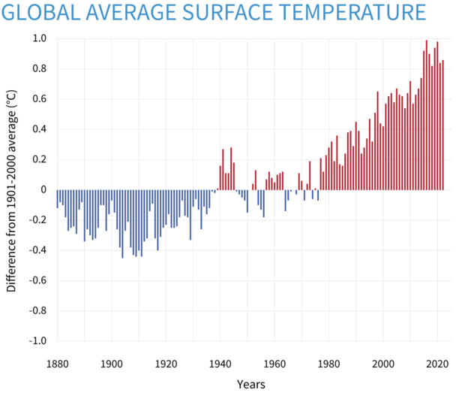
Fig 1. Rise in global average surface temperature, 1880-2020 (Lindsey and Dahlman, 2023).

As shown here, global temperatures have risen dramatically over the past 100 years, with the greatest change occurring over just the last 40. This has resulted in the north and south ice caps melting to a greater extent and for longer periods, coral reefs being bleached, wildfires breaking out in dry forests, acidification of the oceans from excessive carbon diffusion and many more detrimental effects to the world’s natural habitats. When you combine that with active habitat destruction through the expansion of industrial and agricultural sites, Earth’s biodiversity is dropping fast, and extinction rates are estimated to be between 1,000 and 10,000 times higher than they should be (Lamm, 2021).
While not as catastrophic as environmental destruction, the social dilemmas facing mankind are equally pressing given their consequences. Racism, sexism, homophobia, transphobia, religious discrimination and more are rampant among the vast majority of countries, with governments generally doing little to solve them. In worse cases, such beliefs are being actively promoted, such as the political turmoil currently facing the USA: A wave of anti-LGBTQ+ bills and legislations have been proposed or passed in Republican states to such a degree that the event has been referred to as an attempted genocide of LGBTQ+ – particularly transgender – people (Goudie, 2023). As well as cultural division and bigotry, portrayals of ideal bodies and lifestyles in the media set standards that are largely unreachable for the average person, resulting in feelings of inadequacy and worthlessness. Cases of depression worldwide have risen by nearly 50% since 1990 (Liu et al., 2020) – no doubt a consequence of the development of the internet, allowing everyone everywhere to see just how much better their life could be at all times.
With all this knowledge in mind, I believe the greatest threat to humanity is humanity itself. We not only cause the most pressing concerns facing our species, our society is built on their perpetuation, with advancements in clean energy, environmentalism and social acceptance being shut down by the systems that directly benefit from the problems said advancements seek to eliminate. We are our own worst enemy, and while experts across the planet are working to find solutions, things will never truly change until we address the rotten foundations upon which our global dominion is built.

Blog Post 2
As an aspiring actor, there are many factors I need to consider if I want to be successful in the future: availability of work opportunities, logistics of travelling to and from auditions – and rehearsals, if I were to get any roles – time management regarding the side-job I’d no doubt get for a more consistent income, the list goes on. At my current stage, though, there is a much more pressing matter I need to think about: my skillset. As with any other profession, acting requires a specific range of skills, but arguably the most important ones don’t have anything to do with the act of acting itself. In my opinion, the most crucial skills an actor can have are those related to communication and cooperation with fellow professionals.
For someone who’s just starting out in the industry, knowing your worth is invaluable. Unless you’re incredibly successful and famous, acting isn’t easy to make a living off of, due in part to the inconsistent nature of the work. In fact, a survey in 2018 found that 63% of entertainment professionals earn less than £5,000 a year, with only 13% earning more than £20,000 (Wooding, 2018). It’s unlikely I’ll join that 13% and, in a field as cutthroat as the performing arts, it’s important that I know the value of my work and what I deserve to get paid for it. That leads into the next crucial skill: communication. Acting is an inherently cooperative profession, as you need to be on the same page as everyone involved with the production. You also need the confidence to speak up about any issues you face, including if you feel your work isn’t being valued appropriately. Being able to negotiate to get the compensation you deserve is crucial to success in this field.
Misunderstanding, misinterpretation and failure to express grievances or difficulties affect the work of and, in some cases, threaten the safety of the cast and crew. To give an extreme example, Harrison Ford was injured on the set of Star Wars: The Force Awakens after a prop door on the Millennium Falcon set was closed while he was in its way, with the crew member responsible having mistakenly believed they were in full rehearsal – in reality, the cameras were not rolling, and Ford hadn’t been told not to stand under the door as it shut. Not only did this result in Ford being seriously injured and production being halted, but the production company responsible for the unsafe conditions that led to the incident were fined £1.6 million (Applebey, 2016). This is definitely a more dire example, but it shows just how important good communication skills can be.
Above all else, though, I believe the most vital skill an actor can have is their adaptability. No two jobs are the same in the performing arts, with each one bringing a new character, new co-stars and a new director trying to realise their own ideas. With this in mind, no trait is more desirable in an actor than the ability to adapt to their circumstances and accept new ways of going about their craft. If the director makes a change to a line, scene or the blocking, being able to tackle that change head on and run with it without complaints makes you much easier and more pleasant to work with, as it minimises conflict and makes sure your colleagues don’t have extra work on their hands.
Of course, don’t take my word as gospel, these are just the skills I believe will be the most important for me. Acting is an incredibly varied profession, of course, and every actor has their own methods and approach to the craft. At the end of the day, the freedom to make my own decisions on how I work and what I value about my skillset is part of the reason I enjoy acting so much.

Blog Post 3
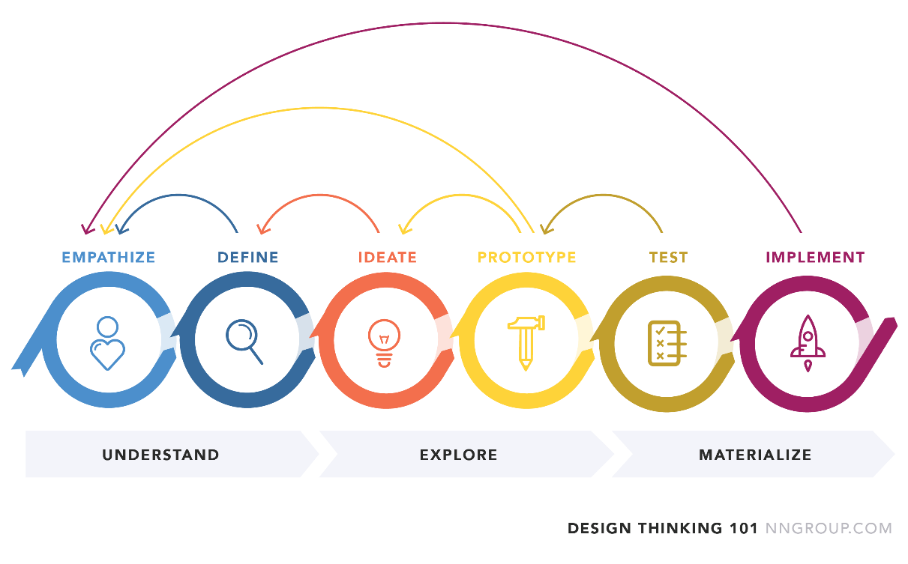
Fig 1. Outline of design thinking process (Gibbons, 2016).
This is design thinking: a hands-on, user-centric approach to problem solving intended to lead to greater innovation. As the diagram shows, it is comprised of six phases and encourages backtracking to previous phases to validate the integrity and merit of one’s ideas, ensuring a consistent vision throughout the process. It is a valuable tool in fields that involve conceptualising and executing solutions to identified problems, but rather than focusing on its application to more conventional design-centred areas of study, I want to see how effective it is when used in one I’m more familiar with: acting. Working in the performing arts presents many problems that an actor must be able to overcome, so how might you make use of design thinking to do so, if at all?
To start with, let’s look at the supposed benefits of design thinking. Arguably the most relevant is its promotion of creativity: once you have identified, defined and understood the issue you’re trying to solve, you are encouraged to experiment with a wide variety of potential solutions to see which works best. If, as an actor, you were trying to nail the delivery of a certain line, you could use design thinking to come up with a variety of different deliveries and test each of them until you land on one that you – and the director, if there is one – like. Another noteworthy benefit is that the process encourages iteration: repeating the creative process to make your end solution as rock-solid as it can be. In acting, it’s important not to get attached to any one idea, as creative decisions are always liable to change. Anacting choice you made when first reading the script could end up not working as well as you’d imagine during rehearsals, and you have to be willing to let it go to try something else. Design thinking doesn’t just promote that ideology, it is fundamentally built on it. (What is Design Thinking?, 2023)

However, the overall structure of the process renders it largely non-applicable to the work of an actor, for one key reason: design thinking is heavily user-centric, meaning it is based on input and research gathered from the end user. While this works well for designing a product, it doesn’t fit with a theatre or film production, as focus groups and target markets typically aren’t directly consulted for those. An actor will rarely be involved with the marketing process, and so objective data and the intended audience aren’t aspects they’re expected to worry about. Much of the design thinking process is focused on testing your solutions with the end user and the audience of a production simply cannot be involved with the creative process up until long after the actors’ involvement has ended (Tsoi, 2021).
Overall, while the mindset and philosophy that guide design thinking definitely have merit for an actor, the model itself just isn’t tailored for an actor’s work. It focuses heavily on the creation of goods and services with extensive involvement from the end user throughout the process, which is fundamentally different from the creative process used in dramatic productions. In order to make use of the genuinely beneficial aspects of design thinking, an actor must separate them from the model as a whole, at which point it can’t be said that they’re even using design thinking anymore.

Sources

Blog Post 1
Goudie, E. (2023) Hundreds protest trans genocide in Transgender Day of Resistance March. Available at: https://huntnewsnu.com/71052/city-pulse/hundreds-protest-trans-genocide-in-transgender-day-of-resistance-march/ (Accessed: 24 April 2023)
Lamm, B. (2021) How the sixth extinction crisis can be stalled – or even stopped. Available at: https://www.weforum.org/agenda/2023/02/how-to-stop-sixth-extinction-crisis/ (Accessed: 24 April 2023)
Lindsay, R & Dahlman, L. (2023) Climate Change: Global Temperature. Available at: https://www.climate.gov/news-features/understanding-climate/climate-change-global-temperature (Accessed: 24 April 2023)
Liu, Q, He, H, Yang, J, Feng, X, Zhao, F, Lyu, J 2020, ‘Changes in the global burden of depression from 1990 to 2017: Findings from the Global Burden of Disease study’, Journal of Psychiatric Research, vol. 126, pp. 134-140.
Richie, H & Roser, M. (2021) CO₂ Emissions. Available at: https://ourworldindata.org/co2-emissions (Accessed: 24 April 2023)

Blog Post 2
Applebey, L. (2016) Star Wars film maker fined £1.6 million for injuring Harrison Ford. Available at: https://www.shponline.co.uk/in-court/star-wars-film-maker-fined-1-6-million-injuring-harrison-ford/ (Accessed: 25 April 2023)
Wooding, A. (2018) EXCLUSIVE: 63% of entertainment professionals earn less than £5,000 per year. Available at: https://www.mandy.com/aa/news/entertainment-industry-pay-report (Accessed: 25 April 2023)

Blog Post 3
Gibbons, S. (2016) Design Thinking 101. Available at: https://www.nngroup.com/articles/design-thinking/ (Accessed: 25 April 2023)
Tsoi, J. (2021) What are the flaws of Design Thinking? Available at: https://uxdesign.cc/what-are-the-flaws-of-design-thinking-83e22213232a (Accessed: 25 April 2023)
What is Design Thinking? (2023) Available at: https://intellipaat.com/blog/what-is-design-thinking/#no6 (Accessed: 25 April 2023)

Link to Blog Site
https://blog26853.wordpress.com/

