

Autism spectrum disorder
(Practitioners guide)

Contents:
Contents - page 2
Introduction – 3
Meeting the childs needs – 4-6
Case studies – 7-9
Effective practice –
Reference list –
Bibliography –

Introduction:
This is a practitioners guide that aims to support and assist individuals that work with children by furthering their knowledge and understanding of autism spectrum disorder to create an inclusive learning environment. There will be an explanation of the barriers that the children face and strategies that will help the child through their struggles. Throughout the guide it will relate to policies, legislation and theorists.
“Autism spectrum disorder is a neurological and developmental disorder that affects how people interact with others, communicate, learn, and behave” (national institute of mental health, ND)
This quote shows exactly how difficult education is for children with autism spectrum disorder. The importance of learning in education is paramount and it says that the way the child learns is affected. Interaction, communication and behaviour is also needed for education to be successful.
Autism spectrum disorder is a disorder that effects a person at any age and can show different symptoms and different stages of their life therefore it varies when a person will get a diagnosis. It is important to remember that children with autism spectrum disorder find it difficult to controle themselves in regards to behaviour therefore it is crucial that you help and do not judge

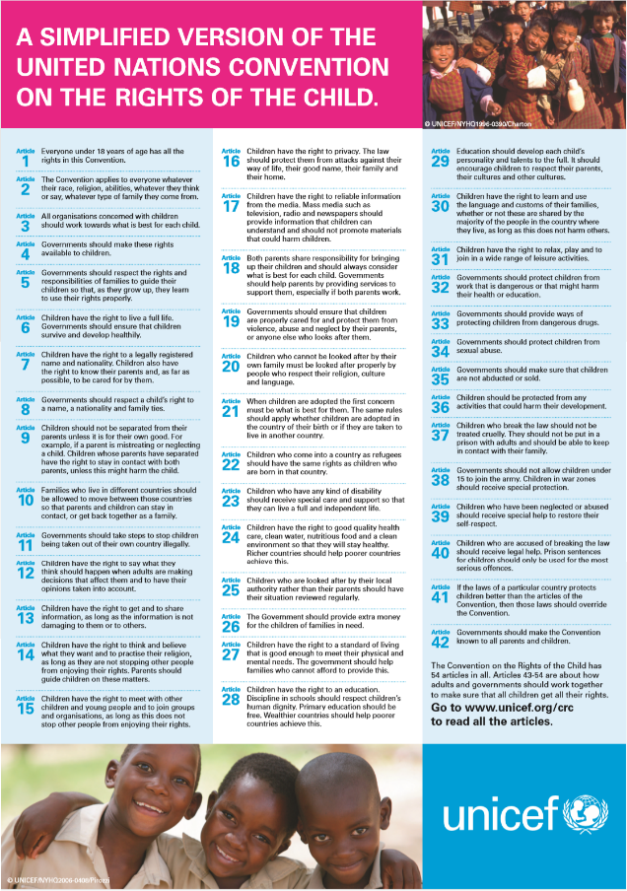
Meeting the childs needs:
- “children who have any kind of disability should receive special care and support so that they can live a full and independent life”
- “children have the right to a standard of living that is good enough to meet their physical and mental needs”
- “ children have the right to an education. Discipline in schools should respect the children’s human dignity.”
(unicef, ND)
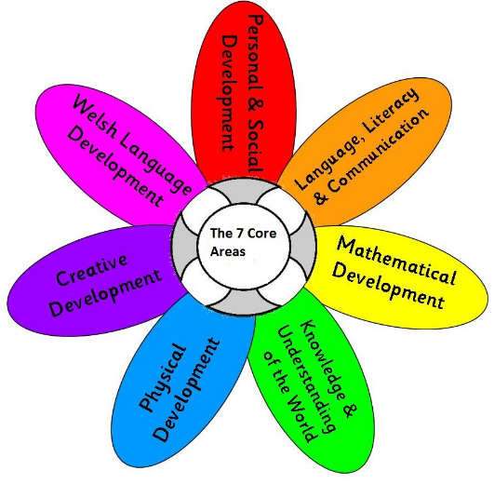
These are just three examples written by United Nations Convention on the Rights of the Child (uncrc) that relate to children with autism spectrum disorder. In order to achieve the fist one there should be different strategies and staff shouldbe more open minded. It would beneficial for staff to go on training to further their knowledge on how to reach the standard. Environment is important to children with autism spectrum disorder therefore the second point can be achieved through assuring that that classroom is appropriate and can provide for the childs needs for example distractions, sensory items and calming resources. Children with asd have difficulty controlling their behaviour therefore it is important to respond appropriately and consider point three so that the child doesn’t feel uncomfortable and have attention drawn to something that is uncontrollable. A practitioner should understand the child and how to communicate on their level using classroom resources as a tool for engagement.
The curriculum for wales is legislation that is set to assure that the needs of the child is being met to a high standard and is a guidance for the best outcome. It discusses the seven core aims, these are the areas that as a practitioner should be considered whilst working with children to help them constantly develop. It has been said that they have difficulty with communication so immediately one of these aspects are a barrier but this then proceeds to effect the social development too. The difficulty to learn is a barrier for every one of these areas due to needing to learn new things being the focus in developing these areas. The difficulty to monitor their behaviour also effects all of the areas as the behaviour is connected to focusing and their attitude towards learning and developing. Lacking in one of these areas will make it more difficult to achieve in the others for any child especially children who already face multiple barriers achieving these.
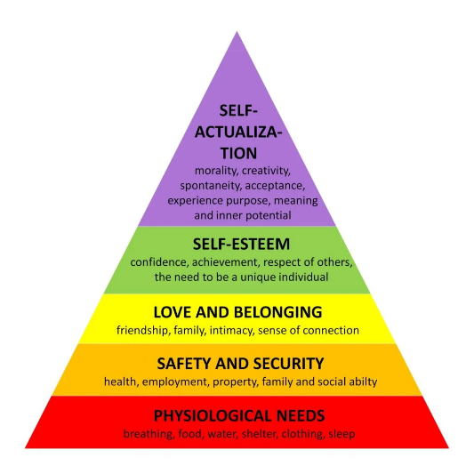
One group of people protected under The equality act 2010 is people with disabilities this covers people with autism spectrum disorder. This act protects them against discrimination. It discusses the way education is provided to children with disabilities to ensure that the correct facilities and resources are provided so that the child can have the same learning opportunities and education level as every other pupil. “A duty to make reasonable adjustments applies to the responsible body of such a school” (equality act 2010) states that this standard needs to be met. As well as the uncrc it also addresses the punishments provided being appropriate and considerate of the childs disability to support equality and inclution. Autism act 2009 is “An Act to make provision about meeting the needs of adults with autistic spectrum conditions” (autism act 2009)this also connects to children to put pressure on understanding the disorder and adapting to their needs. This esures that the guidance provided to practitioners is reviewed frequently and training is as recent as possible. This guarantees the best possible knowledge and assistance for the child. The safeguarding vulnerable groups act 2006 works with the equality act in regards to the safety of the child and to avoid any discrimination against the child. It protects the child and is similar to some of the childrens rights created by the uncrc. It not only makes sure that the practitioner has the childs best interest but also that they assess and monitor that others around them also have their best interest. Children with autism spectrum disorder are classed as a vulnerable group not only because of their age but also the barriers they face with the disorder for example communication. Maslow hierarchy of needs have barriers for a child with autism specrum disorder on every level “physiological needs” with their sensory issues. “Safety and security” and “love and belonging” when they struggle to build relationships, “self-esteem” when they understand the effect their autism has on themselves and “self-actualization”when they struggle with their self-esteem.

Case studies:
These case studies will demonstrate the struggles and support children with autism spectrum disorder need. There will be two case studies to compare and contrast.
Alex aged four
Alex’s prescool treacher noticed that alex found social ineractions difficult so decided to asses him that lead to a diagnosis at age three. Alex had an excellent vocabulary however was not able to achieve a back and forth conversation. Alex struggled to roleplay with other children however was often roleplaying trains by himself. There was an issue with different textures and loud noises for alex and would often show discomfort. The intervention put in place focused on these things providing training for his social skills and sensory therapy. The outcome for this after only six months showed progress in his social play such as turn taking and he would occasionally initiate interactions.
The inability to maintain back and forth conversations effects bonds and relationships Alex should be creating with not only his classmates but also his teachers, parents and agencies that would support him. People can find it difficult to provide support to someone that is unable to communicate their thoughts efficiently. There can be cases of miscommunication where there will not be the correct support the child is looking for. It can be frustrating for the child to feel like nobody understands them and be unable to communicate efficiently in their own way this can lead to effecting their mental health in the future and they may not have the confidence to even attempt conversations with people. Role play is an humongous part of a childs play in the early years it is included in a large amount of areas in a foundation phase classroom and is also sometimes a part of their work. Having this inability limits their options. Role play is a form of helping development too such as understanding of the world in roleplay areas therefore they may not develop their knowledge as fast if they cant learn from their peers.
There are constantly different textures that occur throughout the day in a school which can make a child uncomfortable and frustrated. All the play areas in the classroom with have different textures for example water, foam bricks or chalk if the child feels discomfort from some of these things that can also limit their play and they will not be provided with the same opportunities as others. They might not enjoy the texture of the food that day this effects their ability to eat which is a right of theirs. It could even be something as little as the feeling of the carpet that they find it hard to walk on as its too scratchy. The scent of a perfume may be a distraction to the child or the cleaner they use to wipe the table. These are all things a child with autism spectrum disorder will react to. It is out of control the noises that are surrounding things like a clock can frustrate a child with asd or the cars outside this is because a child with autism spectrum disorder is likely to be more sensitive to noise therefore loud noises can be worse for them and cause physical pain.
Harrison aged two
When Harrison started preschool he was completely nonverbal and was expected to not ever have the ability to talk. This made it nearly impossible for him to communicate with his peeres. This is a barrier for a child not being able to communicate their feelings and needs means that they might be struggling and not being able to ask for help. This will also have an effect on their physical health and also mental health as it will be extremely frustrating comparing how easy it is for others and being unable to do something as easy as communicate, he needs a drink. Due to not being able to talk he also will have difficulty interacting and socialising with other children this will also have an effect on his mental health when not having any friends. It will not only affect his social development but also other areas of his development as he will not have the same play experience as other children to help him physically and cognitive development for example with the problem solving aspect of role play. This could affect his relationships as people may find it hard to bond with a child they have no interaction with. People may find it difficult to make effort with a child that cannot reciprocate the effort. Fortunately his setting discovered that a Visual timetable that helped him and provided PECs support for his parents for consistency not to confuse the child and achieve the best outcome. After this Harrison started to talk and develop more vocabulary with time. Harrison has developed coping mechanisms now he has the ability to communicate as he can portray his struggles much more clear and has a better understanding when peers are trying to help. It would be beneficial for Harrison to partake in a strategy called bucket time where he would learn more about taking turns and patience. It is important for Harrison’s new setting to also use visual boards and PECs for the transition to go more smooth and something familiar for Harrison to use.

Effective practice
Attention Autism Bucket Time
Bucket time was designed to use visual activities that children find exiting to encourage engagement and communication through making it a fun game. The aim of this strategy according to centre for autism Middletown is
“1. To engage attention
2. To improve joint attention
3. To develop shared enjoyment in group activities
4. To increase attention in adult-led activities
5. To encourage spontaneous interaction in a natural group setting
6. To increase non-verbal and verbal communication
7. To build a wealth and depth of vocabulary
8. To have fun!”
Attention autism is set in four different stages that need to be followed, and a child must not to move on to the next step if they can not complete the current step successfully. The child may not even be ready to complete the full stage and may need to be eased in gradually. It may take a long time to achieve all steps however it is important not to rush the process and go at the child’s pace
stage one is called the “attention grabber” you must use something thrilling to receive the childs attention for example bubbles whilst singing the selected song they will associate with bucket time. On a whiteboard they will visually see the three activities they will experience that day. After singing the bucket song each time the practitioner will pull out a new toy for them to experience however, they are not aloud to touch the items. This is teaching them patience whilst also stimulating their brain and holding their attention.
Step two is called the attention builder this is where the activities become more engaging and will gradually involve longer participation. This typically involves something more messy as its more likely to maintain the child’s attention and they will be eager to have a turn. Everybody has a turn during this step so they need to learn to sit patiently as this is very difficult for some children with autism due to the dopamine rush they will achieve.
Step three is the turn taking stage is for smaller groups and must be done daily for them to completely understand. This is the stage developed from stage two however this time not all children get a turn this encourages communication as the child will express their feeling of this. the practitioner must make sure that the child that doesn’t geta turn goes first the next day this will tech them patience and that with time they will receive their opportunity.
Stage four focuses of shifting and re-engaging attention where the child will observe a simple task being completed then will receive the resources to do it independently in their own area. The children will then regather and show their complete activity to the group. This encourages independence and the child will need to stay focused to regather rather than getting distracted is something nearby.
Sensology
Sensology is an activity that stimulates the senses which is thrilling for children with autism spectrum disorder as many of them have sensory hypersensitivity. It is important for children to understand their senses, what they are feeling and what they enjoy. It also helps the child control their senses and focus on one thing at a time. The activities should be fun for the child to enjoy the sensory activity. To introduce the activity there should be a sensory related song that the child can associate with it and start with a simple activity that is to do with an activity but doesn’t entail much focus for example spraying water as they feel it but do not need to focus. The practitioner will then say the phrase ‘Mirror, Mirror on the wall, who can sense the best of all’? the chosen child will then refer to the body part they they are using during that activity and explain their experience. Theis is giving them a better understanding of their sensory needs. They will learn what they enjoy and what is too much for their senses. This will develop their independence and they will be less likely to search for that sensory thrill from something else. Similar to bucket time the it is important to ease the child into the activity starting with only one sense and eventually achieving all five. There should be a calming activity at the end with a relevant song so that the child is not too exited and can then focus after the sctivity is over.
Sesory circuits
Sensory circuits are usually done at the start of the day to help stimulate the childs brain to help them focus from the start of the day. The activities should be fun for the child to enjoy buy also enquire thinking to help the brain focus. Movement for the child to be more active from the start of the day and also calming so that they are not too exited and will be able to partake in activities.

Reference list:
National Institute of Mental Health, ND. Autism spectrum disorder (ASD). National Institutes of Health. Available at: https://www.nimh.nih.gov/health/topics/autism-spectrum-disorders-asd (Accessed 20 January 2025).
Sista Library, ND. A simplified version of the United Nations Convention on the Rights of the Child. Available at: https://www.sistalibrary.com.vu/a-simplified-version-of-the-united-nations-convention-on-the-rights-of-the-child/ (Accessed 20 January 2025).
Legislation.gov.uk, 2010. Equality Act 2010, Section 85. Available at: https://www.legislation.gov.uk/ukpga/2010/15/section/85 (Accessed 20 January 2025)
Legislation.gove.uk,2009. Autism Act 2009, section 3. Available at: https://www.legislation.gov.uk/ukpga/2009/15/section/3 (Accessed: 20 January 2025).
Neurolaunch, ND. Autism case study, Available at: https://neurolaunch.com/autism-case-study/ (Accessed: 20 January 2025).
Simply Psychology, ND. Maslow's hierarchy of needs, Simply Psychology, Available at: https://www.simplypsychology.org/maslow.html (Accessed 27 Jan. 2025)
Autism Early Support, 2021. Case studies. Available at: https://autismearlysupport.org.uk/wp-content/uploads/2021/02/Case-Studies.pdf (Accessed 27 Jan. 2025)
https://mail.google.com/mail/u/0?ui=2&ik=a5ddd432f5&attid=0.1&permmsgid=msg-f:1821498166261631316&th=194742ee770cc954&view=att&zw&disp=inline
http://best-practice.middletownautism.com/approaches-of-
intervention/attention-autism/
https://mail.google.com/mail/u/0?ui=2&ik=a5ddd432f5&attid=0.1&permmsgid=msg-f:1821498217112352821&th=194742fa4dfd3835&view=att&zw&disp=safe

Bibliography:
http://artpictures.club/view.php?img=https://media.istockphoto.com/id/1065019564/vector/borders-of-colorful-jigsaw-puzzle-pieces-frame-of-colorful-puzz.jpg?s=612x612&w=0&k=20&c=pQjpeMl1ZMx2m6m_h6Oevq0VXbEcIO_1EYgNdFi8FVE=

laura’s journal, April 2023, ‘the foundation phase’ available at Laura's Journal: The Foundation Phase (accessed 20 january 2025)
Safeguarding Vulnerable Groups Act 2006

