The Role of Circular Economy, the Public and Third Sector in Welsh Wellbeing – Rationale, Staff Survey & Analysis

- Rationale for studying the Wellbeing of Future Generations Act (Wales) 2015 and the Five Ways of Working (FWW) in relation to Waste and Professional Development.
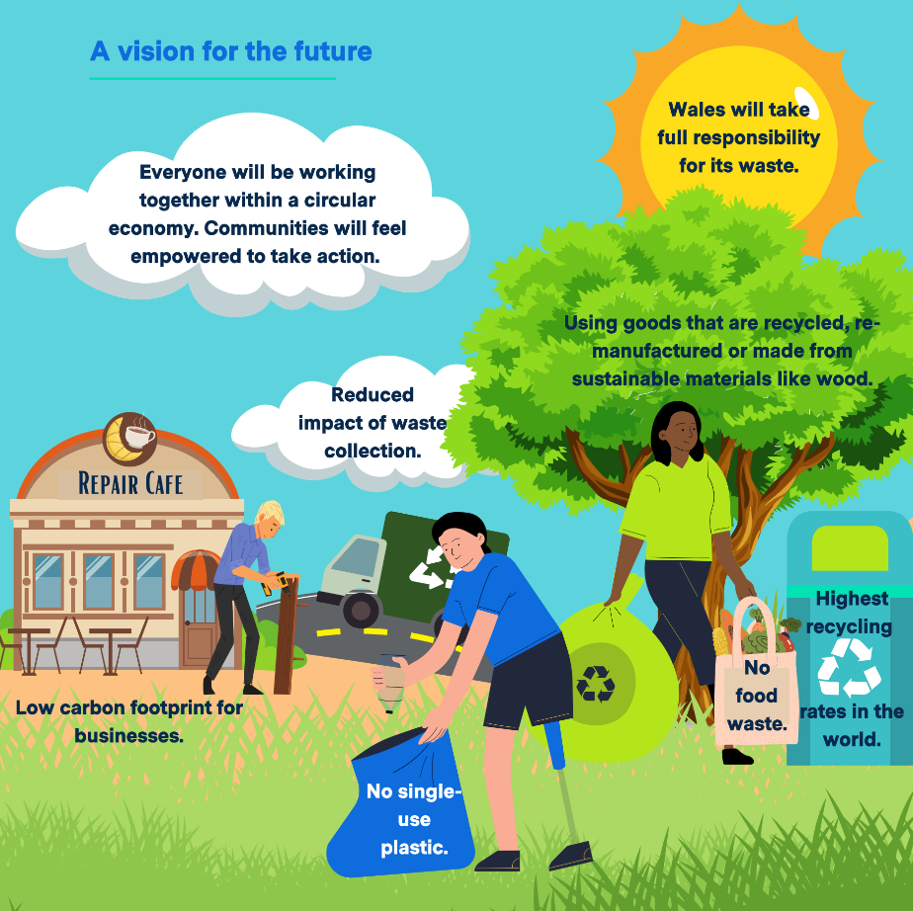
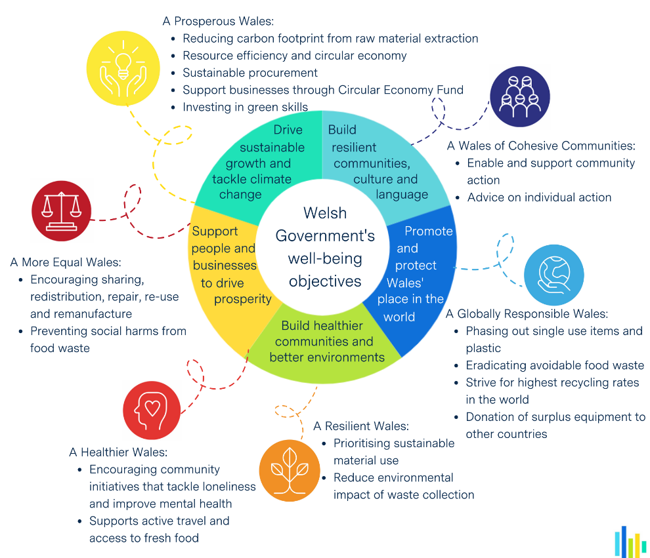
The Wellbeing of Future Generations Act (Wales) 2015 (referred to hereinafter as WFGA) was designed by Welsh Government in response to the present and future challenges posed by climate change, poverty, health, coronavirus and the economy. Welsh Government recognised that in order to ensure future generations have a good quality of life in light of these challenges, our current decisions must be made with long term impacts in mind, and this legislation is designed to ensure the public sector does this. Resource efficiency, which is the underlying principle of the circular economy, is a key component of the Welsh Government’s legislative framework in Wales and is included in the ‘Prosperous Wales’ Goal under the WFGA (DEFRA, 2020). Moreover, Wales having a fully functional circular economy represents one of the most ambitious steps listed on the Journey to a Globally Responsible Wales (Welsh Government 2021b). Modern waste management has undergone significant change in Wales, from policy oriented around waste disposal and landfill, to more recycling oriented, and now and even more progressive framework shaped by the “toward zero waste” (2010) and “Beyond Recycling” (2021) strategy documents. This latter and most recent policy document was framed by the WFGA to maximise contribution to wellbeing through “bold and innovative action” by Welsh Government (WG), local authorities, businesses and communities, illustrated in figure 1 (Welsh Government 2021b). Welsh Government’s approach to resource/waste management is ambitious, holistic and progressive (Farmer et al., 2015; Bees and Williams, 2017; Fletcher, 2019), and ambitious goals and targets require expansion of the sector to drive innovation and maximise resource efficiency. The number of people employed within the waste and recycling sector has increased in recent years which are predominantly operational roles (Drane et al., 2022). At the same time, Wales has a relatively proportion of people employed in machinery operations, process plants and elementary occupations (around 18%) which is higher than the UK average of around 16% (Ellen Macarther Foundation, 2019). The waste sector therefore represents significant opportunity to satisfy the local authority’s contributions to the WFGA as expansion and evolution of the waste sector as outlined in our national policy framework (Towards Zero Waste, Beyond Recycling Strategy, Circular Economy Package) directly contributes to Welsh Government’s Well-being objectives of 1) driving sustainable growth and tackling climate change and 2) supporting people and businesses to drive prosperity (a Prosperous Wales). Our national policy framework promotes a shift toward seeing waste as a resource and has already on the local level facilitated considerable innovation at the local scale pioneered chiefly by the public and third sector in terms of funding and delivery respectively. This has translated to real tangible increases in repair and reuse, where community groups are supported in taking action in establishing their own circular economy projects, creating a Wales of Cohesive Communities as well as a more Prosperous Wales where resources are shared and distributed and our carbon footprint from raw material extraction is reduced, a Healthier and more Equal Wales where access to food and resources in easier and communities are more cohesive via resource sharing, a Globally Responsible Wales where avoidable food waste is eradicated and single use plastic is phased out, and surplus equipment is donated to other countries. Finally, the prioritisation of sustainable material use and the minimisation of the impacts of waste collection (such as maximising route efficiency, electrifying fleet, etc.) creates a more resilient Wales, as less resources are wasted and thus available to allocate to those in need, illustrated in Figures 1 and 2.
Figure 1: Welsh Government's Vision for the Future regarding Circular Economy/Waste Management – (Welsh Government, 2021b)
Figure 2: The contributions to the WFGA made by the Beyond Recycling Strategy (Welsh Government, 2021b).
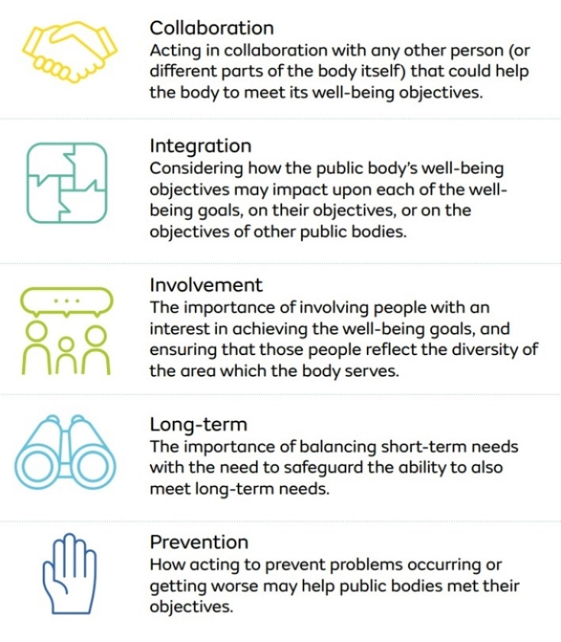
Wales has a long-standing commitment to the sustainable development principle, with its inclusion in Government of Wales Act which established Welsh Government (WG) in 1999 (Howe, 2023). To evidence they have applied the Sustainable Development Principle, WG must apply the five ways of working (enshrined in the WFGA) as described in Figure 3.
Figure 4: The Five Ways of Working
With regard to my own developmental needs, the WFGA provides a clear framework of goals which in addition to the FWW, align with my circular economy work. Studying the WFGA and the FWW therefore ensures that my work will maximise the service’s contributions to the WFGA Goals through incorporating long term thinking, promoting more interdisciplinary collaboration.

- The role and impact of the Act in Wales (using examples of implementation and output)

  - WFGA Influence on Resource Management Policy Framework
When reflecting on Welsh recycling achievements, Sophie Howe, the first Future Generations Commissioner commended the WFGA for promoting a holistic approach to achieving Net Zero Waste (Howe, 2023). While this is certainly true for the Beyond Recycling Strategy (2021), Howe’s representation evokes a sense of Act being solely responsible for shaping WG’s waste/resource management framework to be as innovative, ambitious and holistic as it is, when in fact, these concepts have been championed by waste and circular economy strategies and policies years before the Wellbeing Act came into force. For example, while the resource policies of its UK Counterparts were framed in more limited terms of economic growth, and waste recovery (Fletcher, 2019), Welsh Government’s 2010 Toward Zero Waste Strategy was already framing Waste in the broader context of culture, social justice, and climate change. I hypothesize this is because waste was one of the earliest devolved powers Wales had, meaning Welsh Government have had autonomy over innovation this policy area for longer than other areas of Welsh Government, resulting in a more mature/advanced policy landscape ahead of the WFGA. Howe (2023) is correct however in her statement as it pertains to WG’s most recent CE development, the Beyond Recycling Strategy (Welsh Government, 2021) which explicitly states in their introduction that the Well-being of Future Generations Act lies at the heart of its development. In addition, they state this strategy has been developed following the Five Ways of Working and was developed through significant community and school consultation. This is likely why you get a resulting strategy which is innovative, ambitious and far more centred in community, equality and justice than resource policy from other UK home nations (Farmer et al., 2015; Bees and Williams, 2017; Fletcher, 2019) or, as Howe (2023) puts it:
“a holistic approach to achieving zero waste, posing the question: how do you reduce waste whilst also improving health, tackling inequality, reducing loneliness and isolation?”
2.3 A vehicle for Spatial Justice
The act operates on the basis of the sustainable development principle (Davies, 2017). In terms of role and impact, the WFGA has received criticism pertaining to the vagueness of the act applies all the way down to this foundational principle, with Lee (2006) noting an all-embracing definition of sustainable development is likely not possible or desirable. Likewise, there were criticisms that the sustainable development concept being the central organising principle was not translating to change in practice (Howe, 2023). However, there are some examples of the Act leading to tangible change. For example, the Act had a role in cancelling the plan to spend all of Wales borrowing capacity building a 13-mile motorway running through environmentally sensitive wetland. While Howe (2023) notes that usually the economy wins over environment, this time, the new framework of the WoFGA bound politicians to decide in favour of environment and communities. Howe (2023) describes this as a watershed moment that defined a change where short term economic gains no longer took precedent over long term environmental losses. I believe that the WFGA to some extent corrects this vagueness with its spatial specificity, meaning the Act is tailored to Wales and Welsh needs which compensates for the ambiguity some argue is caused by the ambiguousness of the sustainable development principle. It is also worth noting that some level of ambiguity is what allows for variance in interpretation, and this interpretation as Nesom et al., (2020) points out, is what enables policy makers to do things differently and tailor decision making for their own localities.
The Act’s capacity as a vehicle for spatial justice posited by Jones et al., (2020) is founded by the same premise that justifies an equally local policy framework for circular economy and resource management, where in my opinion, the propensity for a region to assert its own capacity to manage resources is central to the efficacy of their resource management.
2.4 Indicators
Welsh Government have established 50 national indicators to monitor progress to Well-being and Sustainable Development Goals. The only indicator that pertains to waste and recycling is the amount (kg) of waste generated that is not recycled per person, which has decreased considerably since 2012 as shown in figure 1.
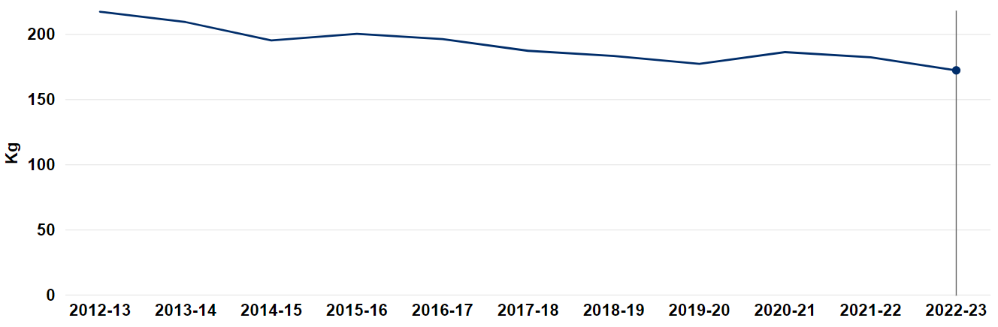
Figure 5: Residual household waste per person (kg) by local authority, 2012-13 to 2022-23

- Appraisal – adherence to and engagement with the act & five ways of working
3.1 – Current contributions from the Council’s Waste & Recycling Department to the Wellbeing Goals [and FWW].
Waste is not the first thing that comes to mind when we think of Well-being, but the Waste & Recycling Department is in fact a key contributor to the Wellbeing Goals on behalf of the local authority. Waste management is of great importance to a Globally Responsible Wales as the way in which waste is managed has a significant impact on greenhouse gas emissions. Our service aims to maximise recycling and we are under legal obligations to reach specific recycling targets as set out by the beyond recycling strategy and net zero by 2030 commitments as set out in the Paris Agreement [Long Term]. Our Kerbside Transformation project will dictate increased separation of Waste in line with the Beyond Recycling Strategy (Welsh Government, 2021a) which will increase the quality of recycling with a Long Term approach being applied to accommodate the lead-in time required with routing, service redesign, vehicle procurement and delivery to accommodate 91,000 households [Integration, Long Term]. Through promoting sustainable material use through our community engagement, communications and outreach, we contribute to building a Resilient Wales, as effective waste management and increased recycling rates mean less pollution, and this means increased ecosystem and (consequently) anthropogenic resilience. As a consequence of our collaboration with the third sector and community groups, the local circular economy, we build a Prosperous Wales who share and build wealth and resources together. This method will increasingly become a major vehicle for local prosperity and wellbeing as it drives local circular economy innovation across Wales (Fuller-Love & Murphy, 2023). A broad range of our activities contribute to a Healthier Wales, where increased recycling means less air pollution (from reduced greenhouse gas emissions from burning and landfill) less terrestrial pollution (from less street litter – we have dedicated officers to educate and regulate disposal of waste [Prevention, Involvement, Long Term], increased separation of recycling (increasing the quality of recycling) as well as the mental health benefits from community initiatives for litter picking and funded projects and upskilling events in repair and reuse [Involvement, Prevention, Collaboration]. A circular economy is a sharing economy which maximises not only resource efficiency but social inclusion and access to goods, skills and knowledge. In this way, the Circular Economy faction of our Waste Department is a critical contributor to A Wales of Cohesive Communities [Integration, Long Term, Collaboration]. As part of the Circular Economy portfolio, we have engaged in significant collaboration and involvement with the Ten Towns communities in Wales. The Ten Towns were chosen to pilot this project as this round of funding was integrated with the Regeneration Department’s work which is heavily centred on supporting the Ten Towns. This involved consultation done by Afallen from August 2022 to February 2023 where community members established their place-based need s and barriers to develop plans and help communities implement circular economy projects throughout the county. The Ten Towns were chosen based on their need for support in terms of economy, infrastructure and community. Our circular economy innovation focussing on this area thus represents a significant step in creating a more equal and cohesive Wales by dedicating our resources in supporting local communities build back their towns in a sustainable, affordable and self-determined manner [includes all FWW]. The waste department operates an assisted lift service to ensure waste disposal is accessible for all residents of Carmarthenshire, contributing to A More Equal Wales [Long Term], and all of our resources are in English and Welsh and any other language required by a resident when we are corresponding with them, contributing to A Wales of Vibrant Culture and Thriving Welsh Language [Collaboration].
3.1 Methodological approach to quantifying organisational engagement
A survey was created on Microsoft Forms to gauge staff in the Waste Service’s understanding of the Wellbeing of Future Generations Act and the Five Ways of Working and how well the council adheres to/engages with these principles. My hypotheses going into this work based on experience in my practice area is that awareness of the Act is low and staff awareness in public service is significantly overrepresented by senior management who engage with the WGFA at the policy and strategy level and underrepresented in the operational deliverers of the service. The question is to what extent does awareness of the WFGA affect the efficacy of the service in contributing to the WFGA.
3.2 Survey Data Analysis
There were 15 Respondents to the survey comprising 7 members of the Operations team and 8 members of the Strategy and Policy team. In response to the question “are you aware of the Well-being of Future Generations Act, 67% said no – only 5/15 staff surveyed. When asked how often the WFGA features in their work, there was an interesting divide where staff either indicated a strong use of the Act with “very often” (20%) or no engagement with the Act at all with “Not at all” (80%). It is of note that while given multiple options, staff deviated at extremes of the spectrum (Figure 5). I believe this may reflect the difference between senior managers and officers across both the waste strategy and policy and operational team, however this can not be confirmed as my survey was anonymous in order to ensure staff across the service would participate in the survey.
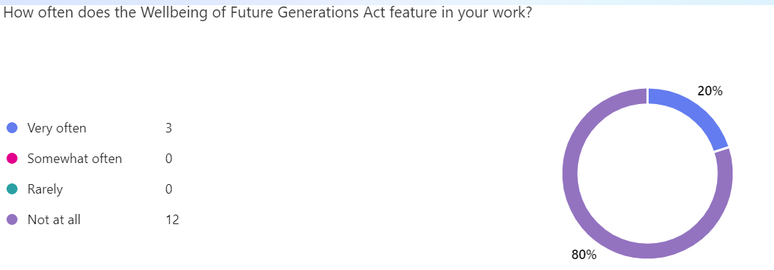
Figure 5: Engagement of staff with the WFGA in their work
Staff who indicated they used the Act often were then prompted to write about what specific work implemented/engaged with the WFGA. Staff referenced the Circular Economy portfolio and how it aligns with the WFGA and that the Circular Economy policy and strategy works toward zero waste. One staff member said “encouraging innovation in waste management by supporting sustainable technologies for waste processing and recycling” which reflects how staff in CCC waste and recycling department are matching the ambition, passion and innovation observed in the national strategy documents, which is deeply encouraging and inspiring to read.
Staff opinions on the council’s adherence to the FWW were low, with most expressing either neutrality or that the council were doing a somewhat poor job at adhering to the FWW, indicating staff are not seeing the FWW demonstrated in their day to day work (Figure 4).

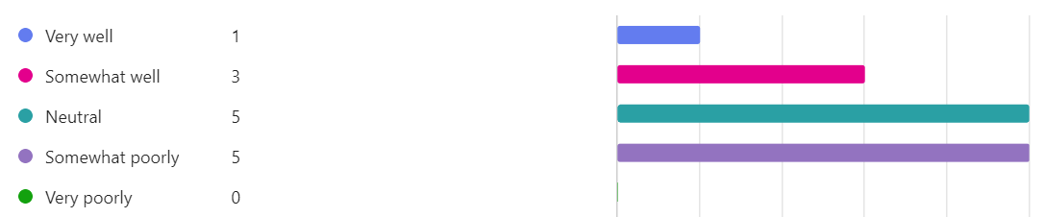
Figure 6: Staff opinions on CCC engagement with the Five Ways of Working
Staff opinions on the organisation’s adherence to the WFGA were more positive (Figure 6) with 40% thinking they engaged with the WFGA somewhat well, however for a service area with policy so richly aligned with the WFGA, you would hope to see more staff indicating they feel the council delivers the WFGA goals, however this could be due to a poor awareness of the content of the act itself, as indicated by the earlier results.

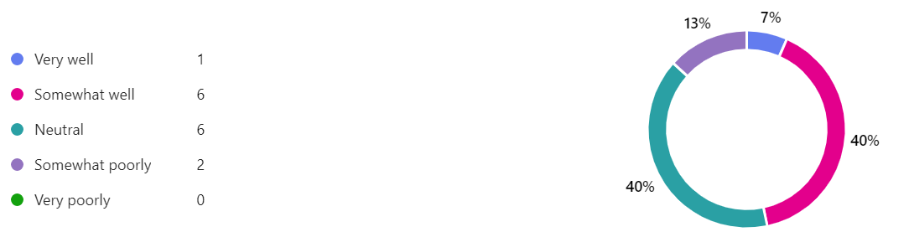
Figure 7: Staff opinions on CCC engagement with the Wellbeing of Future Generations Act.
Staff were then asked to rank the performance of their department (Waste and Recycling) specifically against each WFGA goal (Figure 8). The goals which staff feel our service most significantly contributes to are 1) a Globally Responsible Wales (73% positive), and 2) A Wales of Vibrant Culture and Thriving Welsh Language (73% positive), A Wales of Cohesive Communities (52% positive) A Prosperous Wales (48% positive) A Resilient Wales (47%) A More Equal Wales (44%). It is interesting that in relation to the Waste Service’s engagement with the goals, staff have ranked the Culture and Language goal higher than most other goals. Future research is needed to ascertain whether this is a consequence of the language services we provide, the proportionality of Welsh speakers in the service that facilitate the thriving of the language, or something else. It is no surprise that a Globally Responsible Wales ranked high, as staff in this service area are likely very aware of the relationship between global responsibility and our consumption and disposal of waste. The other goals however should reasonably be ranking as high as the Global Responsibility Goal, as my appraisal above evidences, our service contributes just as much to the Global Responsibility Goal as it does contribute to a Prosperous, Resilient, more Equal, Healthy Wales of Cohesive Communities. The fact these score low indicate to me that 1) more work needs to be done to educate staff on the WFGA and how we contribute and 2) we must expand and improve our services to maximise our contributions as outlined in the WFGA and the Beyond Recycling Strategy. These aims will be achieved by my implementation plan outlined in Assignment 2.
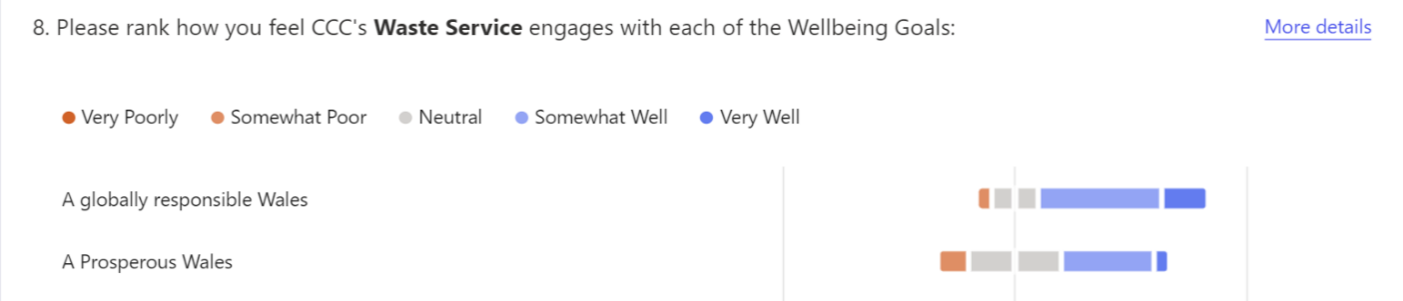
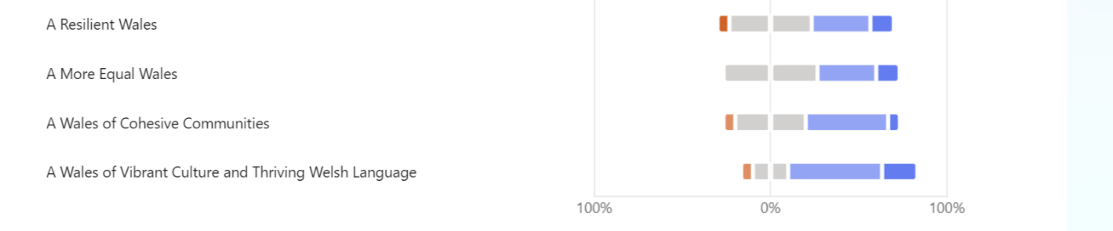
Figure 8: Staff assessment of Waste Service's engagement with each WFGA goal.

REFERENCES
Carmarthenshire County Council, 2017. Report to Cabinet: Future Waste Strategy.
Ellen MacArthur Foundation, 2019 Completing the picture: How the circular economy tackles climate change [online]. Cowes: Ellen MacArthur Foundation. Available from: https:// ellenmacarthurfoundation.org/completing-the-picture [Accessed 29 December 2024].
DEFRA, 2018. Our waste, our resources: a strategy for England. HM Government.
Drane, A, R. M., G, L., L, R. and Wooldridge, A., 2022. Circular Economies and Sustainable Health and Well-being. The Public Health Impact of Welsh Public Bodies Refocusing on Waste Reduction and Reuse. Summary Report.
Farmer, T.D., Shaw, P.J., Williams, I.D., 2015. Destined for indecision? A critical analysis of waste management practices in England from 1996 to 2013. Waste Management. 39, pp.266–276.
Fletcher, Carly A and Dunk, Rachel M (2018) In the search for effective waste policy: alignment of UK waste strategy with the circular economy. Detritus, 04. pp. 48-62. ISSN 2611-4135
Fuller-Love, N., & Murphy, L. (2023). Circular economy implementation: Case studies in Wales. Cardiff Metropolitan University.
Howe, S., 2023. Implementing intergenerational fairness–the Welsh approach. Nordic Journal of Wellbeing and Sustainable Welfare Development, 2(1), pp.59-62.
Nesom, S. and MacKillop, E., 2021. What matters in the implementation of sustainable development policies? Findings from the Well-Being of Future Generations (Wales) Act, 2015. Journal of Environmental Policy & Planning, 23(4), pp.432-445.
Netherwood, A., Flynn, A. and Lang, M., 2017. Well-being Assessments in Wales: Overview Report.
Stokes, E. and Smyth, C., 2024. Hope-Bearing Legislation? The Well-being of Future Generations (Wales) Act 2015. Transnational Environmental Law, 13(3), pp.569-587.
Welsh Government (2015) The Wellbeing of Future Generations Act (2015); Well-being of Future Generations (Wales) Act 2015. Accessed 25th November 2024
Welsh Government, 2021a. Beyond Recycling: A strategy to Make the Circular Economy in Wales a reality: Beyond recycling: strategy and assessments | GOV.WALES
Welsh Government, 2021b, Welsh Government, 2021a: Beyond Recycling & Well-being: Waste-strategy-English.pdf
Wales Future Generations Commissioner, 2021. Procuring Well-being in Wales: A Review into how the Well-being of Future Generations Act is informing procurement in Wales.

