

International Business LCMB7014
Philips’s International Business in United Kingdom


Student Name: Krupaben Hasmukhbhai Dhameliya
Student Id: 2207957
Module Name: International Business
Module code: LCMB7014
Lecturer Name: Dr Hossein Shokri
Word count: 5000 words
Submission Date: 3th May 2023

Table of Contents
Introduction 3
Philips N.V. - Company Background 3
Philips’s Objectives and Strategies 4
Countries’ Specifications 4
The Netherlands - Home Country 4
The UK - Host Country 5
External Analysis 5
A Comparative PESTLE Analysis 5
Industry Five Forces 8
Market Analysis 10
Host Country Analysis 11
The UK’s National Diamond 11
The UK’s Business Risks 11
Internal Analysis 12
Global value chain 12
Primary Activities 12
Support Activities 13
Global Production 14
Global Marketing 14
Global HRM 15
SWOT analysis 16
International Strategies 17
Entry Modes 18
Corporate Social Responsibility 19
Conclusion 21
References 22
Appendix 29
Appendix 1: Political Stability of Home and Host Nations 29
Appendix 2: Population (based on age) in Home and Host Nations 30

Introduction
The current report has aimed to highlight the internationalization strategy of Philips in its market expansion from the Netherlands to the United Kingdom. The current report will evaluate the company's background and objectives and the specification of the home and host country. The Macro environmental factors are evaluated through the PESTLE analysis and the market analysis of the host countries through business risk and national diamond will be evaluated, along with the identification factors through the analysis of the internal factors affecting the company, which will be identified through the SWOT analysis, along with the entry mode and internationalization strategy. This report will also evaluate the corporate social responsibility of Philips in its strategy. The current study has aimed to shed light upon the various factors of international business and strategies adopted by the companies such as Philips. It will evaluate the features that contribute towards the business success in the global environment and also the major decisions taken by the global businesses in their strategy. The report will also reflect upon different modes of engagement in the global market and also the role of macro-environmental factors.

Philips N.V. - Company Background
In order to produce incandescent lamps and other electrical goods, Frederik and Gerard Philips created Philips in Eindhoven (Netherlands) in 1891. Koninklijke Philips Electronics N.V. business began as Philips & Co. Limited Partnership. The Gloeilambpenfabrieken of N.V. Philips was established in Eindhoven, the Netherlands, in 1891 and became a limited liability corporation on September 11, 1912 (Stewart, 2023). Philips is a prominent Dutch manufacturer of electronic machinery, consumer electronics, medical imaging apparatus, home utilisations, lighting tools, and supercomputer and telecommunications equipment also formally known as Royal Philips NV (Deckmyn, 2023).
When Anton and Gerard Philips founded Philips & Co. in Eindhoven, the Netherlands, in 1891, the company set the groundwork for Philips. By the turn of the century, the company, which had initially produced carbon-filament lamps, had grown to become one of Europe's major producers ( Koninklijke Philips N.V, 2023). Around 17.83 billion euros were made by Philips in 2022, the company's largest annual income since 2018. Revenue rose in 2012 to 23.46 billion euros, the greatest sum for the period of time given (Stewart, 2023). In 2021, Philips generated over 17.2 billion euros in revenue, which was adequately sufficient to put it among the globe's top manufacturers of medical technology. Around 21.8 thousand of Philips' workers worked in North America in 2021, in contrast to 19.8 thousand in Europe (Stewart, 2023).

Philips’s Objectives and Strategies
Philips is a market leader in health technology today with a mission to improve people's lives via significant innovation. The company aims to attain the same with motivation, dedication, cooperation, and multiplicity of its workforce (Comparably, 2023). The company have more than 17,000 bright individuals spread across more than 50 locations (Koninklijke Philips N.V., 2023). Moreover, the company is also constantly looking for more people to join it thereby promoting a more connected and positive community while also undergoing personal and professional growth. Employment at Philips is more than just a job. In addition to this, the journey at the company is full of surprises that will change the life of the employees for the betterment in the long run.
At Philips, the company work to upsurge three billion people's lives annually by 2025 in pursuit of its attempt to make the world healthier and more sustainable through innovation (Koninklijke Philips N.V.,, 2023). Over the past ten years, Philips has changed to reorganise its portfolio and become a targeted health technology company. As a result, the company operate in markets that are very enticing and have enormous potential for growth and higher margins. After evolving in recent years to become a health technology company, the company is now focusing on maximising the value of its robust portfolio with leading positions.
The goal of Philips is to make a meaningful difference in people's health and well-being. By 2030, the company aspires to improve the lives of 2.5 billion people annually entailing 400 million people living in underserved areas (Koninklijke Philips N.V., 2023).

Countries’ Specifications
The Netherlands - Home Country
The Netherlands, usually known as Holland, is a country in northwest Europe. In fact, the nation is miraculously low-lying and flat, with vast expanses of rivers, lakes, and waterways. Despite 500,000 people departing the country as a consequence of government-encouraged emigration after World War II, the Netherlands is one of the most populous nations on the globe nowadays. The Netherlands has been an extremely industrialised nation since World War II, performing an integral part in the economic development of the western part of Europe. Even though it merely makes up a small portion of the country's GDP and labour force, agriculture persists to be a highly specialised source of Dutch exports (Heslinga, et al., 2023).
The UK - Host Country
The entire island of Great Britain, which is made up of England, Wales, and Scotland, along with the northern part of the island of Ireland, constitutes the United Kingdom. London, the capital of the United Kingdom, is one of the world's most significant, financial, commercial and cultural hubs in the world. The UK has had a major impact on the worldwide economy, especially in the fields of industrial production and innovation. The UK economy has always been heavily reliant on trade. The total value of imports and exports amounts to nearly fifty per cent of the nation's GDP (Kishlansky, et al., 2023).

External Analysis
The external analysis of the nations is done using models like Pestle, and Industry 5 forces along with the National Diamond model for host country analysis.

A Comparative PESTLE Analysis

Factors | The Netherlands | The UK
Political Factors  (refer appendix 1) | - The Netherlands is a member of the European Union along with other international bodies like United Nations, NATO, CoE, WTO, IMF, OECD, and OSCE (International Business Publications, 2018)  - Corruption is not tolerated and the nation scores very low in terms of corruption levels with the nation being ranked at 8th position within 180 countries (Transparency International, 2023)  - The political stability within the nation is high with a score of 79.72% in the year 2021 as per World Bank (Trading Economics, 2023) | - The UK has been member of a large number of international organisations like United Nations Security Council (Wood & Sthoeger, 2022)  - It is also the founding member of the G7, G8, G20, NATO, AUKUS, OECD, WTO, Council of Europe, OSCE, and the Commonwealth of Nations (Gaskarth, 2013)  - Corruption is comparatively high in the UK as the nation is ranked at 18th position within 180 countries (Transparency International, 2023)  - Brexit has resulted in political instability within the nation irrespective of which the political stability within the nation is high with a score of 77.36% in the year 2021 as per World Bank (Trading Economics, 2023)
Economic Factors | - A high-income nation with a high GDP per capita which is $56,489  - In March 2023, the unemployment rate was 3.5%  - Ranked at 42nd position within a list of 190 nations  (www.countryeconomy.com, 2023) | - Though the GDP is high it is lower than the Netherlands. The GDP per capita of the UK is $45,775 (www.countryeconomy.com, 2023)  - In Feb 2023, the unemployment rate was 3.8%  - Ranked at 8th position within a list of 190 nations thereby endowing companies with better opportunities to pursue their business in the nation. Right from starting a business to getting electricity and dealing with construction permits, registering property, credit, minority investors, taxes, trading, contracts and insolvency.  (www.countryeconomy.com, 2023)
Social Factors  (refer appendix 2) | - The nation has an ageing population with the majority being in the age group of 40 to 65 years (Statista, 2022)  - The nation has female dominance with 99 males for every 100 females (Statistics Netherlands, 2023) | - Approximately 50% of the total population is above the age of 40 years (Government of the UK, 2023)  - The nation has a female dominance with 51% of the population belonging to this gender group (Government of the UK, 2023)
Technological Factors | - 7th Largest ecommerce market amongest European nations  - 95% respondents use smartphones thus providing ample scope for online shopping in future  (Yltaevae, 2022) | - 30% of total retailing in the UK done through ecommerce (International Trade Administration, 2023)  - The UK ranked at the 1st position within the entire European Union for digital advancement (Digital Catapult , 2021)
Legal Factors | - Abides by EU norms for trade sanctions (Kaarls, 2020)  - Strongly encourages foreign investments (Kaarls, 2020)  - Abides by a two-tier taxation mechanism. (Deloitte, 2015) | - For doing business in the UK a wide range of laws needs to be abided by. Some of these laws are consumer protection law, employee protection law and government procurement laws to name a few.  (Lopes, 2020)
Environmental Factors | - Plastic pollution is very high in the Netherlands  - The nation has failed to meet a wide range of objectives for meeting the environmental standards especially those related to GHG emissions  - Significant impact of climate change  - Natural resources are exploited excessively  (Zappi, 2019) | - The most signficant environmental issued faced in the UK is air pollution  - Higher Carbon and other greenhouse gas (GHG) emissions owing to burning of fossil fuels  - The UK government taking measures like ensuring that organisations report their emissions  - Significant fines on violation of environmental laws  (Terrapass, 2022)

Industry Five Forces
The five forces provided by Porter that are analysed in the case of The Netherlands and the UK are depicted below:
Bargaining power of Consumers (High) – The bargaining power of the consumers within the personal care appliance industry is relatively high mainly because the consumer can choose from a wide range of products provided by various companies. Along with this the consumers can also purchase fake products, or those manufactured by regional players which are cheaper options. Further consumers also have the liberty to purchase substitute products like hair removal instead of any appliance, consumers can purchase hair removal creams. This increased their bargaining power.
Bargaining power of Suppliers (Low) – There are a large number of suppliers for various parts that are used in developing personal care appliances. Also, the suppliers are highly fragmented which further lowers their bargaining power. Thirdly, considering that Philips is the leader within this segment and has a strong brand image with a huge business scale, it is difficult for the suppliers to bargain with the same.
Threat of New Entrants (Low to Medium)- Personal care industry is a highly cluttered industry with a large number of significant players operational within the industry. This process for significant threat for new entrants as it is changing for them to compete with customised grants like Philips Johnsons and Johnsons havells and Dyson. Though the industry is lucrative at the same time investment required to be successful in this industry is very high with generates entry barriers for the new entrants.

The above details are presented in the figure below:

Figure 5 Porter's 5 Forces Analysis for Personal Care Industry
Source: Adapted from (Dälken, 2014)

Threat of Substitutes (Medium to High)- template of substitutes is medium mainly because the substitutes provide a temporary solution and not a long-term one it’s stops but as the substitutes are reasonably and easily available across markets the threat related to the same is high. For example, for hair removal various creams and razor is available thereby posing a significant threat to the products offered by Philips.
Existing Competition (High)- the existing competition and the threat related to the same as high in the personal care industry as a wide range of companies operating within the industry. Some of the most significant companies are Conair Corporation, Dyson Ltd., Havells India Ltd., Helen of Troy Limited, Panasonic Corporation, Spectrum Brands Holdings Inc., The Procter & Gamble Company, The Wahl Clipper Corporation, Vega Industries Private Limited, Yongkang Xinji Hairdressing Appliance Factory, Braun GmbH, Norelco Consumer Products Company and Johnson & Johnson (Research and Markets, 2023).

Market Analysis
The global personal care appliances industry is expected to expand and reach a mark of 24.32 billion USD by the year 2026 from 19.31 billion USD in the year 2022. The CAGR for the years 2022 to 2026 is expected to be approximately 5.9% (Research and Markets, 2023). The primary categories of personal care appliances are hair care, oral care, and hair removal. In the UK, this industry is expected to increase by 0.32 billion USD by the year 2027 from its current market value.
Along with Philips N.V. the other primary players within this industry are Conair Corporation, Dyson Ltd., Havells India Ltd., Helen of Troy Limited, Panasonic Corporation, Spectrum Brands Holdings Inc., The Procter & Gamble Company, The Wahl Clipper Corporation, Vega Industries Private Limited, Yongkang Xinji Hairdressing Appliance Factory, Braun GmbH, Norelco Consumer Products Company and Johnson & Johnson (Research and Markets, 2023).
The key success factors of this industry are
- Technological innovations like Hair Clipper 3000 series by Phillips for men that uses Dual Cut and Trim & Flow Technology or the EH-NA67-W by Panasonic that uses nanotechnology
- Increased participation of women in the workforce
- Increased demand for designing and styling, especially with people seeking to ‘do it yourself
- Increased awareness within men for self-grooming and personal care
- Increased shopping online through e-commerce platforms
- Developing strategic partnerships for catering markets

Host Country Analysis
The UK’s National Diamond
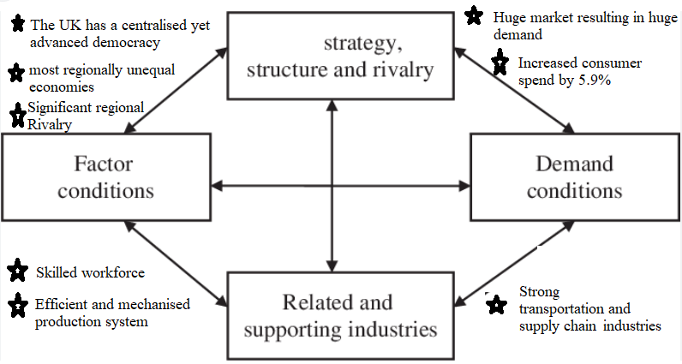
Figure 6 The UK's Nation's Diamond Model Analysis
Source: Created By Author

The UK’s Business Risks
Overall the nation presents a medium level of business risk. The intensity of risks is depicted in the figure below:
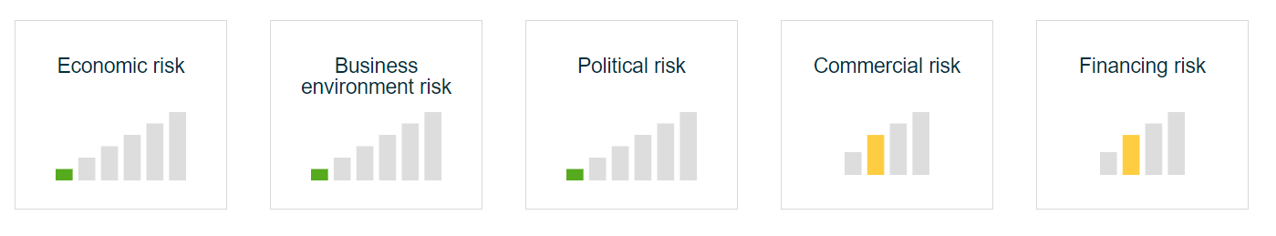
Figure 7 Business Risks in the UK
Source: (Allianz Trend, 2023)
From the above figure 7, it can be derived that the five primary risks that can be faced by companies in the UK are economic risks, business environment risks, political risks, commercial risks and financing risks. It can be derived from the above figure that economic risks, business environment risks and political risks are low in the UK (Allianz Trend, 2023). Commercial risks and financing risks are at a medium level thus posing a significant issue for the enterprises (Allianz Trend, 2023).
Overall, investment-related policies in the UK are constructive but at the same time owing to Brexit, there have been increased barriers to trade with the European Union. This has resulted in increased business risks (Allianz Trend, 2023). The recessions-related risks are high owing to Covid-19. Inflation rates have increased within the nation along with increased interest rates. There has been an increase in corporate risks owing to an increased number of businesses going bankrupt during the pandemic period. For companies, there might be a risk related to energy as the UK might experience an energy crisis. Energy costs are expected to increase by 50% thereby increasing operational costs in the organisations' (Allianz Trend, 2023).

Internal Analysis

Global value chain

Primary Activities
There are various primary activities performed by Philips which are unswervingly involved in the manufacturing and supply of goods and services.
Inbound Logistics - Philips has close connections with a large network of suppliers across the globe. Further, a fundamental role in value creation is played by supply management and at present, Philips centralises 74% of its supplier spending. All firms now use a global supplier rating system which has led to a more professional framework for assessing suppliers' performance and taking subsequent corrective actions.
Operations - Philips have a major supply base and manufacturing centre in China which is a low-cost country. In addition to this, the company have smaller manufacturing facilities in about 25 nations and entailing France Netherlands, Hungry, Mexico, Belgium, Brazil, and Argentina. For identifying the supply market opportunities across the globe, Philips work closely with the Supply Market Intelligence And Service Group.
Outbound Logistics – Outbound logistics at Phillips ensure that inventory is effectively and efficiently managed. Efforts are taken to ensure that time-to-market is reduced with increased cost efficiencies. The outbound logistics at Phillips ensure that the products are made available to the consumers without any damages or other issues.
Marketing and Sales - Philips have a team of dedicated sales representatives for selling its products. Apart from this, the product is sold through telephone, OEMs, ODMs websites, retail, and other indirect channels. Further, salesforce is used to sell the products to big customers such as healthcare industries and small customers are sold goods with the help of print, advertising, TV, and websites. There are sales organisations for Philips in more than 60 nations.
Customer Service - As many areas are covered by the products sold by Philips, the company offers specialised customer support. TV and other portable electronic products are offered 24-hour customer support. In addition to this, the company also offers 24-hour professional support for lighting, its healthcare products, and specialised business such as dictation and a system for speech recognition. Along with phone support, specific product-based FAQs and online support also point to Philips's strong customer service.

Support Activities
Technology - The company spent about 2.2 billion on research and development. Contrast agents for medical applications, the drug delivery potential of microbubbles, and OLEDs as the future of indoor lighting are some of the major areas of research performed by Philips. Advanced technologies like artificial intelligence are also actively used by Phillips.
Procurement- The procurement at Phillips is supported by its four pillars. These pillars are developing strategic partnerships with the vendors, providing them with insights along with data, creating the right teams by choosing the right leaders and concentrating mainly on strategic suppliers (Walker, 2021). The procurement policy is further developed based on the DfX methodology which is Design for eXcellence ( Philips N.V., 2023).
Firm Infrastructure – Philips has a strong international presence which is functional going to a powerful infrastructure set-up.
HRM – The HR policies at Philips ensure that quality talent is higher as well as promoted within the organization thereby ensuring that the jobs are effectively and efficiently.

Global Production
Philips has implemented a decentralised manufacturing system wherein the production is done locally as opposed to being centralised in one place and then dispersed throughout. With the help of decentralised production, the company aims to produce products as close as feasible to the consumer. Being a decentralised manufacturing organisation, Philips has numerous facilities spread across a sizable area, enabling the production and distribution of goods close to consumers. The demand for highly customised products in today's fiercely competitive global market has forced Philips to reconsider its manufacturing techniques.
However, having a too-decentralised manufacturing system, Philips had to face a lot of problems. National organisations within the corporation do not cooperate strategically as a whole. In addition to this, the national organisation matrix lacks accountability. Because of regional manufacturing hubs, there is inefficient production as well as highly delayed technical and commercial consensus management. In response to the same, the company is moving towards a centralised system for reaping the benefits of consistent output, better forecasting, more effective utilisation of resources, and more local jobs. Additionally, by embracing centralised production facilities that are situated close to the source of such supplies, the cost of materials might also be lower for Philips.
Further, a great deal of manufacturing is offshored or contracted by Philips to inexpensive places. In addition to this, R&D and sales and marketing are the main areas retained by the company.

Global Marketing
The production is done at Philips after considerable research and development at different R&D labs located in different nations. Further, the company acquires various components from the suppliers such as the requirement of LCD panels is fulfilled by critical lamp components acquired from the suppliers. The majority of manufacturing facilities are outsourced to low-cost countries. Philips' manufacturing is heavily concentrated in Eindhoven. Additionally, the national organisations carry out the manufacturing independently, and PDS serves as a presumably formal production department. The national Philips organisation makes its own decisions on the product mix and which technological standard to be utilised. The reorganised organisation led to improvements in dedicated multimarket production sites around the world.
The marketing functions at Philips are not outsourced and are majorly retained by the company. The company has sales in 60+ nations where the company execute its own marketing activities. Additionally, in order to gain a marketplace, the company has created foreign joint ventures. The corporation can effectively sense and adapt to numerous markets owing to its autonomous national organisations. Marketing is a weak area for Philips owing to organisational inconsistency. The company has therefore attempted to meet the global marketing plan as a whole by emphasising marketing rather than technology.

Global HRM
The human resources division of Philips directly influences the working environment. Philips employees give their workplace a C+ and are quite satisfied with it. Further, the employees also perceive that the culture and workplace at Philips are effortful and balanced, and they also experience a sense of accomplishment working at Philips (Comparably, 2023).
The HR specialists at Philips People Service Team work with a fantastic group of people thereby developing professionally and personally supporting one another in attaining success. The human resource professionals at Philips focus on enhancing Philips' workplace culture constantly. Employees at Philips are given decision-making authority by their managers, which enables them to grow professionally and gain new skills like leadership (Koninklijke Philips N.V, 2023).
Philips is dedicated to attaining 30% gender diversity in managerial positions by the end year 2025 since it believes that a just and equitable equilibrium among all genders offers a pleasant place to work (Koninklijke Philips N.V, 2022).
The company also implemented principles of transparency for the recruitment appointment and promotion of all the senior leadership positions. Additionally, it has also enabled data visibility of gender balance for all the executive members and HR business partners through monthly reviewed dashboards to offer insight and review progress toward the company’s gender goals.
For the hiring, appointing, and promotion of all senior leadership positions, the corporation also adopted transparent hiring, appointment, and advancement practices. In an effort to offer insight and track progress towards the company's gender targets, it has also allowed data visibility of gender balance for all executive members and employees in HR through monthly assessed dashboards (Koninklijke Philips N.V, 2022).
Additionally, Philips provides a range of perks, such as flexible scheduling and holiday policies, to support the personal and professional life of its employees and maintain their mental and physical well-being. In addition, the organisation offers coaching and reverse mentoring as part of a continuous learning environment. Everyone's voice is being heard and acknowledged at the company, thereby permitting innovation and creativity in the organisation (Koninklijke Philips N.V, 2022).

SWOT analysis
In the current report, the brand Philips is analysed using the acronym SWOT, which stands for strengths, weaknesses, opportunities, and threats. The strengths and weaknesses are the internal components of Philips' SWOT analysis, whilst the opportunities and threats are the external factors.
Strength: Philips is a leading consumer electronics company operating in more than 100 countries worldwide demonstrating its impact in the international market and its capability to reach a wide array of customers. The local market conditions are addressed by the company through its specific technical capabilities. Research and development, innovation, and creativity are all important to Philips. In response to this, the business currently operates more than 7 research centres in different nations all throughout the world.
Weakness: The company failed to reap the advantage of economies of scale owing to local production plants. The company has also not been able to profit from research and development. The Netherland based product divisions have weak control on the national organisation resulting in conflict in the company’s strategy. Many consumers have claimed that Philips' product prices are a little bit higher than those of its rivals in the marketplace. And therefore, many budget-conscious buyers are being turned away by the premium price strategy of Philips. Philips is also confronting tough competition from both local and international players offering numerous options to the customers where they can go and shop in the market.
Opportunity: The usage of green products is promoted by several environmental and social activists along with governmental institutions. This opportunity can be exploited by Philips to its advantage. New ecological-conscious customers can be certainly attracted by Philips. In emerging economies like Bangladesh, Pakistan, China, and others, Philips is expanding its market share. Such markets have significant room for growth, rendering the company's expansion a wise financial move. Philips should therefore maintain its upward trajectory. Green items from businesses that use sustainable energy are becoming more and more in demand. Philips ought to adopt these patterns and market its reputation as the leader in green and clean energy. Such tactics would enhance the result.
Threat: Philips has also to face certain threats. The cost of tech items is falling as a result of mass production, economies of scale, and technological innovation. In simple terms, it reduces the cost of technology. Such low-price trends are detrimental for Philips' high-end items. Given that Philip operates its commercial activities in more than 100 nations worldwide, it is imperative for the company to handle both export and import activities on daily basis. In such scenario, the selling and profitability of the company are significantly impacted by even a little change in the exchange rate's pricing. Philips is also significantly impacted by the national and international trade laws of numerous governments and nations. Most notably, the tax systems in several nations differ and influence the profitability of Philips. Many producers duplicate Philips' logo and market their low-quality goods in developing nations under the name of the brand. These fake goods put the company's reputation at danger.

International Strategies
The most significant international strategies are multi-domestic, international strategy, transnational and global strategies.
Multi-Domestic Strategy – A multi domestic strategy is primarily adaptation of the multinational strategy. In this approach the company makes an effort to integrate itself within the local environment thereby meeting the regional demands of the host nation (Tulung, 2017). In such an approach companies manufacture within the host country and market in these nations.
International Strategy – An international strategy is one in which the company has lower levels of responsiveness towards regional requirements as well as global integration. This strategy has lower levels of scope within an economy as well as does not support economy of scope too.
Global Strategy – A global strategy is a centralised strategy wherein a standardised approach is resorted to (Kaur & Sandhu, 2014). The company aims at deriving benefits from economies of scale by manufacturing the same product for all of its host markets.
Transnational Strategy – with the help of a transnational strategy organization aim at striking a balance between a multinational approach and a global approach (Abbott & Snidal, 2013). In this strategy, the organization resorts to a centralised control mechanism with its operations spread across multiple nations. It is one of the most commonly used internationalization strategies by companies across the world (Doz, et al., 2017)
Of the above strategies, Philips resorts to a multinational strategy as depicted in the figure below:
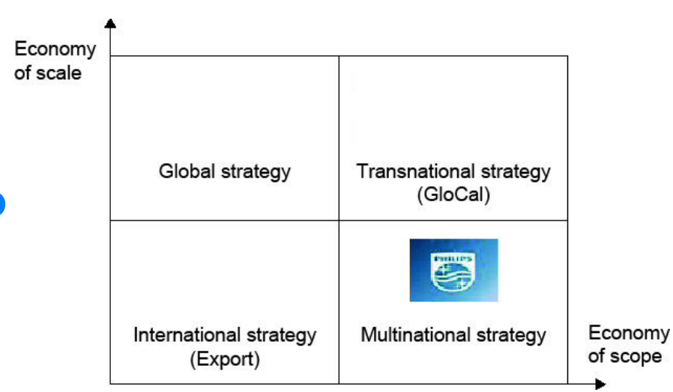
Figure 8 Multi-national Strategy of Philips
Source: (Witt, 2020)

Entry Modes
Different types of entry strategies are used by Philips to meet the consumer requirements of the host country. The company uses exporting approach as well as local manufacturing thereby endowing consumers with a white product portfolio (Douglas, 2015). Considering the case of Africa it has been derived that the majority of the products are imported but it also resorts to a local-for-local production strategy. This strategy helps the company to minimise its cost to meet the local consumer demands as observed in the case of Africa (Douglas, 2015).
However, the primary entry mode as adopted by Philips is depicted in the figure below:
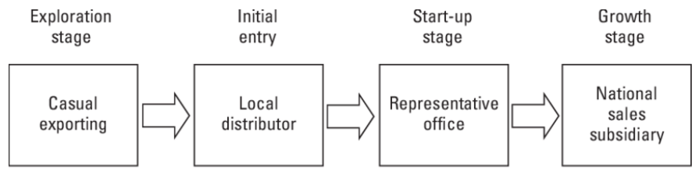
Figure 9 Entry Mode of Philips
Source: (Schuh & Holzmüller, 2003; Glowik, 2020)

Corporate Social Responsibility
The key objective of the CSR policy at Philips is to set up guidelines for the company to turn CSR into a business process for society's sustainable development. By focusing on the short- and long-term social and environmental effects of their actions, it attempts to enhance the government's role in strengthening social welfare guidelines ( Koninklijke Philips N.V., 2023).
Under its CSR endeavours, the company in accordance with UN Sustainable Development Goals 12 which is to ensure sustainable consumption and production patterns and Goal 13 which is to take immediate action to fight climate change and its implications, the company practises responsible stewardship of the environment ( Koninklijke Philips N.V., 2023). After achieving its environmental goals for 2020, Philips has embraced ambitious novel objectives to slow down climate change and leave a healthy planet for upcoming generations through the prudent use of resources ( Koninklijke Philips N.V., 2023).
After achieving its environmental goals for 2020, Philips also set ambitious new objectives to slow down climate change and leave a strong planet for future generations through the prudent use of resources. Philips also succeeded in 2020 in attaining its objectives of operating in a carbon-neutral manner and procuring all of its electricity from renewable sources (Zwirs & Mazzoni, 2020).
The company is also determined to lessen CO2 emissions throughout its whole value chain for complying with a 1.5 °C warming worldwide scenario. In addition to this, Philips is also committed to sourcing more than 75% of its overall consumption of energy from renewable sources by 2025 (Koninklijke Philips N.V, 2023).
Furthermore, Philips has begun a CSR initiative to create awareness and offer aid for the health issue of paediatric pneumonia. As the business's commitment to corporate social responsibility grew, it proceeded to reach out to family members, parents, and carers to spread consciousness about the condition of childhood pneumonia, which is one of the most prevalent infectious diseases in the nation contributing to under-five mortality (Khurana, 2019).
In five hospitals, Philips put an electronic terminal in collaboration with the local government that allowed patients to track their place in the queue, alleviating them of the need to stand by for hours for their turn without really missing their appointment. This device was ultimately implemented in 10 hospitals in Shanghai. It improved patient flow and minimised overcrowding (Cheng & Arora, 2014).
According to Philips, companies have a duty to uphold human rights and the power to have a constructive influence on such rights. By 2030, the company aspires to have enhanced the lives of 3 billion people yearly (Koninklijke Philips N.V., 2019). The foundation of this goal is the advancement of individualised, inexpensive, and inclusive care that is backed by respect and the support of human rights. Different due diligence techniques are in place to support Philips' commitment to do all that is feasible and reasonable to prevent and mitigate (possible) negative human rights impacts in its operations and value chain.
Philips had been diligently attempting to include solutions focused on the needs of consumers into its products. Reaching out to emerging markets and especially those at the base of the worldwide financial pyramid was an approach used by the corporation as a component of its mission to improve people's quality of life. Philips also began to focus on social breakthroughs, and it made an important advancement in India by launching a woodstove, a low-cost, smokeless stove (Tiwari, 2018).
To stay relevant in society, the company has incessantly reinvented itself. The company today creates intelligent solutions that support consumers around the world in resulting in healthier habits and help healthcare providers accomplish the quadruple aim: augmenting the experience of the patient, bettering health results, dipping the cost of care, and refining care providers’ work life (Globe Newswire, 2021). This is done by combining systems, devices, software, advanced analytics, and artificial intelligence (AI).

Conclusion
Overall the internationalisation strategy of Philips has been successful which has resulted in the company emerging as a market leader across all segments including personal care. The company has been resorting to a wide range of strategic approaches tenets coast countries to ensure that it can meet the requirements of the regional people and realise its organizational objectives. Irrespective of the challenges faced the company has been performing effectively and efficiently in the host country as well as in the home country.

References
Abbott, K. & Snidal, D., 2013. Taking responsive regulation transnational: Strategies for international organizations.. Regulation & Governance, 7(1), pp. 95-113.
Allianz Trend, 2023. United Kingdom - (Economic and fiscal) checks and balances. [Online]
Available at: https://www.allianz-trade.com/en_CA/resources/country-reports/United-Kingdom.html#link_internal_3
[Accessed 12 Apr 2023].
Cheng, H. & Arora, V., 2014. How Philips used CSR to promote its brand message in China. [Online]
Available at: https://www.prweek.com/article/1299292/philips-used-csr-promote-its-brand-message-china
[Accessed 25 April 2023].
Comparably, 2023. Philips Human Resources. [Online]
Available at: https://www.comparably.com/companies/philips/human-resources
[Accessed 25 April 2023].
Comparably, 2023. Philips Mission, Vision & Values. [Online]
Available at: https://www.comparably.com/companies/philips/mission
[Accessed 24 Apr 2023].
Dälken, F., 2014. Are porter’s five competitive forces still applicable? a critical examination concerning the relevance for today’s business. Twente: University of Twente.
Deckmyn, D. C., 2023. Philips Dutch manufacturer. [Online]
Available at: https://www.britannica.com/topic/Philips
[Accessed 25 April 2023].
Deloitte, 2015. Taxation and Investment in Netherlands, Netherlands: Deloitte.
Digital Catapult , 2021. New global index ranks UK first in Europe for advanced digital technology. [Online]
Available at: https://www.digicatapult.org.uk/about/press-releases/post/new-global-index-ranks-uk-first-in-europe-for-advanced-digital-technology/#:~:text=New%20global%20index%20ranks%20UK%20first%20in%20Europe%20for%20advanced%20digital%20technology,-Posted%2020%20Sep
[Accessed 24 Apr 2023].
Douglas, K., 2015. How Philips is adapting its global strategy to better address the African market. [Online]
Available at: https://www.howwemadeitinafrica.com/how-philips-is-adapting-its-global-strategy-to-better-address-the-african-market/46663/
[Accessed 26 Apr 2023].
Doyle, P. & Stern, P., 2006. Marketing Management and Strategy. 4 ed. Essex: Pearson Education Limited.
Doz, Y., Prahalad, C. & Hamel, G., 2017. Control, change, and flexibility: the dilemma of transnational collaboration. In: International Business . Oxon: Routledge., pp. 349-375.
Gaskarth, J., 2013. British Foreign Policy: Crises, Conflicts and Future Challenges. Bristol: Policy Press.
Globe Newswire, 2021. 130 years of Philips innovation, collaboration, and social responsibility. [Online]
Available at: https://www.globenewswire.com/news-release/2021/05/12/2227868/0/en/130-years-of-Philips-innovation-collaboration-and-social-responsibility.html
[Accessed 25 April 2023].
Glowik, M., 2020. Market Entry Strategies: Internationalization Theories, Concepts and Cases. Berlin: De Gruyter.
Heslinga, M. W., Rowen, H. H. & Meijer, H., 2023. Netherlands. [Online]
Available at: https://www.britannica.com/place/Netherlands/People
[Accessed 25 April 2023].
International Business Publications, 2018. Netherlands Company Laws and Regulations Handbook (Volume 1)- Strategic Information and Basic Laws. Washington DC: International Business Publications.
International Trade Administration, 2023. United Kingdom - Country Commercial Guide. [Online] Available at: https://www.trade.gov/country-commercial-guides/united-kingdom-ecommerce [Accessed 24 Apr 2023].
Kaarls, A., 2020. Doing Business in the Netherlands: Overview. [Online]
Available at: https://uk.practicallaw.thomsonreuters.com/0-500-8538?transitionType=Default&contextData=(sc.Default) [Accessed 24 Apr 2023].
Kaur, S. & Sandhu, M. S., 2014. Internationalisation of born global firms: Evidence from Malaysia.. Journal of the Asia Pacific Economy, 19(1), pp. 101-136.
Khurana, A., 2019. Philips CSR campaign; generates aid & awareness around childhood Pneumonia. [Online]
Available at: https://crossbarriers.org/philips-csr-campaign-generates-aid-awareness-around-childhood-pneumonia [Accessed 25 April 2023].
Kishlansky, M. A., Smith, L. B. & Josephson, P. R., 2023. United Kingdom. [Online]
Available at: https://www.britannica.com/place/United-Kingdom/Economy
[Accessed 25 April 2023].
Koninklijke Philips N.V, 2022. ​​Join in a team as diverse as the world we live in. [Online]
Available at: https://www.careers.philips.com/global/en/diversity-and-inclusion
[Accessed 25 April 2023].
Koninklijke Philips N.V, 2023. Driving climate action in our own operations and beyond. [Online]
Available at: https://www.philips.com/a-w/about/environmental-social-governance/environmental/climate-action [Accessed 25 April 2023].
Koninklijke Philips N.V, 2023. Over the past decade we have transformed into a focused leader in health technology. [Online]
Available at: https://www.philips.co.in/a-w/about.html [Accessed 25 April 2023].
Koninklijke Philips N.V, 2023. Philips People Services: Managing resources with a human touch. [Online]
Available at: philips.com/a-w/asiapac/our-people/life-at-philips/articles/working-at-philips/philips-people-services-managing-resources-with-a-human-touch.html [Accessed 25 April 2023].
Koninklijke Philips N.V., 2019. Philips re-aligns its ‘Lives Improved’ target with the UN 2030 Sustainable Development Agenda following the completion of its portfolio transformation. [Online]
Available at: https://www.philips.com/a-w/about/news/archive/standard/news/press/2019/20190328-philips-re-aligns-its-lives-improved-target-with-the-un-2030-sustainable-development-agenda.html [Accessed 25 April 2023].
koninklijke Philips N.V., 2023. Environmental. [Online]
Available at: https://www.philips.com/a-w/about/environmental-social-governance/environmental [Accessed 25 April 2023].
Koninklijke Philips N.V., 2023. Our strategic focus. [Online]
Available at: https://www.philips.com/a-w/about/our-strategy.html#:~:text=Philips'%20purpose%20%E2%80%93%20to%20improve%20people's,center%20of%20everything%20we%20do. [Accessed 24 Apr 2023].
Koninklijke Philips N.V.,, 2023. Over the past decade we have transformed into a focused leader in health technology. [Online]
Available at: https://www.philips.co.in/a-w/about.html#:~:text=We%20aim%20to%20improve%202.5,way%20to%20make%20life%20better. [Accessed 24 Apr 2023].
Lopes, L., 2020. Doing Business in the UK: Overview. [Online]
Available at: https://uk.practicallaw.thomsonreuters.com/5-500-5090?transitionType=Default&contextData=(sc.Default)&firstPage=true [Accessed 24 Apr 2023].
O'Neill, A., 2023. Age distribution in the United Kingdom 2011-2021. [Online]
Available at: https://www.statista.com/statistics/270370/age-distribution-in-the-united-kingdom/ [Accessed 24 Apr 2023].
Philips N.V., 2023. Design for Excellance. [Online]
Available at: https://www.engineeringsolutions.philips.com/looking-expertise/industry-consulting/design-for-excellence/
[Accessed 25 Apr 2023].
Research and Markets, 2022. The UK Beauty and Personal Care Market is Expected to be Valued at $40+ Billion in 2027. [Online]
Available at: https://www.globenewswire.com/en/news-release/2022/04/12/2420757/28124/en/The-UK-Beauty-and-Personal-Care-Market-is-Expected-to-be-Valued-at-40-Billion-in-2027.html [Accessed 25 Apr 2023].
Research and Markets, 2023. Global Personal Care Appliances Market 2022 to 2031 - Major Players Include Koninklijke Philips, Conair, Dyson and Havells India. [Online]
Available at: https://www.globenewswire.com/en/news-release/2023/01/24/2594068/28124/en/Global-Personal-Care-Appliances-Market-2022-to-2031-Major-Players-Include-Koninklijke-Philips-Conair-Dyson-and-Havells-India.html# [Accessed 24 Apr 2023].
Schuh, A. & Holzmüller, H., 2003. Marketing Strategies of Western Consumer Goods Firms in Central and Eastern Europe. In: Change Management in Transition Economies: Integrating Corporate Strategy, Structure and Culture. Berlin: Springer, pp. 176-188.
Statista, 2022. Beauty & Personal Care - United Kingdom. [Online]
Available at: https://www.statista.com/outlook/cmo/beauty-personal-care/united-kingdom
[Accessed 25 Apr 2023].
Statista, 2022. Population of the Netherlands 2022, by age. [Online]
Available at: https://www.statista.com/statistics/519754/population-of-the-netherlands-by-age/ [Accessed 24 Apr 2023].
Stewart, C., 2023. Number of Philips employees worldwide by region from 2020 to 2022. [Online]
Available at: https://www.statista.com/statistics/496009/philips-number-of-employees-by-region/ [Accessed 25 April 2023].
Stewart, C., 2023. Philips' revenue worldwide from 2009 to 2022. [Online]
Available at: https://www.statista.com/statistics/272107/philips-revenue-worldwide-since-2006/ [Accessed 25 April 2023].
Terrapass, 2022. U.K. Environmental Issues: The Threats and How the U.K.’s Responding. [Online]
Available at: https://terrapass.com/blog/uk-environmental-issues-threats/ [Accessed 24 Apr 2023].
The Global Economy, 2023. Netherlands: Political stability. [Online]
Available at: https://www.theglobaleconomy.com/Netherlands/wb_political_stability/
[Accessed 24 Apr 2023].
The Global Economy, 2023. United Kingdom: Political stability. [Online]
Available at: https://www.theglobaleconomy.com/United-Kingdom/wb_political_stability/#:~:text=Political%20stability%20index%20(%2D2.5%20weak%3B%202.5%20strong)&text=The%20latest%20value%20from%202021,to%20compare%20trends%20over%20time. [Accessed 24 Apr 2023].
Tiwari, A., 2018. Philips goes rural with lanterns, cooking stoves. [Online]
Available at: https://www.dnaindia.com/business/report-philips-goes-rural-with-lanterns-cooking-stoves-1242313 [Accessed 25 April 2023].
Trading Economics, 2023. Netherlands - Political Stability And Absence Of Violence/Terrorism: Percentile Rank. [Online]
Available at: https://tradingeconomics.com/netherlands/political-stability-and-absence-of-violence-terrorism-percentile-rank-wb-data.html [Accessed 24 Apr 2023].
Trading Economics, 2023. United Kingdom - Political Stability And Absence Of Violence/Terrorism: Percentile Rank, Upper Bound Of 90% Confidence Interval. [Online]
Available at: https://tradingeconomics.com/united-kingdom/political-stability-and-absence-of-violence-terrorism-percentile-rank-upper-bound-of-90percent-confidence-interval-wb-data.html [Accessed 24 Apr 2023].
Transparency International, 2023. Transparency International Netherlands. [Online]
Available at: https://www.transparency.org/en/countries/netherlands
[Accessed 24 Apr 2023].
Transparency International, 2023. United Kingdom. [Online]
Available at: https://www.transparency.org/en/cpi/2022/index/gbr
[Accessed 24 Apr 2023].
Tulung, J., 2017. Resource availability and firm’s international strategy as key determinants of entry mode choice. Jurnal Aplikasi Manajemen, 15(1), pp. 160-168.
Walker, N., 2021. Philips: procurement as a strategic partner. [Online]
Available at: https://www.b2e-media.com/executiveinsights/philips-procurement-as-a-strategic-partner [Accessed 25 Apr 2023].
Witt, F., 2020. International Corporate Strategy. In: F. Witt & D. a. S. V. Linowski, eds. Globalisation in Crisis - Challenges of International Management. Hongkong: SCI Research SAR Hong Kong, pp. 70-87.
Wood, M. & Sthoeger, E., 2022. The UN Security Council and International Law.. Cambridge: Cambridge University Press.
Wood, M. B., 2013. Essential Guide to Marketing Planning. 3 ed. Harlow: Pearson Education Limited.
www.countryeconomy.com, 2023. Country Comparison: The Netherlands and the UK. [Online]
Available at: https://countryeconomy.com/countries/compare/netherlands/uk
[Accessed 24 Apr 2023].
Yltaevae, L., 2022. E-commerce in the Netherlands - statistics & facts. [Online]
Available at: https://www.statista.com/topics/4909/e-commerce-in-the-netherlands/#topicOverview [Accessed 24 Apr 2023].
Zappi, L., 2019. The Netherlands: Environmental Issues, Policies & Clean Technology. [Online]
Available at: https://www.azocleantech.com/article.aspx?ArticleID=964#:~:text=The%20key%20environmental%20issues%20affecting,the%20overexploitation%20of%20natural%20resources. [Accessed 24 Apr 2023].
Zwirs, B. & Mazzoni, L., 2020. Philips on track to become carbon-neutral in own operations. [Online]
Available at: https://www.philips.com/a-w/about/news/archive/standard/news/press/2020/20200225-philips-on-track-to-become-carbon-neutral-in-its-own-operations-this-year.html [Accessed 25 Apr 2023].

Appendix

Appendix 1: Political Stability of Home and Host Nations
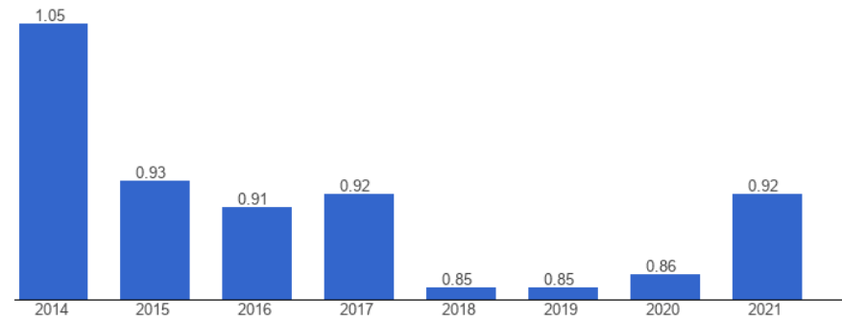
Figure 1 Political Stability of The Netherlands
Source: (The Global Economy, 2023)
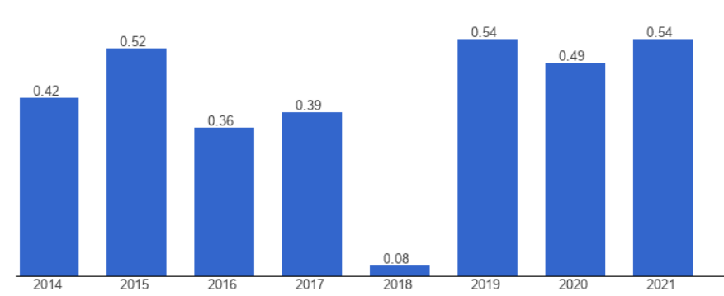
Figure 2 Political Stability in the UK
Source: (The Global Economy, 2023)

Appendix 2: Population (based on age) in Home and Host Nations
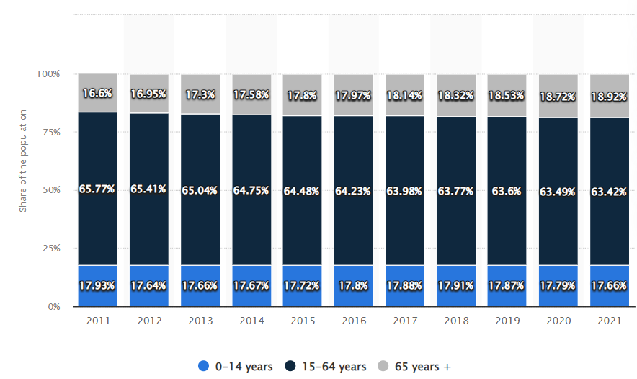
Figure 3 Age Composition in the UK
Source: (O'Neill, 2023)
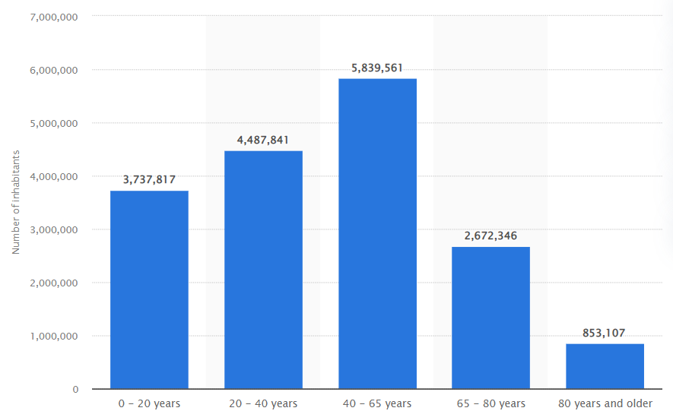
Figure 4 Age Composition in the Netherlands
Source: (Statista, 2022)

