Ryan Jones (2009252)
2009252@student.uwtsd.ac.uk
Assignment 1: E- Portfolio

Changemackers: Creativity and value creation
ACCA5033

Table of Contents
Introduction 2
E Portfolio Link 2
Screenshot home 3
Screenshot Assignment 1 3
Screenshot Task1: Mind Map 4
Screenshot Task2: What’s the Problem 5
Screenshot Task3: The Worst possible idea 6
Student Questionnaire 7
References 7
Appendix 7

Introduction

I have created an E portfolio which includes a mind map around innovation and a second mind map focusing on the research project idea.
The project idea is developing a Tae Kwon-Do training app which replicates a traditional manual guide. Such an app could be a valuable tool for students and enthusiasts due to its convenience, accessibility, and ability to enhance learning and progression. By creating a Tae Kwon-Do training app, individuals can access instructional content, training routines, and educational resources anytime and anywhere, making it suitable for busy schedules and remote learning. The app can provide step-by-step video tutorials, detailed explanations of techniques, and interactive features for practicing forms and combinations. Progress tracking features, such as belt progression, performance assessments, and goal setting, can motivate the user and guide practitioners in their Tae Kwon-Do journey. Additionally, the app can have a sense of community by connecting users with fellow students, allowing for shared experiences, discussions, and support. Overall, a Tae Kwon-Do training app can revolutionise the way individuals learn and train, providing a comprehensive and immersive learning experience. The research will compare and contrast data from those subjects who have used the app and those who have used the traditional manual to prove or disprove this hypothesis.
The assignment demonstrates what research philosophies have been explored and which apply to the project idea, in addition to the databases and search strategies that have been used and relevant feedback methods. The strategies surrounding the qualitative and quantitative research have been compared and how to increase validity and reliability in the project has been outlined. I have designed and included my proposed survey in the form of a questionnaire and focus group topics will ultimately be devised from the data gathered from the source.

E Portfolio Link

https://sites.google.com/view/e-portfolio-2009252?usp=sharing

Screenshot Home
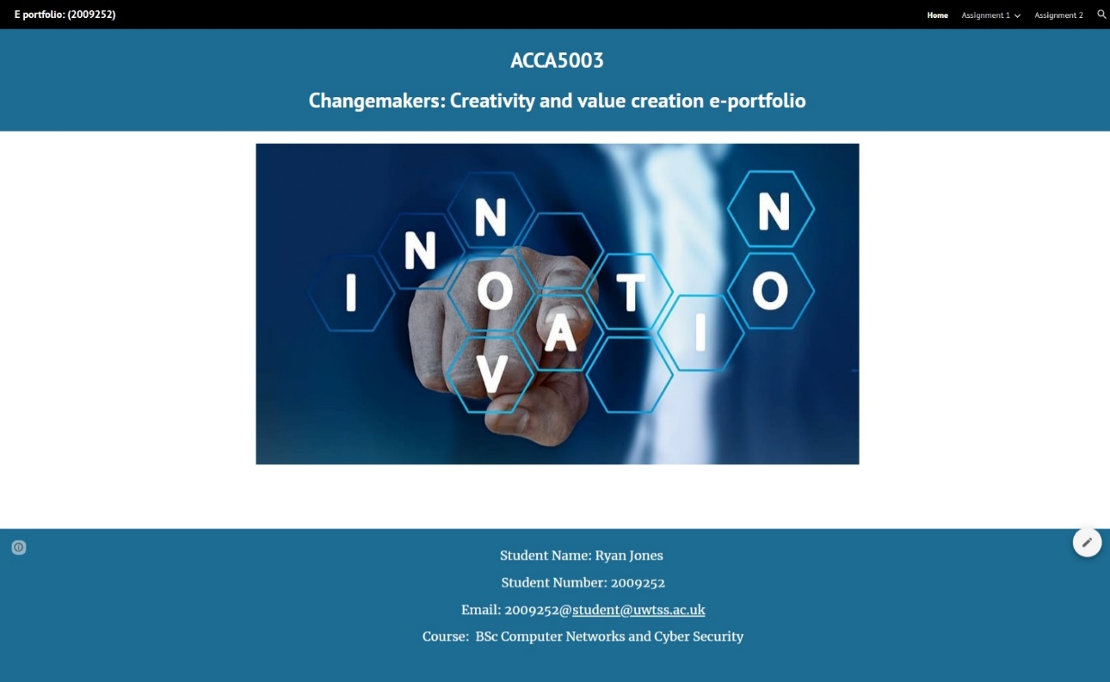

Screenshot Assignment 1
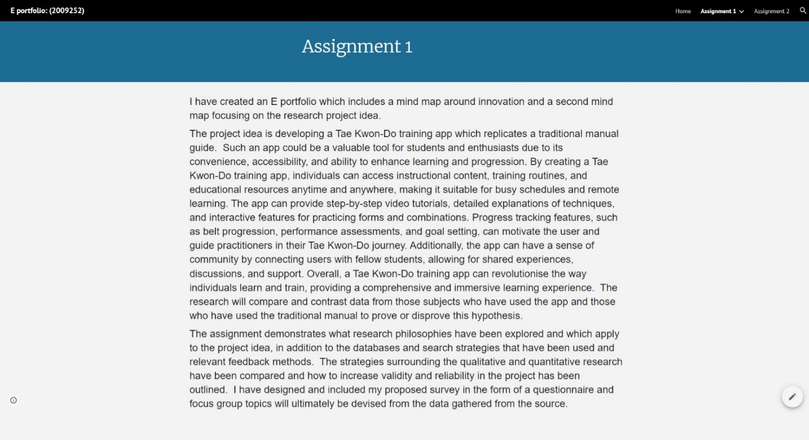

Screenshot Task1: Mind Map
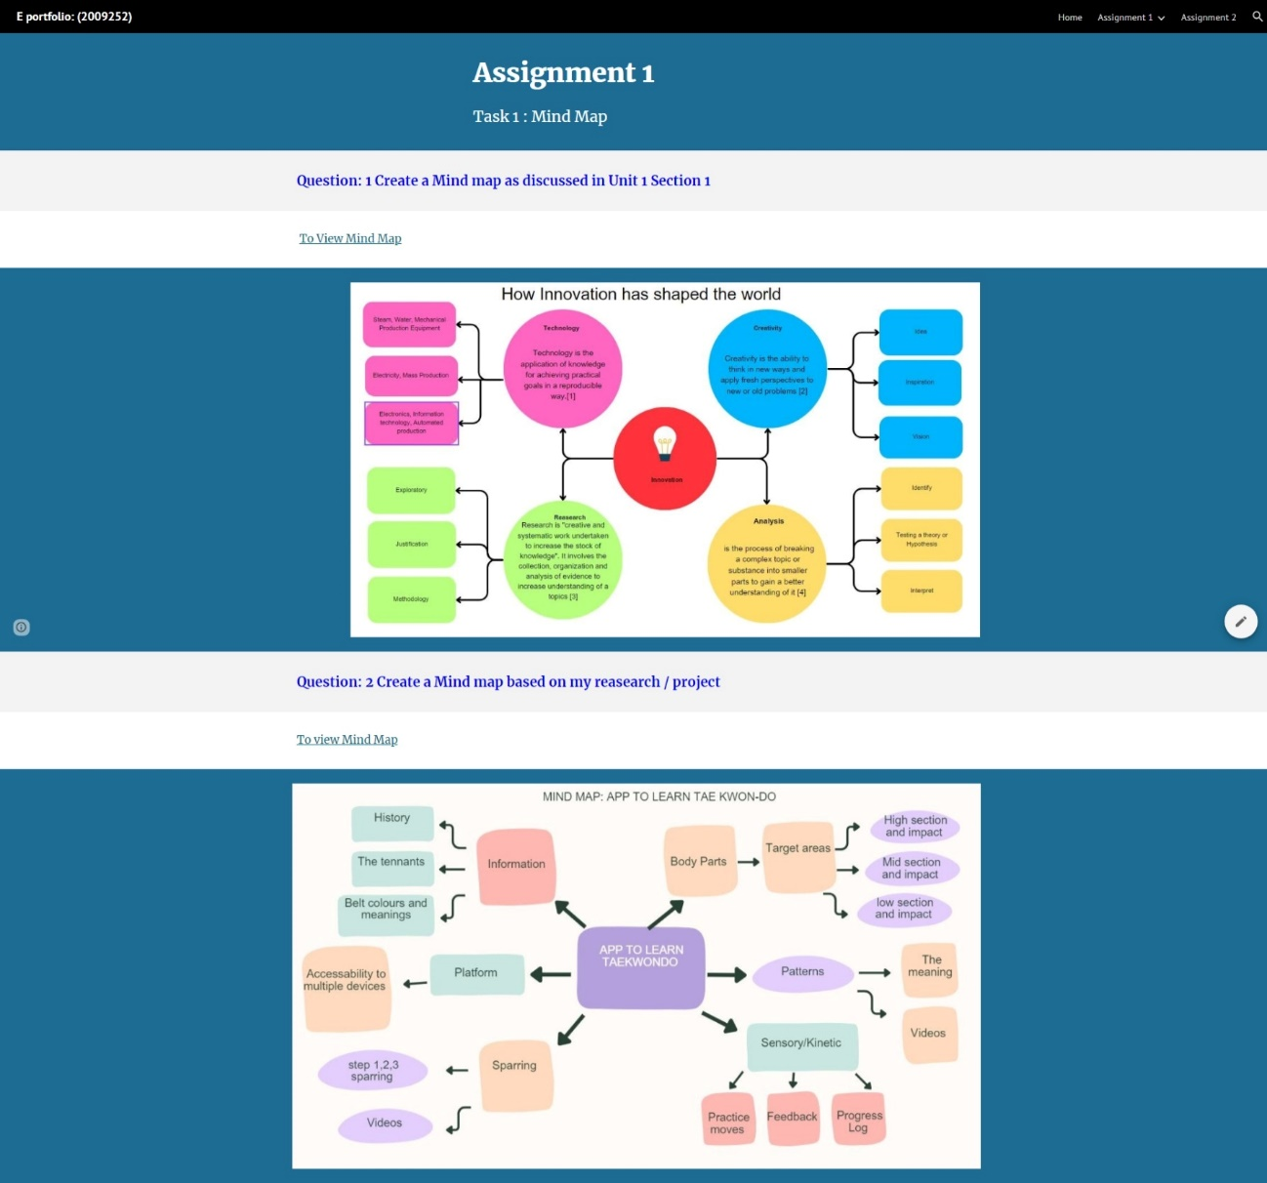

Screenshot Task2: What’s the Problem
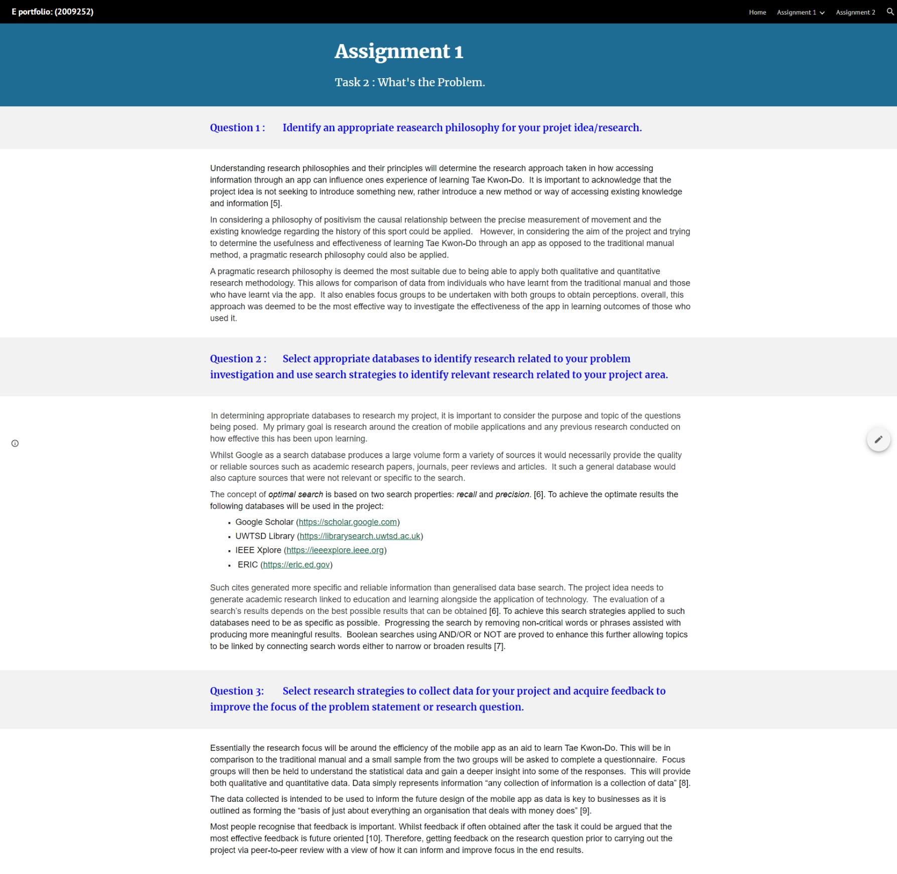

Screenshot Task3: The Worst possible idea
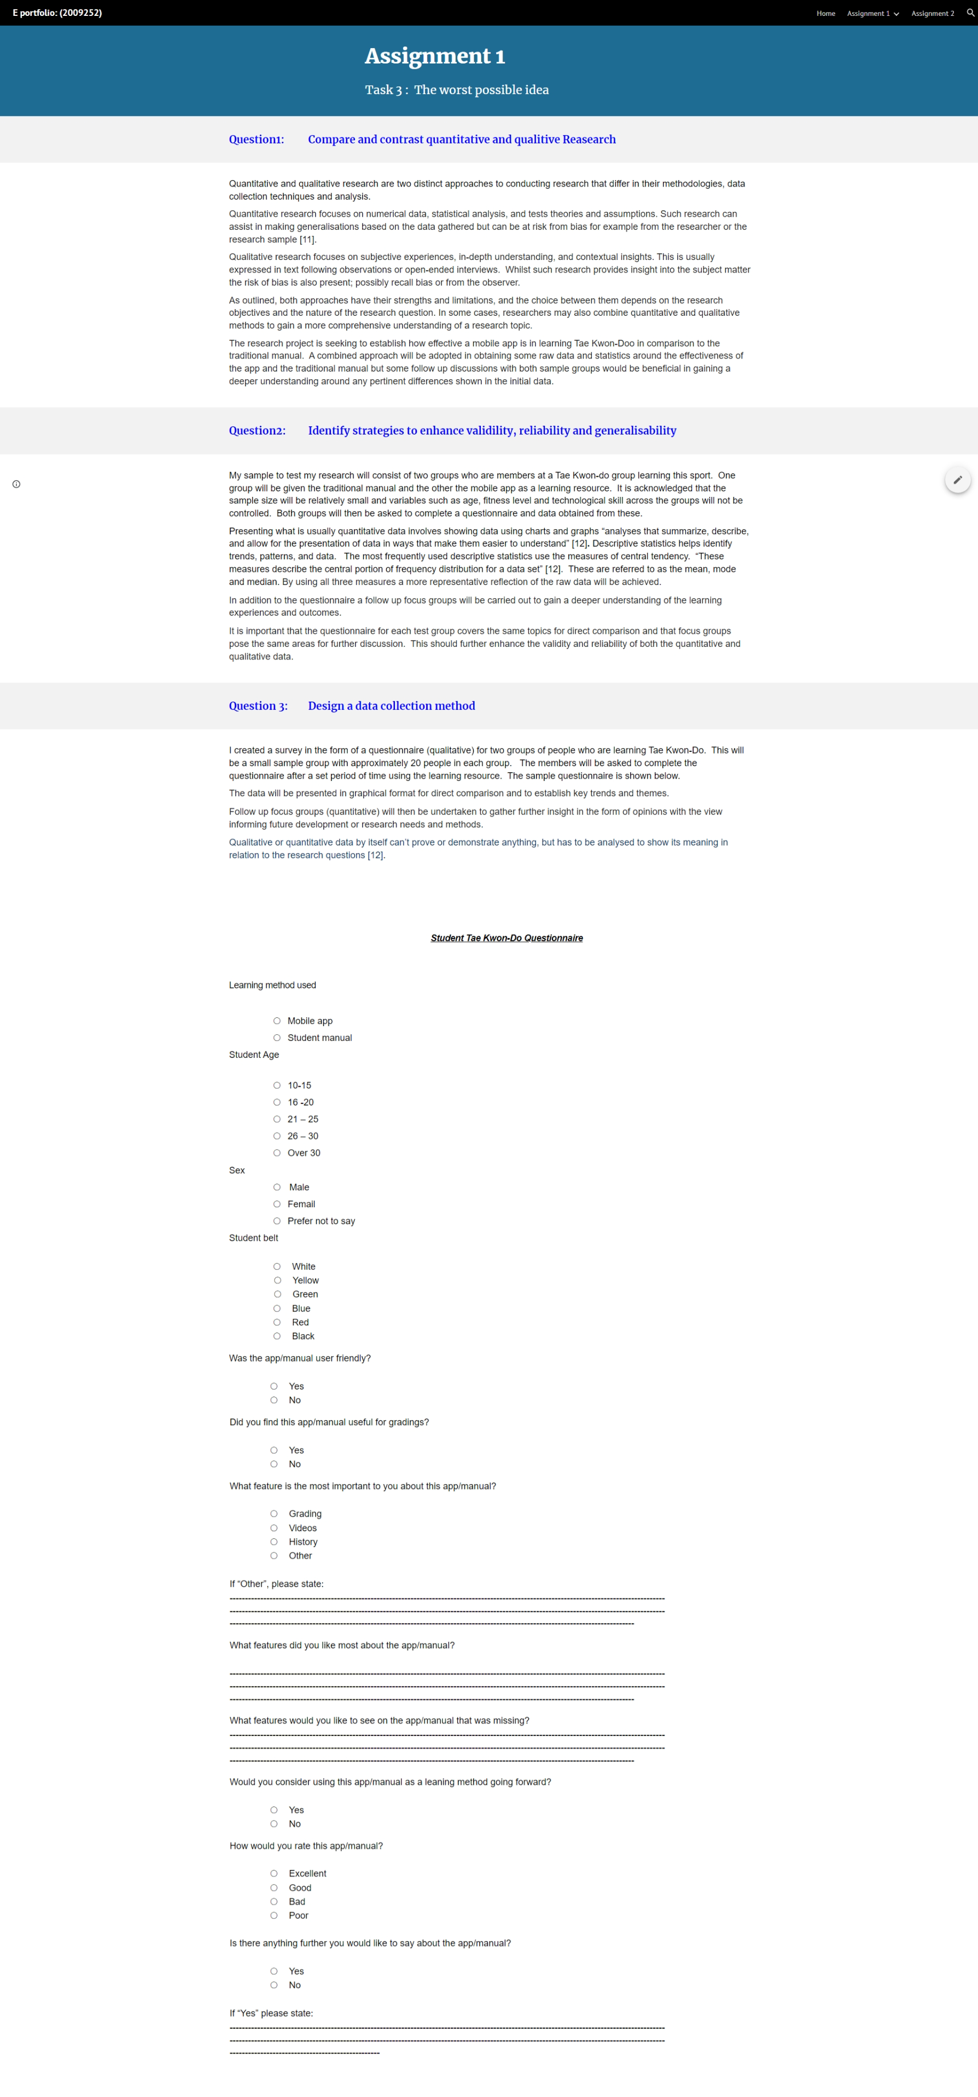

Student Questionnaire
https://uowtsd-my.sharepoint.com/:w:/g/personal/2009252_student_uwtsd_ac_uk/Ec1PS3h54jBOn8ARGRKe6PEB3nQaeC0GyP-m2JkJfZzvVg?e=kuEsCJ

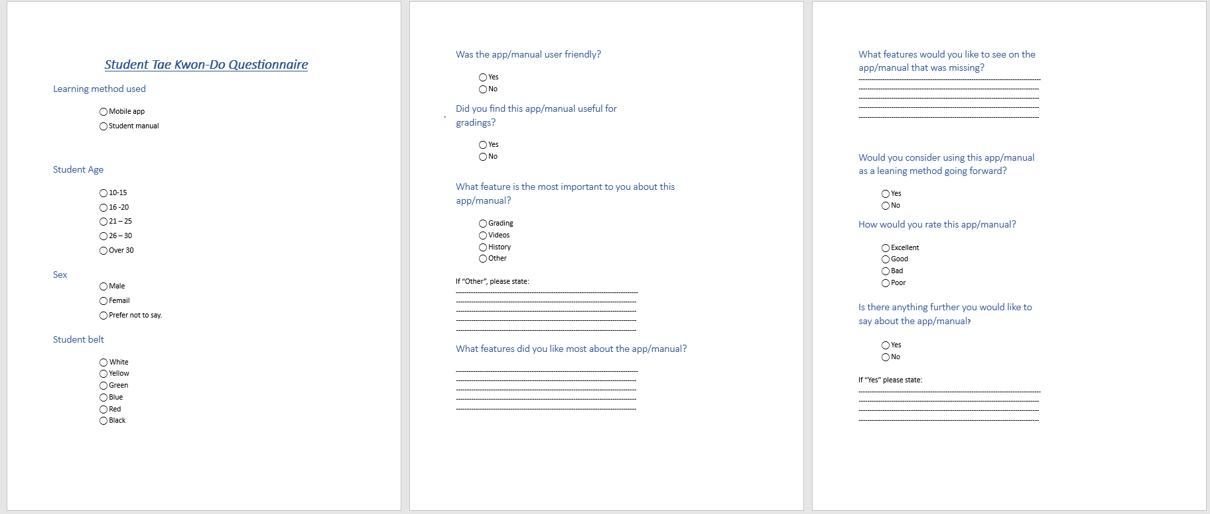

References
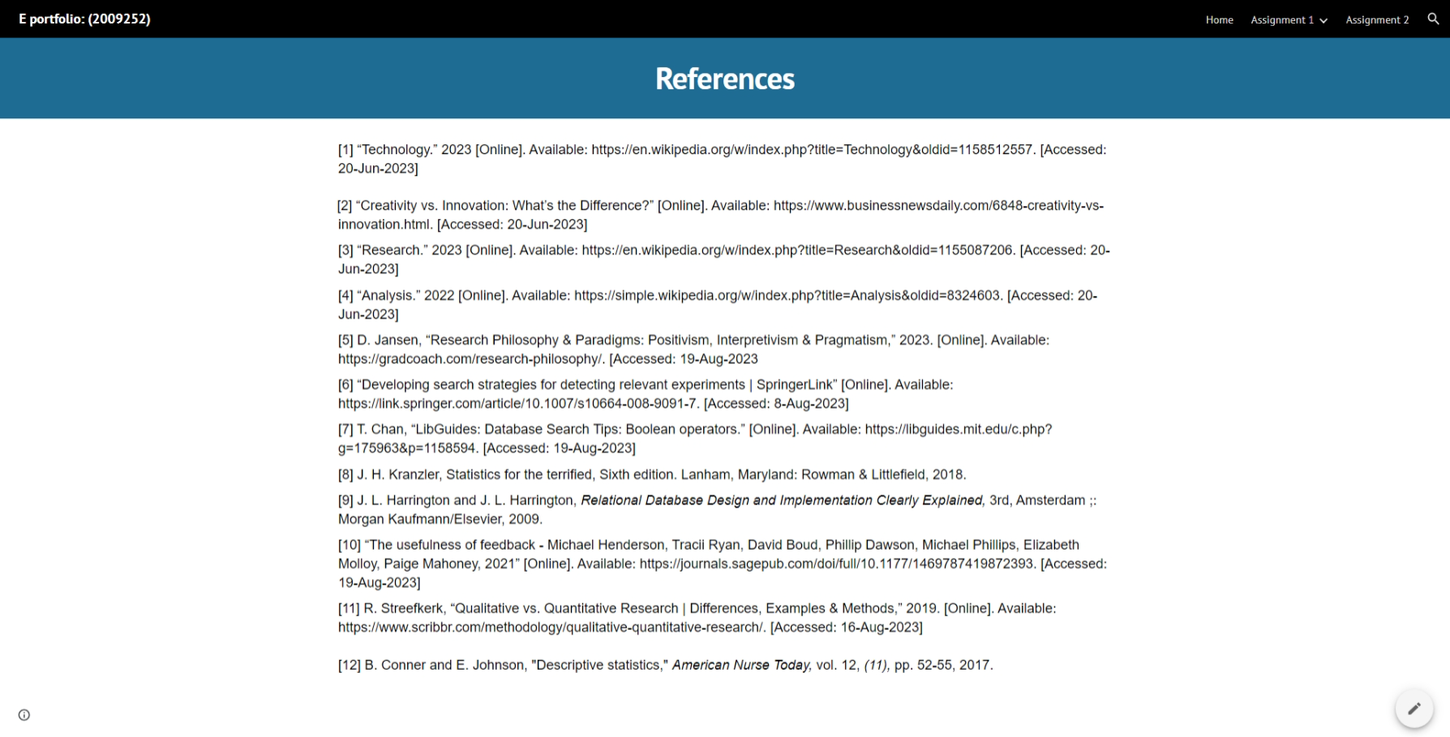

Appendix

https://uowtsd-my.sharepoint.com/:w:/g/personal/2009252_student_uwtsd_ac_uk/EY4gnOYOEZNAjoAN52xbjVABmt4QLWCG8t6A_RtrwpT6KQ?e=rqvEhv

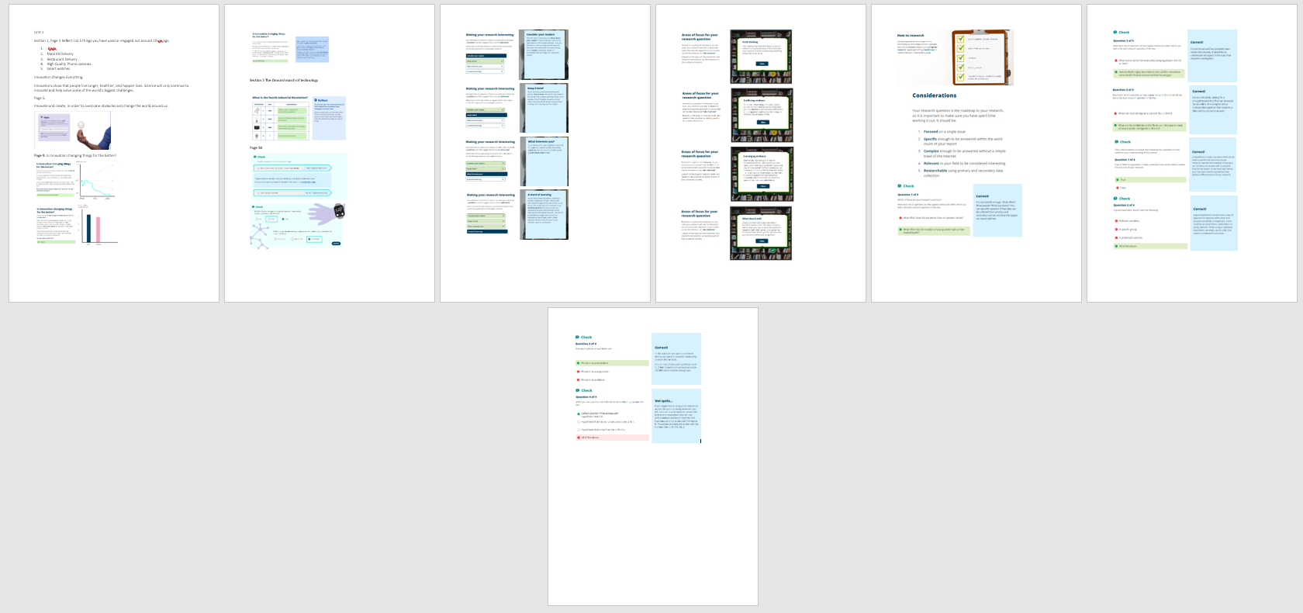

https://uowtsd-my.sharepoint.com/:w:/g/personal/2009252_student_uwtsd_ac_uk/Eev9SujwhKVFhk1BMIsUmlMBJ6NwWBukJ_36dtFJvUPIWg?e=V2s1r6



