Problem Solving Decision Making

Student Name | Vanessa Liverpool
Student Number | 1917235
Module Number | BMSW4004
Module Title | Problem Solving Decision Making
Lecturer | Balendran Kandasamey

Statement of Authenticity

By the act of submitting this assignment, I Vanessa Liverpool declares that this is my work. This has in any part, knowingly been presented anywhere else. The material used, has been from acknowledge. I hereby, confirm this statement to be true and understand the consequences, if found, plagiarism and unfair practice.

Contents
Problem Solving Decision Making 1
Vanessa Liverpool 1
1917235 1
BMSW4004 1
Module Title 1
Problem Solving Decision Making 1
Lecturer 1
Balendran Kandasamey 1
Statement of Authenticity 1
Problem Solving Decision Making 3
1.Introduction 3
2.The Workplace Problem 4
3. Analysing Information 4
3.1 SWOT Analysis 5
3.2 Fishbone Analysis 6
3.3 PESTEL Analysis 6
4. Range of Alternative Solutions 7
5. Evaluation of the Solution 7
6. Implementing the Solution 8
7. Communication plan to Stakeholders 8
8. Monitoring and review Techniques 8
9. Conclusion 9
References 9
Appendix 9

Problem Solving Decision Making

1.Introduction
Problem solving and decision making is undertaking action of defining a problem, determining the cause of the problem, whilst identifying, with in order of importance and selecting a substitute for a solution and administer the solution. (Engel, 1997).
Consequently, this is an important factor for the workplace, employers like to see these skills as it helps to show great level of competency such as creativity, critical thinking, analytic thinking and determination. In addition, it can help with progress more quickly and develop career opportunities. Being fully staffed is a vital importance in order to run the operations; lack of staff can cause delays and can cause lost in cost and deficit for the organisation. To begin with, Eurostar is an organisation of transport via train which takes passengers to and from London, Paris, Amsterdam, and Brussels since 1999. Whilst, Eurostar is a train form of transport it is considered to have the same rules and regulations as the aviation. However, Eurostar has been reported in the evening standard to be losing staff based on their lack of hiring and communication. In addition, they process at least 20.000 passengers a day. At passenger screening, we screen passengers, luggage, passport, and body search. Furthermore, we screen to protect passengers, staff, and Eurostar properties whilst ensuring that items and people including staff does not enter the restricted zone with prohibited items. Most airports face these issues. We have conducted a survey anonymously using a questionnaire. This report will discuss the short of staff issues in the organisation and its impact whilst analysing the shortage of staff and the communication problems using a SWOT and PESTEL analysis and the fishbone concepts to demonstrate the impact of the problem and causes and effect.

2.The Workplace Problem
To begin with, the law is that females are to search females, with that being said, all staff must remain to their position for twenty minutes, which is loading the passenger items, body-search where a male and female stand and that position just in case either gender sets the alarm off and they need to be search, screening where the staff either gender, seats in-front of the screen to check possible prohibited items in passenger luggage. Additionally, there is also a staff member who is here for when the screen reader rejects the bags for search, rather there is an item than is not quite visible or just for routine checks. Admittedly, this does not always happen, as we are constantly short of female, and so the change around, in other words, the change of position for specifically females are not always possible. For this reason, the organisation is struggling with breaks, such as lunch break and toilet breaks; in fact, team leaders have a list as to who goes to the toilet first depending on a first come first serve basis regardless of the sense of urgency. Hence why staff take sick leave under stress as these females are unable to cope with the lack of staff, along with women who go off on maternity. In fact, those who are at work but are unable to work due to pregnancy. Certainly, due to their rights this has a great impact on the organisation, which needed to be addressed in order to make a decision moving forward (Stafford, 2018).

3. Analysing Information
Subsequently, as mentioned above, the female staff issues are really having an impact on the organisation. Eurostar is constantly short of staff for these issues, stress at the workplace, a lot of sickness, pregnancy and maternity leave. Due to this some staff have become selfish and even aggressive towards each other, as staff think about their own personal wellbeing. Some female staff have to stand for longer time than the handbook requires them to. On the other hand, whilst staff are unhappy, the managers are not actively doing something about it, most times, it is the union involvement which will create another batch of recruitment process. Which usually take a while, due to the nature of the job its confidentiality and counter-terrorism clearance. As an example, when I was pregnant, I felt bullied, however, I also felt the pressure for my peers, as I could only sit on the screening position, bag search and exit check which affected the operations greatly. Because of this, my peers had to stay on the body search for a longer time such as forty minutes. Moreover, I could not go to the toilet as I wished as a mom to be as someone had to cover my position each time, sometimes my colleagues refused to cover me as they were frustrated, and if they did cover me the chances would be that they are next to sit and may well lose their opportunity to do so. As returning to their position after covering was never guaranteed. The consultant came up with all the why`s in the questionnaire in the appendix and the fishbone diaphragm to explain the impact and causes of Eurostar.

3.1 SWOT Analysis
Analysis of the shortage of staff and communication.
Strength – this is a point which make the company has reliable grounds. The communication must be communicated effectively among the staff and passengers; this would be at a great advantage for the organisation so it to grow and develop, as a result, communicating the reasons for delay will help passengers to have an element of understanding and will show that the organisation actually cares for its passengers.
Weakness – this Is where the organisation needs to be more alert, as lack of staff and communicate among themselves more effectively. As a result, passenger may well go elsewhere.
Opportunities – these would be beneficial for the company by hiring more staff, and promote those with experience with managerial positions, whilst providing frequent training for the new recruit.
Threat – these would cause the organisation to make great lost if they are found to be unable to recruit, as they may well lose passengers and staff will potentially walk away, such can put the organisation in a financial distress.

3.2 Fishbone Analysis
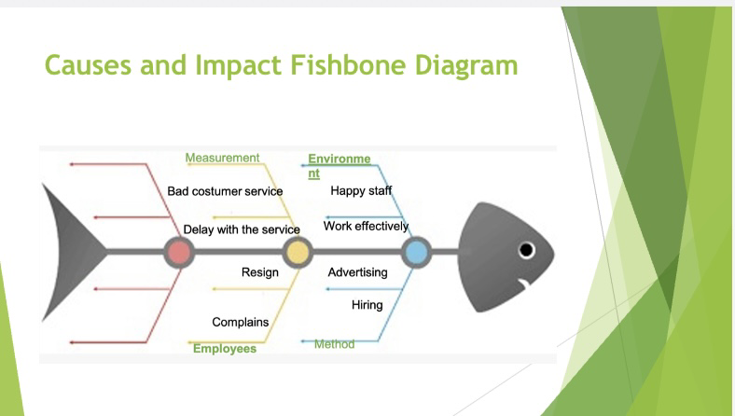
Similarly, whilst analysing this situation, it came to my understanding that there is a lot of changes needed to be done, consequently, with the way in which the management communicated with staff and how they adhered to their problems. I found that the employees where not heard, specifically the females on site. It is almost as if they were being discriminated against. Their environment was quite uncomfortable, there was a sense of malice based of the shortage of staff and the lack of communication among colleagues. As a result, these women were unable to do their jobs effectively and were always unhappy. Subsequently, the company faced delays and bad customer service, in addition, the staff threatened to hand in their resignation and this has created a great number of complaints from staff and passengers. (Bowen,2016)

3.3 PESTEL Analysis
Along with my previous analysis, I have also used PESTEL analysis to discuss the external impacts of Eurostar staff problem shortage. Whilst the political factor did not affect our company, it did affect it economically, as we are having to recruit staff whilst there is enough on the books. Socially, the way in which we are seen, such as this report being in the newspaper was not a good look for Eurostar. However, the technological does not affect the company in any way, however, the environmental impact surely affects Eurostar, as it depicts the idea of travel and tourism in itself. The legal aspect has a great impact on Eurostar, as staff could potentially take the organisation to court for discrimination and health and safety (Johnson, 2008).

4. Range of Alternative Solutions
For this purpose, they are a few solutions that I may have come up with, for instance, providing a refresher training for team leaders to better enhance the team on an equal level. In addition, it is imperative that the management finds way to assist excepting mothers, for example, ensuring that there is a possible office where they can work from. It would be great if Eurostar could consider bank staff ready to work to cover any form of sickness whilst waiting for the new recruits to be trained. Nevertheless, I do understand that these changes may be costly as bank staff can be pricey and may well be a disadvantage for the organisations, meanwhile be a great advantage to the staff. I do appreciate that cost is a great factor, but if recruitment is conducted as soon as staff have reported their pregnancy then all could potentially reduce cost. Yet another solution in my evaluation would be to close a few machines, instead of having ten, we can then work with eight and have a few staff a float in order to cover toilet breaks or overworked staffs.

5. Evaluation of the Solution
After brainstorming, I came up with the evaluation that hiring staff was the best possible solution for the organisation. I have made this conclusion as in my opinion, if the organisation keeps hiring staff, then it keeps the level of maternity leave a float. If the management adhere to staffs concerns this will enhance the capacity of which Eurostar can give to its passengers. Re-training staff and managers will also enhance the communication between each other. As a result, managers will be more flexible in which ways they can allocate breaks such as toilets breaks, specifically with those who may need it the most and often as may need to. I have created a PMI (plus, minus, interesting) chart, to explain my decision (Combes Taylor, Lashman,1994).
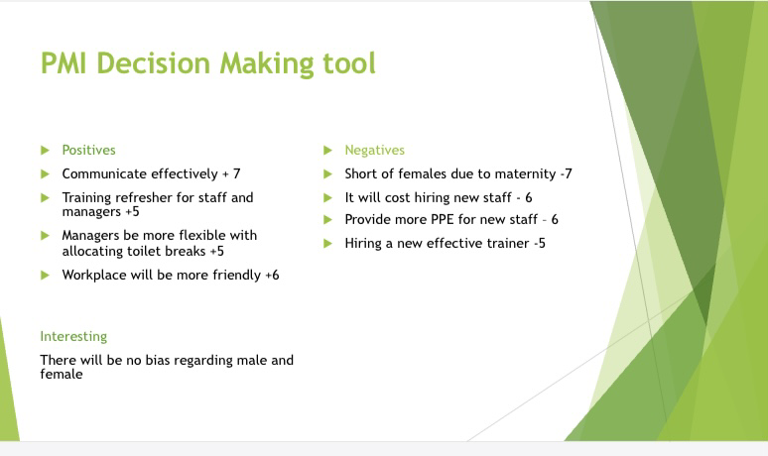

6. Implementing the Solution
Admittedly, to execute this plan, I have to come up with ways of implementing it. To begin with, I have designated a manager specifically to be in charge with hiring staff and communicating effectively by re-training all personnel. Nevertheless, this will be communicated to everyone, via email and staff meetings. I have also decided, who would be accountable for and who would be responsible to execute this feasible goal; in other words, who and how will updates be provided, and how often will this be – and so I have decided that this should be done on a monthly basis.

7. Communication plan to Stakeholders
Assuredly, in this situation, it is vital to understand that our employees, manager, and owner (contractor) are my shareholders then later my customers. However, it is my intuition that in this problem, I needed to focus on the internal stakeholders. These are very important, as if these are not happy or well communicated with then it can potentially affect our external stakeholders, moreover, affect the way in which the organisation is run. As I result, I will be communicating with these via email, and monthly staff meeting.

8. Monitoring and review Techniques
Above all, it is vital that we implement a time frame, by using a monthly strategy review session. These dates will be set, for an entire year in advance. We will continue to keep a record of our findings by doing this we will be requesting feedback, by monitoring, questionnaires, and asking others who may have been affected by my decisions.

9. Conclusion
To conclude, the shortage of female staff hurdles, are connected with communication issues at the workplace. Mainly financial, as the organisation has to find extra funding in order to recruit staff, advertise for the position and also for training purposes. However, with the new team put in place, with great communication skills, and continuous reviews, Eurostar has the potential to reboot their losses, and will be able to create a safe and fair environment for its staff. As a result, they will be able to fulfil their goal whilst maximising its capacity, this should help their customers to be happy and refute any delays cause by shortage of female staff. Last but not least, this will enhance a better working environment, friendly and amicable staff.

References
Stafford, K (2018). Work the problem: How Experts Tackle Workplace Challenges
Combes Taylor, J, Lashman, R (1994). Practical Problem-solving Skills in the Workplace American management association 1994.
Johnson (2008). A PESTEL Analysis of the company Siemens.
Bowen, P (2016). The Fishbone Diagram Handbook, publisher Emereo Pty Limited, 2016
Engel, A (1997). Problems – Solving Strategies

Appendix



