Student name: Sharif Fathi
Module: AI and Machine Learning
Module code: ACDA5003
Lecturer: G Dickers
Assignment Title: Search

TASK 1:
The supervisor has asked me to write application in C++, that implement an AI agent that systematically search a storage. it was expected to use function or class to create the application or game that will simulate and display the agent searching for the objects in the facility.
The storage area map must be read from file. The walls can be represented by character. To do this, I’m going to write algorithm that convert the format to a graph representation and the map should be a grid of at least 16 by 16 squares with the agent occupying one grid square at a time.

Here is the menu of the application, the user can choose these options by entering 1, 2 or 3.

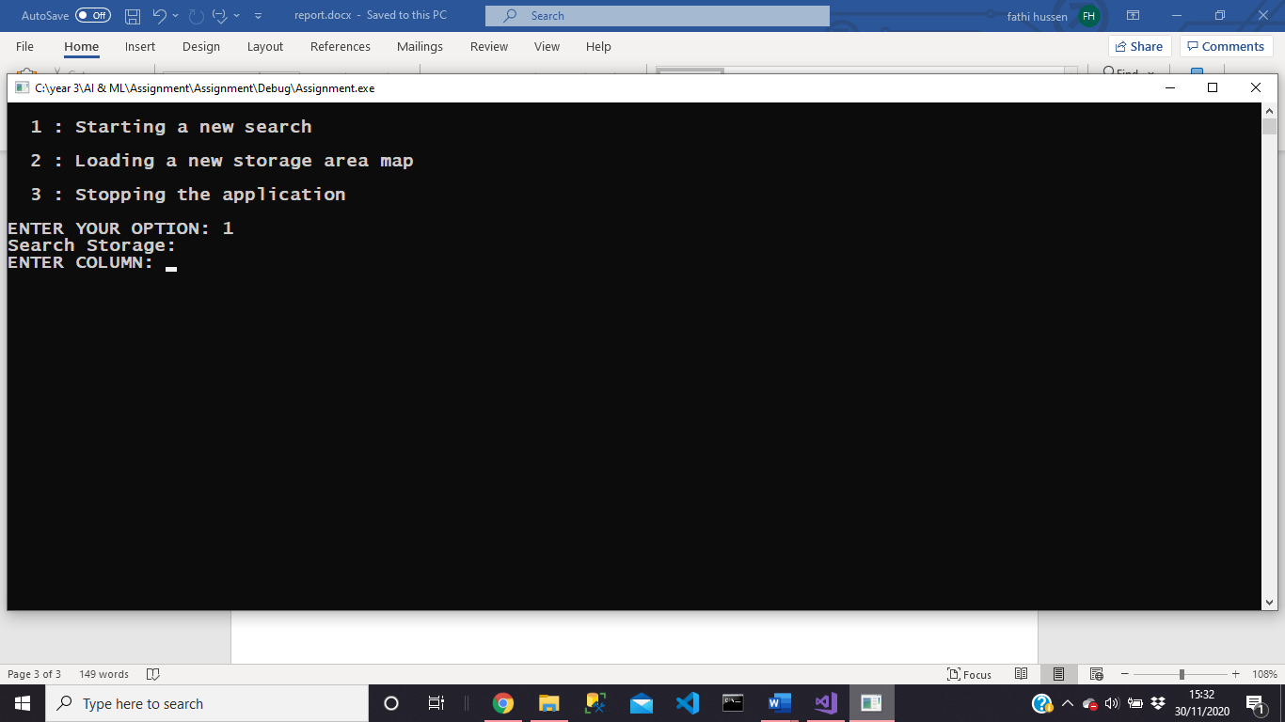
When a user choices option one, then the software allows the users to search.

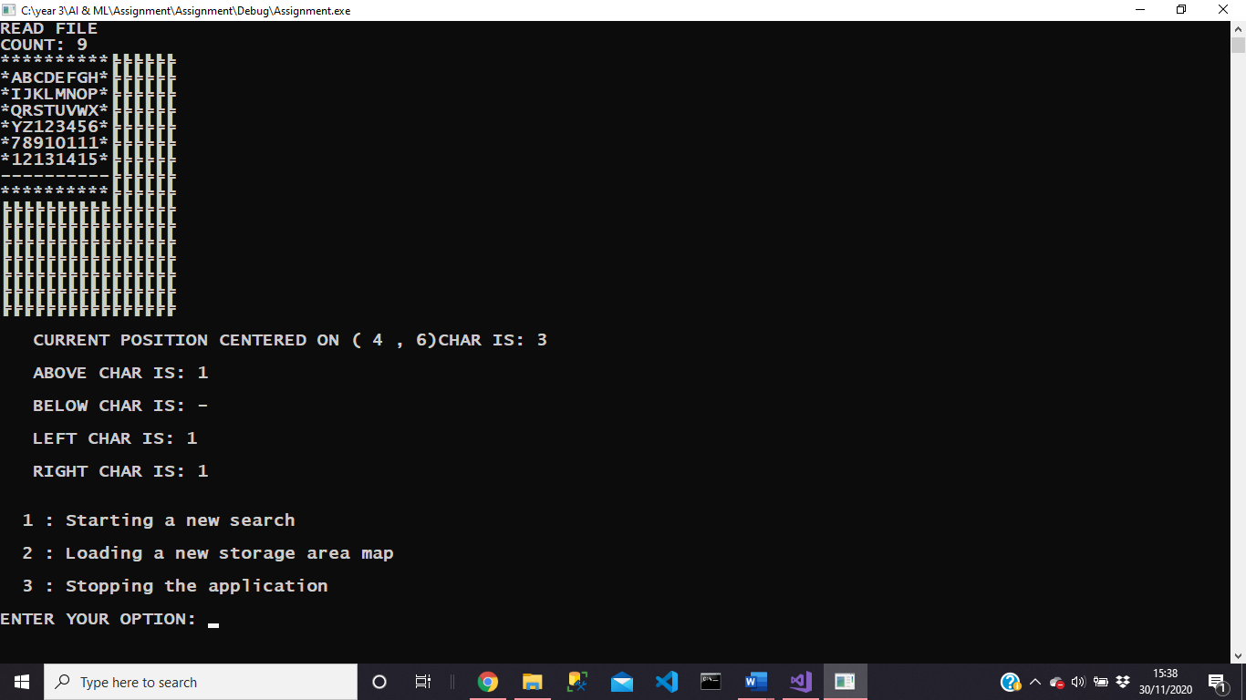
Here is after when the user searched. It shows the gird map which is 16 by 16 and it also shows the users the position they searched.

If the user chooses the option 2, it allows them to see the grid map.
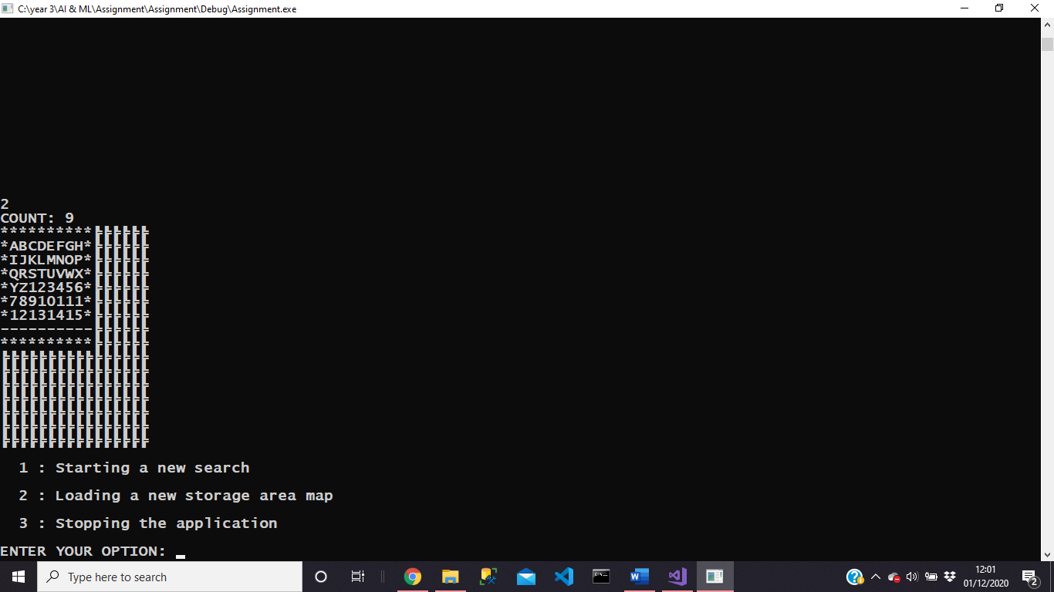

Option three ends the application.
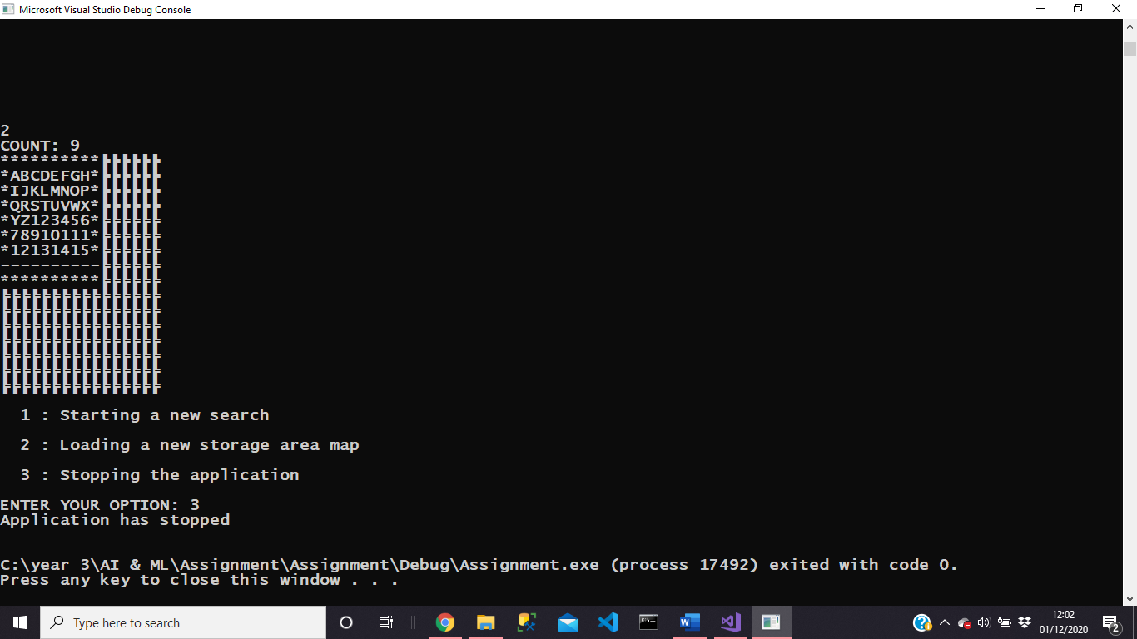

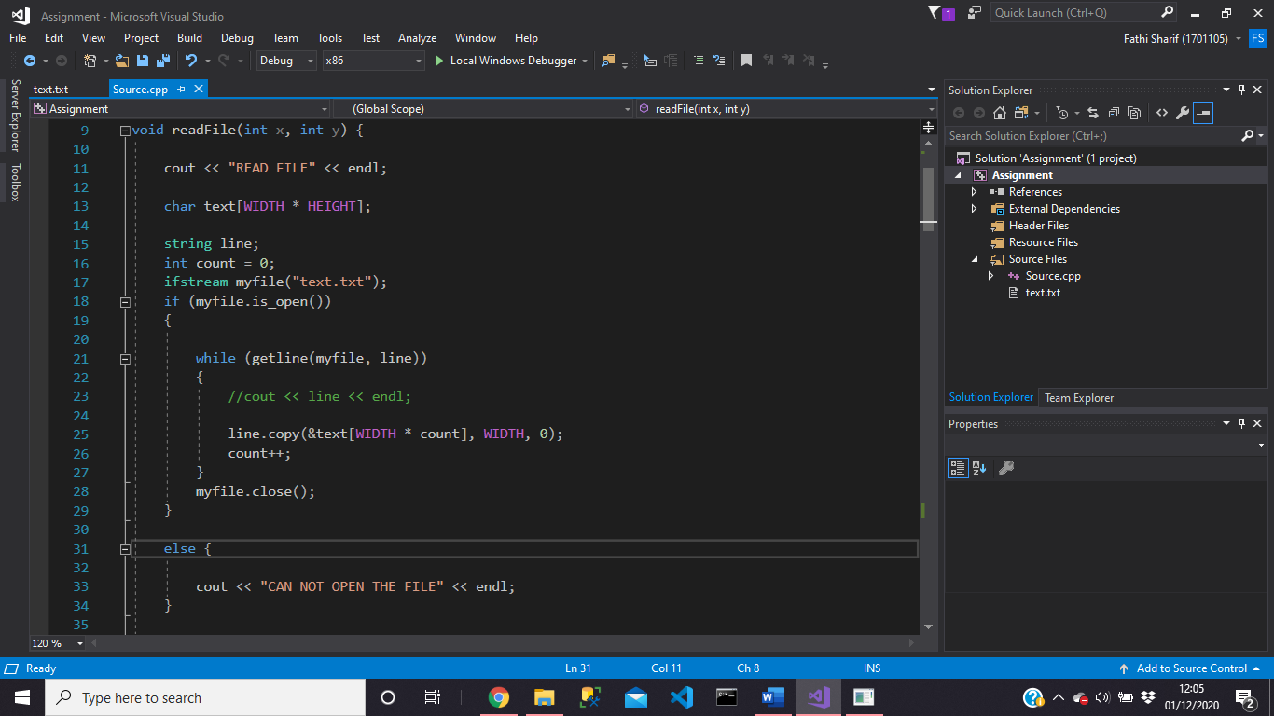
Here there is screenshot of function that reads the files and outputs the 16 by 16 grid map. As you can see the if statement checks if the file can be opened.

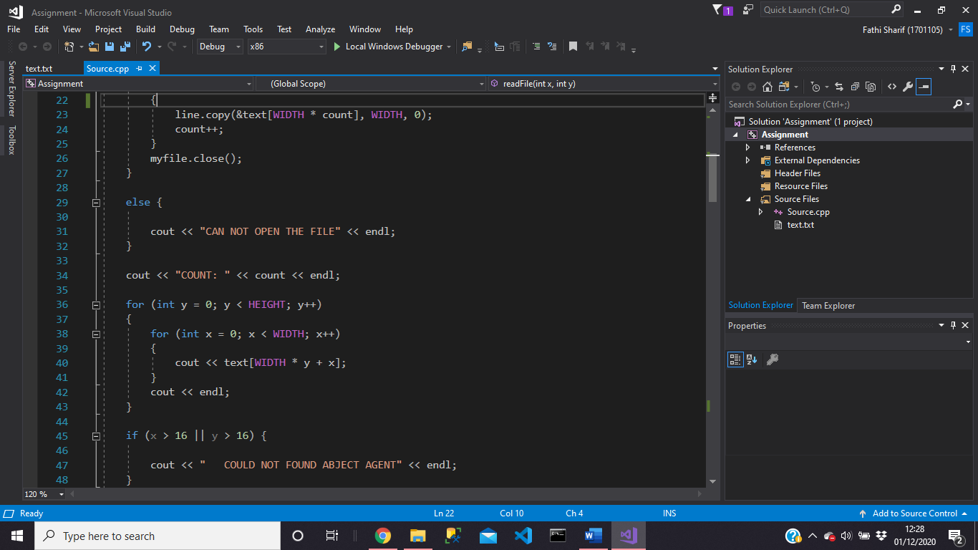
Here there is loop that loops over two-dimensional array and then outputs 16 by 16 grid.

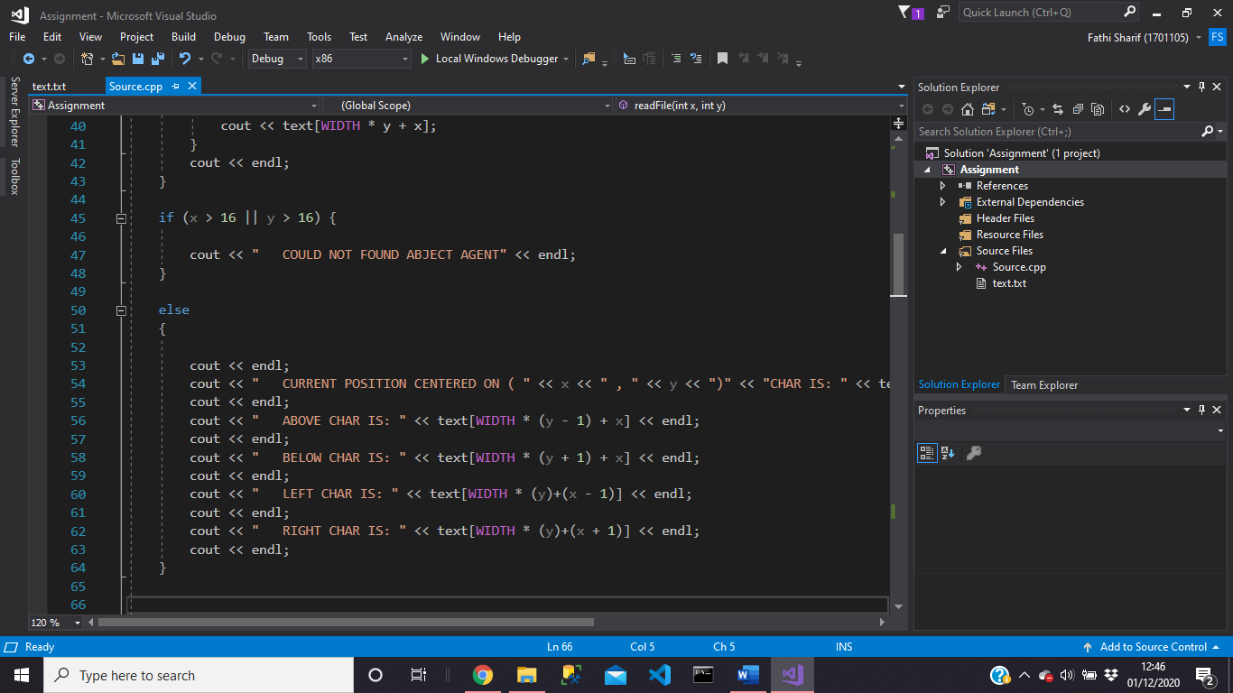
Here, there is code that outputs the users search.

As you can see screenshot, there is function that allows the user to search.
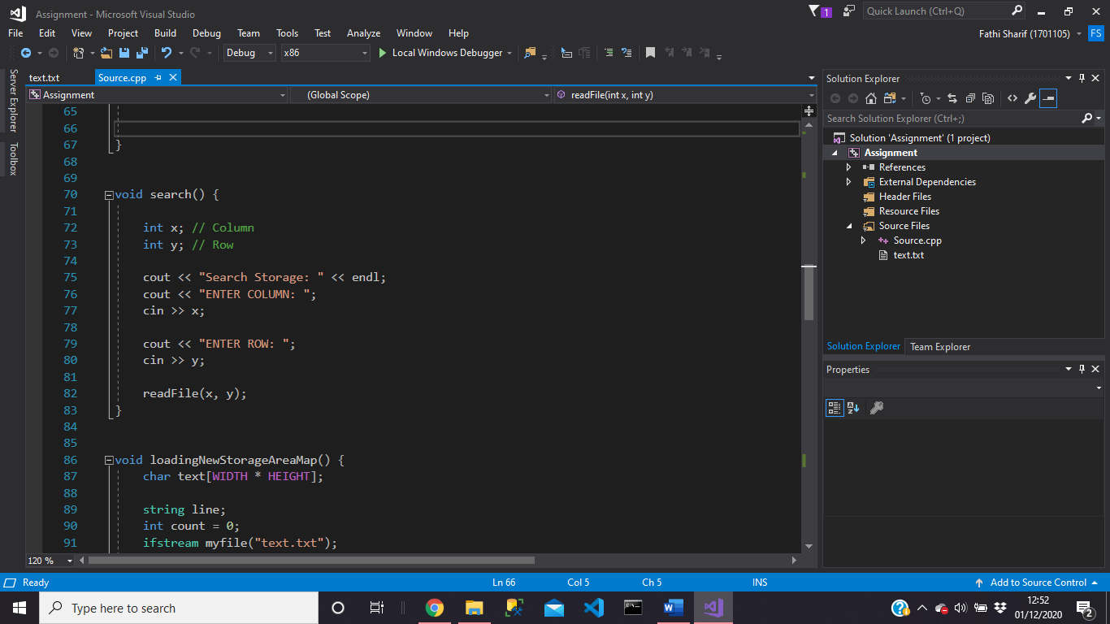

This function outputs the 16 by 16 grid.
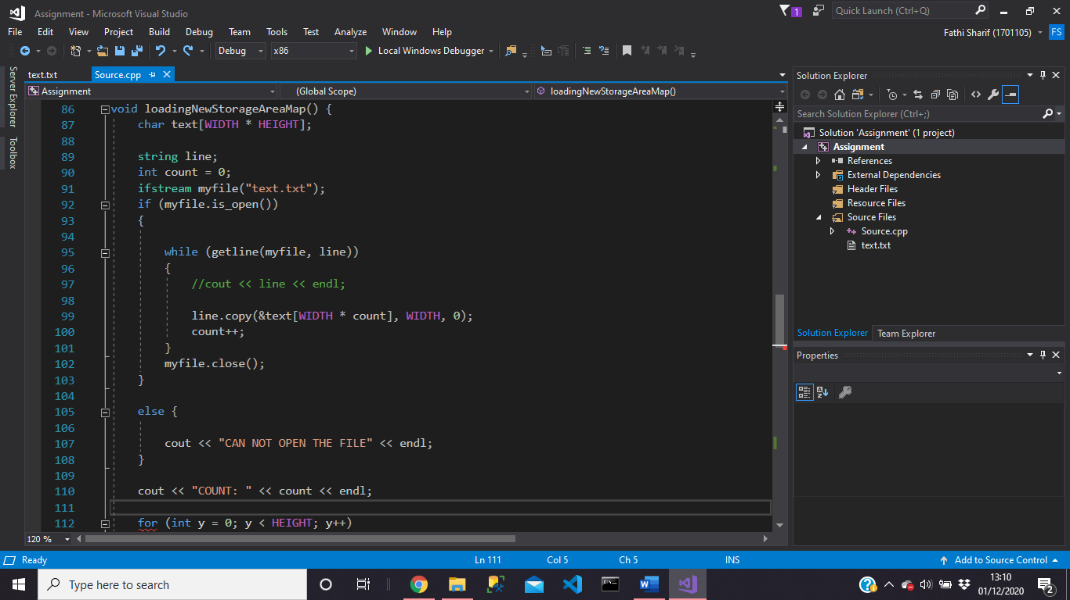
Here is the menu that allows the user to choose their option, and as you can see there is switch statement takes the option of user.
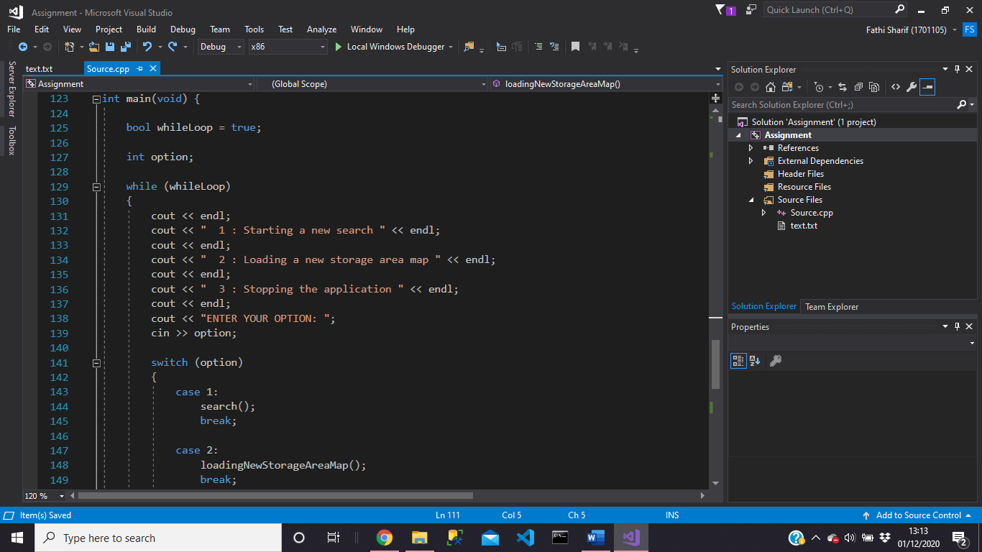

Task 2:
What is Hill Climbing?
In Computer science hill climbing is an algorithm method which is part of the family of local search which continuously moves in the direction of the value increasing to find the peak of the mountain or the best solution to the problem. This algorithm is for example a traveling salesman problem in which we need to minimize the distance travelled by this salesman. This algorithm is also a greedy algorithm which is only looks to its good immediate neighbour state and not outside that. A node of hill climbing algorithm has two different components and they are state and value.
Here are the main features of hill climbing is that it generates, and test method produce feedback which helps to decide the direction to go when searching. This algorithm search moves in the direction which is going optimizes the cost and it also doesn’t backtrack the search space, as it doesn’t remember the previous states.
The algorithm has different regions in the state space landscape and the first one is local maximum which is a state that is better than its neighbour states, there is a higher state known as global maximum which is the best possible state of state landscape. Current state is the state that the agent is currently present. Flat local maximum is the space where the landscape neighbour states of current states have the same value and shoulder is where plateau region has an uphill edge [1].
Simple Hill climbing:
According to the author [2] there are different types of hill climbing the first one is known as simple hill climbing which is one of the easiest methods. The way that it works is by taking one state of a neighbour node at each time, and then looking for the current cost and declares the current state. After checking the status of the next neighbour state, then if the success rate is higher than the previous state, then it tries to move otherwise it stays the same position. The good thing about this is that it takes less time but the bad thing about this is that it does not guarantee the best optimal solution as it gets affected by the local optima.
Here are the steps of Simple Hill climbing:
Step 1: First evaluate the initial state.
If statement:
- If the If statement found the final state, then stop and return success (True).
- If the If statement doesn’t find the final state, then make this the current state.
Step 2: If the If statement doesn’t find the given solution, it performs a loop.
- A state that was not applied should be selected as the current state and this help the state because it produces a new state.
- Then that new state is evaluated and produced.
If statement:
- If the If statement found the final state, then stop and return success (True).
- If the If statement found a better state then the current state, then declare the new state as a current state and proceed.
- If the If statement doesn’t find a better state, then perform looping until it reaches a solution.
Step 3: End the process.

Steepest Ascent Hill climbing
This second type of hill climbing algorithm is known as Steepest Ascent Hill climbing the way it works is that it selects the next node by analysing all the neighbour nodes. What happens is that after the node that gives the best solution is selected as the next.
Here the steps of Steepest Ascent Hill climbing:
Step 1: First the algorithm will perform evaluation on the initial state.
If statement:
- If the If statement achieves the goal state, then program stops the process.
- If the If statement doesn’t achieve the final state, then the current state needs to be declared as the initial state.
Step 2: It will repeat the state if the current state doesn’t find a solution or fails to change.
Step 3: End the process.

Stochastic Hill Climbing:
The third type of the algorithm is known as Stochastic Hill Climbing and is very different from other two because the way it works is by selecting neighbour nodes randomly and it decides to move or randomly choose another node.
Problems of Hill climbing algorithm and ways to overcome the problems:
Local maximum: After learning about this algorithm, I found that the algorithm has some limitation and often it gets stuck. The hill climbing algorithm it always trying to move in the direction of the increasing value, but it ends up in a local maximum because the neighbour states is worse than the current state when is compared. The Hill climbing algorithm is going to end the process because is following a greedy approach. One way that you can overcome this problem is by using backtracking technique where the algorithm keeps tracking the value of every state that it already visited.

Plateau: It also gets stuck when all neighbouring states has the same value which is makes it hard for the algorithm to choose a proper direction. You can overcome this problem by using the method known as Stochastic Hill Climbing because this type of method chooses random state far from it is current state.

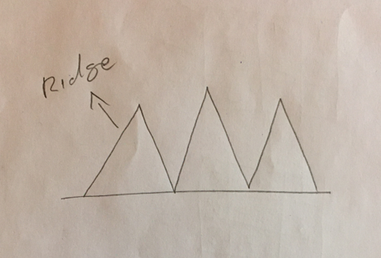
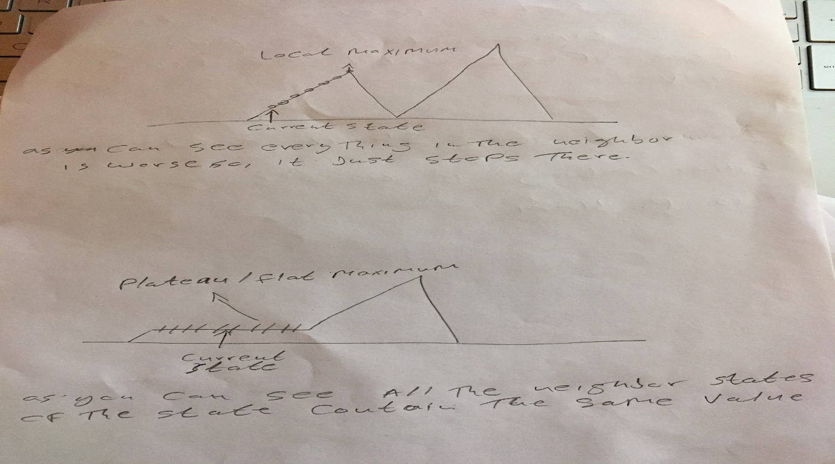
Ridge: The third problem of hill climbing algorithm is that there are sequences of local maxima, making it hard for the algorithm to navigate. There is way that you can overcome this issue and the way that you can overcome is by applying a technique that allows it to travel in all possible directions at a time.

Task 3:
It was asked to solve the Eight Tiles problem which is commonly used in AI to test and evaluate local search algorithms. The puzzle is 3 by 3 grid with 8 square blocks that was labelled 1 to 8 and a block square as shows below.
1 | 4 | 2
6 | 3 | 5
7 |  | 8
 | 1 | 2
3 | 4 | 5
6 | 7 | 8

The goal of the puzzle is to rearrange the blocks so they can be in order with blank space is at the start of the puzzle. It was also asked to show how hill climbing is can be used to solve this problem by working through the problem above one move at a time. When answering the problem, it was asked to the heuristic function h (), where h () represents the number of titles out of place after a move is compared to the finished puzzle. It was also asked to calculate the value of h () for all potential valid moves and so I can select the best each time. So, I must draw the 3 by 3 grid when a move is been made, I must write down all h () values calculated for that move.
Before starting to solve the puzzle, I needed to understand what heuristic function was and after doing a lot of research I found out that heuristic function is a technique that ranks all the possible alternatives at any branching steps in searching algorithm based on the information is available for the heuristic function [3].
For me to understand how to find potential valid moves, I have created a graph of neighbours for the puzzle problem. This the starting point of the puzzle and as you can see the neighbours are 3, 7 and 8. After understanding now I can define the neighbours based on where the empty tile is.
1 | 4 | 2
6 | 3 | 5
7 |  | 8
 | 1 | 2
3 | 4 | 5
6 | 7 | 8
Index = 0, [1, 3]
Index = 1, [0, 2, 4]
Index = 2, [1, 5]
Index = 3, [0, 4, 6]
Index = 4, [1, 3, 5, 7]
Index = 5, [2, 4, 8]
Index = 6, [3, 7]
Index = 7, [4, 6, 8]
Index = 8, [5, 7]

 | 1 | 2
3 | 4 | 5
6 | 7 | 8

1 | 4 | 2
6 | 3 | 5
7 |  | 8
H = 5
Potential moves: 7, 3, 8

Here is the Starting point of the problem and there are total of nine boxes. Each tile has one digit from one to eight. The current values that is in the correct place are (2, 5, 8) and all the other 5 values must move into the correct places.
1 | 4 | 2
6 | 3 | 5
 | 7 | 8
H = 4
Potential moves: 6, 7

1 | 4 | 2
 | 3 | 5
6 | 7 | 8
H = 3
Potential moves: 1, 3

1 | 4 | 2
3 |  | 5
6 | 7 | 8
Move up, now number 6 is in the correct place and there are 3 tiles that out of place after comparing to the goal puzzle.
Move left, now number 7 is in the correct place and there are 4 tiles that out of place after comparing to the goal puzzle.
H = 2
Potential moves: 3, 4, 5, 7

Move right, now number 3 is in the correct place and there are 2 tiles that out of place after comparing to the goal puzzle.
1 |  | 2
3 | 4 | 5
6 | 7 | 8

H = 1
Potential moves: 1, 4, 2

Moving up, now number 4 is in the correct place and there are 1 tile that out of place after comparing to the goal puzzle.

 | 1 | 2
3 | 4 | 5
6 | 7 | 8
H = 0
Potential moves: --

Moving left, now number 1 is in the correct place and there are 0 tile that out of place after comparing to the goal puzzle. End process.

Task 4.
On Task 4, it was asked to identify another suitable distance measurement to use the heuristic function and repeating task 3 using this measurement. Will be using Manhattan distance heuristic which is one of the simplest ways you can measure, and it also can estimate the number of moves required to bring a given puzzle state to the solution state. The way that it works is by adding the distances of each tile from where it should belong.
1 | 4 | 2
6 | 3 | 5
7 |  | 8
 | 1 | 2
3 | 4 | 5
6 | 7 | 8

Current State Goal State

= 5
1
1
1
0
1
1
1
0
0
8
7
6
5
3
4
2

References

[1] | javaTpoint, "javatpoint," [Online]. Available: https://www.javatpoint.com/hill-climbing-algorithm-in-ai. [Accessed 1 12 2020].
[2] | T. Bahirat, "mygreatlearning," 22 5 2020. [Online]. Available: https://www.mygreatlearning.com/blog/an-introduction-to-hill-climbing-algorithm/. [Accessed 1 12 2020].
[3] | geeksforgeeks, "geeksforgeeks," 21 8 2019. [Online]. Available: https://www.geeksforgeeks.org/introduction-hill-climbing-artificial-intelligence/#:~:text=Hill%20Climbing%20is%20a%20heuristic,the%20field%20of%20Artificial%20Intelligence.&text=A%20heuristic%20function%20is%20a,based%20on%20the%20available%20information.. [Accessed 2 12 2020].

