Digital Signal Processing and Communications
Safran Seats gb |
Assingment 1
ryan stapleton
2022
Contents
Table of Figures 2
1. Abstract 3
2. Introduction 4
2.1 ASK System 4
2.2 PSK System 4
2.3 QPSK System 4
2.4 QAM System 5
2.4.1 QAM Constellation Diagrams 5
2.5 Sound to Noise Ratio 5
2.6 Bit Error Rate 5
3. Background Information 6
3.1 Simulation Models 6
3.1.1 ASK System 6
3.1.1.1 ASK System Parameters 6
3.1.2 PSK System 7
3.1.2.1 PSK System Parameters 8
3.1.3 QPSK System 9
3.1.3.1 QPSK System Parameters 9
3.1.4 QAM System 11
3.1.4.1 QAM System Parameters 11
3.2 Simulation Results 13
3.2.1 ASK System Results 13
3.2.2 PSK System Results 13
3.2.3 QPSK System Results 14
3.2.4 QAM System Results 14
3.2.5 Systems Comparisons 15
4. Discussion 16
4.1 Results 16
4.1.1 ASK Results 16
4.1.2 PSK Results 16
4.1.3 QPSK Results 16
4.1.4 QAM Results 17
5. Conclusion 18
Bibliography 19

Table of Figures
Figure 1- 8-bit Constellation Diagram Figure 2- 4-bit Constellation Diagram 5
Figure 3- ASK Model 6
Figure 4- PSK Model 7
Figure 5- QPSK Model 9
Figure 6- QAM Model 11
Figure 7- ASK Model Results 13
Figure 8- PSK Model Results 13
Figure 9- QPSK Model Results 14
Figure 10- QAM Model Results 14
Figure 11- System Comparison Results 15

1. Abstract
The following document will outline the results of BER (Bit Error Rate) with the introduction of noise using an AWGN in various systems, which include ASK, PSK, QPSK and QAM.
The following systems were modelled using MATLAB and simulated to gain the results from these models. These results were then entered into an excel spreadsheet to produce graphs which show the average of BER against SNR, which are shown later in the document. Conclusions can then be taken from the graphs and results about the effects noise has on the BER in these various systems.
Briefly, the simulations showed that the QAM was affected by noise the most out of all 4 systems, by having the highest failure point.
The QPSK was the least affected by noise, having the lowest failure point, and also had the most ‘gradual’ increase of BER.
The ASK had the least gradual increase of BER and was the least predictable. Followed by the PSK which wasn’t the most predictable, or the least affected by noise, but was average in both categories.

2. Introduction
Before modelling and simulating the following systems, a general understanding of how these system work, and what applications these systems have needed to be developed.

2.1 ASK System
ASK or ‘Amplitude Shift Keying’ is a type of system used for modulating and demodulating to improve signal characteristics such as amplitude, frequency, or phase in relation to the carrier wave.
[1]The ASK method requires to input signals, one being in binary format, and the other being a carrier input. It is important to take note that the carrier signal will have a higher amplitude than the binary signal.
The input binary signal amplitude will vary in accordance with the carrier signal voltage. The binary signal will be multiplied with the carrier signal. This will be repeated for the time intervals, which will vary from system to system. For example, if the input binary signal is ‘High’ for a specific time interval, then the same response should be sent to the output ports. So, the main aim behind this technique is to improve the voltage characteristics of the binary signal with relation to the carrier wave.
The signal will then need to be demodulated, which essentially means reconstructing the original signal at the receiver end of the system.
This system is most commonly used for transmitting data over optical fibre cables.

2.2 PSK System
[2]PSK (Phase Shift Keying) is another type of digital modulation. Similar to the ASK method, this method is used to improve signal characteristics by changing or modulating the carrier. However, where the ASK method focuses on the amplitude of the carrier wave, this method focuses on the phase of the carrier wave. This method is used to represent digital information, for example, binary digits (1 and 0).
[3]There are various applications for PSK modulation, such as Bluetooth technology, Radio frequency identification (RFID) and wireless local area networks (WLAN).

2.3 QPSK System
[2]QPSK (Quadrature Phase Shift Keying), similar to PSK, however focuses on using 4 phases to encode 2 bits per symbol.
[1]This method changes the phase of the carrier wave in accordance with the digital baseband signal. If this logic input is 1 or ‘HIGH’, then the phase of the carrier will remain the same. However, if the logic input is 0 or ‘LOW’, then the carrier signal will undergo and phase shift. [4]There will be four carrier phase offsets, which will have a phase difference of 90⁰. This allows four combinations of 2 bits (00,01,10,11).
This system is typically used in satellite broadcasting, streaming SD satellite channels and HD channels.

2.4 QAM System
With the QAM (Quadrature Amplitude Modulation), there are a few variations of this method, which range from 4-bit QAM, 8-bit QAM etc. 4-bit QAM is in essence the same as the QPSK method, however, focuses on amplitude as opposed to phase.
In this method, the value of the amplitude change is less than the value of phase change. This is due to amplitude changes being more susceptible to noise and require greater shift changes than phase changes. Therefore, the number of phase shifts used by a QAM system is larger than amplitude shifts used by this system.
[5]These systems are commonly used in short- and long-range wireless telecommunication systems, optical fibre systems to increase bit rate and digital cable television.

2.4.1 QAM Constellation Diagrams
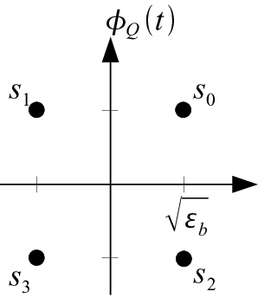
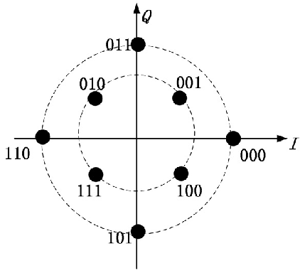

Figure 1- 8-bit Constellation Diagram Figure 2- 4-bit Constellation Diagram
[6]The constellation diagrams above show the various state positions within the 2 different QAM systems. As the order of the modulation increases, as does the number of points available on the constellation diagrams. [7]For example, 16-bit system would have 16 points available, 32-bit system would have 32 points available etc.

2.5 Sound to Noise Ratio
[8]SNR is the concept of signal to noise power ratio, which describes the power of the largest signal in relation to the background noise. This can be seen in a frequency domain plot of the signal. SNR is expressed in decibels (dB), using the logarithmic scale.

2.6 Bit Error Rate
[6]Bit error rate is a key component of any data communications systems, wired or wireless. Its important to be able to determine the bit error rate of any system.
Testing Bit Error Rate measures end to end performance of a system, from the transmitter, receiver, and anything in between. This allows the actual performance of the whole system to be tested whilst its in operation, rather than testing individual components in the system.

3. Background Information

3.1 Simulation Models

3.1.1 ASK System
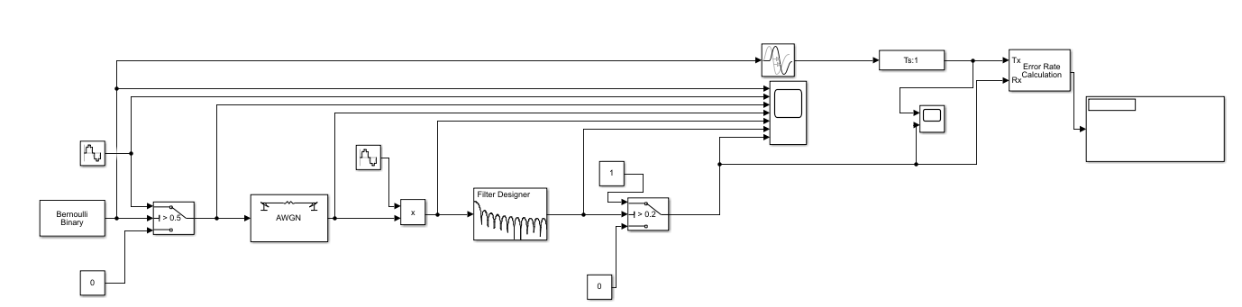
Modulation
Demodulation
Figure 3- ASK Model
Figure 3- ASK Model shows the whole ASK system, with the modulation and demodulation sections highlighted.

3.1.1.1 ASK System Parameters
Filter Parameters
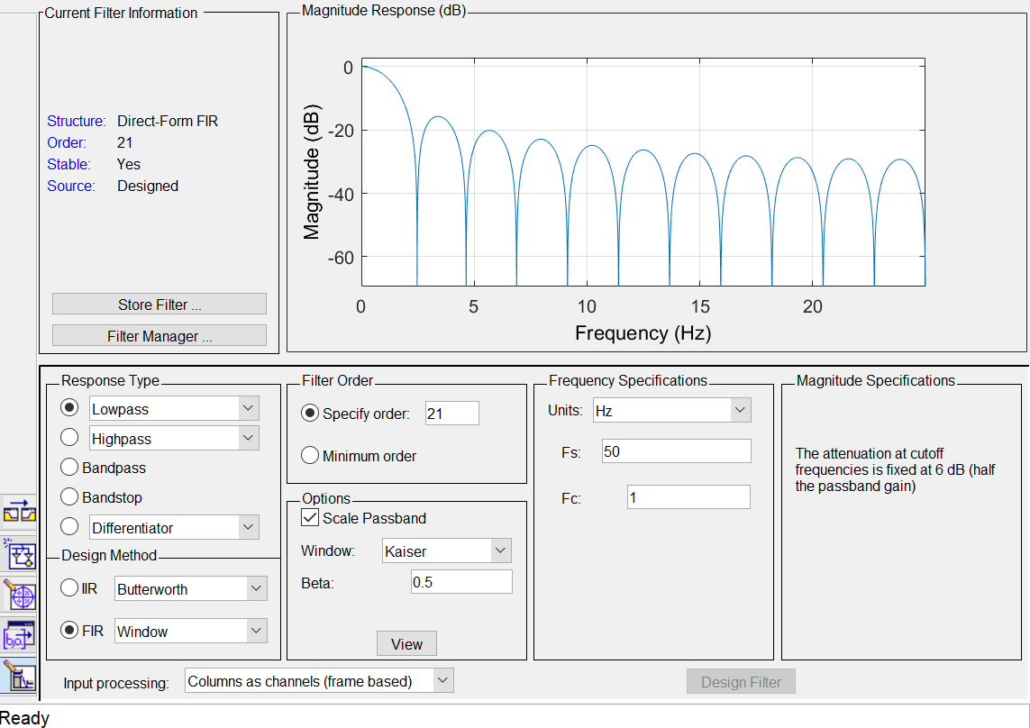

Sine Wave 1&2 Parameters
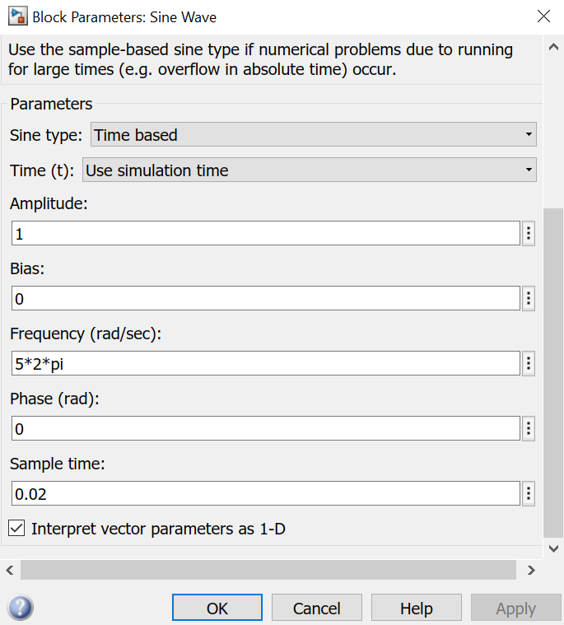

3.1.2 PSK System
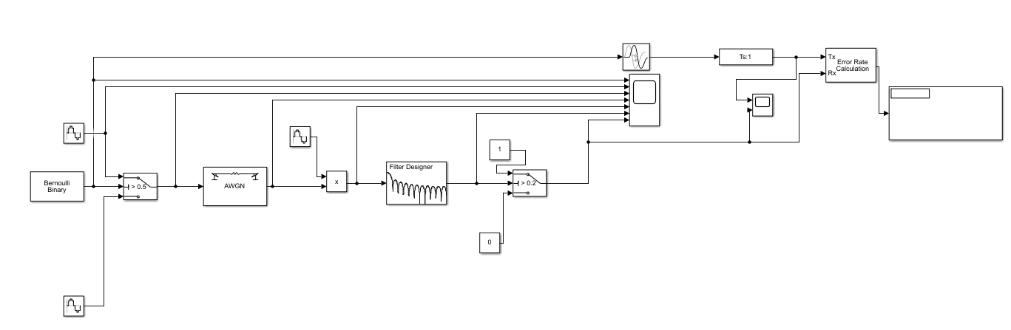
Demodulation
Modulation
Figure 4- PSK Model
Figure 4- PSK Model shows the whole PSK system, with the modulation and demodulation sections highlighted.

3.1.2.1 PSK System Parameters
Sine Wave 1&3 Parameters
Sine Wave 2 Parameters
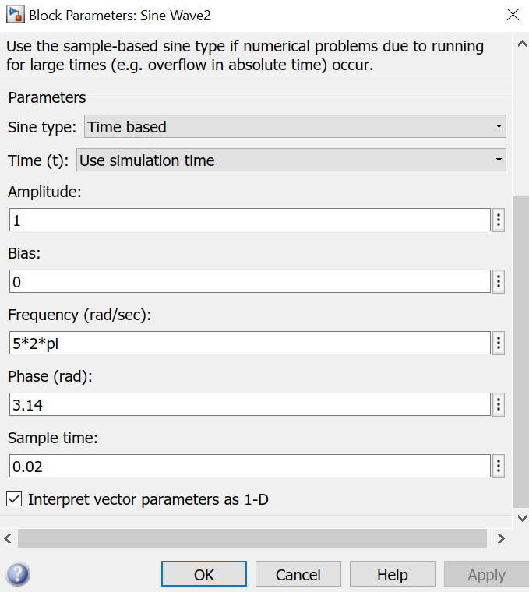

3.1.3 QPSK System
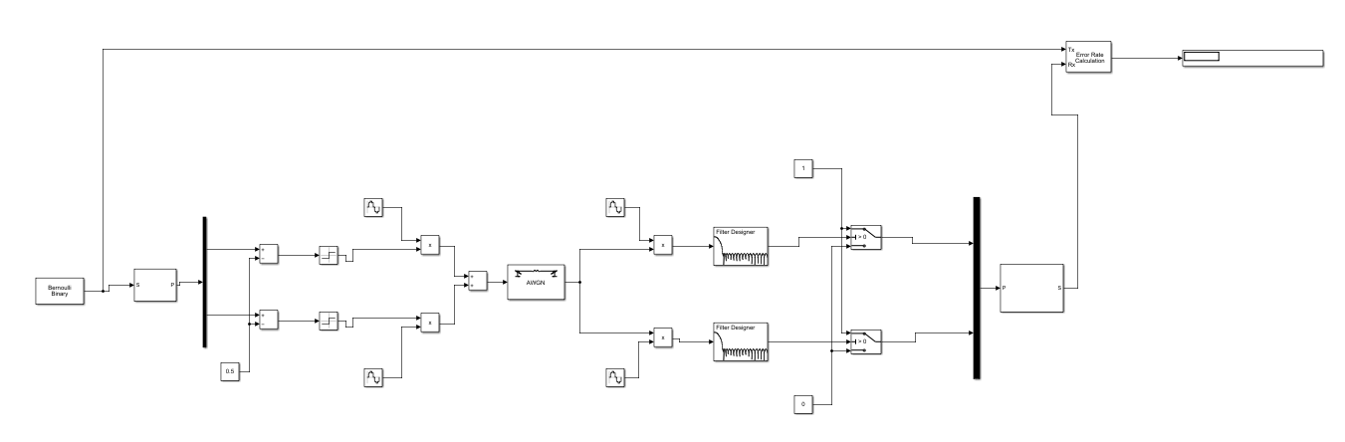
Modulation
Demodulation
Figure 5- QPSK Model
Figure 5- QPSK Model shows the whole QPSK system, with the modulation and demodulation sections highlighted.

3.1.3.1 QPSK System Parameters
De-serializer Parameters
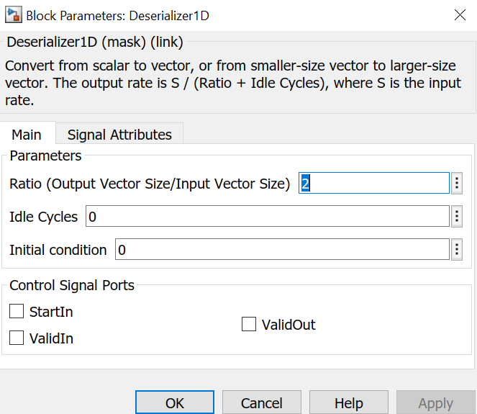
Sine Wave 1&3 Parameters
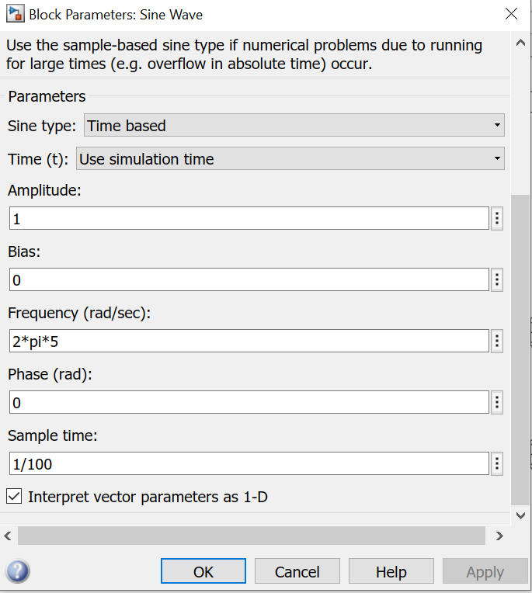

Sine Wave 2&4 Parameters
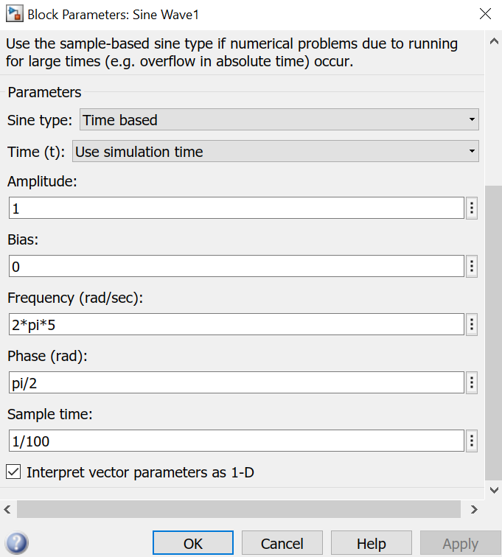

Filter 1&2 Parameters
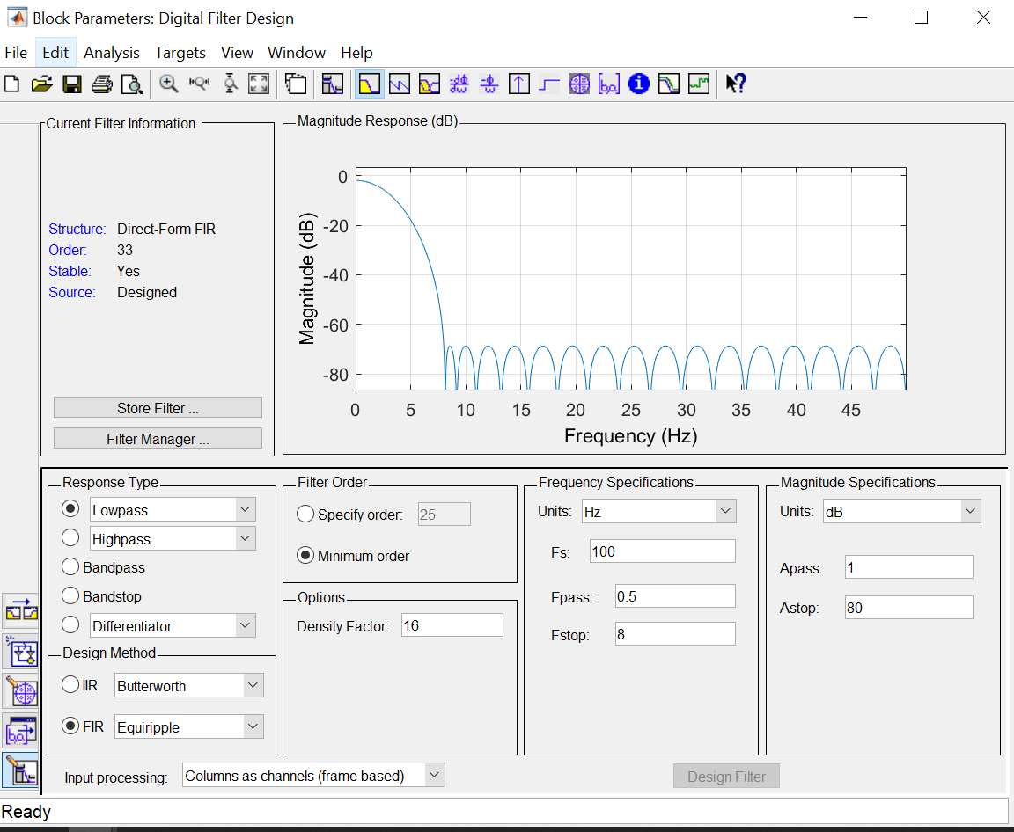

3.1.4 QAM System
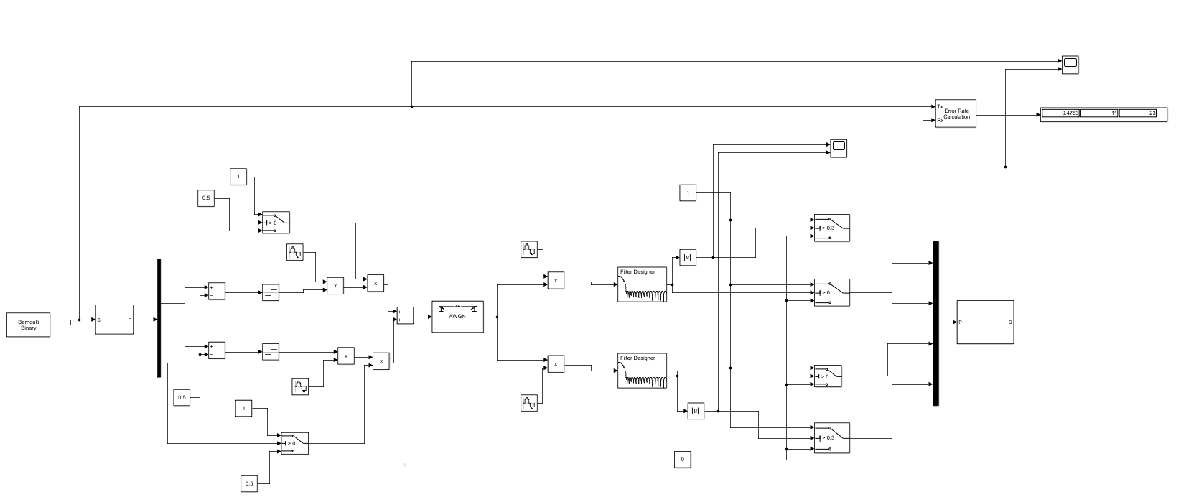
Demodulation
Modulation
Figure 6- QAM Model
The image above shows the entire QAM system, with the modulation and demodulation sections highlighted.

3.1.4.1 QAM System Parameters
Serializer Parameters
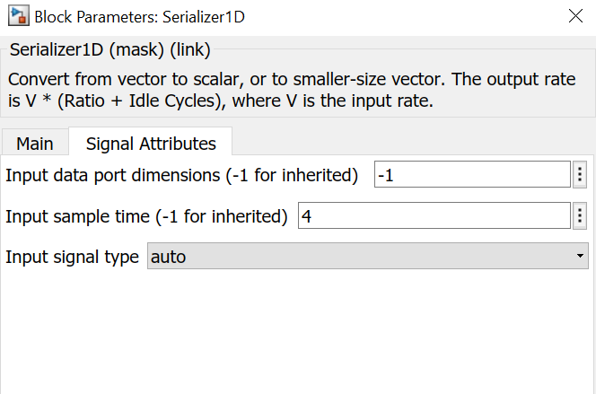

Error Rate Calculation Parameters
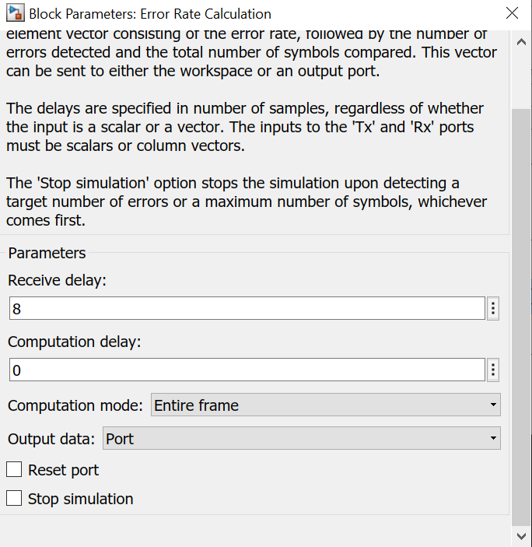
The receive delay is set to 8 as there was an 8 second delay between the input signal and output signal, shown in the scope display below.
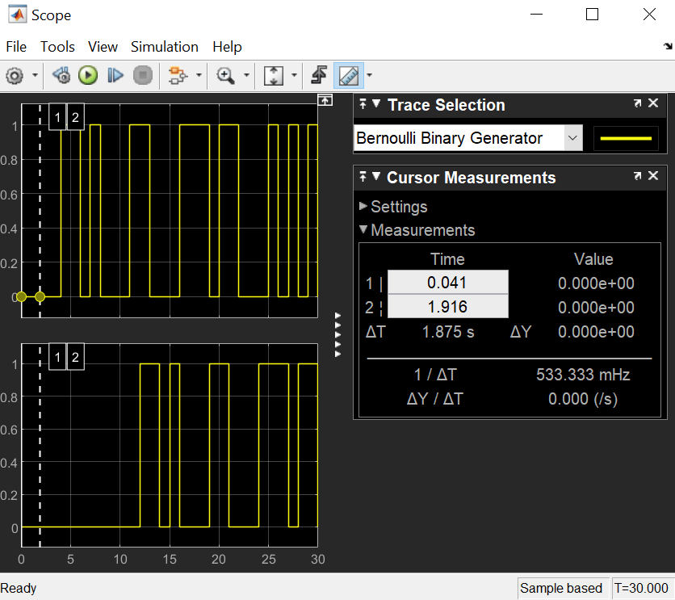

3.2 Simulation Results

3.2.1 ASK System Results
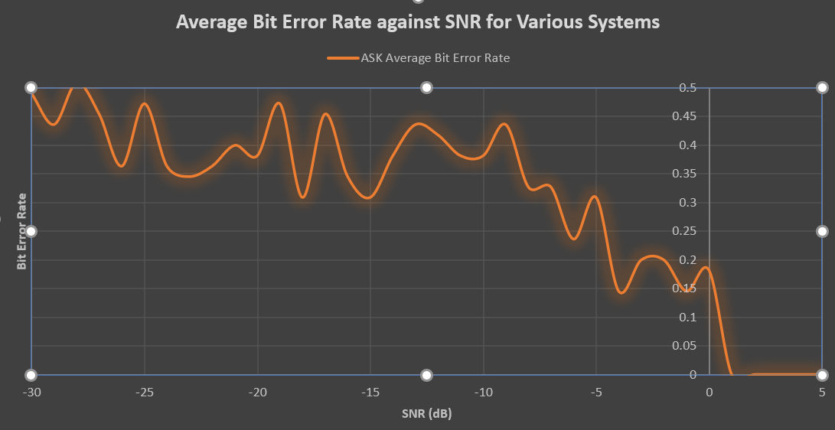
Figure 7- ASK Model Results

3.2.2 PSK System Results
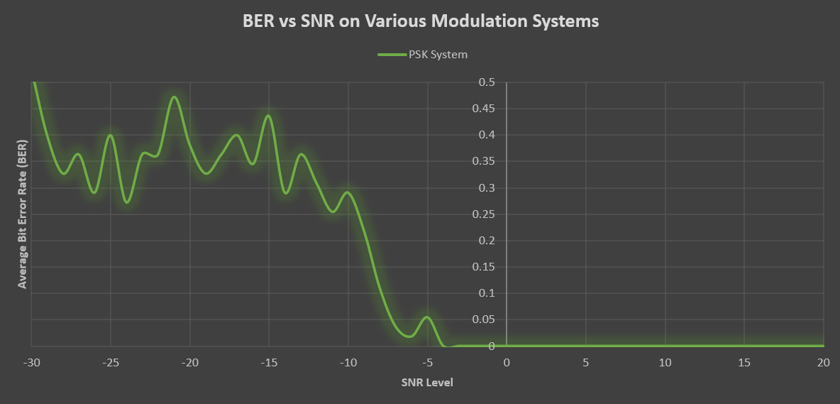
Figure 8- PSK Model Results

3.2.3 QPSK System Results
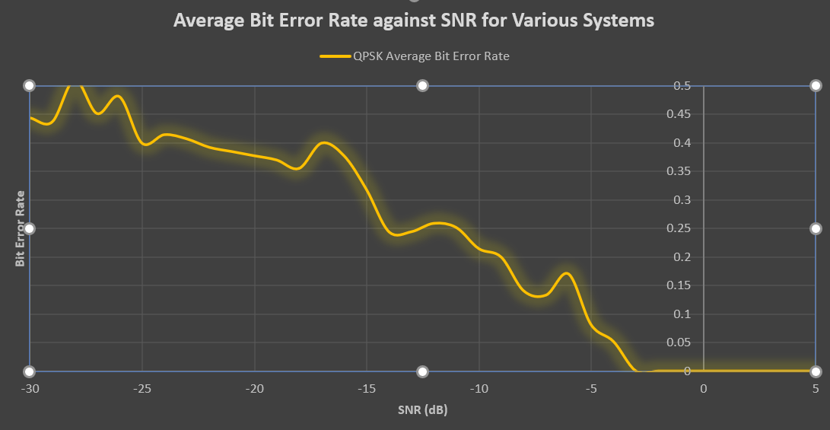
Figure 9- QPSK Model Results

3.2.4 QAM System Results
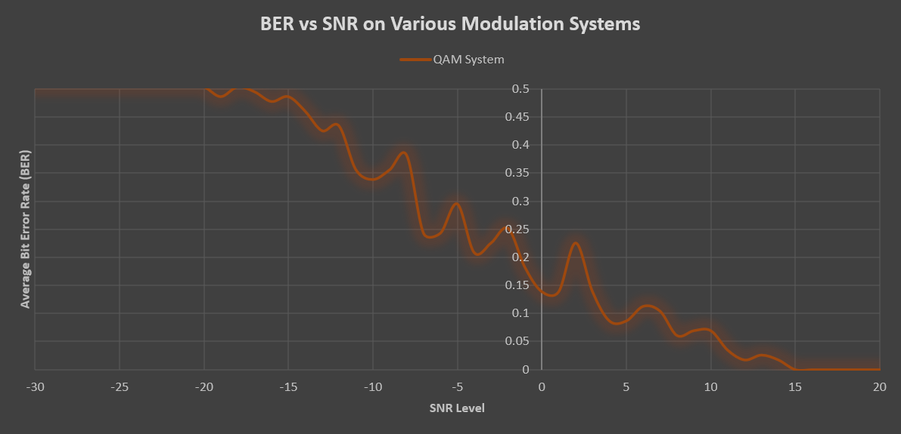
Figure 10- QAM Model Results

3.2.5 Systems Comparisons
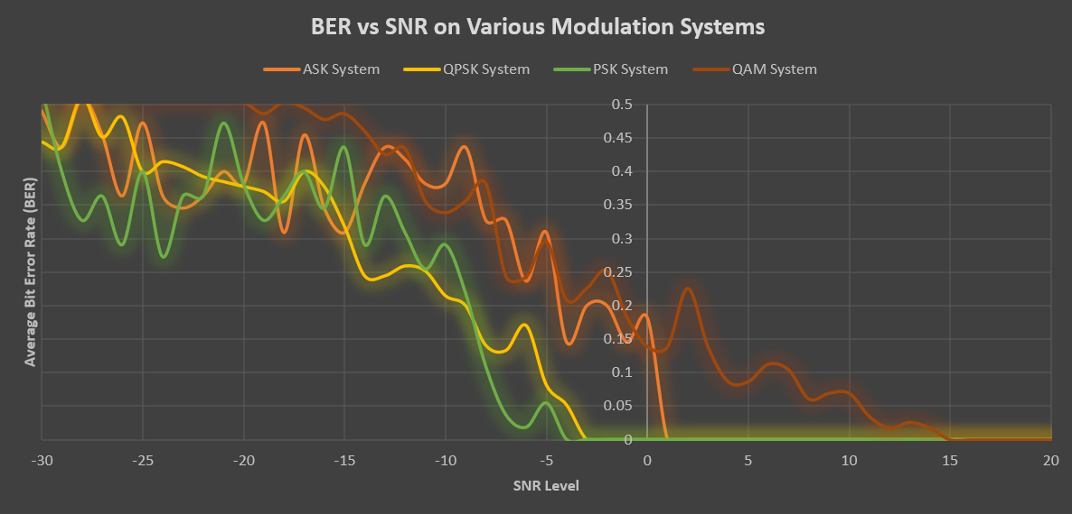
Figure 11- System Comparison Results

4. Discussion

4.1 Results

4.1.1 ASK Results
From looking at the graph (Figure 6- ASK Model Results), we can see that the system begins to become susceptible to noise around the 1-0 dB range and starts affecting our Bit Error Rate. This shows us that the system is easily affected by noise, and a good signal is required for this system to run efficiently. The graph also shows that the BER spikes up to 0.2, rather than gradually increasing the lower the decibel range gets. This also indicates this system is heavily susceptible to noise. A small amount of noise on the system and 1/5 of bits will induce an error. The overall system looks ‘unstable’ whilst in a negative dB range, however this could be a consequence of using a random signal generator. This could also be a consequence of the quantity of data collected. The data collected was collected in 1dB increments. However, if this was changed to 0.5 or 0.25, more data would be gathered, which may smooth out the graph results as there’s more datum points to go off.
From looking at the graph, it also indicates that the system seems to fail around -26dB, as the average bit error rate is over 0.5. The reason 0.5 is the failure point, because it shows that ½ the bits will induce an error, indicating the signal isn’t being reconstructed properly due to the noise on the system. At 0.5 BER, half of the information being transmitted is either wrong or lost, making that information being transmitted obsolete.

4.1.2 PSK Results
From looking at the graph (Figure 7- PSK Model Results), we can see that this system begins to become susceptible to noise around -4dB. This is already an improvement on the ASK system, as that system began to be susceptible around +1dB. However, we still get the big spike in BER, except this time it is around the -7dB - -10dB range. The BER jumps from 0.05 to 0.3, which is a fairly large spike. There still seems to be the same ‘instability’ and lack of consistency in the BER. Again, this could be down to quantity of data collected, and the consequence of using a random signal generator.
This system seems to fail around -29dB, as the average BER is over 0.5. Again, the reason 0.5 is the failure point, because it shows that ½ the bits will induce an error, indicating the signal isn’t being reconstructed properly due to the noise on the system. At 0.5 BER, half of the information being transmitted is either wrong or lost, making that information being transmitted obsolete.

4.1.3 QPSK Results
From looking at the graph (Figure 8- QPSK Model Results), the system becomes susceptible to noise around -4dB, which is similar to the PSK system. However, what we can see from this graph, is how much ‘smoother’ and ‘consistent’ the average BER is as the noise increases, with small spikes throughout the graph. These small spikes could also be reduced is more data was collected and might make the graph even smoother. This indicates a more consistent, and predictable system.
The graph also shows that the failure point for this system is around -26dB, as the BER averages more than 0.5. Again, the system fails at this point, which may be down to the random signal generator, or due to the quantity of data collected.

4.1.4 QAM Results
From looking at the graph (Figure 10- QAM Model Results) it is evident that noise starts to have an impact the BER much sooner than it does for the other systems simulated. To explain why this is happening, a constellation diagram is needed to support the reasoning.
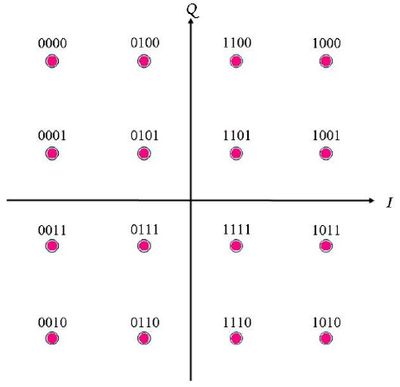

The reason the BER is affected sooner, is due to the available points being closely bunched together, which makes them more susceptible to noise. This can be seen from the results of the simulation. From the graph, it can be seen that errors start to induce around 14dB, and the system fails around -19dB. The system also looks fairly unpredictable, with the graph showing various spikes in BER when the system is on its way to failure. For this system to be usable in a real-world application, other precautions would need to be taken to make this system less susceptible to noise. This system is also more complex, as it focuses on modulating both phase and amplitude.

5. Conclusion
To conclude, from carrying out this exercise, it highlighted the effects noise has on the BER of various modulation systems.
From referring to Figure 11- System Comparison Results, comparisons can be drawn from the various systems. The QAM system was the most effected by noise, due to the available points being compact, which results in them being susceptible as there is less ‘space’ between them.
The QPSK was the least affected by noise, and also had the most gradual increase of BER against SNR, which also identifies it is the most predictable system.
The PSK system had the lowest failing point, failing at -29dB, compared to the ASK which failed at -26dB, QPSK which failed at -27dB, and QAM which failed at -19dB.
The ASK system seemed to be the least predictable, by showcasing more ‘spikes’ in BER as the noise in the system gradually increased. Followed by the PSK, QPSK, and finally the QAM being the most predictable, even though its failure point was the highest. However, this could be a consequence of using a random signal input, which will vary with every simulation conducted. It could be a result of the amount of data collected for each system. If more data was collected, with shorter intervals (every 0.5 or 0.25) this may smooth out the graphs seen earlier in the document.

Bibliography

[1] | "ElProCus," [Online]. Available: https://www.elprocus.com/amplitude-shift-keying-ask-working-and-applications/#:~:text=ASK%20Demodulation%20Process%20Demodulation%20is%20the%20process%20of,signal%20at%20the%20output%20stage%20of%20the%20receiver.. [Accessed 25 March 2022].
[2] | "Technopedia," [Online]. Available: https://www.techopedia.com/definition/1701/phase-shift-keying-psk#:~:text=Techopedia%20Explains%20Phase-Shift%20Keying%20%28PSK%29%201%20Quadrature%20Phase-Shift,type.%20Uses%20two%20phases%20separated%20by%20180%20degrees.. [Accessed 27 March 2022].
[3] | C. Chaichomnan, "Chutpipat Chaichomnan," in IEEE, Chiang Mai, Thailand, 2021.
[4] | M. N. Chowdhury, M. R. U. Mahfuz, S. H. Chowdhury and M. M. Kabir, "Design of an improved QPSK modulation technique in wireless communication systems," in IEEE, Khulna, Bangladesh, 2017.
[5] | "Eletrical4U," [Online]. Available: https://www.electrical4u.com/quadrature-amplitude-modulation-qam/#:~:text=Some%20of%20the%20applications%20of%20QAM%20include%3A%201,like%20Wi-Fi%2C%20Digital%20Video%20Broadcast%20%28DVB%29%2C%20and%20WiMAX.. [Accessed 31 March 2022].
[6] | "Electronics Notes," [Online]. Available: https://www.electronics-notes.com/articles/radio/modulation/quadrature-amplitude-modulation-types-8qam-16qam-32qam-64qam-128qam-256qam.php. [Accessed 27 March 2022].
[7] | A. Suhartomo and V. Vincent, "Comparison of BER Performance for M-ary QAM and PSK on DWT-based OFDM System with PTS Technique Through AWGN Channel," in 2020 IEEE International Conference on Sustainable Engineering and Creative Computing (ICSECC), Indonesia , 2020.
[8] | M. Parker, Digital signal processing 101 : everything you need to know to get started, Oxford, United Kingdom ; Cambridge, MA: Newnes, 2017.

