5CO02 - Evidence-based Practice
Final word count (task 1): 3,189
Task 1
AC 1.1
The concept of Evidence-based Practice (EBP) is defined as a structured approach to decision-making that integrates credible research, organisational data and professional judgement from multiple sources to ensure ethical and informed decisions are made (Woodhams and Perkins, 2022, cited in Taylor and Woodhams, 2022). The CIPD Profession Map places evidence-based decision making at the very centre of its framework; it is an essential component for people professionals to incorporate when making decisions (CIPD, 2025d).

CIPD’s six-step sequential model (Figure 1), can provide Technivara with a clearly structured process to guide informed, systematic decision-making (CIPD 2025a). According to CIPD (2025a) and Barends et al. (2014), applying CIPD’s Six Steps at Technivara begins with clearly defining a specific organisational issue, in relation to Technivara this could target areas such as low employee engagement or limited ambition to pursue career progression. The next step involves acquiring and appraising relevant evidence through critical thinking and research. Evidence-based findings are then combined to identify patterns, applied through informed interventions, and assessed using measurable outcomes such as improved levels of engagement or growth.
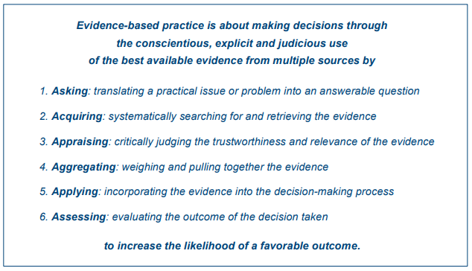

Figure 1: Evidence-based Practice Infographic (Barends et al., 2014, pp 4).

Conversely, it is crucial to understand EBP’s limitations if misapplied, particularly in cases where unreliable or incomplete evidence is used to support organisational decisions (Briner, 2024). To mitigate this risk, it is important to research using the Four Sources of Evidence (Figure 1), to make sound decisions through researching: external scientific evidence, data from professional experts, organisational data, and stakeholder perspectives (Briner, 2024). CIPD (2025a) argues that although the four sources of evidence are extremely useful, practitioners can remain naturally biased by ‘cherry picking’ research that supports their view or perspective; therefore, this factor is difficult to avoid but is important for practitioners at Technivara to be aware of before beginning any type of research.

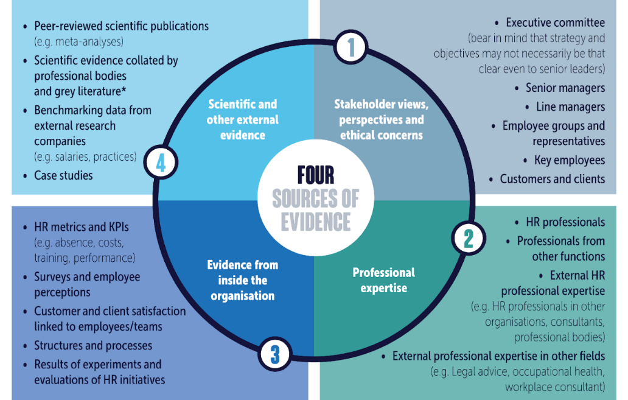

Figure 2: EBHR Sources of Evidence Framework (Briner, pp.1, 2024)

One example of where Technivara could apply EBP is by using evidence from the four sources to decide whether to replace paper-based practices with data-driven Human Resource (HR) systems. The first step would involve gathering data from existing employees to understand their perceptions of current HR practices, to identify main issues of concern, which will highlight what problems a new system would potentially need to resolve (Gilford, 2016). Technivara could also strengthen its use of EBP by gathering evidence from other organisations or consulting with external HR professionals who have implemented similar or alternative HR platforms (Gilford, 2016). These benchmarking approaches allow leaders to compare metrics and practices to gain valuable insights to support decision-making at Technivara (CIPD, 2024).

Another area in which EBP can impact decision-making is through modernising its recruitment and selection process. As Technivara seeks growth to expand following years of consecutive progress, reliance on traditional recruitment processes may pose a risk to attracting and attaining skilled engineers and technical specialists (CIPD, 2025e). The People Practice team will analyse internal recruitment data at Technivara, including job advertising methods, use of technology and time-to-hire to identify trends, weaknesses and areas for improvement (CIPD, 2025a; Tunsi et al., 2023).

AC 1.2
As Technivara are seeking to expand and grow its company, it is important to undertake a thorough organisational analysis to effectively recognise and diagnose issues, challenges and opportunities. A SWOT (strengths, weaknesses, opportunities, and threats) analysis is a widely used planning tool that has become a fundamental method for organisations to evaluate their internal capabilities alongside external environmental conditions (Benzaghta et al. 2021). One of the primary advantages of SWOT is its accessibility, as it does not require specialist analytical expertise to undertake and can be used collaboratively across different departments within an organisation (Puyt et al. 2020). However, Mintzberg (1990) states that some criticisms have been made regarding a SWOT analysis when the initial problem or purpose has been poorly defined, especially when deciding on strengths and weaknesses. Mintzberg explains this is due to a lack of accuracy surrounding the chosen subject, which therefore makes unhelpful judgments.

Research is a process of exploring credible information in a methodical approach by collecting, analysing and interpreting results to reach conclusions and generalised solutions (Aithal and Aithal, 2020). An example of where Technivara could gather date would be to gathering data from the opinions of employees at Technivara surrounding current HR processes (Taylor and Perkins 2022). To undertake the research process, there is a range of cross-sectional designs and analysis methods that Technivara could apply to gain information from employees, stakeholders or HR professionals (Taylor and Woodhams, 2022).

One highly appropriate analysis method is a staff questionnaire. Questionnaires allow organisations to collect a large range of perceptions of quantitative or qualitative information to identify patterns, diagnose underlying organisational issues and evaluate how particular challenges are impacting employees (CIPD, 2025a). Taylor and Woodhams (2022) explain that the advantages of distributing a questionnaire to employees are that it is cost-effective, simple to organise and can achieve a broad coverage, resulting in the production of a large amount of information. In relation to Technivara, if the SWOT analysis highlighted areas of concern like low morale, poor communication, duplication of work or a lack of technical HR software, a questionnaire could be utilised to diagnose and reveal specific challenges within this area (Taylor and Perkins, 2022). This assists Technivara in identifying opportunities to improve current practices by revealing gaps and, therefore, enabling leaders to adapt processes. However, designing a questionnaire is unfortunately neglected by many researchers due to a lack of knowledge and experience (Edwards et al. 2023).

AC 1.3
Critical thinking is a cognitive activity involving the process of being able to think rationally about any given situation. The process involves evaluating credible information whilst considering different perspectives to reach a fair and logical conclusion (HRM Handbook, 2025). In relation to HR, critical thinking allows HR professionals to make sound decisions following the main critical thinking principles to help achieve business goals (HRM Handbook, 2025). The main principles of critical thinking are objective and rational thinking, well-reasoned argument, questioning and checking the validity of sources and validity of ‘evidence’ and having an awareness of bias – conscious and unconscious from yours and other perspectives (CIPD, 2019). According to Woodhams and Perkins (2022), cited in Taylor and Woodhams (2022), HR professionals should be sceptical and refrain from a certain type of thinking which leads to taking shortcuts or ‘heuristics’, as this can lead to bias and poorly made judgments.

Applying the critical thinking principles to your own ideas to assist objective and rational debate may involve developing a critical self-awareness within the workplace. In more depth, being aware of your own beliefs, personal biases and cultural scripts allows you to question yourself to ensure that your arguments are well reasoned and established by credible and fair evidence rather than personal assumptions (Bouygues, 2022). Within companies like Technivara, it is often difficult to separate fact from fiction, as this naturally arises from personal agendas; therefore, it is important for employees to have a consciousness of ‘fake news’ and not take all information at face value (Taylor and Woodhams, 2022). Another way the principles can support your ideas at Technivara is to ensure clarity of terminology and by differentiating between fact and opinion, as this enables you to communicate your ideas effectively and ensure they are backed by solid reasoning (Adair, 2019). For example, if a manager at Technivara needed to address high levels of absence, it is essential for them to be able to separate and provide factual absence data from their own opinions, as this supports rational debate and prevents unfair assumptions influencing decision-making.

Secondly, applying critical thinking at Technivara to others’ ideas through teamwork, collaboration and professional discussions is essential to assist objective and rational debate. Bouygues (2022) states that making conflict productive can ensure the best decisions are made. She explains that when an idea is critically questioned by a group of professionals, it allows ideas to be examined thoroughly and safeguards organisations from falling into group-thinking where individuals agree with the dominant view without an evidence-based evaluation. However, it is also important for professionals at Technivara to remain respectful to others’ ideas by listening, comparing and recognising different methodologies and approaches at the same time by triangular and testing of conclusions (Woodhams and Perkins, 2022, cited in Taylor and Woodhams, 2022).

AC 1.4
Edward de Bono’s Six Thinking Hats was developed in 1985, a structured framework which involves six imaginary different colour hats, each representing a specific type of thinking (BBC Bitesize, n.d). The model promotes balance, well-organised and inclusive thinking, which is particularly useful in settings like Technivara as it enables teams to explore issues from different perspectives, which can reduce conflict and positively impact collaborative decisions and relationships (De Bono, 2021). The table below was created by Mahoney et al. (2022). It outlines the meaning of each hat and clarifies the specific role within the Six Thinking Hats Framework.

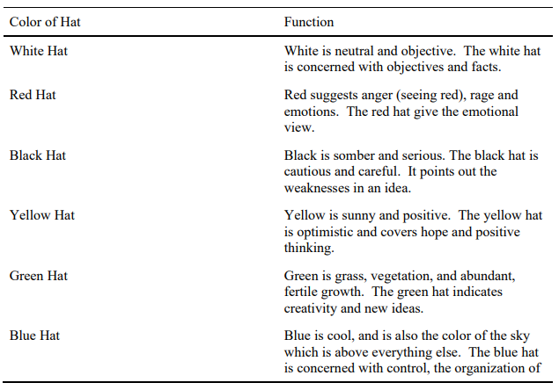
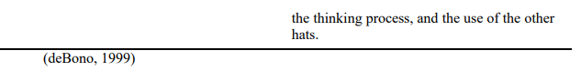

Figure 4: Colour of Hat and its Function (Mahoney et al., pp. 4, 2022).

De Bono (2021) explains that there are two main purposes of the Six Thinking Hats. First, to allow the person to think and focus on one area without having to involve other aspects, like emotions, logic, hope and creativity at the same time. Secondly, to allow a switch in thinking. For example, if a person in a meeting is constantly displaying negative emotions, that person can be asked to take off their black hat and replace it with a yellow hat. This action is a direct request for them to become positive without coming across as aggressive. In relation to Technivara, The De Bono Group (n.d) state this method can be used to support HR leadership meetings, organisational decision-making and critical thinking tco ensure communication is clear and non-biased, and finally to ensure the appropriate outcomes are achieved ethically and fairly.

The second decision-making process that could be used by Technivara to ensure effective outcomes are achieved is the Kepner-Tregoe (KT) Problem Analysis Framework. The KT-method is a structured approach used to diagnose issues and evaluate solutions in a systematic and logical manner (Gultom and Siallagan, 2025). This approach is a rational method and encourages people to move away from asking common questions (Mulder, 2025). Instead, Markopoulos (2025) states that the KT-method builds as a holistic framework, developed effectively by initially asking the right questions in the correct order to create a collection of information needed to understand the problem effectively. In more depth, he explains that there are four basic thinking processes for people to ask themselves in every situation (Figure 5).
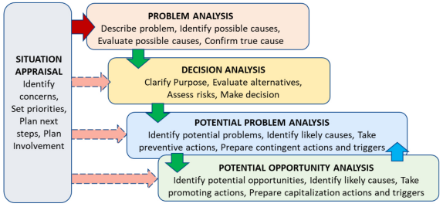

Figure 5: Kepner and Tregoe’s Method thinking foundations (Markopoulos, pp.199, 2025).

In relation to Technivara, the KT-model will support managers to identify the most important factors, analyse the problem and root cause, anticipate risks and opportunities, and finally make balanced and evidence-driven decisions (CMI, 2020). For example, the People Practice manager at Technivara is choosing between two technical recruitment software packages. Using the KT-method will allow them to clarify priorities like security, candidate-tracking accuracy and integration through problem and analysis (Markopoulos, 2025). However, according to CMI (2026) this method can be time consuming and complex, therefore, when using this method, managers should avoid jumping to obvious conclusions without completely the full process and avoid cutting corners, especially if the decision change complex implications.

AC 1.5
Ethical practice is the concept of applying ethical-based values to organisational conduct, ensuring that decisions are fair, rational and morally aligned with an organisation’s values (CIPD, 2025f). It involves investigating dilemmas using ethical values and methods that support and guide HR professionals in their interactions with employees, stakeholders, and the wider organisation (Naithani and Goyal, 2022). The integration of ethical considerations is essential to professional HR conduct as it ensures everyone requires an understanding of the different ethical perspectives of others, whilst maintaining a strong moral compass (Armstrong and Taylor, 2023). Personal beliefs can shape decision-making, including religious values, particularly in areas such as equality, inclusion, or disciplinary action, where managers must balance personal opinions with organisational policy and legal rules (CIPD, 2015).

Utilitarianism is a consequentialist ethical theory which focuses on making the best possible decision by prioritising actions that generate the greatest benefit for a large number of people (Marchington et al. 2025). Rousseau (2019) explains that this approach allows professionals to focus on outcomes that will benefit the whole workforce, ensuring decisions reflect good practice rather than individual interests. However, there are some weaknesses if this theory is not utilised appropriately as CIPD (2015) argues that the Utilitarian approach is only effective if it genuinely produces wellbeing for all. In relation to the People Practice team at Technivara, the utilitarian approach can influence decision-making by encouraging HR professionals to assess the consequences of their decisions (Marchington et al, 2020). For example, if Technivara were to implement a new Artificial Intelligence (AI) Recruitment System, HR professionals would evaluate whether the system maximises overall employee motivation and productivity without creating negative and harmful team dynamics (Naithani and Goyal, 2022).

Another theory that can be utilised to support Technivara to make effective decisions is the deontology theory. This theory is a non-consequential ethical theory that accentuates the significance of following moral rules and principles, despite of the consequences (Naithani and Goyal, 2022). In HR, this theory supports professionals to make decisions based on what is right and fair, regardless of the inconvenience it may cause (Abu and Mensah, 2023). To show an example, as Technivara expand their company, its dilemma focuses on widening skill gaps within the workforce to ensure all employees possess the necessary skills to perform effectively during and after the growth period. HR professionals would consider the responsibility to treat all employees equally, regardless of organisational pressures, where certain departments may need more training than others. This theory will influence Technivara to make fair decisions, follow a consistent and transparent process, such as offering equal opportunities and training for everyone. However, Abu and Mensah (2023), does highlight the theory can be overly rigid as it focuses on adherence to rules and duties rather than outcomes which can limit flexibility for some organisations.

AC 3.1
There are several different ways that Technivara could measure financial and non-financial performance. To begin, Technivara could measure financial performance by using a tool named a balance sheet. A balance sheet is a financial document devised to prove how much an organisation is worth by itemising and quantifying all of a company’s assets, liabilities and owners’ equity at a single point in time (Stobierski, 2020). The aim of a balance sheet is to take a snapshot of Technivara’s financial condition to support decision making and reveal if the company is financed through debt or equity, and track changes over time (Abiola-Adams et al. 2021). Broome (2024) highlights that although the balance sheet is a certified document, it does require a considerable amount of time and professional expertise to prepare; it relies on the accurate collection of extensive financial data to be effective and useful for a company. Broome (2024) continues to explain that inaccuracies within the balance sheet can lead to poor organisational decisions and, therefore, the document should be completed by an experienced professional to ensure reliability.

One practical example of how a balance sheet can support Technivara to measure their financial situation is by analysing their current situation to decide whether the company can afford expansion. If the balance sheet shows strong liquidity, for example, high current assets, HR and senior management at Technivara may choose to invest in new recruitment software but only if its financial situation proves they have sufficient capacity (Broome, 2024).

Measuring non-financial performance allows leaders and HR practitioners to measure the health of their workforce and the efficiency of HR practices (Omran et al, 2021). One method Technivara could use to measure non-financial performance is the implementation of structured exit interviews. Exit interviews are valuable to both private and public sectors, but in relation to Technivara, exit interviews can measure non-financial performance, which provides valuable qualitative information on why employees choose to leave the organisation (CIPD, 2025g). Unlike financial metrics, exit interviews capture feelings, experiences, and perceptions which allow a department or company to reflect on setbacks, achievements and objectives through measuring the voices of employees (Mokibelo, 2020). For example, if several software engineers at Technivara reported that they left the organisation due to limited progression opportunities, this would highlight a non-financial performance issue. HR can use this information to redesign career job descriptions, introduce clearer development plans, or strengthen internal flexibility to allow employees to progress (Mokibelo, 2020). However, CIPD (2025g) argues that exit interviews are more effective and less prone to bias if they are conducted by an external provider, as this can capture more accurate data as employees will be more willing to be more honest when conversations are treated confidentially.

AC 3.2
According to Stephen and Taylor (2018), there are three key types of contribution in which people practices add value: delivering business objectives, providing excellent administrative service, and acting as a champion for effective people management. For Technivara, fostering value creation supports the process of generating benefits, which relies on ensuring that people practices are actively contributing to building skills, improving engagement, and supporting effective ways of working across the organisation (Burke, n.d). In relation to Technivara adding value requires ongoing strategic interventions from HR such as crisis prevention, continuous improvement, and effective change management (Stephen and Taylor, 2018).

People practices can add value to Technivara by ensuring that organisational policies and procedures align with overall strategy and workforce planning (CIPD, 2025h). This includes areas such as performance and reward, where employees are acknowledged and rewarded fairly against KPI’s and performance data following organisational policies and values. People Practices also add value through legal and fair recruitment processes, through high-quality, legal and thorough selection (Lucy et al 2023). Finally, people practices play a crucial role in ensuring employee relations are healthy and aligned with current and incoming legislation (Burke, n.d).

The impact of these people practices can be evaluated effectively through two key measurement methods: the use of HR KPIs and metrics, and the application of cost–benefit analysis (CBA). Using HR KPIs and metrics to measure the impact of the people practices can provide organisations with a data-driven understanding of how effectively their initiatives are operating (CIPD, 2024). According to Sachs (n.d), HR metrics are essential tools used to track and improve areas of HR like recruitment, retention and well-being. For example, HR KPIs and metrics can show whether a wellbeing initiative is having a desired impact by indicating reductions in sickness or stress-related leave, while improvements in recruitment should reflect faster hiring times and lower recruitment costs (Sachs, n.d). With regards to a CBA, Stobierski (2019) describes a CBA as a systematic method that evaluates the financial value of a project or decision, for example, wellbeing programmes, recruitment campaigns, training or reward schemes. The quantitative method allows leaders to understand the impact and whether the benefits of a project or decision outweigh the costs, allowing one to make evidence-based decisions based on factual data about people to solve business problems (CIPD, 2024).

Task 2
Final word count (task 2): 1100 MAX
Quantitative and Qualitative Analysis Review

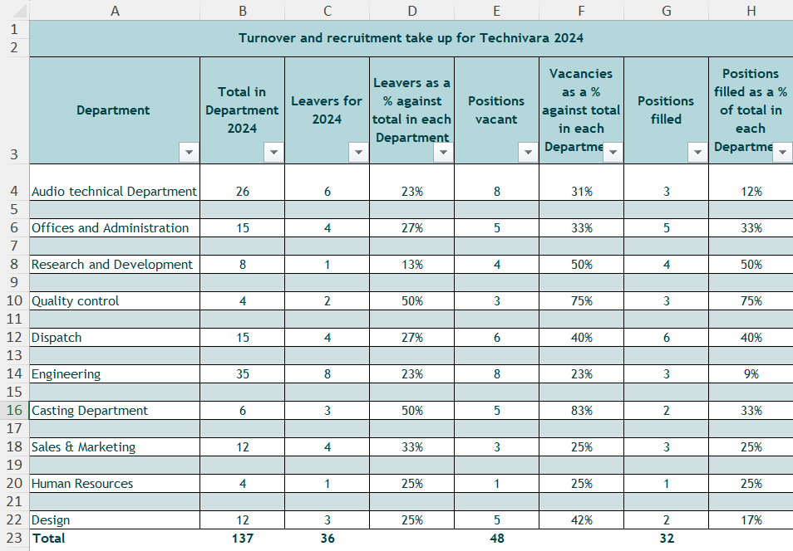
AC 2.1 – Data conversion

AC 2.2 - Analysis of Data Using Three Types of Diagrams
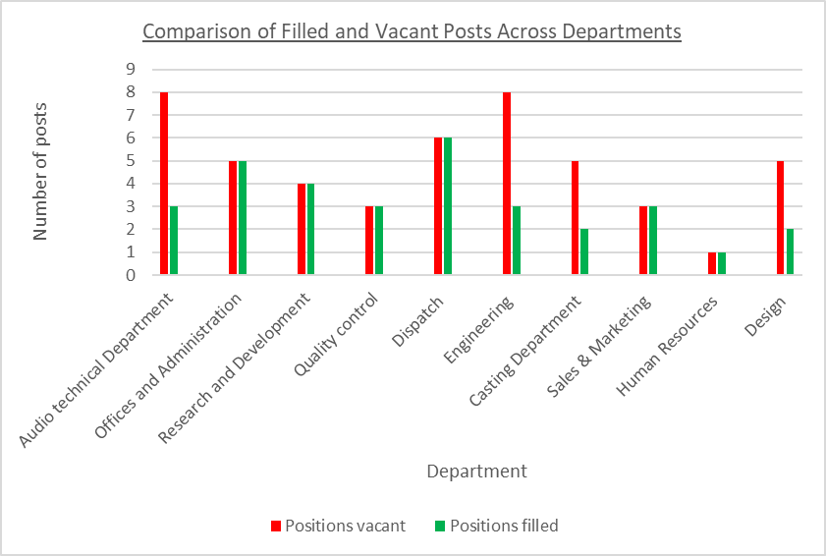

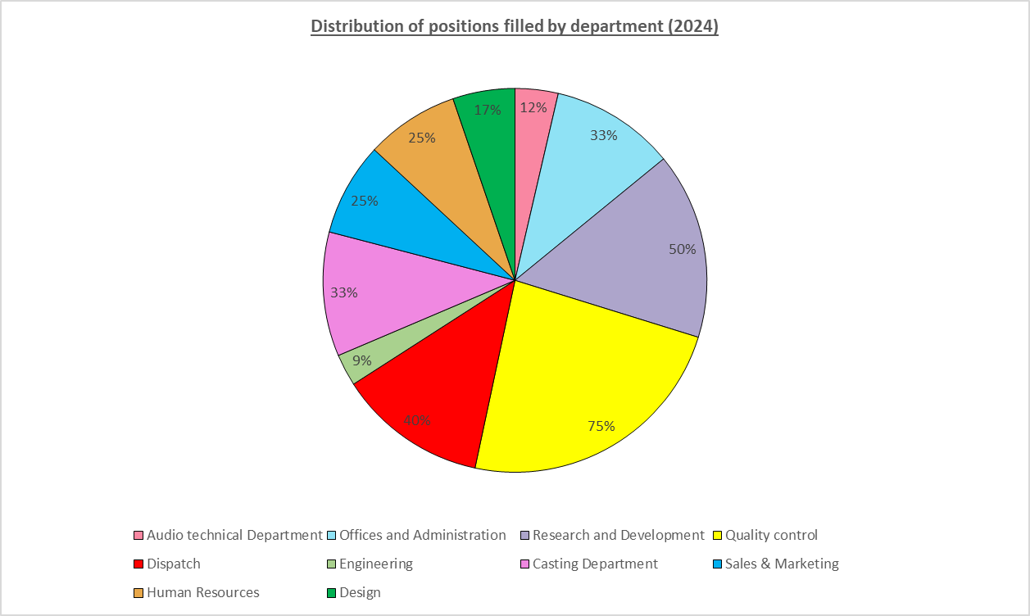
AC 2.3 – Recommendations
The evaluation feedback from 42 employees highlights several key benefits and downfalls associated with the L&D activity delivered by Technivara. The evaluation data clearly indicate positive employee perceptions of the delivery of the learning activity, where the majority of participants highlighted the facilitator’s strong subjectknowledge, stating that the activity was well-structured, supported with clearly defined objectives, and supported by high-quality explanations and resources. CIPD (2024b) states that although the delivery of resources within one’s ‘kitbag’ is an important aspect of L&D, creating an impact is equally important. Overton (2030) emphasises that effective learning is more than the delivery of content and depends on how the activity influences behaviour, performance and long-term organisational outcomes.

For instance, trends from the evaluation data also proved that employees felt the L&D activity was not suitable for their needs. The feedback indicated that a substantial proportion of employees, specifically 39, disagreed or strongly disagreed that their learning preferences had not been considered in advance of the training, and therefore the learning did not relate to their performance targets. According to CIPD (2025h), when L&D activities fail to provide meaningful or appropriate training, this can undermine their perceptions of future development opportunities. If individuals feel that previous interventions lacked benefit, they may become disengaged or sceptical about the purpose and effectiveness of future learning activities, posing a risk to long-term participation and organisational learning culture.

A similar theme emerged in relation to employee participation, where the majority of employees, specifically 35, felt they could not engage with questions and answers on the training topic, suggesting that the content or delivery did not sufficiently support active participation. This pattern is consistent with evidence presented in GOV (2025), which shows employee engagement is highly influenced if it is relevant and related to their job role. The review highlights that when employees do not connect to the material, this reduces their immediate involvement and therefore risks negatively impacting their passion to learn. This subsequently has a detrimental impact on how employees transfer learning to their roles (CIPD, 2022).

The risks outlined above carry several notable direct and indirect, short- and long-term financial consequences to Technivara. One direct financial implication is the loss of working time. The evaluation data proved this, with 22 employees disagreeing and a further 8 employees strongly disagreeing that they were unable to transfer the knowledge, skills and behaviours from the activity to their role. This reduces return on investment (ROI) due to loss of productive working time and therefore impacts operational duties, especially when multiplied across large groups of people (CIPD, 2022). Additionally, the direct costs associated with the direct costs of the L&D practitioner, as well as their time, venue costs, resources and digital platforms. Further evidence from the data supports this concern, as 18 employees strongly disagreed that set learning outcomes were not achieved. The long-term financial implications of this are substantial, as it may involve persistent skills gaps within the workforce, where employees are unable to apply learning to their roles, therefore, negatively impacting performance, which over time will contribute to increased organisational costs.

A key recommendation is for Technivara to implement a Learning Needs Analysis (LNA). According to Al-Ismail et al. (2023), an LNA is described as a methodical approach used to identify the specific knowledge and skills an individual needs to learn. An LNA entails collecting valuable data from employees, which allows L&D practitioners to understand and locate skill gaps, enabling them to prioritise learning needs and plan targeted L&D activities that align with organisational objectives (CIPD, 2025i). The results from the LNA will allow L&D practitioners at Technivara to implement solutions, support the development of personal development plans, prioritise detected performance gaps and report on the overall needs of Technivara (CIPD, 2025i). However, there is a notable risk if the LNA is seen as a rigid, box-ticking exercise, as this will negatively impact findings used to make evidence-based decisions (CIPD, 2025i). Therefore, the practice must be aligned with organisational objectives and be completed by competent and experienced professionals (Muir, 2023).

By failing to act on the evaluation data provided by employees at Technivara, the organisation increases the risk of being susceptible to risky decision-making (CIPD, 2015). Furthermore, if Tehcnivara decided not to implement the LNA, the organisation will continue to implement training which is not targeted to individual needs, meaning training is ineffective, lacks purpose and impact and ultimately increases costs with no measurable return (Muir, 2023).

Finally, undertaking an LNA can have several direct and indirect costs, which primarily involve the cost of employing a Specialist Level L&D Consultant to undertake and lead on delivering the LNA. Although one may think current practitioners at Technivara can undertake this task alone, Johnson (2017) disagrees and explains that the main reason why interventions fail is due to the people who are required to do the job, as they either have not been trained to do so or lack experience. According to Indeed (2026a), the direct cost of hiring a Specialist Level L&D Consultant is approximately £38, 137 per year, with a weekly rate of £698 per week (not including travel or expenses) and an hourly rate of £19.89 per year. Similarly, indirect costs involve L&D employees undertaking interviews, surveys or focus groups which take them away from their normal duties, alongside additional administrative tasks required to implement the LNA successfully.

Another key recommendation for Technivara, based upon the evaluative feedback following the L&D activity, is to improve their current evaluation process by implementing an evidence-based method that evaluates the whole process rather than feedback alone. Implementation of the Kirkpatrick Model will allow L&D practitioners at Technivara to holistically evaluate learning activities on multiple different levels, including learner reaction, gained knowledge, learner behaviour and organisational results (Figure 7) (CIPD, 2025j). These additional evaluative insights can be obtained through the use of enhanced questionnaires, surveys, interviews or observations as it will allow L&S practitioners to gather a wide range of evidence not solely based on employee reaction and immediate opinions (CIPD, 2024).
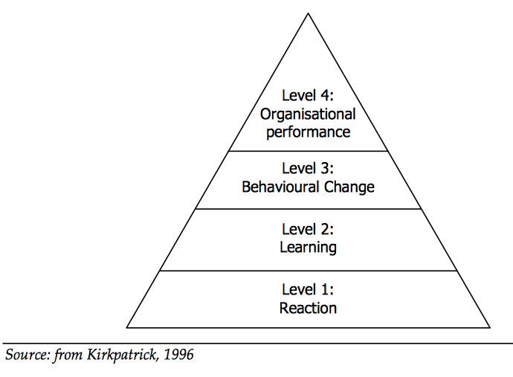

Figure 7: The Kirkpatrick Model (Kurt, 2018).

According Crowley and Overton’s (2021) Learning and Skills at Work Survey, there are some risks linked to the time and commitment required to effectively implement the Kirkpatrick model as evidence proved that most L&D practitioners’ incline to focus most of their attention on the reaction stage (level 1) and this was largely because measuring the three other levels can be time-consuming and resource intensive. However, if Technivara commits time to implementing the full model the organisation is more likely to generate meaningful insights that demonstrate whether learning is being transferred into workplace behaviours and organisational performance (CIPD, 2025k). Additionally, CIPD (2025j) highlight that using growing technology and Artificial Intelligence (AI) can increase efficiency and the speed of learning processes, specifically during the data collection and evaluation stage.

Understanding the precise direct costs of implementing the Kirkpatrick Model is challenging; however, responsibility would typically fall to the L&D Manager. Based on current salary data from Indeed (2026b), the average annual salary for an L&D Manager in the United Kingdom is £42,359, equating to approximately £232 per day. If the L&D Manager at Technivara were to dedicate two days per week to implement and embed the model over a 6-month period, the cost of their time would total £12, 064 (26 weeks × 2 days × £232 per day). This figure provides a realistic estimate of the staffing cost associated with project implementation. Additionally, indirect costs may involve the time taken to deliver training to all members of the L&D team, increased workload during the data gathering stage and cultural resistance (CIPD, 2025j).

The impact of implementing an effective method like the Kirkpatrick Model to evaluate organisational learning, Technivara will be able to create a clear evaluation strategy, which centres less on validating the training itself and more on the impact and transferable skills (CIPD, 2025k). If Technivara choose not to apply the Kirkpatrick Model to their current L&D evaluative practices, it may lead to insufficient knowledge transfer, as Technivara would be unable to measure whether training activities have had the desired impact or transfer to individual roles. Making these recommendations will ensure L&D are equipped with evidence-based data to support and inform decision making when planning, designing and implementing activities for all employees at Technivara.

References:
Adu, B. O.-S., and Mensah, M. A. (2023). ‘Examination of Aspects of Deontological and Teleological Theories that Promote Professional Practice’. International Journal of Academic Research in Accounting, Finance and Management Sciences, 13(2), 36–47. Available at: http://dx.doi.org/10.6007/IJARAFMS/v13-i2/16795

Abiola-Adams, O., Azubuike, C., Sule, A.K. and Okon, R. (2021). ‘Optimising balance sheet performance: Advanced asset and liability management strategies for financial stability’. International Journal of Scientific Research Updates, 2(1), pp.55-65. Available at: https://doi.org/10.53430/ijsru.2021.2.1.0041

Adari, J. (2019). Decision Making and Problem Solving – Break Through Barriers and Banish Uncertainty at Work. Kogan Page.

Aithal, A and Aithal P. S. (2020). ‘Development and Validation of Survey Questionnaire & Experimental Data – A Systematical Review-based Statistical Approach’. International Journal of Management, Technology, and Social Sciences (IJMTS), 5(2), 233-251. Available at: http://doi.org/10.5281/zenodo.4179499

Al-Ismail, M. S., Naseralallah, L. M., Hussain, T. A., Stewart, D., Alkhiyami, D., Abu Rasheed, H. M et al (2022). ‘Learning Needs Assessments in Continuing Professional Development: A Scoping Review’. Medical Teacher, 45, 203-211. Available at: https://doi.org/10.1080/0142159x.2022.2126756

Barends, E. and Rousseau, D.M. (2018). Evidence-based management: How to use evidence to make better organisational decisions. Kogan Page

Barends, E., Rousseau, D. and Janssen, B. (2023). People managers: An evidence review. Scientific
summary. Chartered Institute of Personnel and Development. Available at:
https://www.cipd.org/globalassets/media/knowledge/knowledge-hub/evidence-reviews/2023-pdfs/2023-people-managers-scientific-summary-8431.pdf (Accessed 14 December 2025).

Barends, E., Rousseau, D.M. and Briner, R. (2024). Evidence-Based Decision Making - The Basic Principles. Centre for Evidence-Based Management (CEBMa). Available at: https://cebma.org/assets/Uploads/EBD_Booklet_Ed-2.pdf (Accessed: 16 December 2025).

Bouygues, H.L (2022). ‘Improving the workplace through critical thinking’. HR Magazine, 21 September. Available at: https://www.hrmagazine.co.uk/content/comment/improving-the-workplace-through-critical-thinking (Accessed: 5 January 2026).

Broome, G (2024). Understanding UK companies’ balance sheet: A clear and simple guide. Available at: https://ukfinancials.org/blog/balance-sheet-explained-uk

Briner, R. (2024) ‘How much do you really know about Evidence-Based HR?’ HRZone, 21 March. Available at: https://hrzone.com/how-much-do-you-really-know-about-evidence-based-hr/ Accessed: 15 December 2025.

Buchanan, D.A. and Huczynski, A. (2023). Organisational behaviour. 11th end. Pearson.

Caldwell, A. (2025). The real-world blueprint to critical thinking, logic & decision making & strategies to sharpen your thinking, outsmart bias, and make smarter decisions. Independently published.

Cameron (2021). The business student’s handbook: skills for study and employment. 7th edn. Pearson Education.

Chartered Management Institute (CMI) (2020). Rational Decision Making: Kepner and Tregoe’s Model. Available at: https://ugc.futurelearn.com/uploads/files/c8/f6/c8f6b763-9cc4-4804-a1a1-2db2f5bd0a36/Rational_decision_making.pdf Accessed: 1 February 2026).

Chartered Management Institute (CMI) (2020). Developing Decision-Making Skills. Available at: CHK- https://www.managers.org.uk/wp-content/uploads/2020/03/CHK-277_Developing_decision_making_skills.pdf (Accessed: 15 January 2026).

CIPD (2015) Ethical decision-making: Eight perspectives on workplace dilemmas. London: Chartered Institute of Personnel and Development. Available at: https://www.cipd.org/globalassets/media/comms/the-people-profession/profession-map-pdfs/ethical-decision-making-2015-eight-perspectives-on-workplace-dilemmas_tcm29-9564.pdf (Accessed: 20 January 2026).

CIPD (2017) Evidence-based practice: an introduction. Available at: https://www.youtube.com/watch?v=ikJ687g2tPo (Accessed: 8 January 2026).

CIPD (2019) Critical thinking. Available at: https://www.cipd.org/uk/knowledge/podcasts/critical-thinking/ (Accessed: 22 January 2026).

Crowley, E. and Overton, L. (2021) Learning and skills at work survey 2021. London: Chartered Institute of Personnel and Development. Available at: https://www.cipd.org/globalassets/media/comms/news/as2learning-skills-work-report-2021-1_tcm18-95433.pdf

CIPD (2022) Evidence-based L&D: measuring learning transfer. Available at: https://www.cipd.org/uk/knowledge/podcasts/transfer-of-learning/ (Accessed: 27 January 2026).

CIPD (2023a) Building an evidence-based people profession. Available at:
https://www.cipd.org/en/views-and-insights/thought-leadership/insight/evidence-based-profession/ (Accessed: 5 January 2026)

CIPD (2024) People analytics: Guide for people professionals. Available at: https://www.cipd.org/uk/knowledge/guides/analytics-practitioner-guide/ (Accessed: 6 January 2026)

CIPD (2025a) Evidence-based practice for effective decision-making. Available at:
https://www.cipd.org/uk/knowledge/factsheets/evidence-based-practice-factsheet/(Accessed 14 December 2025).

CIPD (2025b) PESTLE analysis. Available at: https://www.cipd.org/uk/knowledge/factsheets/pestle-analysis-factsheet/ (Accessed: 5 January 2026).

CIPD (2025c) SWOT analysis. Available at: https://www.cipd.org/uk/knowledge/factsheets/swot-analysis-factsheet/ (Accessed: 5 January 2026).

CIPD (2025d) Evidence-based. Available at: https://www.cipd.org/uk/the-people-profession/the-profession-map/explore-the-profession-map/professional-values-purpose/evidence-based/ (Accessed: 5 January 2026).

CIPD (2025e) Recruitment: An introduction. Available at: https://www.cipd.org/uk/knowledge/factsheets/recruitment-factsheet/ (Accessed: 6 January 2026).

CIPD (2025f) Ethical practice and the role of people professionals. Available at: https://www.cipd.org/uk/knowledge/factsheets/ethics-role-hr-factsheet/ (Accessed: 20 January 2026).

CIPD (2025h) Employee turnover and retention. Available at: https://www.cipd.org/uk/knowledge/factsheets/turnover-retention-factsheet/#Whatare (Accessed: 25 January 2026).

CIPD (2025i) Learning needs analysis. Available at: https://www.cipd.org/uk/knowledge/factsheets/learning-needs-factsheet/ (Accessed: 30 January 2026).

CIPD (2025j) Learning evaluation, impact and transfer. Available at: https://www.cipd.org/uk/knowledge/factsheets/evaluating-learning-factsheet/ (Accessed: 30 January 2026).

CIPD (2025k) Learning and development tools. Available at: https://www.cipd.org/en/knowledge/tools/learning-and-development/ (Accessed: 30 January 2026).

Constantinescu, M., and Kaptein, M. (2020). Chapter 11 Ethics management and ethical management: mapping criteria and interventions to support responsible management practice. In Research Handbook of Responsible Management, Cheltenham, UK: Edward Elgar Publishing. Available at: https://doi.org/10.4337/9781788971966.00018

De Bono Group. (n.d.) Six Thinking Hats. Available at: https://www.debonogroup.com/services/core-programs/six-thinking-hats/ (Accessed: 14 January 2026).

Edwards, P.J., Roberts, I., Clarke, M.J., DiGuiseppi, C., Woolf, B. and Perkins, C. (2023). ‘Methods to increase response to postal and electronic questionnaires’. Cochrane database of systematic reviews, (11) Art. No.: MR000008. Available at: https://doi.org/10.1002/14651858.MR000008.pub5

Gilford, J. (2016). In search of the best available evidence. London: Chartered Institute of Personnel and Development. Available at: https://cullenscholefield.com/wp-content/uploads/2020/07/CIPD%202016%20In-search-of-the-best-available-evidence.pdf (Accessed: 6 January 2026)

GOV.UK (2025) A rapid review of reviews on the nature of the relationship between learning and development and employee engagement, wellbeing, attraction and retention. Available at: https://www.gov.uk/government/publications/learning-and-development-employee-engagement-and-wellbeing/a-rapid-review-of-reviews-on-the-nature-of-the-relationship-between-learning-and-development-and-employee-engagement-wellbeing-attraction-and-retent (Accessed: 27 January 2026)

HRM Handbook (n.d.) Critical Thinking. Available at: https://hrmhandbook.com/core/critical-thinking/ (Accessed: 15 January 2026).

Indeed (2026a) Learning and development consultant salary in the United Kingdom. Available at: https://uk.indeed.com/career/learning-and-development-consultant/salaries (Accessed 20 January).

Indeed (2026b) Learning and development manager salary in the United Kingdom. Available at: https://uk.indeed.com/career/learning-and-development-manager/salaries?from=top_sb (Accessed 20 January).

Johnson, B. (2017) ‘Learning needs analyses often feature too little analysis’. People Management, 8 April.
Available at: https://www.peoplemanagement.co.uk/article/1743752/learning-needs-analyses (Accessed: 30 January 2026).

Jo, J., Chadwick, C. and Han, J.H., 2024. ‘How the human resource (HR) function adds strategic value: A relational perspective of the HR function’. Human Resource Management, 63(1), pp.5-23. Available at: https://doi.org/10.1002/hrm.22184

Kurt, S. (2018) Kirkpatrick Model: Four Levels of Learning Evaluation. Available at: https://educationaltechnology.net/kirkpatrick-model-four-levels-learning-evaluation/ (Accessed: 30 January 2026).

Lucy, D., Mason, B., Sinclair, A., Bosley, A. and Gifford, J. (2023). Fair selection: An evidence review. Practical summary and recommendations. London: Chartered Institute of Personnel and Development. Available at: https://prod.cipd.org/globalassets/media/knowledge/knowledge-hub/evidence-reviews/2023-pdfs/fair-selection-evidence-practice-summary_tcm18-114569.pdf

Markopoulos, E., Refflinghaus, J., Roell, M. and Vanharanta, H. (2022) ‘Understanding Situationality Using the
Kepner-Tregoe Problem Solving Method in the Company Democracy Model to Increase Employee Engagement and
Knowledge Contribution. AHFE Open Access, Vol. 31, pp. 196-207. Available at: https://doi.org/10.54941/ahfe1001522

Mintzberg, H (1990) The design school: ‘Reconsidering the basic premises of strategic management’. Strategic Management Journal, Vol 11, pp. 171-195.Available at: https://doi.org/10.1002/smj.4250110302

Marchington, M., Wilkinson, A., Donnelly, R., and Kynighou, A. (2020) Human Resource Management at Work: The Definitive Guide. 7th edn, CIPD, Kogan Page.

Mokibelo, E. (2020) ‘Exit interviews: A mirror for the employer’, European Journal of Human Resource, 4(1), pp.47-62. Available at: https://doi.org/10.47672/ejh.527

Mulder, P. (2025). Kepner-Tregoe Method of Problem Solving. Available at: https://www.toolshero.com/problem-solving/kepner-tregoe-method/ (Accessed: 14 January 2026).

Naithani, V and Goyal, A (2023). ‘Ethics in Human Resource Management: A Conceptual and Theoretical Analysis’, Social Science Journal, (12)5. Available at: https://www.researchgate.net/publication/379053618_Ethics_in_Human_Resource_Management_A_Conceptual_and_Theoretical_Analysis (Accessed 21 Jan. 2026).

Newsome, R. (2024). Exit interviews: Their Purpose & Best Practices. Available at: https://www.peoplehr.com/en-gb/resources/blog/exit-interviews/ (Accessed: 25 January 2026).

NHS (n.d) Standard 2 Planning and Learning Needs Analysis. Available at: https://digital.nhs.uk/services/training-quality-improvement/education-and-training-standards-and-benchmarking/standard-2-planning-and-learning-needs-analysis

Overton, L. (2023) Learning at work 2023. London: Chartered Institute of Personnel and Development. Available at: https://www.cipd.org/globalassets/media/knowledge/knowledge-hub/reports/2023-pdfs/2023-learning-at-work-survey-report-8378.pdf

Puyt, R., Lie, F.B., De Graaf, F.J. and Wilderom, C.P., (2020). ‘Origins of SWOT analysis’, Academy of Management Proceedings, Vol. 2020, No. 1, p. 17416. Available at: https://doi.org/10.5465/ambpp.2020.132

Rousseau, D.M. (2019). Evidence-based management: Helping Managers Make Better Decisions. Available at: https://hstalks.com/t/2464/evidence-based-management-helping-managers-make-be/ (Accessed: January 20).

Sachs, T. (n.d.) HR metrics that matter: A guide to people analytics. Available at: https://www.hibob.com/guides/metrics-that-matter/ (Accessed: 26 January 2026).

Stobierski, T. (2020). ‘How to read a balance sheet’. Harvard Business School Online, 2 April. Available at: https://online.hbs.edu/blog/post/how-to-read-a-balance-sheet (Accessed: 22 January 2026).

Taylor, S. and Woodhams, C. (2022). Studying Human Resource Management: A Guide to the study, context and practice of HR. 3rd ed. Kogan Page

Tunsi, W., Tayyoun, R.A., Othman, M., Saleh, Y., Assaf, R., Bakir, A., Kanan, M, Binsaddig, R., Alramahi, N. and Al-Sartawi, A., (2023). ‘Factors influencing adoption of HR analytics by individuals and organisations’, Information Sciences Letters, 12(7), pp.3193-3204. Available at: http://dx.doi.org/10.18576/isl/120744

