DR. MUSHFIQUR RAHMAN – LECTURER
WH1

Developing Relationships and Workplace Achievement
ASSESSMENT TASK 2
BMSW5102_LON

Table of Contents
Introduction
Teamwork
Communication
Leadership
Shift Development plan
Conclusion

Introduction
In following up on the presentation of training and development of a HR officer in the workplace in assessment one This report will look at a gap identified within the organisation. The Gap identified was teamwork. The lack of communication and leadership within a particular shift within the workplace, which if not looked at will see the organisation’s performance levels dramatically fall and could lose good staff due to lack of training. Within this shift task were overlooked and effecting the next shifts chores, which in turn then caused them to have to complete previous task before starting their own.
Teamwork
You must build relationships with your colleagues to work as a team this involves:
Working cooperatively
- Understanding of how to work effectively with other people on equal basis towards commonly held aims and objectives
Contributing to groups with ideas, suggestions, and effort
- Achieving company objectives by working collectively
Communication
- The transformation of information from one place or person to another
Sense of responsibility
- To be aware of responsibilities to yourself and others
Bruce Tuckman’s group development model forming – storming – norning and performing are phases used to learn and grow, face challenges, solve problems and in the end deliver results.
Forming
Getting to know each other in a team, this part of the model is to establish the group before getting on to the next stage of storming.
Storming
Each member tries to define their position within the group by making themselves and their skills known to others, also challenging opinions made by others. This storming stage is good, it gets everyone bringing what they have to the table and eventually things will settle, nothing is taken personally. Some groups do not get further than this stage, but those that do, move on to the norming stage.
Norming
To work well with each other and accept other is in the group individual skills and knowledge which will help benefit the group. This phase also allows team member to be open minded with ideas and opinions welcomed by the group, which allows them to move on to the performing stage.
Performing
At this phase everyone is focused and knowledgeable and can literally work on their own without leadership, to unite and achieve their goal

NORMING  Working with each other | STORMING  Challenging each other
PERFORMING  Working as One | FORMING  Learning about each other

FIG:1 TEAM DEVELOPMENT - BRUCE TUCKMAN’S MODEL

Communication

In 1948, Shannon was an American mathematician, Electronic engineer and Weaver was an American scientist both join to write an article in “Bell System Technical Journal” called “A Mathematical Theory of Communication” and called as “Shannon-Weaver model of communication”. This model is specially designed to develop the effective communication between sender and receiver. Also, they find factors which affecting the communication process called “Noise”. At first the model was developed to improve the Technical communication. Later it’s widely applied in the field of Communication.
The model deals with various concepts like Information source, transmitter, Noise, channel, message, receiver, channel, information destination, encode and decode.
Sender: The originator of message or the information source selects desire message
Encoder: The transmitter which converts the message into signals
Note: The sender’s messages converted into signals like waves or Binary data which is compactable to transmit the messages through cables or satellites. For example: In telephone the voice is converted into wave signals and it transmits through cables
Decoder: The reception place of the signal which converts signals into message. A reverse process of encode
Note: The receiver converts those binary data or waves into message which is comfortable and understandable for receiver. Otherwise receiver can’t receive the exact message and it will affect the effective communication between sender and receiver
Receiver: The destination of the message from sender
Note: Based on the decoded message the receiver gives their feedback to sender. If the message distracted by noise it will affect the communication flow between sender and receiver
Noise: The messages are transferred from encoder to decoder through channel. During this process the messages may distracted or affected by physical noise like horn sounds, thunder and crowd noise or encoded signals may distract in the channel during the transmission process which affect the communication flow, or the receiver may not receive the correct message
Note: The model is clearly dealing with external noises only which affect the messages or signals from external sources. For example: If there is any problems occur in network which directly affect the mobile phone communication or distract the messages (Anon., 2011)
(Citied from assignment bmsk002_lon m foster)



Leadership

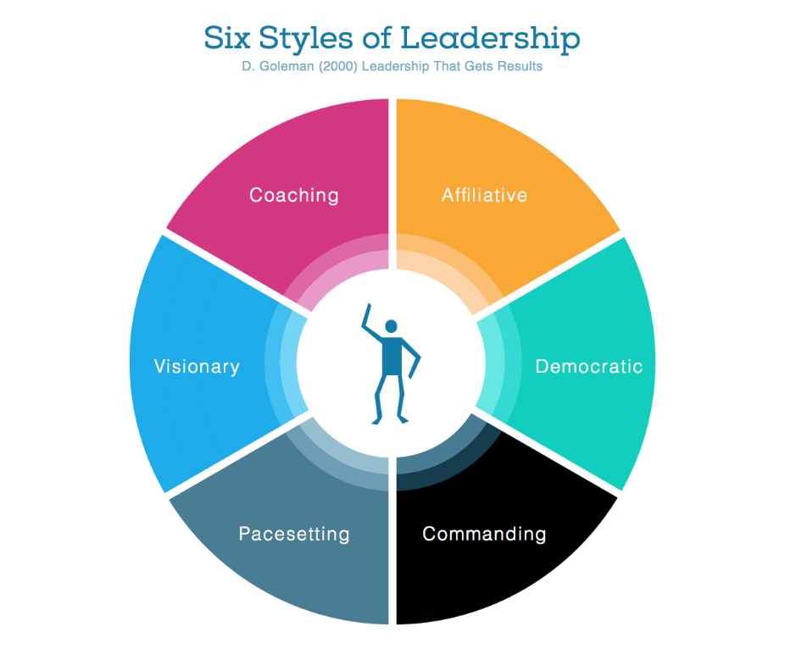

Implemented Development Plan

NAME | SKILLS TO  IMPROVE | RESOURCE | ACTIVITY | GOAL TERM &  DURATION
BILL  WILLIAM  SCOTT  MARTIN | LEADERSHIP  COMMUNICATION &  TEAMWORK  COMMUNICATION &  TEAMWORK  COMMUNICATION  &  TEAMWORK | TRAINING  TRAINING  TRAINING  TRAINING | ONLINE COURSE  TEAMWORKING  ACTIVITY  TEAMWORKING  ACTIVITY  TEAMWORKING  ACTIVITY | SHORT TERM  3 MTHS  SHORT TERM  3 MTHS  SHORT TERM  3 MTHS  SHORT TERM  3 MTHS

Couldn’t finish assignment – illness preventing

