Critical thinking
Nicola brain 1811898
Submitted by 10/12/21
Maria Heffernan

Executive summary
This report will look into what McDonald’s are doing towards sustainability towards the way they produce their beef and how they can help the planet with change, I looked at how Max Weber bureaucracy managerial theory and were put to practice how they can help be implemented to their employees and would

Contents page

- – Introduction
- – Findings
  - – Values, Beliefs and Attitudes
  - - Old management theory
  - – Modern management theory
- – Conclusion
- – Executive summary
- – Reference list

1.0 Introduction
This report was requested by the CEO McDonalds this report has to be done by the president for sustainability.
Date report requested – 17/11/21
Date report submitted to CEO – 10/12/21

2.0 Findings

2.1 In the 1940’s the McDonald brothers Dick and Mac opened their first restaurant in San Bernardino, California, which has grown into an American icon that proudly serves 63 million customers every day around the globe.
Ray Kroc’s became their franchise agent in the 1950’s and his vision was that there would be 1,000 McDonald’s restaurants solely in the United States. Yet, McDonald’s continued to grow and expand into international markets beginning in 1967 opening in Canada and Puerto Rico. Today, the company has over 36,000 restaurants in over 100 nations.
In 2020 McDonald’s opened its first net zero-designed restaurant at Walt Disney World Resort, which creates enough renewable energy on-site to cover 100% of its energy needs on a net annual basis.
McDonald’s mission is to make delicious feel-good moments easy for everyone. The backbone of their brand is, and always has been, a commitment to a set of core values that define who they are and how they run their business and restaurants.

Values, beliefs and attitudes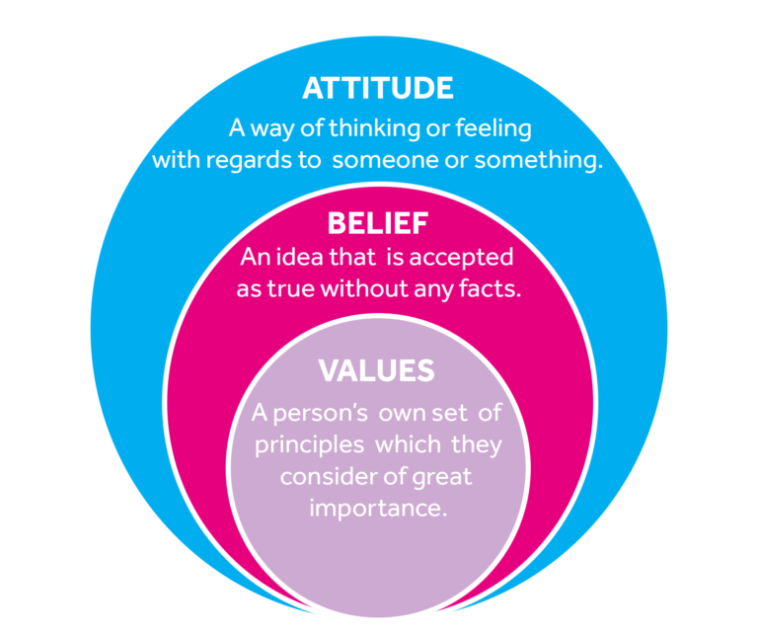

McDonald’s values are -
Serve.
Inclusion.
Integrity.
Community.
Family.

McDonald’s live by their values every day and are committed to fostering a safe, respectful and inclusive workplace for their employees providing quality jobs, McDonalds value all their employees and making opportunity open to all which includes helping their employees with university fees to help them progress with their future careers, McDonalds are committed to regularly assessing their practices and approach, in order to be more transparent and effective in supporting their employees.

With McDonald’s working towards sustainability they looked at how they could change the way that their food can be produced, too look for a way that not only protects the environment and contributes positively to a thriving global food system, but also helps rehabilitate and enhance ecosystems around farms through better soil health.
McDonalds (2021)
More sustainable beef production gives McDonald’s one of their greatest opportunities to address climate change and drive positive change in the global food system. As one of the world’s biggest buyers of beef, they are striving to make sure that its production contributes to a more sustainable food system in which people and communities, animals and the planet thrive.
McDonald’s have worked alongside a diverse, global network of suppliers, farmers, ranchers, nongovernmental organizations (NGOs) and scientists for many years. Through these efforts, they have collaborated with farmers and ranchers who have shown them it’s possible to produce beef in a way that protects and maintains native landscapes including grasslands, improves biodiversity and sequesters carbon in soils while supporting farmer livelihoods for the long term.
However, while beef is beloved by Americans – who ate 25bn lbs (11bn kg) in 2013 – it’s also one of the most environmentally damaging food in today’s diet. So the fast-food giant’s move to make beef more palatable for the environmentally conscious should be a welcome move. Except it is unclear what exactly is so sustainable – or indeed verifiable about the beef of the future.
The beef industry is only at the beginning of a long journey to figure out how it can green its burgers, not everyone, however, applauded the work. Two weeks after it was published, 23 NGOs responded with a co-signed letter condemning the effort as a “fundamentally flawed” attempt at greenwashing.
It’s widely agreed that beef has a sustainability problem. According to the latest assessment from the UN, livestock production accounts for 14.5% of greenhouse gas emissions.
Sustainability experts were excited to see beef industry heavyweights make the issue a priority, says Andrew Gunther, program director at Animal Welfare Approved, an organization which certifies humane and environmentally sound meat and dairy producers. Considering the degree of competing interests between national producers and different industry sectors, he adds, “getting [stakeholders] in a room to start talking about sustainability and to start working together is a phenomenal step forward.
The guardian (2015)
McDonalds believe climate change is the biggest environmental issue of our time, with impacts that affect communities around the world,
One of their biggest opportunity areas is their packaging, it plays an important role in reducing food waste and helping serve hot and freshly prepared food quickly and safely to customers. But when packaging and plastic waste aren’t recovered or recycled correctly, it can have a negative impact on our planet, creating litter and pollution. McDonald’s switched from plastic to paper straws so they can be recycled with their cups, they also took all the plastic toys away from their happy meals and replaced them with a soft toy or a book this represents the biggest reduction in plastic by McDonald’s UK and Ireland to date and is the next step in its mission to reduce its environmental impact across all areas of the business. The move will eliminate over 3,000 metric tons of non-sustainable plastic, whilst continuing to give McDonald’s customers the Happy Meal they know and love.
However even though McDonalds are playing their part with climate change and the environmental issues around recycling with thousands of cars a day going through their drive thru’s this contributes highly to carbon emissions.
(Mcdonalds.com 2021)

2.2 – old management theory

Max Weber believed that Bureaucracy was better than traditional structures. In a bureaucratic organisation, everyone is treated equal and the division of labour is clearly described for each employee.
Weber was unlike most workplace leaders today. His theory of management, also called the bureaucratic theory, stressed strict rules and a firm distribution of power. He would've scolded today's managers, most of whom are open to new ideas and flexible work arrangements, for their leadership style.
(Business.com 2021)
According to Weber, there are the six characteristics of bureaucracy:
Task specialization- (division of labour) Weber felt that task specialization promotes the timely completion of work at the highest level of skill. This works for McDonald’s because when they focus on putting people in areas that they are best in them can serve more customers with better satisfaction.
Hierarchical management structure- Weber advocated that management should be organized into layers, with each layer being responsible for its team's performance. This also applies well and works for McDonalds as when they have this system in place everybody will stay in the jobs they are delegated. This system allows the managers in the highest jobs to focus on their tasks and trust that the ones below them are working efficiently.
Formal selection rules- In the ideal organization, Weber believed that employees should be chosen based on their technical skills and competencies. This is important for a business such as McDonalds because the managers in higher positions may have to oversee many locations therefore they would need to be sufficiently qualified for the position.
Efficient and uniform requirements- Employees, argued Weber, should always know exactly what is expected of them. In the ideal organization, the rules are clearly defined and strictly enforced. This promotes uniformity within McDonalds and keeps the company running as smoothly and efficiently as possible. This would be important for a fast food chain such as McDonalds because of the high demand from the amount of customers they have daily.
Impersonal environment- Under Weber's theory, relationships between employees are to be only professional only. This allows a company such as McDonalds to make decision based solely on what is most beneficial to them as a company. This point of the theory reinforces his point on formal section rules and achievement based advancement, as a company with no personal ties is more likely to promote or higher somebody based only on their skill.
Achievement-based advancement. Weber felt that promotions within an organization should be based solely on achievement, experience and technical qualifications. This last point is essential for a company like McDonalds as this would complete the whole process of his theory. Only allowing staff to move up in the company once they are qualified enough allows them to keep working efficiently and keeps the work place strictly professional.
(Business.com 2021)

2.3 – modern management theory
Douglas McGregor developed two contrasting theories that explained how managers' beliefs about what motivates their people can affect their management style. He labelled these Theory X and Theory Y, these theories continue to be important even today.
(MindTools.com 2021)
McGregor proposed two theories by which managers perceive and address employee motivation. He referred to these opposing motivational methods as Theory X and Theory Y management. Each assumes that the manager’s role is to organize resources, including people, to best benefit the company. However, beyond this commonality, the attitudes and assumptions they embody are quite different.
(Lumen.com 2021)
Theory X
. Most will avoid work where they can and show no interest in their role.
. Will have little ambition and no desire for responsibility.
. Have no incentive to work and needs to be enticed by rewards.
. Would need to be supervised.

Theory Y
.Happy to work on their own initiative.
.More involved in decision making.
.Self-motivated to complete their tasks.
.Enjoy taking ownership of their work.
.Seek and accept responsibility, and need little direction.
.View work as fulfilling and challenging.
.Solve problems creatively and imaginatively.
(MindTools.com 2021)
Theory X managers tend to assume that their employees are naturally unmotivated and dislike work. As a result, they think that team members need to be prompted, rewarded or punished constantly to make sure that they complete their tasks, work in organizations that are managed like this can be repetitive, and people are often motivated with a "carrot and stick" approach. Performance appraisals and remuneration are usually based on tangible results, such as sales figures or product output, and are used to control staff and "keep tabs" on them.
Theory Y managers have an optimistic, positive opinion of their people, and they use a decentralized, participative management style. This encourages a more collaborative, trust-based relationship between managers and their team members.
People have greater responsibility, and managers encourage them to develop their skills and suggest improvements. Appraisals are regular but, unlike in Theory X organizations, they are used to encourage open communication rather than control staff.
Theory Y organizations also give employees frequent opportunities for promotion.
(MindTools.com 2021)

However McDonald’s employees that have worked their way up to become managers and would have had to have had a lot of training to be where they are right now, with McDonalds efforts towards sustainability using the Y theory it comes naturally and they can see the effect it has on the planet.

Conclusion

References

Corporate.mcdonalds.com. 2021. Sustainable Agriculture & Beef. [Online] Available at: https://corporate.mcdonalds.com/corpmcd/our-purpose-and-impact/our-planet/sustainable-agriculture.html [Accessed 17 November 2021].
The Guardian. 2021. Will McDonald's ‘sustainable beef’ burgers really be any better?. [Online] Available at: https://www.theguardian.com/sustainable-business/2015/jan/13/sustainable-beef-mcdonalds-meat-environment [Accessed 6 December 2021].
Mcdonalds.com. 2021. McDonald’s pledges to remove non-sustainable hard plastic from its iconic Happy Meal. [Online] Available at: https://www.mcdonalds.com/gb/en-gb/newsroom/article/plastic_free_zone.html [Accessed 8 December 2021].

Business.com. 2021. [Online] Available at: https://www.business.com/articles/management-theory-of-max-weber/ [Accessed 6 December 2021].
Mindtools.com. 2021. Theory X and Theory Y: Understanding People's Motivations. [Online] Available at https://www.mindtools.com/pages/article/newLDR_74.htm [Accessed 8 December 2021].

Courses.lumenlearning.com. 2021. Reading: McGregor’s Theory X and Theory Y | Introduction to Business. [Online] Available at https://courses.lumenlearning.com/wmintrobusiness/chapter/reading-douglas-mcgregors-theory-x-and-theory-y-2/ [Accessed 8 December 2021].

