
MODULE CODE: BMSW4011
ASSIGNMENT NAME: Business Plan
and Reflection
STUDENT NAME: Sophie Jenkins
STUDENT NUMBER: 2440056
LECTURER: Mel Squire

Word count 1132

AI Acknowledgement

I acknowledge the use of apple Siri to help with my grammar and clarity of academic tone. I confirm that I have not presented any AI generated text as my own work. I confirm that I have copies of my drafts, notes, and other resources I used before, and after the use of AI tools which I may be asked to provide.

CONTENTS

- Business Overview ……………………………………… Page 4
- Inspiration And Personal Motivation …………………… Page 6
- Legal Structure – Private Limited Company …………. ...Page 6
- Mission, Aim and SMART Objectives …………………..Page 6
- Location Analysis and Community Demand …………... Page 7
6. Human Resources………………………............................Page 8
7. Marketing Strategy…………………………………….…Page 10
8.Financial Plan …………………………………………… Page 11
9.Competitor Analysis ………………………... ....................Page 12
10.SWOT Analysis …………………………………….……Page 13
11. Conclusion ………………………………………………Page 13
12.Reference List ……………………….………………….. Page 14

Business Plan. Little Explorers Childcare.
Safe hands, Curious Minds.

1.Business Overview
Little Explorers childcare is a community focused, early years and wrap around childcare provider based in St.Edeyrns Village, Bridge Road, Old St. Mellons, Cardiff CF3 6AW. The Business will operate from a commercial premises marketed through Fletcher Morgan (2025) Situated in a growing housing area.

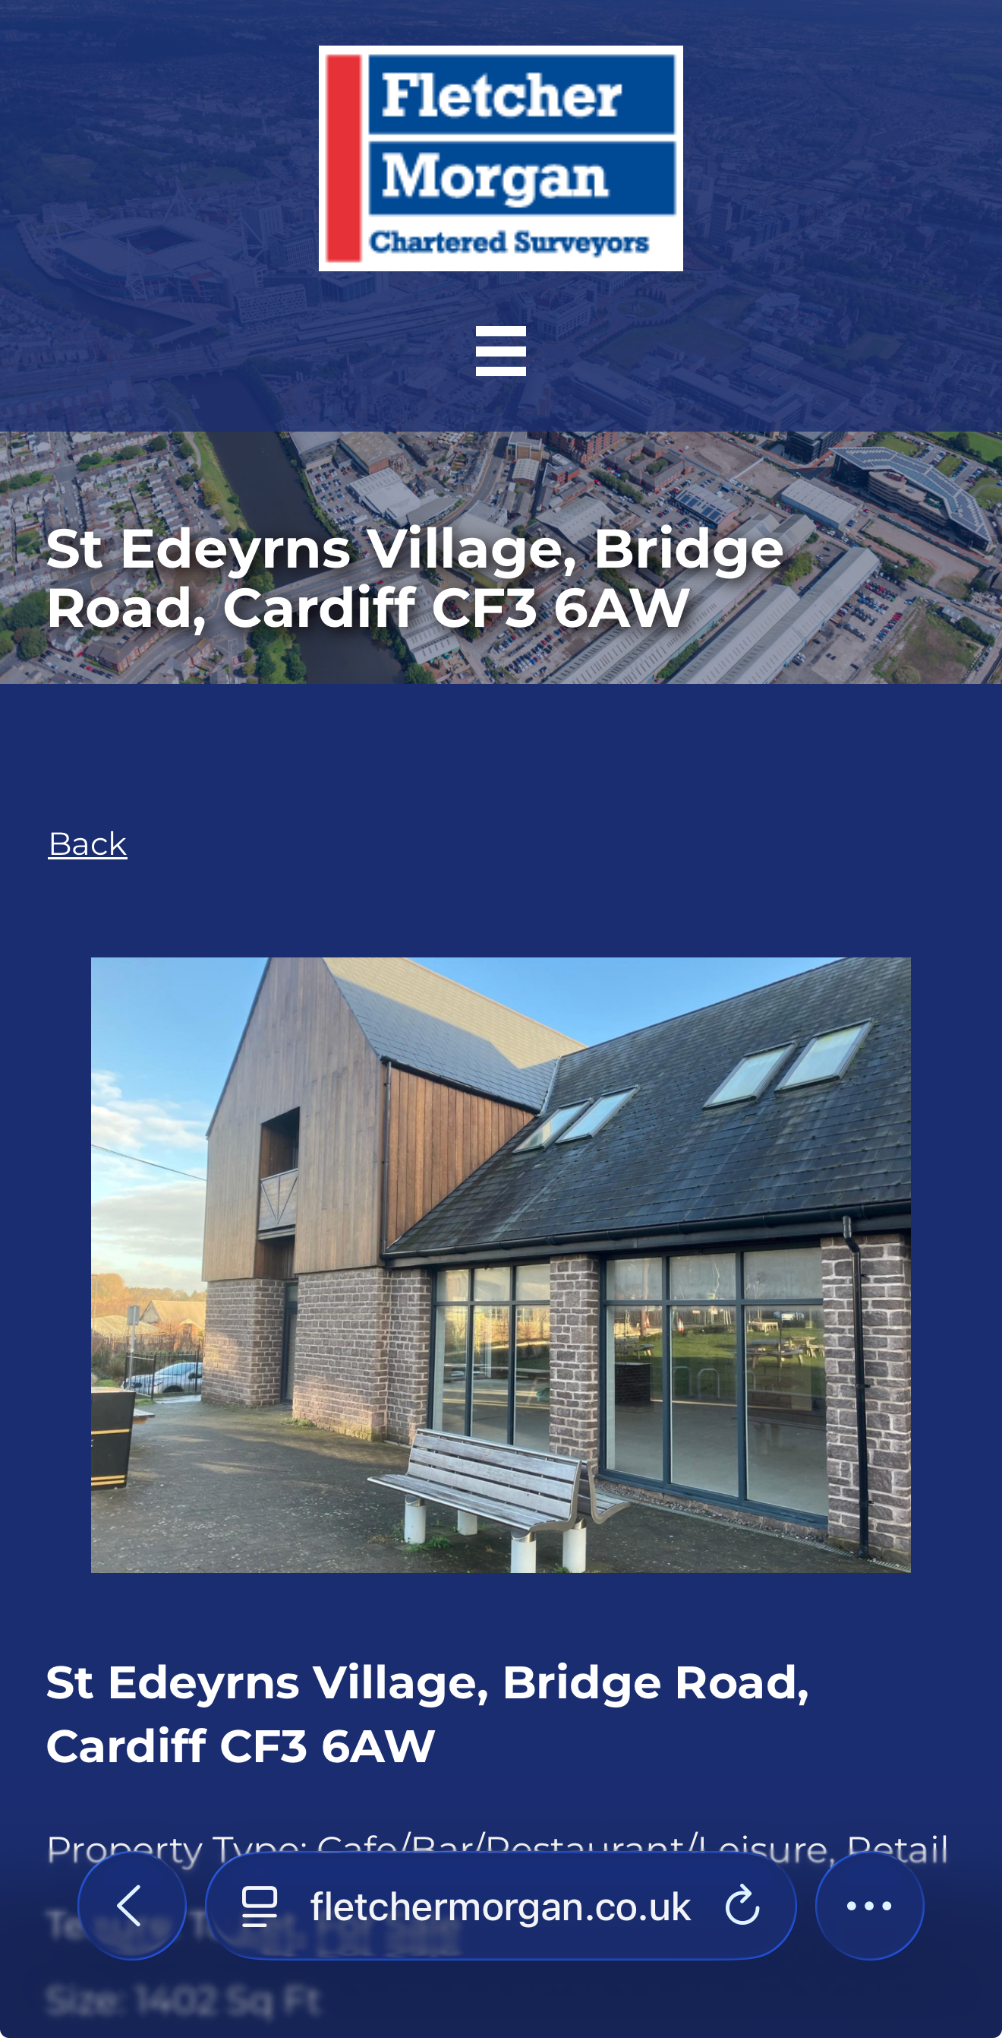
Figure 1: Proposed commercial premises at St.Ederyns Village, Bridge Road, Cardiff Cf3 6aw (Fletcher Morgan,2025)

This business will provide high quality childcare for children aged 0-11 years, offering full day nursey care alongside after school and holiday provisions. Services
for little ones 0-5 will follow the Early Years Foundation stage statutory framework (DfE,2023) and Welsh government guidelines ensuring focusing on learning through play, emotional well-being and inclusive practise. Provision for older children will include structured play, homework support and social activities that support social and emotional growth.
The setting aims to provide a stimulating environment but also safe and a home from home feel where children can thrive while supporting working families who require flexible reliable childcare.

Parents will be able to find full business information and contact details on the official Little Explorers business page
Littleexplorerscf3.my.canva. site

2. Inspiration and Personal Motivation
The idea for Little Explorers has been developed not only as a business opportunity but from personal experience and passion. Being a single parent and relying heavily on childcare services especially in my child's early years and growing up around social work and foster care environments provided a passion and a deep understanding of the importance of stable, nurturing environments for vulnerable children. According to research high quality early years provision significantly improves outcomes for disadvantaged children (Smith and Jones,2022).
This personal background shapes the ethos of Little Explorers- creating a safe, emotionally supportive environment for children across both early years and primary age children within the community.
Not just caring for children supporting families!

3.Legal Structure
Private Limited Company
Little Explores will operate as a Private Limited Company (Ltd). This has been chosen due to the advantages in financial protection, credibility, and growth.

Advantages:
- Easier access to funding and investment
- Limited liability protects personal assets
- Increased Professionalism and trust
- Plan for future growth
Disadvantages:
- Higher Set up costs
- Annual reporting obligations
- Extra procedural demands
Despite the additional responsibilities this supports growth, long-term and long lasting making it the most suitable choice for a childcare business to be able to expand. Given the projected annual of 300,000, this structure is more than appropriate

4.Mission, SMART objectives And Aim
Mission Statement-
To Provide a safe, inclusive, and high-quality childcare that supports children's emotional wellbeing and development while supporting busy families.

Business Aim-
Creating a trusted childcare environment that delivers all round support from babies to primary age within the local community.

Objectives-
1.Develop a partnership with the local community and schools within 18 months.
2.Complete business registration and secure regulatory approval within 12 months.
3.Acheive at least 70% occupancy within the first year of running business.
4.Introduce holiday club provision within the first two years.

These objectives are achievable, realistic and supporting structured growth!

5.Location Analysis and Community Demand
St.Ederyns Village, forms part of Cardiff's strategic housing expansion (Cardiff City Council,2024). The new area has expanded by thousands and continuing to attract young families with an increasing demand for childcare services.

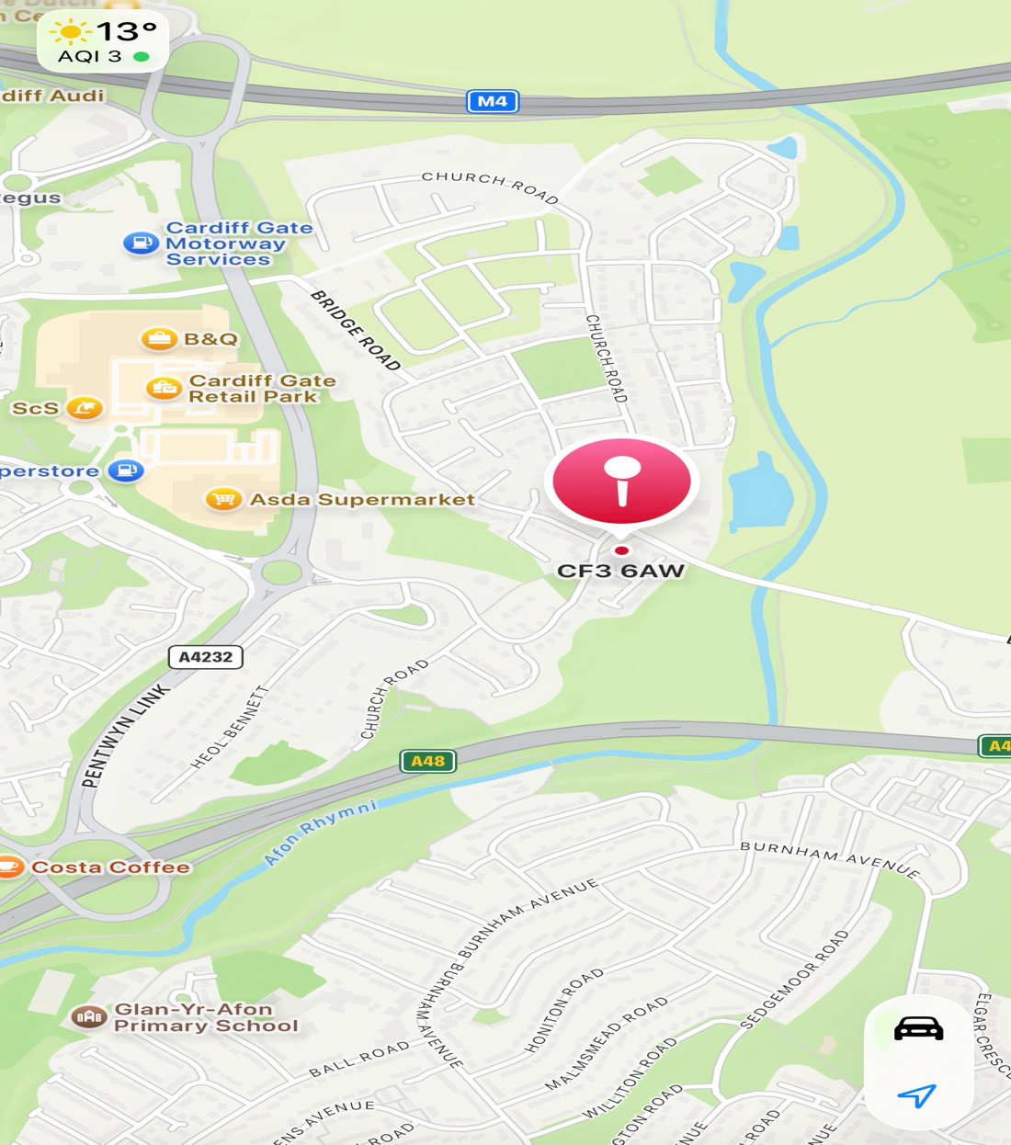
Figure.2 google maps of location (Authors screen shot)
A key development is the opening of Old St. Mellons Church in Wales Primary School, established due to increased child population resulting from housing growth (WalesOnline, 2021). This is confirming long term population growth creating a demand for
- Full day Nursey Care
- Before School Provision
- After school care
- Holiday Clubs

National Statistics show rising dual income households across the UK (ONS,2023), increasing reliance on formal childcare. Parents also tend to prefer childcare close to home or school (ONS,2024), making this location beneficial.

6.Human Resources
The staffing structure for Little Explorers childcare has been designed to ensure the best quality provision, effective operational management, regulatory compliance. The planned organisational structure is shown in figure 2.

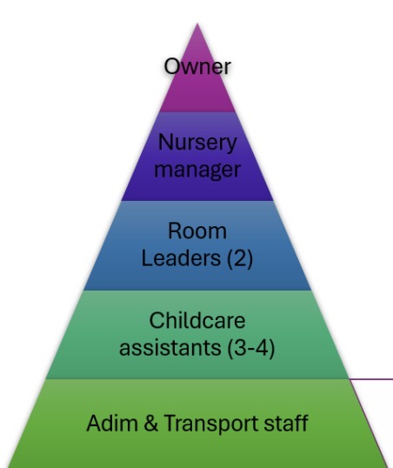
Figure 3. Proposed staffing structure for Little Explorers Childcare (Authors own design,2026)

Workforce Structure
This nursery will operate with the following staffing structure:
- 1 Nursery Manager
- 1 Deputy Manager
- 2 Room Leaders
- 3 Childcare Practitioners
- 1 Administrator & Transport/Support Staff

This structure shows clear Leadership, responsibility, and defined roles within the setting.
Staffing will comply with statutory adult to child ratios outlined in the Early Years Foundation stage framework (DfE,2023):
- Babies under 2: 1;3
- 2 years: 1:4
- 3-5 years: 1:8
All Employees will have to undergo
- Enhanced DBS Checks
- Safeguarding Training
- Paediatric First Aid training
- Ongoing Professional development

According to research staff quality as the most influential factor in parental childcare choice (NDNA,2024). Therefore, recruitment will prioritise qualifications, experience, and commitment to child centred practice.

7.Marketing Strategy
Marketing activities will include:


Figure. 4 Brand Logo (Authors own design)

- A brand logo
- Flyers distributed locally
- Social media
- St.Ederyns Village community Facebook page
- Launch open day
- Business website
- NHS and student discounts

Parents tend to research childcare providers online before enrolment (Family and Childcare Trust,2024) Therefore, being seen online is essential.

Little Explorers will be seen as professional but also a community hub, offering flexible payment options for low-income families.
Figure.5 Little Explores website (Authors design)

8.Financial Plan
Monthly Forecast:
Income: £25,000
Costs: £13,820
Monthly Profit: £11,180
Annual Forecast:
Income: £300,000
Costs: £165,840
Annual Profit: £134,160
Government childcare funding schemes support affordability (UK Government,2024). While staffing remains the largest operational cost (NDNA,2024), Investment in qualified staff strengthens enrolment stability and reputation.

The financial plan demonstrates sustainability long term probability.
Our largest cost is staffing, fler
t is staffing
9.Competitor Analysis
Researching local competition includes private nurseries and school-based childcare and religous setting based childcare.
Strengths of competitors:
- Established brand recognition
- Existing customer
Weaknesses
- Limited community focused discount structures
- Not Focused on emotional wellbeing
- Faith base settings may limit appeal to some families

Little Explorers sets itself apart by offering dedicated NHS discount schemes, embedding Special Educational needs (SEN) informed approaches into daily practice, prioritising children's emotional wellbeing, and locating the setting strategically within a growing residential area close to new housing developments and school facilities.

10.SWOT Analysis
Strengths
- Unique wellbeing focus
- Limited liability business protection
- Community centred model
- Growing location
Weaknesses
- Initial marketing costs
- New brand
- High start up costs
- Dependency on occupancy

Opportunities
- Rising dual-income households (ONS,2023)
- New primary school increasing childcare demand (WalesOnline,2021)
- Continued housing expansion (Cardiff City Council,2024)

Threats
- Competition
- Regulatory changes
- Economic instability

11.Conclusion
Little Explorers childcare is financially viable, located in a perfect strategically community focused area.
The new school located in walking distance and the rising cost of living and increasing childcare expenses across wales have placed significant financial pressure on families, increasing a demand for accessible community based childcare provision (Welsh Government,2023; Coram Family and childcare,2024). Operating as a Private Limited Company protects financial risk and supports professional credibility and long-term growth.
With a reliable workforce structure, financial plans, local research and community support positions as both a socially and commercially viable sustainable enterprise needed within St.Ederyns Village.

References

1.Cardiff City Council (2024) Local Development Plan and housing growth strategy. Available at www.Cardiff.gov.uk

2.Care Inspectorate Wales (2024) Regulation and inspection of childcare settings. Cardiff: CIW. Available at www.careinspectorate.wales

3.Coram Family and Childcare (2024) Childcare Survey 2024. London: Coram Family and Childcare. Available at www.coramfamilyandchildcare.org.uk

4.Department for Education (DfE) (2023) Statutory framework for the Early Years Foundation Stage. London: DfE. www.gov.uk

5.Family Information Service Cardiff (2024) Local childcare provision statistics. Cardiff: Cardiff Council.

6.Fletcher Morgan (2025) Commercial property listing: St Edeyrns Village, Bridge Road, Cardiff CF3 6AW. www.fletchermorgan.co.uk

7.NDNA (2024) UK Nursery Sector Report 2024. Huddersfield: National Day Nurseries Association. https://www.ndna.org.uk

8.Office for National Statistics (ONS) (2023) Families and the labour market, UK: 2023. London: ONS. www.ons.gov.uk
9.Office for National Statistics (ONS) (2024) Childcare usage and parental employment patterns. London: ONS. www.ons.gov.uk

10.Public Health Wales (2023) Child development and wellbeing indicators report. Cardiff: PHW.

11.Smith, J. and Jones, L. (2022) The impact of high-quality early years provision on child development outcomes. Journal of Early Childhood Studies, 14(2), pp. 45–60.

12.UK Government (2024) Help with childcare costs. https://www.gov.uk/help-with-childcare-costs

13.WalesOnline (2021) New primary school in Cardiff’s St Edeyrns development to meet rising demand. www.walesonline.co.uk/news/wales-news/new-primary-school-cardiff-pontprennau-22516260

14.Welsh Government (2022) Curriculum for Wales: Foundation Phase guidance. Cardiff: Welsh Government.

15.Welsh Government (2023) Childcare Offer for Wales: guidance for providers. Cardiff: Welsh Government. https://www.gov.wales

Individual Reflection

I have really enjoyed completing this assessment. At the beginning when I first looked at the assignment brief and started the lectures, especially anything to do with numbers and financial planning, my mind was honestly blown. It all felt very overwhelming. Spreadsheets, projected income, costs ratios and profit calculations seemed far more complicated than I expected, I didn't think I would get my head around it and be able to fully understand it.
However, once i started looking into what was set out to do and breaking it down step by step, realising the numbers make up the planning a lot more than you think when looking into a business. By playing around with Excel and Powerpoint i realised it was not as impossible as it first felt. I learnt how to calculate projected income and expenses, how rates cn affect profit, and how staffing directly impact financial planning i also learnt how to create numerous charts and graphs some i didnt know exsisted, to present financial data clearly. At the start i didnt think i could do things like that confidently, but by the end of the assignment i was able to put structure on financial information in a way that made sense.
Because I live in Old St.Mellons this project felt very personal to me. Ive watched the area grow and establish from being one of the first streets and there being nothing around and there has been an empty space a stone throw away fom my home that ive always looked at, so being able to reasearch what it would actually take to turn something like this into a childcare buisness something i have passion about so close to home made me more determined to understand and not to just complete the assesment. Being able to physically and visually see while reasearching the housing growth around me, the new school development and is there local demand for what i was talking about.
Throughout this project i would say i developed research skills and analytical skills, instead of assuming there was demand, i had to find evidence, i had to find evidence to support what i was saying and my decisions while making the plan, looking into the housing expansion which is a lot bigger than i expected even living here, the new school development and two income households helped me justify a business idea properly.
I also strengthed my organisational and communication skills. Writing a full business plan sounded easy fun but required structure and clear linking between sections. Playing around with Canva and powerpoint presentations helped me hopefully simplify information while keeping it sounding professional.
The skill that had the biggest impact on me was confidence in the financial planning again at the start, i genuinely doubted my idea and my ability in the financial area. By the end, i understood profit and financial sustainability, would this business work, ive definitly changed how i view a business planning.
Looking through it all, this assesment has made me realise that something i look at every day could genuinely become a business a profitable community business with the right planning. It has increased my confidence, developed my skills and given me a realistic understanding of what it would take to turn an idea into a successful enterprise.

Word Count
549

