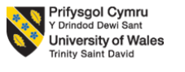
Programme: Master of Business Administration.
Module: International Marketing: Principles and Practices.
Module code: LCMB7026
Student name: Arab Naima Nadimahmed.
Student id:2503320
Lecturer: Tushara Balendran and Dian Mayasari.
Table of Contents
Section 1: Comparative Market Analysis of Zara in France and Italy 3
A. Compare and contrast the macro-environment using PESTEL Framework 3
B. Comparative Analysis of Zara’s STP Strategy and International Marketing Mix in France and Italy 17
1. Segmentation, Targeting and Positioning (STP) 17
2. International Marketing Mix (7Ps) Strategies of Zara in France and Italy 23
C. Directional Development Strategy of Zara in France 34
D. Ethical Issues in the Marketing Mix of Zara in France 35
E. Recommendations for Future International Marketing Strategy of Zara in France and Italy 36
Section 2: Reflection 38
References 42

Section 1: Comparative Market Analysis of Zara in France and Italy
Zara is a Spanish fast-fashion apparel brand owned by Inditex (Simpson, 2025). It operates in 96 countries including France and Italy (Forbes, 2025). The study will compare the macro-environment of France and Italy using the PESTEL framework (Peterdy, 2025) analysing the way these factors influence the retail fast-fashion market and marketing strategies of Zara. The report will conduct a detailed comparative analysis through applying STP strategy and Internal marketing mix. The directional development strategy of Zara in France will also be described in this report along with the ethical issues. Several recommendations will also be provided in this report that can help Zara to improve their operations in the foreign market. A reflective account will also be presented in this report.
Background Information about the company
Zara was founded in 1975 by business enthusiast Amancio Ortega and his wife Rosalía Mera with the mission to offer affordable and high-quality fashion items to customers. The vision Zara follows is to become a global leader of ethical and sustainable fashion.

A. Compare and contrast the macro-environment using PESTEL Framework
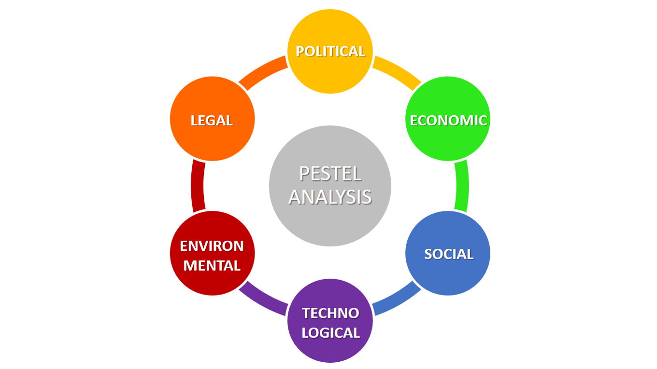
Figure 1: PESTEL Analysis
(Source: ESG News, 2025)
It refers to the structured framework through which businesses can access the external environmental impact on the business operations and performances. The Framework consists of multiple external factors such as political, economic, social, technological, environmental, and legal.
1. Political Factors
In France, the policymakers have taken a strict stance against fast-fashion for environmental concern. The legislations are targeting fast-fashion companies including eco-taxes and advertisement restrictions to reduce environmental damage caused by mass-clothing production (ESG News, 2025).
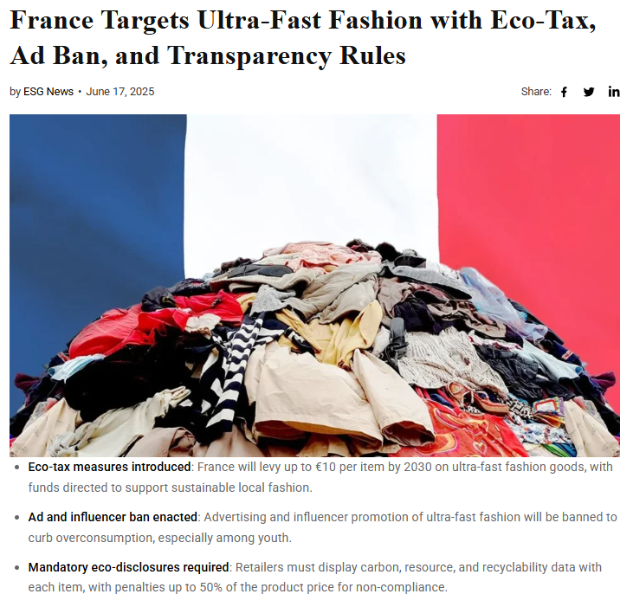
Figure 2: Restrictions for fast fashion brands
(Source: ESG News, 2025)
These policies reflect the French government’s focus on sustainability and responsible consumption.
In Italy, the government has implemented policies to protect its domestic fashion industry. It has considered the introduction of levies on low-value imports from international e-commerce platforms to support the local manufacturers and maintain the commitment of “Made in Italy” goods (Withersworldwide, 2023).
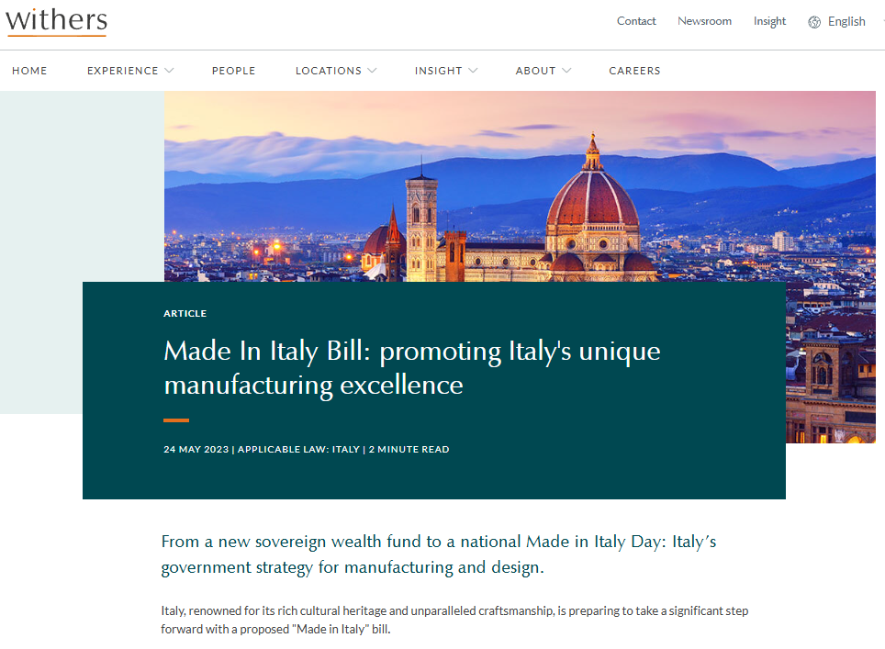
Figure 3: Made in Italy bill
(Source: Withersworldwide, 2023)
Such political environment strengthens the value of domestic talents and high quality fashion.
Zara can operate in these two countries aligning with the European sustainable. Political stability and EU trade regulations are favourable for Zara, as they decrease the barriers of trades. But, strict eco-regulations of France and Italy’s protection of domestic industry are unfavourable for the company because of extra compliance pressure.
2. Economic Factors
France is one of the largest fast-fashion markets in Europe. The French apparel market to rebound by 2.2% (Safaya, 2024) showcasing strong customer demand. The French fashion industry generates €153 Billion in annual revenue contributing 2% of the national GDP (Park, 2026).
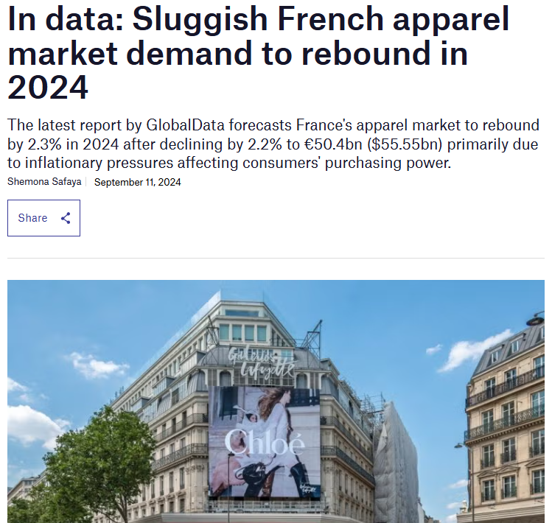
Figure 4: Rebound of Market
(Source: Safaya, 2024)
This strong economic foundation supports the presence of global fashion brands like Zara.
Italy’s apparel market generates $70.6 Billion in revenue (IMARC Group, 2025) with household expenditure on clothing and footwear is increasing. The Italian fashion retailers experienced an 11% increase in gross merchandise value in fashion purchases (Apparel Resources News-Desk, 2025).
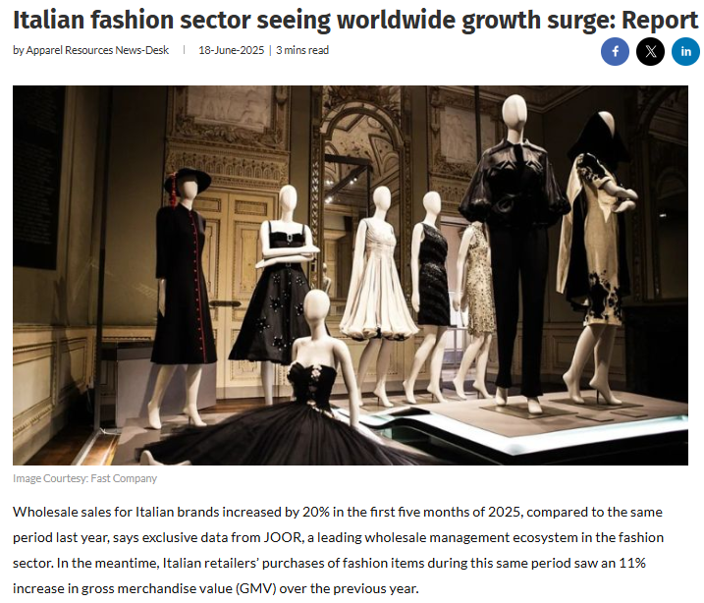
Figure 5: Growth in Italian fashion market
(Source: Apparel Resources News-Desk, 2025)
Both the markets are of similar sizes but the customer spending pattern is different as Italian customers spent high for each item with high annual per capita spending. French customers are price conscious for economic pressures and the growth of second-hand markets. This economic difference means Zara should maintain competitive pricing and offer frequent collections to increase appeal to the price sensitive customers in France and address the quality expectations in Italy.
Economic factors are favourable for the company due to strong market growth and high revenue in both countries.
3. Social Factors
The social factors include culture, lifestyle, and customer attitude towards fast fashion which are significant for Zara.

Fashion culture
France hosts various luxury brands and fashion houses and this industry contribute 3% to its national GDP (Accuracy, 2024). French customers are typically sensitive to their lifestyle, elegance, style and timeless fashion against short term trends. Currently the customer behaviour in France is evolving as increased number of buyers preferring second-hand fashion for sustainability commitments and cost savings. In 2025, the second-hand clothing accounted 16.30% of France’s total apparel sales increasing 10.9% from FY2024 (Houghton, 2026).
In Italy there is a strong tradition of talented craftsmanship and design excellence aligning with the “Made in Italy” tag (Naef, 2025). The Italian customers generally prefer high quality, exclusive design, and authenticity. The fashion sector benefits from this strong domestic parent culture an international reputation for luxury fashion.
Customer behaviour
French customers prioritise sustainability and affordability while purchasing fashionable clothes. The young demographics are aligned towards resale platforms and sustainable fashion. The fast-fashion is popular due to its accessibility and frequent product updates in real-time.
The Italian customers show different behavioural patterns as research indicates that 65% of Italian shoppers analyses fashion brands or social media like Instagram before purchasing (Hubstyle, 2026).
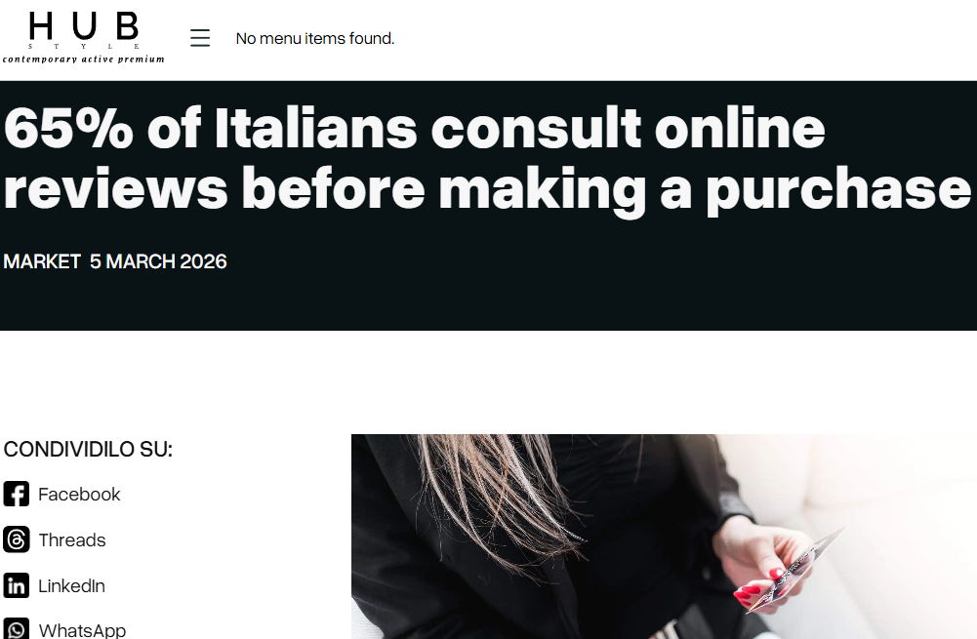
Figure 6: Customer behaviour in Italy
(Source: Hubstyle, 2026)
36% customers make purchases online through e-commerce platform and 58% of them are check sustainability claims made by the fashion brands (Rawshot, 2025). Italian customers give time for research and analysing the products before purchasing a fashion item. It shows that the Italian customers are more involved in decision making compared to the French customers who make faster purchase according to market trends and affordability.
Cultural factors: Cultural differences mentioned by the Hofstede model can explain the segmentation patterns. France shows higher individualism which means customers express personal identity with the help of fashion. Italy on the other and score is low in uncertainty avoidance that customers in the country often research products before purchasing and they frequently prefer trusted brands.
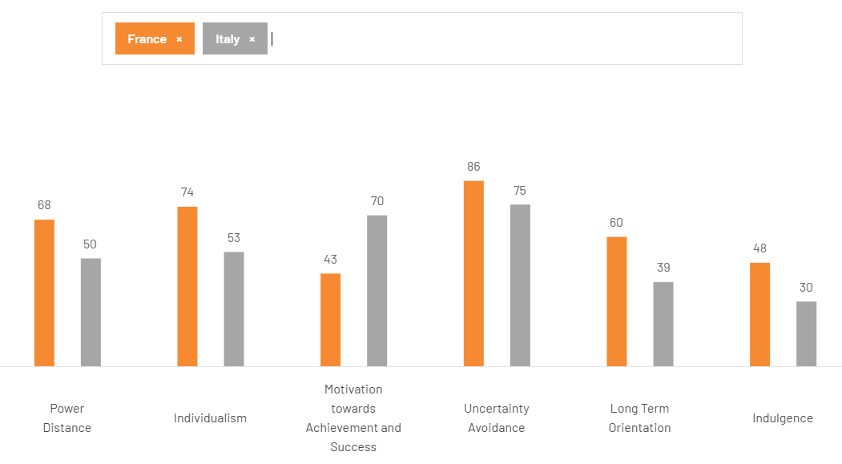
Figure 7: Comparison of culture
(Source: Theculturefactor, 2026)
The cultural factors are favourable for Zara. Individualism of France supports self-expression through fashion. In contrast, Italy’s brand preference builds loyalty. One disadvantage of Hofstede model is it oversimplify the cultures. But one advantage is it provides useful market insights for segmentation and strategy.
Implications for Zara
This social difference impacts Zara’s marketing strategy. In France, Zara focuses on fast-changing collections and accessible pricing to meet demand for affordable clothing. In Italy, Zara focuses on design quality, style inspiration, and digital engagement in social media to attract more fashion-conscious customers.
Social factors are favourable for the company because of consumer interest in fashion. This supports demand.
4. Technological Factors
In France, there is a rapid growth in ecommerce with online fashion sales reached $23.66 billion in 2025 (Coherentmarketinsights, 2025). However, after COVID-19 pandemic, many consumers have returned to physical stores to do in-person shopping, reflecting the importance of Omni channel retail strategies.
In Italy, there can be also a strong digital growth can be witnessed. In the country, online fashion sales has increased significantly with €85.4 billion and projected to grow at a CAGR of 8.46%.
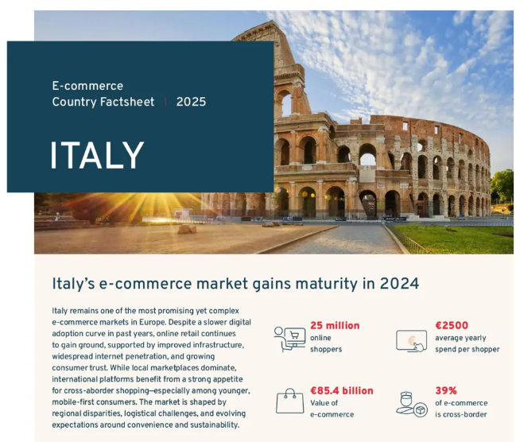
Figure 8: E-commerce market in Italy
(Source: Landmarkglobal, 2025)
Additionally, almost 50.9% of Italian consumers preferred to buy fashion products online (Landmarkglobal, 2025).
Zara operates a strong Omni-channel retail model to ensure its growth. Technological infrastructure in both the countries effectively supports the company to offer integrated online and offline shopping experiences to the customers. The company is also using digital tools like mobile apps, online ordering, and inventory tracking systems to improve customer experience.
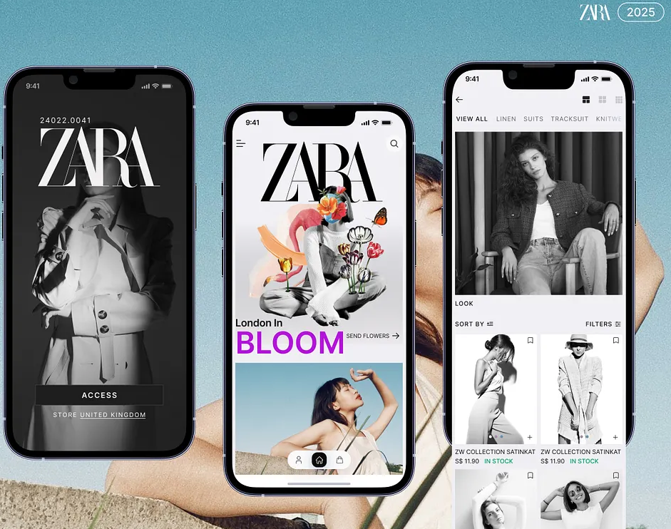
Figure 9: Zara App
(Source: Akter, 2025)
Technological Factors highly favours the company. Advanced e-commerce and omni-channel growth boost the operation of the company.
5. Environmental Factors
Environmental systems abilities now major issue for the fashion industry, especially in the Europe.
In France, due to the increase environmental issues criticism of fast fashion and penalties for unsustainable practices are increasing. For example, France imposed €40 million fine to Sheinfor deceptive commercial practices (Nilsson-Julien, 2005).Rising number of public awareness campaigns as well as policy proposals targeting Ultra-FastFashion retailers (Wong, 2025) is indicating the importance of sustainable production and responsible consumption.
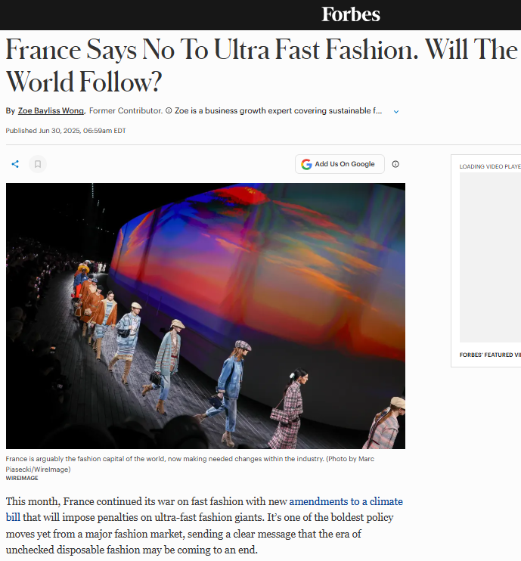
Figure 10: France says no to ultra-fast fashion
(Source: Wong, 2025)
Italy is also facing an increasing demand for sustainable fashion. The sustainable fashion market in the country is expected to reach $1763.35 million by 2033 (Morgan, 2025) because the consumers increasingly prefer companies offering environmentally friendly materials and ethical production processes.
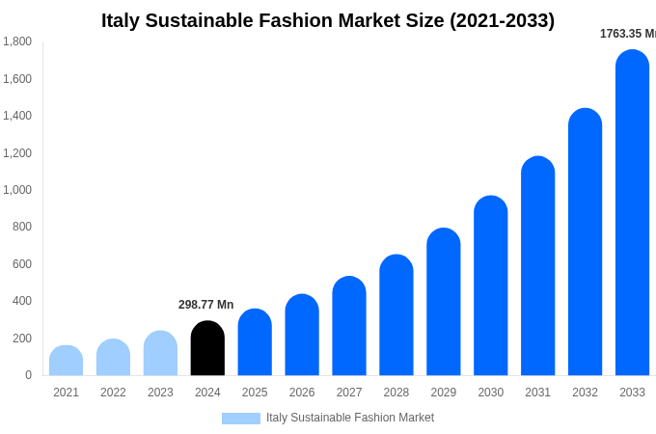
Figure 11: Sustainable fashion market in Italy
(Source: Morgan, 2025)
As a result, Zara has taken several sustainability initiatives like using recycled materials and fostering eco-friendly collections.
The environmental factors and strict sustainability expectation creates an unfavourable condition for the company. It enhances the cost, but it also create opportunities for the brand.
6. Legal Factors
In Italy, authorities have intensified scrutiny in fashion supply chains like "Made in Italy" has recently come under intense scrutiny (Naef, 2025).
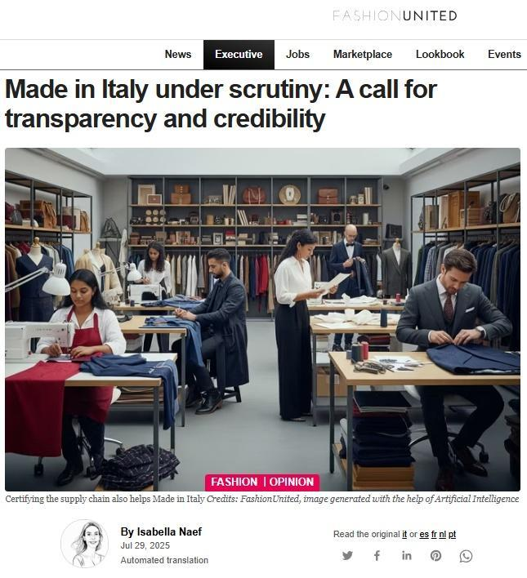
Figure 12: Supply chain transparency issue
(Source: Naef, 2025)
They are investigating into labour practices within premium brand production networks (Occhio, 2025). Withthese developments, there is an increasing importance of transparency and ethical sourcing in the Italian fashion industry.
In the same manner, authorities in France have introduced regulations which requiring fashion brands to give transparent and detail information about product materials and environmental impact (Modaes, 2025). These regulations are focusing on enhancing sustainability transparency and encouraging responsible production.
For Zara, it is important to comply with these legal requirements to maintain customer trust as well as avoid reputational harms.
Legal factors are unfavourable for the company as Strict EU laws increase compliance requirements.
Similarities and Differences
Aspect | Similarities | Differences
Political | Both follow EU regulations and promote sustainability policies affecting fast fashion. | France enforces stricter eco-laws; Italy focuses on protecting “Made in Italy” industry.
Economic | Strong fashion markets with growing demand supporting global brands. | France is price-sensitive; Italy has higher per capita spending and premium focus.
Social | Increasing awareness of sustainability in both countries. | France favours affordability and resale; Italy values quality, design, and research.
Technological | Growth in e-commerce and omnichannel retail in both markets. | Italy shows higher online adoption; France still values physical stores more.
Environmental | Rising sustainability pressure and eco-conscious consumers. | France imposes stricter penalties; Italy emphasizes sustainable luxury growth.
Legal | Strict EU-based regulations on labour and environment. | France stresses transparency laws; Italy emphasizes supply chain authenticity.

B. Comparative Analysis of Zara’s STP Strategy and International Marketing Mix in France and Italy

1. Segmentation, Targeting and Positioning (STP)
Segmentation
The European fashion market is segmented by Zara based on democratic psychographic and behavioural factors. The primary consumer segment in both France and Italy is young urban customers aged between 18 and 40 who focuses on fashion trends and want stylish clothing at affordable prices.
In France, segmentation of Zara reflects sustainability awareness and price sensitivity. French customers are considered in environmental impact run party Singh any fashion product. Second-hand fashion market observed 2.8 Billion units sold in FY2024 which is a record accounting 7.1% of total fashion market mostly in women apparels segment (Globaltextiletimes, 2024).
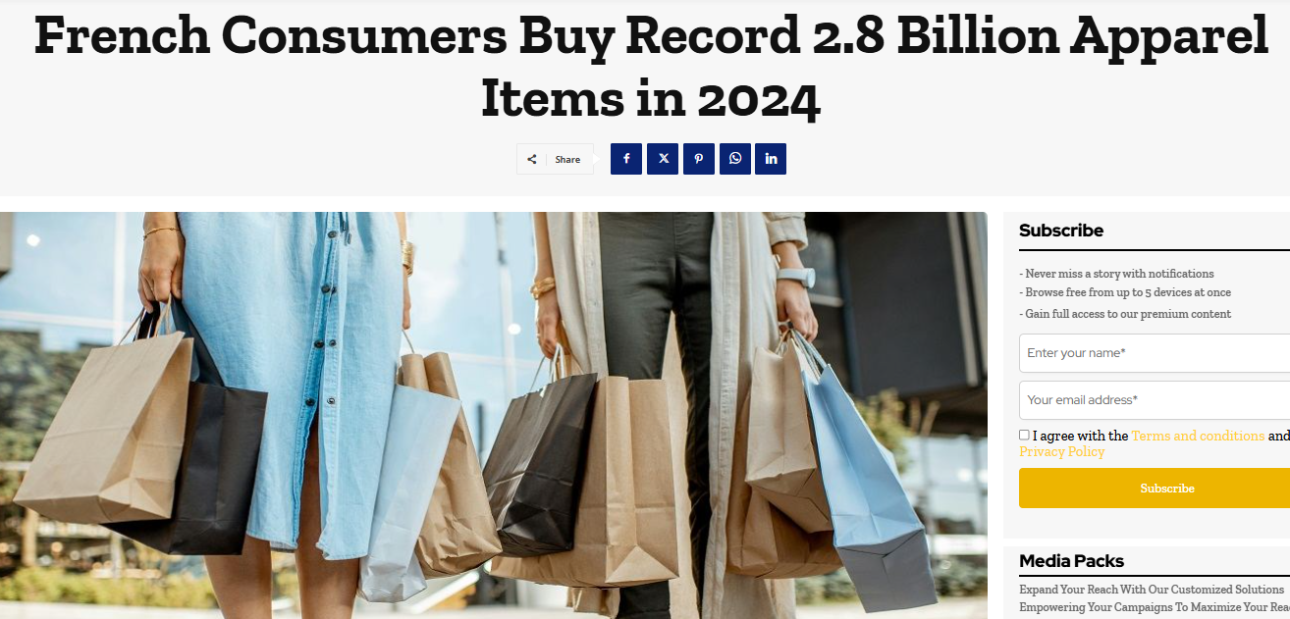
Figure 13: Record made by French customers
(Source: Globaltextiletimes, 2025)
Highlights that French customers are significantly aware about overconsumption and they are interested in sustainable fashion.
In contrary, market segmentation in Italy indicates stronger focus on fashion environment, design appreciation, and craftsmanship. Fashion textile market of Italy is projected to reach $104.2 billion by 2034 (IMARC Group, 2025).
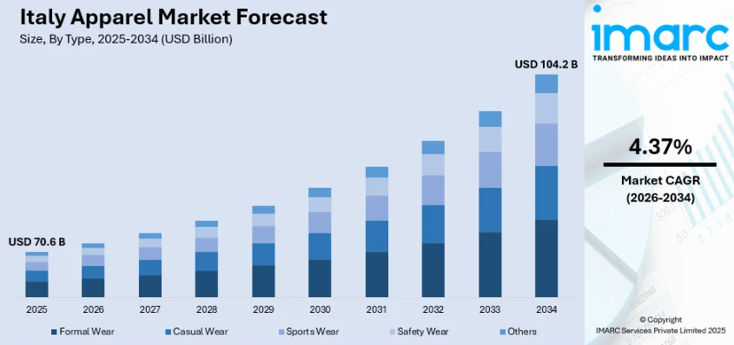
Figure 14: Fashion textile market in Italy
(Source: IMARC Group, 2025)
This makes it one of the largest fashion producers in Europe. In general, French customers preferred design quality, authenticity, and brand image, cultural significance of the maid in Italy identity.
Targeting
Zara generally targets fashion conscious urban customers who focuses on friendly clothing at moderate and affordable prices. However, the company has adjusted its targeting approach slightly in each country.
In France Zara targets young professionals as well as students in large cities like Paris, Marseille, and Lyon. The company focuses on price sensitive fashion consumers and also sustainable aware shoppers. In France, customers often follow fast changing fashion trends what generally remain aware about rice and environmental impact. Hence, Zara focuses on eco-friendly product lines like ‘join life’ sustainable range and affordable collections (Weavabel, 2024).
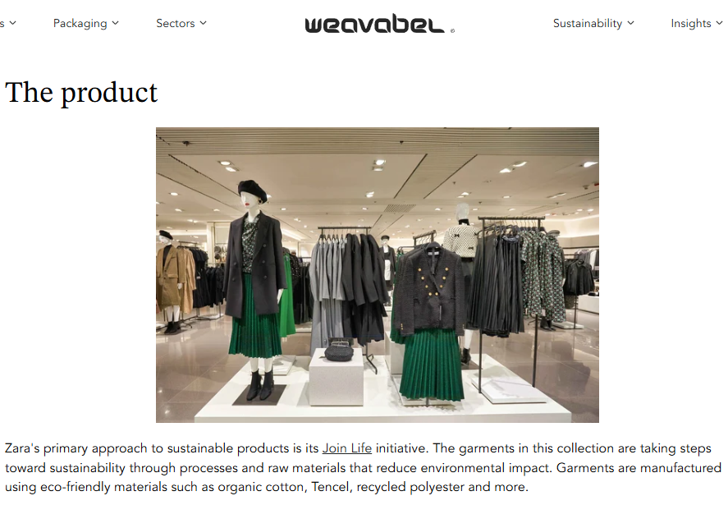
Figure 15: Join Life by Zara
(Source: Weavabel, 2024)
In Italy Zara targets style oriented customers who are interested in the design craftsmanship and digitally engaged shoppers who generally research about products online and also focus on influencing customers why social media fashion trends. According to studies, more than 77.5% of Italian fashion shoppers research products online or through social media before making any purchase decision and 70% combining online and offline purchases (Fotoshoemagazine, 2025).
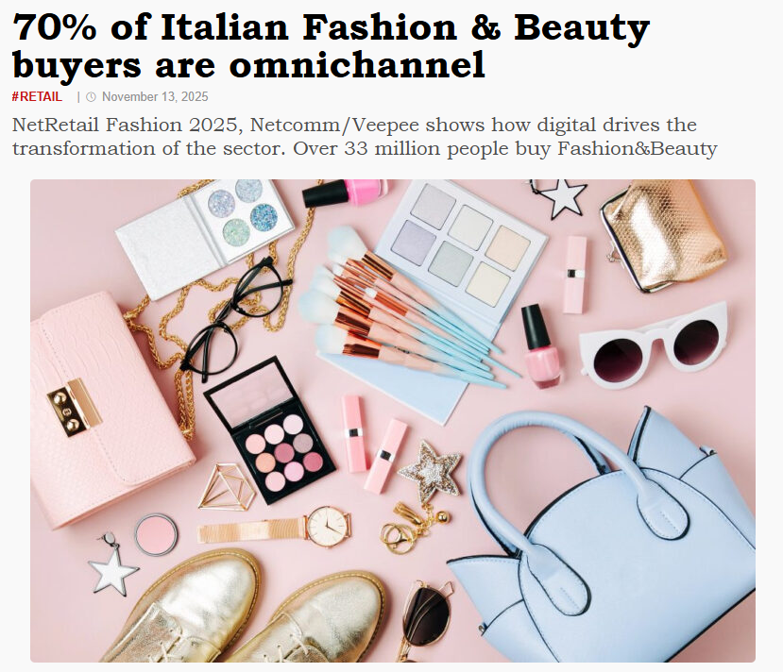
Figure 16: Customer preferences
(Source: Fotoshoemagazine, 2025)
In the country, many people are willing to pay more for sustainable clothing. However Zara uses digital marketing as well as fashion inspired storytelling to reach Italian customers.
Positioning
Across the globe, Zara creates a fast-fashion brand by bringing new runway fashion to customers at an affordable price point. However, the brand's message and product offering differ marginally in France versus Italy.
In France, Zara’s positioning emphasises:
- Inexpensive fashion with new styles released regularly
- second-hand platform (Alonso, 2023)
- Fashion-forward styles for all occasions
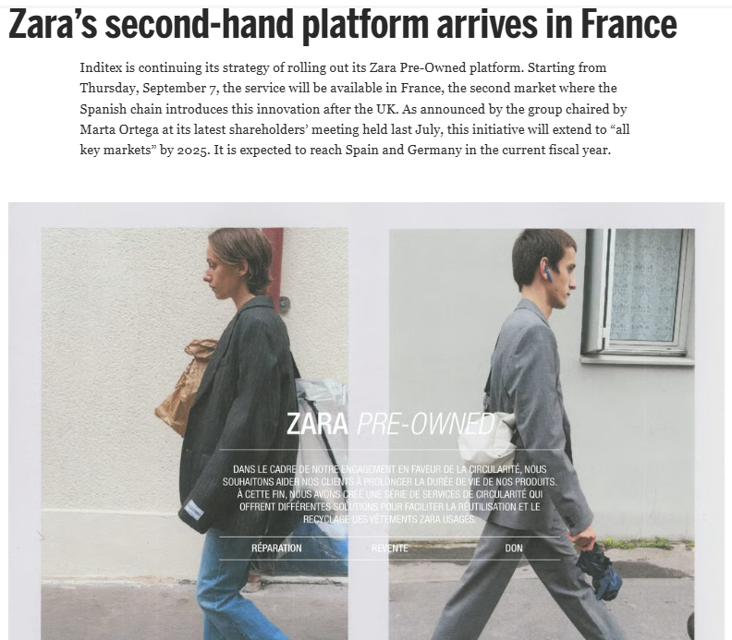
Figure 17: Second-hand platform of Zara
(Source: Alonso, 2023)
In Italy, Zara’s positioning emphasises:
- Fashionable yet stylish looks
- Affordable styles inspired by designer collections
- A modern lifestyle brand that fits within Italy's fashion culture
As a result, Zara has created a consistent brand presence globally but has modified its message according to the respective culture and expectations of the marketplace.

Perceptual Map (France) -Zara Positioning

Luxury brands like Louis Vuitton and Chanel
Fashionability/ trendiness (Low to high)

Zara

Basic brands like Promod and Pimkie

Price (low to high)

Figure 18: Perceptual Map of Zara in France
(Source: Self-made)
Explanation: In France, Zara is positioned as high-fashionability but affordable brand. The company sits between luxury fashion houses and low-cost basic retailers. This highlights its strategy of providing runway-inspired styles at affordable price.

Similarities and Differences
STP Element | Similarities | Differences
Segmentation | Targets young, urban, fashion-conscious consumers using psychographic and behavioural factors. | France focuses on sustainability and price sensitivity; Italy emphasizes design, craftsmanship, and brand value.
Targeting | Focus on trend-driven customers seeking affordable fashion. | France targets price-conscious, eco-aware shoppers; Italy targets style-focused, research-driven, digital consumers.
Positioning | Zara positioned as affordable, fast-fashion brand globally. | France highlights affordability and sustainability; Italy emphasizes style, quality, and designer-inspired fashion.

2. International Marketing Mix (7Ps) Strategies of Zara in France and Italy
Zara implements international marketing mix in accordance to the local cultural, economic, and variation in behaviour of consumer to be successful in global markets.
1. Product Strategy: Product strategy of the company mainly concentrates on offering fashionable clothing inspired by runway trends with fast production cycles.
In France, the company focuses on affordable and frequently updated collections in accordance to the change in trends of fashion. French customer gives importance to elegance and style but they also prioritise sustainability and affordability. the apparel market in France is forecast to reach at CAGR of 2.1% from 2023 to 2028 (Safaya, 2024).
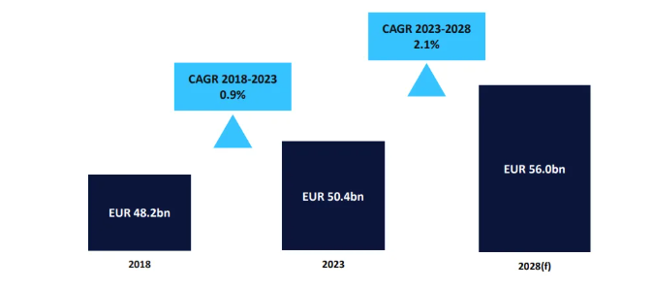
Figure 19: Apparel market in France
(Source: Safaya, 2024)
Furthermore, in 2025, the France Second-Hand Products Market was valued at USD 18.34 billion (Mmrstatistics, 2026).
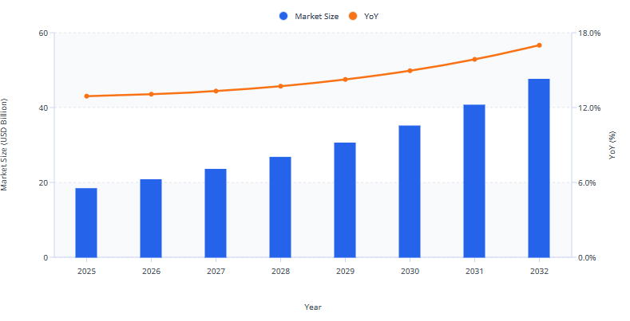
Figure 20: Second hand market size in France
(Source: Mmrstatistics, 2026)
These highlight the increasing sustainability consciousness among the consumer. In response to this trend company promotes its Join Life sustainable collection (Zara, 2026). This collection uses recycled fabrics and eco-friendly materials.
In Italy, the company implements its product strategy to resonate with the country’s strong tradition of design, craftsmanship, and fashion culture linked with the identity of “Made in Italy”. The fashion textile market in Italy is expected to reach are venue of US$ 49,566.9 million by 2030 (Grandviewresearch, 2024). The Italian consumers give preference to high-quality fabrics, refined designs, and unique styles. Hence, Zara is focusing more on premium-looking garments, structured tailoring, and fashion-forward pieces.
Overall, the company maintains an identity of fast fashion in both markets. Zara offers a wide product width in both France and Italy, including women’s and men’s wear, kids clothing accessories, beauty product and footwear. The company offers affordable, minimalist styles with sustainable options like the Join Life collection, including casual dresses, eco-friendly outerwear in France.
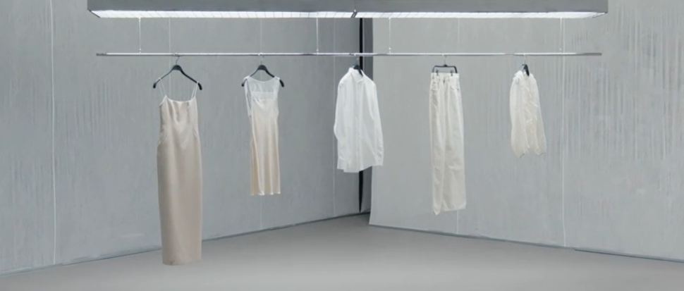
Figure 21: Join life collection of Zara
(Source: Zara, 2026)
In Italy, Zara focuses on premium-looking garments such as tailored blazers, structured dresses, and luxury-inspired accessories.
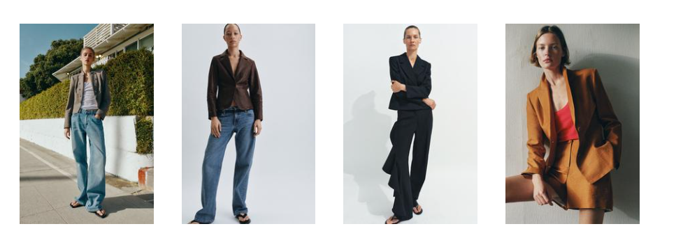
Figure 22: Zara’s tailored blazers collection
(Source: Zara, 2026)
The main change lies in depth. In France, the company focuses on sustainability and practicality, and Italy highlights design, craftsmanship, and elegance.
2. Price Strategy: Zara’s competitive positioning across European markets is dependent on its pricing strategy. The company adopts a mid-range pricing strategy.
In France, as the customers are price sensitive, the company maintains a competitive and accessible pricing. Value for money was the prime factor impacting France consumer’s apparel purchases. It was followed by quality, fit, and price (GlobalData, 2024). Hence, the company makes sure that its pricing remains affordable compared with luxury brands while still providing fashionable designs inspired by high-end collections.
On the other hand, consumers in Italy shows higher spend per fashion item. Italian consumers spend an average of €710 per year on clothing, this is higher than the European average of €490 (Mohiuddin, 2025).
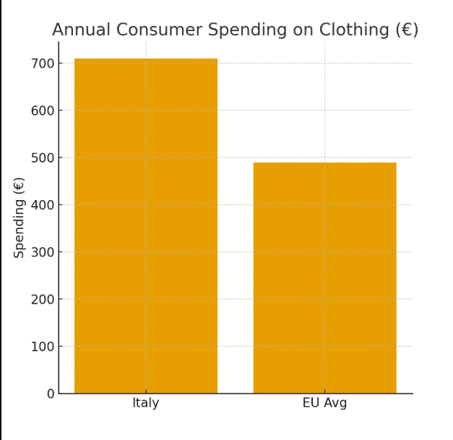
Figure 23: Annual customer spending on clothing in Italy
(Source: Mohiuddin, 2025)
Italian consumers are willing to pay slightly higher prices for clothing perceived as stylish, high quality, or environmentally responsible. Hence, pricing strategy of Zara in Italy can be slightly higher than in some other European markets.
Overall, Zara implements a value-based pricing strategy. It is keeping the prices affordable in France and focusing perceived design value and quality in Italy.
3. Place (Distribution) Strategy
Zara is known for its integrated Omni-channel distribution model. It combines physical retail stores with digital platforms.
In France, the company has a strong presence in primary urban fashion centres like Paris, Marseille, and Lyon. Flagship store of the company is mainly located in high-traffic shopping areas and luxury retail districts. Furthermore, online fashion sales in France are expected to exceed USD 20 billion by 2028 (Mohiuddin, 2025).
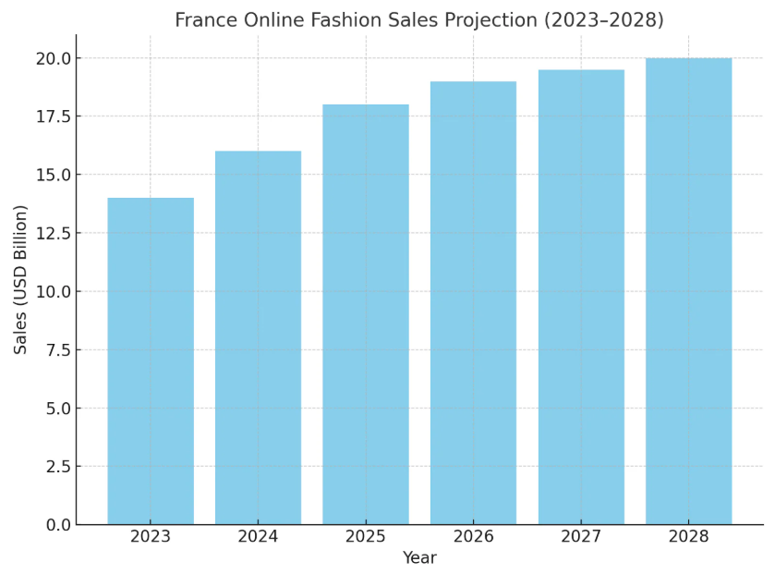
Figure 24: Online fashion sales projection of France
(Source: Mohiuddin, 2025)
This highlights the significance of digital retail channels. Zara combines its website and mobile application with physical stores. This supports customers to check availability of the product, order online, and collect purchases in store.
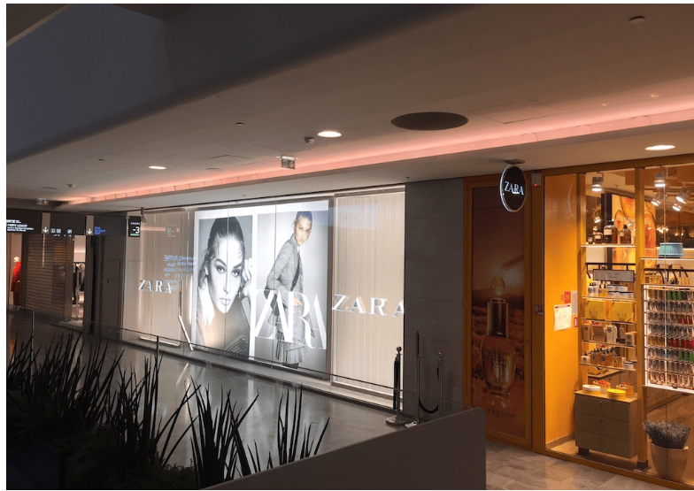
Figure 25: Zara store in Paris
(Source: Stillinparis, 2025)
In the same way in Italy Zara operates stores in main fashion cities like Milan, Rome, and Florence. In 2025, Italy's e-commerce market has reached to €85.4 billion. There are 25 million online shoppers spending €2,500 annually on average. Clothing and footwear lead the online categories by 35% (Landmarkglobal, 2025). This figure indicates a strong digital adoption. Hence, the company focuses on mobile shopping, digital payment systems, and integrated logistics.
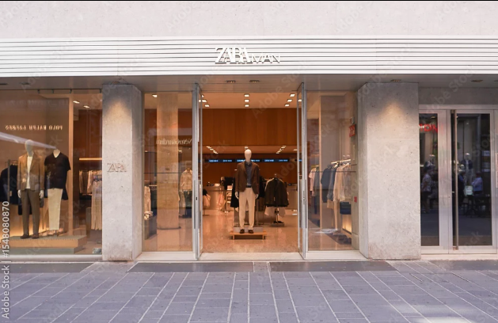
Figure 26: Zara store at Bari, Italy
(Source: Stock.adobe, 2025)
4. Promotion Strategy
Integrated Marketing Communications (IMC) refers to the strategic coordination of various communication channels to deliver a unified message to consumers (Tetteh, 2021).For Zara, IMC ensures unified communication and adaption of messaging to various international markets and preferences of the consumer.
The company invest a very small amount in traditional advertising, instead of this company depends on location of the store, visual merchandising, and digital engagement.
In France, the company focuses more on experience of store and fashion accessibility. Flagship stores in prime location acts as a powerful marketing tool to attract environmentally conscious French consumers. The company demonstrate its sustainability initiatives (Inditex, 2024).
In Italy, promotion of the company depends mainly on digital marketing and social media engagement. In 2025, it is estimated that 70% of luxury purchases will be influenced by social media interactions (Marketresearchfuture, 2025). Therefore, to attract Italian customers, Zara concentrates on visually appealing digital campaigns, influencer collaborations, and online fashion storytelling.
Thus, company’s promotional strategy in France, focuses on brand visibility through physical retail and sustainability messaging. In contrast, strategy in Italy concentrates on digital interaction and fashion inspiration through social media platforms.
5. People Strategy
These components demonstrate the employees and customer service experiences that shape perception of the brand.
In France, because of high volume of customers visiting stores in major fashion cities, staff of the company is trained to provide efficient and fast customer service. The employees help the customer to find the items quickly. The main focus is on speed and accessibility. In the country, the company employs a total of 11,300 workers, of whom 70% are part of Zara's staff (Alonso, 2023).
In Italy, customer service is focused on advice on fashion and styling assistance. 57.3% of Italians intend to reduce their retail expenditure, mainly by doing more price comparisons online before purchasing items (UK.finance, 2024). Hence, the role of the staff is important in providing product recommendations, styling suggestions, and detailed information about materials or design. ZARA ITALIA has approximately 5K employees as of December 2025 (Leadiq, 2025).
6. Process Strategy
Zara is known for its rapid design-to-retail cycle. It creates new designs and puts them into stores in a week or two (Roll, 2021).
The company uses advanced inventory management systems and digital logistics in both France and Italy. This makes sure those products are replenished frequently and there is minimum shortage of stock. This encourages repeat visit among the consumer.
However, in France the process focuses on fast product turnover and regular update of trend. On the other hand, in Italy, it ensures availability of fashionable yet refined designs that match expectation of the consumer for style and quality.
To support its fast-fashion model, Zara follows a centralised yet locally responsive customer complaints process in both countries. Customers can raise complaints with the help of in-store staff, official website, mobile app, or customer care services. In France, the process is digitally powered and speed-focused. This ensures fast resolution. On the other hand, in Italy, there is greater emphasis on personalised in-store assistance and quality-related resolution,
7. Physical Evidence
Physical evidence means the factors that impact the point of view of the customer for the brand like the design of the store, packaging, and visual merchandising.
The stores of the company in both the market follow a modern minimalist design concept (Amworldgroup, 2025). It features spacious layouts, neutral colours, and well-organised clothing displays.
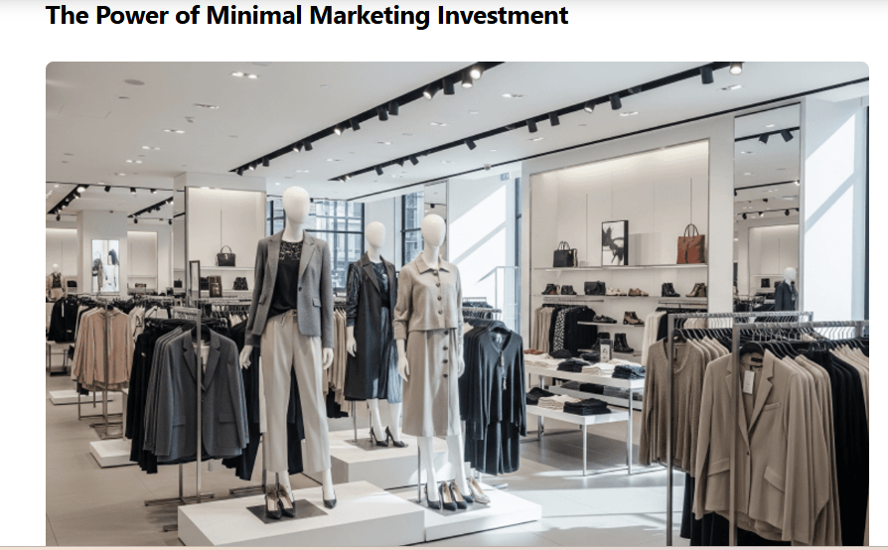
Figure 27: Inside of Zara store
(Source: Amworldgroup, 2025)
In France, stores emphasise on large window displays and seasonal fashion presentations. This indicates the country’s strong fashion culture centred around Paris.
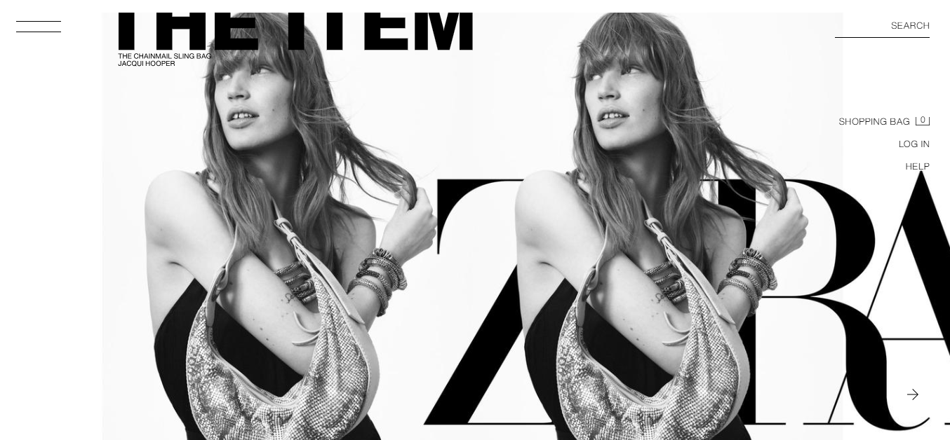
Figure 28: Website of France
(Source: Zara, 2026)
In Italy, stores highlight stylish product arrangements and design-focused collections. This aligns with the country’s reputation for creativity in fashion.
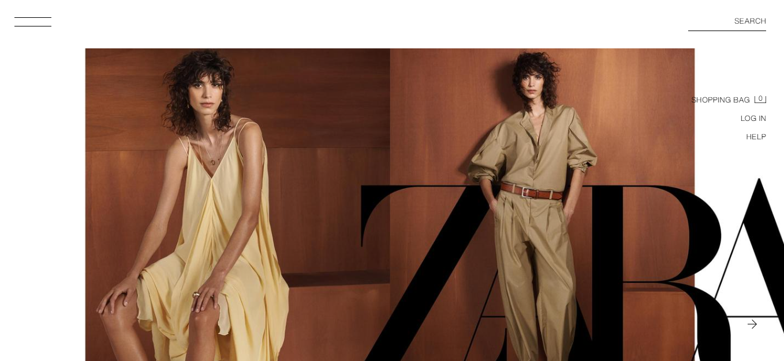
Figure 29: Zara Italy website
(Source: Zara, 2026)
Overall Comparison
The company maintains a constant global marketing mix. It makes strategic adaptations according to the cultural and economic differences in both the markets. In France, to attract price sensitive and environmentally aware consumers; the organisation focuses on affordability, sustainability messaging, and frequent product updates. In contrast the strategy in Italy concentrates on quality of design, digital engagement, and fashion inspiration.

C. Directional Development Strategy of Zara in France
The Ansoff Matrix describes the expansions of Zara and how this expansion strengthens its position in the market.
- Market Penetration: The Company mainly enhances its market penetration by increasing the sales of existing products in the French market. The brand operates flagship stores in major cities such as Paris, Lyon, and Marseille. France’s online fashion sales exceeded $23 billion in 2025 (Coherentmarketinsights, 2025). This encourages the company to combine online shopping with in-store experiences.
- Product Development: The company implements product development by launching new collections customised to sustainability trends. For instance, Join Life collection uses recycled materials and eco-friendly fabrics. 73% of textile fibre used by the company are of lower impact (Zara, 2026)
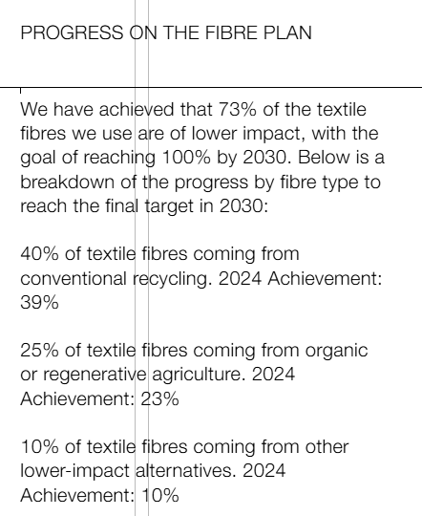
Figure 30: Progress on Fibre plan
(Source: Zara, 2026)
This responds to growing environmental awareness as second-hand clothing accounts for 10.9% of apparel sales by volume in France (Borlizzi, 2025).
- Market Development: With the help of market development, the brand expands its reach. It strengthens its digital platforms and targeting younger online consumers through e-commerce and mobile applications
- Diversification: Zara explores diversification through sustainable fashion initiatives, digital innovations, and new retail technologies. This supports long term growth in French fashion market.

D. Ethical Issues in the Marketing Mix of Zara in France
1. Environmental Sustainability and Fast Fashion: One of the main ethical concerns of Zara’s marketing mix in both France is the environmental impact of the fast-fashion business model. To maintain its rapid trend cycle, the company launches thousands of new designs annually. This encourages more consumption. The fashion industry is accountable for 10% of global carbon emissions, producing 1.2 billion tons of carbon dioxide annually (Brui, 2024).
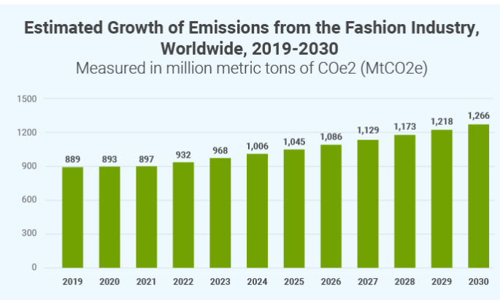
Figure 31: Estimated growth of emission from fashion industry
(Source: Brui, 2024)
In France, policymakers have become increasingly critical of fast fashion, proposing regulations targeting high-volume production and waste. In response, the brand is forced to ensure that its product strategy promotes sustainable production and various recycling initiatives.
2. Supply Chain Transparency and Labour Practices: Another issue is labour practices and transparency in supply chain. French regulations increasingly require brands to provide transparent information about product materials and environmental impact (CIMETIERE, 2025). To protect the reputation of brand and comply with stricter European regulations, Zara must maintain ethical sourcing, fair labour standards, and transparent production

E. Recommendations for Future International Marketing Strategy of Zara in France and Italy
France
Strengthen Sustainability and Circular Fashion: The brand can enhance its sustainable collections and circular fashion initiatives in France, where environmental awareness is high. World produces 92 million tons of textile waste every year (Ruiz, 2026).
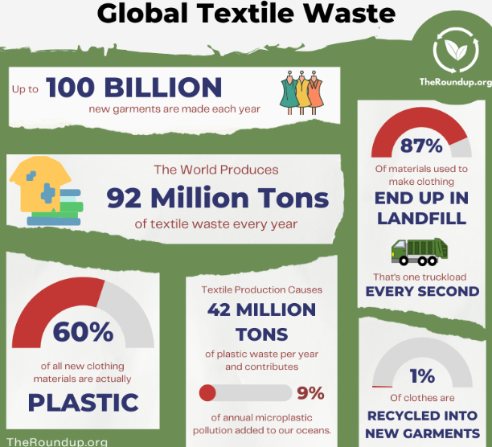
Figure 32: Global textile waste
(Source: Ruiz, 2026)
Enhancing the use of recycled fabrics, clothing repair services, and garment recycling programmes would align with stricter European sustainability regulations.
Focus on digital engagement: The company should also prioritise digital and omni-channel marketing. Globally, 20.9% of people prefer buying fashion online (Uniformmarket, 2025). To increase engagement and loyalty, the company should invest in mobile apps, personalised recommendations, and social media platforms.
Italy
Enhance Premium Customer Experience: In Italy, the company can enhance its position by improving in-store presentation, visual merchandising, and personalised services. Italian consumers gives preference to style and craftsmanship. Hence, tailored assistance, curated collections, and high-quality store environments will boost the satisfaction of the customer.
Leverage Data-Driven Digital Innovation: To predict fashion trends and deliver targeted collections, the company should invest in AI-driven analytics (Stryker, 2024). The company should also enhance its omni-channel strategies, such as click-and-collect and personalised online recommendations.

Section 2: Reflection
International marketing principles play a pivotal role in the business that operates in domestic as well as foreign markets. The company namely Zara, one of the well-established and renowned global fast-fashion companies has been selected in this report. Along with that Italy and France have been chosen as their foreign markets in order to conduct a detailed analysis on their different marketing approaches and practices. By applying the Gibbs’ Reflective Cycle, my overall learning journey has been analysed here (Taets, 2024).
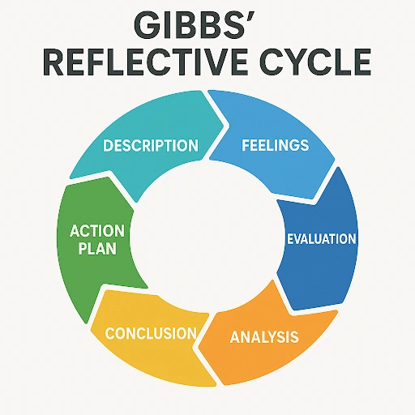
Figure 33: Gibb’s Reflective Model
(Source: Flynn, 2024)
Description
During the course of research for the assignment, I have learnt about the different effective marketing strategies that Zara uses especially in their foreign markets like France and Italy. By conducting a PESTEL analysis on Zara in both the international markets like France and Italy, I have got knowledge about the macro-environmental factors such as political, economic, social, technological, environmental, and legal which plays crucial role in the fashion trends, customer behaviour, purchasing pattern, and cultural preferences of customers in both these countries. Several credible information sources like business reports, academic journals, and industry-based current data help me gather important information about the pattern of fashion consumptions in both the markets (Flynn, 2024). After identifying macro-environmental factors through PESTEL analysis, I have conducted a competitive analysis on the marketing practices of Zara within both the foreign markets like France and Italy with the help of STP framework. This comparative analysis helped me to understand the different brand positioning approaches that Zara uses in their France and Italy markets for customers who have different cultural preferences and fashion choices. During the course of writing, I have also analysed how Zara uses their different promotional approaches, pricing strategies, product offerings in both the foreign markets as per cultural preferences and economic conditions with the help of 7P's marketing mix framework. Apart from this, I have also gathered information on instances such as fast-fashion criticism, labour exploitation, and unethical product-sourcing of Zara within France and Italy in order to ensure ethical concerns in their international marketing approaches.
Feelings
I feel very excited during the course of learning and working on this project on Zara. It provides me with an adequate opportunity to learn about the global brand Zara which is one of the most famous fast-fashion brands in the world that have different and engaging marketing strategies for the different markets. Throughout the process of gathering information on Zara I feel very engaged (Ide, 2023). However, I started to feel overwhelmed due to the extensive amount of information that I gathered while conducting the PESTEL analysis on Zara within their foreign markets France and Italy. I have also struggled to recognise the relevant and suitable macro-environmental factors that can align with the fast-fashion industry.
Evaluation
During the course of work, I experienced both good and negative learning experiences. One of the most significant positive points of my whole learning experience is that it has provided me with enough chances to enhance my research skills by allowing me to gather an extensive amount of information about the different marketing approaches of Zara in their foreign markets. However, at first I faced difficulties gathering relevant information related to the choosing topic from the internet. Over the course of the learning process, I have realised the importance of credible information sources in the research process such as business publications, academic books, journals, and industry and market reports. The learning process also helps me to improve my analytical skills (Young, 2023). By using several structured frameworks like 7 P's marketing mix, PESTEL, and STP, I have learnt to organise the extensive amount of gathered information more logically. Despite these positive aspects of my learning experiences, I have also identified my limitations. Due to the lack of critical thinking abilities, I often struggled in comparing the different cultural nuances of foreign countries. Furthermore, due to my poor time management skill I struggled to organise my research and writing work and complete the task within the set deadline.
Analysis
During the progression of my learning journey while working in this assignment I have realised that an individual requires several professional and academic skills to conduct an effective international marketing analysis. Critical thinking abilities are one of the crucial academic skills that is highly required while conducting this kind of business analysis. With the help of effective critical analytic skills, one can effectively comprehend the importance of different cultural values on fashion choices (Herbert-Smith, 2025). It also helps in understanding the way cultural influences link to the effectiveness of marketing strategies. Another significant academic skill is analytical thinking abilities which help one to effectively compare different marketing strategies on the basis of consumer expectations, economic conditions and cultural influences. I have also realised that academic writing skill is also very important for ensuring high efficiency and performance delivery while working on the assignment of international marketing strategies.
Conclusion
This assignment can be considered as one of the significant learning experiences of mine during my academic journey. It helps me to identify my area of strengths as well as the skills that I need to develop more. While working on this project, I have improved my research skill and gained deep knowledge about the different marketing strategies in the international business scenario (Cutillas and Benolirao, 2023). I have also realised that I need to improve my critical thinking abilities which will help me improve in conducting comparative evaluations. By improving my time management skills, I could have invested more time to be involved in the deep research and understand the analysis more effectively (Hart, 2024).
Action Plan
- I need to develop my critical thinking abilities by investing more time in going through market analysis of different businesses which will help me identify the implications of the information more effectively.
- I am also required to improve my time-management skills by breaking the large assignment task into small and achievable targets. It will help me provide adequate time to every segment of my work such as researching, taking notes, drafting, writing, and editing. It will help me avoid work pressure and improve my academic performances (Zimmerman, 2023).
- I also plan to enhance my research skill abilities by assessing credible academic databases and business reports. It will help me gather more related and relevant information related to the assignment topics.

References
Accuracy (2024). ECONOMIC POINT OF VIEW - THE ECONOMY AND FINANCE OF FRENCH LUXURY: THE ART OF LIVING, FIRST AND FOREMOST! - Accuracy. [online] Accuracy. Available at: https://www.accuracy.com/economic-point-of-view-the-economy-and-finance-of-french-luxury-the-art-of-living-first-and-foremost/.
Alonso, T. (2023). Available at: https://ww.fashionnetwork.com/news/Zara-opens-new-flagship-store-on-the-champs-elysees-in-paris,1508699.html.
Alonso, T. (2023). Zara’s second-hand platform arrives in France. [online] Fashionnetwork. Available at: https://ww.fashionnetwork.com/news/Zara-s-second-hand-platform-arrives-in-france,1551569.html.
Amworldgroup (2025). The Minimalist Power of Zara Advertising in a Noisy Market | AMW. [online] Amworldgroup.com. Available at: https://amworldgroup.com/blog/zara-advertising.
Apparel Resources News-Desk (2025). Italian fashion sector seeing worldwide growth surge: Report | Retail News Italy. [online] Apparel Resources. Available at: https://apparelresources.com/business-news/retail/italian-fashion-sector-seeing-worldwide-growth-surge-report/.
Borlizzi, G. (2025). Is Second Hand Becoming The First Choice? [online] Available at: https://reflawn.com/articles/is-second-hand-becoming-the-first-choice/189.
Brui, A. (2024). Fast Fashion: The Second Largest Polluter | GreenMatch. [online] www.greenmatch.co.uk. Available at: https://www.greenmatch.co.uk/blog/2016/08/fast-fashion-the-second-largest-polluter-in-the-world.
CIMETIERE, V. (2025). France Publishes Environmental Cost Labeling for Textile Products. [online] SGSCorp. Available at: https://www.sgs.com/en/news/2025/10/safeguards-14625-france-publishes-environmental-cost-labeling-for-textile-products [Accessed 9 Mar. 2026].
Coherentmarketinsights (2025). France Fashion Ecommerce Market Size & Share Analysis - Industry Research Report - Growth Trends. [online] www.coherentmarketinsights.com. Available at: https://www.coherentmarketinsights.com/industry-reports/france-fashion-ecommerce-market.
Cutillas, A. and Benolirao, E. (2023). Does Mentoring Directly Improve Students’ Research Skills? Examining the Role of Information Literacy and Competency Development. Education Sciences, [online] 13(7), p.694. doi:https://doi.org/10.3390/educsci13070694.
ESG News (2025). TRIIBE Changemaker Summit. [online] ESG News. Available at: https://esgnews.com/france-targets-ultra-fast-fashion-with-eco-tax-ad-ban-and-transparency-rules/.
Flynn, B.B. (2024). The Importance of Self-Reflection as a Learning Tool. Advances in higher education and professional development book series, pp.135–151. doi:https://doi.org/10.4018/978-1-6684-9024-2.ch008.
Forbes (2025). Zara. Forbes. [online] Available at: https://www.forbes.com/companies/zara/.
Fotoshoemagazine (2025). 70% of Italian Fashion & Beauty buyers are omnichannel - Fotoshoe Magazine. [online] Fotoshoe Magazine. Available at: https://fotoshoemagazine.com/70-italian-fashion-beauty-buyers-omnichannel/ [Accessed 9 Mar. 2026].
GlobalData (2024). France Apparel Consumer Insights - Who Shops, What do they Shop, How do they Shop and Why do they Shop. [online] Market Research Reports & Consulting | GlobalData UK Ltd. Available at: https://www.globaldata.com/store/report/france-apparel-consumer-trend-analysis/.
Globaltextiletimes (2025). French Consumers Buy Record 2.8 Billion Apparel Items in 2024. [online] Global Textile Times. Available at: https://www.globaltextiletimes.com/news/french-consumers-buy-record-2-8-billion-apparel-items-in-2024/.
Grandviewresearch (2024). Italy Fashion Textile Market Size & Outlook, 2030. [online] Grandviewresearch.com. Available at: https://www.grandviewresearch.com/horizon/outlook/fashion-textile-market/italy.
Hart, H. (2024). Productivity And The Hard Truth About Time Management. [online] Forbes. Available at: https://www.forbes.com/sites/hannahart/2024/01/25/productivity-and-the-hard-truth-about-time-management/ [Accessed 9 Mar. 2026].
Herbert-Smith, K. (2025). The importance of self-reflection. [online] Irisconnect.com. Available at: https://blog.irisconnect.com/uk/community/blog/importance-of-self-reflection/ [Accessed 9 Mar. 2026].
Houghton, O., Harkin, F., Oduwole, S. and Coffey, R. (2026). Vinted tops France’s fashion market as second-hand sales surge. [online] Vinted tops France’s fashion market as second-hand sales surge | LS:N Global. Available at: https://www.lsnglobal.com/article/view/32056.
Hubstyle (2026). 65% of Italians consult online reviews before making a purchase- HUB Style. [online] HUB Style. Available at: https://hubstyle.it/en/2026/03/05/65-percent-of-italians-consult-online-reviews-before-making-a-purchase/.
Ide, Y. (2023). Challenging perspectives: Reflexivity as a critical approach to qualitative social work research. Qualitative Social Work, [online] 23(4), p.147332502311735. doi:https://doi.org/10.1177/14733250231173522.
IMARC Group (2025). Italy Apparel Market Size, Share, Growth and Industry Report. [online] Imarcgroup.com. Available at: https://www.imarcgroup.com/italy-apparel-market.
Inditex (2024). INDITEX | Sustainability. [online] Inditex.com. Available at: https://www.inditex.com/itxcomweb/es/en/sustainability.
Landmarkglobal (2025). Top 10 Essential Facts About Italian E-commerce (2025 Edition). [online] Landmark Global. Available at: https://landmarkglobal.com/eu/en/news-insights/top-10-essential-facts-about-italian-e-commerce-2025-edition/.
Leadiq (2025). ZARA ITALIA Employee Directory, Headcount & Staff | LeadIQ. [online] Leadiq.com. Available at: https://leadiq.com/c/zara-italia/5d986131408f0cc3d916fa66/employee-directory [Accessed 21 Apr. 2026].
Marketresearchfuture (2025). Italy Luxury Fashion Market. [online] Marketresearchfuture.com. Available at: https://www.marketresearchfuture.com/reports/italy-luxury-fashion-market-46367.
Mmrstatistics (2026). France Second-Hand Products Market Size and YoY Growth (2025–2032) | MMR Statistics. [online] Mmrstatistics.com. Available at: https://www.mmrstatistics.com/statistics/224079/france-second-hand-products-market-size-yoy-growth [Accessed 9 Mar. 2026].
Mohiuddin, Y.B. (2025a). TOP 20 FRANCE FASHION MARKET STATISTICS 2025. [online] best colorful socks. Available at: https://bestcolorfulsocks.com/blogs/news/france-fashion-market-statistics?srsltid=AfmBOorJWFDYHJWiGtUrIRoLxJrG0h0FnDgoI4My1Z2JGcl2L1VGRcQp [Accessed 9 Mar. 2026].
Mohiuddin, Y.B. (2025b). TOP 20 ITALY FASHION MARKET STATISTICS 2025. [online] best colorful socks. Available at: https://bestcolorfulsocks.com/blogs/news/italy-fashion-market-statistics?srsltid=AfmBOooAYvJxLpHWrKUFWK484wefH5IYhcNi1jBTfqbLrTYItnqegHiN [Accessed 9 Mar. 2026].
Park, M. (2026). France Fashion Industry Statistics. [online] Gitnux. Available at: https://gitnux.org/france-fashion-industry-statistics/.
Peterdy, K. (2025). PESTEL analysis. [online] Corporate Finance Institute. Available at: https://corporatefinanceinstitute.com/resources/management/pestel-analysis/.
Rawshot (2025). Italian Fashion Industry Statistics. [online] Rawshot.ai. Available at: https://rawshot.ai/statistic/italian-fashion-industry.
Roll, M. (2021). The secret of Zara’s success: A culture of customer co-creation. [online] Martin Roll. Available at: https://martinroll.com/resources/articles/strategy/the-secret-of-zaras-success-a-culture-of-customer-co-creation/.
Ruiz, A. (2026). 17 Most Worrying Textile Waste Statistics & Facts. [online] TheRoundup. Available at: https://theroundup.org/textile-waste-statistics/.
Safaya, S. (2024). In data: Sluggish French apparel market demand to rebound in 2024. [online] Yahoo Finance. Available at: https://finance.yahoo.com/news/data-sluggish-french-apparel-market-103539924.html.
Safaya, S. (2024). In data: Sluggish French apparel market demand to rebound in 2024. [online] Just Style. Available at: https://www.just-style.com/news/in-data-sluggish-french-apparel-market-demand-to-rebound-in-2024/.
Simpson, E. (2025). Zara: Inside the secretive world of the fashion brand. BBC. [online] 8 May. Available at: https://www.bbc.com/news/articles/c62j2dxe9zyo.
Statista (2026). Turnover of the textile manufacturing industry Italy| Statista. [online] Statista. Available at: https://www.statista.com/statistics/386120/turnover-manufacturing-textile-industry-italy/?srsltid=AfmBOorAZ5dal89ZlbJPZcIlriMYLrMGjtWbNmu5tcvf4hCx0FyK2vbJ.
Stillinparis (2025). Zara stores in Paris : opening hours, informations, all locations and addresses. [online] StillinParis. Available at: https://stillinparis.com/todoin/shopping/zara-stores-paris/ [Accessed 21 Apr. 2026].
Stock.adobe (2025). Bari, Italy - May 10, 2025: Facade of the Zara store at Bari, Italy Stock Photo | Adobe Stock. [online] Adobe Stock. Available at: https://stock.adobe.com/in/images/bari-italy-may-10-2025-facade-of-the-zara-store-at-bari-italy/1548080870 [Accessed 21 Apr. 2026].
Stryker, C. (2024). What Is AI Analytics? | IBM. [online] Ibm.com. Available at: https://www.ibm.com/think/topics/ai-analytics.
Taets, J. (2024). Self-Reflection as A superpower. Forbes. [online] 30 Jan. Available at: https://www.forbes.com/councils/forbesbusinesscouncil/2024/01/30/self-reflection-as-a-superpower/ [Accessed 9 Mar. 2026].
Tetteh, V.A. (2021). Future of Integrated Marketing Communications | EBSCO. [online] EBSCO Information Services, Inc. | www.ebsco.com. Available at: https://www.ebsco.com/research-starters/marketing/future-integrated-marketing-communications.
Theculturefactor (2026). Country comparison tool. [online] Theculturefactor.com. Available at: https://www.theculturefactor.com/country-comparison-tool?countries=france%2Citaly.
UK.finance (2024). Italy Apparel Consumer Insights Report 2024: Who Shops, What do they Shop, How do they Shop and Why do they Shop. [online] Yahoo Finance. Available at: https://uk.finance.yahoo.com/news/italy-apparel-consumer-insights-report-141200467.html [Accessed 9 Mar. 2026].
Uniformmarket (2025). Ecommerce Fashion Insights And Trends (2025 Data) | UniformMarket. [online] UniformMarket. Available at: https://www.uniformmarket.com/statistics/ecommerce-fashion-insights-trends.
Weavabel (2024). Is Zara sustainable? An overview of the fast fashion giant | Weavabel. [online] www.weavabel.com. Available at: https://www.weavabel.com/blog/is-zara-sustainable-an-overview-of-the-fast-fashion-giant.
Withersworldwide (2023). Made In Italy Bill: promoting Italy’s unique manufacturing excellence | Withersworldwide. [online] www.withersworldwide.com. Available at: https://www.withersworldwide.com/en-gb/insight/read/made-in-italy-bill-promoting-italy-s-unique-manufacturing-excellence.
Young, R. (2023). The Power Of Critical Thinking: Enhancing Decision-Making And Problem-Solving. Forbes. [online] 28 Jul. Available at: https://www.forbes.com/councils/forbescoachescouncil/2023/07/28/enhancing-decision-making-and-problem-solving/ [Accessed 9 Mar. 2026].
Zara (2026). JOIN LIFE | ZARA India. [online] Zara.com. Available at: https://www.zara.com/in/en/z-join-life-mkt1399.html.
Zara (2026a). Search engine | ZARA Italy. [online] Zara.com. Available at: https://www.zara.com/it/en/search?searchTerm=tailored%20blazer§ion=WOMAN [Accessed 21 Apr. 2026].
Zara (2026b). ZARA France | New Collection Online. [online] www.zara.com. Available at: https://www.zara.com/fr/en/.
Zara (2026c). ZARA Italy | New Collection Online. [online] www.zara.com. Available at: https://www.zara.com/it/en/.
Zara (2026d). [online] Zara.com. Available at: https://www.zara.com/hu/en/z-join-life-mkt1399.html?v1=1468716 [Accessed 21 Apr. 2026].
Zimmerman, B.J. (2023). Self-Regulating Academic Study Time. Self-regulation of Learning and Performance, [online] 1(1), pp.181–199. doi:https://doi.org/10.4324/9780203763353-8.

