Looking at the Software and Displaying data on the MapInfo Window (Tutorial 1)

MapInfo opens a MapInfo table from the Quick Start dialog box or from the pull down menu options. The quick start being the first window you see. You can view your data in both a Map window and a Browser window, and also manipulate these windows to display the data the way in various ways. You can create subsets of data from an existing data sets, graph this data, ands save your work session in a Workspace file.

Objectives
- View a Map
- View Tabular Data
- Create a Subset of Data
- Save a Subset of Data
- Create a Graph
- Save a MapInfo Session

Viewing a map is an integral part of every MapInfo function.

To Open the UK-regns table in a Map window:
1. Start MapInfo
2. Choose Open a Table from the Quick Start dialog.
3. Press Open. The Open Table dialog displays.
The data for this class is located in the directory Tutorial Data.
The Tutorial Data folder contains several folders that are used throughout the class:
4 . Open the Tutorial Data folder.
5 . Open the UK folder.
6 . Choose UK-regns.
7 . Press Open.
You will see a window display with a map of the UK displaying several regions. This window is called a Map window.
You can resize the Map Window by clicking and dragging the sides of the window.
Alternatively, you can maximize the window by clicking the middle button in the top right of the Map Window.
Notice that on the right you will have two overlapping Toolbars. A Drawing toolbar and the Main Toolbar you can position these by dragging to a location that is convenient for you we only need to use the main tool bar.
Look at the menu at the top of the window. Note that Map is now an option on the menu bar.
This is a window-specific menu option and is present only when a Map Window is the active window.

You may want to see your data as text, in database or spreadsheet form.

To display the database information in the UK –REGNS table, we use a Browser Window which is used to show the tabular view of your table.
To view the UK -REGNStable in a Browser window:
1. Choose Window on the menu bar.
2. Choose New Browser Window.

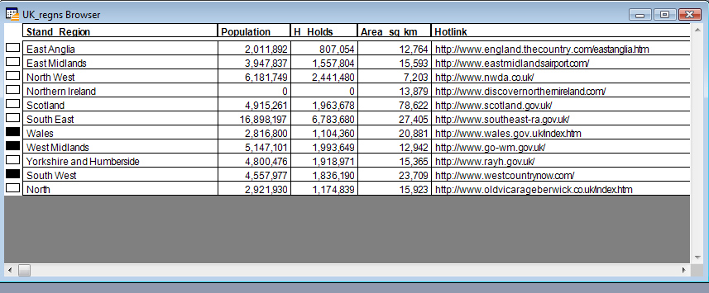

The tabular information associated with the UK –REGNS table displays.
Look at the menu at the top of the screen. Note that Browse has replaced Map as an option on the Menu bar. This is a window-specific menu option and is present only when a Browser Window is active.

You may only want to display certain parts of your table. This may be necessary because tables can hold extremely large amount of data, and some of the analysis you do may only require a specific subset of that table. To view only a portion of data from a table, we make a selection. A selection is a temporary table used to store a chosen subset of records from your table and can be viewed separately from the rest of the table.

In MapInfo it is possible to work with an entire table at once, or with a subset of that table.
For example, lets say we want to create a graph comparing the population of several regions. We can make a selection from the UK –REGNS table, and choose the regions we wish to display in our graph.
1. Make sure the Select button is chosen from the Main Button Pad.
2. On the map, point and click on three or four states.
3. Hold down the SHIFT key and click to select more than one state.
Notice that the small boxes in the left-hand column of the browser are also highlighted. It is possible to select records from the browser by clicking in these boxes.

4. Switch to the Browser window and click on the small square to the left of the state(s). Hold down the shift key to select more than one state.
The selected UK –Regns are now in the temporary table called Selection. This selection is temporary because it only exists in the working session on your computer. The selected UK –Regns can now be viewed separately from the rest of the UK –REGNS table.
5. From the Window menu, choose New Map Window
6. Choose Selection and press OK. A new Map window will be displayed.
Notice that whether you select UK –Regns from the Browser window or from the Map window, the selection is made in both windows. In a MapInfo table, the database information is hot-linked to the map. A selection made in any view of the UK –REGNS table is immediately reflected in all the windows showing that table.

Graphs provide yet another way to present data within MapInfo.

MapInfo can create graphs and charts from database information. To create a graph of your selected regions:
1. Choose Window on the menu bar.
2. Choose New Graph Window .
3. Select a Graph and template
4.Press Next
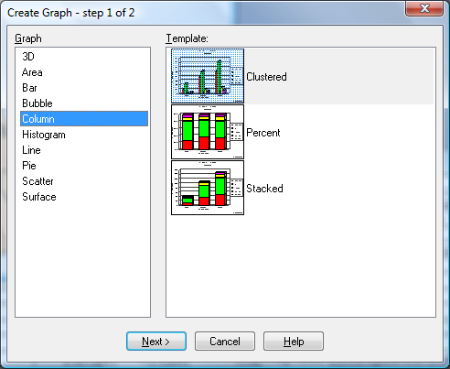.

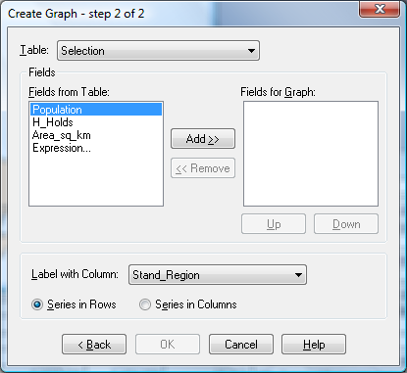

MapInfo assumes as its default choice that when you are creating a graph, you will be graphing the entire table. We will create a graph of only the UK –Regns we chose:

5 . Choose Query1 or selection from the Table drop-down list.
6 . Select Population from the Fields from Table drop down list and press Add.
7. Press OK.
The graph displays. Notice that Graph replaces Browse as an option on the Menu bar. You will always see this Graph menu option when a Graph window is the active window.
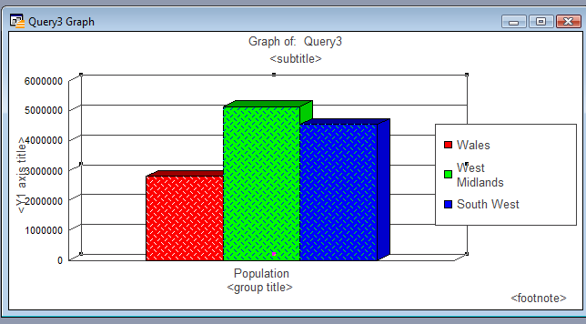
The name of this Graph is Query1. Graphs that you create will be named Query1, Query2, and so on. These queries will be numbered sequentially.

Saving a MapInfo workspace will allow you to continue work done at a previous time.

1. Choose File on menu bar.
2. Choose Save Workspace
3. At the File Name box, type tutorial1.
4. Choose the folder to save your workspace.
5. Press Save.

Now that we have saved our workspace, let's close all open tables.
1. Choose File menu on menu bar.
2. Choose Close All.
Now, let's open the workspace we just saved.
1. Choose File on menu bar and Open.
2. Navigate to the directory you saved your workspace.
3. From the Files of Type drop down, choose Workspace (*.wor)
4. Choose tutorial1
5. Click Open.

Any windows that you had on your screen when you saved the workspace, now display. A workspace is simply a text file of instruction that MapInfo reads to recreate your work session. These instructions tell MapInfo which tables to open and what windows to display on your screen. A workspace is not the data you are working with; it just opens those tables for you.

Try opening some of the other data files in the UK folder have a look at the map and the browser data. Much like any database we can only make sense of the map if we have attribute data. This will allow us to create selection i.e. queries and graphs.

Points on saving a workspace.

The following script is produced when you save your session as a workspace. The main points to note is the path to the tables or maps that you use. This points to the C: drive of my computer and the workspace will only open if the correct path is found.

!Workspace
!Version 950
!Charset WindowsLatin1
Open Table "mapinfo data download\Training_Data\UK\UK_regns" As UK_regns Interactive
Map From UK_regns
Position (0.0520833,0.0520833) Units "in"
Width 6.58333 Units "in" Height 3.19792 Units "in"
Set Window FrontWindow() ScrollBars Off Autoscroll On Enhanced On Smooth Image High
Set Map
CoordSys Earth Projection 8, 79, "m", -2, 49, 0.9996012717, 400000, -100000
Center (360321.9956,405216.0174)
Zoom 1473.254883 Units "km"
Preserve Zoom Display Zoom
Distance Units "km" Area Units "sq km" XY Units "m"
Distance Type Cartesian
Set Map
Layer 1
Display Graphic
Global Pen (1,2,0) Brush (2,16777215,16777215) Symbol (35,0,12) Line (1,2,0) Font ("Arial",0,9,0)
Label Line None Position Center Font ("Arial",0,9,0) Pen (1,2,0)
With Stand_Region
Parallel On Auto Off Overlap Off Duplicates On Offset 2
Visibility On
Activate Using "" On Objects Relative Path Off
Set Window FrontWindow() Printer
Name "HP Photosmart C4500 series (Copy 2)" Orientation Portrait Copies 1
Papersize 1
Browse * From UK_regns
Position (1.70833,2.125) Units "in"
Width 8.80208 Units "in" Height 3.19792 Units "in"
Set Window FrontWindow() Enhanced On
Set Window FrontWindow() Printer
Name "HP Photosmart C4500 series (Copy 2)" Orientation Portrait Copies 1
Papersize 1
Set Window FrontWindow() Printer
Name "HP Photosmart C4500 series (Copy 2)" Orientation Portrait Copies 1
Papersize 1

