Carbon Neutral Motorsport
F1
The FIA, Formula 1’s governing body, have been carbon neutral since 1997. They work closely with universities to calculate the precise amount of carbon produced by the sport. This includes running the cars over test and practice sessions, and covers all race weekends. It also includes the transportation of personnel across the globe to attend races. Once calculated, the FIA work with reforestation projects in Mexico, and are therefore carbon neutral. As of 2008, the annual figure to be traded off was 20,000 tonnes of carbon
In the late 1990’s the structure of qualifying sessions saw the cars being limited to fewer laps in an attempt to make the sport more interesting decreasing the amount to time available for a team to qualify for good grid positions, and to improve the perception of a wasteful image. Also, motorsport in general is turning towards the idea of biofuels. Formula 1 is trailing fuels, teams currently having to run a fuel comprising at least 5.75% biofuel.
Cars are constantly becoming lighter currently weighing in at around 700kg. Long life components are being introduced in many areas of the car, and a standard ECU is in place across the grid. Although the main priority is to stop teams spending so much money, this also means they will not be using up so many resources, there will be less raw materials used up in producing endless components and this essentially saves energy.
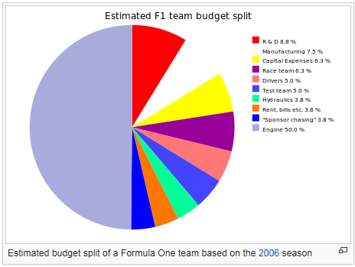
The FIA Foundation, is an organisation that campaigns for road safety all around the world. The Foundation researches issues regarding public safety, the impact of cars on the environment, the future in sustainable transport and of course safety within motorsport as well. They issue grants and fund initiatives across the globe and get involved with activities such as reducing the number of road related deaths in Africa, and raising awareness of crash structures and safety ratings in the UK. Those are just two examples of the many projects the FIA Foundation gets involved with, and it’s all working towards reducing the impact on the environment and on society of both road and sports cars

Rallying: Norwegian Prime Minister backs green rally
Norwegian Prime Minister Jens Stoltenberg joined Sebastien Loeb to promote a series of environmental initiatives at this weekend’s carbon-neutral Rally Norway.
Using Citroen’s prototype C4 hybrid WRC car, Loeb drove the Norwegian Prime Minister around the first stage of the rally prior to the official start of the event. This was then followed by a photo shoot to support the FIA’s 'Make Cars Green' campaign.
These initiatives highlight Rally Norway’s latest environmental moves that have turned it into a completely emissions neutral event.
The rally is one of a number of major sporting events around the world to be selected to join the UN’s Climate Neutral Network, an initiative led by the United Nations Environment Programme (UNEP) to promote global action and involvement towards low-carbon economies and societies.
Jens Stoltenberg said: “The solution to the problem of climate change has to be global, but different factors can contribute in order to limit humanly induced climate change. It is important to offset emissions as Rally Norway does. Rally Norway’s environmental approach, combined with hybrid technology sends a signal that motor sport is an important contributor to developing new environmentally-friendly vehicle technology”.
Even Wiger, Managing Director of Rally Norway, said: “The Prime Minister values our commitment to environmental causes and can clearly see that the event is positive for Norway’s profile internationally. To have the Prime Minister here in the world’s only rally-hybrid car is just fantastic. It sends a signal that motor sport is a great platform for developing new environmentally-friendly vehicle technology.”
Wales Rally GB 2008
The event’s CO2 emissions were measured, including participants’ energy usage and the travel of officials and marshals to, from and during the event, as well as all spectator travel the rally then set in motion plans to reduce CO2 gradually through internal changes for instance immediately reduced CO2 emissions to zero through carbon offsetting
Event organisers are working on a sustainability programme to reduce what emissions they can internally, through initiatives like car-pooling for officials and marshals, replacing battery-powered torches with wind-up alternatives and putting in place a full recycling plan. The remaining emissions have been ‘offset’ through The Carbon Neutral Company – they organise for every one tonne of CO2 to be ‘neutralised’ by one tonne saved somewhere else in the world through a climate friendly project. One ‘offsets’ the other. Set up ten years ago, The CarbonNeutral Company is the world’s leading carbon offset and climate consulting business, working with over 300 businesses and 60,000+ consumer clients
Breakdown of Wales Rally GB’s emissions by activity:
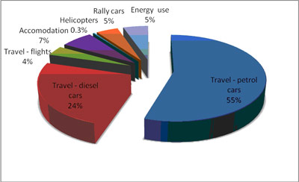
Measurement:
The 2008 Wales Rally GB produced 4,333 metric tonnes of CO2 – mostly through travel to and from the event (CO2 is traded internationally in metric tonnes) (rallygb.org,2009)

Formula 1 and the environment
Racecar Engineering, Sam Collins, Jun 23, 2012

Although Formula 1 is not a sport that associated with greenness in the public consciousness, it actually has a strong track record of delivering environmentally relevant technology and capability. Success in Formula 1 is all about efficiency; the teams attempt to wring every drop of performance from a fixed set of resources to allow them to gain a competitive advantage over their rivals. In doing so, they create and develop technology which allows wider society to enjoy improved performance from fewer resources. This paper explores the positive environmental aspects of Formula 1 in general and the green credentials of Lotus F1 Team in particular to reveal the positive role that this unique sport plays in delivering a more sustainable future.
“Formula 1 has a long history of providing technological development that has much wider implications than simply making fast racing cars. The trickle down of useful technology has, however, been incidental to the aims of the sport. In recent years by contrast, the sport has taken a conscious decision to structure its regulations to ensure that the technology it delivers is of immediate and direct relevance to the future improvement of road car efficiency. Lotus F1 Team has played, and continues to play a constructive role in the creation of these regulations. Back in our factory, we have delivered many smaller scale initiatives to ensure that our direct activities have a reduced carbon footprint. So, whether on the small stage of our operations at Enstone or on the wider stage of the strategic direction for Formula 1, Lotus F1 Team is committed to promoting and supporting initiatives that ensure that our activities contribute to a greener future for society.” Eric Bouiller, Team Principal Lotus F1 Team
2014: New regulations
Although the current generation of F1 cars has already embraced hybrid technology with KERS (Kinetic Energy Recovery System), the sport is poised for a technological revolution in 2014 which will push environmentally relevant technology right to the fore. The entire thrust of the sport in 2014 will be to deliver cars that are capable of racing at today’s speeds whilst using around 40% less fuel than we currently consume. Furthermore, built into the regulatory roadmap is a fuel consumption descalator that will require the teams to deliver competitive racing with less fuel each year thereafter. Of course, it is impossible to deliver on these challenging targets without technological change.
The teams and the governing body of the sport (the FIA) have jointly constructed a fresh set of regulations that allow the teams to invest in many new technologies that will be of substantial use to the wider road car industry. The new regulations will see the capacity of the engines slashed from 2.4litres to just 1.6litres. At the same time, acceleration performance will be maintained by permitting a much larger hybrid system into the cars -more than doubled in its authority compared to the current cars.
In addition to capturing the kinetic energy available during braking (this is the traditional way that a hybrid works), the cars will also be allowed to capture the heat energy that is currently wasted in the engine exhaust. There is nothing especially new about this; exhaust heat recovery has been performed by turbochargers in many applications for around 100 years. However, there is a twist on the exhaust heat recovery rules for 2014 that allow a novel and properly useful technology to be developed. The new rules permit the turbocharger system to be linked to an electric motor/generator unit. Why is this useful? Turbochargers have always offered efficiency gains, but these gains come with a price. Because it takes a certain amount of time to spin up to full speed when it is needed, the turbocharger does not deliver the instant power that is required when a driver puts his foot down. Lots of different tricks have been used over the years to try to reduce the so called “turbo lag” that prevents a turbocharged engine from delivering rapid power changes.
The 2014 rules propose to solve this problem by linking the turbo to an electric motor/generator. With this solution, the electric motor can rapidly spin up the turbo when instant power is required. Similarly, when the turbo has more energy than it needs (at the end of a straight say), then it can be used to drive the linked generator unit, allowing electrical energy to be generated and stored in a battery when it can be used later on. Although proposed many times at a theoretical level, this elegant engineering solution has never been pursued in a real application. It is a difficult challenge, and it is exactly the sort of technological problem that Formula 1 is brilliant at solving. In two years’ time, our sport will be running the first working e-turbo units in racing conditions.
It is widely expected that once the technology is mastered it will be an ideal candidate to allow future road cars to continue to move down the fuel efficient path of downsizing the internal combustion engines while scaling up the turbocharger. The regulations for the 2014 power unit are bulging with similar, highly relevant technologies. It is the first time that the sport has chosen a pathway that is consciously aligned with the development roadmap for the road car industry and these regulations provide a blueprint for how to embed social relevance into the DNA of the sport.
Aerodynamics
It is not immediately obvious how the intense aerodynamic development of small racing cars, festooned as they are with drag producing wings, can be of any relevance to society. However, the investment that the teams have made in aerodynamic development continues to drive technology that is of significant environmental importance.
All the teams make a large investment in aerodynamic competence as the car with the best aerodynamic package generally wins the championship. Although our racing cars look nothing like road cars, buildings, wind generators or aeroplanes, all of these fields require significant aerodynamic expertise, and all of them benefit to some degree from the rapid development of aerodynamic understanding that Formula 1 engenders.
For example: Wind Tunnels. For many years, to be successful, a Formula 1 team must have mastered the skills necessary to maximise the “ground effect” downforce that can be generated between the underside of the car and the road. Pursuit of this downforce has given rise to many, many millions of pounds of investment by the teams in wind tunnel technology that allows this tricky area of design to be accurately exploited. Although neglected for many years by the mainstream road car industry, the aerodynamic importance of the region between the underside of the car and the ground has recently come to the fore, as it is clear that careful design in this region can yield substantial fuel consumption benefits through drag reduction. Major road car manufacturers are now using precisely the same wind tunnel technology pioneered and perfected by Formula 1 ten years earlier to allow them to exploit this benefit.
The development of Wind Tunnel technology, important though it has been, pales into insignificance alongside the rapid growth of Computational Fluid Dynamics (CFD). With a wind tunnel, experiments are made by blowing wind over a real object in a controlled environment and measuring the aerodynamic forces that arise.
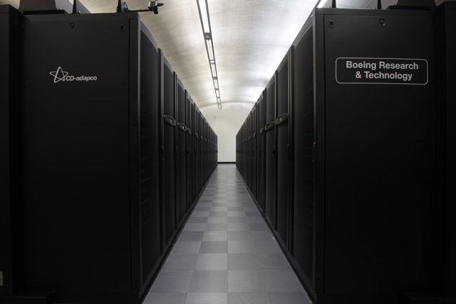
In CFD, the same experiment may be conducted in the form of a computer simulation. Although the equations that govern these computations have been understood since the 1930s, they are complex to solve and require the sort of computing power that has only become truly practical in the last 15 years or so.
A huge range of industries benefit from the mastery of aerodynamic design that a successful CFD programme enables. It is probably no surprise that the aerospace, road car and wind turbine industries use CFD in their design process. It might be less obvious that it also brings significant advantage in hundreds of other industries. In fact, in any application where there is any sort of fluid (gas or liquid) flow, CFD can bring benefit. Climate modelling, the force of wind on a building, the way in which medicine is distributed in an inhaler, efficient air conditioning design, transport of gas or liquids in pipelines; the list of applications is truly enormous. All of these applications benefit, to a greater or lesser extent from the investment that Formula 1 has made in the growing technology of CFD.
For a sustained period of around 20 years, the teams in Formula 1 have ploughed money into the development of CFD, as it has been clear for a long time that mastery of this tool would be a prerequisite for success in the sport. Teams have sponsored the development of improved CFD techniques at top universities and they have also put money directly with the providers of commercial CFD codes to ensure that the considerable challenge of accurately simulating the aerodynamic behaviour of a Formula 1 car has turned from an aspiration to a reality. It would be wrong to pretend that the development of subsonic CFD codes has been the sole responsibility of the Formula 1 industry, but no serious observer of the industry would deny that the combined investment of the teams has been very significant.
An example of the positive role that Formula 1 plays in this field can be seen in the relationship that Lotus F1 Team enjoys with Boeing and CD-adapco. At Lotus F1 Team, the aero department makes use of two sets of CFD codes to run virtual simulations on our cars. One code is commercially available from CD-adapco, while the other code is available through our partnership with Boeing. The Boeing code is highly specific and used for the design of aircraft, but it has significant application within Formula 1. Development of this code at Lotus F1 Team, in partnership with Boeing, has produced industry-leading optimisation software. The potential benefit to Boeing of this development is not trivial: For example, a 1% reduction in drag will reduce an airline’s direct operating costs by 14% due to reduced fuel usage will result in lower CO2 emissions.
Aerodynamics Dr. Mori Mani, Senior Technical Fellow in CFD for Boeing explains: “With the reduced-cycle time CFD has the potential to become a primary contributor to vehicle design, as opposed to being primarily an analysis tool. In particular, the collaboration between Lotus F1 Team and Boeing has helped to accelerate further this type of numerical design, as well as improve the robustness of the tool suite through analysis of the challenging F1 geometry, which is typically more complicated than aircraft geometry.”
A case study was carried out by Lotus Renault GP for Nissan to demonstrate the power of this newly developed optimisation technique for road car design. Nissan provided the team with a virtual model of an existing Nissan road car as a test case and using this new CFD software we were able to optimise the external shape of the car and reduce drag by over 4%. This figure was then confirmed by Nissan using a different CFD code. This 4% drag reduction is a significant improvement and is achieved through geometry changes not easily identified using conventional CFD codes. In this example the wider benefit of this novel CFD technology is clearly contributing to the design of more fuel-efficient cars. In addition to the development of this optimisation tool, further more general enhancements have been made to Boeing’s code by Lotus F1 Team and Boeing.
One example involved a revision to the algorithms, which increased the speed of the code by a factor of six. Therefore, every six hours spent using the old code takes only one hour using the new code. The savings in resources are obvious, but importantly the time saved allows more design cycles to be run, refining the design and leading to even greater efficiency of the end product. Likewise, Lotus F1 Team works closely with our commercial code supplier, CD-adapco, making suggestions and recommendations to help drive the code development in directions that benefit not only Lotus F1 Team but other users of this software as well. Unlike the Boeing code, this code is less specialised with a wider range of users and beneficiaries. Dr. Bill Clark, Sr. VP of Operations for CD-adapco says, “CD-adapco has many Formula 1 customers, but our unique relationship with Lotus F1 Team is truly forward looking. The technology we are working on with the team today will recoup environmental and performance benefits for many industries in the years to come.”
This mutual vision will also be needed to face upcoming challenges beyond external aerodynamics such as engine downsizing, turbocharging, and energy recovery systems. “The competitive nature of Formula 1 and the desire to extract greater levels of performance from the car has undoubtedly helped to develop the capabilities of CFD software at an ever-increasing rate,” says Daniel Bell, Senior Lecturer in Thermo-fluids at Oxford Brookes University. “Methods developed by Formula 1 teams for applying CFD to simulate performance can be seen filtering down into passenger car development where more complete and detailed simulations are helping to improve safety at the same time as efficiency.”
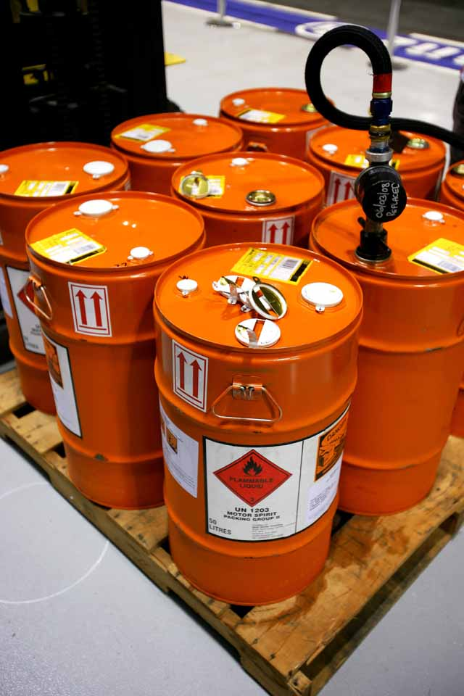
Fuel
A common misconception about Formula 1 is that on-track performance is a function solely of power. In fact, performance comes from a number of different sources, and one of those is fuel consumption. If you can lower fuel consumption while still generating the same performance, you improve the car’s efficiency. Achieve this in Formula 1 and your car will possess a performance advantage in racing conditions since less fuel needs to be carried, which reduces overall weight and improves performance.
Fuel consumption and the efficient conversion of fuel into energy, are therefore major development priorities for engine and fuel manufacturers. It is for this reason that Lotus F1 Team’s close working relationship with TOTAL is of such importance, especially with the ban on refuelling in 2010, which means cars must carry enough fuel to last the entire race distance. “In 2010 the ban on refuelling means that we don’t want to carry any more fuel than absolutely necessary to keep the weight of the car to a minimum,” explains Eric Boullier. “TOTAL has therefore been working extremely closely with us to ensure that our race fuels achieve high efficiency per unit of mass.” Total engineers also seek to minimise friction wherever it can occur in the car, not only in the engine, but also into the gear box, oil pumps, hydraulic pumps, transmissions and bearings by adapting and optimising lubricants and greases for the needs of each mechanical component.
However, the benefits don’t just apply to the racetrack because what TOTAL learns from Formula 1 is transferred directly to its commercial products. One way to achieve maximum performance from the lowest quantity of fuel is to combine the fuel with certain additives to help reduce the level of friction on the pistons. Additives also help clean the engine and avoid deposits in the combustion chamber, and minimises friction which leads to reduced fuel consumption. It is the same additives developed for Formula 1 fuel that are used in TOTAL’s commercial fuel in road cars.
Formula 1 fuel has been strictly regulated since 1996, when the FIA imposed unleaded fuel that had to meet the Euro 95 standard applied to pump fuel for normal road cars. Prior to this date, Formula 1 had used leaded fuel and chemical additives with very high octane ratings for maximum power. Since specifying the use of ‘pump fuel’, the FIA’s focus for the evolving regulations on fuel has been environmental, and Formula 1 has operated in advance of standards in force for production cars: in 1999, fuel already conformed to the production standards for 2000; in 2001, fuel met 2005 standards; and since 2004, fuel has met production standards that have been applicable since 2009. Recent regulations for Formula 1 fuel has seen the introduction of a percentage of bio-fuel, such as ethanol, which is of great relevance for TOTAL because European law now requires that commercial fuel also includes a percentage of bio-fuel. At the same time European car manufacturers are focussed on producing smaller cars with low CO2 emissions. What TOTAL learns through its involvement in Formula 1 has therefore been applied to its commercial fuels. The research has focussed on ensuring the balance of bio-fuels in the formulation leads to usable fuels with clean combustion in the engine to reduce as much as possible the levels of unburned fuel, thus improving efficiency and lowering fuel consumption and CO2 emissions.

