
University of Wales Trinity Saint David
School of Engineering

Analysis of power generation cycles & application of compression-vapour cycle
Thermofluid Mechanics
ACMA5011
Gwydion Gwyn Clement
Student ID: 1804252
Date: 06/01/21

Contents
1 Introduction 1
1.1 Aims 1
1.2 Objectives 1
2 Part A 2
2.1 Question (a) 2
2.1.1 Results (i) 2
2.1.2 Results (ii) 3
2.2 Question (b) 3
2.2.1 Results 3
2.3 Question (c) 4
2.3.1 Results 4
2.4 Question (d) 5
2.4.1 Results 5
2.5 Question (e) 6
2.5.1 Temperature-entropy diagram 6
2.5.2 Results 6
3 Part B 9
3.1 Gas Turbine Power Plant 9
3.2 Steam Turbine Power Plant 10
4 Part C 12
5 References 13
6 Appendices 15
6.1 Appendix A - (Question a) 15
6.2 Appendix B – (Question b) 19
6.3 Appendix C – (Question c) 21
6.4 Appendix D – (Question d) 22
6.5 Appendix E – (Question e) 23

Figure 1 - Flow diagram single shaft Gas Turbine Power Plant (Ibrahim, et al., 2017) 9
Figure 2 - Media evaporative cooling example (Peltier, 2010) 10
Figure 3 - Steam Turbine Process (Peltier, 2010) 11
Figure 4 - Components of Vapour Compression cycle (Baksi, 2019) 12
Figure 5 - Reversed heat engine cycle (Heikal, 2011) 13
Figure 6 - TS diagram for ideal Carnot Cycle (Heikal, 2011) 13
Figure 7 - TS diagram for basic vapour compression cycle (Heikal, 2011) 13
Figure 8 - Vapour Compression Cycle Diagram (Baksi, 2019) 14

Introduction

Aims

This report has been split into three sections, split as Part A, B and C. Part A will look at 5 different problems presented, these questions will look at otto cycles, the dual combustion cycle, efficiency, steam plants and turbines. At the start of each question in Part A the problem will be presented as a figure, with the pure results following. These will show how the results were found but for further details all the workings out for all of Part A will be presented in the appendices.

When looking at Part B Consideration will be given towards a Gas Turbine Plant and a Steam Turbine Plant. Here, different to Part A, real processes will be considered for both. These systems will be discussed, and practical methods will be presented by a means in which to improve efficiency on both plants. With the aid of power cycle diagrams and schematics for both processes, the aim will be to show where improvements can be made to increase efficiency.

Finally, for Part C a refrigerator and a heat pump will be looked at. With these two-process manipulating the second law of thermodynamics, research and discussion will be carried out as to explain how vapour compression cycle work. Following this will be suitable cycle diagrams that will show how they differ from an ideal cycle. Then following on from this the coefficient of performance for these cycles will be looked at and discussed.

Part A

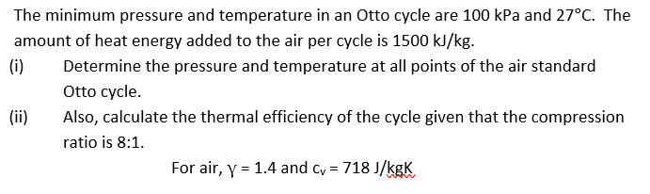
Question (a)

Results (i)
Process 1-2 Is isentropic so we can use: $T_{2}$= $T_{1}{(\frac{V_{1}}{V_{2}})}^{γ-1}$
Therefore: $∴ T_{2}$ = 689.22K _{to 2d.p}

To find $P_{2}$ the Ideal gas equation should be used: $P_{2}=\frac{P_{1}.{V_{1}.T}_{2. }}{{V_{2}T}_{1}}$
So: $∴ P_{2}=$ 1837.92kPa _{to 2d.p}

Where: $Q=$c_{v.}${(T}_{3}-T_{2})$
$∴T_{3}=$ 2778.36kPa _{to 2d.p}

For Process 3 – 4 (Isentropic): $T_{4}$= $T_{3}{(\frac{V_{3}}{V_{4}})}^{γ-1}$
${∴ T}_{4}$= 1209.35K _{to 2d.p}

Now the Ideal Gas equation can be used for $P_{3}$: $P_{3}=\frac{P_{2}.{V_{2}.T}_{3. }}{{V_{3}T}_{2}}$
So: $∴ P_{3}=$ 7408.95kPa _{to 2d.p}

And the same for $P_{4}$: $P_{4}=\frac{P_{3}.{V_{3}.T}_{4. }}{{V_{4}T}_{3}}$
So: $∴ P_{4}=$ 403.12kPa _{to 2d.p}

Results (ii)
For thermal efficiency we can use : $η=1-( {\frac{1}{r} )}^{γ-1}$
Therefor: $η=$ 56.47%

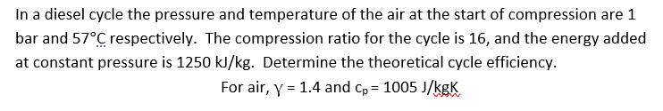
Question (b)

Results
For this ($η=1-\frac{1}{r^{γ-1}}$($\frac{{rc}^{γ}-1}{γ(rc-1}$)+1) should be used, first rc must be found
So: $rc=\frac{Q}{cp.T_{1.}r^{γ-1}}$
$∴rc=$ 2.24 _{to 2d.p}
Therefor:
$η=$ 60.22%

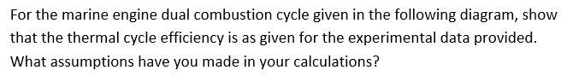
Question (c)

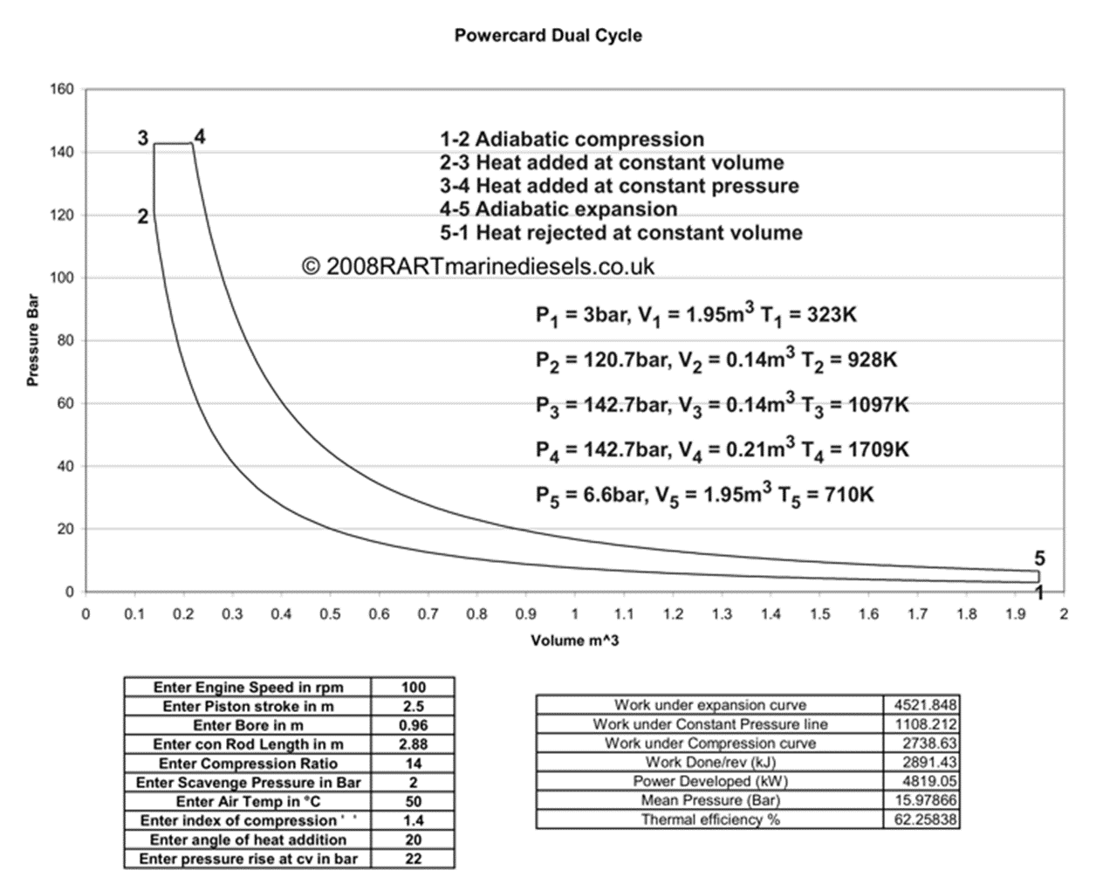

Results
Assumption: Mass of air = 1Kg, c_{v} of air = 718 J/kg, c_{p} of air = 1005 J/Kg
Thermal efficiency = $η=1-\frac{Heat Rejected}{Heat Supplied}$
So, heat energy supplied = H_{s}
$$∴ H_{s}=m.c_{v}\left(T_{3}-T_{2}\right)+m.c_{p}(T_{4}-T_{3})$$
$∴ H_{s}=$ 736402 J/Kg
And for Heat Energy Rejected = H_{r}
$$∴ H_{r}=m.c_{v}\left(T_{5}-T_{1}\right)$$
$∴ H_{r}=$ 277866 J/Kg
Therefor: $η=$62.27%

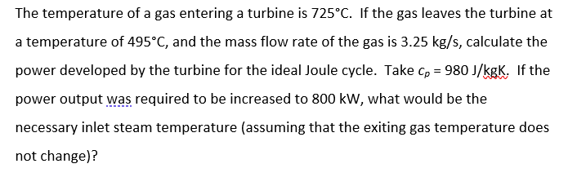
Question (d)

Results
Where Turbine Power = $W=m.c_{p}(T_{1}-T_{2})$
Then $W=$ 732550 W or 732.55 kW
So, for 800 kW we can sub in for Turbine Power and make T₁ the Subject to find the required inlet steam temperature:
T₁ = 746°C or 1019 K

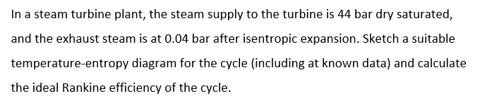
Question (e)

Temperature-entropy diagram
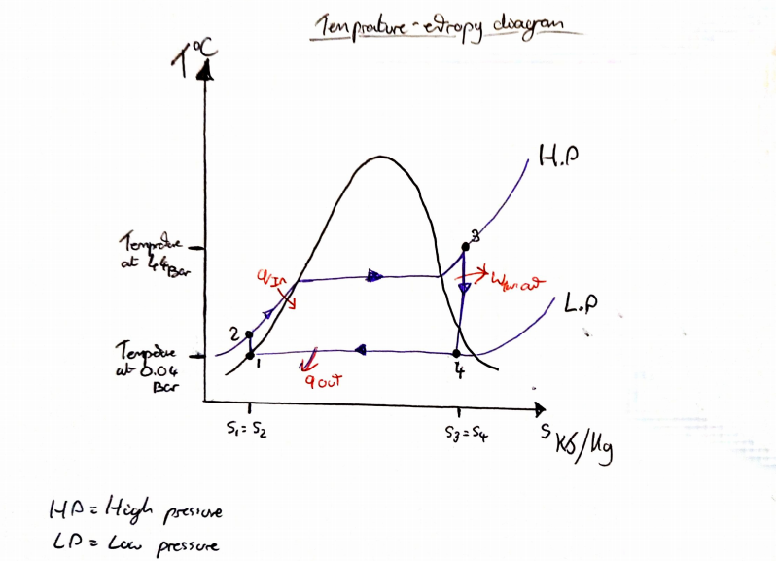

Results

For the Rankine efficiency use: ${ η}_{R}=\frac{h_{3}-h_{4}}{h_{3}-h_{1}}$ but first the Enthalpy values must be found. Through taking data from steam table A-5 we can first find values for the lower pressure of 4kPa.
where $x=0$.
$h_{f}=$ 121.39 kJ/kg
$h_{fg}=$ 2432.3 kJ/kg
Then using: $h_{1}= h_{f}+x.h_{fg}$
$∴h_{1}=$ 121.39 kJ/kg

For h₃ at 4400 kPa and Saturated vapour, linear interpolation must be used to find value between 4000 kPa and 500kPa.
Where:

Table 1- Steam Table A-5 for Sat vapour Enthalpy
kPa | Sat Vapour - Enthalpy kJ/kg
4000 | 2800.8
4400 | h₃
5000 | 2794.2

Then using:
$$y= y_{1}+\left(x-x_{1}\right).\frac{y_{2-}y_{1}}{x_{2}-x_{1}}$$

$∴$ h₃ = 2798.16 kJ/kg

For h₄ – Process 3-4 is isentropic so the quality $x$ must be found. Where $s_{3}=s_{4}=s_{x}$ the same linear interpolation can be used again. From table A – 5:

Table 2 - Steam Table A-5 for Sat vapour Entropy
kPa | Sat Vapour- Entropy kJ/kg.K
4000 | 6.0696
4400 | $$s_{x}$$
5000 | 5.9737

Therefor: $s_{x}=$6.03124 kJ/kg.K

From Table A-5 for 4 kPa:
$s_{f}=$ 0.4224 kJ/kg.K
$s_{fg}=$ 8.0510 kJ/kg.K

Now the dryness fraction can be arranged to make $x$ the subject

$$s_{x}=s_{f}+x.s_{fg}$$
$$∴ x= \frac{s_{x}-s_{f}}{s_{fg}}$$
$$∴ x=0.6966$$
Now use for h₄:
$$h_{4}= h_{f}+x.h_{fg}$$
Where:
$h_{f}=$ 121.39 kJ/kg
$h_{fg}=$ 2432.3 kJ/kg
And:
$$x=0.6966$$
Therefor:
$h_{4}=$ 1815.93 kJ/kg
So for the Rankine efficiency:
$${ η}_{R}=\left( \frac{h_{3}-h_{4}}{h_{3}-h_{1}} \right)×100$$
$∴{ η}_{R}=$ 36.69%

Part B

Gas Turbine Power Plant
A gas turbine can have many applications but its production of electricity in a powerplant can be considered one of its main features (Noroozian & Bidi, 2016). Many countries have re-examined their energy policies in recent years due to increased awareness of the planets energy resources, within the scientific communities the attention was drawn towards energy conversion to better utilise existing resources (Ibrahim, et al., 2017). Due to the research and development carried out performance of industrial gas turbines has been improved considerably in the conversion efficiency of fuel to electricity (Dev, Dev, Attri, & Attri, 2017).

The components within the system consist of, an air compressor, combustion chamber and gas turbine (figure 1). Each of these components can affect the efficiency of the gas turbine power Plant (Ibrahim, et al., 2017)
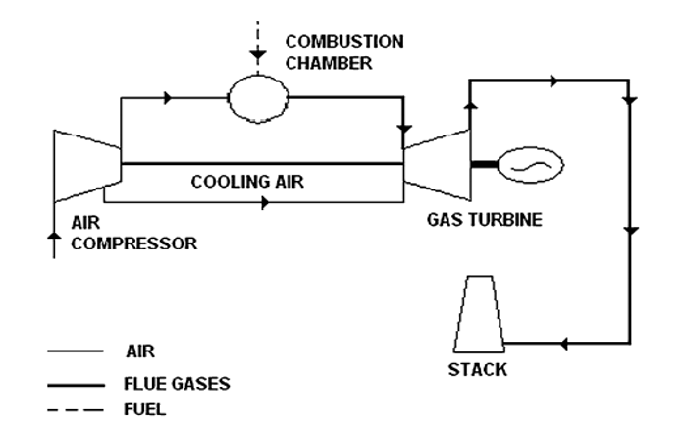
Figure 1 - Flow diagram single shaft Gas Turbine Power Plant (Ibrahim, et al., 2017)

To optimise the energy of a Gas Turbine Plant not only will the thermal efficiency of turbine itself need to be looked at, but also the power balance between power and heat produced. Power output depends on air mass flow, as Gas Turbines work on a constant-volume cycle (Hunt, 2007). Warm air is less dense than cold air meaning that power output would be reduced. This warm air also requires more power to compress meaning that internal losses in the compressor will increase. The work required by the compressor alone can be 66% of the total turbine power (Hunt, 2007). Electrical efficiency or the turbine depends primarily upon the pressure ratio in the air compressor and the temperature of the combustor outlet. Yet it is the average turbine inlet temperature that is considered the most important (Kotowicz, Brzęczek, & Job, 2018). For these reasons compressor inlet air cooling is one of the most recognised methods to increase efficiency (Noroozian & Bidi, 2016). Three examples of these methods are as follows:

- Mechanical chiller or absorption chiller: This is where a mechanical chiller will cool inlet air that is passed across electrically operated cooling coils that have intermediate refrigerant fluid circulated. In turn Absorption Chillers require steam or hot water as their source of energy, as a result they will require less electrical energy than that of the mechanical chiller (Noroozian & Bidi, 2016).
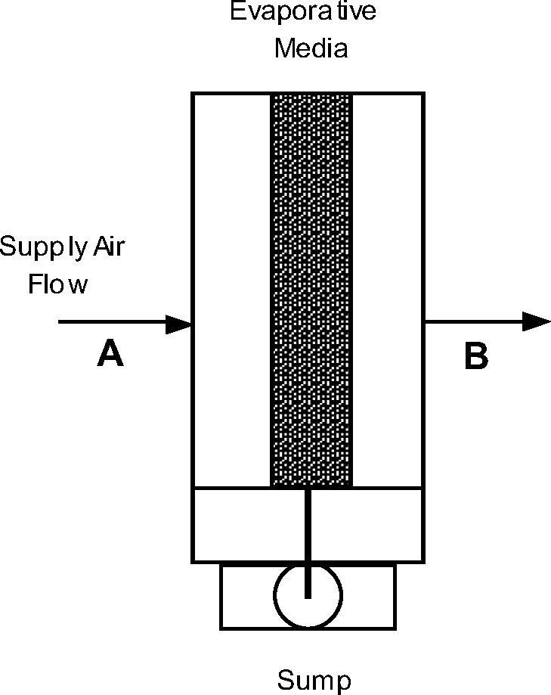
Figure 2 - Media evaporative cooling example (Peltier, 2010)
- Chilled water storage or ice harvesting: better used for small storage capacity

- Media evaporative cooling and Fogging: With the media cooling, water gets distributed from the top as hot air passes through the media, in turn causing evaporation (figure 2). Fogging in turn is where high pressure nozzles add fine droplets or water to the inlet air before entering the compressor. (Noroozian & Bidi, 2016).

Deterioration will happen over time regardless, (Dev, Dev, Attri, & Attri, 2017) advises that preventative measures can be as effective as practical changes. Through carrying out systematic maintenance on these components it will also aid in the efficiency over time (Dev, Dev, Attri, & Attri, 2017).

Steam Turbine Power Plant

Operating differently to Gas Turbines, Steam Turbines are rotated by the currents caused by hot water vapour. This in form creates a closed water cycle that is condensed and then heated until it evaporates (figure 3). Steam Turbines do not meet with the fuel deployed and can operate between 500°C and 650°C (kraftwerkforschung, 2011).

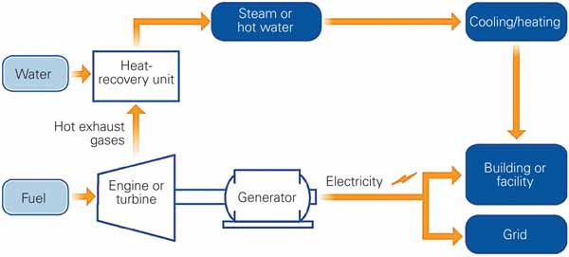
Figure 3 - Steam Turbine Process (Peltier, 2010)

When looking at a Steam Turbine it typically has a longer life service than that of the Gas Turbine (Kler, Stepanova, & Maksimov, 2018). Meaning that the issue of ware on the components is less than previously mentioned in (3.1) This in part is because less scarce materials are required to produce a steam boiler and steam turbine (Kler, Stepanova, & Maksimov, 2018). However, deterioration is still a prominent factor as will be discussed.

Much like the Gas Turbine Plants however, Steam Plants are facing the need to cut on CO2 emissions. Since they now provide a crucial energy source, the focus on the efficiency also needs to be considered (Engineering, 2011). There are four prime causes of losses in steam turbine efficiency:

- Surface erosion of nozzle and bucket surface
- Damage to mechanical components from foreign objects
- Leakage through inlet stem pipes, shaft packing, and tip seals.

The packing and tip seal losses along can account for 50% of the efficiency loss and as the steam turbine ages extreme operating temperatures can cause the components to deteriorate (MacDonald, 2017). Therefor it can be stated that, as a turbine deteriorates its efficiency will degenerate proportionally. Through identifying any improvements that can be made in Combustion, heat transfer, aerodynamics (for turbine blades) and materials for components efficiency can be improved (MacDonald, 2017).

Advances in Computer Aided Design means that more adequate components can be designed. Improved nozzle profiles have proven to help stationary blade losses, whereas redesign in turbine sidewalls have been shown to increase turbine efficiency up to 10% (MacDonald, 2017). Design itself is not the main element though, as the correct materials need to be used also. Advanced material science has enabled the creation of components that have a higher resistance to corrosion, as well as turbine manufactures suppling sealing systems for the turbine to aid in any leaks that may occur (MacDonald, 2017).

Part C

A vapour compression cycle can also be known as (VCC) can be better referred to as a refrigeration cycle (Baksi, 2019). A key element of the vapour compression cycle is to remove heat from a space so that it is at a lower temperature to its surroundings, such as a refrigerator. A similar device however can be used increase the area from the surroundings to a higher temperature, such a device can be referred to as a heat pump. The distinction between the two are more due to their purpose as opposed to their function (Heikal, 2011). Components of Vapour Compression Cycle can be seen in (figure 4).

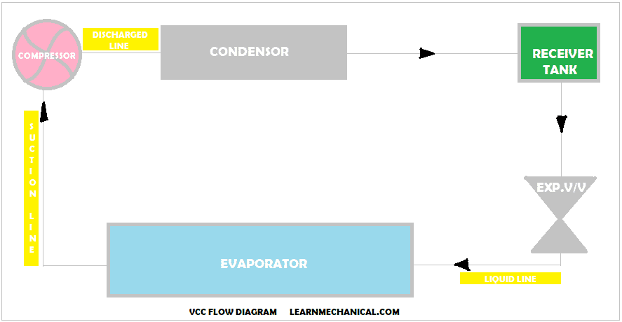
Figure 4 - Components of Vapour Compression cycle (Baksi, 2019)

The vapour compression cycle is an example of the mechanical refrigeration process, this belongs to a class of reversed heat engine cycles (Figure 5) (Heikal, 2011).

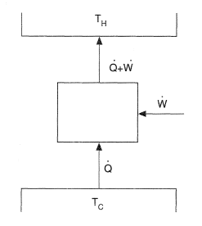
Figure 5 - Reversed heat engine cycle (Heikal, 2011)

Vapour compression cycle works by raising the pressure of fluid vapour (refrigerant) that is coming from an evaporator from a low pressure to a high pressure (figure 4) (Heikal, 2011). This then moves through a condenser with a higher pressure and then back to a lower pressure in the evaporator. The temperature -entropy diagrams bellow shows the difference between that of an ideal Carnot Cycle (figure 6) and that of a real vapor compression cycle (figure 7). (Heikal, 2011)
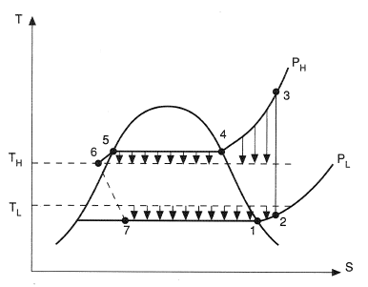
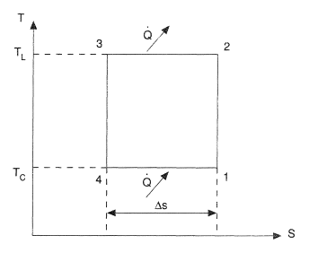

Figure 6 - TS diagram for ideal Carnot Cycle (Heikal, 2011)
Figure 7 - TS diagram for basic vapour compression cycle (Heikal, 2011)

Practical reversed heat engines can be compared to the Carnot Cycle such as in the following relationship (Heikal, 2011)
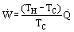
To measure the efficiency of such a process the following could be done (Heikal, 2011)
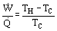
The lower of the value of the ratio of means that the process is more efficient, however it is more common for vapour compression cycle to use the inverse of this which is known as coefficient of performance as stated below (Heikal, 2011).
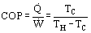
The formula above states that the Coefficient of Performance becomes greater as the temperature difference decreases. for this reason, Coefficient of Performance will be less in a refrigerator than that of the ideal Carnot Cycle (Heikal, 2011).
(figure 8) Shows a closer look at the vapour compression cycle.
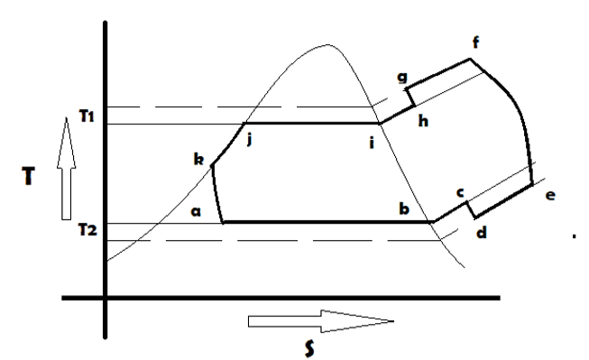
Figure 8 - Vapour Compression Cycle Diagram (Baksi, 2019)

(Baksi, 2019) Describes the processes as follows:
- Process a-b-c - Shows the flow of refrigerant at pressure and temperature T₂
- Process c-d - Here there is a drop in pressure due to valve resistance on the compressor
- Process d-e - Heat is added to the refrigerant here from the cylinder wall
- Process e-f - The actual compression within the compressor
- Process f-g - Here represents the cooling of refrigerant at the exit of the compressor
- Process g-h - There is a pressure drop here because of resistance due to the discharge valve
- Process h-i-j-k - The superheating a vapour to a dry state and subcooling of refrigerant
- Process k-a - Here sub cold refrigerant gets throttled from condenser pressure to evaporator pressure

References
Baksi, S. (2019, June 25). vapour compression cycle. Retrieved from learnmechanical.com: https://learnmechanical.com/vapour-compression-cycle/
Dev, N., Dev, N., Attri, R. K., & Attri, R. K. (2017). Evaluation of gas turbine power plant efficiency using graph theoretic approach. International journal of system assurance engineering and management, Vol.8, p.676-689.
Engineering, T. E. (2011, May 29). Tips to improve steam plant efficiency | TLV - A Steam Specialist Company (International. Retrieved from Tlv.com: https://www.tlv.com/global/TI/news/uk-tips-to-improve-steam-plant-efficiency.html
Heikal, M. R. (2011, Feb 2). content 1086. Retrieved from thermopedia.com: http://thermopedia.com/content/1086/
Hunt, J. (2007, Nov 01). Gas turbine plant efficiency – balancing power, heat and operational flexibility. Retrieved from www.powerengineeringint.com: https://www.powerengineeringint.com/coal-fired/equipment-coal-fired/gas-turbine-plant-efficiency-balancing-power-heat-and-operational-flexibility/
Ibrahim, T. K., Basrawi, F., Awad, O. I., Abdullah, A. N., Najafi, G., Mamat, R., & Hagos, F. (2017). Thermal performance of gas turbine power plant based on exergy analysis. Applied thermal engineering. Applied thermal engineering, Vol.115, p.977-985, p.977-985.
Kler, A. M., Stepanova, E. L., & Maksimov, A. S. (2018). Investigating the efficiency of a steam-turbine heating plant with a back-pressure steam turbine and waste-heat recovery. Thermophysics and aeromechanics, pp.929–938.
Kotowicz, J., Brzęczek, M., & Job, M. (2018). The thermodynamic and economic characteristics of the modern combined cycle power plant with gas turbine steam cooling. Energy (Oxford), Vol.164, p.359-376.
kraftwerkforschung. (2011, Sep 10). the difference between steam and gas turbines. Retrieved from kraftwerkforschung.info: https://kraftwerkforschung.info/en/quickinfo/basic-concepts/the-difference-between-steam-and-gas-turbines/
MacDonald, J. A. (2017, Feb 26). increasing steam turbine power generation efficiency. Retrieved from www.linkedin.com: https://www.linkedin.com/pulse/increasing-steam-turbine-power-generation-efficiency-sultan-zafar
Noroozian, A., & Bidi, M. (2016). An applicable method for gas turbine efficiency improvement. Case study: Montazar Ghaem power plant, Iran. Journal of natural gas science and engineering, Vol.28, p.95-105.
Peltier, R. (2010, Feb 1). plant efficiency begin with the right definitions. Retrieved from www.powermag.com: https://www.powermag.com/plant-efficiency-begin-with-the-right-definitions/

Appendices

Appendix A - (Question a)

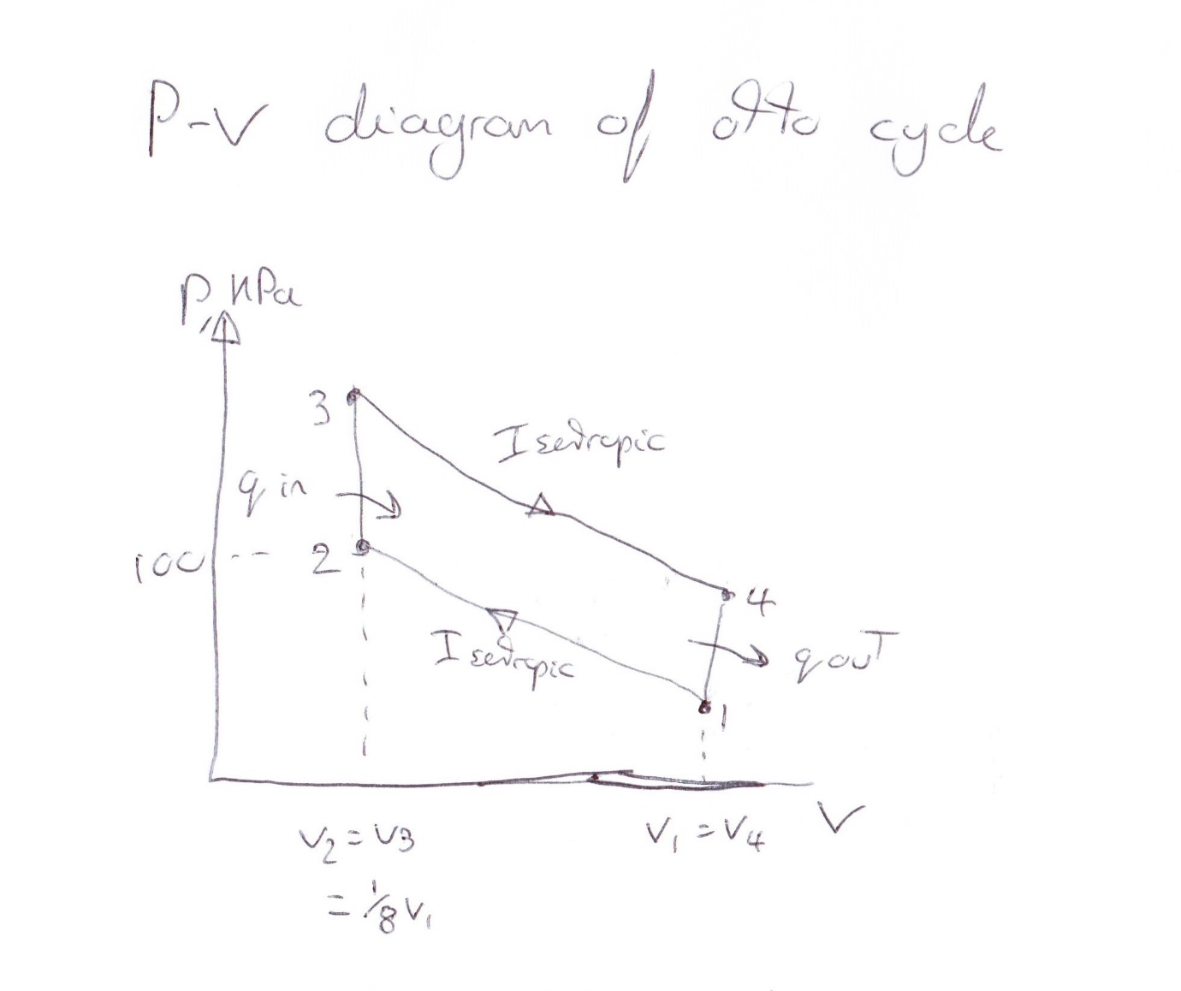

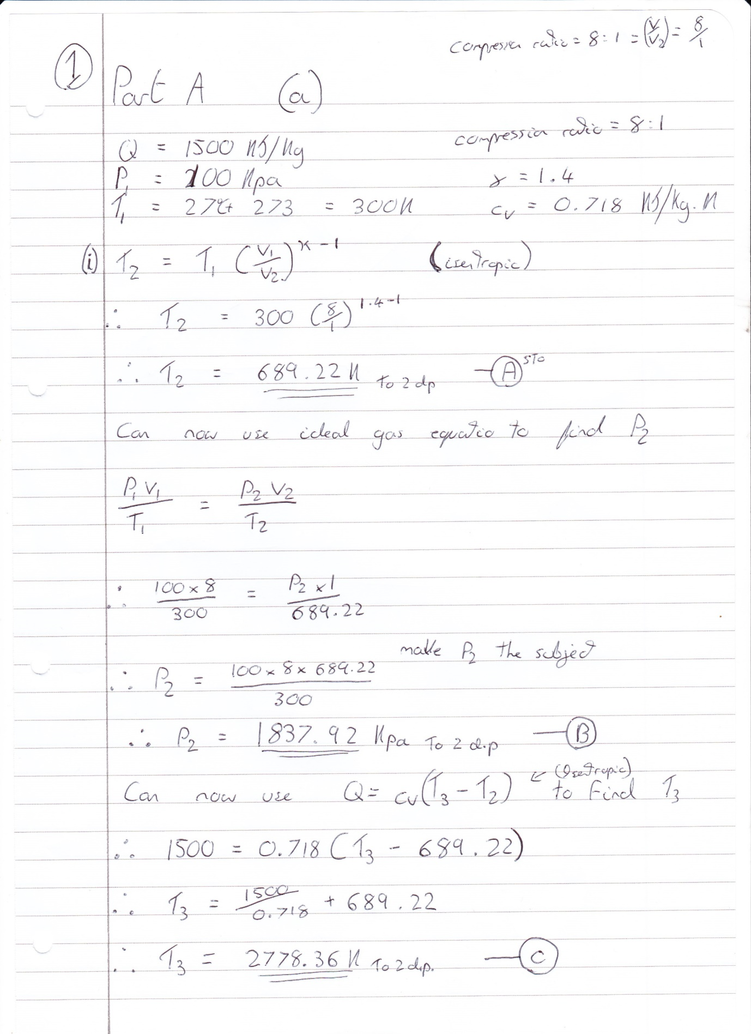

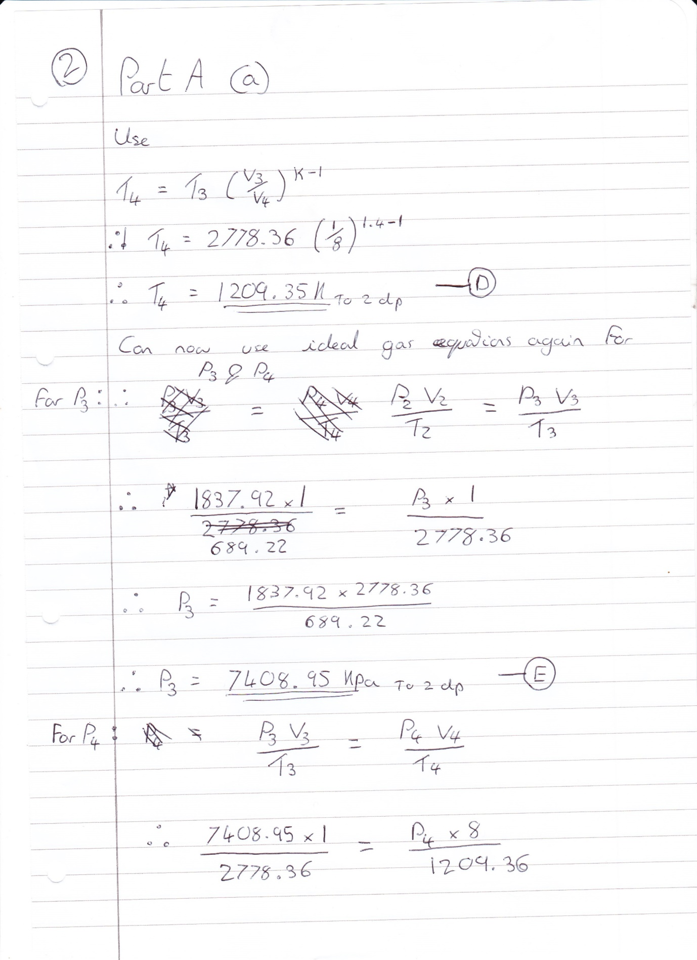

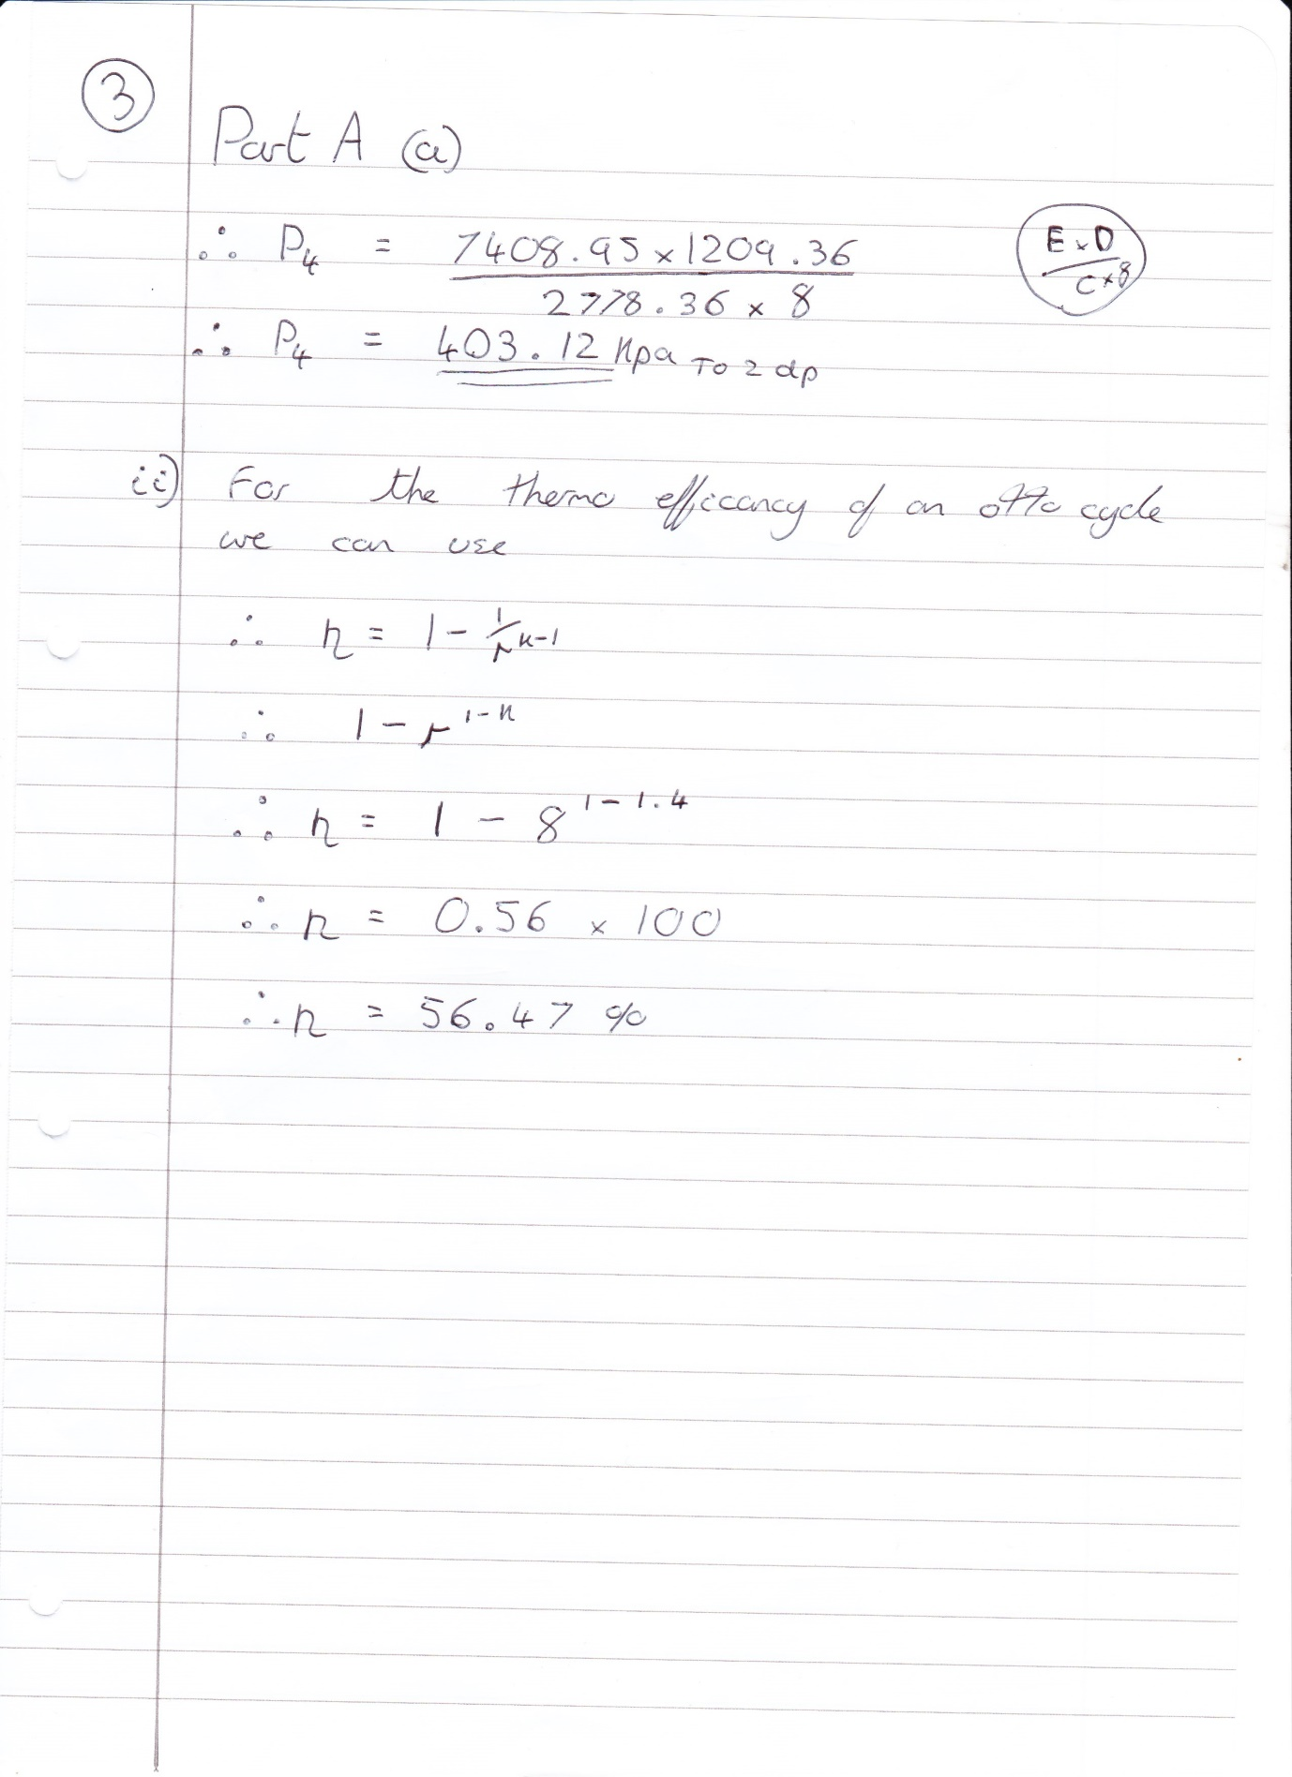

Appendix B – (Question b)

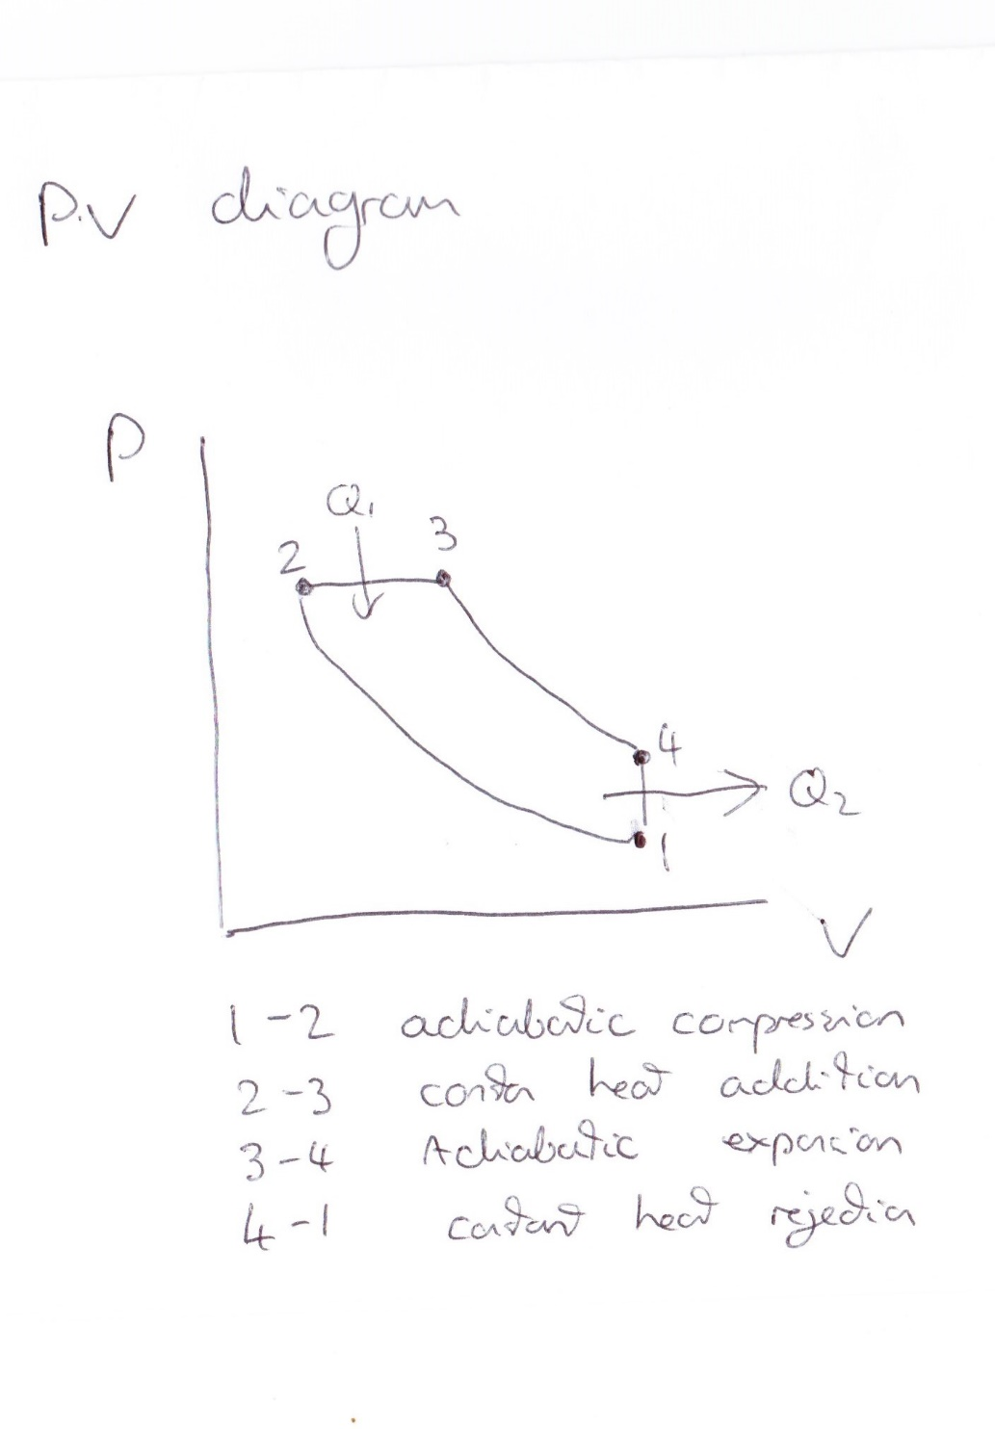
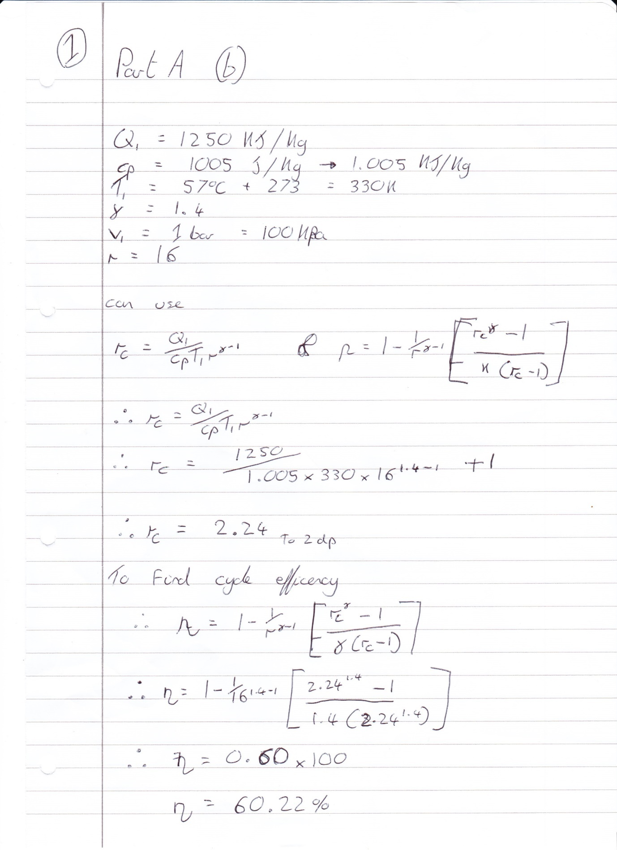

Appendix C – (Question c)
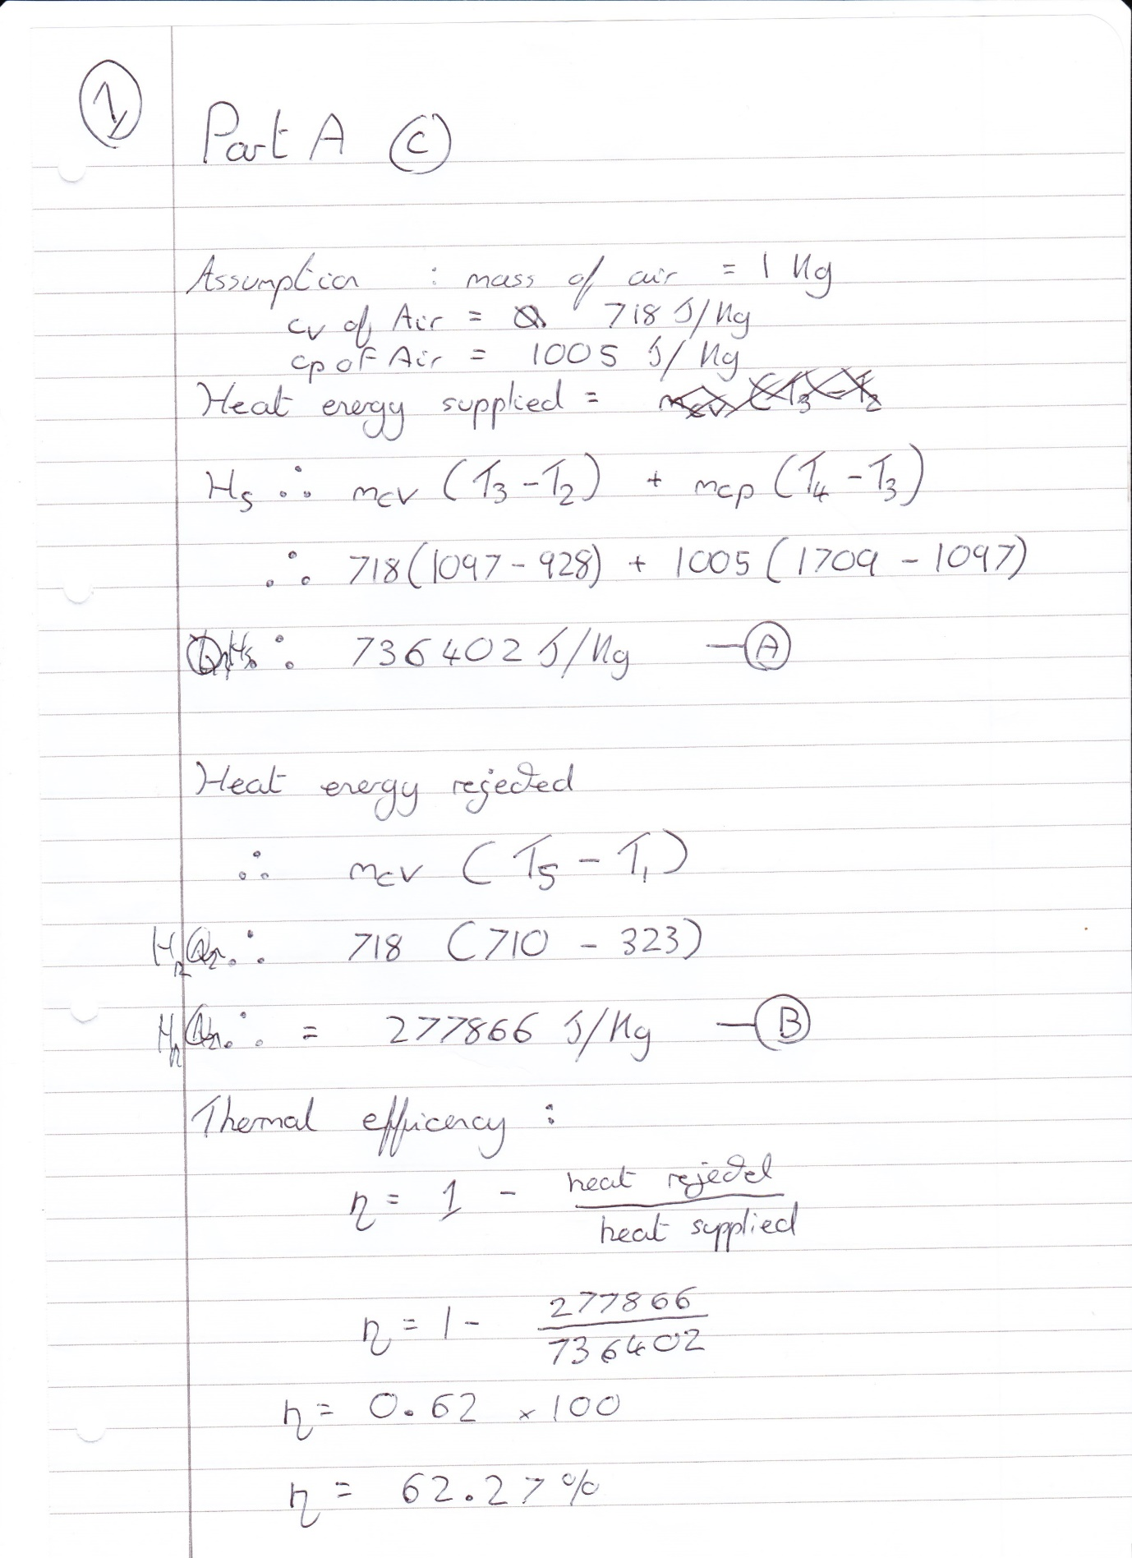

Appendix D – (Question d)
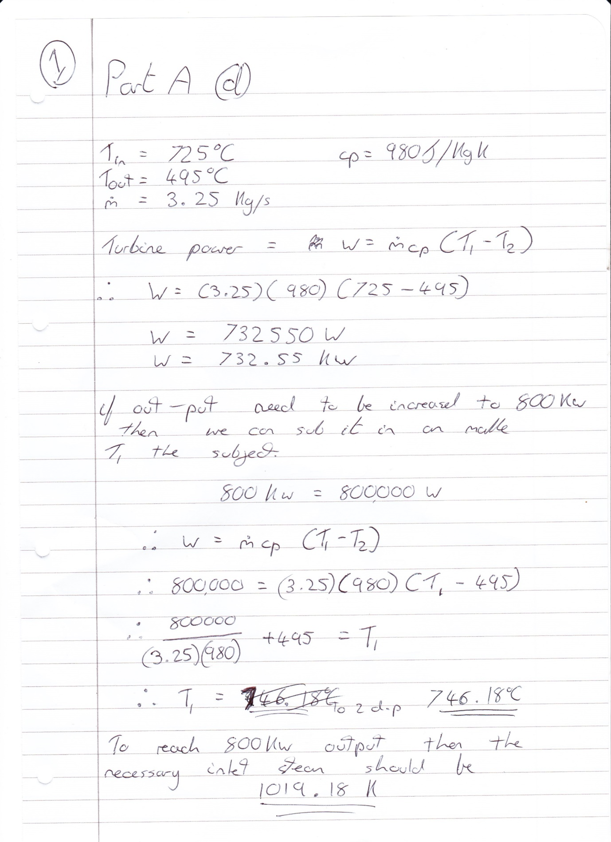

Appendix E – (Question e)



