
MASTER OF BUSINESS ADMINISTRATION
Marketing Management
LCMB7024
Assessment Component 1
Marketing Environment Analysis
Anglo American plc: Lower-Carbon Growth and Competitive Positioning

Student name: Soyab Ali
Student ID: 2614515
Tutor’s Name-Taonga Kaonga Sobere-Snithers (Birmingham)
Submission date: 21, October 2026
Final word count: 2,515

Table of Contents
List of Abbreviations 3
1. Task 1 - Marketing Environment Analysis 4
1.1 Company context and analytical focus 4
1.2 External actor 1 - Natural environment and climate change 4
1.3 External actor 2 - Technological change and innovation 5
1.4 External actor 3 - Legal environment 6
1.5 Integrated judgement 8
2. Task 2 - Strategic Growth and Competitive Positioning 8
2.1 Ansoff matrix and strategic recommendation 8
2.2 Porter’s Generic Strategies: Differentiation and green innovation 9
2.3 Strategic implementation and controls 10
3. Task 3 – Managerial and Professional Reflection 11
3.1 Reflection on key decisions 11
3.2 Limitations and information that a consultant would still seek 11
3.3 Senior leadership conclusion 11
Reference List 13

List of Abbreviations
Abbreviation | Full form / meaning
AI | Artificial intelligence
CBAM | Carbon Border Adjustment Mechanism
CO₂ / CO2 | Carbon dioxide
CO₂e | Carbon dioxide equivalent
DRI | Direct reduced iron
IEA | International Energy Agency
IPCC | Intergovernmental Panel on Climate Change
MtCO₂e | Million tonnes of carbon dioxide equivalent
plc | Public limited company

1. Task 1 - Marketing Environment Analysis

1.1 Company context and analytical focus
Anglo American plc is a suitable case because its post-2025 portfolio centres on copper, premium iron ore and crop nutrients linked to the energy transition. In 2025, Scope 1 and 2 emissions were 6.3 million tonnes of carbon dioxide equivalent (MtCO₂e), compared with 7.3 MtCO₂e in 2024. Meanwhile, Scope 3 emissions were 136.6 MtCO₂e compared with 170.6 MtCO₂e (Anglo American plc, 2025a). Much of the value-chain impact therefore sits with customers. The analysis focuses on three external actors: the natural environment, technological change and the legal environment, with the natural environment receiving the strongest attention because it drives the other pressures.

1.2 External actor 1 - Natural environment and climate change
The most important external factor is the natural environment, particularly changing land, water, energy and carbon conditions. Global metal extraction increased almost fourfold between 1970 and 2022. Consequences of extraction and processing are documented extending through global supply chains (Giljum et al. 2025). The Intergovernmental Panel on Climate Change (IPCC, 2022) acknowledges that heavy industries are major challenges to achieving a low-carbon economy as emissions are often locked in energy, materials and products. Therefore, companies like Anglo American face challenges to decrease their footprint, while keeping their products useful to meet the needs of the decarbonizing economy. Should they fail to do either, they risk losing their social and business license to operate and future client demand.
There are signs of positive change in Anglo American’s 2025 emissions data, but the company also limits opportunities to make broad claims. Scope 1 and 2 emissions decreased by 14% year over year, while Scope 3 decreased by 20% (Anglo American plc, 2025a). Anglo American disclosed that some Scope 3 improvements relate to businesses that the company sold or divested during 2025, and the remainder relates to company operations (Anglo American plc, 2025a). This is an important consideration for marketing credibility because clients expect comparable boundaries, clear methods and evidence at the product level. Measurement quality, in this case, can support client trust and potentially serve as a basis for stronger, broad sustainability claims.
The World Bank (2020) estimates that by 2050 a climate-smart pathway would increase the demand for minerals such as graphite, lithium and cobalt. The International Energy Agency (IEA, 2021) links the expansion of electrical networks with growing copper demand and in the IEA (2025), copper demand is expected to increase by 30% under the Stated Policies Scenario to 2040. This shows the viability of Anglo American's Copper strategy, but increased mining of this metal increases the impact on land, water and energy. This makes it essential to increase controls on the environment. The actor works both ways. Climate goals and the associated increase in mining and demand of minerals pose a challenge while at the same time raising the bar on how stringently the industry is judged.
A favorable comparative advantage exists in Anglo American's quality of iron ore. Kumba's 2025 Sustainability Report indicates that around 98% of its total greenhouse gas emissions are Scope 3, and around 95% of Scope 3 is from processing sold products. The report states that 49% of the 2025 iron-ore sales by volume was sold to customers with verified net-zero targets (Kumba Iron Ore, 2025). The report explains why the commercial offer is related to downstream emissions. Anglo American should position its ore as contributing to a lower-carbon future. The ore alone will not accomplish this.
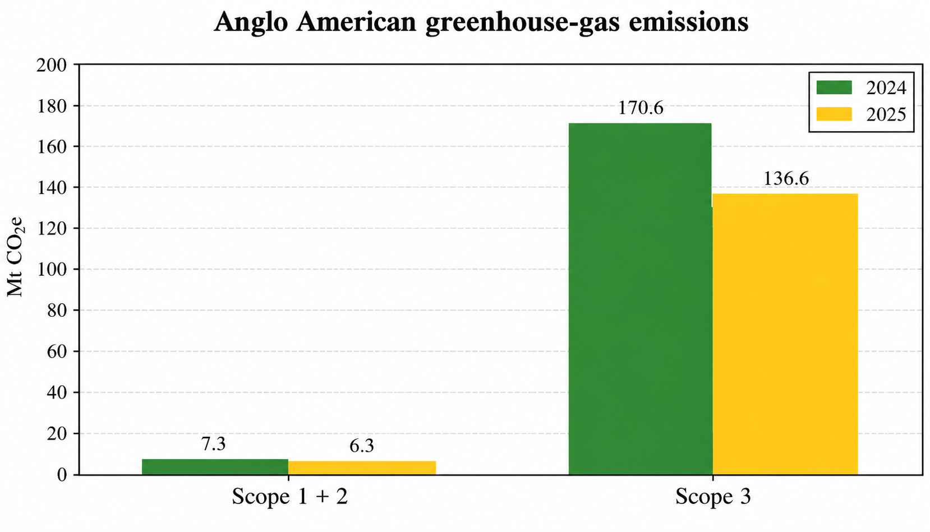
Figure 1: Anglo American greenhouse-gas emissions, 2024 versus 2025.
Source: Self-made based on Anglo American plc (2025a).

1.3 External actor 2 - Technological change and innovation
Technological change is a major external actor because automation, artificial intelligence (AI), electrification and new steelmaking methods can reshape mining productivity, safety, carbon intensity and demand for particular ore grades. Anglo American’s 2025 Integrated Annual Report describes digital and artificial-intelligence capabilities intended to support operational reliability, productivity and safer decisions (Anglo American plc, 2025a). Its 2025 partnership with the University of Birmingham and Cambridge Future Tech on carbon-recycling technology also links innovation with lower-emission steelmaking (Anglo American plc, 2025b). These tools may also improve maintenance planning and reduce exposure to hazardous operating conditions. These opportunities do not guarantee an advantage. Digital systems require accurate operational data, suitable skills, cybersecurity, governance and investment. New steelmaking routes may also change the ore grades and processing requirements buyers value.
The IEA (2020) explains that steel decarbonisation requires changes to process routes, energy supply and materials. Direct reduced iron (DRI), electrification and hydrogen-based methods may lower emissions where infrastructure, power and plant design support them, but cost and scale remain constraints. Anglo American should therefore avoid assuming that a technology announcement proves a product is low-carbon or commercially superior. It should compare life-cycle emissions consistently and validate ore performance with steelmakers before making claims (Anglo American plc, 2025a; Anglo American plc, 2025b). Pilots should measure carbon intensity, energy use, quality, reliability and total cost against a baseline, with accountability for data quality. Scaling should follow only when results are repeatable and benefits are demonstrated. Organisational learning can connect green innovation with competitive advantage, but benefits depend on implementation, not novelty alone (Khanra et al., 2022; Tu and Wu, 2021).

1.4 External actor 3 - Legal environment
The legal context is an important external actor since government actions determine permits, royalties, taxes, trade access, and environmental responsibilities and incentives related to critical minerals. All of these factors influence cost structures and potential markets Anglo American can enter. The Carbon Border Adjustment Mechanism (CBAM) is set up by EU legislation to create a carbon-related context for specific imports and make emission reporting commercially significant (European Parliament and Council, 2023). Destination of products and emissions of downstream supply chain could thus affect clients' compliance burden and sourcing strategies. Legal requirements are part of market access and value-chain data needs, not just a compliance matter. As the carbon border rules affect particular categories of products, Anglo American should find out whether there are any direct or indirect obligations imposed on its operations by means of customers' downstream supply chain.
Policies could stimulate demand for copper and other materials required for construction of new infrastructure and clean-energy transition, but the signals differ from one country to another and from one period of time to another. Permitting procedures, water constraints, environmental assessment, obligations towards the community, royalties, and export bans could delay projects or increase their costs. On the contrary, clear and consistent rules can help to decrease the uncertainty and stimulate low-emission investments. Energy transition is material-intensive process but increased demand does not imply that management can avoid taking into account impact on the local communities and regulatory legitimacy (World Bank, 2020; IEA, 2025). Anglo American needs to analyze regulations and timeframes in priority markets, not simply to believe sustainability claims.
The different systems of permitting and consultation require different project scheduling. The management should develop a country-specific policy map for priority assets and customers, including permits, carbon reporting, trade, taxation, mineral security policies. Analysis of scenarios should cover the impacts on costs, timeframes, and the value of products. Carbon and quality information should be auditable and appropriate for client reporting, avoiding any unexpected costs and unsupported claims (Anglo American plc, 2025a). The map should be frequently updated.
Table 1: Critical summary of the three external marketing environment actors
Actor | Key pressure | Critical implication | Management response
Natural environment | Climate, water, biodiversity and extraction impacts | Lower emissions improve legitimacy, but growth can increase environmental impacts | Renewable energy, efficiency, high-grade products, verified carbon data
Technology | Automation, electrification, AI and low-emission routes | Innovation improves safety and emissions, but cost and scale remain uncertain | Pilot, test and verify technical performance
Legal | Permits, tax, carbon and trade rules | Policy creates opportunities but adds cost and uncertainty | Map rules; test scenarios

1.5 Integrated judgement
These actors work together as opposed to operating in isolation. The natural environment puts pressure to reduce the impact but maintain demand for transition minerals; technological change affects how efficiently and credibly the company can respond; and legal decisions affect permits, trade access and emissions reporting. These three actors interact to shape both risks and opportunities. Anglo American must compete based on value, not just quantity or green talk. Green innovation can serve as a strategic resource if it provides value that is difficult to imitate (Khanra et al., 2022), and organisational learning can help connect innovation and competitive advantage (Tu and Wu, 2021). The firm requires linkage between environmental performance, product quality, and customer benefits.
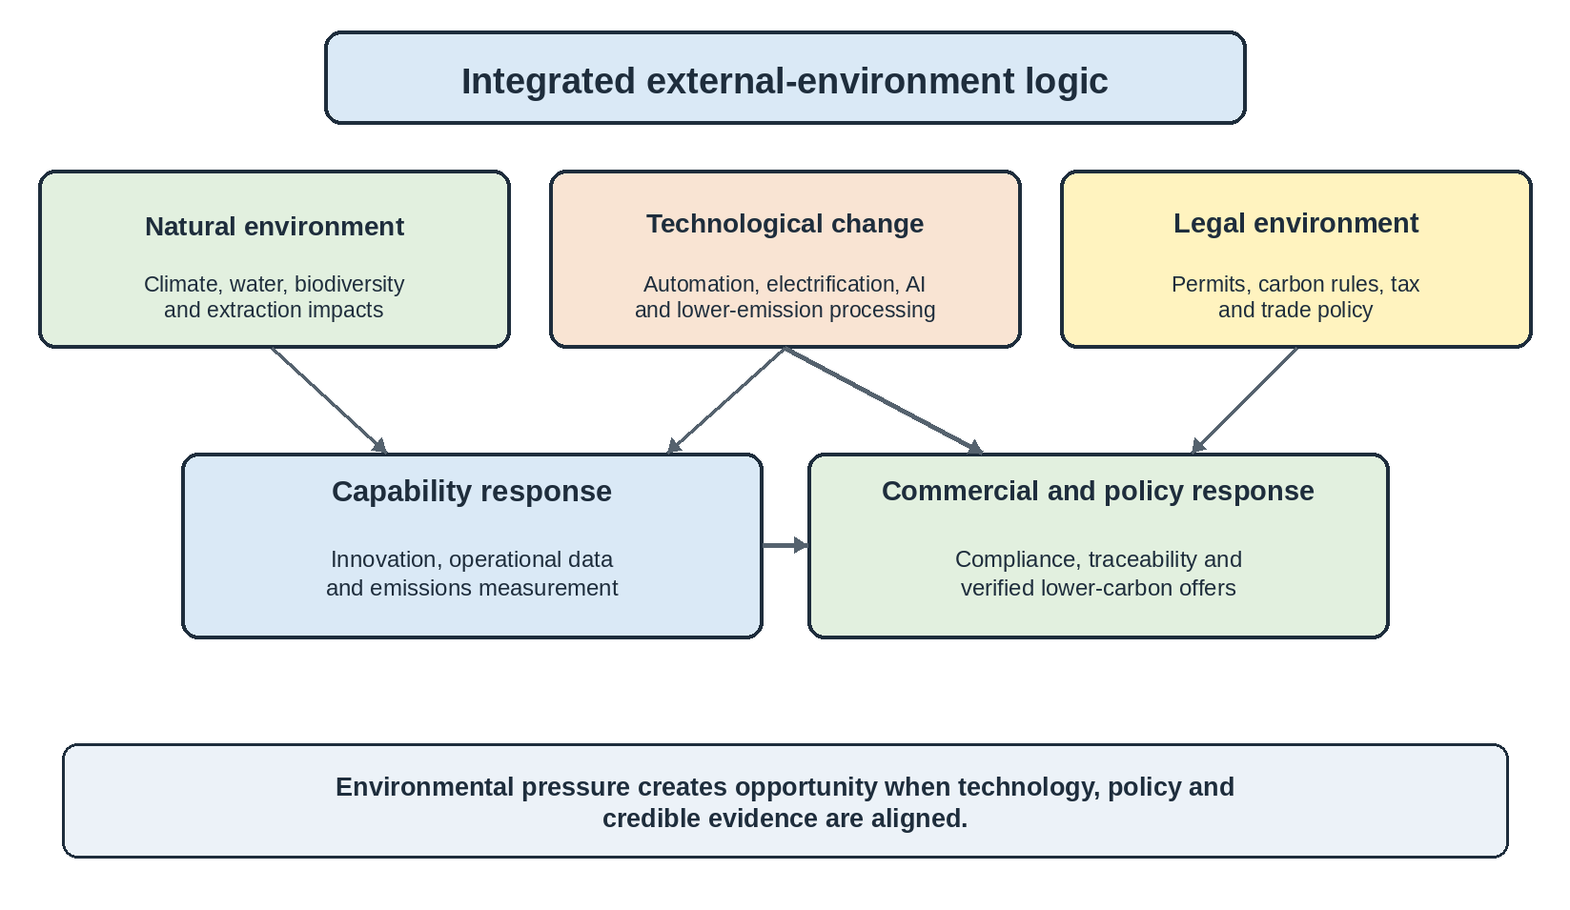
Figure 2: External-environment logic for Anglo American.
Source: Self-Developed.

2. Task 2 - Strategic Growth and Competitive Positioning

2.1 Ansoff matrix and strategic recommendation
According to the Ansoff Matrix, there are four ways of growth: market penetration, market development, product development and diversification (Kotler, Armstrong, Harris and He, 2024). Product development is the most justified way of growth for Anglo American. It already has minerals, industrial customers and technical expertise. The strategic change is in offering improved product propositions making lower-carbon value measurable and useful for current and adjacent customers. The main offer should be a proven lower-carbon premium iron-ore proposition backed up with emissions data on the product level, quality data and customer trials. This is product development as the value proposition and specification are redefined based on a new customer need.
Market penetration has limited opportunities as it involves improving the sale of current products without changing the environmental proposition. Market development might have some opportunities in new regions, although new markets without differentiation could lead to increased price competition and regulations. Diversification is the riskiest path as it involves new products and markets at the same time. Product development provides a better risk-fit ratio as Anglo American can leverage its current competencies while addressing the challenges revealed in Task 1. The recommendation is to develop, pilot and scale lower-carbon product variants rather than diversify into something else.
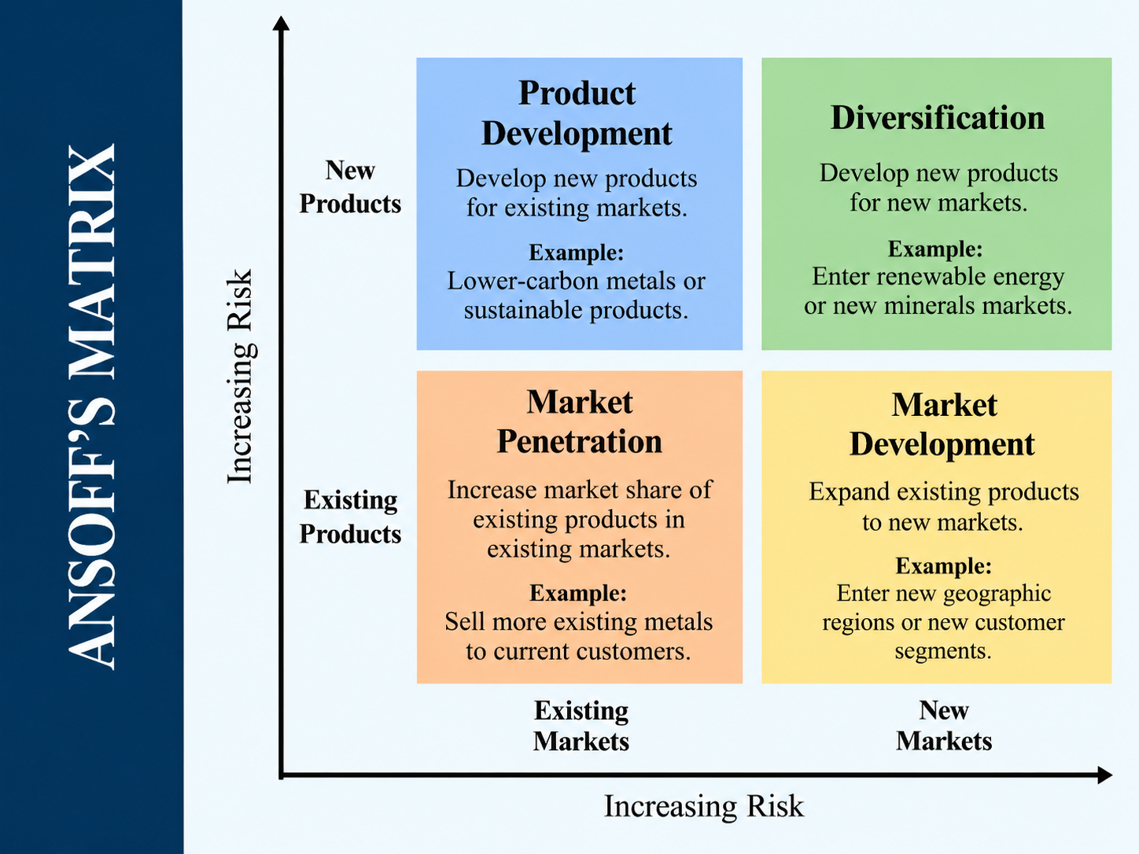
Figure 3: Ansoff Matrix and recommended product-development route.
Source: Self-developed.

2.2 Porter’s Generic Strategies: Differentiation and green innovation
Porter’s Generic Strategies consist of cost leadership, differentiation and focus. Anglo American should follow the differentiation strategy of delivering high-quality ore, traceability and lower carbon value rather than competing on price (Porter, 1980). Green innovation may lead to competitive advantage if it becomes the capability, not the campaign (Khanra et al., 2022). There are some green innovation cases in Anglo American. In 2022, it joined nuGen zero-emissions haulage system with First Mode and invested in acceleration (Anglo American plc, 2022). In 2025, it collaborated with the University of Birmingham and Cambridge Future Tech in order to create carbon-recycling technology for low-emission steelmaking (Anglo American plc, 2025b).
Rival programmes show these partnerships do not yet prove unique advantage or customer premium (BHP, 2025; Rio Tinto, 2025). There are three capabilities that must become the core of the competitive advantage. First, Anglo American needs the product-level carbon measurement in order to be able to compare its materials consistently. Second, Anglo American needs technical collaboration with steelmakers in order to measure ore quality, processing and emissions simultaneously. Third, it needs rigorous green marketing that ensures that all the claims are verifiable. It is important because the trust and risk perception influence the decision-making process regarding green purchase (Sharma, 2021). This will reduce the possibility of greenwashing that may harm the differentiation strategy.

2.3 Strategic implementation and controls
Implementation must be phased. In the first phase, Anglo American must establish the common product specification, the scope of the lifecycle, carbon-measurement method and protocol for claims. In the second phase, it should launch pilot projects with anchor customers who have to prove the link between ore quality and low-emission steelmaking route and their willingness to pay. Finally, in the third phase, Anglo American should scale only in case of proving customer value, effectiveness of abatement and profit margins. The research on digital business models shows that digital innovation can help to respond to the institutional sustainability pressure and improve green performance (Liang, Zhao and Lee, 2023).
The research on green supply chains also proves that the environmental practices and strategy must be aligned in order to achieve good results (Alghababsheh et al., 2022). Management must track four controls: product carbon intensity; sales related to customers that have credible transition targets; margin on differentiated products; capital cost per tonne of avoided carbon. The gate must compare the verified customer benefit with the cost of production, certification and delivery of the differentiated product. It will help to avoid the assumption that any investment in sustainability will produce market returns. The competitive advantage must be based on resource quality, low-carbon capability, customer partnerships, data and commercial rigor.

3. Task 3 – Managerial and Professional Reflection

3.1 Reflection on key decisions
I chose Anglo American because of a connection between changes in the natural environment, high-quality iron ore, copper and innovation. I identified the natural environment as the root pressure, with customers translating these into purchasing criteria and competitors offering alternative solutions. This differentiates actors in a customer choice process from other factors such as regulation which represents a useful distinction for this particular evaluation brief. Evidence underpins my Ansoff decision, with product development responding to a lower-carbon demand without the risk of new product and market combinations. The model provides the framework for making the decision, while company and competitor evidence determines whether the proposal is viable from a commercial perspective.

3.2 Limitations and information that a consultant would still seek
I recognise that the main limitation lies in the use of publicly available information. Corporate reports are a good source of primary data, but I recognise that the management framing can influence the performance and strategy. I would therefore carefully interpret the 2025 emission reductions requirement, because Anglo American reports portfolio movements along with underlying performance measurements (Anglo American plc, 2025a). I also recognise customer evidence as another limitation because market surveys cannot provide the precise willingness to pay of individual customers. As a real consultant, I would request the contract data from the customers, lifecycle assessment of product, competitor carbon-intensity benchmark, project-level abatement costs, carbon price scenarios and the evidence on specific ore characteristics that steelmakers value to produce low-emission steel. I would also analyse the speed at which such technologies as hydrogen-based direct reduction can scale and whether electricity availability would affect the business case (IEA, 2020; Johansson and Kriström, 2022).

3.3 Senior leadership conclusion
My recommendation to senior leadership is to pursue the lower-carbon product development as a business strategy rather than as a sustainability initiative. I consider Anglo American to have the right base in premium iron ore, copper, emissions measurement, and innovation partnerships, but I would not rely on the assumption that the customer will be willing to pay for just the green tag. I would therefore recommend proving the customer value, validating the environmental claim, testing the economics and then scaling. This recommendation is in line with the research findings that green product innovation could help achieve performance when market innovation and organisational capabilities are in place (Appiah and Essuman, 2024; Tu and Wu, 2021). I would recommend that senior leadership support the targeted pilots, the high bar of evidence and stage-gating of the investment. In my view, success will be achieved through profitable lower-carbon growth that the customer trusts and that competitors cannot easily replicate.

Reference List
Alghababsheh, M., Abu Khader, D.E., Butt, A.S. and Moktadir, M.A. (2022) ‘Business strategy, green supply chain management practices, and financial performance: A nuanced empirical examination’, Journal of Cleaner Production, 380, 134865. Available at: https://doi.org/10.1016/j.jclepro.2022.134865 (Accessed on: 7 October 2026).
Anglo American plc (2022) ‘Anglo American combines nuGen™ with First Mode and invests $200m to accelerate Zero Emissions Haulage Solution’. Available at: https://www.angloamerican.com/media/press-releases/2022/07-12-2022 (Accessed on: 7 October 2026).
Anglo American plc (2025a) Integrated Annual Report 2025. Available at: https://www.angloamerican.com/~/media/Files/A/Anglo-American-Group-v9/PLC/investors/annual-reporting/2025/aa-annual-report-full-2025.pdf (Accessed on: 7 October 2026).
Anglo American plc (2025b) ‘Anglo American partners with University of Birmingham to commercialise carbon recycling technology for lower emission steelmaking’. Available at: https://www.angloamerican.com/media/press-releases/2025/23-01-2025 (Accessed on: 7 October 2026).
Anglo American plc (2025c) Sustainability-related Disclosure Supplement 2025. Available at: https://www.angloamerican.com/~/media/Files/A/Anglo-American-Group-v9/PLC/investors/annual-reporting/2025/sustainability-related-disclosure-supplement-2025.pdf (Accessed on: 7 October 2026).
Appiah, L.O. and Essuman, D. (2024) ‘How do firms develop and financially benefit from green product innovation in a developing country? Roles of innovation orientation and green marketing innovation’, Business Strategy and the Environment, 33(7), pp. 7241–7252. Available at: https://doi.org/10.1002/bse.3864 (Accessed on: 7 October 2026).
BHP (2025) Annual Report 2025. Available at: https://www.bhp.com/ar2025 (Accessed: 12 October 2026).
European Parliament and Council (2023) Regulation (EU) 2023/956 of the European Parliament and of the Council of 10 May 2023 establishing a carbon border adjustment mechanism. Available at: https://eur-lex.europa.eu/legal-content/EN/TXT/?uri=CELEX:32023R0956 (Accessed on: 7 October 2026).
Giljum, S., Maus, V., Sonter, L.J., et al. (2025) ‘Metal mining is a global driver of environmental change’, Nature Reviews Earth & Environment, 6, pp. 441–455. Available at: https://doi.org/10.1038/s43017-025-00683-w (Accessed on: 7 October 2026).
International Energy Agency (IEA) (2020) Iron and Steel Technology Roadmap: Towards more sustainable steelmaking. Paris: IEA. Available at: https://www.iea.org/reports/iron-and-steel-technology-roadmap (Accessed on: 7 October 2026).
International Energy Agency (IEA) (2021) The Role of Critical Minerals in Clean Energy Transitions. Paris: IEA. Available at: https://www.iea.org/reports/the-role-of-critical-minerals-in-clean-energy-transitions (Accessed on: 7 October 2026).
International Energy Agency (IEA) (2025) Global Critical Minerals Outlook 2025. Paris: IEA. Available at: https://www.iea.org/reports/global-critical-minerals-outlook-2025 (Accessed on: 7 October 2026).
IPCC (2022) Climate Change 2022: Mitigation of Climate Change. Cambridge: Cambridge University Press. Available at: https://www.ipcc.ch/report/ar6/wg3/ (Accessed on: 7 October 2026).
Johansson, P.-O. and Kriström, B. (2022) ‘Paying a premium for “green steel”: Paying for an illusion?’, Journal of Benefit-Cost Analysis, 13(3), pp. 383–393. Available at: https://doi.org/10.1017/bca.2022.24 (Accessed on: 7 October 2026).
Khanra, S., Kaur, P., Joseph, R.P., Malik, A. and Dhir, A. (2022) ‘A resource-based view of green innovation as a strategic firm resource: Present status and future directions’, Business Strategy and the Environment, 31(4), pp. 1395–1413. Available at: https://doi.org/10.1002/bse.2961 (Accessed on: 7 October 2026).
Kotler, P., Armstrong, G., Harris, L.C. and He, H. (2024) Principles of Marketing. 19th edn. Harlow: Pearson. Available at: https://www.pearson.com/en-gb/subject-catalog/p/principles-of-marketing-global-edition/P200000010013 (Accessed on: 7 October 2026).
Kumba Iron Ore (2025) Sustainability Report 2025. Available at: https://www.angloamericankumba.com/~/media/Files/A/Anglo-American-Group-v9/Kumba/investors/annual-reporting/sustainability-report-2025.pdf (Accessed on: 7 October 2026).
Liang, Y., Zhao, C. and Lee, M.-J. (2023) ‘Institutional pressures on sustainability and green performance: The mediating role of digital business model innovation’, Sustainability, 15(19), 14258. Available at: https://doi.org/10.3390/su151914258 (Accessed on: 7 October 2026).
MEPS International (2025) ‘Green steel survey finds sales remain sector specific’. Available at: https://mepsinternational.com/gb/en/news/green-steel-survey-finds-sales-remain-sector-specific (Accessed on: 7 October 2026).
Porter, M.E. (1980) Competitive Strategy: Techniques for Analyzing Industries and Competitors. New York: Free Press.
Rio Tinto (2025) 2025 Climate Action Plan. Available at: https://www.riotinto.com/-/media/content/documents/invest/reports/climate-change-reports/2025-climate-action-plan.pdf?rev=00e9f51ee9b245f8996e9ea288ba8f06 (Accessed: 12 October 2026).
Sharma, A.P. (2021) ‘Consumers’ purchase behaviour and green marketing: A synthesis, review and agenda’, International Journal of Consumer Studies, 45(6), pp. 1217–1238. Available at: https://doi.org/10.1111/ijcs.12722 (Accessed on: 7 October 2026).
Singh, S.K., Del Giudice, M., Chiappetta Jabbour, C.J., Latan, H. and Sohal, A.S. (2022) ‘Stakeholder pressure, green innovation, and performance in small and medium-sized enterprises: The role of green dynamic capabilities’, Business Strategy and the Environment, 31(1), pp. 500–514. Available at: https://doi.org/10.1002/bse.2906 (Accessed on: 7 October 2026).
Tian, H.-H., Huang, S.-Z. and Cheablam, O. (2023) ‘How green value co-creation mediates the relationship between institutional pressure and firm performance: A moderated mediation model’, Business Strategy and the Environment, 32(6), pp. 3309–3325. Available at: https://doi.org/10.1002/bse.3301 (Accessed on: 7 October 2026).
Tu, Y. and Wu, W. (2021) ‘How does green innovation improve enterprises’ competitive advantage? The role of organizational learning’, Sustainable Production and Consumption, 26, pp. 504–516. Available at: https://doi.org/10.1016/j.spc.2020.12.031 (Accessed on: 7 October 2026).
World Bank (2020) Minerals for Climate Action: The Mineral Intensity of the Clean Energy Transition. Washington, DC: World Bank. Available at: https://www.worldbank.org/en/news/press-release/2020/05/11/mineral-production-to-soar-as-demand-for-clean-energy-increases (Accessed on: 7 October 2026).

