

Programme: MBA - Master of Business Administration
LCMB7020 - Dissertation
Effectiveness Of Burberry’s Influencer Marketing Strategies in Influencing the Purchasing Behaviour of Gen Z Customers in the UK

Shraddha Vasantbhai Shrimali
Student ID 2309972
Supervisor Name : Jia Miao



Master’s Degrees by Examination and Dissertation
Declaration Form.

I, Shraddha Vasantbhai Shrimali, declare that this dissertation has been composed by myself, that the work contained herein is entirely my own except where explicitly stated otherwise in the text, and that this work has not been submitted for any other degree or qualification, in whole or in part, except as specified.

Signature: ……… Shraddha Vasantbhai Shrimali.....................

Date: …………………13.10.2024……………............................

Table of Contents
Chapter 1: Introduction 4
1.1 Background and context of the study 4
1.2 Purpose of the study 6
1.3 Research aim 6
1.4 Research objectives 6
1.5 Research questions 7
1.6 Rationale 7
1.7 Methodology 7
1.8 Limitations of the research 8
1.9 Structure of the research 8
1.10 Summary 9
Chapter 2: Literature Review 10
2.1 Introduction 10
2.2 Factors associated with influencer marketing strategies 10
2.3 Issues in Adopting Influencer Marketing Strategies 11
2.4 Impact of influencer marketing strategies on the purchasing behaviour of Gen Z customers 13
2.5 Measures in addressing the problems of influencer marketing 14
2.6 Benefits of influencer marketing in encouraging customers 15
2.7 Influencer marketing strategies in the fashion industry 16
2.8 Effect of influencers on the purchasing behaviour of customers 18
2.9 Purchasing behaviour of Gen Z consumers 19
2.10 Theoretical implication 20
2.11 Literature gap 22
2.12 Summary 23
Chapter 3: Research Methodology 24
3.1 Introduction 24
3.2 Research philosophy 24
3.3 Research design 25
3.4 Research approach 26
3.5 Research Strategy 26
3.6 Research method 27
3.7 Sampling 28
3.8 Data collection 28
3.9 Data analysis 29
3.10 Ethical considerations 29
3.11 Research limitations 30
3.12 Reliability and validity 30
3.12 Summary 30
Chapter 4: Analysis and Findings 31
4.1 Introduction 31
4.2 Analysis 31
4.3 Findings 38
4.4 Summary 40
Chapter 5: Conclusion and Recommendations 41
5.1 Conclusion 41
5.2 Recommendations 42
5.3 Future research 43
Reference list 44

Chapter 1: Introduction

1.1 Background and context of the study
1.1.1 Background
Influencer marketing is a type of marketing that allows businesses to collaborate with individuals who have a higher number of followers. The reason for collaborating with such influencers is to increase brand exposure by publishing the company's product or services through social media content to gain more awareness from the public. Since the COVID-19 pandemic, there has been an exponential rise in the influencer market in recent years due to its popularity on social media platforms and the loyalty of millions of followers. More than 84% of Gen Zs in the UK follow influencers, which was the result of a triple increase in influencer marketing size reaching 791 million British pounds at the end of 2023 (statista.com, 2024). Influencer marketing has a significant impact on connecting with customers through authentic stories and rendering a positive impact on customer's purchasing behaviour. This is because of the ability to effectively sell products and services while leveraging trust, social proof, authenticity, and emotional connections. While many trends come and go, the trend associated with the generation of young consumers is more appreciated based on the values and social impact. This is why Gen Z looks for options through people they trust and the reason for getting attracted through influencer marketing content.
Influencers play a vital role in shaping the purchasing options and behaviours of their audience. This is because of Gen Z's continual and fluid communication on online platforms, which allows influencers to connect with them without any real barrier between online and offline. Several retail fashion brands have collaborated with fashion influencers over influencer marketing channels such as Instagram, YouTube, and Facebook to extend their reach. These influencers promote the company's products to their followers while generating traffic and sales from their promotional content featuring the product. As per the report, the global fashion influencer marketing size was valued at USD 5.03 billion in 2023 and is expected to grow to USD 58.50 billion in 2031 in the UK with a CAGR of 35.9% in the forecast period (skyquestt.com, 2024). This is due to the relevance of Gen Z and millennials, who are the most active and influential users of social media while turning to social media or influencer marketing campaigns to gain fashion inspiration. According to a report, more than 68% of responding Business-to-consumer (B2C) marketers were using influencer marketing. In comparison, the remaining 32% were not, but more than 21% of marketers said they plan to implement influencer marketing in the future (Dencheva, 2023).
1.1.2 Context
The influencers promote several trends associated with influencer marketing campaigns in the fashion industry while swaying consumers' behaviour by leveraging the halo effect. Gen Z customers prefer expressive and comfortable clothing such as crop tops, oversized pieces, and loose-fitting jeans. One of the most influential trends in influencer marketing is artificial intelligence, which will become even more data-driven in the future. This will be appropriate in measuring how effective their influencer campaign is while staying ahead of the competition and looking for ongoing partnerships. For instance, 21% of people aged 18-54 and 32% of Gen Z are known to purchase from influencer's recommendations (Shandrokha, 2023). This is because of the authentic branding of influencers that helps to build consumer trust, which is because customers who trust a brand are 53% more likely to purchase its products. Another impactful key trend associated with influencer marketing strategies are the Influencer-Generated Content (IGC), and User-Generated Content (UGC) that has made influencer campaigns feel more organic and less like traditional advertising. This recent development in the fashion industry is known to resonate with audiences on a deeper and more personal level while creating an immersive brand experience for Gen Z customers. Additionally, such Gen Z who likely remain loyal to a brand they trust while turning to social media when discovering brands instead of using search engines. Influencer marketing attracts Gen Z customers the most as the new generation of young consumers appreciate businesses based on their social impact and values. This is the reason why influencer marketing is applauded by Gen Z customers as they always look for options through people they trust due to the popularity of UGC content. According to a report, more than 75% of Gen Z consumers consider following content creators or influencers while making purchasing decisions to resonate with the brand preferences (Norman, 2024).
Burberry is a popular fashion house in the UK that specialises in the manufacturing of luxury men's coats and raincoats for a demanding and wealthy clientele. It has a total reach of 50.05 million across social media platforms, with its biggest engagement rate in TikTok and its biggest audience on Instagram (Barnett, 2024). The organisation has collaborated with 187 celebrity endorsements and influencers such as Emma Mackey, Kano, Georgia Jagger, and more to promote their clothing lines via interactive campaigns. Burberry has launched several influencer marketing campaigns by looking forward to the future while inspiring the youth to bring a community of different talents together (burberryplc.com, 2020). By employing an omnichannel approach, Burberry has ensured its products reach different distribution channels including major luxury shopping districts and fashion capitals. More than 88% of customers know about Burberry, while 28% use them in the luxury fashion segment (Kunst, 2024). This is because of the company's presence across 20 different social media platforms with a large portfolio of target audiences instigating purchases through influencer marketing campaigns.

1.2 Purpose of the study
The purpose of the study is to understand the approaches by which influencers through their marketing campaign engage with Gen Z to render positive purchasing behaviour. Neglecting these impactful approaches and influencer marketing strategies can result in limited reach, missed opportunities, and challenges in targeting accurate target demographics. The study will serve the purpose of identifying the influencer marketing strategies in Burberry while understanding the purchasing insights of Gen Z customers and comparing them with different fashion brands in the UK to gain increased brand exposure (Belanche et al. 2021).
The purpose of the study is also to understand the consistency of influencers to influence consumer behaviour by sharing and creating content, which generally aligns with their style, niche, and tone. It is important to assess the compatibility of the personal brand and audience while boosting sales and revenue of the company. The importance of understanding the level of authenticity and relevance can allow companies to keep viewers interested as seen through influencer marketing campaigns, which is not possible in traditional corporate content. This social proof is essential for potential customers to gain confidence and ultimately drive customer acquisition while aligning with the target market of the brand. According to the views of Genoveva (2022), influencer marketing generates demand among the customer segment while fostering customer loyalty and increasing profitability.

1.3 Research aim
The research aims to explore the influencer marketing strategies of Burberry in influencing the purchasing behaviour of Gen Z customers in the UK.

1.4 Research objectives
- To identify the factors associated with influencer marketing strategies in encouraging customers to undergo a purchasing insight into Burberry
- To determine the issues in adopting influencer marketing strategies while influencing the purchasing behaviour of customers in Burberry
- To evaluate the impact of influencer marketing strategies on the purchasing behaviour of Gen Z customers in Burberry
- To recommend strategic measures in addressing the problems of influencer marketing and understanding the purchasing behaviour of Gen Z customers in Burberry

1.5 Research questions
- What are the factors that are associated with influencer marketing strategies in instilling customers’ purchasing behaviour in Burberry?
- What are the issues related to influencer marketing adoption while understanding the purchasing behaviour of customers?
- How does influencer marketing affect the purchasing behaviour of Gen Z customers in Burberry?
- What are the measures by which influencer marketing problems can be resolved to understand the purchasing behaviour of Gen Z customers better in Burberry?

1.6 Rationale
The rationale of the research unveils the power of influencer marketing strategies in fashion brands while promoting products and services to new audiences and increasing brand awareness significantly. This is effective in reaching untapped audiences around the global fashion house and understanding the strategies that foster genuine connections between customers and brands (Tanwar et al. 2022). While identifying the factors that are associated with influencer marketing strategies, a comprehensive understanding of the influencers' originality, sponsor salience, and followers' size will be generated as prominent for a fashion brand operating mon a global scale.

The rationale for addressing this research is to initiate and develop customer value by maintaining good connections with customers through the loyalty chain. This is usually possible in influencer marketing strategies that directly resonate with customer needs while creating tailored experiences for them to solve their marketing problems. According to a report, 82% of brands lead from influencer marketing in terms of sales and revenue as they feel it to be the most effective marketing strategy better than other campaign types (Memon, 2024). As influencers slowly talk and endorse the products, the brand builds trust with the target audience while resonating with the positive experiences of users. This study will provide a new perspective to Burberry while bringing fresh, out-of-the-box marketing ideas to the table (Harrigan et al. 2021).

1.7 Methodology
The involvement of the secondary data collection method in this research is effective in gathering information related to the research subject and answering the research questions. The reason for using the secondary data collection method is because of its cost-effectiveness while accessing secondary sources, which is even very easy. Some examples of secondary sources include peer-reviewed journals, government publications, business newspaper articles, Burberry's annual reports, and past research data on the research subject. This will include the influencer marketing trends, consumer's desire to mimic, consumers' preferred platforms, and challenges within the influencer marketing of the UK fashion retail industry (Aw, and Chuah, 2021). The study will use the positivism research philosophy to assess the social phenomenon of customers getting attracted to influencer marketing campaigns. Integrating the inductive research approach is effective in allowing flexibility in the study as well as supporting generalisations based on specific data and developing new theories. This is a highly adaptable approach for synthesising diverse sources of data and easily analysing it with a structured framework. The secondary data will be analysed through the qualitative method in the form of thematic analysis by identifying the patterns, trends, and themes associated with influencer marketing in Burberry.

1.8 Limitations of the research
The limitation of the research likely involves the use of primary data, which was not addressed in this study. This could have been effective in drawing first-hand information on the influencer marketing strategies of Burberry by directly asking its customers and influencers. By carrying out interviews or surveys, the researcher could have produced relative and accurate research results that secondary sources often cannot offer (Chetioui et al. 2020). The research limitation involves not presenting the hypothesis of the study which could have been effective in framing the design of the research work and the expected results. This could have allowed for reliable data that could be further used to test the theories and assumptions of the study into realistic action. Apart from that, the research has been limited in terms of supporting claims of the limitations' effects without exaggerating their impact. An unintentional bias can come across when the secondary data collection measure of the researcher uses contrasting ideas and opinions compared to the research scholars (Djafarova, and Bowes, 2021).

1.9 Structure of the research
- Introduction
The introduction chapter consists of the background and context of the influencer marketing strategies and their influence over Gen Z customers' purchasing behaviour. Furthermore, the research aim, objectives, and questions are mentioned.
- Literature review
The literature review will address the research objectives and research questions by framing different headings and subheadings on the secondary literature of the research subject. Apart from that, relevant theoretical implications and literature gaps will be provided in this section.
- Methodology
The methodology section consists of all the research methods relevant to the research subject. It will follow the Research Onion model to assess the research techniques effectively for the study and collect suitable secondary data after which thematic analysis is performed.
- Findings and analysis
The findings and analysis section will address the influencer marketing strategies from the already published data. It will also convert the findings into thematic analysis to identify the trends associated with influencer marketing and its influence over Gen Z consumers.
- Conclusion and recommendation
The last section of the research will involve a complete summary of the influencer marketing strategies of Burberry by drawing inferences from purchasing behaviour approaches of Gen Z consumers. Furthermore, relevant recommendations will also be provided in this context.

1.10 Summary
It can be summarised that the introduction section has completely proposed the research objectives and questions that need to be followed throughout the research work. The problem statement of the research underlying the fake activity, cost-effectiveness, and compliance risk has affected the purchasing behaviour of Gen Z customers as well as the influencer marketing campaigns of Burberry. This research has affected the rationale and purpose of the study, which needs to be followed to achieve the research objectives until the end of the study. The study will allow the readers to have an idea about the effectiveness of influencer marketing strategies in instigating Gen Z consumers to make a purchasing decision.

Chapter 2: Literature Review

2.1 Introduction
This literature review section has provided a comprehensive overview of the research and debates relevant to a particular topic. It has examined the impact of influencer marketing strategies that influence the purchasing behaviour of Gen Z customers through already existing data and literature information. This section has drawn evidence that influencers have more and more impacts on people's lives. Such impact is not only concentrated on shopping behaviour and lifestyle choices of customers but also on diet needs and political opinions.
Influencers often promote a holistic lifestyle for individuals by exposing their content centering on healthy and unhealthy food options. They are responsible for influencing the public on different social and political issues while encouraging them to view the brand as an ethical choice (Rundin, and Colliander, 2021). On the other hand, influencers often target active consumers on social media platforms based on their campaigns and collaborations to inspire them to emulate their lifestyle through shopping behaviour. The purpose of the literature review is to assess the effectiveness of influencer marketing strategies that play a vital role in shaping the purchasing behaviour of consumers. This literary section has also included theoretical implications to provide an in-depth explanation and meaningfulness to the research.

2.2 Factors associated with influencer marketing strategies
Online presence
Influencers need to develop a trustworthy online presence on the social media platform by sharing their opinions on a product or service of a brand. This will encourage their followers to make positive purchasing decisions based on their recommendations while driving conversations about the product and service. Brands collaborate with only those influencers who have many followers to promote their products or services to the influencer's followers. For instance, 78% of brands prioritise the online presence of influencers before collaborating with them to increase brand awareness (Dunn, 2024).
Content attractiveness
Influencer content is typically more personal and conversational as it differentiates from competitors based on brand-driven and sales-oriented posts. Sharing interactive content by influencers through giveaways, challenges, and live sessions drives customer engagement and renders prompt actions like making purchases. The influencers share exclusive discount codes or special offers through their content to track conversions directly linked to their promotion. Their seemingly unscripted content reinforces authentic and spontaneous engagement among customers while fostering a personal connection with them. For instance, Burberry's social media content is showcasing regal-looking aesthetic fashion designs, opting for a modernised version for the Gen Z consumers in its imagery for the new Burberry 2023 rebranding (dontdiewondering.com, 2023).
Trust and authenticity
The personal stories and experiences of influencers with a product or service can make a brand more relatable due to the increasing trust of consumers towards them. For instance, a survey shows that 92% of people trust recommendations from influencers even if they don't know them while purchasing a particular product (fastercapital.com, 2024). Influencers need to have a track record of honest reviews and maintain transparent partnerships while fostering genuine product recommendations to customers. Burberry's target customers are millennials who were the reason for a 4% increase in sales due to their trust in the brand after a monogram challenge that delivered one billion views on its UGC video platform (Faull, 2019).
Platform choice
Platform choice is a potential factor in instigating influencers to promote a specific product on their public channel to attract a large segment of customers. The variations in the platform are due in part to the nature and features of the platform along with the characteristics of the people they attract. Moreover, the users often change their engagement from one social media to the other depending on the demanding trends in the global market. While undergoing influencer marketing, organisations need to make sure of the choice of the platform while targeting influencers to promote their product. For instance, 90% of influencers are active on Instagram in comparison to 66% on TikTok, and 34% on Facebook, which ascertains the variations of customer engagement in different platforms (Kashyap, 2023). More than 25% of luxury fashion users in the UK use Burberry, implying the effectiveness of influencer marketing strategies (Kunst, 2024).

2.3 Issues in Adopting Influencer Marketing Strategies
Lack of control
Influencers running their own social media accounts indicate a lack of control of the companies. This is because an influencer might post something that doesn't align with the brand's values and objectives, which might damage the brand's reputation (Kostygina et al. 2020). For instance, the influencer's content is great at the beginning of the contract but the quality might start to slip as time goes by. This ascertains the lack of control of the brand to encourage the influencers to market their products through significant brand approaches (Wielki, 2020). There are apprehensions of some organisations that they cannot control some other brands or the influencers retaliating for their choice of content when marketing a specific product.
Cost-effectiveness
Cost-effectiveness is another issue in adopting influencer marketing strategies due to the variation of costs of different influencers. This is because of the differences in budgets and partnership with mega-influencers which is significant for most of the brands. For instance, mega-influencers charge +$10,000 and micro-influencers charge $100 - $500 to advertise a brand's product or services (Dogtiev, 2024). The cost of influencers depends on the number of their followers and their reach across the target audience, reflecting more accessibility towards consumers. For instance, Burberry has emphasised showing its artisanal skills through behind-the-scenes content, which has rendered huge costs for the brand due to the adoption of augmented technologies like AI (Warrior, 2024).
Fake activity
Influencer fraud is common in influencer marketing, which is basically of two types, imposters and fake followers. The imposters are those Instagram users who claim themselves to be authentic influencers by posting high-quality images and using fake followers. As these users do not influence target customers, the businesses collaborating with them are unlikely to deliver false results. On the other hand, fake followers are used both by real influencers and imposters to increase the size of their audience and attract huge users on a global scale. Some common tactics of fake activities include purchasing comments, likes, and story views from different fake websites. For instance, 68% of businesses experienced influencer fraud in 2022, and more than 50% of Instagram marketers face inauthentic engagement as a result (forbes.com, 2022). For instance, Burberry has undergone several influencer marketing campaigns due to which there have been 228 influencer mentions with sponsored endorsements from Aimee Song and Adam Gallagher (influencerintelligence.com, 2024).
Long-term relationships
Maintaining long-term relationships with influencers is challenging as both the brand and the influencers have to maintain relevance over time as the consumer's interest and trends change. For instance, Burberry has already partnered with Apple to maintain long-term relationships with clients, which is a big problem for the organisation while embracing omnichannel experience through its influencer marketing strategies (Mcdowell, 2019). Another major reason for such a challenge is the fear that influencers might create dependency on a brand if they suddenly decide to work for a competing brand. According to a study, 93% of influencers revealed that they are willing to work for a brand for free products until they love the brand's product or until a competitor brand hires them (Burchill, 2024).

2.4 Impact of influencer marketing strategies on the purchasing behaviour of Gen Z customers
Today, brands are aware of the behaviour of customers as they target influencers to post any type of content with their products, which will certainly increase their sales. The most common customers are the Gen Zers who are more likely to trust the recommendations of the influencers while sharing any sources of information. For instance, more than 75% of Gen Z customers actively follow content creators on influencer marketing platforms while instilling positive purchasing behaviour in any product or service (Norman, 2023). Gen Z customers are those who feel that traditional forms of advertising are not as effective as influencer marketing due to a lack of transparency and authenticity, which is exhibited in influencer content. There is a positive impact of influencer marketing on the purchasing behaviour of customers because of its trustworthiness and connection with users through authentic stories. Neglecting such an impactful strategy can result in limited reach, missed opportunities, and challenges in engaging with target demographics. For instance, Burberry's TikTok channel has been a great influencer marketing platform for customers as it has a total of 4 million followers with 49.6K likes and a 1.25% engagement rate (collabstr.com, 2024). Their advertising and manufacturing scope of high-quality products with the help of influencers has encouraged maximum customers to get persuaded easily to make a successful purchase. For instance, Burberry has 20.1 million followers on Instagram with 7K several likes per post, which is because of their influencer marketing campaigns (hypeauditor.com, 2024).
Burberry has held several influencer marketing campaigns with popular influencers such as Georgia Jagger, Adam Driver, Shakira, and Emma Mackey to attract a large audience. On the other hand, influencers can sell required products and services to their followers by leveraging credibility, trust, emotional connections, and social proof. This renders a significant impact on customer purchasing behaviour due to the strong connections between customers and influencers while driving business growth (Kostygina et al. 2020). For instance, Burberry's frequent influencer marketing campaigns with celebrities and influencers to promote their clothing lines via interactive engagement have been excellent. This has contributed to a market capitalization of $3.16 billion in 2024, which makes them the world's 3383th most valuable company (companiesmarketcap.com, 2024).
For instance, the Millennials and Gen Z comprised 63% of the target market for Burberry in 2021, implying a strategic advantage for the company to use influencer marketing (burberryplc.com, 2022). This indicates that the consumers are more appealed to purchase those products as influenced by the influencers to render positive purchasing behaviour. The Fear of Missing Out (FOMO) largely renders an influential impact on the purchasing behaviour of customers due to its greater resonance and a sense of urgency to try out the product before the trend disappears. For instance, 54% of 18-29 year-old social media users have claimed that influencer marketing impacts their purchasing decisions a lot due to a little bit of FOMO (Raines, 2023).

2.5 Measures in addressing the problems of influencer marketing
Choosing the influencer
It is important to select the right influencers, implying that businesses need to look for those who have lots of followers. They need to make sure that their followers are authentic and not fake or dummy accounts, which might incur huge losses and a poor brand reputation in the organisation (Shankar et al. 2022). Organisations need to select influencers whose posts match the brand's values and might appeal to the target audience while showcasing interest in a certain product or service. Checking the engagement rate of influencers and evaluating their post frequency is crucial to improve influencer marketing campaigns in an organisation while keeping the brand fresh in its audience's minds. For instance, Burberry has 187 celebrity endorsers and influencers who have worked with Georgia Jagger, Shakira, and Adam Driver (Barnett, 2024).
Using social listening tools
Social listening tools need to be implemented by brands to understand the conversation surrounding their brand and the products and services they are offering to their customers. For instance, Hootsuite, Digimind, and BuzzSumo are some of the social listening tools that provide valuable consumer data to businesses while targeting influencer marketing through popular influencers. This helps to gauge brand awareness and improve the perceived usefulness of their products and services among the target customers. By understanding the purchasing behaviour of customers through these social listening tools, organisations can address the problems of influential marketing (Trivedi, and Sama, 2020).
Customer touchpoints
To understand the purchasing behaviour of Gen Z customers, organisations need to act with the customers as influencers while identifying their pain points and areas for improvement. This could involve anything from simplifying the checkout process or making it easier for customers to find the required information of a product from the influencers. Tracking the customer journey by coming across the touch points is effective in converting browsers into customers due to the robust interface of User Experience (UX) design. For instance, Burberry has won six customer touchpoints across their omnichannel strategy after creating the native product line “B Series”, acquiring 16 million followers in 4 years (layerise.com, 2023). Hyper personalization is one of the effective strategies to endorse customer touch points as it helps to understand the customers on a deeper level while creating a more personalised experience for them.
Reaching out privately
To foster long-term relationships with influencers, brands need to start communicating with them while interacting organically with their poets. The organisation needs to be appreciative by sending a direct message to the influencer instead of flooding comments in the comment section of their posts to enrich partnership conversation (Campbell, and Farrell, 2020). Finding the email address of influencers on different marketing platforms and sending them customised emails individually instead of mass emails can render better relationships in the future (Janssen et al. 2022).

2.6 Benefits of influencer marketing in encouraging customers
Increased brand awareness
Influencer marketing is known to encourage customers by creating exciting content on the brand's products, which inevitably grows among the followers. It is a significant way to create hype around the launch of a new product or collection. This ascertains that organisations that leverage the authenticity and engagement of the audience are known to create strong brand awareness for the company. Partnering with influencers provides a direct segment of prospects toward the products and services while increasing brand awareness. For instance, Athletics Green targeted TikTok influencers to spread awareness of their nutritional supplements for Gen Z health-conscious customers. This campaign leveraged hashtags such as #athleticgreens and #athleticgreenspartner, which had more than 90.6 million views and 39.5 million views respectively (Memon, 2024).
Credibility and trust
Leveraging influencer marketing targets influencers who talk positively about the brand through engaging content to build a good reputation. This helps to add positive purchasing decisions of customers while rendering a positive perception about the brand. Influencers allow direct interaction between the brand and the customers through likes, comments, and shares of posts and content. This two-way communication helps to build trust and credibility in the brand while truly supporting the brand and encouraging the target audience to connect with the brand. For instance, 18% of the global fashion users in the UK trust Burberry and likely say that they will use it again (Kunst, 2024). This is achieved only through influencer marketing that helps to build trust and credibility within the targeted market.
Higher sales and orders
Investing in influencer marketing is known to increase sales both directly through shared discounts and codes and indirectly through the growth of brand awareness. For instance, the annual promotion of Burberry seeks relevance to 10% to 50% off of discount offers and promo codes on must-have school items, along with special deals for educators and students (burberry.worthepenny.com, 2024). As every influencer has different codes, brands can understand which influencer had the most impact when someone uses the code on their online store. These promotion codes help to target customers when they see their favourite influencers share content about a brand's product, they feel encouraged to place repeat orders. For instance, Bulldog, a UK-based skincare brand, used the TikTok creator program to reach the markets in Germany by creating a series of shaving mistake video campaigns, which led to 29.8 million impressions and a 5-10% sales increase (Memon, 2024).
Strengthening online community
Influencer marketing can strengthen the online community of a brand for like-minded people to connect, swap, and chat tops while sharing advice on particular topics. The influencers are known to flourish mostly on social networks, which helps to build connections with their customers. By building a loyal customer base, the influencers connect emotionally with customers by using hashtags and specific tactics to attract a large segment (Perikos, and Micheal, 2022). Involving influencer marketing means getting the brand endorsed by individuals while amplifying the brand through influencers and community marketing campaigns.

2.7 Influencer marketing strategies in the fashion industry
Influencer-Hosted Events
Generally, influencers host events or undergo live fashion shows, Q&A sessions, and product launches to improve brand visibility and increase customer engagement in influencer marketing. These events are effective as they offer direct interaction with the audience while fostering a sense of engagement and community. For instance, an influencer hosting a live stream on an Instagram channel might showcase exquisite new fashion products to customers while answering their questions and engaging with them in real-time (Schaffer, 2020). These provide a platform for the influencers to connect with the target audience while showcasing the products of the brand directly to the customers. Community-building and networking are important aspects of influencer-hosted events that are targeted by the majority of fashion brands while amplifying the contribution of fashion influencers. Burberry's top influencer Andrea Kee has hosted a live-streamed event, the Spring Summer 2023 VIC event (instagram.com, 2024). This is because of their favourite influencer or popular products from their personal experiences or recommendations with the brand (Borchers, and Enke, 2021).
Data-Driven Campaigns
Brands need to maintain effective management of data-driven campaigns with influencers to achieve a higher return on investment. Involving real-time tracking tools is effective in assessing the performance of all influencers when audiences engage with their content and make positive purchasing decisions. This allows the organisations to make quick adjustments based on the purchasing behaviour or observation of the customers as it resonates with the target audience. Collecting feedback from influencers as well as audiences is effective in adjusting the marketing content of the campaign as per the preferences of the audience and from different content and angles. For instance, Burberry has undergone several data-driven campaigns in 2023 through Instagram reels for smarter purpose of existing resources (theimpression.com, 2024).
Immersive campaign design
To create immersive campaign design, most fashion influencers focus on a particular topic, such as sustainability in fashion to extend from design to runaway. They use several new technologies such as Augmented reality (AR), video, photography, and blogging to influence and encourage customers to make positive purchasing decisions based on their immersive experiences. For instance, Marks & Spencer has rendered the best-performing social content from their influencers, which has returned around 30% higher engagement from customers (Gilliland, 2023). AR filters are also used nowadays to showcase different outfits of a person in different plans, which further enriches the experience of customers to provide insight into their preferences.
Exclusive discounts and giveaways
Influencers offer special discounts and codes only to their followers and host certain giveaways or free hampers in collaboration with the fashion brand. This strategy is effective in increasing customer loyalty and engagement while driving sales. An influencer can provide a certain giveaway of a certain piece of clothing, such as a women's hoodie across the social media channel. This increases the brand's visibility as they are targeting a huge population of the audience to showcase their fashion products effectively and resonate with their followers. For instance, Burberry has collaborated with different YouTube and Instagram influencers to provide exclusive giveaways from popular influencers. Apart from that, the influencers also provide gift hampers through a box, which contains a variety of water, gourmet treats, and amenities, whose starting price is $65, and the minimum quantity to be purchased is 36 (perksgifting.com, 2024).

2.8 Effect of influencers on the purchasing behaviour of customers
Influencers sway consumer behaviour by leveraging the halo effect, where the credibility of influencers leads to trusted opinions of the consumers in other areas. The desire to be a part of the social group and conform to social norms is a strong endurance of the influencers to engage with the audience. A collaboration between the influencers and the brand when their audiences overlap can allow the influencers to endorse a genuine review of a product. For instance, 32% of Gen Z and 21% of Millennials purchased a product based on an influencer's recommendation in the last quarter of 2023 (Shandrokha, 2023). Apart from that, 63% of marketers find relatable content more effective while considering purchasing decisions as it induces long-term relationships. Such long-term campaigns are far better than short-term campaigns as the influencers with highly engaged audiences don't depend on a single sponsored post but on millions of posts in their social media channel. Working with influencers on specific niches is effective as they instill positive purchasing behaviour in customers while being more knowledgeable and passionate about certain product categories. For instance, Gucci engaged TANKE to promote its Gucci Guilty fragrances on the occasion of Valentine's Day, which reached 428,1K audience with 713,1K impressions (tanke.fr, 2024). A key advantage to the effect of influencers on consumer purchasing behaviour is to reach targeted audiences due to their followers' specific needs and interests, which align with the brands' offerings. This targeted reach also increases sales and greater success for the brand as the influencers transfer their social proof to the consumers for the brands they endorse. On the other hand, if the audience detects a lack of transparency of the influencers in connection with their partnerships or sponsorships to the brand, it can affect their purchasing decisions. It was due to this reason that Burberry's online sales grew through influencer marketing strategies, implying an increase from €33 billion in 2019 to €49 billion in 2020 (Mandelli et al. 2023). The emotional connection established between the consumers and the influencer's content influences the consumers to prioritise these products over alternatives, which ultimately leads to positive purchasing behaviour and increasing sales of the brand. For instance, Zara's influencers conducted live shopping experiments in Europe and the United States, which attracted 800,000 viewers and 57% of them purchased its products via TikTok shop (economictimes.indiatimes.com, 2024). Integrating UGC in the influencer's content allows consumers to feel more relatable with the content and make purchasing decisions by creating a positive feedback loop. Therefore, influencers are responsible for rendering a dominant force in the modern marketing landscape as they play a potential role in shaping the purchasing decisions of consumers. For instance, Burberry's consumers' purchasing behaviour has been greatly proliferated through their effective campaigns, such as targeting TikTok influencers to reach Chinese millennials has reached 1 million impressions (Cunningham, 2019).
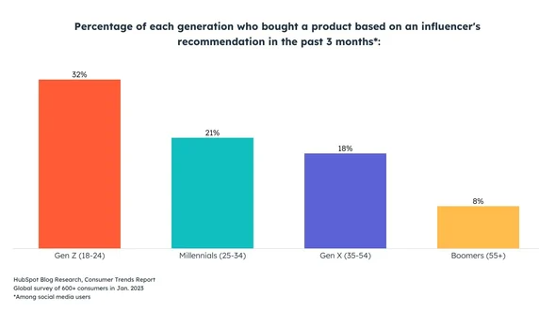
Figure 1: Percentage of each generation who bought a product based on the influencer’s recommendation in the past 3 months
(Source: Shandrokha, 2023)

2.9 Purchasing behaviour of Gen Z consumers
Gen Z consumers are particularly adept at reading reviews, conducting online research, and comparing prices and products while making purchasing decisions. This is because of their positive behaviour that reinforces the value of convenience, customisation, and speed in their digital interactions. It allows them to gravitate towards social media platforms such as Instagram, TikTok, YouTube, and Facebook to get daily content on lifestyle, fashion, beauty, and branded content. As per the views of Raghupathi, V. and Raghupathi, (2020), Gen Z consumers prioritise consumption as access rather than possession while expressing individual identity as a matter of ethical concern. This is because of their social responsibility that allows such customers to address the sustainability, inclusivity, and ethical practices of the brand when making purchasing decisions. The popularity of tech-driven content greatly attracts consumers as it encourages brands to meet their growing demand for transparent business practices. It is due to their perseverance to limited-edition products that seek the attention of Gen Z consumers as soon as their favourite influencers promote the products across the global scale. On the other hand, Barhate, and Dirani (2022) opined that the purchasing behaviour of Gen Z consumers reflects a greater intensity and orientation towards low prices as they desire to purchase unique yet trustworthy and nostalgic products when prioritising the recommendations of influencers. As Gen Z consumers seek direct communication, relevance, and authenticity compared to other segments of customers, they are the preferable ones for the retail and luxury companies to target as prime customers of the brand. The reason for their influence on influencer marketing campaigns is because of the loyalty and trustworthiness that they levy towards a brand while engaging with the influencers. Apart from that, the peer validation created through UGC allows customers to make positive purchasing decisions as they are supported by their peers, who are none other than their favourite influencers. For instance, Burberry has promoted its new Lola bag by understanding the purchasing behaviour of their Gen Z customers demanding Lola bags, so they partnered with popular TikTok creator Sylvaniandrama to make Burberry a viral marketplace (Fasano et al. 2022).

2.10 Theoretical implication
The theory of planned behaviour is determined by attitudes, intentions, and subjective norms that are different for different individuals. This is effective in considering the decision-making process of the organisations while they identify different purchasing behaviour, buying patterns, and other factors associated with customers through the process of marketing. The theory assumes that when an individual intends to perform a specific behaviour, such as listening to the recommendations of influencers, then they will do so (Pick, 2021). Implementing the theory of planned behaviour is effective in assessing the behavioural intentions of Gen Z consumers who get influenced by the attitudes and recommendations of the influencers about the likelihood of any product or service. This theory ascertains that behavioural achievement depends on two aspects, ability and motivation. In this case, the subjective norms of the audience are considered as they have certain beliefs about whether to approve or disapprove the recommendations of influencers.
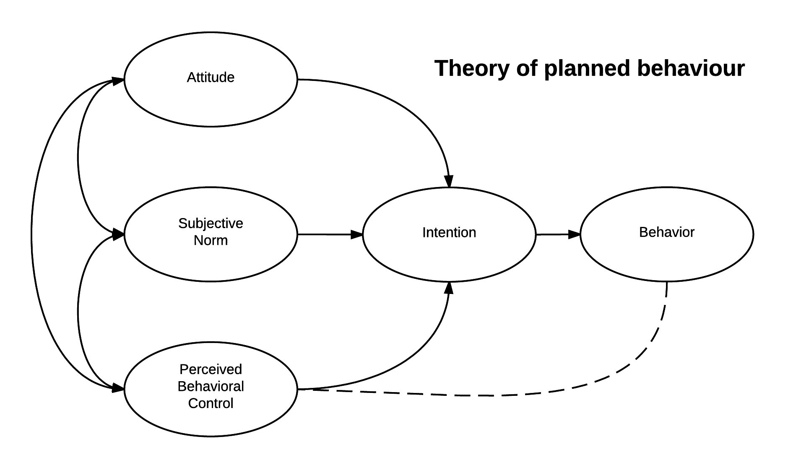
Figure 2: Theory of planned behaviour
(Source: Pick, 2021)
On the other hand, the application of social identity theory ascertains the characters and motivations of an individual by categorising themselves into different social categories and building into their own social identity. By integrating the social identity theory, organisations can adopt influencer marketing campaigns as they might influence consumers to purchase a particular product based on their personalised recommendations. This provides a nuanced understanding of the complexities of social factors that instigate customers to imply purchasing behaviour (Vrontis et al. 2021). Involving the Social identity theory is effective to analyse the changing behaviours of Gen Z customers if they modify their self-identity or part of their self-concept to drive knowledge. This indicates that the influencer marketing approach instigates consumers to assess their self-identity through the recommendation of the influencers while purchasing any product or service. In this case, group membership and affiliation play a great role in defining the personal identity of an individual. For instance, Gen Z customers are affiliated with the product recommendations of influencers while claiming to be followers of those influencers and purchasing their selected products.
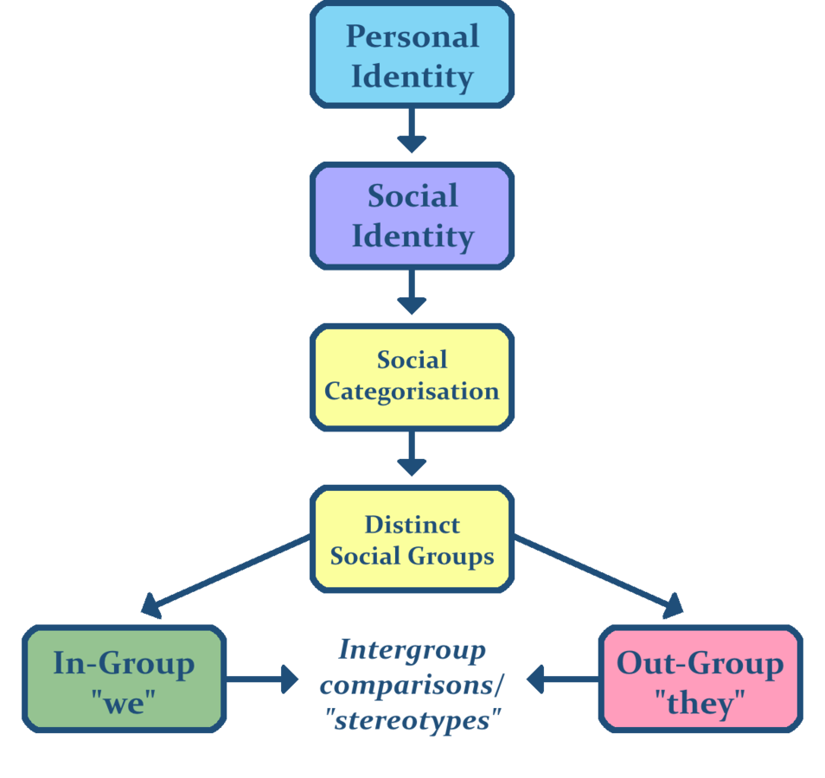
Figure 3: Social identity theory
(Source: Vrontis et al. 2021)
On the other hand, the application of the Two-step flow of communication theory ascertains that the flow of information and influence from the masses to the audience occurs through two steps, from the mass to the individuals, and from the individuals to the public (Qin, 2021). A mass-media message is sent to influence mass-media audiences through the recommendations of opinion leaders. In this case, the influencers are the opinion leaders for Burberry's influencer marketing campaigns who are responsible for amplifying the marketing message to influence consumers to render positive purchasing behaviour regarding their products. These influencers spread their interpretations in the media to enclose the personalised content of the audience for those who are willing to get influenced.
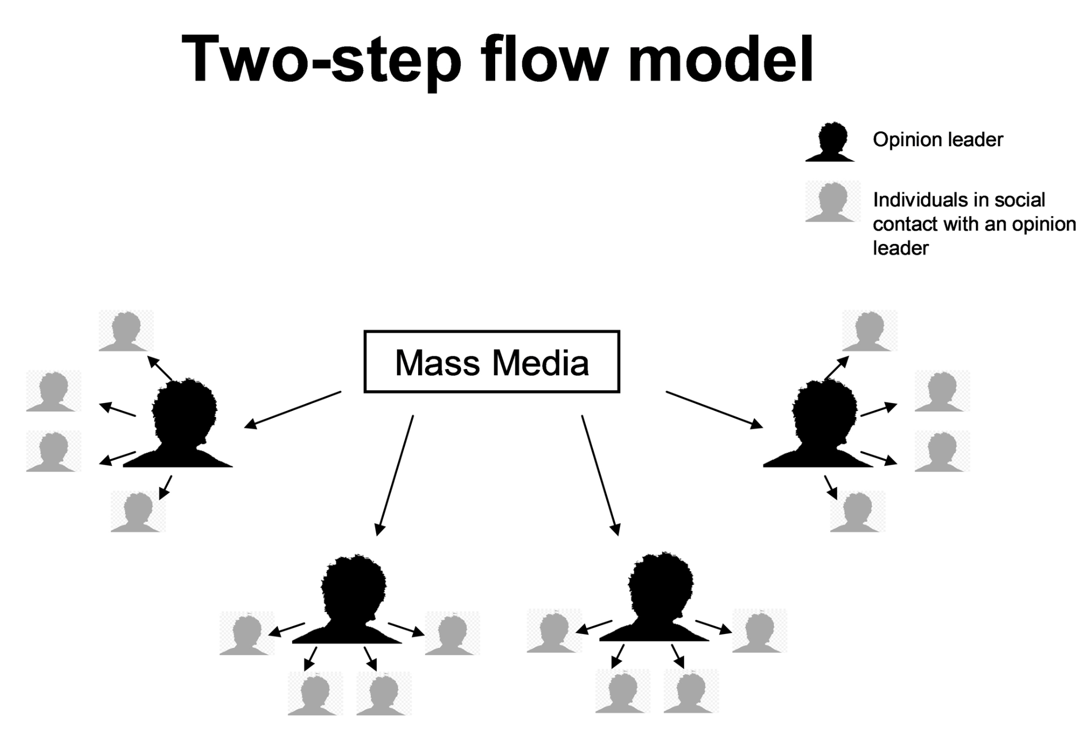
Figure 4: Two-step flow of communication theory
(Source: Van Ruler, 2020)

2.11 Literature gap
The literature gap in the research implies different influencer marketing strategies of organisations that affect the purchasing behaviour of customers. Another literature gap is failing to provide a comprehensive overview of the real-life examples of retail companies like Burberry where influencer marketing has rendered a positive impact on customer's purchasing insights. Despite extensive research on understanding the impact of influencer marketing on purchasing behaviour of customers, there is a literature gap in assessing the ways by which these influencer marketing strategies influence the purchasing insights of Gen Z consumers. The research has not particularly addressed the unique purchasing behaviours of customers while seeking recommendations from influencers through influencer marketing strategies. Another literature gap in the research is the effectiveness of influencer marketing on the long-term brand loyalty of Burberry, which should have been implicated in this research work with sufficient literary evidence (Series, 2023).

2.12 Summary
It can be summarised that the online presence and content attractiveness of influencer marketing is the important factors associated with influencer marketing in encouraging Gen Gen Z consumers to make a purchasing decision. Conducting influencer marketing campaigns is effective in making data-driven decisions and making prompt offers by seeking the recommendations of the influencers. Brands need to be careful of the challenges that are pertinent while implementing influencer marketing as it can affect their brand visibility and resonance towards its global audience. However, relevant theories need to be implemented to understand the effectiveness of influencer marketing strategies in influencing Gen Z consumers in companies.

Chapter 3: Research Methodology

3.1 Introduction
Research methodology refers to a detailed plan that provides research with scientifically sound findings with exact data and interesting results. This section has covered the research methods and techniques that are used to assess the effectiveness of influencer marketing strategies in Burberry to instill the purchasing behaviour of Gen Z customers in the UK. The use of effective research methods has been appropriate in this context to keep researchers on track by limiting the scope of the research. The involvement of the Saunders Research Onion Model in this study has been effective in describing the different decisions of research approaches that the researcher has taken to develop the research methodology (Fahed et al. 2015). The Saunders onion model comprises different stages such as research philosophy, approach, design, strategy, data collection, and data analysis which have been covered in this study. This model serves the purpose of accomplishing the research objectives and research questions by explaining pictorially the various aspects of the research.
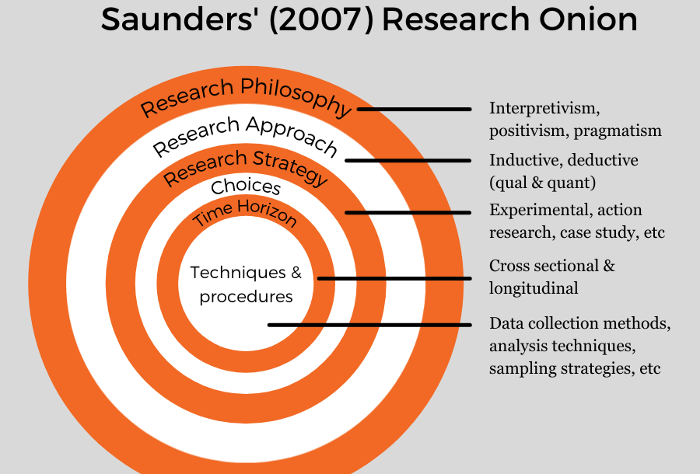
Figure 5: Saunders Research Onion model
(Source: Fahed et al. 2015)

3.2 Research philosophy
Research philosophy is a framework that entails the ideas about reality and the nature of knowledge on a specific research subject. It is of four different types including positivism, realism, pragmatism, and interpretivism philosophies. The researcher has used the positivist research philosophy to reveal the knowledge of the research subject from a neutral and measurable observation of activity (Rahman et al. 2021). This has been effective in measuring the effectiveness of Burberry's influencer marketing strategies that influence Gen Z consumers to make a successful purchasing decision. The reason for using the positivism philosophy is to gather factual knowledge on the impact of influencer marketing on the purchasing behaviour of Gen Z consumers. As positivism philosophy is evident in the use of concrete data and statistics, it would be effective to cover the influencer marketing effectiveness with the help of figures and statistics to showcase its importance in Burberry. Another major reason for using this philosophy is that it does not allow any interpretation of value-free reason due to which it reflects related theories and concepts to the object of study. By developing knowledge objectively, the researcher has addressed the truth associated with influencer marketing strategies issues in Burberry, which is impacting their consumer purchasing decisions. The knowledge obtained from positivist philosophy is congruent with reality, and accurate data (Huang, and Copeland, 2020). It is because of this reason that has enabled the researcher identifies online presence, content attractiveness, platform choice, and trust of influencers as the factors influencing consumer purchasing behaviour in Burberry with their influencer marketing campaigns. A major disadvantage of using the positivism philosophy is its inability to accurately prove the hypothesis uncovered in the research topic through empirical experiments.

3.3 Research design
Research design outlines the theories and models associated with the research question by integrating different components of the study logically and coherently. The four main types of research design include descriptive, experimental, correlational, and quasi-experimental designs. This research has used the descriptive research design to establish cause-and-effect relationships on influencer marketing strategies among different variables. The reason for using the descriptive design is to determine the characteristics of Gen Z consumers who are influenced through influencer marketing campaigns in Burberry. This design was helpful to assess the patterns in the characteristics of Gen Z consumers encouraging them to make a successful purchasing decision (Djafarova, and Bowes, 2021). Different patterns were established from the research literature concerning personalised experience, peer influence, transparency, and digital savviness. The researcher has selected the descriptive design to ensure that high-quality and honest data is collected from the secondary literature. Unlike experimental and quasi-experimental designs, the descriptive research design does not control or manipulate any of the research variables, but instead observes and measures them. In this study, the researcher has observed and measured the inference over Gen Z consumer purchasing behaviour while selecting Burberry's products. The goal of descriptive research design in this context was to provide a comprehensive and accurate picture of issues related to influencer marketing adoption while understanding Gen Z's consumer purchasing behaviour. By providing valuable insights on influencer marketing strategies in Burberry, the researcher has identified the trends associated with influencer marketing strategies to meet Gen Z customer's needs and preferences. There is little to no control over variables in the descriptive research design, implying potential biases, the major limitation of using the descriptive research design (Abrar et al. 2021).

3.4 Research approach
The research approach is the plan and procedure used by the researcher that spans detailed steps in a research method to undergo broad assumptions about the data collection and analysis process. The research approaches are of two types, inductive and deductive approaches. In this study, the researcher has used the inductive research approach to collect and analyse data on specific research subjects by developing theories, concepts, and hypotheses based on definite themes and patterns. This type of bottom-up approach has enabled the researcher to start with specific observations on influencer marketing strategies in Burberry and then move on to general ideas or theories. By assessing broad generalisations on the factors influencing Gen Z consumers to instigate positive purchasing behaviour, the researcher has uncovered rational theories. This has enabled the researcher to make several different assumptions on influencer marketing campaigns that foster genuine connections between Burberry and its customers. The reason for using the inductive approach was to generate new theories on the literature and findings while discovering unexpected patterns in Gen Z's consumer purchasing behaviour that might not fit into an existing theory (Djafarova, and Foots, 2021). This research has not used the deductive approach not only because of interpreting data from existing theory but also because it is associated with scientific investigation, which is not required in this context. By finding patterns and relationships in influencer marketing campaigns of Burberry, the researcher has used the new theory to formulate the research question. One of the major limitations of using the inductive approach is that it might be subjected to research bias and it does not guarantee 100% accuracy.

3.5 Research Strategy
A research strategy is a plan that guides the research activities undergone in a particular research work to achieve the desired goals. There are four major research strategies including qualitative interviews, quantitative surveys, case studies, and action-oriented strategy. Involvement of the case study research strategy in this study has been effective in assessing an in-depth inquiry about the research topic. The reason for undergoing the case study strategy is to explain the causal real-life links associated with influencer marketing in terms of holding long-term relationships with Gen Z consumers (Ma, 2021). As these findings are too complex in a survey or experimental strategies, the case study strategy is used to gain a better understanding of influencer marketing dynamics and context in Burberry. This strategy can explore deeper causes of phenomena underlying influencer marketing strategies in Burberry's consumer purchasing behaviour. Different case studies were used in this context to describe, compare, evaluate, and understand different aspects of the research problem pertinent to the limited reach and missed opportunities of influencers in influencer marketing campaigns for real-life companies like Burberry. A major limitation of using the case study strategy was the difficulties in generalising findings from one case study to another case study (Tran, 2020).

3.6 Research method
Research method is the process or technique used to collect data or evidence for analysis by uncovering new information on a given research topic. There are three different research methods quantitative, qualitative, and mixed methods. The involvement of a qualitative research method was effective in this context as the research involved collecting non-numerical data to understand concepts of influencer marketing. This method collected several findings on the influencer marketing strategies of Burberry and consumer purchasing behaviour from the opinions and experiences of consumers and brand associates as collected from the secondary literature study. The reason for using qualitative research is to answer questions that cannot be easily put into numbers but can be understood through human experience. Apart from that, the researcher has generated incredibly detailed and in-depth information on influencer marketing strategies in the fashion industry such as influencer-hosted events, exclusive discounts, and data-driven campaigns. By diving deeper into the research study through qualitative insights, the researcher has captured new beliefs on the purchasing behaviour of Gen Z consumers while making purchases from Burberry as per the recommendations of influencers (Liang et al. 2022). As the qualitative method is less stringent and much easier than the quantitative method, it was preferred in this study to extrapolate any evolving beliefs associated with influencer marketing strategies in the fashion industry. This method has carefully aligned the secondary findings by accomplishing the research objectives and research questions. One of the disadvantages of using the qualitative method is its time-consuming nature and subjective process that leads to inaccurate results.

3.7 Sampling
Sampling is the process by which a subset of a population is interpreted to represent the whole population. Involving the probability sampling method is effective in this context as it has allowed the researcher to make strong statistical inferences about the whole group. The reason for using probability sampling is to use random secondary articles and journals assessing the research topic. This has been appropriate in concluding a large population of consumers attracted by influencer marketing campaigns of Burberry. Probability sampling has enabled the researcher to predict the behaviour of variables associated with influencer marketing and consumer purchasing behaviour from different probable data. A major disadvantage of using this sampling method is that greater expertise and knowledge of the subject matter needs to be determined while approaching this research method (Lin, and Chen, 2022). The inclusion and exclusion criteria were also assessed while collecting evidence on the research as follows:
Inclusion criteria
- Peer-reviewed academic journals in the last 5 years, i.e. from 2020
- Researching about influencer marketing campaigns of Burberry
- Analysing the purchasing behaviour of only Gen Z consumers
- Written only in the English language
Exclusion criteria
- Non-reviewed journals before the last 5 years
- Researching influencer marketing campaigns of other companies
- Analysing the purchasing behaviour of other customers such as Gen X, millennials, and others except for Gen Z
- Written in other languages except English

3.8 Data collection
Data collection is the process of collecting and measuring proposed findings on a particular research subject to answer relevant questions. Among the two types of data collection methods, primary and secondary, the researcher has used secondary data collection to assess in-depth findings on the effectiveness of influencer marketing campaigns in Burberry that influence the positive purchasing behaviour of Gen Z consumers. The reason for using secondary data collection was to generate detailed insights on the factors associated with the positive and negative impact of influencer marketing on Burberry's purchasing insights. This was effective in gathering information from already existing datasets without the hassle of collecting one-by-one as in the primary data collection method. As secondary data collection encompasses an enormous range of highly original and extensive studies, the researcher has selected this approach to retrieve already available data on influencer marketing campaigns of Burberry. The purpose of using such a data collection method was because of its less time, money, effort, and resources to conduct the study (Chaturvedi et al. 2020). Involving the qualitative research method was effective to proceed with secondary data as it included broad findings on the opportunities and challenges associated with influencer marketing strategies in Burberry. The secondary data collection method was appropriate in gaining insights of Burberry's influence over Gen Z's purchasing behavior through empirical research studies. Apart from that, the secondary data was effective in collecting evidence on UGC and influencer marketing impacting Burberry's operation phases. Several secondary data were used to collect evidence on the research subject including sources from peer-reviewed articles, research journals, academic databases, Burberry's annual reports and website, and published works. A potential limitation of using the secondary data collection method is that the information might be coloured by the researcher's own bias or faulty approach, which might affect the research outcome.

3.9 Data analysis
Data analysis aims to interpret and analyse useful information to support decision-making and formulate conclusive outcomes. The researcher has used the thematic data analysis procedure to analyse the findings collected in the above section. This has been effective in closely examining the impact of influencer marketing on the consumer purchasing behaviour of Gen Z while choosing products of Burberry. Some common themes, patterns, and ideas have been interpreted from the secondary findings such as consumer purchasing behaviour, Gen Z consumers, influencer marketing, the influence of influencers, Burberry, and the marketing strategies of Burberry (Wang, 2021). The reason for using thematic analysis was to work with a wide range of data types and offer textual data, which was effective in analysing the secondary data. These themes were assessed by generating initial codes on similar datasets and interpreting themes in terms of qualitative data analysis. By generating codes from the secondary data sets, the researcher has emphasised in-depth findings of influencer marketing strategies in Burberry. A limitation of thematic analysis is its interpretative nature due to which the identification and analysis of themes rely heavily on the researcher's perspective.

3.10 Ethical considerations
The researcher has maintained honesty and integrity throughout the research work while carrying out secondary data collection methods and thematic data analysis. Involvement of the Data Protection Act 2018 has been effective in protecting the secondary data from potential threats or biases. The researcher has re-used data to assess the secondary findings by using in-text citations to respect the credibility of the researchers (McCoy et al. 2021). Apart from that, the secondary data was kept confidential in a safe digi-locker through an encrypted password, which was opened only by authorised research personnel. All the research information used in this study was peer-reviewed and original, implying the adherence to a certain code of conduct by the researcher while collecting data from others. The researcher has taken permission to conduct the research work from the ethics committee of the University to ensure ethical compliance. There was no misuse of data by the researcher as the researcher prevented it from exploitative or manipulative purposes.

3.11 Research limitations
The research has concentrated on the influencer marketing strategies of Burberry and not on other real-time companies, which could have provided a comprehensive insight into the influencer marketing scope instilling Gen Z consumers. This study has not addressed the impact of Gen Z's consumer purchasing behaviour on the marketing scope of Burberry in a broader context. Another research limitation is not involving any contextual data on different influencer marketing platforms such as Facebook, Instagram, YouTube, and LinkedIn to get real-time updates on its influencer marketing campaigns (Leung et al. 2022). Apart from that, the research is limited in highlighting the positive and negative effects of influencer marketing on the purchasing behaviour of Gen Z consumers. The research could have also used quantitative research methods in the form of online surveys to get real data from the practical experience of consumers and employees of Burberry as an alternative form of research method.

3.12 Reliability and validity
The reliability of the research was conducted appropriately as it used the source of information from authentic websites to assess the peer-reviewed articles, published journals, and academic databases. To evaluate the reliability of secondary data sources, the researcher considered the use of the source's publication date, purpose, and credibility while undergoing the secondary data collection process. On the other hand, the validity of the research was maintained by looking at the research methods and data collection techniques, which were all appropriate in terms of originality and credibility (Evans et al. 2021). The validity was also ensured by checking whether the data undergoes potential biases and was cross-checked with other reputable sources for consistency.

3.12 Summary
It can be summarised that Saunders's research onion framework was used in this research work to assess appropriate research methods and techniques. The involvement of secondary data collection through peer-reviewed journals was effective in gathering an in-depth understanding of influencer marketing strategies that instigate Gen Z's purchasing behaviour in Burberry. The use of thematic data analysis through appropriate themes and patterns helped the researcher to assess the research questions. Apart from that, the ethical consideration in the research was met by following appropriate codes of conduct and honesty throughout the research work.

Chapter 4: Analysis and Findings

4.1 Introduction
The analysis and discussion section is of utmost importance as it evaluates the contradictory findings of the study by developing creative solutions to the research problem. A more profound understanding of the influencer marketing strategies of Burberry is addressed in this section to assess its influence on the purchasing behaviour of Gen Z consumers. The purpose of this section is to identify patterns, trends, and relationships with the secondary data identified in the data collection process (Li et al. 2021). Drawing insights into Burberry's influencer marketing strategies, a conclusive inference can be interpreted based on the research objectives and questions.

4.2 Analysis
Themes | Sub-themes | Key codes/factors
Theme 1: The online presence of the brand and the content attractiveness of influencers are the major factors associated with influencer marketing strategies to encourage customers to make a successful purchase at Burberry | - Visual aesthetics in online channel  - Influencer-customer interaction | - High-quality imagery  - Social media reach  - Real-time feedback  - Interactive Features
Theme 2: Fake followers lead to a loss in brand trust and ineffective purchasing behaviour of consumers in Burberry while making purchase decisions from influencer marketing | - Influencer credibility  - Brand perception | - Verified influencer accounts  - Social media audits  - Transparency in sponsorship  - Customer loyalty
Theme 3: Influencer marketing strategies render strong brand awareness and true connection with customers influencing them to purchase Burberry's products | - Emotional connection  - Word-of-mouth effect | - Personal anecdotes from influencers  - Product reviews  - Social proof  - Audience engagement rate
Theme 4: Influencer-hosted events and data-driven campaigns needs to be implemented by Burberry to understand the purchasing behaviour of Gen Z consumers | - Campaign optimisation  - Gen Z engagement strategies | - Predictive analytics  - Live event feedback  - Personalised offers  - Brand-influencer collaborations

Theme 1: The online presence of the brand and the content attractiveness of influencers are the major factors associated with influencer marketing strategies to encourage customers to make a successful purchase at Burberry
Influencer marketing strategies are not just a trend but a vital component in modern marketing strategies to drive consumer engagement rates and deliver high ROI. Burberry's online presence is remarkable as it aims to engage with customers across different digital platforms and touchpoints. They have sought to create an immersive and cohesive brand experience that greatly resonates with their target audiences. It is evident from the Instagram account of Burberry that they have 20.1 million followers, implying an attractive online presence of the brand (instagram.com, 2024). Burberry frequently partners with influencers and celebrities to promote their clothing line in influencer marketing channels such as Instagram and TikTok. They have live-streamed their runaway show on Instagram and Snapchat stories during London Fashion Week, which has provided exclusive access to millions of fans. This suggests that the online presence of a brand is a potential factor in influencing customers to make a successful purchase. Burberry has seamlessly integrated different social media platforms to endorse their influencer marketing strategies, which has increased the likelihood of customer conversions and engagement rate.
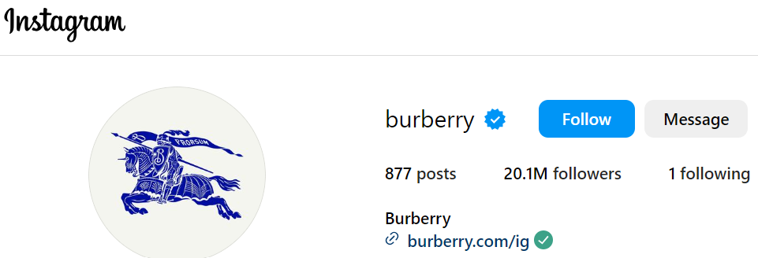
Figure 6: Instagram account of Burberry
(Source: instagram.com, 2024)
On the other hand, the content attractiveness of influencers resonates with the successful purchasing decisions of consumers on the influencer marketing platform. The brand has worked with 187 celebrity endorsers and influencers such as Georgia Jagger, Shakira, Sarwendah, and Baekhyunee to resonate with diverse audiences globally. The majority of the influencers have used hashtags such as #burberry to increase the engagement of customers and reach the target audiences (instagram.com, 2024). This has enabled customers to discover unified content they care about while sparking conversations and increasing brand visibility through such influencer marketing strategies. Burberry's influencers have integrated exclusive visual aesthetics or high-quality imagery in their content to attract the target audience while discerning the brand's values and identity. The content attractiveness of those influencers is due to their high level of experience in interactive campaigns that have impacted the purchase intentions of consumers. Engaging content has been the main driving factor for influencers to engage maximum customers as it drives emotional connections with them. The purchasing insights of customers largely depend on the content attractiveness of the influencers as it communicates genuine appreciation of the company's products among customers. For instance, Burberry worked with an influencer as well as a streetwear designer Virgil Abloh to release a limited edition collection in 2021, which increased the full-price comparable sales price by up to 30% (burberryplc.com, 2022).
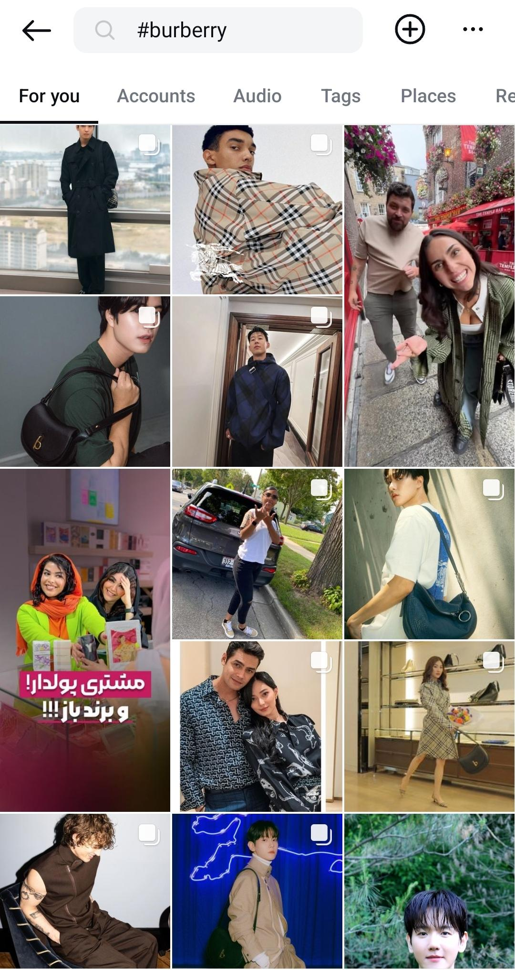
Figure 7: Hashtags of Burberry in Instagram channel
(Source: instagram.com, 2024)
Theme 2: Fake followers lead to a loss in brand trust and ineffective purchasing behaviour of consumers in Burberry while making purchase decisions from influencer marketing
While implementing influencer marketing strategies for luxury fashion brands such as Burberry, there is a huge problem related to fake likes and fake social media followers, which is affecting the purchasing decisions of consumers. These fake followers on social media are used not only to spread misinformation but also to boost certain influencers. The higher the number of fake followers, the lower the consumer's trust in the brand as it impacts their purchasing decisions when finding a lack of posts missing bio, or very few followers. According to a report, Burberry stands in the 9th position of being a luxury fashion brand with 29.05% fake followers to increase their follower count within their influencer marketing channels (Cole, 2023). This reflects that Burberry's social media platforms are somewhat run by scammers or bots run by algorithms while reducing the engagement rate of consumers. Burberry is greatly concentrated on its customers for exclusivity and authenticity, but the fake followers in their influencer marketing platforms are affecting the brand's visibility and reputation. This perceived inauthenticity is hurting the sentiments and most importantly the purchasing behaviour of customers who value trustworthiness and genuine connections with the brand.
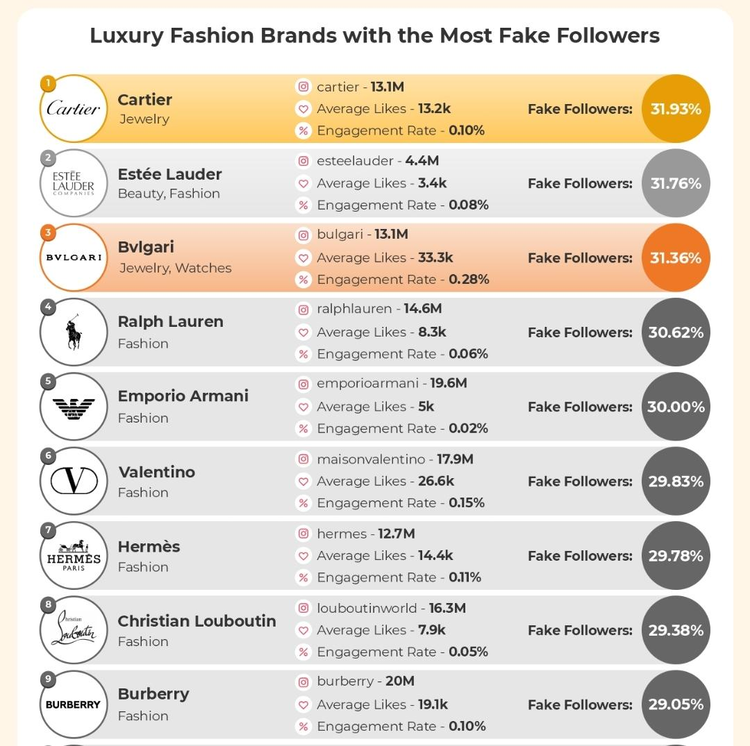
Figure 8: List of fake followers of luxury brands on social media accounts
(Source: Cole, 2023)
On the other hand, fake followers offer zero engagement for a brand while engrossing influencer marketing campaigns on the social media platform. When a large percentage of followers are fake accounts, then the influencers might not be able to encourage customers to make a successful purchasing decision. It might be due to this reason that Burberry is struggling amidst weaker demand for luxury goods, especially in the markets of China and America. As per the report, the sales of Burberry in the Asia Pacific region and mainland China have fallen to 23% and 21% respectively in 2024 compared to 2023 (Edser, 2024). This is because of the lack of trust of customers and poor brand commitment due to which customers won't be interacting with the influencer's content even if it is appealing or highly eye-catching. The influencers fail to connect with the audience, which is similar to those of Burberry as their influencers are not holding meaningful conversations with audiences. Burberry has also gotten into a trap with such fake followers when they have chosen popular Instagram influencers and has wasted the majority of their marketing resources.
Theme 3: Influencer marketing strategies render strong brand awareness and true connection with customers influencing them to purchase Burberry's products
Influencer marketing strategies build credibility and trust for the brand when they select certain influencers to drive more engagement and traffic from consumers. As per the report, the average engagement rate of Burberry on Instagram has decreased from 6.08% to 2.66% with 0.03% average interactions per post (phlanx.com, 2024). Despite the decrease in average interactions and engagement in Burberry, it still demonstrates a healthy relationship with the audience. However, if Burberry's engagement rate is less than 0.5%, then it might indicate that their account has a large percentage of fake followers. Burberry has launched a new campaign "Voices of the Future" as a part of its initiative to support the communities in unprecedented times, an inspiration from the youths and Gen Z people. To create long-term relationships with customers, Burberry has partnered with popular influencers such as Ishmael Auguiste, Tess Carter, Sophie Alice, and so on as a part of its influencer marketing campaigns. This campaign has encouraged a huge number of customers to purchase Burberry swimwear as the brand has promoted a video capturing the carefree spirit of summer with models enjoying the sand and sun wearing those swimwear. It is due to this reason that the sales of Burberry's swimwear have increased 3% within 6 months of launch in 2023 (Mohammed, 2023).
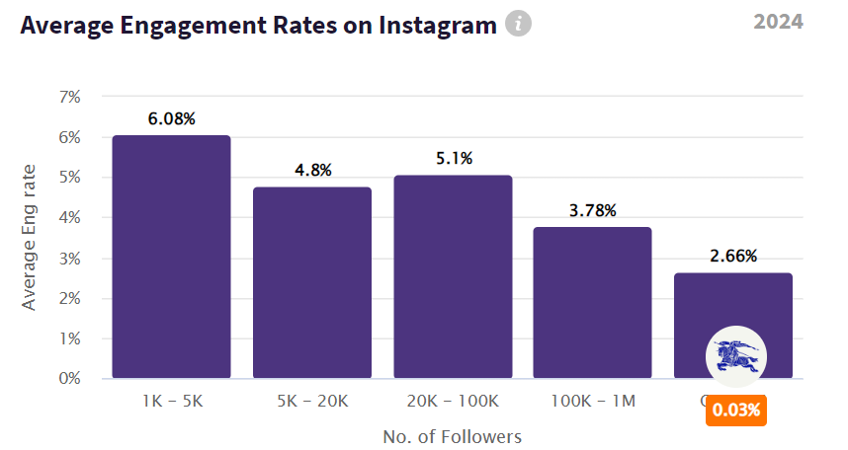
Figure 9: Average engagement rate of Burberry's followers
(Source: phlanx.com, 2024)
On the other hand, influencer marketing campaigns have rendered a positive impact on the purchasing behaviour of Gen Z consumers as Burberry has collaborated with influential people from the fashion and entertainment sectors. As these influencers are wearing Burberry's products while promoting the brand, consumers are increasingly trusting the brand due to a sense of reliability and authenticity in their content. The application of influencer marketing campaigns in Burberry gives them a win-win situation as their influencers give extra value to the followers, and the company ultimately grows its customer base. It is because of these influencers that has enabled the brand fast-track the customer journey while moving their followers from awareness level to advocacy level at an accelerated rate. According to a report, Burberry's organic traffic has reached 3.2 million followers with a traffic value of $1.5 million, which is due to its strong brand awareness among customers (ahrefs.com, 2024). This reflects that the brand is successfully creating strong connections with customers while influencing them to purchase the company's products.
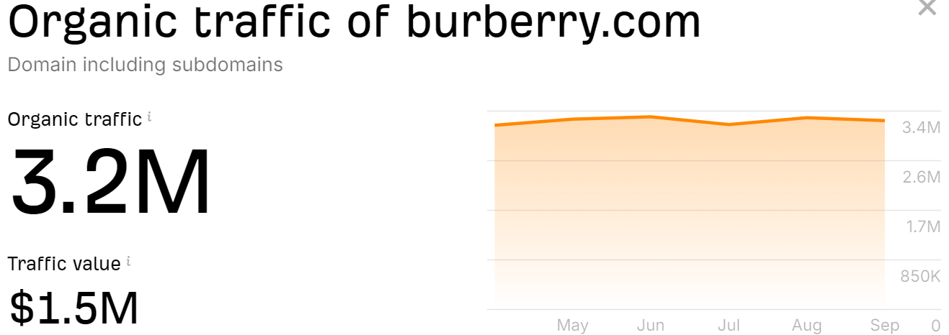
Figure 10: Organic traffic of Burberry
(Source: ahrefs.com, 2024)
Theme 4: Influencer-hosted events and data-driven campaigns needs to be implemented by Burberry to understand the purchasing behaviour of Gen Z consumers
Influencer-hosted events are regarded as a gold mine for increasing brand awareness and visibility as influencers mingle in an event to generate a significant online charter. They are the ones who flood social media feeds with branded content and hashtags while placing the company at the forefront of potential customer's minds. Experiential and interactive events across social media are like a magnet for Gen Z people as they always look for options through which they can trust or commit (Dash et al. 2021). Burberry needs to host influencer events or live stream events to engage with maximum audiences and turn them into potential customers. They need to recruit fashion-forward influencers who will understand the needs of customers in luxury fashion such as identifying the trends of sustainable manufacturing, vintage items, and personalisation. For instance, Zara has expanded its live shopping broadcasts through influencer-hosted events by partnering with popular influencers in the UK, Europe, and the United States to showcase its handbags, shoes, and jewellery. As per the report, a team of 70 people is working on Zara's event and has already attracted 800,000 unique viewers per show, including Gen Z ones (economictimes.indiatimes.com, 2023). Implementing such events in Burberry is effective not only to connect with Gen Z consumers but also to make them a part of the brand's journey. Hosting styling sessions, behind-the-scenes content, and drops of limited-edition products can be a remarkable way of undergoing successful campaign optimisation and increased profits. On the other hand, data-driven campaigns are also effective in engaging maximum Gen Z customers as they are mostly active on social media platforms. Leveraging social media analytics through Facebook, Instagram, and YouTube has been effective for most luxury fashion brands to fit with Gen Z's needs and resonate with their values of social responsibility. Implementation of data-driven campaigns can allow Burberry to gain real-time personalisations of their customers through exclusive offers and personalised recommendations. For instance, Boohoo is increasing its social media investment by encouraging thousands of influencers to host the brand's events on their pages. They have reportedly spent £80 million on influencer marketing, such as collaborating with style icon influencer Megan Fox to hear about limited-edition clothing from Boohoo on their Instagram channel (Gilliland, 2020). Therefore, Burberry needs to undergo influencer-hosted events and data-driven campaigns to better understand the motivational and behavioural factors of Gen Z's purchasing insights.

4.3 Findings
Finding 1: Factors affecting purchasing decisions in influencer marketing.
It can be analysed from Theme 1 that influencers' content attractiveness and the online presence of the brand are the major factors that affect the purchasing decisions of customers in influencer marketing. This is because when influencers share content about the brand or its products, they are exposing the brand to a wider audience that is leading to increased recognition of the brand. In the case of Burberry, brand awareness is at 88% in the UK in terms of aided brand recognition as customers respond to both the brand's logo as well as the written brand name (Kunst, 2024). Influencer marketing has enabled Burberry to tap into the influencer's existing fan base while creating authentic content and increasing brand visibility by resonating with the target audience. It is evident from the findings that Burberry's influencers highly determine the effectiveness of their influencer marketing campaigns as noted from their content's attractiveness. This attractiveness includes different factors such as the influencer's content style, personality, appearance, and overall reputation. Burberry has a close relationship between such virtual influencer's attractiveness and their consumer's purchase intentions. The purchasing decisions of consumers are influenced by shaping emotions, brand perceptions, and behaviours, ultimately impacting loyalty and engagement. For instance, Burberry's Riccardo Tisci's runaway collection debut is promoted by their exclusive influencers on the 17th of every month, which has resulted in strong double-digit percentage growth to around 50% in online and mainline stores (Singh, 2019).
Finding 2: Challenges in influencer marketing campaigns
It can be reflected from theme 2 that adopting influencer marketing campaigns in organisations renders potential challenges due to which consumer's trust erodes and leads to a possibility of ineffective customer purchasing behaviour. The most popular target segment in influencer marketing is Gen Z groups who value authenticity and credibility in the brand while trusting potential influencers. Amidst such trustworthiness, some influencers have fake followers that take the campaign down the drain. This is the case in Burberry as they have been found to have an association with 29.05% fake followers within the total followers’ count. It was due to this reason that Burberry faced a $30 billion annual loss as their influencers with fake followers were counterfeiting while diluting the brand identity (Rana, 2024). The high cost of influencer marketing has been a challenge for Burberry as they have to partner with popular influencers in return for a huge sum to grow their brand. On the other hand, failing to endorse effective campaigns by influencers can lead to a low response rate in the marketing campaign if they do not present the content appropriately. This might be due to a lack of control over influencers due to which they gain the advantage of promoting the brand's products according to their wish while failing to abide by the brand guidelines. Implementation of influencer marketing channels has also threatened Burberry to denote a positive impact on the purchasing behaviour of customers due to a lack of clarity on influencer performance.
Finding 3: Purchasing behaviour of Gen Z's through influencer marketing
It can be analysed from theme 3 that influencer marketing creates strong brand awareness and deeply connects with the target audience, especially the Gen Z. Influencer marketing is substantially dependent on the purchase decisions of Gen Z consumers as it offers a powerful Avenue for brands to connect with such a demographic. For instance, Burberry's Winter 2024 influencer campaign generated 14.6 million views due to high-quality runaway footage of the influencers, implying Gen Z as the main target segment (Soar, and Mellery-Pratt, 2024). The personal anecdotes from influencers in terms of Burberry's clothing line have influenced other segments of customers to make a successful purchasing decision. This is due to the increased trust of the customers towards influencers while dictating the line of clothing through their content across different influencer marketing channels. The two most important factors in assessing the purchasing behaviour of Gen Z are their paramount nature toward authenticity and relevance. Burberry's consumers are increasingly concentrated on "functional luxury" products and fine craftsmanship, which is uniquely positioned by their brand influencers on social media platforms. Apart from that, connecting with Gen Z through authentic stories as promoted by influencers leads to positive sales and targeted demographics as seen in the case of Burberry.
Finding 4: Approaches to Improve Influencer Marketing Campaigns
It is evident from theme 4 that adopting influencer marketing through data-driven campaigns and influencer-hosted events are remarkable options for Burberry to generate positive purchasing behaviour among Gen Z consumers. This is because of their clear objectives as influencers while influencing every decision to impact consumers through genuine interest and a high engagement rate (Wibowo et al. 2020). It is evident from the findings that Gucci and Zara have already implemented effective influencer marketing campaigns due to limited fake followers and strong brand resonance in the global luxury fashion market. Crafting a compelling pitch through influencer-hosted events can allow Burberry to personalise its approach when connecting with the target audience through influencers. A clear line of communication in the influencer marketing campaign needs to be established in such events to render positive purchasing decisions of customers as they will clearly understand the marketing objectives and the importance of considering the promoted product by the influencers. Burberry needs to undertake significant data-driven campaigns after which measuring the profit versus the expenditure of the campaign is compulsory to understand the actual purchasing behaviour of customers. Apart from that, collaborating with authentic influencers can build effective promotions, which should be the ongoing strategy of Burberry to influence Gen Z consumers to make a successful purchase (Choi et al. 2024).

4.4 Summary
It can be summarised that the thematic analysis has presented different themes and patterns from the findings while addressing the research objectives. Hosting live events or providing exclusive discounts to target audiences are the influencer marketing strategies of Burberry that have rendered successful purchases among Gen Z consumers. They need to remove the number of fake followers to build a long-term collaboration with influencers as well as customers to reflect beyond one-time engagement while making a purchasing decision by customers.

Chapter 5: Conclusion and Recommendations

5.1 Conclusion
It can be concluded that influencer marketing leverages trust, social proof, and emotional connection with customers as they look for purchasing options after their recommendations. The context of influencer marketing is popular nowadays for more marketers due to the prevalence of authenticity and endorsements created by influencers. An impactful insight of influencer marketing is UGC which allows consumers to feel more comfortable and organic while seeking purchasing decisions from their recommendations. The research has proposed relevant aims and objectives, which has further helped to formulate research questions and address them until the completion of the research work. There are several factors including content attractiveness through social-oriented posts and platform choice such as Facebook, Instagram, and YouTube to be associated with influencer marketing strategies. Burberry has been a popular luxury brand for the last few decades that adopts influencer marketing by partnering with popular celebrity endorsers and influencers around social media platforms. Investing in influencer marketing strategies in the fashion industry is popular such as in the case of Burberry as they organise influencer-hosted events, data-driven campaigns, and exclusive discounts or giveaways to resonate with the target audience.

Implementing the theory of planned behaviour, social identity theory, and two-step flow of communication theory is effective for Burberry to implement its influencer marketing strategies while encouraging customers to make a purchasing decision. The research has used the Saunders Research Onion framework to undergo the research work by dividing it into a series of steps such as from research philosophy to data analysis. The involvement of the secondary data collection method and thematic data analysis was appropriate in assessing the impact of influencer marketing in Burberry. The researcher has followed relevant inclusion and exclusion criteria while conducting the data collection and analysis methods. The involvement of social media audits and customer loyalty affect the purchasing behaviour of Gen Z customers while seeking recommendations from their favourite influencers across several social media platforms. It is evident from the thematic analysis that Burberry's influencer marketing campaigns have been effective in increasing the engagement rate of audiences and promoting word-of-mouth marketing through personal anecdotes of influencers. On the other hand, brand-influencer collaborations and live event feedback are some of the effective influencer marketing strategies for Burberry that can enable them to meet the demand of Gen Z consumers. This will be because of their emotional connection with the influencers as well as with the brand, which will provoke them to make purchasing decisions.

5.2 Recommendations
Recommendation 1: Embracing short-form content
Investing in short-form content can allow Burberry to reach a wider audience due to its high shareability option and endorsing different types of audiences. The fast-paced nature of online consumption is achieved through short-form content that can enable brands to quickly engage with customers and understand their purchasing behaviour on a rapid note (Dolega et al. 2021). Burberry needs to make short-form content such as behind-the-scenes of their manufacturing and production of products, challenges of wearing a Burberry product and tagging the brand, and certain collaborations with Instagram or TikTok creators. Defining campaign goals and creating detailed influencer guidelines while posting short-form content can allow Burberry to have better control of its influencers.
Recommendation 2: Focusing on sustainability messaging
Burberry needs to prioritise sustainability messaging by encouraging influencers to make content on environmental issues, which will support both the brand objectives as well as the global problems of users. This will allow Burberry to be perceived as more responsible and trustworthy while being increasingly vigilant about the authenticity of the products as sought from the recommendations of influencers. Emphasising Burberry's sustainability efforts should be the main motive of their influencers as it would quickly reach a global audience, especially the Gen Z ones (Bi, and Zhang, 2022). By introducing sustainability messaging, Burberry can avoid issues compromising long-term relationships while ensuring clear communication and clear expectations with the customers.
Recommendation 3: Investing in co-created campaigns
Involvement in co-created campaigns can enable Burberry to reach a broader audience due to its incorporation of diverse perspectives and voices. This will allow the organisation to foster a sense of belongingness and ownership around the Gen Z customers as it will directly resonate with their purchasing behaviour (Lou, 2022). Burberry can gather fresh ideas and break from its status quo while making decisions based on the perceived notions of the customers as sought with influencer marketing strategies (Berne-Manero et al. 2020). These co-created campaigns can allow Burberry to reduce its marketing costs after publishing the same content while reaching a broader audience.
Recommendation 4: Leveraging data analytics
By leveraging the data to identify influencers, Burberry can cover their specific products and services by directly resonating with the brand experience to customers. Investing in influencer campaign analytics can allow Burberry to ensure that their objectives are followed by influencers or not, and whether their promotional content of influencers aligns with the followers' taste or not. Introducing data analytics in Burberry is effective in eliminating the problems of fake activity in Burberry as it will ensure a targeted campaign. Apart from that, tracking engagement metrics through social analytical tools can allow Burberry to measure its fake followers (Do, and Do, 2020).

5.3 Future research
Future research on the study involves the impact of new influencer platforms on the purchasing behaviour of Gen Z customers in Burberry or other similar brands. Addressing the importance of data analytics in the scope of influencer marketing strategies or purchasing decisions of Gen Z customers can be accomplished in future studies. This research needs to explore the effectiveness of sustainability and ethical practices for influencer marketing campaigns as those directly influence Gen Z's purchasing insights (Larsen, and Pedersen, 2021). The impact of creating interactive videos such as Instagram reels, YouTube shorts, and TikTok reels through influencer marketing can be addressed in future research work. Researchers can also undergo a comparative analysis of micro-influencers and micro-influencers in influencing the purchasing behaviour of Gen Z consumers while making purchases of retail or luxury products.

Reference list
Abrar, M., Sibtain, M.M. and Shabbir, R., (2021). Understanding purchase intention towards eco-friendly clothing for generation Y & Z. Cogent Business & Management, 8(1), p.1997247. https://www.tandfonline.com/doi/full/10.1080/23311975.2021.1997247
ahrefs.com, (2023). Burberry AHREFS https://ahrefs.com/traffic-checker/?input=burberry.com&mode=subdomains
AlFarraj, O., Alalwan, A.A., Obeidat, Z.M., Baabdullah, A., Aldmour, R. and Al-Haddad, S., (2021). Examining the impact of influencers’ credibility dimensions: attractiveness, trustworthiness and expertise on the purchase intention in the aesthetic dermatology industry. Review of International Business and Strategy, 31(3), pp.355-374. https://www.emerald.com/insight/content/doi/10.1108/RIBS-07-2020-0089/full/html
Aw, E.C.X. and Chuah, S.H.W., (2021). “Stop the unattainable ideal for an ordinary me!” fostering parasocial relationships with social media influencers: The role of self-discrepancy. Journal of Business Research, 132, pp.146-157. https://www.sciencedirect.com/science/article/abs/pii/S0148296321002630
Barhate, B. and Dirani, K.M., (2022). Career aspirations of generation Z: a systematic literature review. European Journal of Training and Development, 46(1/2), pp.139-157. https://www.emerald.com/insight/content/doi/10.1108/EJTD-07-2020-0124/full/html
Barnett, D., (2024). Burberry V Jimmy Choo: A Brand Analysis Influencer Intelligence https://www.influencerintelligence.com/blog/TVb/burberry-v-jimmy-choo-a-brand-analysis
Belanche, D., Casaló, L.V., Flavián, M. and Ibáñez-Sánchez, S., (2021). Understanding influencer marketing: The role of congruence between influencers, products and consumers. Journal of Business Research, 132, pp.186-195. https://www.sciencedirect.com/science/article/pii/S0148296321002307
Berne-Manero, C. and Marzo-Navarro, M., (2020). Exploring how influencer and relationship marketing serve corporate sustainability. Sustainability, 12(11), p.4392. https://www.mdpi.com/2071-1050/12/11/4392
Bi, N.C. and Zhang, R., (2022). “I will buy what my ‘friend’recommends”: the effects of parasocial relationships, influencer credibility and self-esteem on purchase intentions. Journal of Research in Interactive Marketing, 17(2), pp.157-175. https://www.emerald.com/insight/content/doi/10.1108/JRIM-11-2023-0416/full/html
Borchers, N.S. and Enke, N., (2021). Managing strategic influencer communication: A systematic overview on emerging planning, organization, and controlling routines. Public Relations Review, 47(3), p.102041. https://www.sciencedirect.com/science/article/abs/pii/S0363811121000333
burberry.worthpenny.com, (2024). 75% Off Burberry.com Promo Codes & Discounts - Aug 2024 Worth Penny https://burberry.worthepenny.com/coupon/
burberryplc.com, (2020). Burberry launches new campaign as part of its initiative to support the voices of tomorrow Burberry https://www.burberryplc.com/news/corporate/2020/burberry-launches-new-campaign-as-part-of-its-initiative-to-supp
burberryplc.com, (2022). Strategic Report | Chair’s Letter Burberry https://www.burberryplc.com/content/dam/burberry/corporate/oar/2022/pdfs/Burberry_2021-22_Strategic_Report.pdf
Burchill, A., (2024). Influencer marketing statistics to know in 2024 Dash https://www.dash.app/blog/influencer-marketing-statistics
Campbell, C. and Farrell, J.R., (2020). More than meets the eye: The functional components underlying influencer marketing. Business horizons, 63(4), pp.469-479. https://www.sciencedirect.com/science/article/abs/pii/S000768132030032X
Chaturvedi, P., Kulshreshtha, K. and Tripathi, V., (2020). Investigating the determinants of behavioral intentions of generation Z for recycled clothing: An evidence from a developing economy. Young Consumers, 21(4), pp.403-417. https://www.emerald.com/insight/content/doi/10.1108/YC-03-2020-1110/full/html
Cole, O., (2023). Luxury brands with the most fake Instagram followers Casino Guardian https://www.casinoguardian.co.uk/articles/luxury-brands-with-the-most-fake-instagram-followers/
collabstr.com, (2024). Free TikTok Engagement Rate Calculator Collabstr https://collabstr.com/tiktok-engagement-rate/burberry
companiesmarketcap.com, (2024). The market capitalization of Burberry (BRBY.L) Companies MarketCap https://companiesmarketcap.com/burberry/marketcap/
Cunningham, E., (2019). How Burberry used TikTok influencers to reach Chinese millennials Glossy https://www.glossy.co/fashion/how-burberry-used-tiktok-influencers-to-reach-chinese-millennials/
Dash, G., Kiefer, K. and Paul, J., (2021). Marketing-to-Millennials: Marketing 4.0, customer satisfaction and purchase intention. Journal of business research, 122, pp.608-620. https://www.sciencedirect.com/science/article/abs/pii/S0148296320306688
Dencheva, V., (2023). Use of influencer marketing among business-to-consumer (B2C) marketers in the United Kingdom as of spring 2022 Statista https://www.statista.com/statistics/1319781/influencer-marketing-use-uk/#:~:text=During%20a%202022%20survey%20carried,do%20so%20in%20the%20future
Djafarova, E. and Bowes, T., (2021). ‘Instagram made Me buy it’: Generation Z impulse purchases in fashion industry. Journal of retailing and consumer services, 59, p.102345. https://www.sciencedirect.com/science/article/abs/pii/S0969698920313539
Do, N.B. and Do, H.N.T., (2020). An investigation of generation Z's intention to use electronic wallet in Vietnam. Journal of Distribution Science, 18(10), pp.89-99. https://journals.sagepub.com/doi/abs/10.1177/2278533720923486
Dogtiev, A., (2024). Influencer Marketing Costs (2024) Business of Apps https://www.businessofapps.com/marketplace/influencer-marketing/research/influencer-marketing-costs/
dontdiewondering.com, (2023). Understanding The Marketing Behind Burberry and its 2023 Re-Branding Strategy ddw https://www.dontdiewondering.com/understanding-the-marketing-behind-burberry-and-its-2023-re-branding-strategy/
Dunn, N., (2024). Influencer Marketing Statistics: Key Insights and Trends Revealed Charle https://www.charleagency.com/articles/influencer-marketing-statistics/
economictimes.indiatimes.com, (2024). After China, Zara expands live shopping experiment to Europe and US ET Retail https://retail.economictimes.indiatimes.com/news/apparel-fashion/apparel/after-china-zara-expands-live-shopping-experiment-to-europe-and-us/110666523
economictimes.indiatimes.com, (2024). Zara expands live shopping experiment to Europe and US The Economic Times https://brandequity-economictimes-indiatimes-com.cdn.ampproject.org/v/s/brandequity.economictimes.indiatimes.com/amp/news/business-of-brands/zara-expands-live-shopping-experiment-to-europe-and-us/110667356?amp_gsa=1&amp_js_v=a9&usqp=mq331AQIUAKwASCAAgM%3D#amp_tf=From%20%251%24s&aoh=17238631162100&referrer=https%3A%2F%2Fwww.google.com&ampshare=https%3A%2F%2Fbrandequity.economictimes.indiatimes.com%2Fnews%2Fbusiness-of-brands%2Fzara-expands-live-shopping-experiment-to-europe-and-us%2F110667356
Edser, N., (2024). Burberry boss ousted as sales continue to fall BBC https://www.bbc.com/news/articles/c0dm42jek80o
Evans, D., Bratton, S. and McKee, J., (2021). Social media marketing. AG Printing & Publishing. https://books.google.co.in/books?hl=en&lr=&id=7lgkEAAAQBAJ&oi=fnd&pg=PT7&dq=info:vN0OAJM2tNEJ:scholar.google.com/&ots=UYWuDi6ahR&sig=JyLmoD7qcYvySaciBoVG_2vHvy0&redir_esc=y#v=onepage&q&f=false
Fahed, L., Brun, A. and Boyer, A., (2015). Influencer events in episode rules: a way to impact the occurrence of events. Procedia Computer Science, 60, pp.527-536. https://www.sciencedirect.com/science/article/pii/S1877050915023017
Fasano, L., Scott, S., and Buller, A., (2022). Luxury LSN https://www.lsnglobal.com/luxury/article/28171/burberry-courts-gen-z-with-viral-tiktok-campaign
fastercapital.com, (2024). Influencer marketing: Online Presence: Strengthening Your Online Presence through Influencers FasterCapital https://www.fastercapital.com/content/Influencer-marketing--Online-Presence--Strengthening-Your-Online-Presence-through-Influencers.html
Faull, J., (2019). ‘Winning the millennial playbook’: Burberry – what’s gone right? The Drum https://www.thedrum.com/news/2019/07/17/winning-the-millennial-playbook-burberry-what-s-gone-right
forbes.com, (2022). The Five Greatest Challenges Facing Instagram Influencer Marketing Forbes https://www.forbes.com/sites/theyec/2021/11/08/the-five-greatest-challenges-facing-instagram-influencer-marketing/
Genoveva, G., (2022). TikTok platform opportunity: how does it influence SMES brand awareness among Generation Z?. Sriwijaya International Journal of Dynamic Economics and Business, 5(3), pp.273-282. https://www.researchgate.net/profile/Genoveva-Genoveva/publication/358471678_TIKTOK_PLATFORM_OPPORTUNITY_HOW_DOES_IT_INFLUENCE_SMES_BRAND_AWARENESS_AMONG_GENERATION_Z/links/621429dd08bee946f39598d1/Tiktok-Platform-Opportunity-How-Does-it-Influence-SMES-Brand-Awareness-among-Generation-Z.pdf
Gilliland, N., (2020). 30 brands with excellent social media strategies https://econsultancy.com/30-brands-with-excellent-social-media-strategies/
Gilliland, N., (2023). How Marks & Spencer has innovated its social media presence Econsultancy How Marks & Spencer has innovated its social media presence https://econsultancy.com/marks-spencer-social-media-innovation/
Harrigan, P., Daly, T.M., Coussement, K., Lee, J.A., Soutar, G.N. and Evers, U., (2021). Identifying influencers on social media. International Journal of Information Management, 56, p.102246. https://www.sciencedirect.com/science/article/abs/pii/S0268401220314456
Huang, O. and Copeland, L., (2020). GEN Z, INSTAGRAM INFLUENCERS, AND HASHTAGS'INFLUENCE ON PURCHASE INTENTION OF APPAREL. Academy of marketing studies journal, 24(3), pp.1-14. https://www.proquest.com/info/openurldocerror;jsessionid=420ACDB6BA7440701815C7BA7E9A7722.i-04469fce10bce5ddf
hypeauditor.com, (2024). Burberry (@burberry) Instagram Stats and analytics HypeAuditor https://hypeauditor.com/instagram/burberry/
instagram.com, (2024). Andrea Kee Instagram https://www.instagram.com/andreakee/p/CqqYRm7Be_C/
instagram.com, (2024). Burberry Instagram https://www.instagram.com/burberry/reels/
Janssen, L., Schouten, A.P. and Croes, E.A., (2022). Influencer advertising on Instagram: product-influencer fit and number of followers affect advertising outcomes and influencer evaluations via credibility and identification. International journal of advertising, 41(1), pp.101-127. https://www.tandfonline.com/doi/full/10.1080/02650487.2021.1994205
Kashyap, K., (2023). 90% of Social Media Influencers Are Active on Instagram Spiceworks https://www.spiceworks.com/marketing/content-marketing/articles/social-media-influencers-are-active-on-instagram/amp/
Kostygina, G., Tran, H., Binns, S., Szczypka, G., Emery, S., Vallone, D. and Hair, E., (2020). Boosting health campaign reach and engagement through use of social media influencers and memes. Social Media+ Society, 6(2), p.2056305120912475. https://journals.sagepub.com/doi/full/10.1177/2056305120912475
Kunst, A., (2024). Burberry brand awareness, usage, popularity, loyalty, and buzz among luxury fashion owners in the UK in 2023 Statista https://www.statista.com/forecasts/1352000/burberry-luxury-fashion-brand-profile-in-the-uk
Larsen, M.B. and Pedersen, E.H., (2021). The effect of influencer marketing (Doctoral dissertation, Aalborg University). https://vbn.aau.dk/ws/files/414944782/Master_s_Thesis___The_Effect_of_Influencer_Marketing.pdf
layerise.com, (2023). Omnichannel strategy: How Burberry is winning customers Layerise https://www.layerise.com/resources/blog/post/omnichannel-strategy-how-burberry-is-winning-customers
Leung, F.F., Gu, F.F. and Palmatier, R.W., (2022). Online influencer marketing. Journal of the Academy of Marketing Science, 50(2), pp.226-251. https://link.springer.com/article/10.1007/s11747-021-00829-4?utm_medium=external_display&utm_source=sciencenet&utm_content=null&utm_term=null&utm_campaign=CONR_ALLPR_AWA1_AP_CNPL_0031Y_HLT23
Liang, J., Li, J. and Lei, Q., (2022). Exploring the influence of environmental values on green consumption behavior of apparel: A chain multiple mediation model among Chinese Generation Z. Sustainability, 14(19), p.12850. https://www.mdpi.com/2071-1050/14/19/12850
Lin, P.H. and Chen, W.H., (2022). Factors that influence consumers’ sustainable apparel purchase intention: The moderating effect of generational cohorts. Sustainability, 14(14), p.8950. https://www.mdpi.com/2071-1050/14/14/8950
Lou, C., (2022). Social media influencers and followers: Theorization of a trans-parasocial relation and explication of its implications for influencer advertising. Journal of advertising, 51(1), pp.4-21. https://www.tandfonline.com/doi/abs/10.1080/00913367.2021.1880345
Ma, Y., (2021). To shop or not: Understanding Chinese consumers’ live-stream shopping intentions from the perspectives of uses and gratifications, perceived network size, perceptions of digital celebrities, and shopping orientations. Telematics and Informatics, 59, p.101562. https://www.sciencedirect.com/science/article/abs/pii/S0736585321000010
Mandelli, A., Piancetelli, C., and Arbore, A., (2023). From London to social media: the digital evolution of Burberry SDA Bocconi https://www.sdabocconi.it/en/sda-bocconi-insight/management-cases/strategy-entrepreneurship--governance-marketing--sales-digital-transformation--innovation/from-london-to-social-media-the-digital-evolution-of-burberry
McCoy, L., Wang, Y.T. and Chi, T., (2021). Why is collaborative apparel consumption gaining popularity? an empirical study of US gen Z consumers. Sustainability, 13(15), p.8360. https://www.mdpi.com/2071-1050/13/15/8360/htm?ref=healthtips.kr
McDowell, M., (2019). Burberry and Apple want to improve brand-client relations Vogue https://www.voguebusiness.com/technology/burberry-chat-r-world-ios-luxury-retail-consumers
Memon, M., (2024). 15 influencer marketing benefits to boost ecommerce sales Dash https://www.dash.app/blog/influencer-marketing-benefits
Mohammed, H., (2023). Daniel Lee Debuts Burberry Swimwear Campaign WWD https://wwd.com/fashion-news/fashion-features/daniel-lee-debuts-burberry-swimwear-campaign-1235645965/
Norman, M., (2023). 10 Stats to Consider When Marketing to Gen Z Captiv https://captiv8.io/blog/2024/01/16/10-stats-to-consider-when-marketing-to-gen-z/#:~:text=With%20nearly%2075%25%20of%20Gen,the%20preferences%20of%20Gen%20Z
Norman, M., (2024). 10 Stats to Consider When Marketing to Gen Z Captiv8 https://captiv8.io/blog/2024/01/16/10-stats-to-consider-when-marketing-to-gen-z/#:~:text=With%20nearly%2075%25%20of%20Gen,influencers%20have%20among%20this%20demographic
Perikos, I. and Michael, L., (2022). A Survey on Tie Strength Estimation Methods in Online Social Networks. ICAART (3), pp.484-491. https://www.scitepress.org/Papers/2022/108451/108451.pdf
perksgifting.com, (2024). *Burberry Plaid Welcome Gift Box* Perks Gifting https://perksgifting.com/Burberry-Plaid-Welcome-Gift-Box__p-2971.aspx
phlanx.com, (2024). Instagram engagement calculator Phlanx https://phlanx.com/engagement-calculator
Pick, M., (2021). Psychological ownership in social media influencer marketing. European Business Review, 33(1). https://www.emerald.com/insight/content/doi/10.1108/EBR-08-2019-0165/full/html
Raghupathi, V. and Raghupathi, W., (2020). The influence of education on health: an empirical assessment of OECD countries for the period 1995–2015. Archives of Public Health, 78, pp.1-18. https://link.springer.com/article/10.1186/s13690-020-00402-5
Rahman, M.S., Hossain, M.A., Hoque, M.T., Rushan, M.R.I. and Rahman, M.I., (2021). Millennials’ purchasing behavior toward fashion clothing brands: influence of brand awareness and brand schematicity. Journal of Fashion Marketing and Management: An International Journal, 25(1), pp.153-183. https://www.emerald.com/insight/content/doi/10.1108/JFMM-07-2019-0137/full/html
Raines, S., (2024). How much power do social influencers have? Too much | Opinion Deseret News https://www.deseret.com/opinion/2024/03/23/influencers-social-media-mrbeast-ballerina-farm/#:~:text=The%20study%20further%20showed%20that,a%20lot%20or%20a%20little.%E2%80%9D
Rana, S, S., (2024). The Cost Of Counterfeit: How Burberry Defended Its Brand Identity - Trademark - Intellectual Property - India Mondaq https://www.mondaq.com/india/trademark/1481206/the-cost-of-counterfeit-how-burberry-defended-its-brand-identity
Rundin, K. and Colliander, J., (2021). Multifaceted influencers: Toward a new typology for influencer roles in advertising. Journal of Advertising, 50(5), pp.548-564. https://www.tandfonline.com/doi/full/10.1080/00913367.2021.1980471
Schaffer, N., (2020). The age of influence: the power of influencers to elevate your brand. HarperCollins Leadership. https://www.tandfonline.com/doi/abs/10.1080/21639159.2022.2052342
Serres, M., (2023). Hermes I: Communication. U of Minnesota Press. https://books.google.co.in/books?hl=en&lr=&id=pWu1EAAAQBAJ&oi=fnd&pg=PT6&dq=info:QkQbqw2n8m8J:scholar.google.com/&ots=ASjua-fBcz&sig=Mxvf5E01ksznk_1_OHHxD5pts0M&redir_esc=y#v=onepage&q&f=false
Shandrokha, J., (2023). The impact of influencer marketing on consumer behavior and purchase decisions Famesters https://famesters.com/blog/how-influencer-marketing-impacts-consumer-behavior-and-purchase-decisions/#:~:text=Influencers%20sway%20consumer%20behavior%20by,also%20drives%20engagement%20with%20influencers
Shankar, V., Grewal, D., Sunder, S., Fossen, B., Peters, K. and Agarwal, A., (2022). Digital marketing communication in global marketplaces: A review of extant research, future directions, and potential approaches. International Journal of research in Marketing, 39(2), pp.541-565. https://www.sciencedirect.com/science/article/abs/pii/S0167811621000720
Singh, P., (2019). Riccardo Tisci's new collection boosts Burberry's sales Fashion United https://fashionunited.com/executive/report/riccardo-tisci-s-new-collection-boosts-burberry-s-sales/2019071628969
skyquestt.com, (2024). Fashion Influencer Marketing Market Size, Share, Trends & Forecast | 2031 Skyquestt https://www.skyquestt.com/report/fashion-influencer-marketing-market
Soar, S., and Mellery-Pratt, R., (2024). Leveraging TikTok for Brand and Sales Success BOF https://www.businessoffashion.com/reports/marketing-pr/leveraging-tiktok-for-fashion-beauty-brand-sales-success-white-paper/
statista.com, (2024). Influencer marketing in the United Kingdom (UK) - statistics & facts Statista https://www.statista.com/topics/7119/influencer-marketing-in-the-uk/#:~:text=Between%202019%20and%202023%2C%20influencer,by%20the%20end%20of%202025
tanke.fr, (2024). Gucci Guilty Influence Marketing Campaign with Tanke Tanke https://www.tanke.fr/en/project/gucci-2/
Tanwar, A.S., Chaudhry, H. and Srivastava, M.K., (2022). Trends in influencer marketing: A review and bibliometric analysis. Journal of Interactive Advertising, 22(1), pp.1-27. https://www.tandfonline.com/doi/abs/10.1080/15252019.2021.2007822
theimpression.com, (2024). Burberry The Impression https://theimpression.com/burberry-digital-spring-2024-ad-campaign-review/
Tran, V.D., (2020). The relationship among product risk, perceived satisfaction and purchase intentions for online shopping. The Journal of Asian Finance, Economics and Business, 7(6), pp.221-231. https://koreascience.kr/article/JAKO202017764018117.page
Trivedi, J. and Sama, R., (2020). The effect of influencer marketing on consumers’ brand admiration and online purchase intentions: An emerging market perspective. Journal of Internet Commerce, 19(1), pp.103-124. https://www.tandfonline.com/doi/abs/10.1080/15332861.2019.1700741
Qin, Z., Tao, X., Lu, J., Tong, W. and Li, G.Y., (2021). Semantic communications: Principles and challenges. arXiv preprint arXiv:2201.01389. https://arxiv.org/abs/2201.01389
Van Ruler, B., (2020). Communication theory: An underrated pillar on which strategic communication rests. In Future directions of strategic communication (pp. 39-53). Routledge. https://www.taylorfrancis.com/chapters/edit/10.4324/9780429295638-4/communication-theory-betteke-van-ruler
Vrontis, D., Makrides, A., Christofi, M. and Thrassou, A., (2021). Social media influencer marketing: A systematic review, integrative framework and future research agenda. International Journal of Consumer Studies, 45(4), pp.617-644. https://francis-press.com/uploads/papers/pg4hPXDHxaVqk1WRfm4J7VmEYGa1GWMsyGtEjUHR.pdf
Wang, W., (2021). How has the fashion industry reacted to Gen's completely different consumption concepts and shopping habits. Academic Journal of Humanities & Social Sciences, 4(10), pp.72-80. https://francis-press.com/uploads/papers/pg4hPXDHxaVqk1WRfm4J7VmEYGa1GWMsyGtEjUHR.pdf
Warrior, S., (2024). Burberry’s Digital Transformation and Brand Revival — How Burberry used digital media to rejuvenate its classic image Medium https://medium.com/@every1lovesyeni/burberrys-digital-transformation-and-brand-revival-how-burberry-used-digital-media-to-rejuvenate-c2e16c5aa944

