UWTSD Session Planner
Venue: Lc2 |  |  | Age group: Year 3 - 5  Number Attending: 15
Date: 2/12/2024 |  |  | Start time: 12.15  Finish time: 2.30
Equipment: cones, tennis rackets, balls, net

Nearest Telephone: Reception | 1st Aid bag: Reception
Risk Assessment completed: Yes | Additional Hazards and actions taken:  N/A
Learning from previous session: |  | Personal action points from previous session:
Goals for the session:
To develop mobility through tennis.
Learn different shots
Racket control with balancing a ball
Introduction and warm-up
All learners will walk around the area of two badminton courts with a ball balanced on a tennis racket. If they drop their ball they must move to the inside of other learners, do five star jumps then put the ball back on the racket and join back in.

Main Content/Game  Around the world  How to hit forehands and  backhands |  | Organisation/diagram
  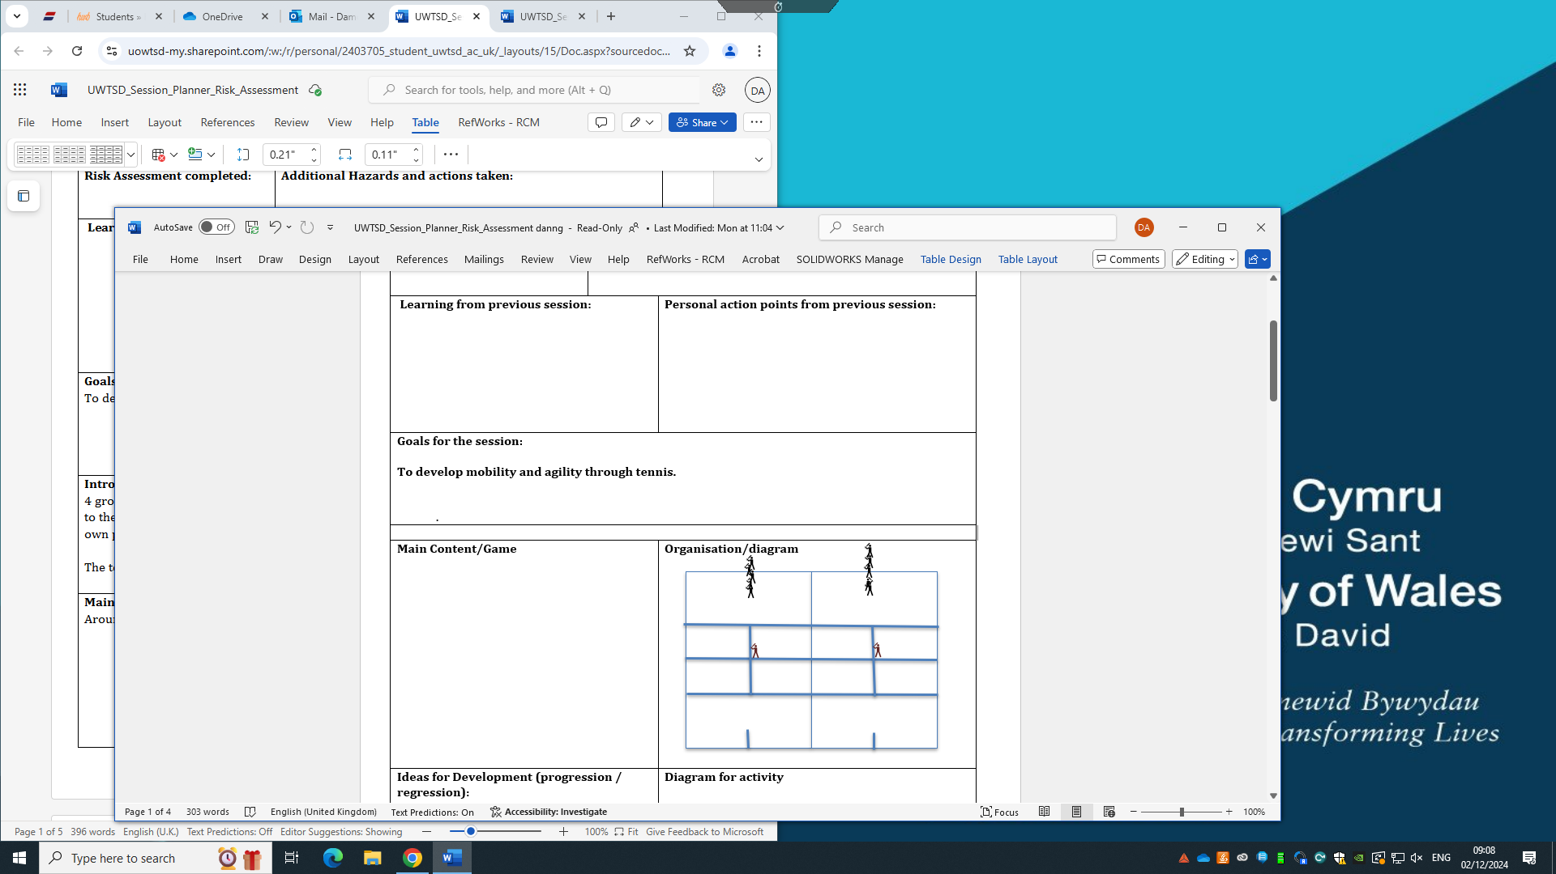
Ideas for Development (progression / regression):  Progression – Feed the ball on the other side of the court with more aggressive feed.  Regression – drop feed balls up close to make it easier to hit |  | Diagram for activity

5Cs to be included in this session | Select 2 of the 5 and apply to session  HOW?
Competence

Confidence:

Connection:

Character and caring:

Creativity:

Cool-down:

Comments on session:

Review of your Coaching Session and Personal Action Plan
For each session you deliver you need to complete a Coaching Session Review and Evaluation plus a Personal Coaching Action Plan.

Practical: Coaching Session Review and Evaluation (Individual Reflection)
Were the aims of the session achieved?  Identify which ones were achieved and which if any, were not. | All aims of the session were achieved.  We improved mobility by having the participants run around the area of two courts. We taught a forehand and backhand shot. We taught balance and control of a tennis ball.
What factors helped ensure that your aims were achieved?  (Reflect upon organisation, appropriateness of activities, coaching styles.) | We made sure to stick to our aims but were ready to adapt our plan to make sure everything ran properly. We made sure our organisation and teamwork skills were good so we could do everything effectively. This meant having three people doing activities with the groups instead of just one person.
What were the reasons for you not achieving your aims? (Reflect upon organisation, appropriateness of activities, coaching styles. | We achieved all our aims.
What changes (if any) did you make to your session that were not in your plan and why? | We had an extra step in the around the world part of the game to teach how to return shots and we had forehand and backhand shadowing. We did this so we could fit everything we wanted to in the session and so there were not people waiting around for things to do.
Would you do anything differently if you were to deliver the session again? | The main bit of feedback was to play an actual tennis match. This would be hard as there are lots of kids and not much time or area. There may also be differences in abilities that may be unfair on some kids. If I was to deliver again, I would find a game that could be played as a big group to make the session more fun for the participants.
What have you learnt about your coaching from this session? | I have learned that I am confident in presenting information about what we are doing, and I am confident when asking for feedback. I can present information clearly and I can help to make people understand what they need to do.
Personal Action Plan
Using the information above, what changes will you make to your planning, coaching delivery and organisation in future sessions?

In the future I will make a more detailed plan. I will plan each task with a specific time including time at the end for feedback. This will make the session run smoother and means I can focus more on the task than working out how much time should be left on each part.
Name of Coach: |  | Venue: LC | Date:25/11/2024

Risk Assessment (Complete Individually)

Ref | Hazard / Task / Activity  Area of Concern | Persons at Risk | Existing Controls | Describe Any Further Controls / Actions Needed | Actions By Whom | Action By When
1 | Falling on balls left on the floor. | Kids and coaches | N/A | To remove the balls that are not being used. Keep them out of the way. | Kids and coaches | During the session
2 | Jewellery getting hit by a ball or being a risk if someone falls. | Kids and coaches | Removing/ covering jewellery. | Removing or covering jewellery reduces the risk of injury. | Kids and coaches | Before the session
3 | Slipping on a wet floor. | Kids and coaches | The LC should have dried anything before our session starts. | Dry and spillages or wet floors that could happen in the session to avoid people falling. | LC staff and coaches | Before the session
4 | Slipping on clothing left close to the area. | Kids and coaches | Moving clothes that aren’t being used away. | Have a designated area away from where we work to store clothes that aren’t being worn. | Kids | Before the session
5 | Slipping on or getting hit with tennis rackets | Kids and coaches | Putting all rackets together and out of the way. Making sure there is enough distance between the kids and that they are not swinging rackets. | Put the rackets in a safe location when not being used to avoid people slipping on rackets or getting hit with them. | Kids and coaches | During the session

