Ways of Perceiving Essay: The Avatar Experience Exhibition

Name: Kayla Pratt

Student Number: 1902293

Word Count: 1518

Tutor: Julia Lockheart

BA Course of study: BA Set Design for Film

Module Code: ADAD4019

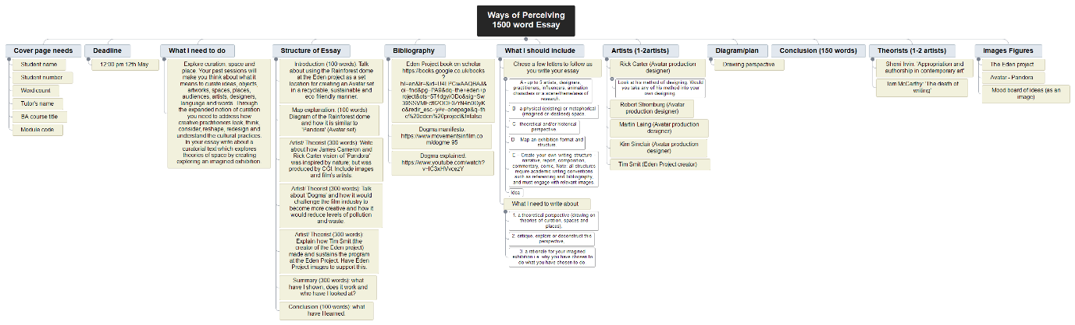

Fig. 1. Mind map for essay

This essay explores how the film set in James Cameron’s Avatar, (Dyer, 2009, p.92-95) can be exhibited in the rainforest biome at the Eden Project in Cornwall (Redman, 2001, pp 74). Avatar is a unique, special experience (SCI-Arc Media Archive, 2018) designed using computer generated imagery (CGI), (Roy 1989, p1). Over time, CGI has become increasingly used within the film industry due to the medium being inexpensive and less wasteful, unlike set design. To improve set designs’ wasteful impact, this exhibition will showcase Avatar’s unique set experience within an eco-friendly space, presenting to both Cameron’s and gardening audiences. The Eden Project’s rainforest biome will be incredible for this exhibition. Areas such as the ‘National Botanic Garden of Wales’ do not compare to the scale, extent of the uneven terrain or the beautiful array of plant species that resemble ‘Pandora’s’ botanical life and reflects the setting for Cameron’s ‘Avatar’ (2009).
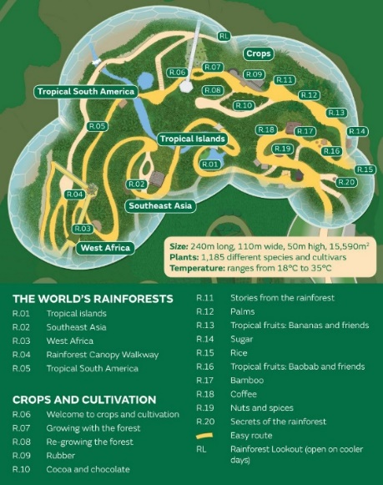
Figure 2. Depicts the space and interior design of the Rainforest Biome at the Eden Project. Inspired by tropical locations such as, South America, Southeast Asia, West Africa and tropical islands (The Eden Project 2020), within the 15,590m2 rainforest biome at the Eden Project, it showcases over 1000 plant species (Treseder et al.,2011). It is unlikely that many audience members will know of all the plants within the space therefore the botanical exhibition is mysterious and exciting, like how I perceive James Cameron’s Pandora world (Avatar 2009).
Fig. 2. The Eden Project’s Rainforest biome (Eden Project, 2020)
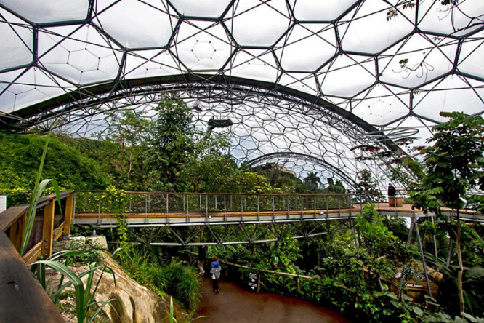
Fig. 3. Rainforest biome canopy bridge (Weibel, 2014)
Avatar’s director Cameron with production designers Robert Stromberg and Rick Carter, documented their process of transforming Cameron’s screenplays and artistic drawings into Avatar’s digital set location, named Pandora (Daily Celebrity, 2018). Throughout this documentary the production crew explained how Pandora’s fictional environment, structure and life cycle formed around Avatar’s, three meters tall humanoid bipeds called the Na’vi (Twentieth Century Studios, 2019). The Na’vi clan’s home Pandora, was inspired by scientific Earth structures such as; magnetic field, places like the China’s Guilin Region, South American jungles, Angel Falls, Venezuela areas in Asia and South America. As for Pandora’s intricate botanical decoration, Avatar’s artists experimented with altering the size and scale of exotic flowers, geometric succulents and vibrant plants that resemble the succulent family (Daily Celebrity, 2018). An average male Na’vi can stand to be three meters tall, therefore the design scale and size of Pandora’s environment was carefully considered. To avoid the set’s habitat from looking microscopic to the Na’vi clan the concept artist director Dylan Cole and botanical consultant Dr Jodie Holt collaborated, to make Cameron’s film appear beautiful. Using each other’s specialist expertise they developed the Pandora’s visuals and scientific design of the planets; light / solar radiation, strong magnetic fields and insignificant gravity. Every detail shown throughout the film was influenced by the science surrounding how the planet’s low gravity would influence the planet’s growth, function and display of plants. If the size and scale of the inspirational Earth’s formations were not considered by the Avatar creative team, then the overall aspect of the film would have been microscopic to the height of the Na’vi, (emphasizing the importance of the scale of the artwork). While the CGI artists acknowledged the science behind the art, they found it challenging to integrate human- like features to the various characters appearances and actions. If the artists resembled a Na’vi clan’s physic to one of a human, then an audience member could consider the characters to be frightening or uncomfortable to watch rather than beautiful. Whether an audience member considers a fictional character to be either beautiful or disturbing is known to be a part of the uncanny valley, (Sideshow Collectibles, 2012), which defines how an audience member perceives a non-human having human characteristics. To avoid the audience from being disturbed by the life on Pandora, finer details such as the bioluminescence patterns / markings where added to the design for Pandora to look realistic beautiful and mesmerizing (Evers, 2013). Therefore the Eden Project will hold the exhibition’s decoration because it matches with the exotic and great space shown in Pandora’s rainforest.

Dogme 95 is a 1995 film manifesto movement created by Lars von Trier and Thomas Vinterberg (Movement in film, 2020). Written within a red pamphlet was the Dogme 95 manifesto, that connected with Truffaut’s Une certain tendance du cinema. The cinema article launched the 1954 French New Wave. Since 1895, films have been produced with additional special effects, (People, 2020), to emphasize the production’s plots and characters. This movement was introduced to inform directors at the 100th film anniversary, ‘Le cinema vers son deuxieme siecle’, if their film work would be classified to participate in part of the movement (Movements in Film, 2020). The ’Vow of Chasity’ is 10 rules created by both writers that defines what a Dogme film is, guiding directors aiming to make a film within the movement. The 10 rules a director would have to obey by are: not to be credited within the work, specialist filming equipment (props, lighting, camera stands), film genre, post-production special effects (lighting and colors), additional sounds, format aside from academy 35mm, superficial action, artificial lighting and current day sets (FilmStruck, 2017). Trier wrote the manifesto in 1990’s, as a protest to big budget Hollywood films therefore focusing back on to the basics of a film’s story, acting and theme rather than the additional costly effects and technology (V Renee, 2014). Between 1895 and now, generations of film audiences and aspiring film makers started to believe that a ‘good’ film could only be made with the usage of special effects. Dogme 95 highlights how a film’s spontaneous music, settings and lighting special effects can deprive the film’s audience’s chance to personally, connection and associate themselves to a film’s original basic art form. Special effects take away the reality of a plot therefore dramatizing and avoiding the true originality of the production’s plot. Another effect of the Dogme 95 movement on the film industry was to, reduce the production waste of sets and materials. Removing the additional flamboyant fictional effects from a film, would significantly reduce the unnecessary waste produced at the end of the production. Dogme 95 films only use the camera team’s cameras, filming environment throughout the film without any additional extras/special effects. Overall this would improve the film industry’s waste, pollution and the Earth’s environment (The Guardian, 2006). This manifesto will influence the design of the exhibition because it will imply that the crew will only use the location surrounding and equipment to form and emphasize that blockbuster films, such as Avatar, do not require specialist equipment to make a great film.

Sir Tim Smit is the creator, co-founder and executive chairman of the Eden Project International Ltd (Eden Project, 2020). Before the public opening of the Eden Project in 2001, the space was known as the Bodelva, a working china clay pit coming to the end of its life expectancy (Smit, 2015, p.40). In 2000, Smit introduced his concept to the Millennium Commission/ Big Lottery of transforming a seeping waste land, into the biggest greenhouse in 2001, as a symbol of hope and renewal of life within a disused area of land. Generously, the Big Lottery invested £56 million into the Eden Project (Eden Project, 2020) and the creation of Smit’s eco-friendly environment within Cornwall. This equates to a third of Avatars’ £190,183,020 film budget (IMDb, 2020). There was no soil available at the time for them to use for the project. The team therefore sourced 83,000 tons of soil from recycled waste. Plant seeds was then sown into the soil for fertilizing. Later dispersed through a thermic wooden monitor onto the surfaces of the former clay pit (FLORB, 2019). £3 million pounds of the funding was invested into purchasing 40 acres of plants (Eden Project, 2020). Some of these beautiful Asian and South American plants, that inspired ‘Avatar’s’ CGI Pandora world, are housed within The Eden Project’s 15,590m2 Rainforest Biome (Treseder et al.,2011). Each biome was influenced, planned and constructed to replicate the humidity, heat, natural lighting found within the plant’s original rainforest and mountains environments. For this reason, I believe the Eden Project would be a perfect location to use for my set design, ’The Avatar Experience Exhibition’ because both attractions share similar inspirational locations as well as emphasize the importance of protecting beautiful, natural botanical life. Cornwall’s volunteers consider the Eden Project to be an eco-friendly and sustainable project and a living theatre. Audiences are informed as to how parts of the Eden Project’s system could be implemented into their lives.

My exhibition has been inspired and influenced by the challenges faced by film industry set designers today. Research regarding the Eden Project has enlightened its audience and artists, with concepts as to how they can implement eco-friendly methods and techniques into their work, more explicitly set design. The Eden Project will provide me with the opportunity to emphasize the fictional size of Pandora’s environment and habitat creatures, overall making the exhibition like the CGI setting features upon Avatar. Furthermore, I strongly believe that my exhibition’s location will highlight the potential for future production set designers to minimize the impact waste has upon set and the world.

Bibliography

Quote references:

- Avatar (2009) Directed by James Cameron [Blu-ray]. Los Angeles: Twentieth Century Fox Corporation.
- Cornmell, H. (2018) A Beginner’s Guide to Dogme 95 [Website]. Available at: https://filmschoolrejects.com/beginners-guide-dogme-95/ (Accessed 15th April 2020)
- Daily Celebrity (2018) Avatar (2009) – Making Of and Behind The Scenes [YouTube] Available at: https://www.youtube.com/watch?v=_Y8Buy5b6DQ (Accessed 16th April 2020)
- Dogme952012 (2012) Dogma 95- The rules [YouTube]. Available at: https://www.youtube.com/watch?v=lC3xHVvcezY (Accessed 2nd April 2020)
- Dyer, J. (2009) ‘James Cameron’s “Avatar”’ Empire, 240, pp.92-95. Available at: https://search-proquest-com.ezproxy.uwtsd.ac.uk/docview/2214911?rfr_id=info%3Axri%2Fsid%3Aprimo (Accessed 21st April 2020).
- Eden Project (2020) Our Funding. Available at: https://www.edenproject.com/eden-story/about-us/our-funding (Accessed 20th April 2020)
- Eden Project (2020) Rainforest Biome. Available at: https://www.edenproject.com/visit/whats-here/rainforest-biome (Accessed 15th April 2020)
- Eden Project (2020) Sir Tim Smit KBE. Available at: https://uwtsd.ac.uk/media/uwtsd-website/content-assets/documents/library-and-learning-resources/infoskills/Harvard-eng_v.1.2.pdf (Accessed 5th May 2020)
- FilmStruck (2017) “Vow of Chasity” – Films of Dogme 95 [YouTube]. Available at: https://www.youtube.com/watch?v=OwmjnG9WvXU (Accessed 19th April 2020)
- FLORB (2019) They Built a Rainforest Ecosystem inside a Geodesic Dome [video]. Available at: https://www.youtube.com/watch?v=MWr67v620kY (Accessed 11th May 2020)
- Hall, R. (1989) Illumination and colour in computer generated imagery. New York: Springer-Verlag.
- IMDb (2020) Avatar. Available at: https://www.imdb.com/title/tt0499549/ (Accessed 5th May 2020)
- Movements In Film (2020) Dogme 95. Available at: https://www.movementsinfilm.com/dogme-95 (Accessed 2nd April 2020)
- People.uncw (2020) Brief History of Special Effects in film. Available at: http://people.uncw.edu/pattersone/resources/notes/DSFX_History.pdf (Accessed 9th May 2020)
- Redman, C. (2001), ‘Feast of Eden’ Time Europe, Vol 157, 12/4, pp. 74
- SCI-Arc Media Archive (2018) Rick Carter & Tom Wiscombe: Avatar (February 6, 2018) [YouTube]. Available at: https://www.youtube.com/watch?v=AKgk0uMSqwg (Accessed 13th April 2020)
- Sideshow Collectibles (2012) The Process of Design on Avatar. Available at: https://www.youtube.com/watch?v=W3DhQyxrBYU (Accessed 5th May 2020)
- Smit, T. (2016) Eden. London: Random House https://books.google.co.uk/books?hl=en&lr=&id=U4LPCwAAQBAJ&oi=fnd&pg=PA9&dq=the+eden+project+book&ots=5T4ehDiNBl&sig=ThbZ-rutKvR6om7pwCpJRDJ3PVQ&redir_esc=y#v=onepage&q=the%20eden%20project%20book&f=false
- The Guardian (2006) Dirty movies: why Hollywood is a polluter. Available at: https://www.theguardian.com/film/2006/nov/14/waste.usa (Accessed 11th May 2020)
- Treseder, K. et al. (2011) Evolution of Pest Management Strategies in the Rain-Forest Biome at the Eden Project, the First 10 Years. Buckinghamshire: Research Information https://www.ingentaconnect.com/content/resinf/opm/2011/00000022/00000001/art00007
- Twentieth Century Studios (2019) The Na’vi. Available at: https://www.pandorapedia.com/navi/life_society/the_navi.html (Accessed 9th May 2020)

Figures references:

- Figure 1.: Pratt, K. (2020) Mind map of essay [Mind Map]. (Accessed 24th March 2020)
- Figure 2.: Eden Project, (2020) Rainforest-biome-map.jpg. [diagram]. Available at: https://www.edenproject.com/file/5093 (Accessed 2nd April 2020)
- Figure 3.: Weibel, B. (2014) Photo: Canopy walkway in rainforest Biome at Eden Project in Cornwall, England. Available at: http://holeinthedonut.com/2014/04/28/photo-canopy-walkway-in-rainforest-biome-eden-project-cornwall-england/ (Accessed 30th April 2020)

