Research, Build and Deploy a Virtualized Enterprise Network
  - Network Operating Systems and Services

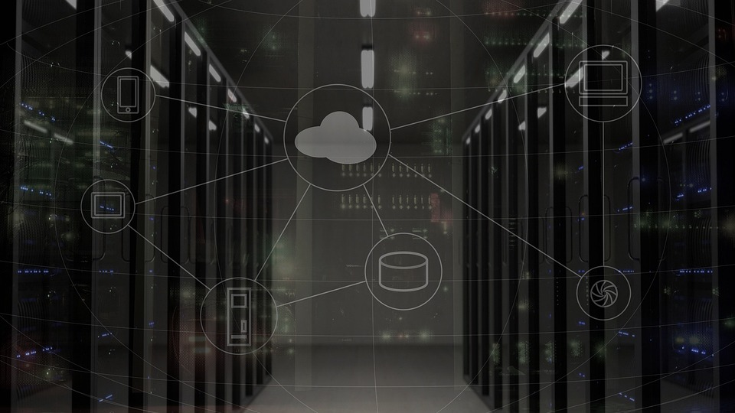

Software Engineering

Kayleigh Davies
Student Number: 2316137

Table of Contents

Task 1 – Research Report 3
Hypervisor 3
IP Addressing 4
Routing 4
Networks Services 5
Task 2 – Technical Documentation 5
Type 2 Hypervisor 5
Downloading and Set Up 6
Configuring IP Addresses 9
Testing and Troubleshooting 11
Additional Evidence 15
References 19

Task 1 – Research Report
This section of the report covers networking concepts, such as IP addressing, routing, and network integration, to ensure successful communication can be achieved across our systems. It compares hypervisors to determine their suitability for the proposed SWANSEA.ACCA domain while reflecting on essential networking services such as VPN, DHCP, Active Directory Domain Services (AD DS), and Certificate Authorities to maintain connectivity, security and effective network management throughout the coursework.

Hypervisor
Hypervisors can be explained as a software layer that sits between hardware and the host operating system, allowing multiple operating systems to run simultaneously on a single machine by using multiple virtual machines [1].
They are categorized as a Type 1 (bare metal) or a Type 2 (hosted) architecture for operating systems [1]. A Type 1 hypervisor works directly on the hardware, while offering strong isolation, a reduced attack surface, and higher performance qualities. This makes them ideal for virtualization because they run beneath the guest operating systems, while securely monitoring and managing system states. [1].
A Type 2 hypervisor will run on top of an existing host operating system, offering greater accessibility, hardware compatibility and easier installation. Even though they involve additional overhead, they are commonly used for development, testing, and educational environments due to their flexibility and minimal setup requirements [1].
For the SWANSEA.ACCA domain topology, the Type 2 hypervisor is the most suitable choice because it requires two separate servers and clients. It supports various operating systems through fast reconfiguration and allow screenshots and rollback to take place during domain testing. These features are essential when building both the basic and complex topologies, where additional clients or services may be introduced as the network develops.
Type 2 hypervisors are suitable for hardware constraints used in student environments, especially when the hardware available is limited. Although a Type 1 hypervisor can offer stronger isolation, the flexibility, compatibility, and practicality features of a Type 2 hypervisor are better suited for developing a virtual domain similar to SWANSEA.ACCA [1].

IP Addressing
From our group activity, I learned that data travels across the Internet in packets, which contain a source IP address and a destination IP address for the data. This ensures the devices will know where the data is coming from and where it is going [3].
Routers can use the IP addresses to determine the best path across different networks and ensure the switches can handle traffic within a local network by forwarding frames onto the correct device [3]. Without suitable IP addressing, packets would have no way of identifying their destination.
IP addressing works through two main versions known as IPv4 and IPv6. The IPv4 uses a 32-bit structure that is made of four decimal octets such as 192.168.1.10 [3]. IPv6 was introduced as a structure because IPv4 was running out of space, and it uses a 128-bit hexadecimal format, described as “IPv6 is alphanumeric/hex” [3], which provides a much larger address range and improves routing efficiency.
Subnetting was another key area we discussed. It allows a large network to be split into smaller, manageable sections, which reduces broadcast traffic through the use of better address utilisation [3]. For example, 192.168.1.0/24 can be divided into four /26 subnets, each supporting 62 usable hosts overall [3].

Routing
Applying the correct routing protocols is essential for managing traffic between networks to ensure the end destination can be met. Static routing applies a “single fix routing template” for all traffic demands within the network, meaning it is predictable as the routing techniques will be the same within the network and won’t change unless the template does [5].
However, applying dynamic routing techniques allows the routing paths to adjust depending on the demand from traffic within the network. Although this option is seen as cheaper and more efficient, it increases the complexity of the routing techniques along with the overhead requirements [5]. Because of this, static routing is preferable due to its simplicity and performance compared to the costly and disruptive nature of dynamic routing techniques [5].
In terms of the SWANSEA.ACCA topology, static routing would be suitable as the network is small and controlled meaning the traffic would flow across predictable paths, ensuring stable communication can be achieved amongst the machines within the network.

Networks Services
A VPN can be explained as a security technology that creates an encrypted tunnel between a device and a private network to ensure data is protected when travelling across the network [8]. The main features of a VPN are privacy protection, security when using public WiFi and bypass geo across restrictions [8].
DHCP automates the process of assigning unique IP addresses and subnet masks to devices meaning they communicate across a network without the need for manual configurations [9].
Active Directory Domain Services is a structure for the management and communication of users and domains within a network [10]. It stores information about the users, devices, security policies and authentication techniques which are managed through the use of permissions and security settings [10].
Combining these network services ensures that the best networking practices are implemented within a topology, with a focus on security, management, and scalability of network environments.

Task 2 – Technical Documentation
This section introduces the selection of a hypervisor that can support the lifecycle of the virtual network, during the initial deployment and the development of required in Coursework 2. It outlines the justification for the chosen hypervisor followed by the practical setup, configuration, and testing tasks while providing evidence that include timestamps.

Type 2 Hypervisor
Choosing a type 2 hypervisor to build the SWANSEA.ACCA virtual domain aligns with the scalability, flexibility and technical requirements of coursework 2 especially when additional services such as DNS, DHCP, Active Directory, and other client machines will need to be incorporated into the topology. This is because the hypervisor can carefully balance multiple requests from the virtual machines, to ensure stable performance even when more services and domain controllers are introduced to the network [2].
A Type 2 hypervisor is accessible, easy to install and compatible with a range of hardware allowing for quick configurations and deployment of clients and servers [1]. Having the features to create, screenshot, roll back and clone virtual machines during the testing and troubleshooting stages of the coursework is beneficial because it allows adjustments to be made without causing problems for the host system. This supports the iterative nature of the coursework, where building, modifying, and expanding the network must be done efficiently and reliably.

Downloading and Set Up
For the virtual machine setup, I downloaded the Windows 11 client and server images from the Evaluation Center and then configured both of the machines with the appropriate network adapters, memory allocation, and other required settings. After the initial setup, I installed VMware Tools on each machine and then renamed the networks, system details, and PC names to match the intended configuration.
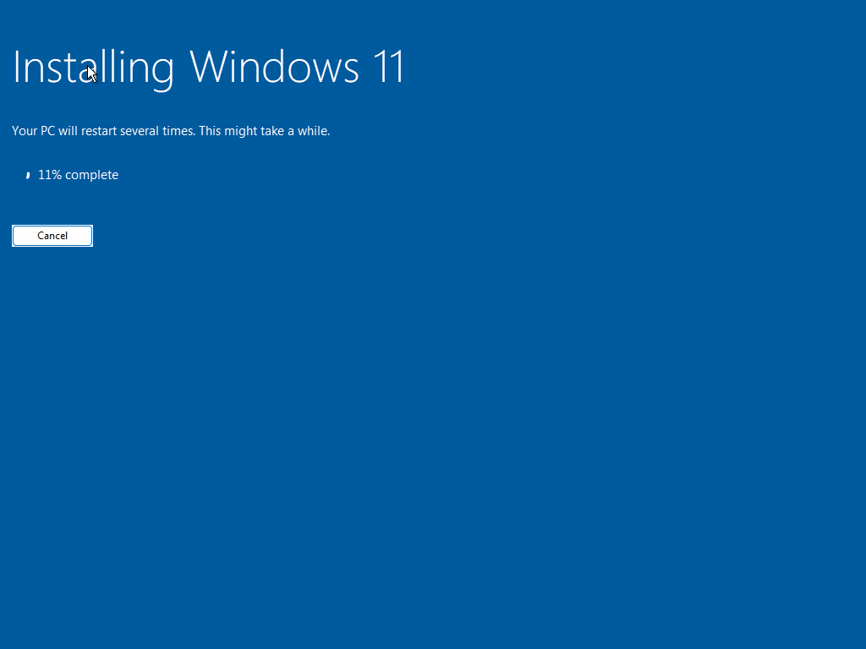
Downloading Windows 11

Installing VMware Tools
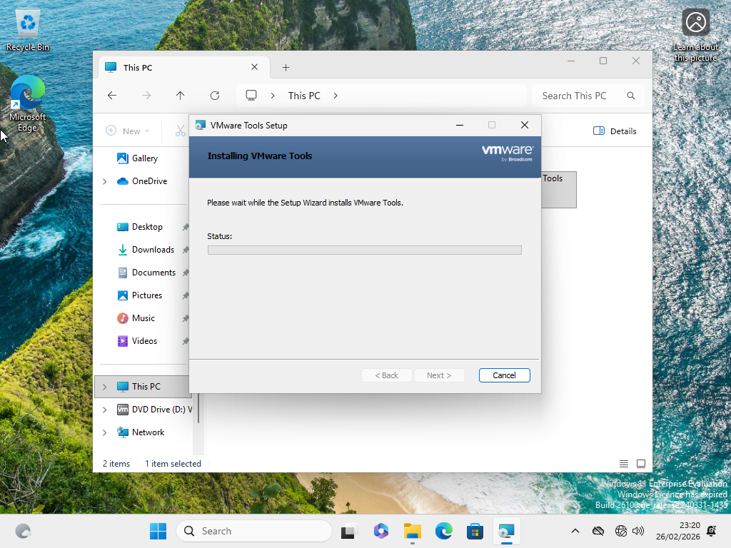
Naming ClientS1 Network
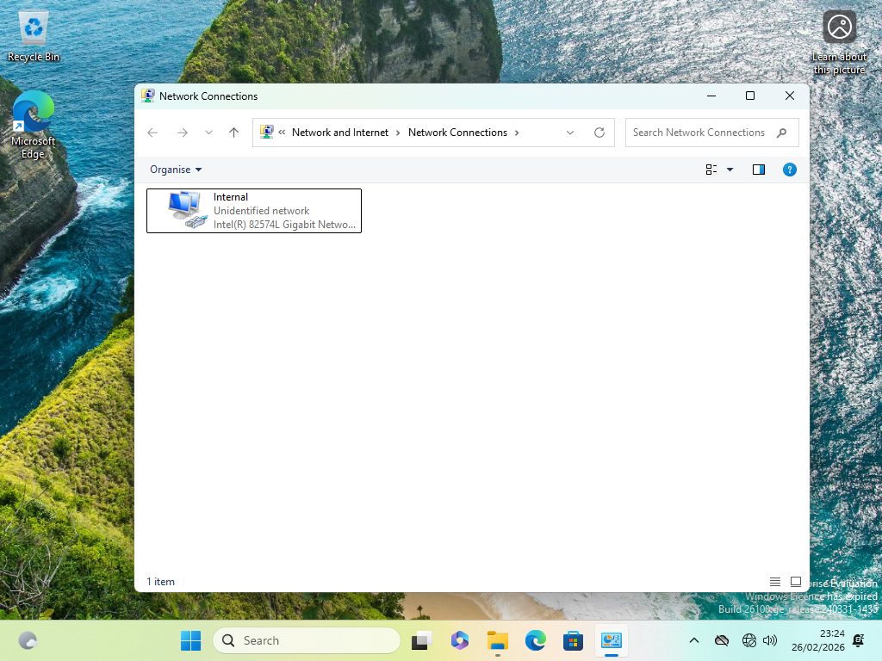
Naming the ClientS1 PC
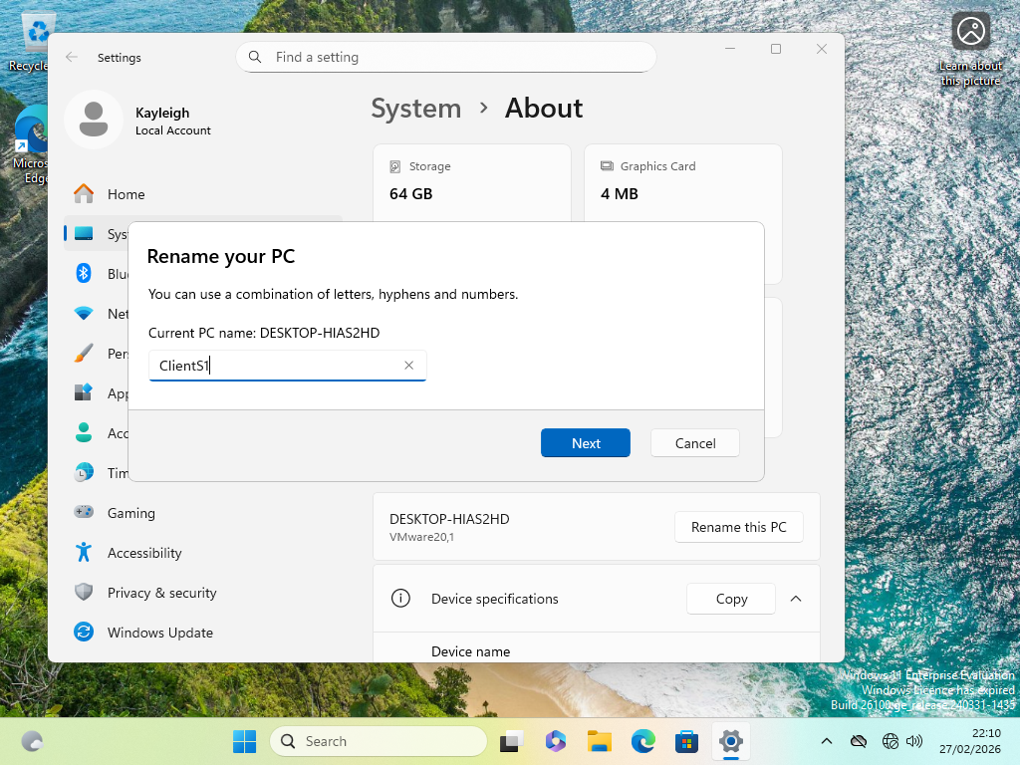
Naming the S-DC Networks
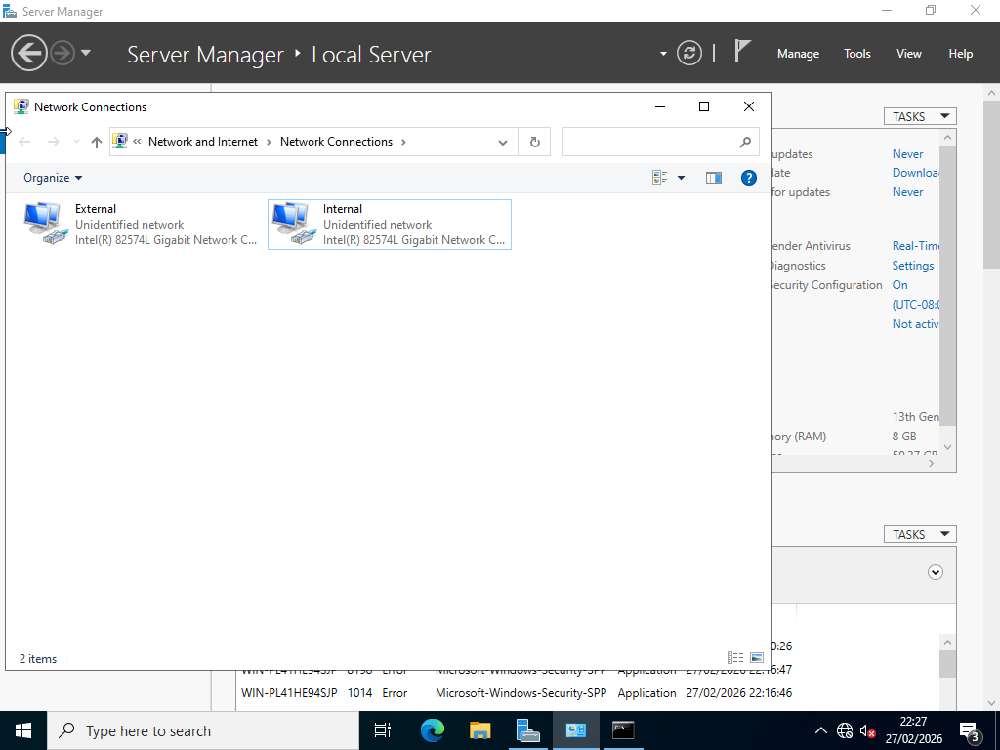
Naming the S-DC System
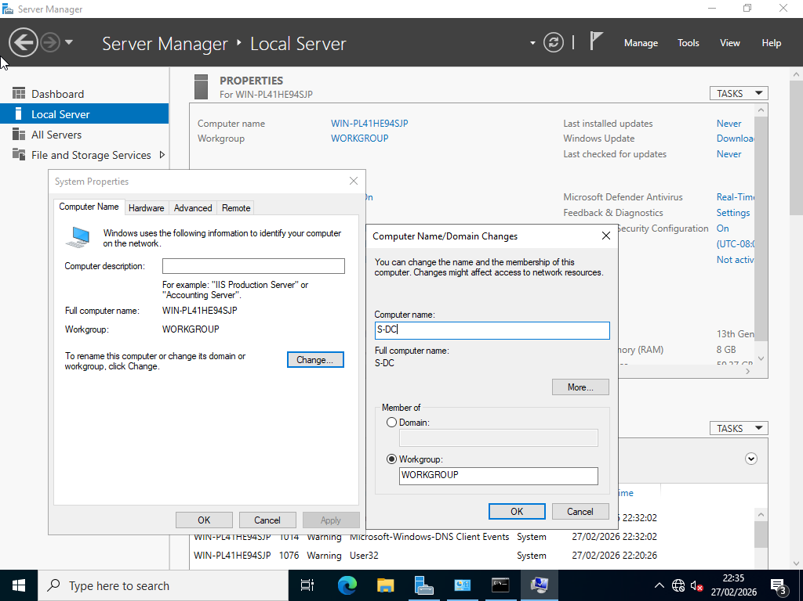

Configuring IP Addresses
Once both machines were successfully deployed, I configured their network settings in the Server Manager. For the ClientS1 and S‑DC system, I assigned unique IP addresses, subnet masks, and DNS server IDs to ensure each machine could communicate during testing.
Configuring IP Addresses (S-DC)
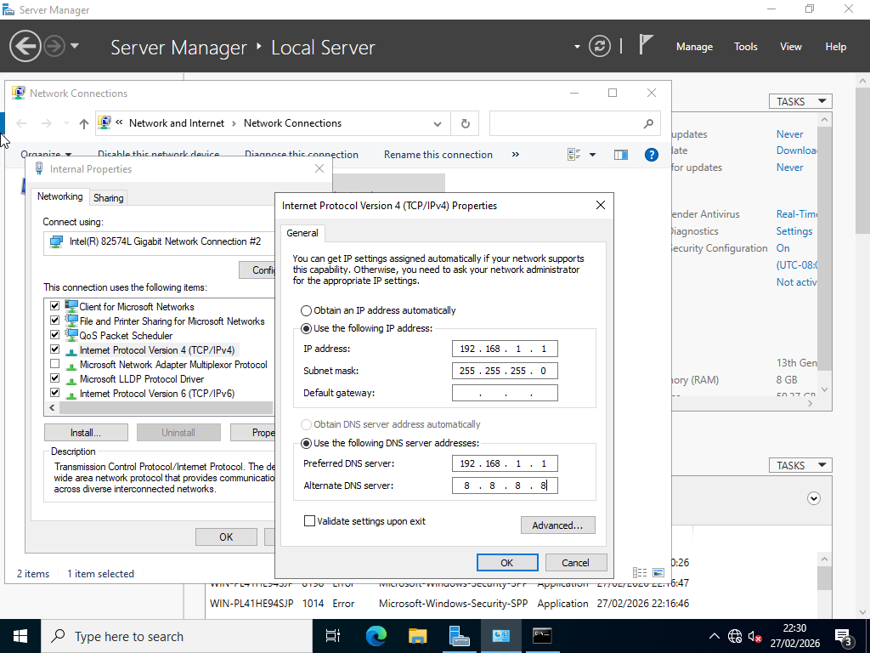

Testing IP Configuration/Network Connectivity (S-DC)
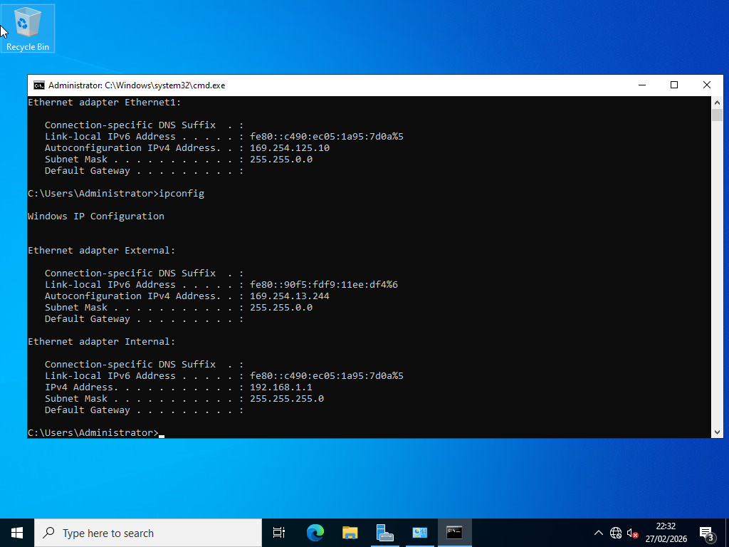
Configuring IP Addresses (ClientS1)
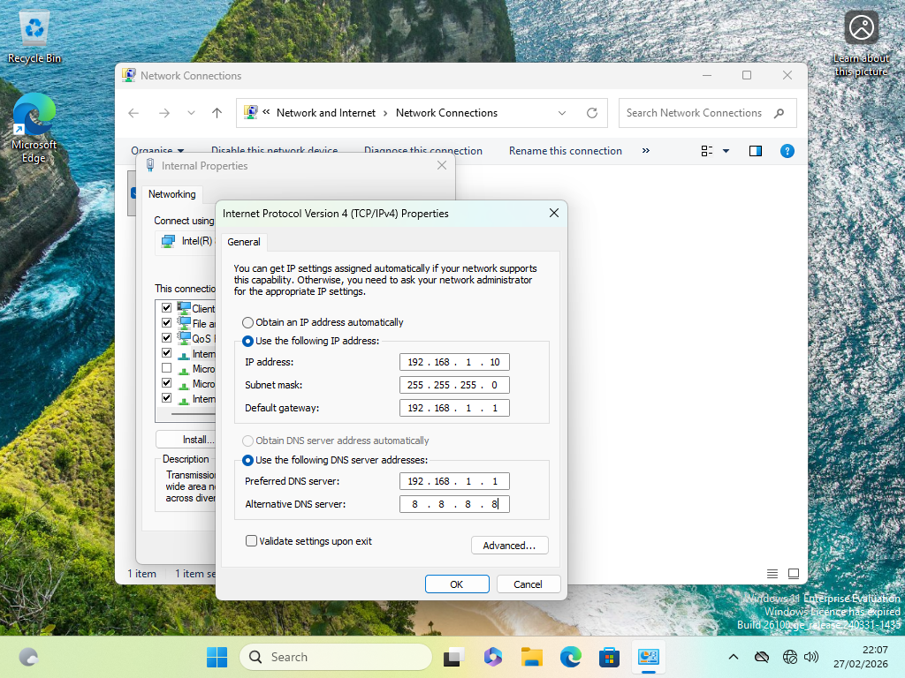

Testing and Troubleshooting
To check that the communication between the client and the server was working, I checked the configuration of the machines to ensure that the changes to the IP addresses had been saved correctly using the `ipconfig` command.
I then used the `ping` command to test communication between the machines both of the machines. The test from the S-DC to the ClientS1 machine was successful but there was an error in the communication from the ClientS1 to the S-DC machine.
To resolve the issue, I removed the firewall configurations in the windows firewall settings and tested the `ping` command again, which fixed the problem, allowing both machines to communicate correctly.

Testing IP Configuration/Network Connectivity (ClientS1)
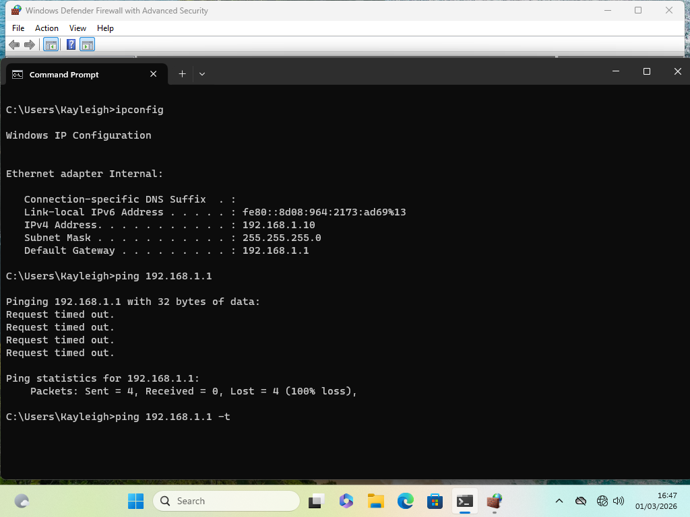

Network Connectivity Fail (ClientS1 to S-DC)
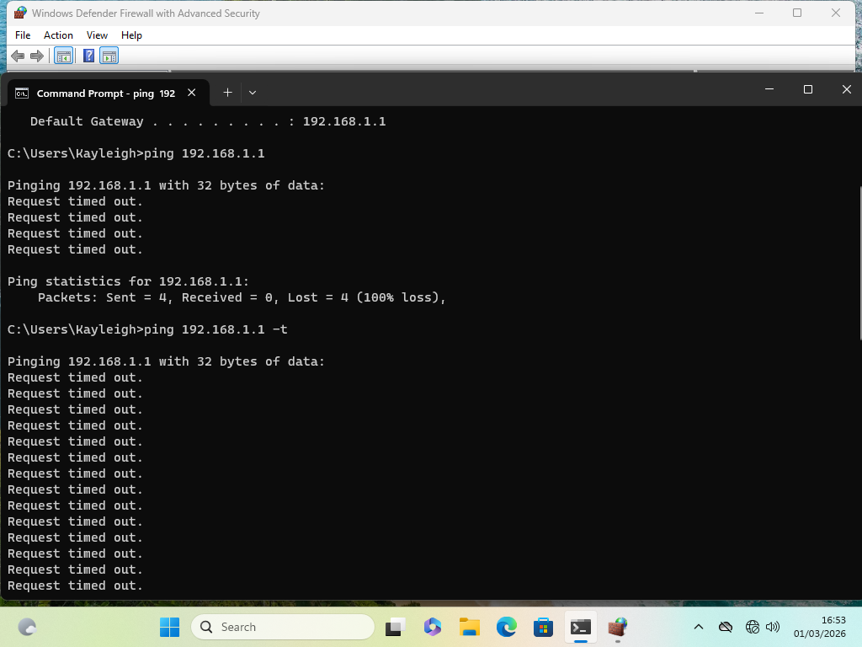
Removing Firewall Settings (ClientS1)
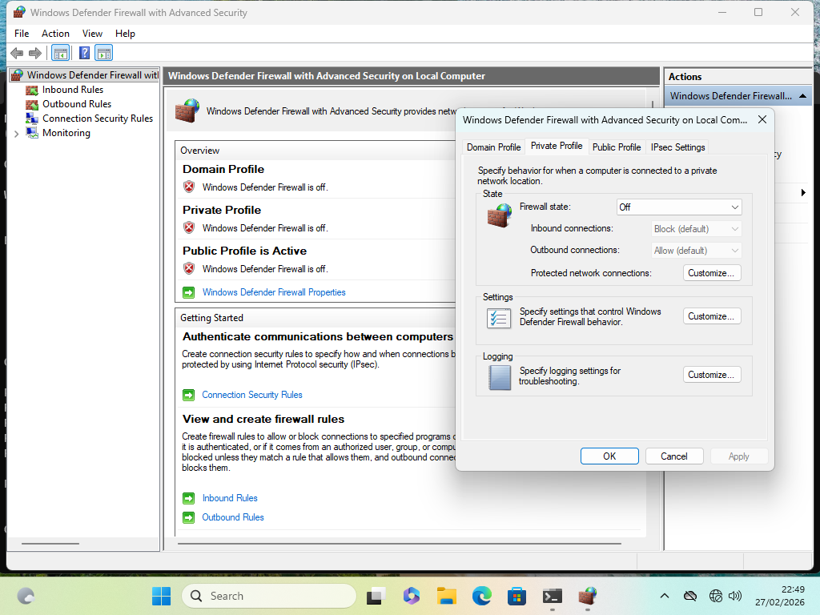
Removing Firewall Settings (S-DC)
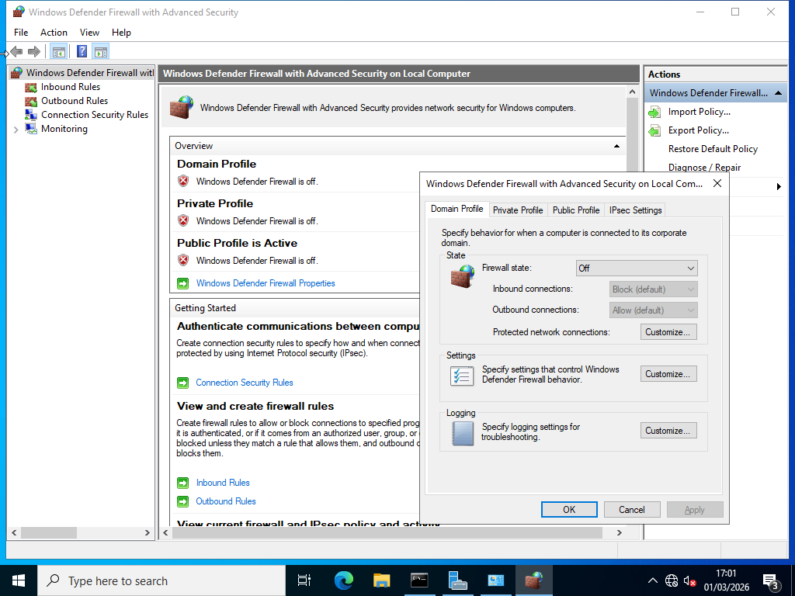
Testing IP Configuration Without Firewalls (ClientS1)
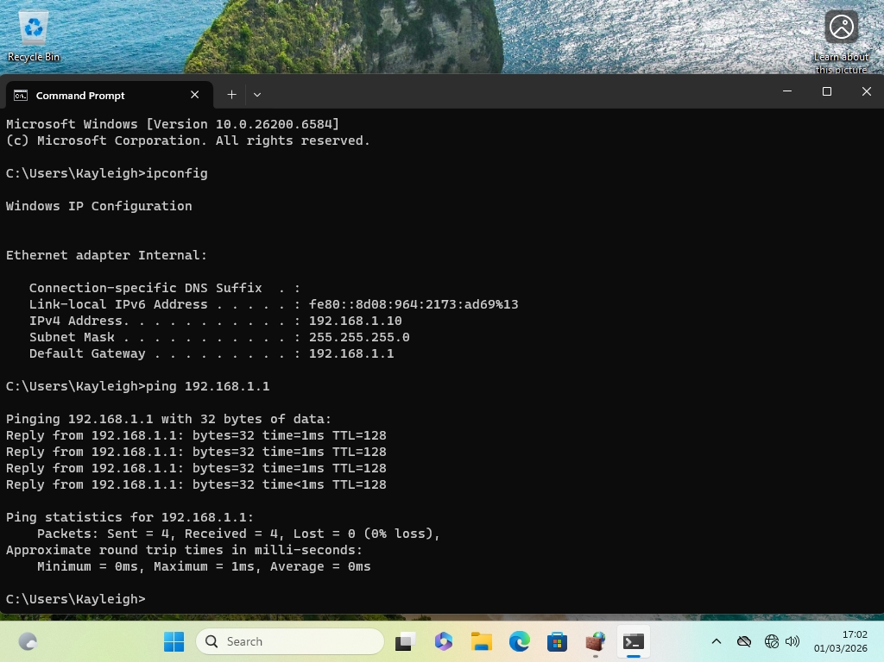

Testing IP Configuration (S-DC) Successful Ping
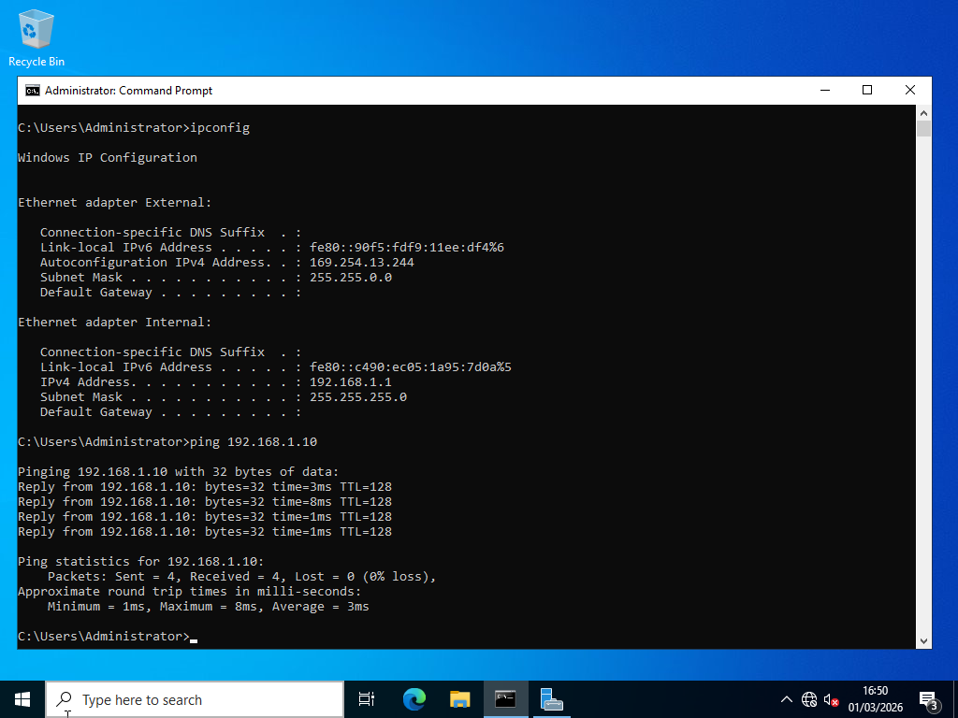

Additional Evidence
Downloading Debian
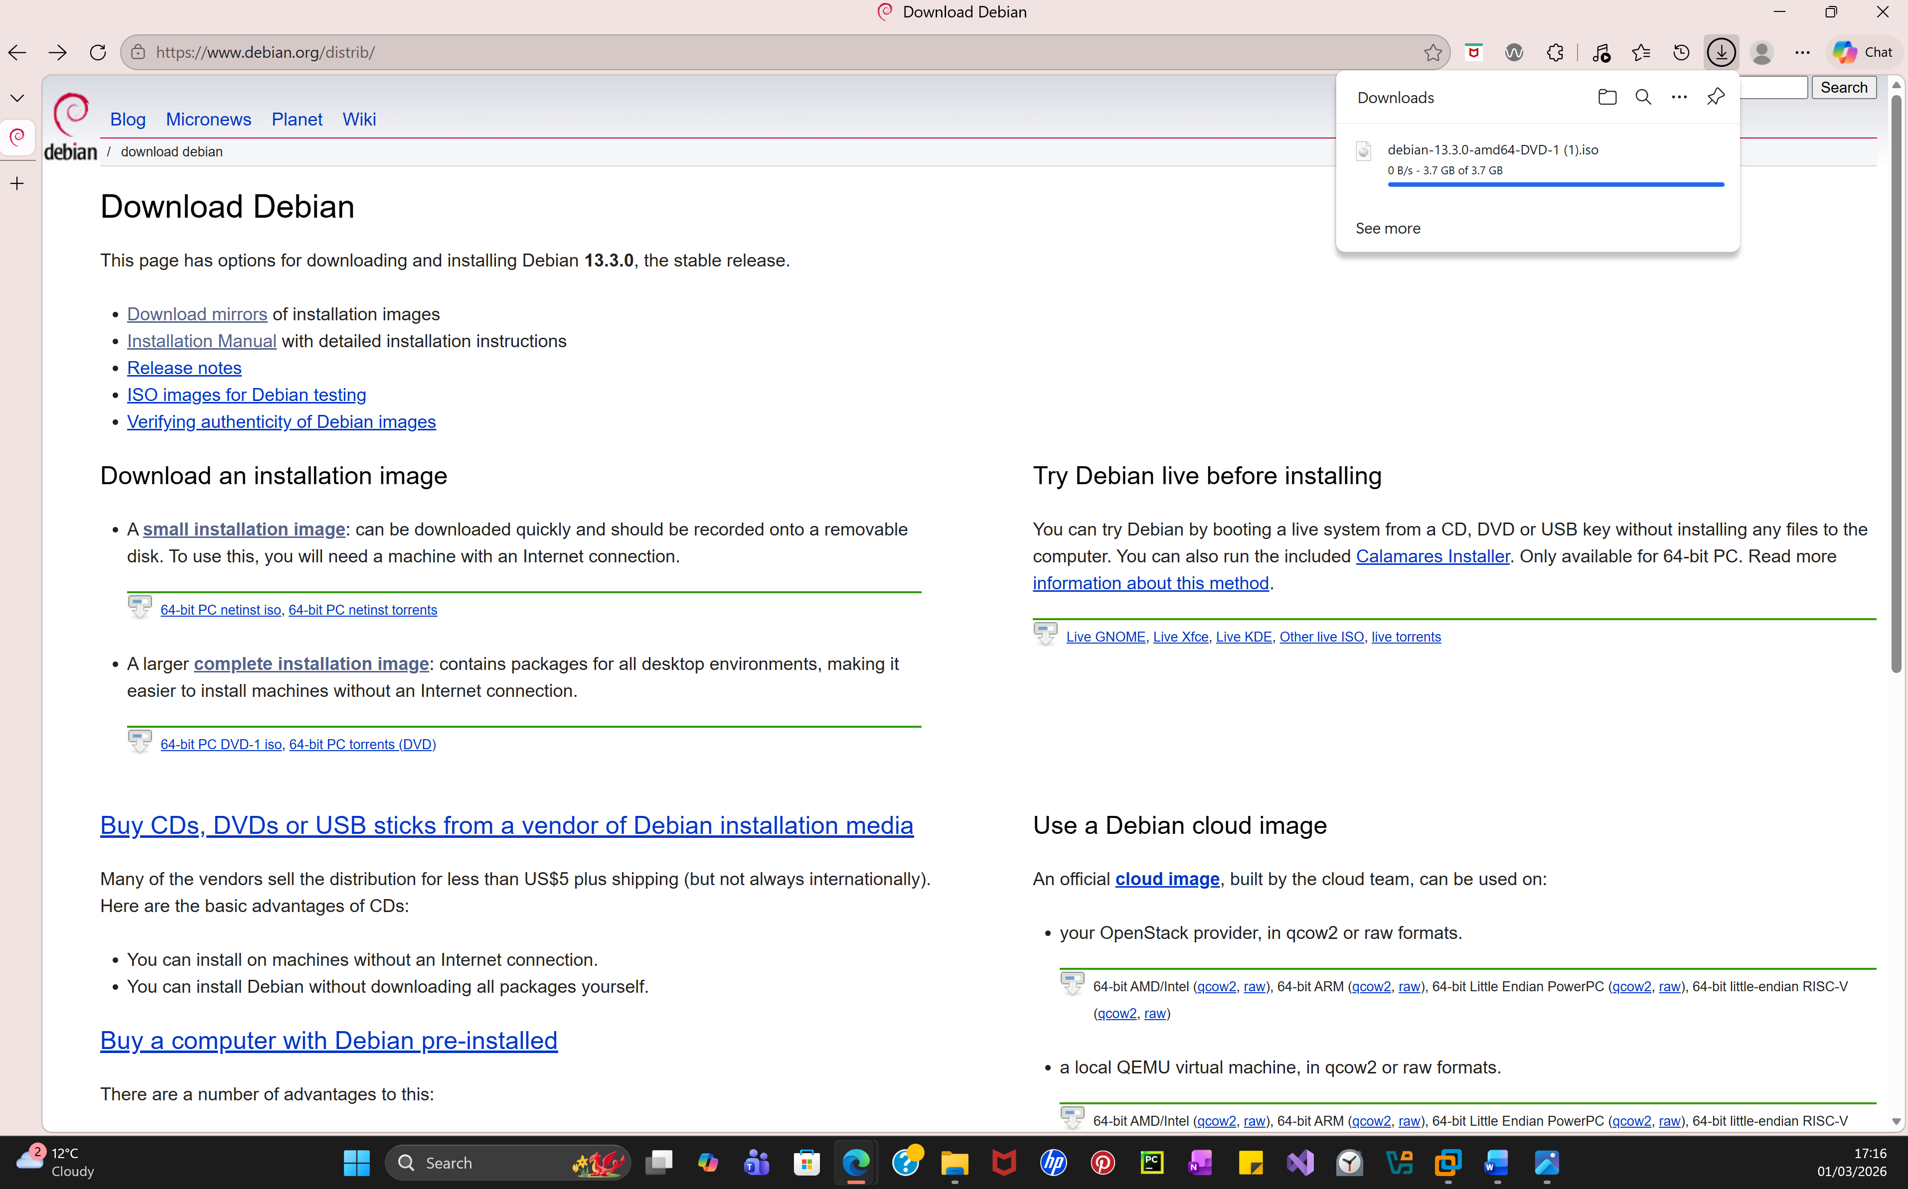
Logging into Debian L-CD
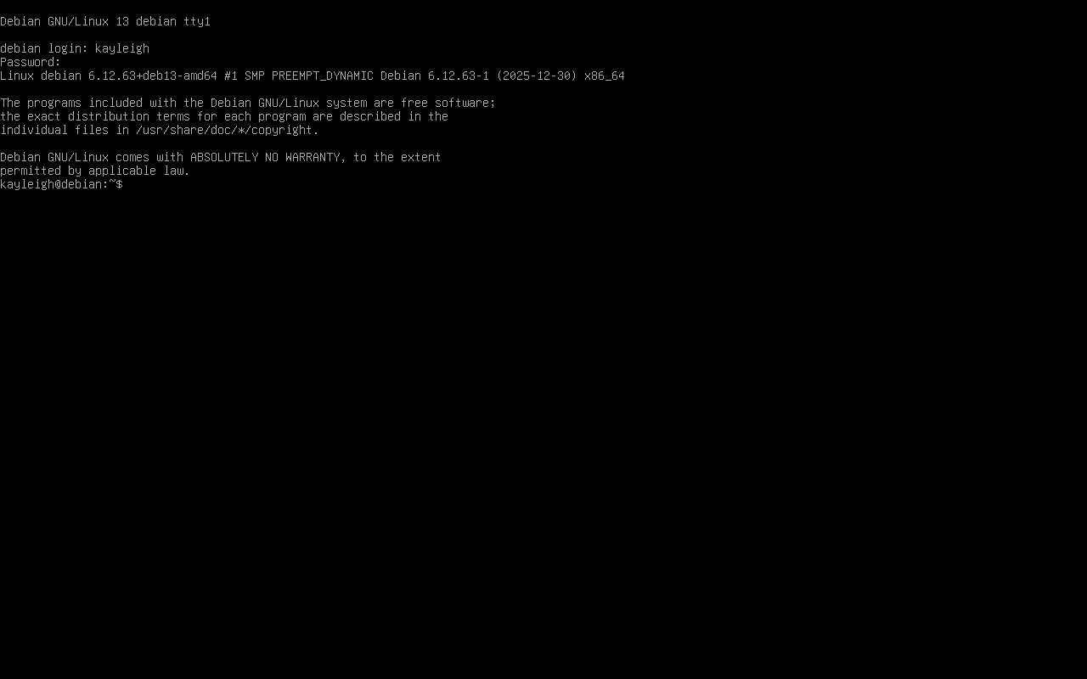
Testing IP config
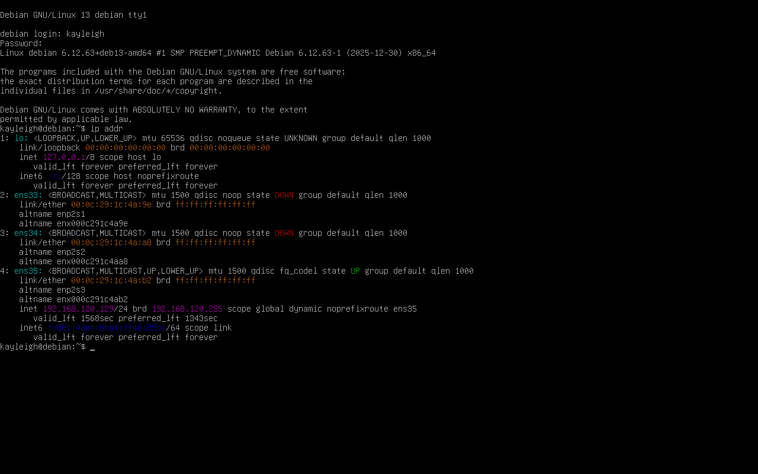

Install Sudo Prompt
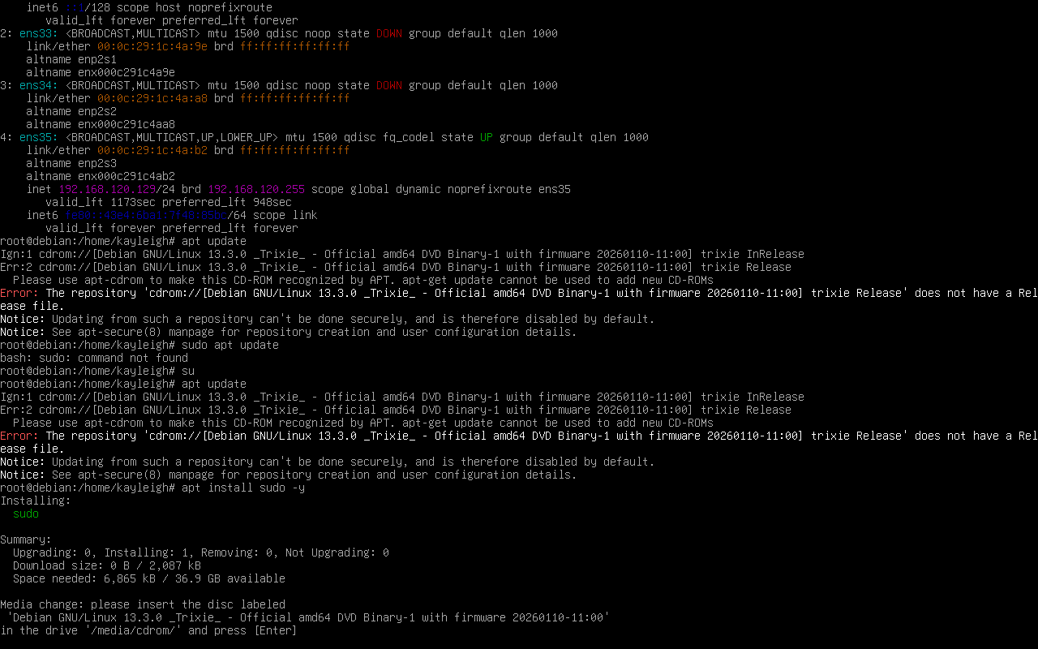


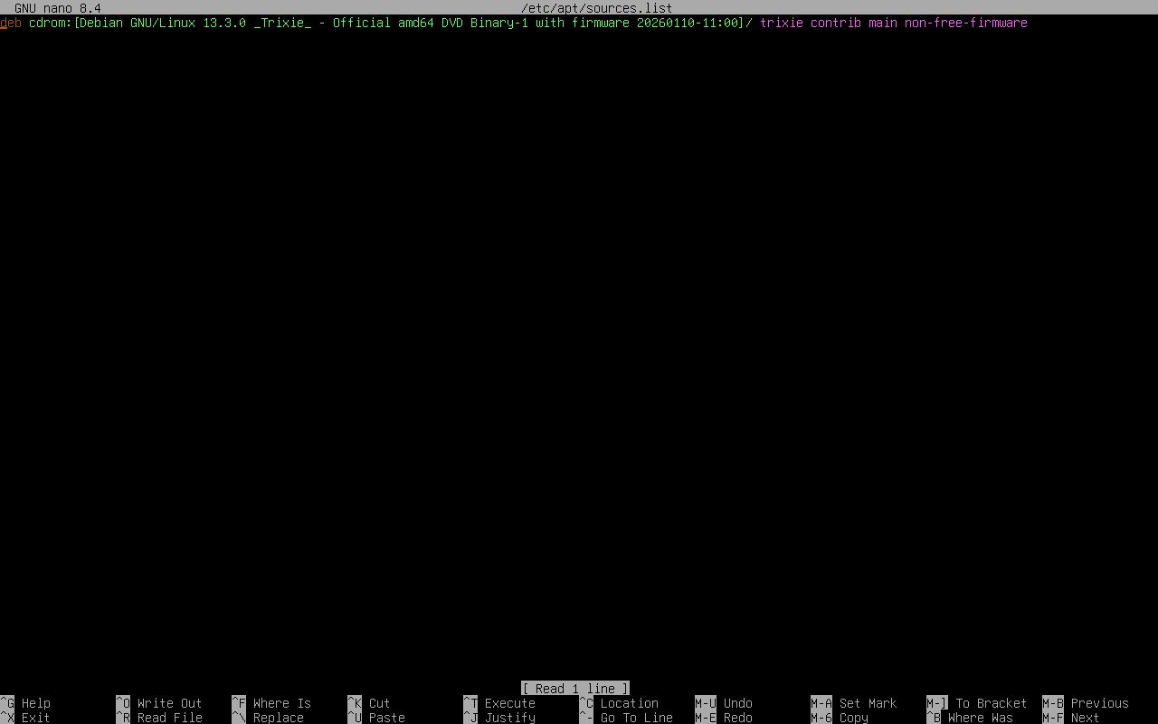
Nano /etc/apt/source.list prompt

Setting Up ClientL1
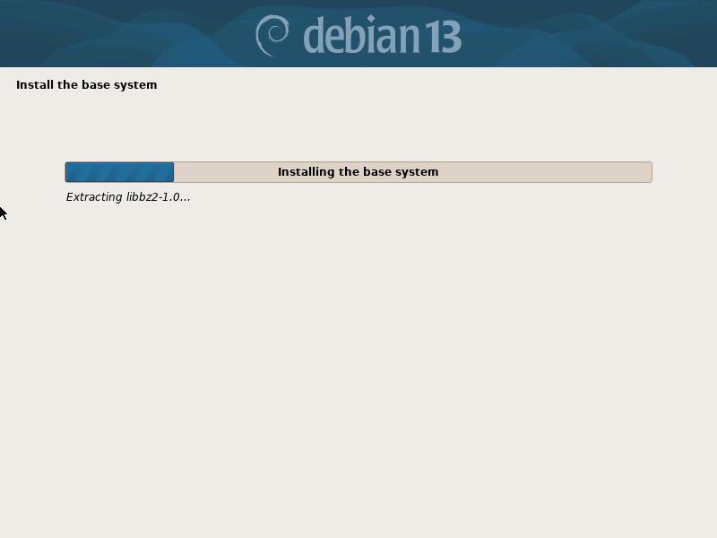

Task 3 – Personal and Technical Reflection
For this assignment, a network was developed to allow communication between multiple devices within a domain. The setup consisted of three servers and two client devices which were given a suitable IP address with the aim of ensuring functionality and reliable communication across the environment.
When configuring and testing the IP addresses, I come across an issue where the ClientS1 device was unable to communicate with the S‑DC server. The ping tests were failing which suggested that there was a connectivity problem even though the devices had the correct IP configuration.
Through further investigation I found that the firewall settings were blocking communication between the devices. To try to fix the connectivity problem, I temporarily disabled the firewall configurations on both machines to test connectivity again. Once these changes were made, the ping tests succeeded, confirming that communication between devices had been restored.
When setting up the Debian server, multiple error occurred when attempting to configure the correct source list and SSH, preventing the server from installing the required packages. This has created a temporary blocker in the deployment process for the second server of the SWANSEA.ACCA domain, delaying further testing and completion of this section of the network topology until the source configuration was corrected.
This highlighted the need for a stronger foundation in using Linux systems, configuration and troubleshooting to solve issues more effectively in the future.

References
[1] E. Bauman, G. Ayoade, and Z. Lin, “A Survey on Hypervisor-Based Monitoring: Approaches, Applications, and Evolutions,” ACM computing surveys, vol. 48, no. 1, pp. 1–33, Sept. 2015, doi: 10.1145/2775111.
[2] M. Portnoy, Virtualization essentials, Second edition. Indianapolis, Indiana: Sybex, 2017.
[3] Group Activity Notes, “IP Addressing (Versions, Class, Structure, Efficiency),” UWTSD, Networking Lecture Week 2, Feb. 3, 2026, unpublished classroom material.
[4] GeeksforGeeks, “What is an IP Address?,” GeeksforGeeks, Oct. 10, 2021. https://www.geeksforgeeks.org/computer-science-fundamentals/what-is-an-ip-address/ (accessed Mar. 03, 2026).
[5] A. Frangioni, F. Pascali, and M. G. Scutellà, “Static and dynamic routing under disjoint dominant extreme demands,” Operations research letters, vol. 39, no. 1, pp. 36–39, 2011, doi: 10.1016/j.orl.2010.11.009.
[6] GeeksforGeeks, “DHCP Relay Agent in Computer Network,” GeeksforGeeks, Jan. 17, 2018. https://www.geeksforgeeks.org/computer-networks/dhcp-relay-agent-in-computer-network/ (accessed Mar. 03, 2026).
[7] J. Savill, Mastering windows server hyper v, First edition. Indianapolis, NY: John Wiley and Sons, 2018.
[8] GeeksforGeeks, “What is VPN? How It Works, Types of VPN,” GeeksforGeeks, Dec. 25, 2020. https://www.geeksforgeeks.org/computer-networks/what-is-vpn-how-it-works-types-of-vpn/ (accessed Mar. 03, 2026).
[9] GeeksforGeeks, “Dynamic Host Configuration Protocol (DHCP),” GeeksforGeeks, Jan. 03, 2018. https://www.geeksforgeeks.org/computer-networks/dynamic-host-configuration-protocol-dhcp/ (accessed Mar. 03, 2026).
[10] GeeksforGeeks, “Introduction of Active Directory Domain Services,” GeeksforGeeks, Aug. 14, 2018. https://www.geeksforgeeks.org/computer-networks/introduction-of-active-directory-domain-services/ (accessed Mar. 03, 2026).

