bhhhhh

On-Call Retention within Mid & West Wales Fire & Rescue Service:

Consultant’s Report

Final Version

Word Count: 4357

__________________________________

Author: Emyr Thomas

email: e.a.thmas@mawwfire.gov.uk

Tel: 07817014892

Date: 6th May 2018

Table of Contents
Executive Summary
1.0 Introduction 4
2.0 Literature Review 5
3.0 Project Justification 7
3.1 Aims and objectives 7
3.2 Key Performance Indicators 7
3.3 Rationale and Justification of Data Collection Methods 8
4.0 Research Findings 11
4.1 Primary Research 11
4.2 Secondary Research 14
5.0 Discussion and Analysis 17
6.0 Conclusion 22
7.0 Recommendations 24
8.0 Referencing and Bibliography 26
9.0 Appendices 28

Executive Summary:
This project has been commissioned by Mid & West Wales Fire & Rescue Service (MAWWFRS), to research, investigate and understand the reasons why staff retention within its On Call (part time employee) Sector is at the current levels.

The appointed consultant has over 20 years’ service in the Organisation and first-hand experience and knowledge of the On-Call Sector.

The literature review will capture definitions of ‘volunteer’, ‘On-call/part-time firefighter’ and ‘emergency’, three defining words that epitomise this sector of the workforce and prompts observations against MAWWFRS.

The main focus of the project was to explore the reasons why On-Call staff, particularly those classed as ‘new starters’ would not serve more than 5 years within MAWWFRS.
Primary research would be in the form of staff engagement, in the form of appreciative questionnaires and interview, ensuring anonymity to encourage participation. All secondary research would be the collation and formatting of statistical data and information held via internal departments within MAWWFRS.

The purpose of the research was to create a more complete picture of the sector through the collation of an evidence base, which comprised of:

Based upon the research carried out, significant finding of the project were:

• 42% of all On-Call leavers since 2010-11 have served for 5yrs or less
• Cost to Service of training these leavers - £1,136,738

Primary motivation of On-Call sector:

• Pride
• Culture
• Community

Main reasons for attrition rate:

• Time Commitment – Contracts & Remuneration
• Expectations – that of the service and new starters
• Volume of Administrative duties

Recommendations emanating from the findings suggest that MAWWFRS should

Appoint a dedicated team to fully review the Sector, with particular focus upon reducing the current attrition rate, by initially introducing flexible Contracts, developing a Communication Strategy that clearly outlines the requirements and benefits of becoming on OCFF and reduce the volume of Administrative duties. Also with a mandate to review other areas that currently impact upon the On-Call Sector.

Introduction
This document is the Consultant’s Report developed and created with the specific aim of identifying the issues directly effecting the current high attrition rate amongst On-Call Firefighters within MAWWFRS and based upon research undertaken, to provide a suite of improvement recommendations for the Executive Leadership Team (ELT) of MAWWFRS to consider.

This will be achieved by a period of research which will initially involve interaction with current and former staff. This will establish the reasons why they are firefighters, the reasons they may have left and what can be done to improve the sector, or in the instance of former employees, what would have made them stay. This will be supported by statistical information and data from internal departments, capturing Human Resource & Financial evidence. This initial work will highlight the extent and the reasons for the On-Call retention issues currently being experienced and identify key focus areas that need addressing.

Throughout the duration of the consultancy project all data will be analyses and both primary and secondary data cross referenced in order to ensure that the recommendations presented to improve On-Call Retention levels within MAWWFRS are appropriate, proportional and fit for purpose.

Literature Review
The reason the Fire & Rescue Service exists is to protect communities in the event of emergencies, which can be defined as, “an imminent or actual event that threatens people, property or the environment and which requires a co-ordinated and rapid response. Emergencies are usually unanticipated, at least in terms of exactly what happens and when and where that take place. However, they can and should be planned for”, (Alexander, 005b, 159), who also goes to say, “a state in which normal procedures are suspended and extra-ordinary measures are taken to save live, protect property, limit damage and return conditions to normal”, (Alexander, 2003; World Health Organization, 2002).

Without a Fire & Rescue Service, the ability to resolve an emergency would not be possible. Within the UK this is undertaken by both Wholetime and On-Call firefighters, with the Wholetime Sector conditioned to a 42hr weeks, in a variety of shift patterns and situated predominantly in urban or heavily populated areas. The On-Call sector however are conditioned to an array of various contractual conditions and provide emergency response in rural locations around the UK. The training received and level of risk is the same within both sectors, with the difference being pay and contracts and the On-Call performing this role in addition to their primary employment and family commitments, which is recognised by Cheshire Fire & Rescue Service, who describe an On-Call Firefighter as, “a person who is 'on call' to respond to a range of emergencies. They are doing everyday jobs (for example, shop workers, office workers, mechanics, etc) until the call comes, then they become professional firefighters. They may be 'part-time', but they are trained and capable people in the front line, saving lives”, (Cheshire Fire and Rescue Service, 2018).

Whilst the roles are the same, the motivations are generally different, within the Wholetime Sector, people will embark upon their career to help and assist others as do the On-Call, but it is also a vocation with attractive pay & conditions, whilst also an opportunity for lucrative career advancement, if someone is willing to apply oneself and is prepared move around the country. However, within the On-Call sector, there are no such opportunities for career advancement, other than to a junior rank at your station and the pay is generally regarded as being nothing other than a disturbance allowance for when an emergency call comes in, but the interest in being an On-Call firefighter has always been (and still is) appealing. So, the motivating factors for becoming an On-Call Firefighter are, whilst similar to the Wholetime, also quite different. Whilst there is very little or no scholarly literature relating to On-Call Firefighters in the UK, there are articles and online references to the volunteer Firefighter sector within the US, akin to the UK’s On-Call sector. Captured on the US’s on-line communities page, a Captain Showers defines a volunteer Firefighter, “a Volunteer Firefighter is defined by courage, honour, respect, strength, endurance, brotherhood, commitment, and putting family life aside to help others in need”, (My.firefighternation.com, 2018).

“Analysis reveals that part-time and full-time employees differed on a number of attitudes and that psychological contract fulfilment could be used to explain differences in certain attitudes (e.g., satisfaction) but not others (e.g., affective commitment). Analysis also show that the relationships between psychological contract fulfilment and outcomes were rarely moderated by work status, suggesting that part-time employees will respond in a similar way as full-time employees to adjustments in their psychological contract”, (Conway and Briner, 2002). This statement acknowledges similarities between the sectors, but also eludes to experiences that staff within the On-Call sector could be experiencing at present, the research within this project is aimed at uncovering what it actually is that is affecting their retention.

Project Justification

Aims and objectives
The aim of this project is to assist MAWWFRS in creating a robust and sustainable On Call Sector within its workforce. This will be achieved by focusing directly on Staff Retention within the sector, which was originally identified as a developing risk during the service’s wider strategic review in November 2016, however, this risk has now steadily become an issue for the Organisation, due to its effect on Appliance Availability, predominantly in Rural Areas. Its objectives will be:

• To identify and confirm the three most significant issues that have the biggest impact upon staff retention, through research and engagement with both internal departments and the sector itself (including staff that have already left).

• Attribute a financial cost to the current retention profile and its impact upon the organisation, enabling the consultant to justify solutions and any associated costs or investment that may be required.

• Produce a timeline of activities, aligning collaborative partners and actions against each individual solution identified.

• The implementation of the solutions against the key performance indicators, as established during the solution development phase.

Key Performance Indicators
As established in consultation with MAWWFRS, the consultant and the Organisation will expect the solutions to realise the following goals:

- An improved level of Appliance Availability for On Call Appliances

- An improved return on their investment (cost of training against length of service)

Rationale and Justification of Data Collection Methods
“Research is a logical and systematic search for new and useful information on a particular topic. It is an investigation of finding solutions to problems through objective and systematic analysis. Information might be collected from different
sources like experience, human beings, books, journals, nature, etc and lead to
new contributions to the existing knowledge to make progress in a field”. (Research Methodology, S. Rajasekar, P. Philominathan, V. Chinnathambi, 2013).

Therefore, to substantiate and reinforce the widely acknowledged issues surrounding On-Call staff retention within MAWWFRS, the consultant must research the sector, exploring both primary and secondary data.

Primary research will be in the form of appreciative questionnaires and interview with both serving and former On Call members of staff. This will form the qualitative data required to inform ELT of the issues that may be contributing to the issues being experienced within the sector. The benefits of this style of data collation is explained by Lisa McQuerrey, “Qualitative interviewing techniques help researchers to observe and record a subject's unique perspective or experience as it relates to a particular issue. Questions are open-ended and the discussion is conversational in nature. The approach allows the subject to provide a first hand, first-person account. This gives the interviewer insight into where a subject is coming from, rather than getting “yes” or “no” answers that provide incomplete feedback”. (Work.chron.com, 2018)

The added benefits associated with Qualitative feedback in the form of discussions and questionnaires can be:

- Establishing Trustworthiness:
- Credibility
- Transferability
- Dependability
- Confirmability

(Archive.learnhigher.ac.uk, 2018)

The above methods of data collation, will afford the consultant the opportunity to gather information of greater detail, as the questions can lead into additional questioning and afford the interviewee’s a chance to discuss related issues that can then be followed up on with a secondary line of questioning. This will enable the consultant to operate as an observer, offering prompts for the subject to elaborate on, establishing a sense of perspective, as this form of qualitative interviewing will enable the collation of emotional data as well.

The Secondary data will be collated from internal records, i.e: Human Resource and Finance/Payroll Departments, as well as both internal and external reports, previously conducted into the On-Call Sector.

The research methods outlined above have two very different approaches and can be categorised as either Interpretivism (interpretivist) Research or Positivism Research.

Interpretivism, also known as interpretivist is associated with qualitative research and involves researchers to interpret elements of the study, thus interpretivism integrates human interest into a study. Accordingly, “interpretive researchers assume that access to reality (given or socially constructed) is only through social constructions such as language, consciousness, shared meanings, and instruments”, (Myers, M.D. (2008) and is aligned to the questionnaire/interview technique to be employed.

Positivism research, is the acquisition of only “factual” knowledge gained through observation, including measurement is trustworthy, limiting the researcher to data collection and interpretation in an objective way. In these types of studies research findings are usually observable and quantifiable - “if you assume a positivist approach to your study, then it is your belief that you are independent of your research and your research can be purely objective. Independent means that you maintain minimal interaction with your research participants when carrying out your research”, (Wilson, J. 2010).

The basic differences between positivism and interpretivism are illustrated by Pizam and Mansfeld (2009) in the following manner:

(fig:1)
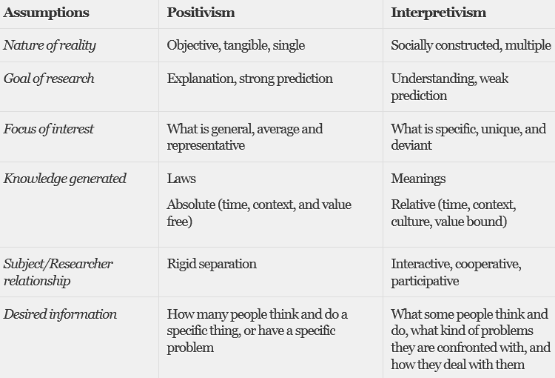
Therefore, between the research methods adopted in this project, the ability to cross-reference data, will enable strong justification for the recommendations presented to ELT.

4.0 Research Findings

4.1 Primary Research
An Appreciative enquiry questionnaire (see appendix i) was sent to 14 On Call Stations (27% of the entire Sector), who are a cross section in terms of performance, specifically Staff retention and appliance availability. The questionnaire comprised of 12 questions, they were:

- What motivates personnel to keep appliances on the run?
- How important is Communication between station members to keeping the appliance on the run? (And how is it achieved?)
- Does it feel like a family station? Do the partners/children know each other?
- What skill sets makes the appliance go off the run or nearest to going off the run? e.g. Lack of drivers, JO, short crew?
- What relevance is there between primary employment and retention?
- How does the recruitment process influence the availability & retention of crews?
- Is there a relationship between management style and appliance availability?
- Is there a relationship between length of service and retention/enthusiasm? (Once passed the 2yr, 5yr are they more likely to stay with MAWWFRS?)
- What is the real reason for staff leaving?
- What is the vital message, skill or attitude that a JO has to have?
- What demotivates On Call staff?
- Any other Comments

Note:
Questions highlighted in red relate specifically to staff retention.

Findings to Staff Retention related questions

Can be found within the full Questionnaire report attached, see Appendix i.

Within the questionnaire, the stations were asked to indicate from 1 – 6 (with 1 being their strongest motivator) their individual motivators for being an On-Call Firefighter and keeping their appliance on the run from the following themes. The motivators presented were as follows:

Response to individual motivator question

(fig:2)
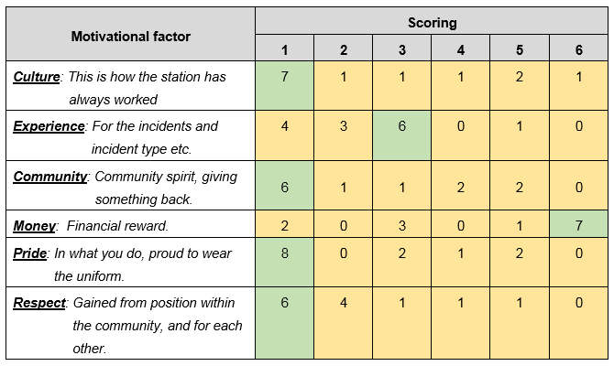

Telephone interview with On Call Leavers
Within the Exit Interviews a ‘reason for leaving’ is briefly given. In order to better understand the reasons for leaving and more importantly what could have made them stay, attempt was made to contact 30 former employees, who had left since 2010-11.

(fig:3)


Calls were conducted during week commencing 16th April 2018, with each former employee attempted a maximum of three times.

Name’s and contact details of former employees are redacted for GDRP purposes.

4.2 Secondary Research

Current On-Call staff retention position

Whilst the employee turnover rates for OC personnel (6.8% during 2012-13, and rising to 10.8% for 2015-16) fall well within the average Total Labour Turnover Rate for the Public Sector Service in 2014 of 14.1% (according to XpertHR), it is considered to be in the interests of the Service to undertake these processes in as efficient a manner as possible, given the increasing trend in turnover.

(fig:4)
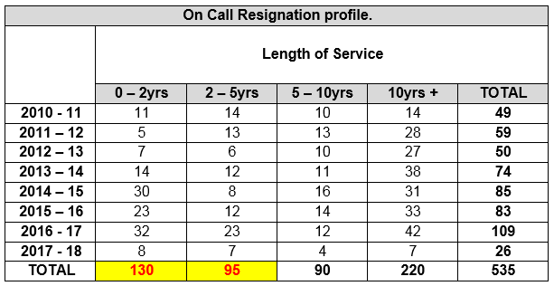

Note: Average Age of 0–2yr leavers is 29 yrs old (range between 18 – 50).

(fig:5)
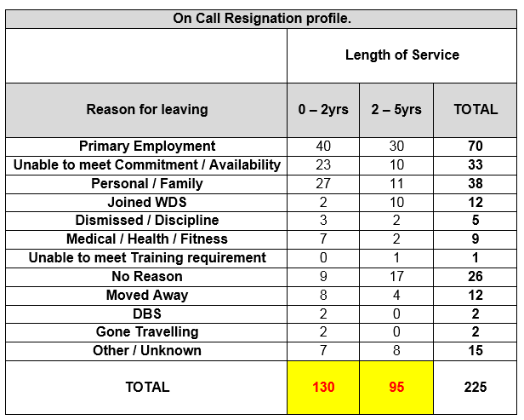

Number of New Recruits that left within the same year as commencement:

(fig:6)
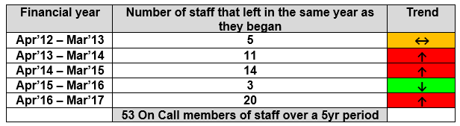

Financial implications of current retention activity

Cost of training a new recruit:
From initial training, through development to competent (2yrs) = £5,052.17 per FF

x 225 leavers (5yrs or under) since 2010-11 = £1,136,738.25

(on average £227,347 per year on training recruits who then leave within 5yrs)

Average earnings of an On Call member of staff within MAWWFRS
From the data extrapolated from the Phase 1 Baseline report below (On Call Firefighters Review - Nov’16), is an approximate average pay that can be expected for each role within the Sector:
(fig:7)

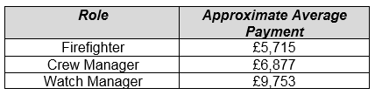

Contractual obligations currently available to On Call Staff within MAWWFRS

(fig:8)
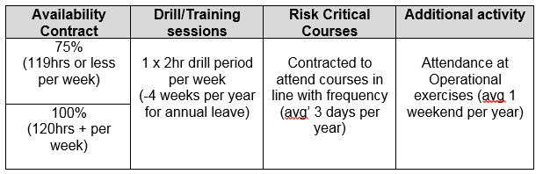

Current On-Call Appliance Availability levels:

From statistical data obtained from Fire Control’s mobilising software system, appliance availability is captured. Of a total of 52 On-Call Fire Appliances, the current appliance availability level for the On-Call Sector within MAWWFRS is 93%.

Discussion and Analysis
The first tranche of data collected would be through secondary research, accessing readily available statistics within service, primarily due to ease of access and collation, prior to embarking on the longer primary research methods.

From the On-Call Resignation profile (fig:4) there is an alarmingly high rate of resignations within the first 5 years of service, accounting for 42% of all leavers since 2010-11, confirming what was already suspected.

However, this statistic only gives a one-dimensional aspect, the reasons as to why these people were leaving would also be required to inform both consultants and employers, ahead of introducing potential recommendations. So, of the 225 leavers with 5 years’ service or less, 141 stated one of the following reasons for resigning (fig:5):

- Primary Employment commitments
- Unable to meet Commitment / Availability
- Personal / Family reasons

These explanations attributed to over 62% of the reasons given for leaving, these three reasons can be associated with various factors, for example the shortage of employment in rural areas, resulting in the migration to more urban areas to find work during daytime hours, as indicated within Welsh Government’s Poverty and Deprivation in Rural Wales Report Jul’08, the demands on domestic arrangements and having to be within 10 minutes of the Fire station may inhibit these activities. There is also the expectations of the service, with only two employment contracts available, requiring in the region of 120 hours of cover per week. Coupled with an individual’s primary employment, family commitments and any other interest they may have, this does not really promote a healthy work v life balance, however further data would be required to confirm.

Alarmingly for MAWWFRS (barring a good year of retention in 2015-16), the resignation rate of personnel within their first year of employment was increasing exponentially, culminating in 20 resignations within 12 months during 2016-17. In addition to the above, the average age for 0-2-year leavers was 29 years old. It may be argued that the On-Call Sector is not suited or attractive to the Millennial generation (born roughly between 1980 – 2000), as traits sometimes associated with this generation are:

- The need for instant gratification
- Work-Life Balance & Flexibility
- Career advancement

And given the reduction in call activity, the need to remain in the locality whilst providing cover and only three Managerial positions per station, the above characteristics may not be easily satisfied.

The next set of Positivism research data was acquired from the Finance/Payroll Department, to plainly capture and visualise remuneration and contract commitment.

You will readily see that financial reward is minimal for the amount of commitment provided, which, when you consider that staff already have other ‘full time’ jobs and family commitments, the ability to find time for leisure activities or relaxation is minimal. Therefore, it can begin to begin to appear that either money or commitment may be having a direct influence upon retention levels, but in order to provide appropriate recommendations a greater depth of understanding would be required.

Hence the need for Primary Interpretivism research, affording the organisation a better appreciation of the issues surrounding poor retention and for the consultant to create a suitable set of recommendations.

Firstly, the production of an Appreciative Questionnaire, which was sent to over one quarter of the On-Call Sector, 6 questions were explicitly regarding staff retention, the remainder were about appliance availability (by request of service, as both are inextricably linked).

Note:
Responses and key findings to the retention questions 3,5,6,8,9 & 11 can be found in appendix i.

Also within the questionnaire was an individual motivation question, which was designed to capture people’s motivation for becoming an On-Call Firefighter in the first instance (fig:5). Remarkably financial reward was the lowest motivation for staff, intangible emotions, such as Pride in the role, the respect garnered from their communities, reinforcing and nurturing the culture of their station and serving their communities were the primary motivators.

When referencing Maslow’s Hierarchy of needs, you will see that On-Call personnel are not in it for the money (or they’d all leave) but are satisfying something more fulfilling, Psychological and Self-Fulfilment.

(fig:9)

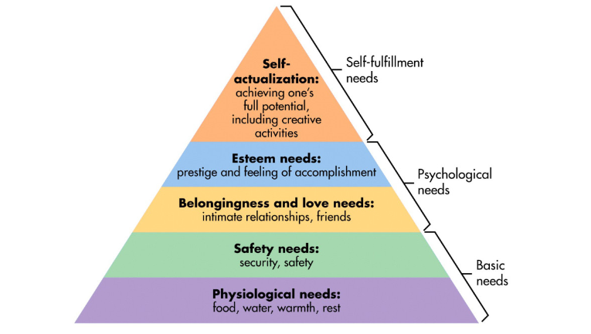
The final piece of Primary research was a telephone conversation with 30 randomly picked former employees who had left within the first 5 years of service and I asked them what wold have made them stay in the role.

Interestingly of the 26-people contacted, the following were identified as changes that would have made them stay on in role:

- A broader range of availability options and more time off = 84%
- A reduction in the administrative responsibility = 11%
- More pay (especially if worked over and above contracted hours) = 15%
- More calls / operational exposure = 11%

Again, these observations obtained by former employees are in line with the appreciative questionnaire to existing staff and goes to show that the motivation to join has always been the same and will continue to be so.

I feel that there is a suitable balance between both readily available Secondary data and the more difficult to obtain Primary data, affording me to cross reference and paint a balanced picture of what really is affecting On Call staff retention levels within MAWWFRS.

The research undertaken has comprised of extensive statistical (secondary) data, accurately depicting the current attrition rate amongst On Call personnel. With focus being placed upon staff with just 5 years of service or less. The internal data supplied from HR was extensive enough to also establish the reasons staff gave for leaving, whilst also identifying trends amongst leavers with less than 12 months service. All of which depicted a worsening situation for the organisation as the trend indicates that more and more are leaving. With Primary Employment commitments, the inability to satisfy the contractual agreement and/or Personal or family commitments attributed as the main reasons for leaving the service.

These difficulties were further confirmed when existing staff were canvassed in an Appreciative Questionnaire, with a cross section of stations (in terms of performance) being engaged, enabling a more balanced response, as opposed to focusing on either the best or worst performing in isolation, which would surely result in an imbalanced or biased response and either offering little depth to the research or an inaccurate reflection of the Sector.

Finally, former staff were spoken to and asked what would have made them stay. This enabled a greater understanding of the reasons as to why they left and their mindset or feelings towards the service and the role. It can unanimously be said that their feelings towards the role of an On-Call Firefighter was one of affection and fondness and their leaving was not done without serious consideration, as their motivations were principally around accomplishment and self-fulfilment.

In relation to the organisation, whilst there was a pride associated with serving MAWWFRS, wearing the uniform and serving their communities, there was however observations and comment on how the service needs to overhaul its practices, policies and contractual arrangements specific to the sector, particularly in terms of a wider range of contracts, a reduction in the administration levels, reward for commitment given and more development opportunities, similar to those offered to their wholetime colleagues.

6.0 Conclusion
Due to balanced research and sector knowledge it can be concluded that if MAWWFRS do not quickly address the issues presented within this consultancy report, then their On-Call Sector will begin to haemorrhage even more personnel, potentially quicker than the rate it is currently experiencing.

Therefore, focus must be turned to improving and radicalising the three most significant issues that are currently hindering staff retention and to maintain the current level of service delivery afforded to rural communities across Mid & West Wales, they are:

- Time Commitment – Contracts & Remuneration
- Expectations – that of the service and new starters
- Volume of Administrative duties

I would also advocate that senior officers within ELT consider Herzberg’s hygiene theory, when making improvement decisions specific to the On-Call sector, ensuring it reduces the risk of further dissatisfaction as it attempts to improve motivation and commitment. At a glance, within the Hygiene factors, Work/Life balance and Administration along with Wages and Benefits align to the three most significant issues identified. Within the Motivator factors, the opportunity for advancement, promotion and growth would look to satisfy personnel’s desire for self-fulfilment, which I may add isn’t as pressing as the Hygiene factors, but equally as significant if we are to build a sustainable, self-sufficient and contented workforce.

(fig:10)

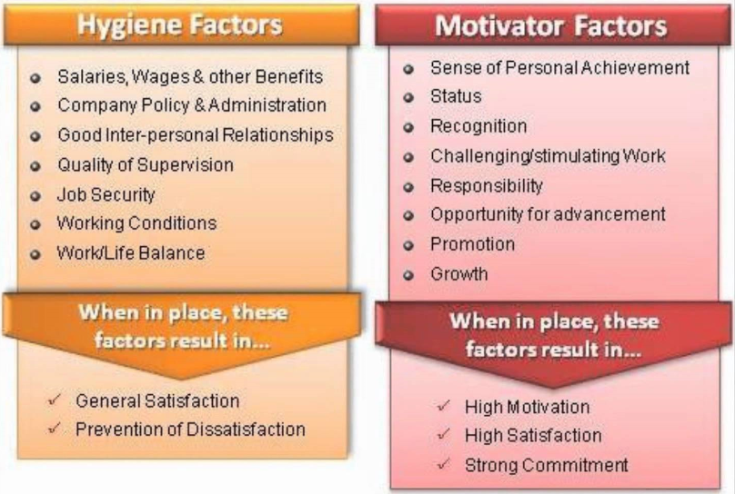

Also, cognisance must be paid towards the average age of the leavers, 29yrs old. Our working environment must evolve to accommodate and appeal to the next generation of employee, whilst not forgetting generations after that (Y & Z), the current On Call model is over 40yrs old and could be deemed unattractive and even unfit for future employees.

In summary, MAWWFRS’s On Call Sector is continuing to function and continues to maintain a high level of appliance availability, however this is based on good will, dedication, pride and commitment, provided by the older members of the stations, predominantly the Baby Boomers and Generation X and personnel who have a settled home life and fortunate to have local employment, unlike the younger people that we are attempting to attract. This sense of loyalty and camaraderie is currently keeping the sector together, but as pressure continually increases upon these loyal employees, urgent action and investment needs to be taken to avoid a potential collapse of the sector.

7.0 Recommendations
Project Team (creation)
The proposal for a small but dedicated project team to be assigned to create sustainable solutions for the three identified issues and within a 12-month period to comprise of:

(fig:11)
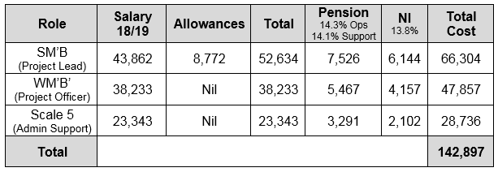

Budget
Currently no resource or budget is allocated for this area of work, also due to 2018/19 budget already being set, the need to resource this is justifiable and consideration given for the release of reserve funds and proposal to be made to Fire Authority.

Financial justification of team:

Cost of training a new recruit:
From initial training, through development to competent (2yrs) = £5,052.17 per FF
x 225 leavers since 2010-11 = £1,136,738.25
(on average £162,391 per year on training new recruits who then leave within 5yrs)

Executive Leadership Team to give consideration as to the benefits of this investment against the continued average loss of approx. £162,391 per year

Resolve the three most significant issues that are currently hindering staff retention

- Creation of flexible Contracts to suit different commitments lifestyles and future generation, along with remuneration options that reflects commitment.

- Develop a Communication Strategy that clearly outlines the requirements and benefits of becoming on On-Call Firefighter - Managing and clearly defining, for the benefit of the individual and their employer

- Rationalise the current volume of Administrative duties for the On-Call Sector

A mandate to review other areas impacting upon the On-Call Sector, namely:
- Recruitment of future generations
- Supervisory Manager succession planning
- Delivery of Training
- Appliance mobilisation

Referencing and Bibliography

(Alexander, 2003; World Health Organization, 2002). [online] Available at: http://www.arcom.ac.uk/-docs/proceedings/9ac79958d9024495cd81e13909ed08cb.pdf
[Accessed 6 May. 2018].

Archive.learnhigher.ac.uk. (2018). Analyse This!!! - qualitative data - qualitative research issues. [online] Available at: http://archive.learnhigher.ac.uk/analysethis/main/qualitative2.html [Accessed 6 May 2018].

Business.linkedin.com. (2018). 8 Millennials' Traits You Should Know About Before You Hire Them. [online] Available at: https://business.linkedin.com/talent-solutions/blog/2013/12/8-millennials-traits-you-should-know-about-before-you-hire-them [Accessed 6 May 2018].

Cheshire Fire and Rescue Service. (2018). What is an on-call firefighter. [online] Available at: http://www.cheshirefire.gov.uk/jobs/on-call-firefighter-recruitment/what-is-an-on-call-firefighter [Accessed 6 May 2018].

Collins, H. (2010). Creative research. p.38.

Conway, N. and Briner, R. (2002). Full-Time versus Part-Time Employees: Understanding the Links between Work Status, the Psychological Contract, and Attitudes. Journal of Vocational Behavior, 61(2), pp.279-301.

Examining the recruitment and retention challenges in the third sector. [online] Available at: https://www.agcc.co.uk/download-file/47 [Accessed 6 May. 2018].

Exploring how flexible job design can drive the retention, recruitment ... (timewise)
www.local.gov.uk. [online] Available at:
https://www.local.gov.uk/sites/default/files/documents/exploring-how-flexible-jo-75f.pdf [Accessed 6 May. 2018].

Interpretivism (interpretivist) Research Philosophy
Research-Methodology. (2018). Interpretivism (interpretivist) Research Philosophy - Research-Methodology. [online] Available at: https://research-methodology.net/research-philosophy/interpretivism/#_ftn1 [Accessed 6 May 2018].

Leadership-Central.com. (2018). Two Factor Theory - Herzberg's Motivation Theory. [online] Available at: http://www.leadership-central.com/two-factor-theory.html#axzz5EAVfwpVz [Accessed 6 May 2018].

Lucky Attitude. (2018). The Ultimate List of Millennial Characteristics | Lucky Attitude. [online] Available at: https://luckyattitude.co.uk/millennial-characteristics/ [Accessed 6 May 2018].

Mid & West Wales Fire & Rescue Service’s Strategic Assessment & Review (Nov’16).

My.firefighternation.com. (2018). Define a Volunteer Firefighter. [online] Available at: http://my.firefighternation.com/group/forthosehowthinkfirefightingisapassionnotajob/forum/topics/889755:Topic:515098 [Accessed 6 May 2018].
Research Methodology, (S. Rajasekar, P. Philominathan, V. Chinnathambi, 2013). [online] Available at: https://arxiv.org/pdf/physics/0601009.pdf [Accessed 6 May. 2018].

Rural Development Sub-committee – Poverty and Deprivation in Rural Wales July 2008. [online] Available at: http://www.assembly.wales/NAfW%20Documents/Poverty%20and%20Deprivation%20in%20Rural%20Wales.pdf%20-%2022072008/Poverty%20and%20Deprivation%20in%20Rural%20Wales-English.pdf [Accessed 6 Apr. 2018].

Simply Psychology. (2018). Maslow's Hierarchy of Needs. [online] Available at: https://www.simplypsychology.org/maslow.html [Accessed 6 May 2018].

Wilson, J. (2010). Essentials of business research.

Work.chron.com. (2018). The Advantages of Qualitative Interviews. [online] Available at: http://work.chron.com/advantages-qualitative-interviews-17251.html [Accessed 6 May 2018].

www.local.gov.uk. [online] Available at:

Appendices

Appendix i.

On Call Appreciative Questionnaire
(answers to retention questions within Section 4).

Appendix ii.

Sample of On Call Staff Exit Interview (redacted), others available to view on request

Consultant’s Signature:



Date:
6th May 2018

