Malcolm Griffith- Thomas
1704210
Managing Digital Identities
(BMSP5004)
Anthony Burns
Assessment 1

Introduction
The aim of this assignment is to compare and contrast how social media platforms can be used to project a personal digital identity, and how a polished professional utilises social media and their digital identity. Stating what is considered as doing right or wrong based on best practice, considering the consequences stemming from how both personal and professionals represent their selves across digital platforms.

What is the definition of identity? According to the Cambridge dictionary the definition of identity is “who a person is, or the qualities of a person or group that make them different from others” (Cambridge English Dictionary, 2020). So, a person can be identified from something that is unique, it belongs to the person in question and only them. Fingerprints are a good example of something that is unique to every individual, nobody has the same fingerprint therefore it is easy to identify someone from them. DNA is another unique form of identity; nobody has the same DNA they can have similar, but everyone’s varies slightly. These are some characteristics used by Police to identify people involved in crime. Several thousand successful convictions are made annually from these two characteristics alone.

What is the definition of digital? According to the Cambridge dictionary digital means “using a system that can be used by a computer and other electronic equipment, in which information is sent and received in electronic form as a series of the numbers 1 and 0” (DIGITAL Cambridge English Dictionary, 2020) this is also known as the binary code. So digital is a language which a computer or electronic device assigns a 0 or a 1 in different sequences to identify characters and translates the binary code into what is seen by the user. When using any digital platform a person also needs to be identified as an individual, this is usually done by entering a minimum set of information to register an account digitally, the company or organisation then assign a username or account number to the individual which is linked directly to the person information, and is stored on a database or network to ensure that the individuals digital identity is kept securely and can be accessed instantly. There are no physical characteristics with digital information such as fingerprints or DNA everyone is identified solely by an account number username or sometimes an email address that must be confirmed to ensure that the information stored is correct. Occasionally individuals are asked to upload document digitally such as birth certificates or passport to confirm their physical identity in the digital world when creating accounts.

What is a social media platform? Any provider that stores details or information digitally is associated with a digital platform “Digital platforms are online businesses that facilitate commercial interactions between at least two different groups—with one typically being suppliers and the other consumers.” (What Are Digital Platforms?, 2020) examples of digital platforms would be Amazon, Air B n B, Cazoo to name a few these are digital platforms aimed at selling to an individual. Other platforms such as social media platforms Facebook, Twitter, Instagram, and Linkedin. Are examples of social media platforms. Social media is a place to socialise, individuals can be kept up tp date with developments, other individuals progression, or just communicate with people worldwide in a social environment. Social media platforms have developed significantly, they now offer advertising opportunities and selling opportunities, enabling business and individuals to advertise or sell their product or services to a wider audience. Social media is a very good tool to use in business, it is a way of projecting your digital identity to a wider audience. Individuals can set up business profiles or personal profiles on social media.

Sir Richard Branson will be the professional digital identity looked at throughout the course of this assignment. Richard Branson is a well known professional. “He founded the Virgin Group in the 1970s, which controls more than 400 companies in various fields.” (Virgin.com | Virgin’s official site, 2020) simply typing Richard Branson’s name into search engine Bing provides various information regarding the individual. His date of birth can instantly be identified, when he founded the company Virgin and all the social media platforms that he is registered on, as seen in the image below
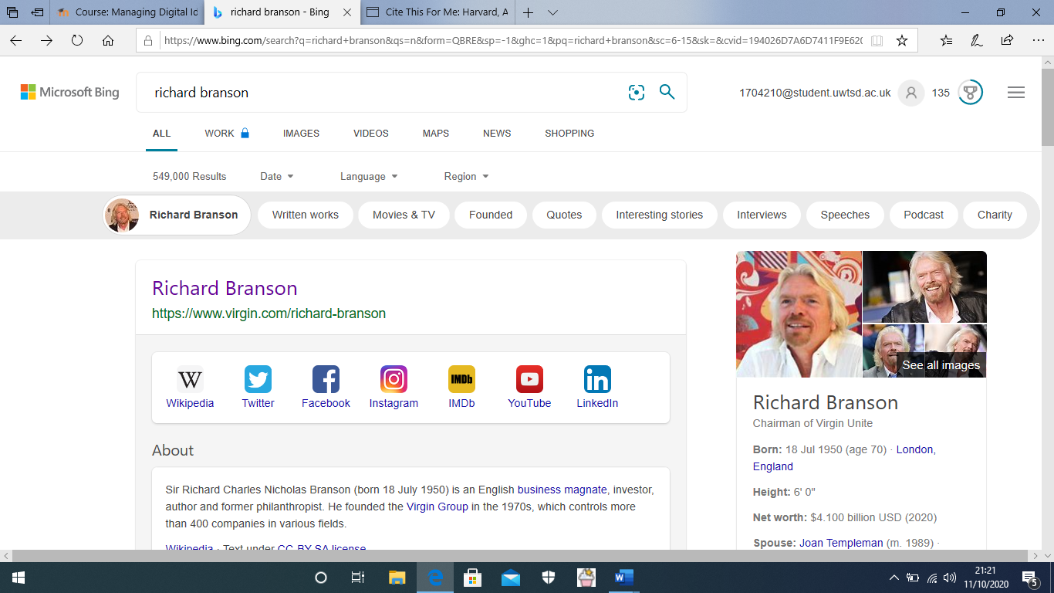
(richard branson - Bing, 2020)
From the image above the things that stand out the most, are all the social media platforms that Richard Branson is registered to, secondly to the right of the image his date of birth is advertised and his net worth. This automatically shows that Richard is a successful businessman as his net worth is a staggering, $54,100 billion USD. Looking into Richard Branson’s own personal website it can immediately be identified that he is the owner of the Virgin brand which controls over four hundred companies, interestingly everyone of the companies have a very similar logo, they all contain the company name Virgin and are all the same colour, red as seen in the image below
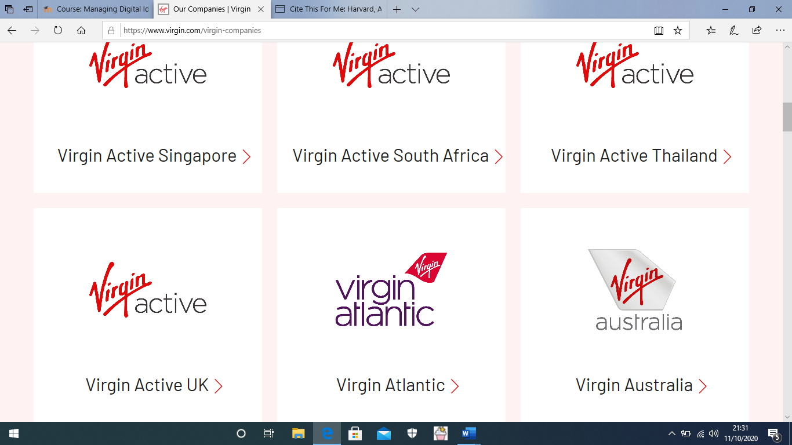
(Virgin.com | Virgin’s official site, 2020)
What is good about the logo’s being of very similar design is that the logo is automatically identified as the brand name Virgin, which is automatically associated with its founder Richard Branson, however one thing to note regarding the companies logo would be that the logo itself is red in colour, a colour that colour blind people cannot see, on the upside though red is usually associated with important messages such as STOP, NO Entry so people are automatically drawn to the colour and tend to take note of the message being projected.

Looking into Richard Branson’s Facebook account the first thing that can be seen is that Richard has released a new autobiography, this is advertised in the banner of his profile page as seen below
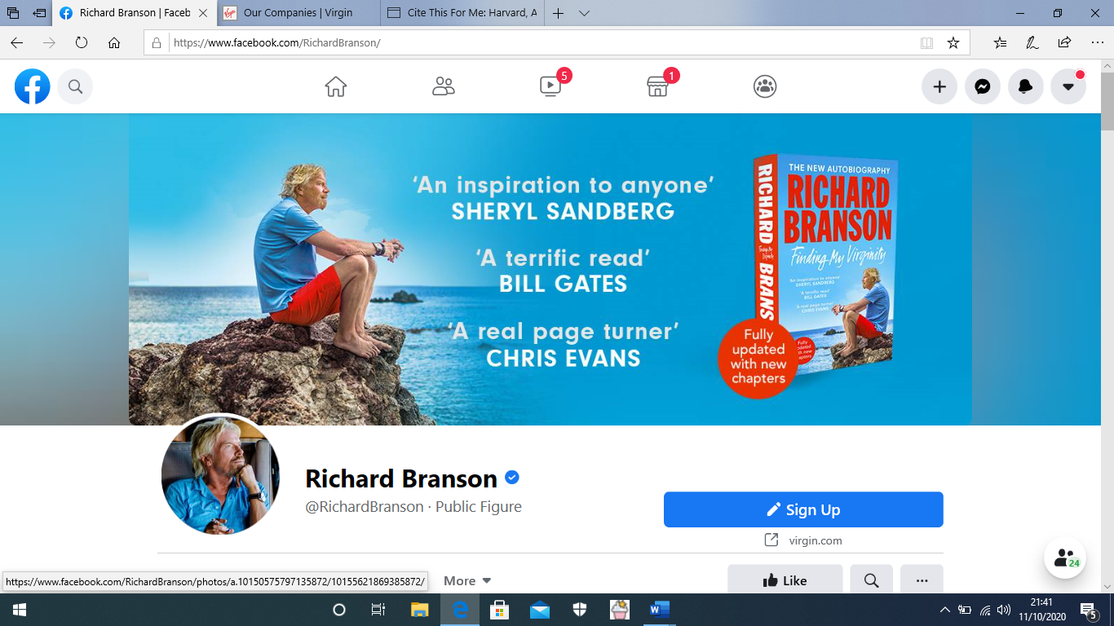
(Richard Branson, 2020)
This is a prime advertising spot for a professional, advertising a autobiography written by himself, and quotes included in the advert from professionals such a Bill Gates, and Chris Evans. Scrolling through just a short passage of Richard profile all entries are regarding his company virgin and the developments the company are making, global warming and plans to lower co2 emissions seem to be the main subject. The profile does not contain any personal information no photos of family members or family days out it is strictly for business use, it is used to advertise and sell products and services to members of the public for financial gain.
Looking at Richard’s Twitter profile the information seen is like that on Facebook, advertising his autobiography, and a similar profile picture.one thing that stands out is the Tweet stating how much Virgin has invested in the recent Pandemic.
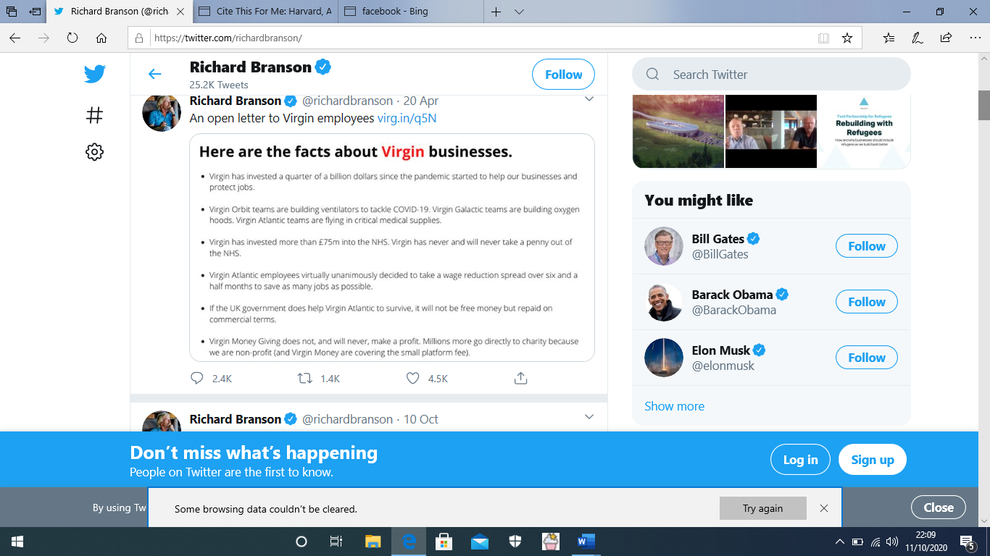("Richard Branson (@richardbranson) on Twitter", 2020)
The image above shows that Richard Branson is trying to show that although he is a professional, when needed he is willing to invest in the public health, however, is this a business proposition where he shows that he is investing in the things that matter in order to gain more business, will consumers support his company if he is reinvesting in lowering c02 emissions and making ventilators to help people suffering from the pandemic.

From the information researched for the purpose of this assignment Richard Branson’s professional social media accounts are all aimed at supporting his business. All the Virgin brands company contain the same logo in red drawing attention to the company’s logo. All companies under the virgin brand contain the Virgin name in the logo’s and is automatically linked to Sir Richard Branson, although not suitable for people who suffer from colour blindness. None of Richard person events or photos are published on any of his social media profiles. The profiles are all of high standard, and every post has been well though out before posting for the world to see, ensuring that they are related to ongoing issues in the world, Covid 19 pandemic, and co2 emissions. Very well-presented photos of Richard are all professional, and there is nothing from anything that Richard may have done wrong from his younger years displayed. He openly speaks about leaving school early and supporting individuals with words of advice from a medical term he also suffers from dyslexia. Showing that it is possible to succeed no matter what obstacles stand in the way.

For the second part of the assignment, Bigmal2004 will be looked at. This is an individuals personal profile.
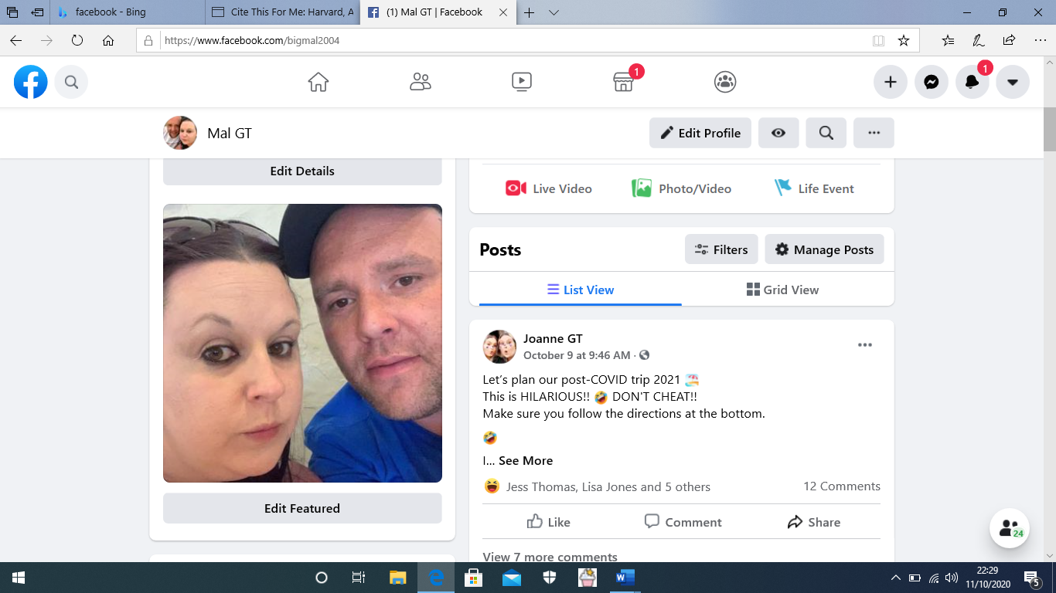
("Facebook", 2020)
The image above shows a picture of Malcolm and his wife Joanne, the picture is of poor quality, and can immediately be identified as casual not professional. Looking at the profile page there are several shared posts from several different friends, most of which are of a funny nature, making the profile look extremely unprofessional. In the about section there is a list of previous employers, the individual’s location can also be seen, as well as a contact number email address and several personal details, these details could be used in digital identity theft. There is enough information displayed on the page to enable a hacker to locate the individual including links to the individual’s family members. As seen in the image below
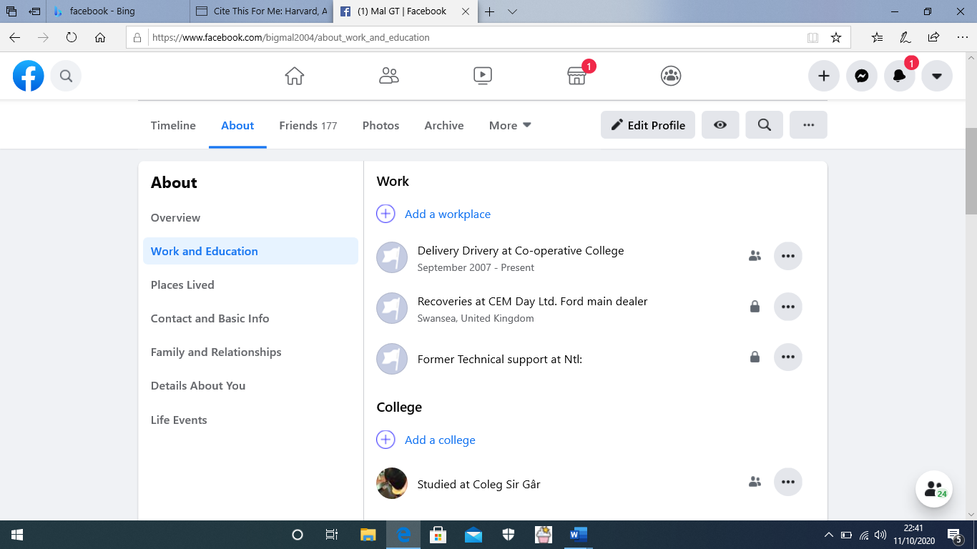
("Facebook", 2020)
Looking through Malcolm’s profile there are several images of dunk nights out, and several posts relating to personal opinions that other might not see appropriate. The profile is very poor, contains too much irrelevant information and would require a complete overhaul to even begin to look professional, some companies look and search for individuals on social media platforms, as it gives them an insight to the persons personal life, this profile would not be very likely to promote any sort of business or employment.

There are several differences between the two profiles researched for the purpose of this assignment, Richard’s profile on all digital platforms seem to be all business aimed, advertising and showing all the good that the company is doing worldwide from medical research to global warming reduction strategies, where as Malcolm’s profile seem to show that he has several jobs in a short period of showing that he may be unreliable, and constantly seeking a new challenge, unlike Richard who has a brand name and over four hundred companies. Richard’s profile picture is clearly professionally taken whereas Malcolm’s picture is a selfie taken on a mobile phone by himself. Richard has no personal information on his profile to enable members of the public to trace his location or any personal information, Malcolm has all personal information such as contact details and a rough location of his address, he also includes details of his workplace and studies, an ideal candidate for digital identity theft. There are also images of drunken night out and personalised opinions displayed throughout which are not relevant, and may cost Malcolm future employment chances. \Richard’s profile is precise to the point and relevant.

In order for Malcolm to improve his digital profile, he needs to remove all personal information, remove irrelevant posts and pictures, and advertise his skills and potential. Creating a professional looking profile is essential in todays society especially when starting or running a company. It can make the difference between success, survival, or collapse of an organisation. A poor digital profile is not good advertising and is not for filling Malcolm’s true potential. A good quality profile picture would be a major improvement. Richards digital image however is very hard to criticise as it ticks all the boxes, and Cleary demonstrates the difference between a professional’s digital identity and a personal digital identity.

